BUSINESS/IT
REQUIREMENTS DOCUMENT

<Project Name: Procurement Intelligence & Vendor Risk Platform>
<Project Reference:>

Project Sponsor: | ChatGPT & Claude
Business Project Manager: | Toushif Hossain
IT Project Manager: | Toushif Hossain
Business Analyst: | Toushif Hossain

Document Author: | Toushif Hossain
Version Number: | V0.1
Last Updated: | 20/08/26
Status: | Draft/Released
DOCUMENT CONTROL
<Blue italic text is included to provide guidance to the author and should be deleted before publishing>
Contacts
<Contacts that would be useful to provide for business information>
Name: | <Contact name>
Title: | <Contact title>
Location: | <Where the contact can be located>
Contact Number: | <Contact internal/external number>
Email: | < The email correspondence for the contact>

Document Approval
<Enter details of all stakeholders who will be subject to approval of this document>
Approver | Title | Business Area | Approval Date

Document Distribution
<Enter details of all stakeholders who will be subject to receipt of this document for reference purposes>
Name | Title | Business Area

Revision History
<Initially a document will be numbered 0.1 to 0.9 until it becomes the first issue for approval at which point the document is numbered 1.0. For future updates the document will be numbered using decimals to 1 place until it adopts the next whole number for issue>
Date | Author | Version | Summary Of Changes | Status

Related Documents
<List any significant documents that precede and relate to the project>
Document Name | Version | Author | Date

<Not all of the following sections may be applicable to the work being performed. If so, the preference would be to keep the section heading, but make a note such as “This section is not applicable for this process” and provide an explanation for the reasons why>

Table of Contents

1 Introduction 5
1.1 Background 5
1.2 Purpose 5
2 Problem/Impact/Successful Outcome 5
3 Objectives 5
4 Purpose Of Document 6
5 Scope 6
6 Definitions, Acronyms and Abbreviations 7
7 Risks 7
8 Assumptions 8
9 Issues 8
10 Dependencies 8
11 As Is Process 9
11.1 Vendor Compliance & Risk Monitoring 9
12 Context Diagram 12
13 Process Overview Diagram 13
14 High Level To Be Business Requirements 14
15 Detailed Business/IT Requirements 16
15.1 Functional Requirements 16
15.2 Process Diagram 19
15.3 Non Functional Requirements 19
16 Business Impact Assessment 25
17 Costs 26
18 Appendices 26

Introduction

Background
Effective vendor management is critical to ensuring uninterrupted procurement operations, regulatory compliance, and cost efficiency. While vendor information and procurement transactions are maintained within Microsoft Dynamics 365 Business Central, there is currently no centralized mechanism for monitoring vendor compliance status, document validity, performance indicators, and overall vendor risk.

Procurement and management teams often rely on manual tracking methods, spreadsheets, and periodic reviews to monitor vendor-related risks. This approach increases the possibility of missed document expirations, delayed identification of underperforming vendors, and limited visibility into supplier compliance and performance trends.

Purpose
The purpose of the Procurement Intelligence & Vendor Risk Platform is to provide a centralized solution for monitoring vendor compliance, evaluating supplier performance, and assessing vendor risk through automated scoring and analytics.

The solution will integrate with Microsoft Dynamics 365 Business Central to retrieve vendor and procurement-related information while maintaining additional compliance, performance, and risk management data within an external application.

Problem/Impact/Successful Outcome

The Problem | The Impact | The Successful Outcome
Vendor information, compliance documents, and performance indicators are currently managed across multiple systems and manual tracking methods. Procurement teams have limited visibility into vendor compliance status, document expiry dates, supplier performance trends, and overall vendor risk. As a result, vendor-related issues are often identified reactively rather than proactively. | The lack of centralized vendor intelligence increases the risk of engaging non-compliant vendors, missing critical document expirations, and continuing business with underperforming suppliers. This can lead to procurement delays, operational disruptions, compliance violations, audit observations, increased costs, and reduced effectiveness in supplier management and decision-making. | A centralized Procurement Intelligence & Vendor Risk Platform provides a single source of truth for vendor compliance, performance, and risk information. Procurement and management teams can proactively monitor vendor status, receive automated alerts for compliance issues, evaluate suppliers using defined KPIs, and identify high-risk vendors through automated risk scoring. This enables better procurement decisions, improved compliance management, reduced operational risk, and enhanced supplier governance.

Objectives

ID | Business Objective | Business Owner | Business Importance
O01 | Improve visibility of vendor compliance status by providing centralized access to vendor documents, validity periods, and compliance information. | Head of Procurement | High
O02 | Reduce the risk of procurement disruptions by proactively identifying vendors with expired or expiring compliance documents. | Procurement Manager | High
O03 | Establish a standardized vendor performance evaluation process using defined procurement KPIs and performance metrics. | Procurement Manager | High
O04 | Enable proactive vendor risk management through automated risk assessment and vendor risk scoring. | Head of Procurement | High
O05 | Improve decision-making by providing procurement and management teams with vendor performance, compliance, and risk dashboards. | Head of Procurement | Medium
O06 | Reduce manual effort involved in monitoring vendor compliance and performance through automation and timely notifications. | Procurement Operations Team | Medium
O07 | Strengthen audit readiness by maintaining a centralized repository of vendor compliance records and historical risk assessments. | Internal Audit / Compliance Team | Medium
O08 | Improve supplier governance by identifying high-risk and underperforming vendors for corrective action or review. | Head of Procurement | High

Purpose Of Document
This Business Requirements Document (BRD) defines the business needs, objectives, scope, and high-level requirements for the proposed Procurement Intelligence & Vendor Risk Platform. The document serves as a formal reference for business stakeholders, project sponsors, business analysts, solution architects, and development teams to establish a common understanding of the business problem and the expected outcomes of the solution.
The purpose of this document is to:
- Document the business drivers and objectives for the initiative.
- Define the scope and boundaries of the proposed solution.
- Capture the business requirements and stakeholder expectations.
- Provide a basis for solution design, development, testing, and implementation activities.
- Ensure alignment between business goals and the proposed technology solution.
- Serve as a reference document for project planning, requirement validation, and stakeholder approval.
This document does not define detailed technical specifications, system design, or implementation approaches. These will be addressed in subsequent functional and technical design documents.

Scope

In Scope | Out Of Scope (For Phase 2)
- Vendor compliance management.  - Vendor performance monitoring.  - Vendor risk assessment and scoring.  - Expiry and compliance alerts.  - Integration with Microsoft Dynamics 365 Business Central for vendor and procurement data. | - Predictive Analytics.  - AI-driven recommendations  - Workflow Automation and Optimization  - Supplier self-service

Definitions, Acronyms and Abbreviations
<This subsection provides the definitions of all terms, acronyms, and abbreviations required to properly interpret the BRS>

Abbreviation/Acronym | Description
BRD | Business Requirements Document
FRD | Functional Requirements Document
ERP | Enterprise Resource Planning
D365 BC | Microsoft Dynamics 365 Business Central
KPI | Key Performance Indicator
PO | Purchase Order
TIN | Tax Identification Number
BIN | Business Identification Number / VAT Registration Number
SLA | Service Level Agreement
API | Application Programming Interface
Vendor Risk Score | A calculated score representing the overall risk level of a vendor based on compliance, performance, quality, and financial factors
Compliance Document | A document required for vendor validation and regulatory compliance, such as Trade License, TIN, BIN, ISO Certification, etc.
Procurement Intelligence | Collection and analysis of vendor, procurement, and performance information to support decision-making
Approved Vendor | A vendor authorized to conduct business after completing onboarding and compliance requirements

Risks

Ref | Risk | Detailed BRS Reference
R01 | Required vendor performance data may not be fully available within Business Central for KPI calculations. | Vendor Performance Monitoring
R02 | Vendor compliance documents may not be maintained consistently, affecting risk assessment accuracy. | Compliance Management
R03 | Business users may have differing definitions of vendor risk and performance criteria. | Risk Assessment Requirements
R04 | Integration limitations or API restrictions may affect data synchronization between Business Central and the external platform. | System Integration
R05 | Historical vendor data may be incomplete, reducing the effectiveness of trend analysis and risk scoring. | Reporting & Analytics
R06 | Future changes to procurement policies may require modification of risk calculation rules and KPI definitions. | Risk Scoring Engine

Assumptions

Ref | Assumption | Detailed BRS Reference
A01 | Vendor master data is maintained and available within Microsoft Dynamics 365 Business Central. | Vendor Data Integration
A02 | Business Central APIs are available for retrieving vendor and procurement-related information. | System Integration
A03 | Procurement and Finance departments are responsible for maintaining accurate vendor information. | Vendor Master Management
A04 | Compliance document expiry dates will be available for tracking within the proposed solution. | Compliance Monitoring
A05 | Procurement stakeholders will define and approve vendor performance KPIs and risk scoring criteria. | Performance & Risk Management
A06 | Users will have appropriate access rights to view vendor information and dashboards. | Security & Access Control

Issues

Ref | Issue | Detailed BRS Reference
I01 | Vendor risk scoring methodology has not yet been formally approved by business stakeholders. | Risk Assessment
I02 | Final list of compliance documents required for each vendor category is pending confirmation. | Compliance Management
I03 | Performance KPI thresholds and target values require validation by Procurement Management. | Vendor Performance
I04 | Alert recipients and escalation procedures for critical vendor risks are yet to be finalized. | Notification Requirements
I05 | Data ownership and responsibility for maintaining vendor compliance records require confirmation. | Vendor Governance

Dependencies

Ref | Dependency | Detailed BRS Reference
D01 | Availability of Business Central APIs for vendor and procurement data retrieval. | System Integration
D02 | Availability and quality of vendor master data maintained within Business Central. | Vendor Master Management
D03 | Procurement department approval of KPI definitions and performance evaluation criteria. | Vendor Performance Monitoring
D04 | Compliance team approval of document requirements and expiry rules. | Compliance Management
D05 | Availability of email or notification services for alert generation and delivery. | Alert & Notification Management
D06 | Stakeholder approval of vendor risk scoring methodology and risk thresholds. | Risk Assessment Engine

As Is Process

Vendor Compliance & Risk Monitoring
Process Objective
To onboard, maintain, monitor, and evaluate vendors used for procurement activities.
Role | Responsibility
Vendor | Submits required documents
Procurement Officer | Maintains vendor records
Procurement Manager | Reviews vendor performance
Finance Team | Verifies tax and banking information
Internal Audit / Compliance | Reviews compliance status
Management | Reviews strategic supplier performance
- Current State Process
- Step 1: Vendor Onboarding
Vendor submits:
- Trade License
- TIN Certificate
- BIN/VAT Certificate
- Bank Information
- Company Profile
↓
Procurement Officer manually reviews documents.
↓
Vendor is created in Business Central.

- Step 2: Vendor Information Maintenance
Vendor master data is maintained in Business Central.
However:
- Compliance documents are stored separately
- Some records are maintained via email
- Some records are maintained in shared folders
- Expiry tracking is often manual
↓
Procurement team updates information when notified.

- Step 3: Compliance Monitoring
Procurement periodically reviews:
- Trade License expiry
- Contract expiry
- Certification validity
Current methods:
- Excel sheets
- Email reminders
- Manual calendar entries
↓
Expiry risks depend on human follow-up.

- Step 4: Procurement Transactions
Purchase Orders are created in Business Central.
↓
Vendor delivers goods.
↓
Goods receipt is recorded.
↓
Invoices are processed.
↓
Payments are completed.

- Step 5: Vendor Performance Review
Procurement team periodically reviews:
- Delivery delays
- Fulfillment performance
- Complaints
- Quality issues
Current challenges:
- Information scattered across systems
- KPI calculation is manual
- Historical analysis is difficult

- Step 6: Vendor Risk Assessment
Current risk assessment is largely experience-based.
Examples:
- Repeated late deliveries
- Expired documents
- Supplier complaints
↓
Procurement managers identify risks manually.
↓
No standardized risk score exists.

- Step 7: Management Reporting
Reports are prepared:
- Monthly
- Quarterly
- Annual
Typically using:
- Excel
- Manual exports from ERP
- Email-based reporting
↓
Management receives limited real-time visibility.

Context Diagram

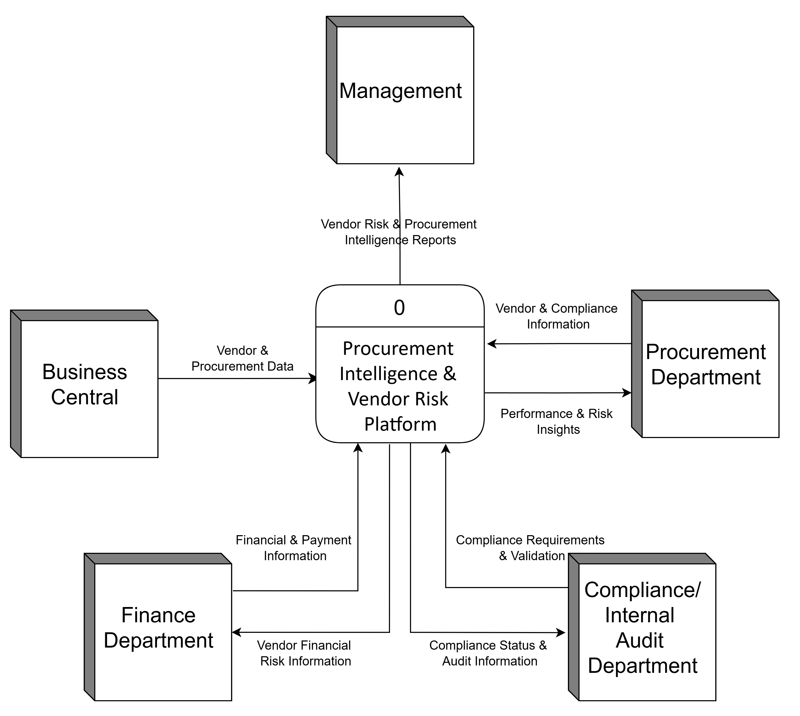

Process Overview Diagram
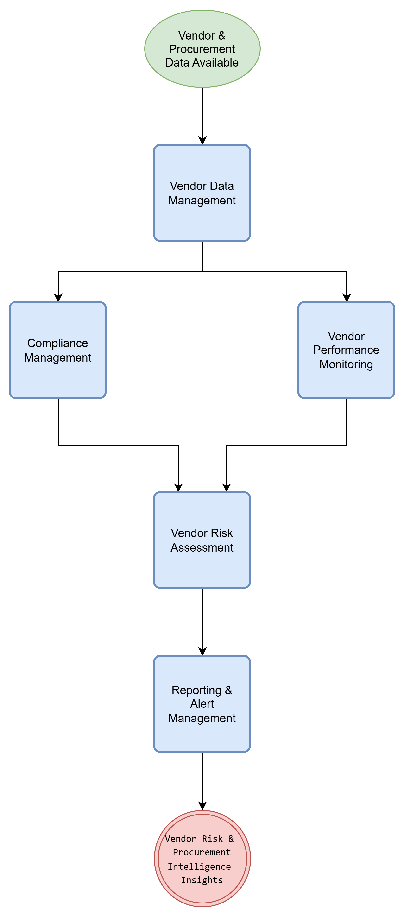

High Level To Be Business Requirements

Introduction
The Procurement Intelligence & Vendor Risk Platform shall provide a centralized solution for monitoring vendor compliance, evaluating supplier performance, assessing vendor risk, and supporting procurement decision-making. The solution shall integrate with Microsoft Dynamics 365 Business Central and provide procurement stakeholders with timely, accurate, and actionable vendor intelligence.

Business Requirements
ID | Business Requirement | Priority
BR-001 | The organization shall maintain a centralized repository of vendor compliance, performance, and risk information. | High
BR-002 | The solution shall provide visibility into vendor compliance status and document validity. | High
BR-003 | The solution shall enable proactive identification of vendors with expired or expiring compliance documents. | High
BR-004 | The solution shall support standardized evaluation of vendor performance using defined procurement KPIs. | High
BR-005 | The solution shall provide an automated mechanism for assessing and monitoring vendor risk. | High
BR-006 | The solution shall provide timely alerts and notifications related to vendor compliance and risk events. | High
BR-007 | The solution shall provide dashboards and reports to support procurement decision-making. | High
BR-008 | The solution shall support vendor segmentation and categorization for monitoring and analysis purposes. | Medium
BR-009 | The solution shall maintain historical records of vendor compliance, performance, and risk assessments. | Medium
BR-010 | The solution shall support audit and governance activities through traceable vendor records and assessment history. | Medium
BR-011 | The solution shall integrate with Microsoft Dynamics 365 Business Central as the source of vendor and procurement transaction data. | High
BR-012 | The solution shall provide a consistent and standardized methodology for vendor risk scoring and classification. | High

Business Requirement Mapping

Business Need | Related Requirement
Compliance Monitoring | BR-002, BR-003
Vendor Performance Management | BR-004
Vendor Risk Management | BR-005, BR-012
Procurement Visibility | BR-007
Governance & Audit | BR-009, BR-010
System Integration | BR-011

Detailed Business/IT Requirements

Functional Requirements

ID | Title | Requirements Description | Type | MoSCoW Priority | Originator | Status | Delivered By | Test ID
FR001 | Vendor Data Synchronization | The system shall retrieve vendor master data from Microsoft Dynamics 365 Business Central. | Integration | Must Have | Procurement | Proposed | Vendor Integration Module | TC001
FR002 | Vendor Profile Management | The system shall maintain a consolidated vendor profile containing vendor master, compliance, performance, and risk information. | Application | Must Have | Procurement | Proposed | Vendor Management Module | TC002
FR003 | Compliance Document Management | The system shall allow authorized users to upload, update, and manage vendor compliance documents. | Application | Must Have | Procurement | Proposed | Compliance Module | TC003
FR004 | Document Expiry Tracking | The system shall track validity and expiry dates of vendor compliance documents. | Business | Must Have | Compliance Team | Proposed | Compliance Module | TC004
FR005 | Compliance Status Calculation | The system shall automatically determine vendor compliance status based on document validity and completeness. | Business | Must Have | Compliance Team | Proposed | Compliance Engine | TC005
FR006 | Vendor Categorization | The system shall allow vendors to be classified into predefined categories. | Information | Should Have | Procurement | Proposed | Vendor Management Module | TC006
FR007 | KPI Calculation | The system shall calculate vendor performance KPIs based on procurement transaction data. | Business | Must Have | Procurement | Proposed | Performance Engine | TC007
FR008 | On-Time Delivery Measurement | The system shall calculate vendor on-time delivery percentage. | Business | Must Have | Procurement | Proposed | Performance Engine | TC008
FR009 | PO Fulfillment Measurement | The system shall calculate purchase order fulfillment percentage for each vendor. | Business | Must Have | Procurement | Proposed | Performance Engine | TC009
FR010 | Vendor Performance Scorecard | The system shall generate a vendor performance scorecard based on defined KPIs. | Application | Must Have | Procurement | Proposed | Performance Module | TC010
FR011 | Vendor Risk Score Calculation | The system shall calculate a vendor risk score using predefined compliance, performance, quality, and financial risk factors. | Business | Must Have | Procurement Management | Proposed | Risk Engine | TC011
FR012 | Vendor Risk Classification | The system shall classify vendors into risk categories (Low, Medium, High, Critical). | Business | Must Have | Procurement Management | Proposed | Risk Engine | TC012
FR013 | Compliance Alert Generation | The system shall generate alerts for documents approaching expiry. | Application | Must Have | Compliance Team | Proposed | Notification Module | TC013
FR014 | High-Risk Vendor Alert | The system shall generate alerts when a vendor exceeds a defined risk threshold. | Application | Must Have | Procurement Management | Proposed | Notification Module | TC014
FR015 | Dashboard Reporting | The system shall provide dashboards displaying vendor compliance, performance, and risk information. | Application | Must Have | Management | Proposed | Reporting Module | TC015
FR016 | Historical Risk Tracking | The system shall maintain historical vendor risk assessment records. | Information | Should Have | Audit Team | Proposed | Risk Engine | TC016
FR017 | Audit Trail Management | The system shall maintain an audit trail of vendor document and risk score changes. | Technical | Should Have | Internal Audit | Proposed | Audit Module | TC017
FR018 | User Access Control | The system shall restrict access based on user roles and permissions. | Technical | Must Have | IT Department | Proposed | Security Module | TC018
FR019 | Vendor Risk Reporting | The system shall generate vendor risk reports for management review. | Application | Should Have | Management | Proposed | Reporting Module | TC019
FR020 | Business Central Integration Monitoring | The system shall log and monitor data synchronization activities with Business Central. | Integration | Could Have | IT Department | Proposed | Integration Module | TC020

* Type Key:-

- Business
- Application
- Information
- Integration
- Technical

** Status Key:-

- Proposed
- Accepted

MoSCoW Rating:-
- Must Have: Describes a requirement that must be satisfied in the final solution for the solution to be considered a success
- Should Have: Represents a high-priority item that should be included in the solution if it is possible. This is often a critical requirement but one which can be satisfied in other ways if strictly necessary.
- Could Have: Describes a requirement which is considered desirable but not necessary. This will be included if time and resources permit.
- Would Have: Represents a requirement that stakeholders have agreed will not be implemented in a given release, but may be considered

Process Diagram
<Include a process flow diagram which links to the functional requirements above if necessary>

Non Functional Requirements

ID | Title | Requirements Description | Type | MoSCoW Priority | Originator | Status | Delivered By | Test ID
NFR001 | User Authentication | The system shall require authenticated user login before access to any application functionality. | Security | Must Have | IT Department | Proposed | Security Module | NTC001
NFR002 | Role-Based Access Control | The system shall restrict access to functions and data based on user roles and permissions. | Security | Must Have | IT Department | Proposed | Security Module | NTC002
NFR003 | Audit Trail | The system shall record all changes to vendor compliance documents, risk scores, and critical vendor information with user and timestamp details. | Audit | Must Have | Internal Audit | Proposed | Audit Module | NTC003
NFR004 | Data Encryption | Sensitive data shall be encrypted during transmission between Business Central and the platform using HTTPS/TLS. | Security | Must Have | IT Department | Proposed | Integration Layer | NTC004
NFR005 | Dashboard Response Time | Dashboard pages shall load within 5 seconds under normal operating conditions. | Performance | Should Have | Business Users | Proposed | Application Layer | NTC005
NFR006 | Risk Calculation Performance | Vendor risk score calculations shall complete within 60 seconds for all active vendors during scheduled processing. | Performance | Should Have | Procurement | Proposed | Risk Engine | NTC006
NFR007 | Availability | The system shall be available 99% of business operating hours excluding scheduled maintenance periods. | Availability | Should Have | Business Users | Proposed | Infrastructure | NTC007
NFR008 | Integration Reliability | Failed Business Central synchronization transactions shall be logged and retried automatically. | Reliability | Must Have | IT Department | Proposed | Integration Module | NTC008
NFR009 | Error Logging | System errors and integration failures shall be logged with sufficient information for troubleshooting and support. | Reliability | Must Have | IT Department | Proposed | Monitoring Module | NTC009
NFR010 | Backup and Recovery | Application data shall be backed up daily and recoverable within 4 hours of a critical failure. | Recovery | Should Have | IT Department | Proposed | Infrastructure | NTC010
NFR011 | Browser Compatibility | The system shall support the latest versions of Microsoft Edge, Google Chrome, and Mozilla Firefox. | Compatibility | Should Have | Business Users | Proposed | Application Layer | NTC011
NFR012 | Business Central Compatibility | The solution shall integrate with Microsoft Dynamics 365 Business Central using supported APIs and authentication mechanisms. | Integration | Must Have | IT Department | Proposed | Integration Module | NTC012
NFR013 | Data Integrity | Vendor, compliance, and risk information shall maintain referential integrity throughout the application. | Reliability | Must Have | IT Department | Proposed | Database Layer | NTC013
NFR014 | Maintainable Architecture | The solution shall follow a modular architecture separating integration, business logic, reporting, and user interface components. | Maintainability | Could Have | Solution Architect | Proposed | Application Architecture | NTC014
NFR015 | User Experience | The system shall provide a consistent and intuitive user interface requiring minimal user training. | Usability | Should Have | Procurement Department | Proposed | UI Layer | NTC015

* Type Key:-

- Technical
- Integration
- Security
- Audit
- Performance
- Capacity
- Availability
- Reliability
- Recovery
- Compatibility
- Maintainability
- Usability

** Status Key:-

- Proposed
- Accepted
<Non Functional requirements checklist:-

TYPE | SAMPLE DETAIL
SECURITY
Login Requirements | Access levels, CRUD levels (Create/Retrieve/Update/Delete)
Password Requirements | Length, special characters, expiry, recycling policies
Inactivity Timeouts | Durations, actions
AUDIT
Audited Elements | What business elements will be audited
Audited Fields | Which data fields will be audited
Audit File Characteristics | Before image, after image, user & time stamp
PEFORMANCE
Response Times | Application loading, screen open & refresh times
Processing Times | Functions, calculations, imports, exports
Query & Reporting Times | Initial loads & subsequent loads
CAPACITY
Throughput | How many transactions per hour does the system need to be able to handle?
Storage | How much data does the system need to be able to store?
Year on year growth requirements
AVAILABILITY
Hours of Operation | When is it available? Consider weekends, holidays, maintenance times etc
Locations of Operation | Where should it be available from; what are the connection requirements?
RELIABILITY
Meantime Between Failures | What is the acceptable threshold for down-time eg. one a year, 4,000 hours etc
Meantime To Recovery | If broken, how much time is available to get the system back up again?
INTEGRITY
Fault Trapping | How to handle electronic interface failures
Bad Data Trapping | Data imports; flag-and-continue or stop the import policies etc
Data Integrity | Referential integrity in DB tables and interfaces
Image Compression & Decompression Standards
RECOVERY
Recovery process | How do recoveries work; what is the process?
Recovery Timescales | How long should a recovery take to perform?
Backup Frequencies | How often is the transaction data, set-up data and system (code) backed up?
Backup Generations | What are the requirements for restoring to previous instance(s)?
COMPATIBILITY
Compatibility With Shared Application | What other systems does it need to talk to?
Compatibility With 3rd Party Applications | What other systems does it have to live with amicably?
Compatibility On Different Operating Systems | What does it have to be able to run on?
Compatibility On Different Platforms? | What are the hardware platforms it needs to work on?
MAINTAINABILITY
Conformance to Architecture Standards | What are the standards it needs to conform to or have exclusions from?
Conformance to Design Standards | What design standards must be adhered to or exclusions created?
Conformance to Coding Standards | What design standards must be adhered to or exclusions created?
USABILITY
Look And Feel Standards | Screen element density, layout and flow, colours, UI, metaphors, keyboards and shortcuts
Internationalization/ Localization Requirements | Languages, spellings, keyboards, paper sizes etc

Business Impact Assessment

Lens | Key Impacts
Process | • Vendor compliance monitoring will move from predominantly manual/periodic monitoring toward centralized and automated monitoring.  • Vendor performance evaluation will be standardized using defined KPIs.  • Vendor risk assessment will become more structured and data-driven.  • Automated expiry and risk alerts will reduce dependence on manual follow-up.  • Existing procurement processes in Business Central are not expected to be fundamentally changed; the proposed platform will primarily provide monitoring, analysis, and intelligence capabilities.  • Any new or amended vendor governance policies, risk thresholds, and escalation procedures will require business approval.
People | • Procurement users will require training on vendor compliance, performance, and risk dashboards.  • Procurement/Compliance users may take responsibility for maintaining additional vendor compliance information.  • Roles and responsibilities for reviewing alerts and taking corrective action will need to be defined.  • No significant additional recruitment is expected for the initial implementation.  • Stakeholder communication and change management will be required to establish consistent use of the platform.
Customer | • No direct customer-facing functionality is planned in the initial scope.  • Improved vendor reliability and procurement continuity may indirectly contribute to better product availability and customer service.  • Vendor-related disruptions caused by non-compliance or poor performance may be identified earlier, allowing mitigation before they affect downstream operations.
Financial | • Potential costs may include application hosting, database/storage, notification services, development, maintenance, and future licensing depending on the selected architecture.  • The solution is expected to reduce manual effort associated with vendor monitoring and reporting.  • Potential financial benefits include reduced procurement disruption, improved supplier performance, reduced compliance risk, and better vendor decision-making.  • A formal benefits measurement approach should be established using baseline metrics before production implementation.
Data & MI | • Vendor master and procurement transaction data will be sourced primarily from Microsoft Dynamics 365 Business Central.  • Additional compliance, performance, and risk information will need to be maintained by authorized users or generated by the platform.  • Data quality and completeness will directly affect the accuracy of performance and risk calculations.  • Data ownership and governance responsibilities must be established.  • Management Information will include vendor compliance status, performance KPIs, risk scores, high-risk vendors, and trends.  • Historical risk and performance data should be retained to support trend analysis and audit requirements.
Product & Proposition | • No direct change to existing customer-facing products is expected.  • The initiative introduces a new internal procurement intelligence capability rather than a new commercial product.  • Vendor governance and procurement decision-making processes may be enhanced through the new intelligence capability.  • No product implementation group is expected to be required for the initial internal solution.
Supplier | • No immediate changes to existing supplier contracts are expected as part of the initial implementation.  • Supplier information and compliance requirements may need to be reviewed to ensure the platform supports existing procurement policies.  • If future supplier self-service functionality is introduced, additional supplier communication, contracts, data-sharing, and governance considerations may arise.  • Supplier data used by the platform must be handled according to applicable organizational data governance requirements.
Management | • Management will require visibility into project readiness, adoption, and expected business benefits.  • Procurement and management stakeholders should approve KPI definitions, risk categories, risk thresholds, and escalation rules.  • A business readiness plan should cover user training, communication, data preparation, testing, and adoption.  • Management sponsorship will be required to establish the platform as part of the vendor governance process.
Governance & Risk | • The platform introduces a more structured approach to vendor risk identification and monitoring.  • Risk ownership and responsibility for responding to high-risk vendors must be defined.  • Risk scoring rules should be documented and approved by the appropriate business owner.  • Changes to vendor risk classifications should be auditable.  • Compliance documentation and risk assessment history should support audit and governance activities.  • Any applicable regulatory or organizational procurement requirements must be incorporated into the final compliance rules.

Costs
<Include any costs associated with this change if applicable.
Note: This section has been specifically added at the request of the Food Business Analysts>

Appendices
<Additional document/s to add as a reference to the requirements>

