|  |  |
| --- | --- |
| 0    **Independent University, Bangladesh**  **Department of Computer Science & Engineering**  **Task 3**  **Course Code:** CSC212L  **Course Title:** Microprocessor, Interfacing & Assembly Language  **Submitted To:**  Mohammad Rejwan Uddin  Department of Computer Science & Engineering   |  | | --- | | **Submitted By:**  **Name:** Rudrita Rahman  **ID:** 2021059  **Section:** 1  **Department:** Computer Science |   **Date of Submission:** 24th February, 2023 |

**Real-Time Monitoring System for Shelf Life Estimation of Fruit and Vegetables**

# **Methodology**

A critical measure that should be immediately taken is to reduce the huge number of postharvest losses, which are reported to be 1.3 billion tons a year, which represents 33% of the production according to. Shelf life is usually defined as the time during which a food product remains safe according to microbiological standards and retaining a desired sensory, physico-chemical and nutritional quality. The patented monitoring system is based on the real-time control of the most influencing environmental variables to estimate the shelf life of the products during the whole supply chain.

The materials and methods described in this paper have been divided into three sections: the equipment designed and used for the continuous monitoring of variables during transport, the physico-chemical and sensory quality tests performed on the commodity to determine its shelf life according to storage temperature, and the mathematical methods used to represent the estimation model.

# **Component Used**

* **Selected Commodity:** Iceberg lettuce (Lactuca sativa’)

**Why picked Lettuce as a model?** This is due to the great trade importance of this vegetable and also to the physiological disorders that occur when stored under improper postharvest conditions of temperature, relative humidity, ethylene and CO2.

* Statgraphics Plus software
* R GNU statistical software

# **Algorithms and Equations**

Two regression models have been tested, multiple linear regression (MLR) and multiple nonlinear regression (MNLR), with n predictor variables**.**

The model are developed from a training set D = {X, Y} of S samples, which is composed of the predictor matrix, or also called design matrix, X = [x1, . . . ,xi , . . . , xS] T and the response matrix Y = [y1, . . . , yi, . . . , yS] T . xi is a column vector of K elements, that can contain all features at a given trial i.

For the MLR Model:



and yi is a column vector of M elements, containing the corresponding days to be estimated at that trial i. Since in our application this is only the days that the commodity keeps the score above 3, yi is reduced to a scalar and M = 1:



We consider MLR as:



In the MNLR model analyzed, we consider that the design matrix X is given by:



to determine the influence of quadratic terms, as well as the possible interaction between the set-point and the area above the set-point.

In this case, the MNLR model is:



Both models can be expressed in the matrix form as:



applying the least-squares criterion, we must estimate those β values that minimize the mean square error, i.e.,:

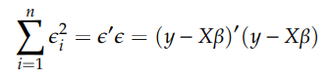

This criterion determines those models that maintain a high explanatory level and contain regressors with statistically significant active influence on the response variable without collinearity issues.

# **Findings**

Table 1: The Shelf Life of Iceberg Lettuces According to the Fixed Storage Temperatures

Model 1 is the model that best correlates with the results. It predicts very well the duration in days and the errors are always in a conservative sense (it proposes a duration lower than that observed) with a maximum error of 1 day. However, it has a complicated interpretation.

Model 2 is easily interpreted. Each increased degree causes a loss of 1.17 days of duration and a unit increase of the area also produces a decrease of 0.025 days. Makes mistakes in both directions, in a range of 3 to 2 days. The model may have some problems since there is a decrease in the R2 predictor relating to the others.

In model 3, the quadratic term of the area is not significant. This model conservatively makes mistakes, in a range of 0 to 2 days.

Although the model 1 and 3 have similar behaviour, model 3 is much easier to interpret than model 1, since an increase in the value of predictor A (Area) leads to a reduction in shelf life. Thus, in model 3, the coefficient corresponding to predictor A is negative (−0.02063), while in model 1 it is positive (0.1654), in the latter case compensating the duration with the negative coefficient of the interaction (−0.03721). In summary, applying the criterion of statistical parsimony, model 3 is the most appropriate since it presents an explanatory level very similar to that obtained with model 1 using a smaller number of predictors.

# **Novelty**

Concerning the regression models, the best results were obtained using the temperature of the set-point and the area above. The average temperature is not decisive in the prediction. The temperature variation observed in the tests corresponds to certain phases of loading or unloading the lettuce into the truck or, in the case of the simulated tests, the transportation of the goods from the handling industry to the cold storage rooms at university.

# **Analysis**

## **Physicochemical Analysis**

The results were expressed in N mm-1:



## **‘Human’ Sensory Analysis**

Visual appearance, colour, compactness, flavour and overall quality were assessed using a 5-point hedonic scale of acceptability:

* Score: 5: excellent
* Score 4: good
* Score 3: fair – limit of retail (LR)
* Score 2: poor
* Score 1: extremely bad.

## **Statistical Analysis**

The experiment was a two–factor (temperature × storage time) design subjected to analysis of variance (ANOVA) using Statgraphics Plus software. Models were generated using R GNU statistical software. Statistical significance was assessed at the level p = 0.05, and Tukey’s multiple range test was used to separate means

# **Research Gap**

Even though the nodes can measure many atmospheric variables, this paper is just focused on temperature as it is the most significant factor by far in the quality degradation kinetics of perishable products, intending to propose a prediction methodology which will apply to the other parameters in future research. The size and flexibility of the nodes allow them to be placed anywhere, i.e., on the walls of the truck, on a pallet or inside the cardboard of commodities.

These observations allow using the system presented as a ‘Shelf life estimator sensor’. The more data tested, the better the model can predict quality and remaining shelf life.

# **Future Work**

The purpose of this work is not to make an exhaustive study of the shelf life, but to provide an estimation model using the technical means currently used in the land transportation of lettuce, such as air temperature measurement. The presented system allows, to the different intermediaries, to know the conditions in which the load have been stored and/or transported and could contribute to reducing the food waste due to bad conditions of conservation or transportation. However, in order to make a more accurate quality loss prediction model, it is necessary to consistently extend the training and validation work throughout the time, not only after transportation but also in the different phases of the cold chain. This target should be evaluated in future works.

In future researches, this tool should be implemented. It should be able to predict the remaining shelf life for all kinds of commodities according to the initial quality and the environmental factors affecting the location where they have been stored or transported from farm to fork. It should also include non-sensory quality attributes such as, i.e. nutritional compounds, like vitamin C content loss, which is being increasingly demanded by consumers for fresh food.

**An Artificial Intelligence Approach Toward Food Spoilage Detection and Analysis**

# **Methodology**

The motivation behind Monitoring and analysis of food spoilage using Machine Learning is to keep track and manage food products to avoid spoilage caused by climatic and atmospheric changes. Monitoring and analysis of food spoilage using Machine Learning saves time and provides accurate and consistent results. Bacteria, virus, protozoa, and fungi are factors of food spoilage. These factors can create harmful results for consumers, but we can apply prevention techniques to them to save the life and quality of food.

# **Component Used**

* **Controller:** Arduino
* Raspberry pi
* Gas Sensor Detector: The gas sensor detects early spoilage via detecting a little amount of gas emission of the food items.
* Humidifier
* Heat Sensor
* Humidity Sensor: The humidity sensor senses the humidity of the environment.
* Temperature Sensor: The temperature sensor monitors the temperature for the predefined threshold value which is controlled by Arduino.
* Cooling module (TEC1-12715-Thermoelectric Cooler 15A Peltier Module)
* Light Sensor
* Camera Sensor: The camera sensor captures the image of fruit or vegetable.
* Fruits360 dataset,

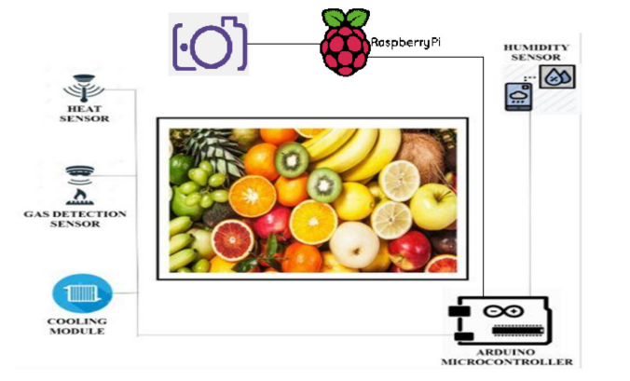

Figure 1: The Architecture of Monitoring and Analysis of Food Spoilage using Machine Learning

# **Algoritms**

We proposed a CNN for object detection and prediction model. This is trained over three different classes. In our model, there are a total of 11 layers. The output layer is SoftMax, and there are four convolutional layers, four max pooling layers, and two fully connected layers. The model has been trained on 50 different types of fruits and vegetables, and it is also capable of identifying multiclass images.

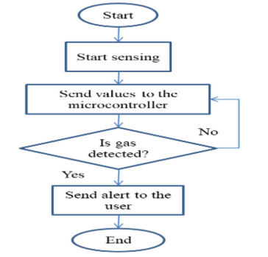

Figure 2: Gas Detection Sensor

Figure 3: Humidity Sensor

Figure 4: Heat Sensor and Cooling Module

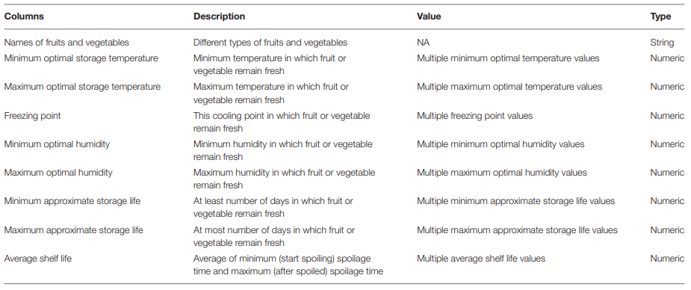

Table 2: Description of the Fruits and Veggies Dataset

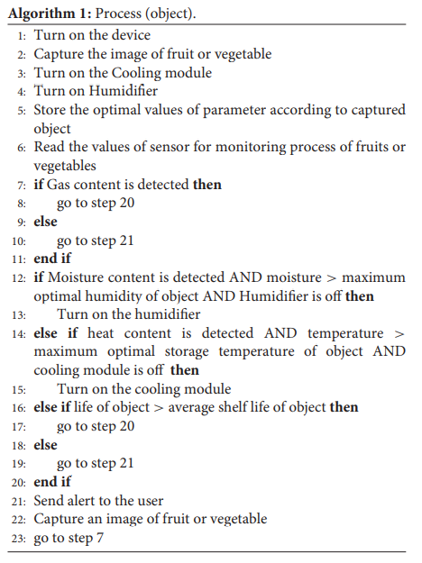

# **Findings**

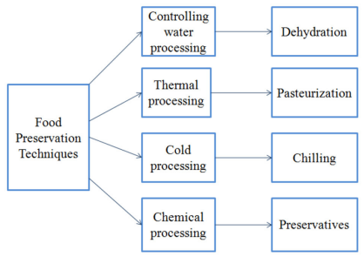

Figure 5: Food Preservation Techniques

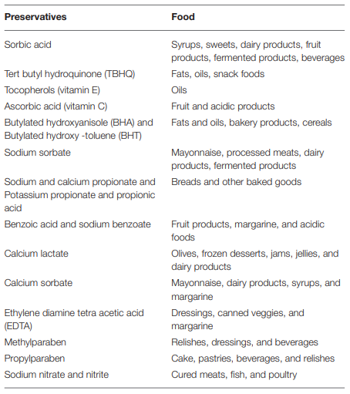

Table 3: Different Types of Food Containing Various Kinds of Preservatives

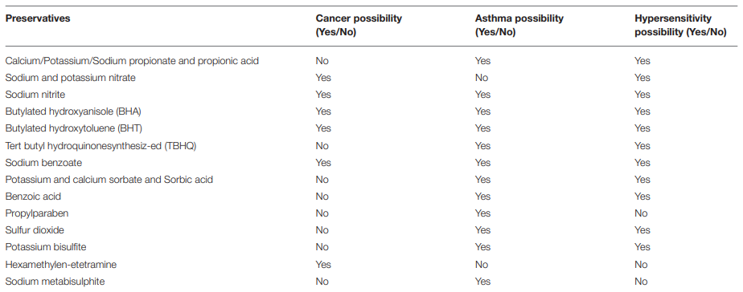

Table 4: Dangerous Food Preservatives Cause Various Diseases

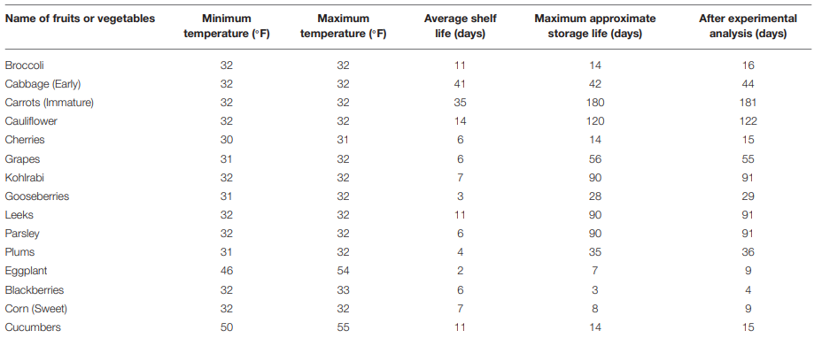

Table 5: Experimental Analysis of Fruits and Vegetables

# **Novelty**

This study presents a novel technique for Monitoring and analysis of food spoilage using a sensor bases system. The device proposed in this study is able to preserve food for more days. Additionally, food items can be prevented from getting spoiled by increasing their lifespan. It monitors the quality of food items and keeps notifying the user with voice-activated commands or via display, and it also generates alerts to the user with the predicted remaining time of the food spoilage.

# **Analysis**

The proposed device shows an accuracy of 95%.

# **Future Work**

The proposed smart device can be improved by applying image processing and machine learning algorithms to detect early spoilage. This can be utilized in refrigeration systems for detecting food items, spoilage, and monitoring for prevention of food spoilage. The device can be incorporated into food transportation containers which would allow tracking and detecting the spoilage if any during transportation. The device could also be tested for different varieties of foods as well.

**Real-Time Surveillance for Identification of Fruits Ripening Stages and Vegetables Maturation Stages with Infection Detection**

# **Methodology**

The combined method of mixing the texture and color features is used. It begins with recognition of fruits with different colors. To identify the images and remove the background edge detection is used.

## **Pros**

Pros of the system are:

* Pre & post-harvest cost is less,
* Farmers will get more profit,
* Reduction in manpower,
* Post-harvest quality of the fruits and vegetables will be increased,
* Agriculture growth in the country would be developed.

## **Drawback**

The drawback in the earlier system was:

* In Banana identification, if it has black sparks, it will be considered as infected,
* Can’t identify every breed of fruits and vegetables,
* Proper Network coverage is needed to get the output messages.

# **System Design**

* The synchronous messages are between Robot and computer.
* The asynchronous messages are between computer, ARDUINO, and Farmer.
* The Reflexive messages are there only on the computer.

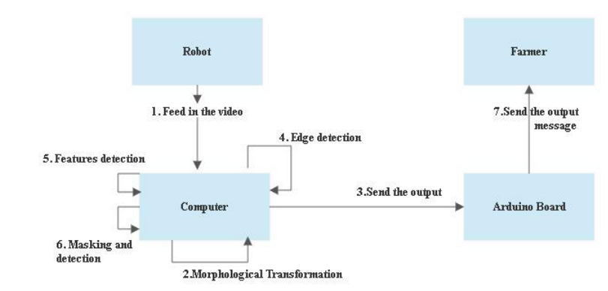

Figure 6: System Design in Communication

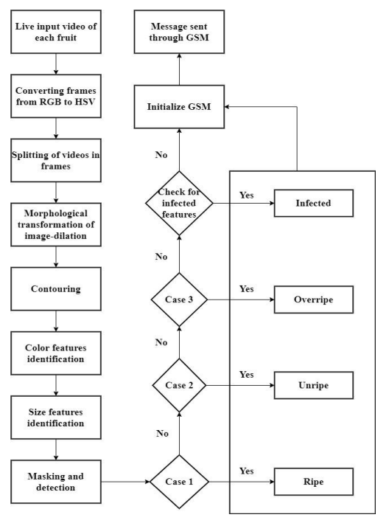

Figure 7: Proposed System Architecture

# **Equation**

Step 1: Working of Surveillance System

Step 2: Morphological Transformation



Step 3. Contouring and Features Detection

Step 4. Masking and Detection

Step 5. GSM Initialization and Message Communication

# **Component Used**

* ARDUINO
* HSV color Algorithm
* OpenCV library in Python
* Wireless Internet Network

# **Findings**

* Comparing processing time of various methods, we get to know our proposed idea processing time is 1.57 seconds.
* Comparing various researcher algorithms get to know that the proposed work takes only 350 MBS. So, we may conclude the proposed work uses minimal amount of memory.

# **Novelty**

Initially, the algorithm which was proposed can be made better to layout a robotic crop health surveillance in the near future. [1]

The future scope is for the development of this method for other fruits rather than lemon. [2]

The accuracy achieved at gross is greater than 95% and the proffred algorithm could process three images with resolution (640480pixels) per second. [3]

This process is done by image classification method based on CNN- Convolution Neural Network. The dataset in this method contains three types of classes. The accuracy of the classification increased by using three features, a RGB color, histogram and a centroid obtained from K-means clustering. The accuracy achieved is 95 percent. [4]

In reference to the above discussions, the proposed system is better than the conventional method of counting, which is manual.

# **Analysis**

The overall accuracy of the proposed method for three classes of fruits and vegetables is 96 percent. The time taken for processing per frame is 1.1s, which is the quickest when compared to the other methods. The memory taken is 300 mbs which is least used when compared to the other methods.

# **Problem Faced**

In the method main challenge arises when we have to count fruits when it is not fully ripe.

# **Future Work**

The future work for this project is the automation of robots. Intelligent robots which are capable to be laborers and pluck the fruits as ordered by farmers. These robots will automize the farming process. The identification ripening stages for vegetables and fruits can be found as planned in scope. The Infected fruits diseases should be included. Top ten diseases of all fruits and vegetables can be included and improved. The stages of crops also can be included based on requirements. This project can be implemented for other breeds of vegetables and fruits as this specifically done south Indian breeds of fruits and vegetable.

# **References**

1. T. Gayathri Devi, P. Neelamegam and S. Sudha, "Image Processing System for Automatic Segmentation and Yield Prediction of Fruits using Open CV," 2017 International Conference on Current Trends in Computer, Electrical, Electronics and Communication (CTCEEC), Mysore, India, 2017, pp. 758-762, doi: 10.1109/CTCEEC.2017.8455137.
2. N. Khera, D. Shukla, P. Sharma and I. G. Dar, "Development of microcontroller based lemon ripening condition monitoring system," 2017 6th International Conference on Reliability, Infocom Technologies and Optimization (Trends and Future Directions) (ICRITO), Noida, India, 2017, pp. 591-593, doi: 10.1109/ICRITO.2017.8342496.
3. A. M. Abdelsalam and M. S. Sayed, "Real-time defects detection system for orange citrus fruits using multi-spectral imaging," 2016 IEEE 59th International Midwest Symposium on Circuits and Systems (MWSCAS), Abu Dhabi, United Arab Emirates, 2016, pp. 1-4, doi: 10.1109/MWSCAS.2016.7869956.
4. Rojas-Aranda, J. L., Nunez-Varela, J. I., Cuevas-Tello, J. C., & Rangel-Ramirez, G. (2020). Fruit Classification for Retail Stores Using Deep Learning. Pattern Recognition: 12th Mexican Conference, MCPR 2020, Morelia, Mexico, June 24–27, 2020, Proceedings, 12088, 3–13. https://doi.org/10.1007/978-3-030-49076-8_1

**Real-Time Quality Assurance of Fruits and Vegetables with Artificial Intelligence**

# **Methodology**

This proposed system will use image processing to classify and grade the quality of fruits and vegetables by extracting features such as color, shape, and HOG (Histogram of Gradient) to classify the given fruit or vegetable. Image pre-processing techniques like data-augmentation and normalization along with Principle- Component Analysis (PCA), and Deep learning (CNN) are used for getting good accuracy and for dimensional reduction. An artificial neural network (ANN) is used to detect the shape, size, and color of fruit samples. Estimating the freshness of the given fruit by finding edibility using sensors.

In this proposed method, we have split the process into two parts:

1. The first part is about the classification of fruit or vegetable and its quality grading using machine learning algorithms and image processing.
2. The second part is about developing an android application for carrying out the told process in the first part by converting the part one into a tensor-flow-lite model using Keras for deployment in android studio.

The accuracy and efficiency of the system are founded on two aspects which are feature extraction algorithms and the database used

# **Component Used**

* Python and Jupiter Notebook
* **Dataset Images Format:** .jpg
* This application is developed using the’ Kotlin language. Using this ’Kotlin’ language, we set up the functioning of the application.

## **Algorithm**

The proposed system uses **Convolutional Neural Networks (CNN)**, a deep learning algorithm, which consists of a class of neural networks as a classifier for image recognition by a specialized way of processing on the grid of pixels. This process trains the system for classifying and grading.

# **Findings**

Table 6: Fruit and Vegetable Quality Monitoring using Hardware and Software Methods

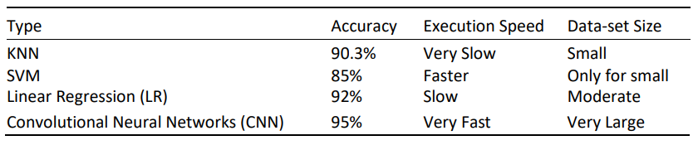

Table 7: Comparison of ML Algorithms

Convolutional Neural Networks (CNN) model was found to be more efficient than other machine learning techniques.

# **Analysis**

## **Quality Analysis**

For detecting the quality of the fruits or vegetables, five main modules or stages are used, described as images data-set collection as input, image pre-processing, feature extraction, feature selection, classification, and detection. The general block diagram of detection of quality is shown in figure below.

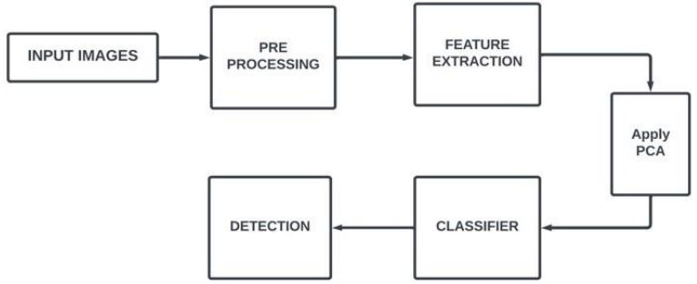

**Figure 8: General Block Diagram of the Quality Detection System**

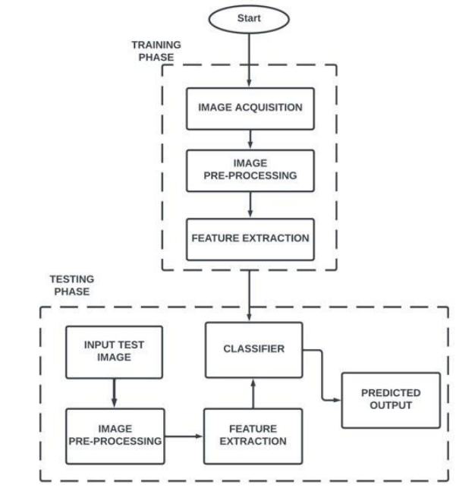

Figure 9: Workflow of the CNN Model

This quality analysis will consist of two phases: Model Training Phase and Model Testing Phase.

1. **Model Training Phrase:** For the training phase, the images of the dataset consist of fresh and stale classes of every fruit and vegetable.
2. **Model Testing Phrase:** The CNN model runs through the data many times, these are called epochs. As the number of epochs increases, the more the model improves to a certain extent [20]. The below figure will show the training, validation accuracy, and training and validation loss of the model.

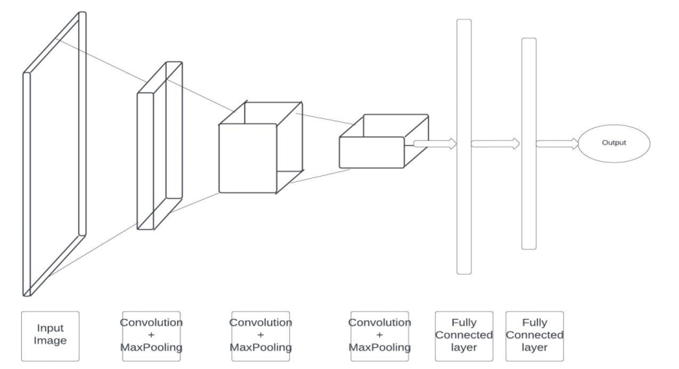

Figure 10: CNN Architecture

Tensor-Flow-Lite Model: The tensorflow-lite model is created using the tensor-flow-lite-maker, an extension of Keras which simplifies the testing of a new image. This tensor-flow-lite model maker converts the CNN model into a ‘tflite’ model which is an optimized version of the CNN model and can be deployed on mobile or embedded devices.

## **Android Application Development**

This android application development will consist of three steps: Configuration of the android studio, Development of the Application, and Deploying the android application on mobile. This android application can be used in fast processing the given process steps.

## **Results**

The result of this project is divided into two parts: one is the result obtained from the quality analysis process and the other is the result obtained from the Android application.

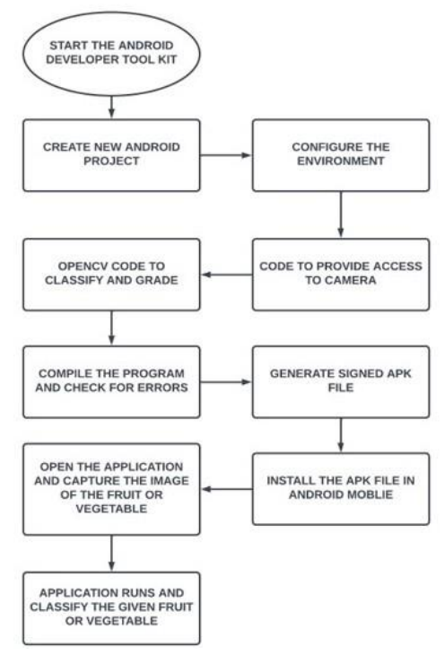

Figure 11: Flow Chart of Android Application

# **Future Work**

The accuracy and efficiency of the system are founded on two aspects which are feature extraction algorithms and the database used. The proposed system can be installed in a hardware device and run using cloud computation which will be helpful in fast processing and in gaining higher accuracy. Even checking the products in large number. This system can be installed in a robot for checking the quality of the fruits and vegetables in the markets. This application system can be used as an information system between customers and shops such as markets, where the products can be graded and uploaded to the database from where the customer can get the required product within the shortest time.

**Identification of Fruits Using Deep Learning Approach**

# **Methodology**

This paper deals with the development of the identification system. An image classifier is trained to identify different images of fruits. It can be adopted in the identification of plant disease and species in the agricultural domain.

# **Algorithm**

Convolutional Neural Network (CNN): Exclusively best accomplishment in object recognition; CNN consists of:

1. Convolutional layers
2. Batch normalization layers
3. Pooling layers
4. ReLU layers
5. Fully connected layers

# **Component Used**

* MATLAB software with Neural Network Toolbox is utilized to create this convolutional neural network.
* ‘ImageNet’, free open dataset: This dataset consists of images of Apple, Banana, Grapes, Litchi and Mango. The RGB images, with three color channels R, G, and B are utilized in the dataset. The dataset is divided into training and validation datasets in which 90% of the images are trained and 10% are validated.

# **Architecture of the Proposed CNN Model**

The model has 41 CNN layers. It comprises feature extraction and classification. The input images are cropped to remove any unwanted information. All the images are resized to 224X224X3 (3 corresponds to three color channels Red, Green, and Blue). The total nuisr of images including all the five classes in the dataset are 4,760.

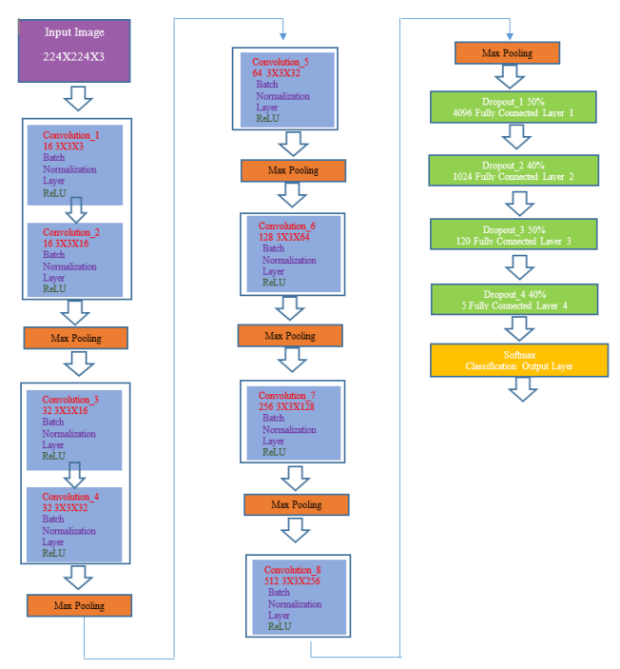

Figure 12: The Architecture of the Proposed CNN Model

# **Findings**

The proposed CNN model is robust and gives very good accuracy.

# **Analysis**

The paper has presented a system that develops an autonomous identification of fruits by the self-service system in the supermarket. The proposed CNN model has achieved classification accuracy of 92.23% on the dataset.

# **Problem Faced**

The dataset is very challenging.

# **Future Work**

As a future scope, the model can be used to train more variety of fruits. It can also examine the impact of various parameters like activation function, pooling function and optimizers.