Web Development
COS10005

Semester 2, 2026

Member Name | Member ID
Tousif Akhand | 105822937

Contents
1. Introduction 2
2. Website Content (HTML) 3
2.1 Shared parts on every page 4
2.2 Home page (index.html) 7
2.3 Explorer page (explore.html) 9
2.4 Families, Genera and Species pages (explore1.html, explore2.html, explore3.html) 11
2.5 Identify page (identify.html) 15
2.6 Contributors page (contributor.html) 17
2.7 Contribute and Enquiry forms (contribute.html, enquiry.html) 18
2.8 Profile page (profile.html) 19
2.9 Enhancements and Acknowledgements pages 20
2.10 Site map 22
3. Website Style (CSS) 24
3.1 Base styles 25
3.2 Header and navigation 28
3.3 Pictures, cards, buttons and tables 32
3.4 Footer 33
3.5 Forms 35
3.6 Page styles 37
Home page 37
Identify page 38
Profile page 39
Explorer pages 41
Contributors page 44
Acknowledgements page 45
3.7 Screen sizes and accessibility 46
3.8 CSS Markups 50
4. Key features (Enhancements) 52
4.1 Fluid layout with a hamburger side menu 52
4.2 Fixed navigation bar 55
4.3 Photo gallery with lightbox 56
4.4 Flip cards 58
4.5 Other enhancements 60
5. Conclusion 66
6. References 67

1. Introduction
Malaysia is home to an abundance of plant life yet much of it is disappearing as forests give way to townships, farms and plantations. While scientists cannot always be on the ground they can rely on the help of the public to document what they have come across. A photo of a plant serves as a small but telling record of its location will collate enough of them and one can easily tell which species are thriving and which are not. This is the main motto behind Pl@netMatrix, the citizen science website I have built for this assignment. With a tag line of “Know it. Name it. Save it.”, I offer the visitor a chance to do just that to learn, name and share.
For the project I have selected 2 families, 4 genera and 8 species. First is the Dipterocarpaceae family which is well suited to a Malaysian context for being the source of most of the giants in the Borneo rainforest and it makes for a straightforward comparison with the other family named Lauraceae. The former has winged fruits while the latter has fleshy berries.
The site is built on HTML and CSS. Moreover, Pl@netMatrix is 12 pages strong, all adhering to the same stylesheet. The green and mint palette is in keeping with the forest theme and with a consistent header, menu bar and footer there is no risk of a visitor getting lost.
What follows is a report on the HTML and CSS of Pl@netMatrix. Section 2 will go through the HTML for each page, complete with line numbers from my code before presenting a site map. In Section 3 the CSS from style.css is broken down and explained. Any improvements over the basic requirements are set out in Section 4 with the project concluded in Section 5.

2. Website Content (HTML)
The following is the layout for the site’s HTML.
- Shared parts - head, header, menus and footer
- Home page
- Explorer pages - Explorer, Families, Genera and Species
- Identify page
- Contributors page
- Contribute and Enquiry forms
- Profile page
- Enhancements and Acknowledgements pages
- Site map

Table 1 gives a summary of the twelve pages. The six principal ones are always at hand in the main menu bar. From the Explorer, a user can make his way from a family down to a species through three child pages. The side menu and footer hold the enhancements and acknowledgements. How these are all linked is shown in the site map at the end of this section. Below is the list of all the pages of the website I built – Pl@netMatrix.
Page | File | What it's for
Home | index.html | This is a very short description of the project and an invitation to get started with the identifying a plant and start exploring buttons.
Explorer | explore.html | This is the primary page for learning. It has a link map, several quizzes, a rating form of 5 stars, a photo gallery and several flip cards.
Families | explore1.html | Here are quick facts, tips and suggestions for recognition on the two families, their profiles and photos.
Genera | explore2.html | Ther is one profile per genus having links straight up to the family and down to the species.
Species | explore3.html | Here are full details on the eight species, covering habitat, range, uses and conservation.
Identify | identify.html | There is a nap, sample search results and a form for uploading a photo or doing a name search – both options are available.
Contributors | contributor.html | I will find nine community photo cards and an outline of how a photo is vetted for the site.
Contribute | contribute.html | Here the users can fill in this form to send in their plant information and photos.
Enquiry | enquiry.html | I will find an open form for putting in a question.
Profile | profile.html | Here is some background information on myself, my interests and many more.
Enhancements | enhancement1.html | The extra features which I have added are to be found here and the tutorials (in class, youtube videos, W3 Schools) which I followed to implement them.
Acknowledgements | acknowledgement.html | Here I will find the credit where it is due for the icons, fonts, facts and photos provided on the site.

The line numbers which are cited here are taken from the HTML files in the submitted folder. Moreover, I will see two screenshots for each part of a page: one from the browser and one from the editor along with the line numbers visible. Additionally, a table beneath will elaborate the code in details.

2.1 Shared parts on every page
I will find that there is a uniform feature to the start and finish all the 12 pages of the website. Likewise, the back to top button, the footer, the menu bar and the head with its logo and search box will be seen throughout the website. So, index.html is used to explain them once and for all. Additionally, one of the biggest advantages is that the visitor needs only to familiarise himself with their placement.
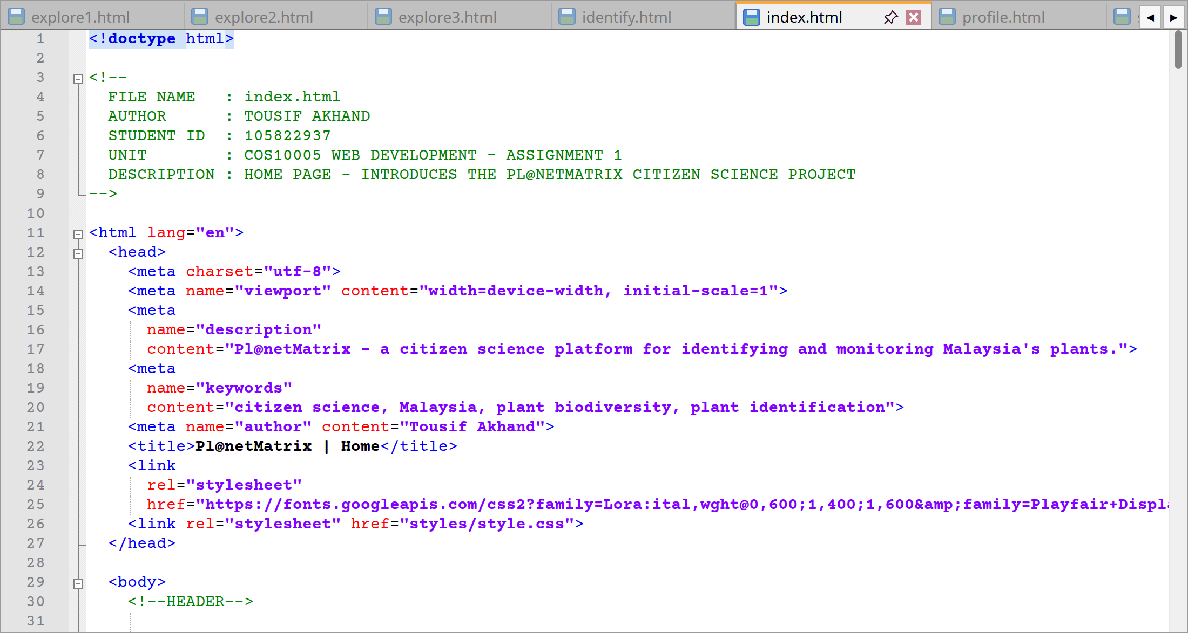
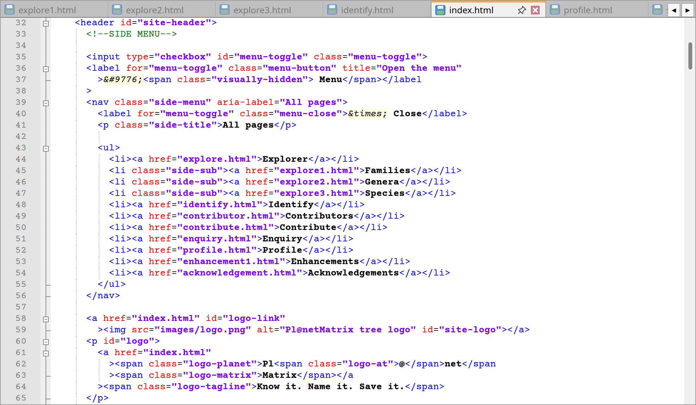
index.html code lines from 1 to 65
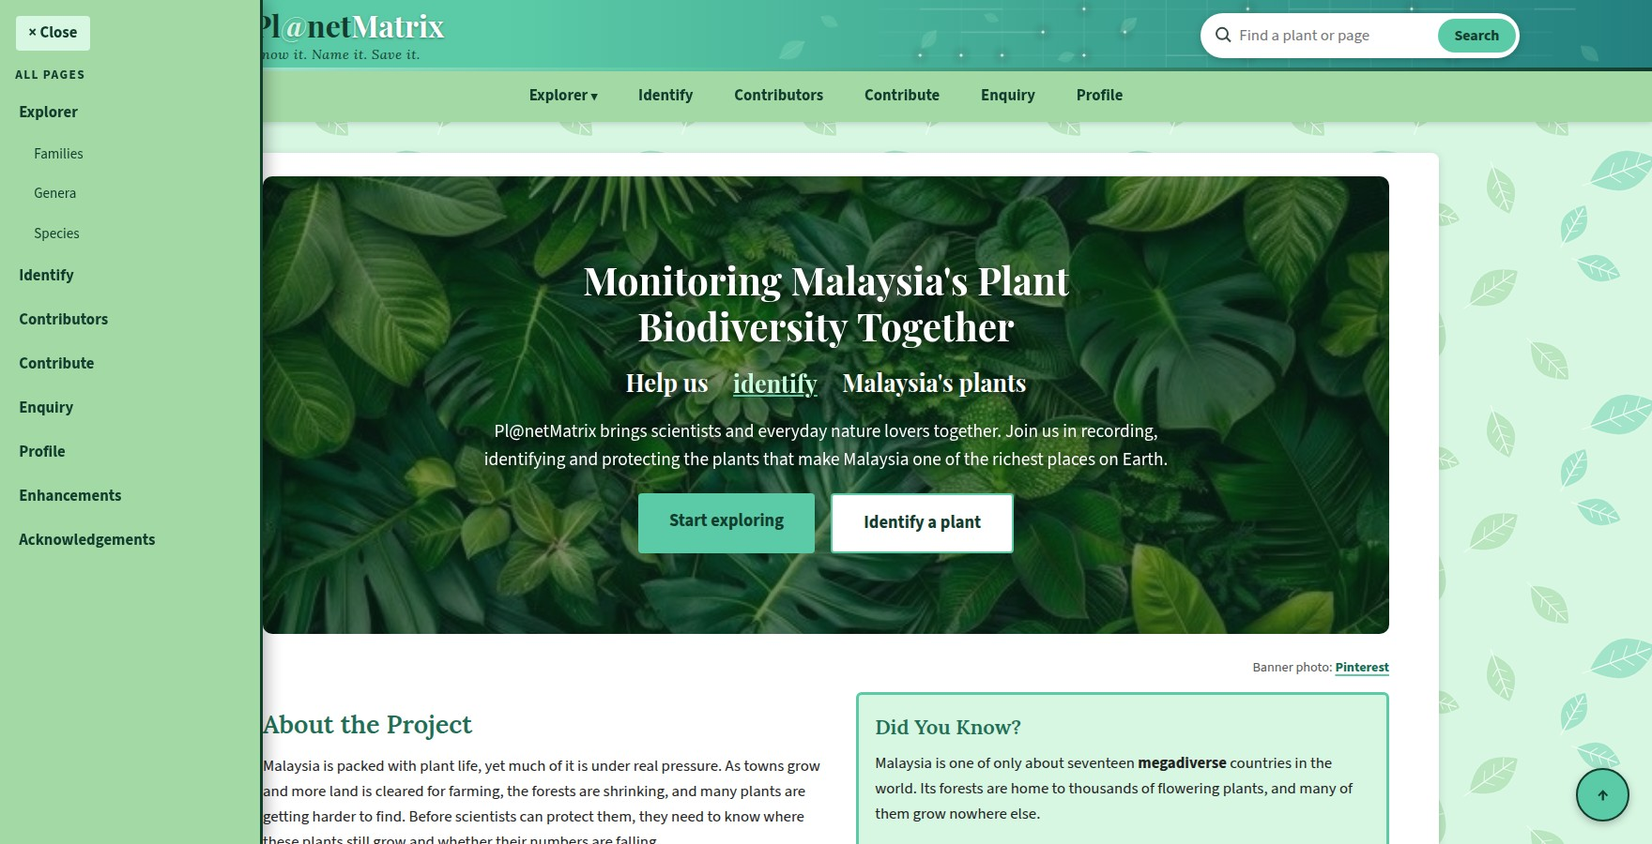
Website: Header having the side menu open
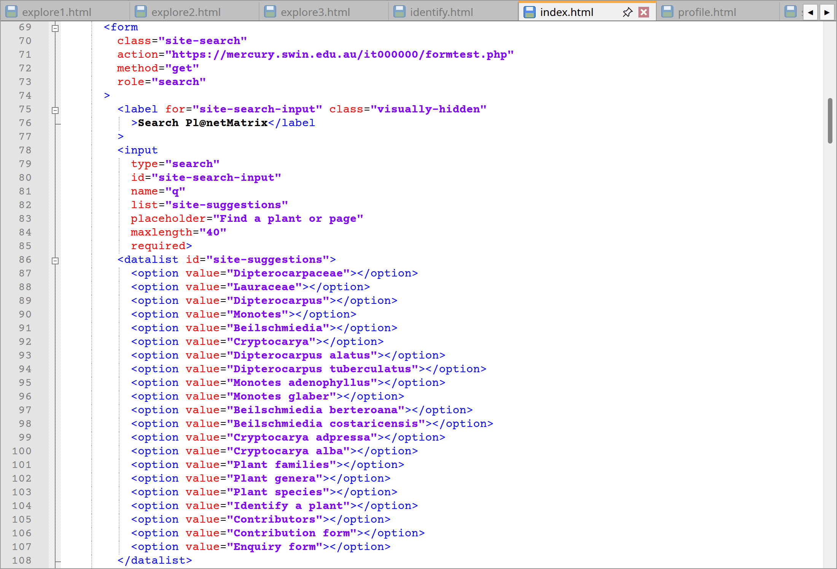
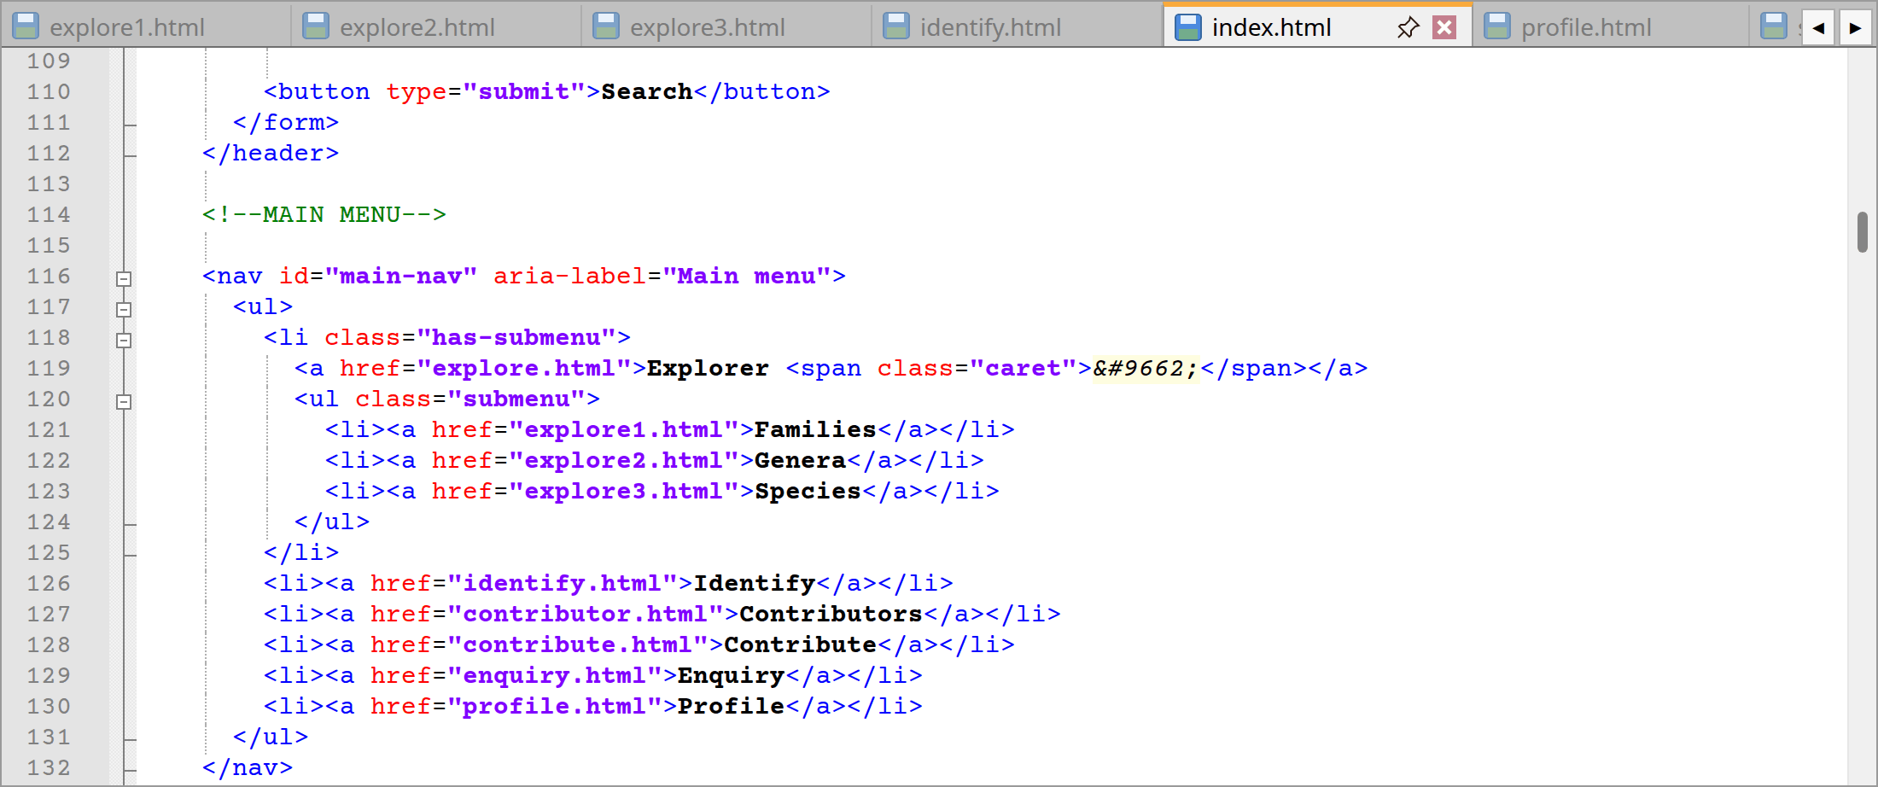
index.html code lines from 69 to 132
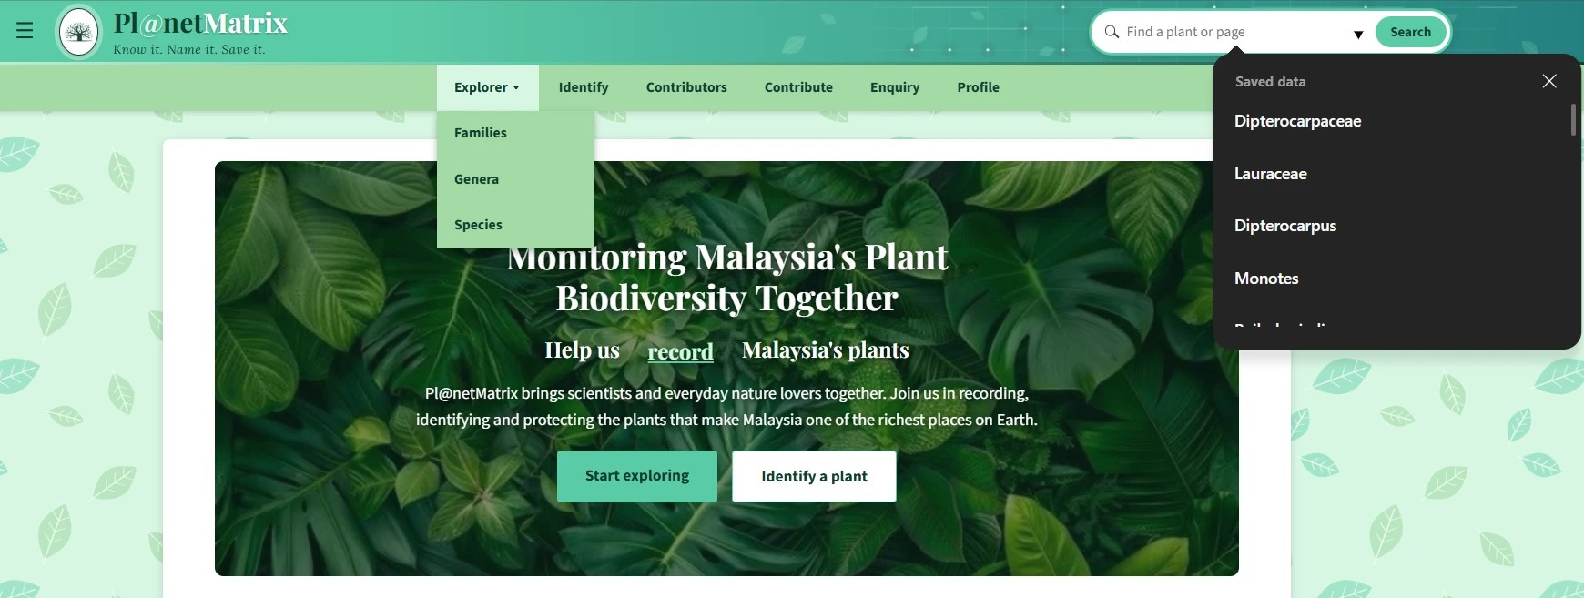
Website: Search box and Explorer drop-down
Lines | Explanation
1 and 11 | Firstly, by virtue of the DOCTYPE, the browser will recognize this as an HTML document accordingly with modern standards. Additionally, the <html> tag carries lang="en" so that screen readers and search engines better know the page is in English and can pronounce the words.
3–9 | Secondly, a header comment (<!-- -->) is the first thing on any of the HTML pages so that anyone will find the file name, author, student ID and a little description of the functions of the pages all in there as well as the purpose for which the work has been done. For instance, I worked for the purpose of the unit COS10005 Web Development - Assignment 1. Moreover, I have put them all in upper case to make them stand out from the code which follows. Additionally, for being a comment it is not something a visitor will see in his browser but should I any individual who opens the file can tell straight away what and who did all the works.
12–27 | Thirdly, while anyone who visits the site do not see what is in the <head>, it has been put there for their convenience. So, proper rendering of the , ↑ and @ in the site name is taken care of by the <meta charset="utf-8">. Moreover, the viewport meta tag has a different purpose which is that it tells the phone to present the page at its true width instead of trying to fit the desktop version into the browser window. On the other hand, search engines will use the description, keywords and author tags to get an idea of the page. Thus, regarding the <title>, it is the content that actually fills the tab. In the same part of the head section, the first <link> on lines 23 to 25 is used to include the Google Fonts and then another <link> at line 26 is used to bring in styles/style.css.
32 | Fourthly, a <header> with id “site-header” is what opens the top of the page by containing the side menu button, search box, site name and logo. Likewise, the id serves to style it and is where the back to top links will jump to.
35–38 | By the fifth point, it is explained what one would tap to put when the side menu is created. Additionally, line 35 has a checkbox, id="menu-toggle" hidden from viewing. Moreover, a <label> on line 36 is tied to it via for="menu-toggle" attribute and it puts the symbol on to the display. Also, by clicking the label one can see that the checkbox has been checked and the CSS does the rest of the job by sliding the menu in and out. Moreover, for screen readers the visually hidden <span> will read Menu.
39–56 | Sixth point says that to set this side menu apart from others for screen reader users, there is a <nav> with aria-label="All pages". Additionally, line 40 is a further label for the same checkbox which functions as a “× Close” button. Moreover, following that is a run of links to every page on the site including enhancements and acknowledgements among them. So, the ones for families, genera and species are given the class side-sub by way of marking them under explorer in the CSS.
58–65 | Seventh point elaborates that line 58 is that the logo image is completed with alt text and inside a link to index.html and the home page. Moreover, I will see the site name in <p id="logo"> on 60th line. Additionally, it has been broken up into <span> tags to put different colours on “Pl@net” and “Matrix” while another span is for the slogan I gave “Know it. Name it. Save it.”
69–111 | Eighth point tells that for the site search purpose there is a <form> with method="get" and role="search". Again, the input has a placeholder and is required (maxlength="40") to preclude blank searches being sent. Then again, a label is present for screen readers even though it is visually hidden. It is also mentionable that it is linked to a <datalist> (from the lines 86 to 108) of 21 options to state a plant name or page name for the benefit of the users to be suggested as he or she types.
116–132 | Nineth point elaborates that the main menu <nav> (id="main-nav", aria-label="Main menu”) has a list of the six principal pages. However, in the case of explorer (from the lines 118 to 125) it is assigned to the has-submenu class and a nested <ul class="submenu"> for the drop down of families, genera and species. So, the small ▾ in the <span class="caret"> is an indication of more links that is yet to come next.
Extra | Lastly is the feature which is common to every page. However, the only difference is in the top comment with the file name, description and the <title>. Additionally, on the link for the page I am on my own to find class="current" and aria-current="page" added. Thus, this is for the benefit of screen readers to know what is to open and to let the CSS underline it.

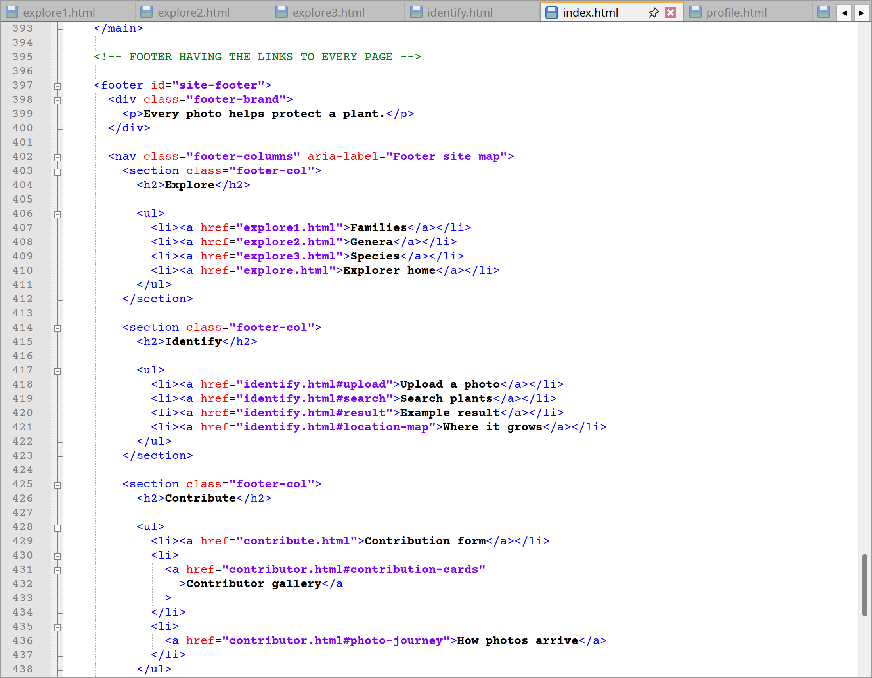
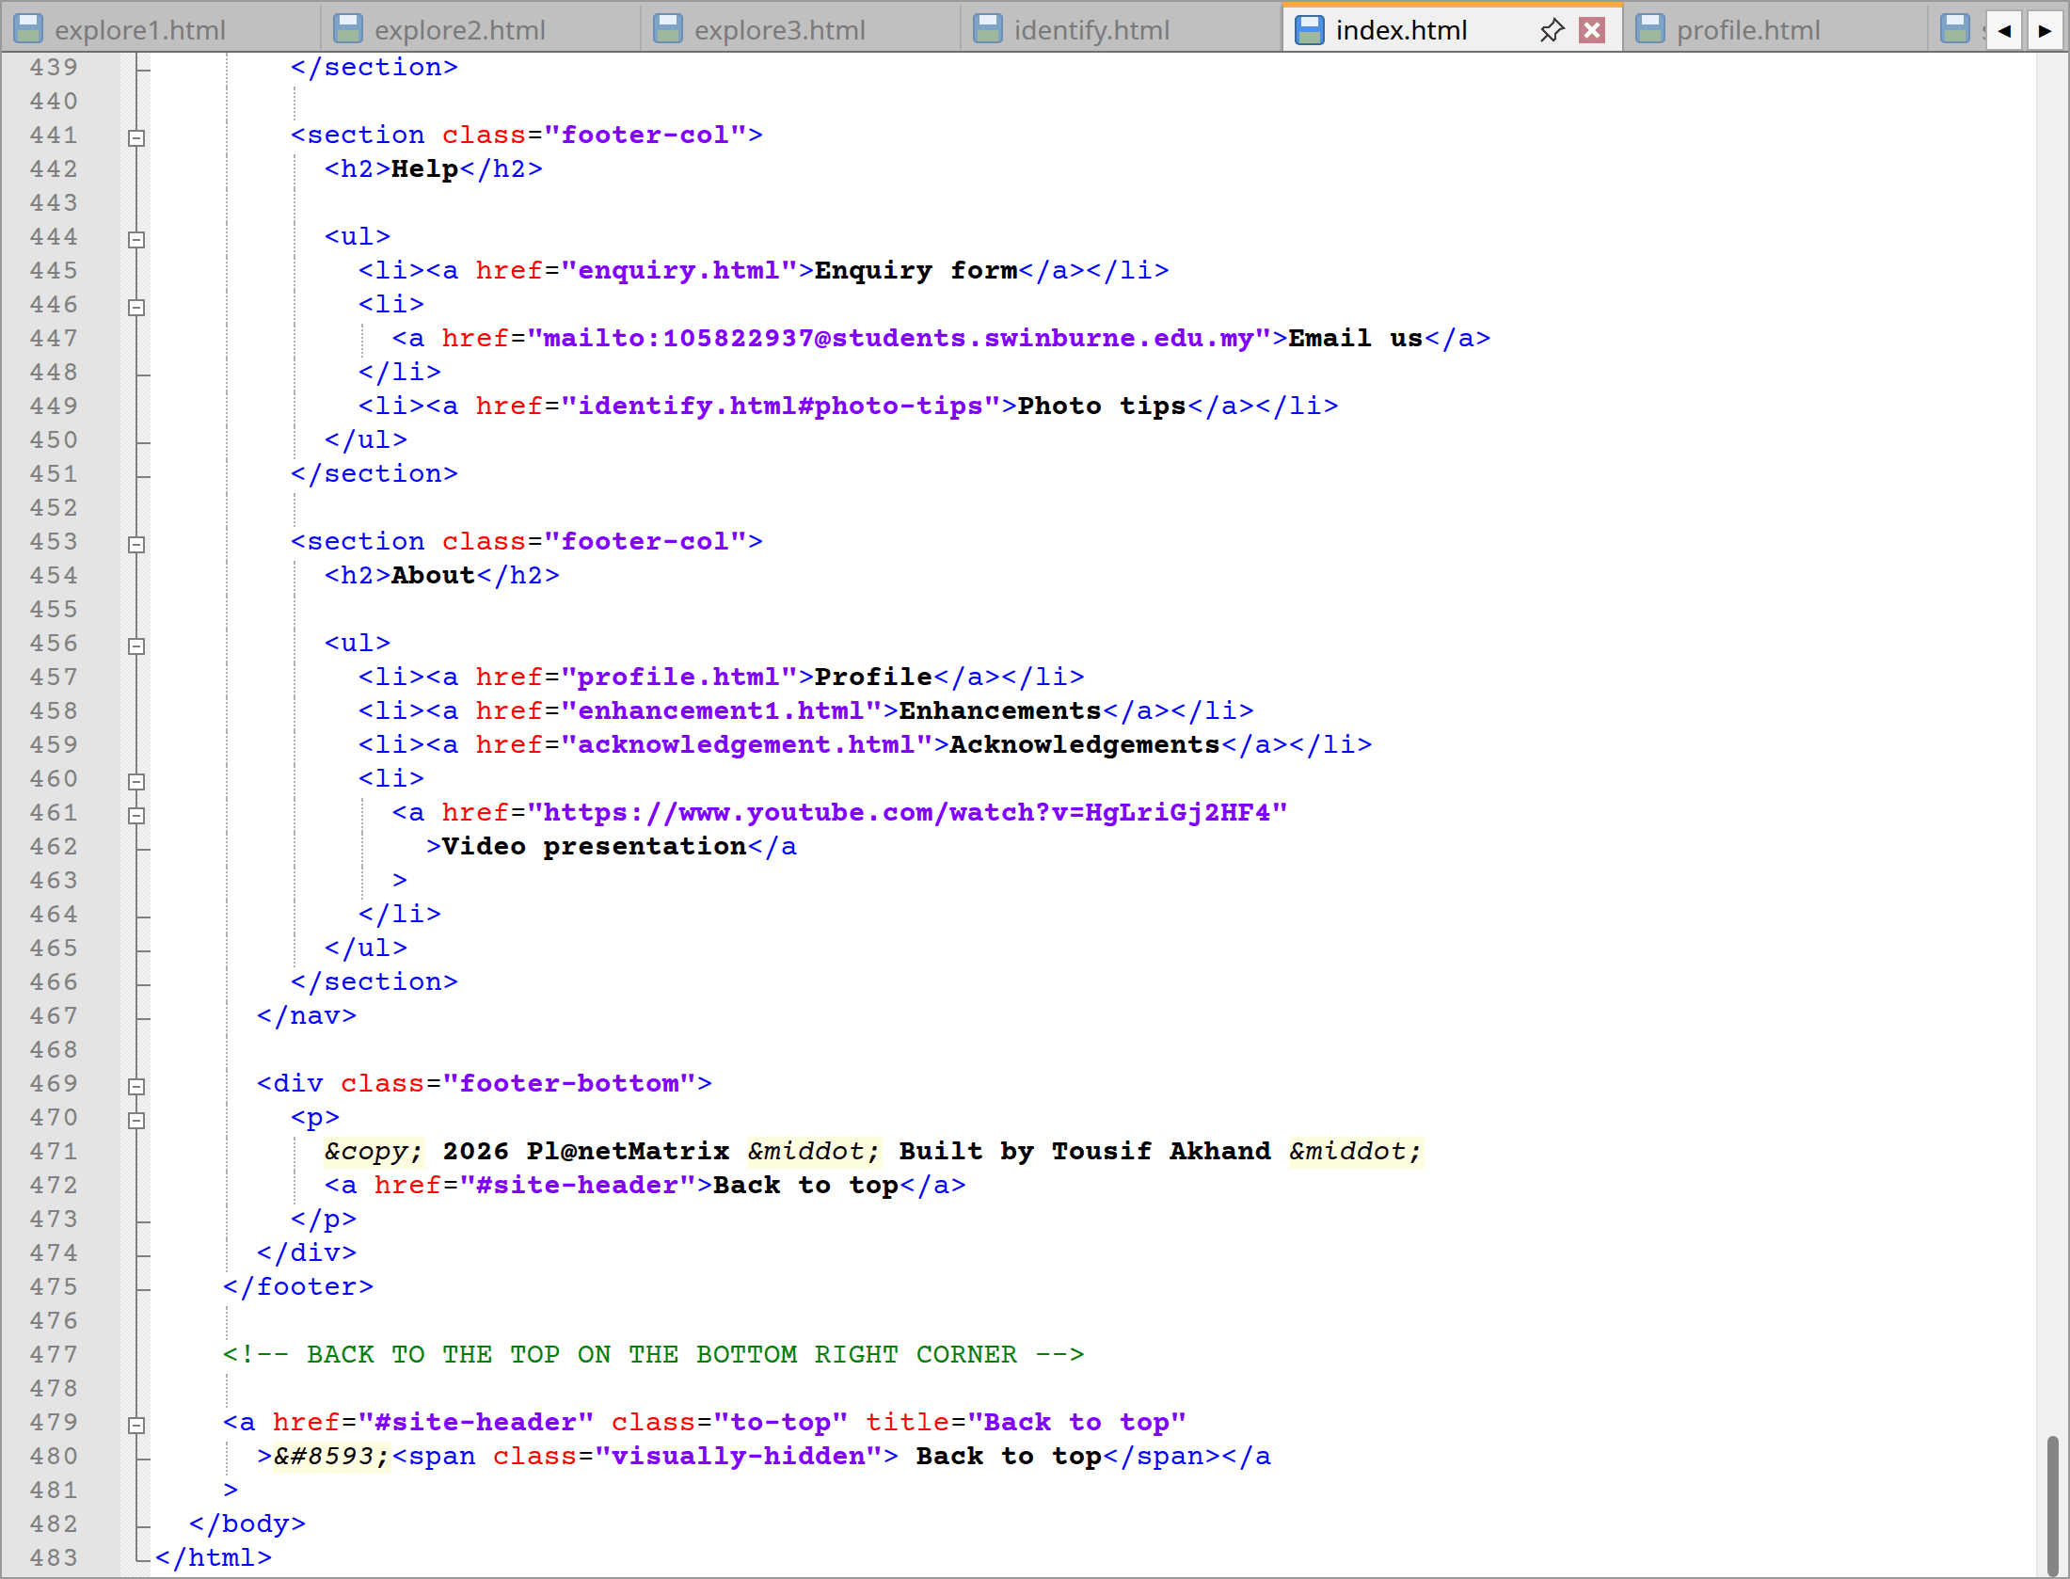
index.html code lines from 393 to 483
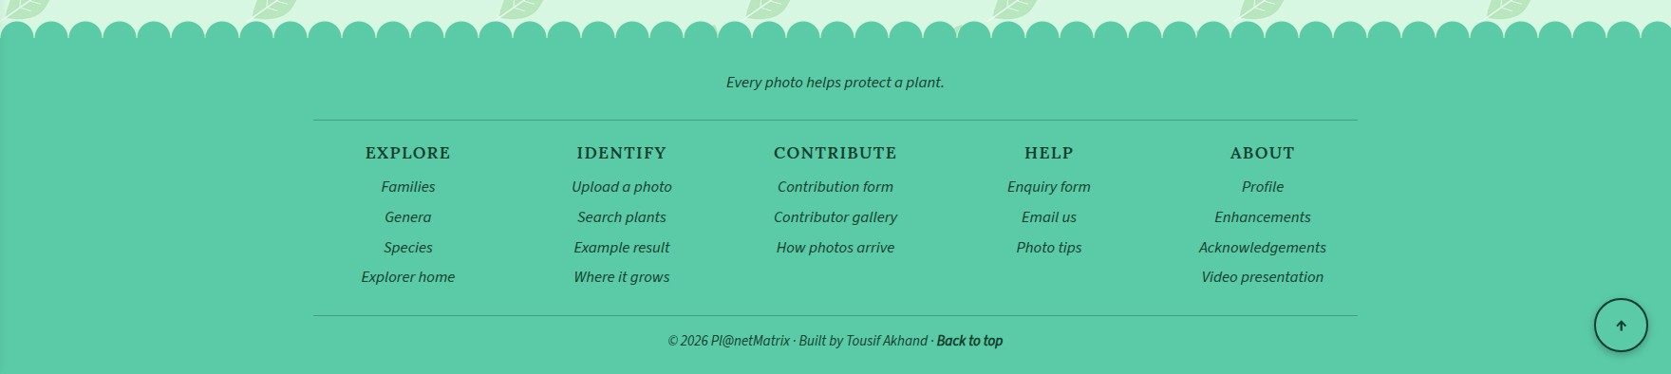
Website: Footer and back to top button
Lines | Explanation
397 | Furthermore, at the bottom of the page there is a <footer> element with id="site-footer”. In addition, an element of this type is employed instead of a <div> to denote that the content is closing information like copyright and site links.
398–400 | Consequently, one will find the mission statement “Every photo helps protect a plant.” in the <div class="footer-brand">.
402–467 | Additionally, a section of the 'Help' menu is located within <nav aria-label="Footer site map"> with five other <section class="footer-col"> under that section for explore, identify, contribute, help and about. It follows that each has an <h2> and its links even a mailto feature for my email address and the ones to other parts of pages such as #upload. Thus, this makes for a complete site map so the visitor need not scroll back up to get where he or she wants to go.
469–474 | Moreover, in the footer-bottom <div> is the “Built by Tousif Akhand” copyright and a link to #site-header to go back to top.
479–481 | Later, I will also find an upward arrow linking to #site-header is the round back to top button. Also, I have put it outside the footer to allow the CSS to put it in the corner of the screen. However, a visually hidden <span> is there to give the arrow meaning to screen readers by saying “Back to top”.
Extra | Lastly, I will find that the footer and the back to top button are always consistent across every pages. While the code is the same, the line numbers will vary from one page to the next due to the differing content.

2.2 Home page (index.html)
Now, I consider the home page as the front door of the website. The main purpose of it is to tell a first time visitor in a matter of seconds what Pl@netMatrix is all about and entice them to click in. Considering that I have kept the paragraphs brief. Most people make up their mind on a web page very quickly. I will find that the page has an animated banner, a side note, four features and flip cards, a “Getting Started” list and an “About the Project” section.
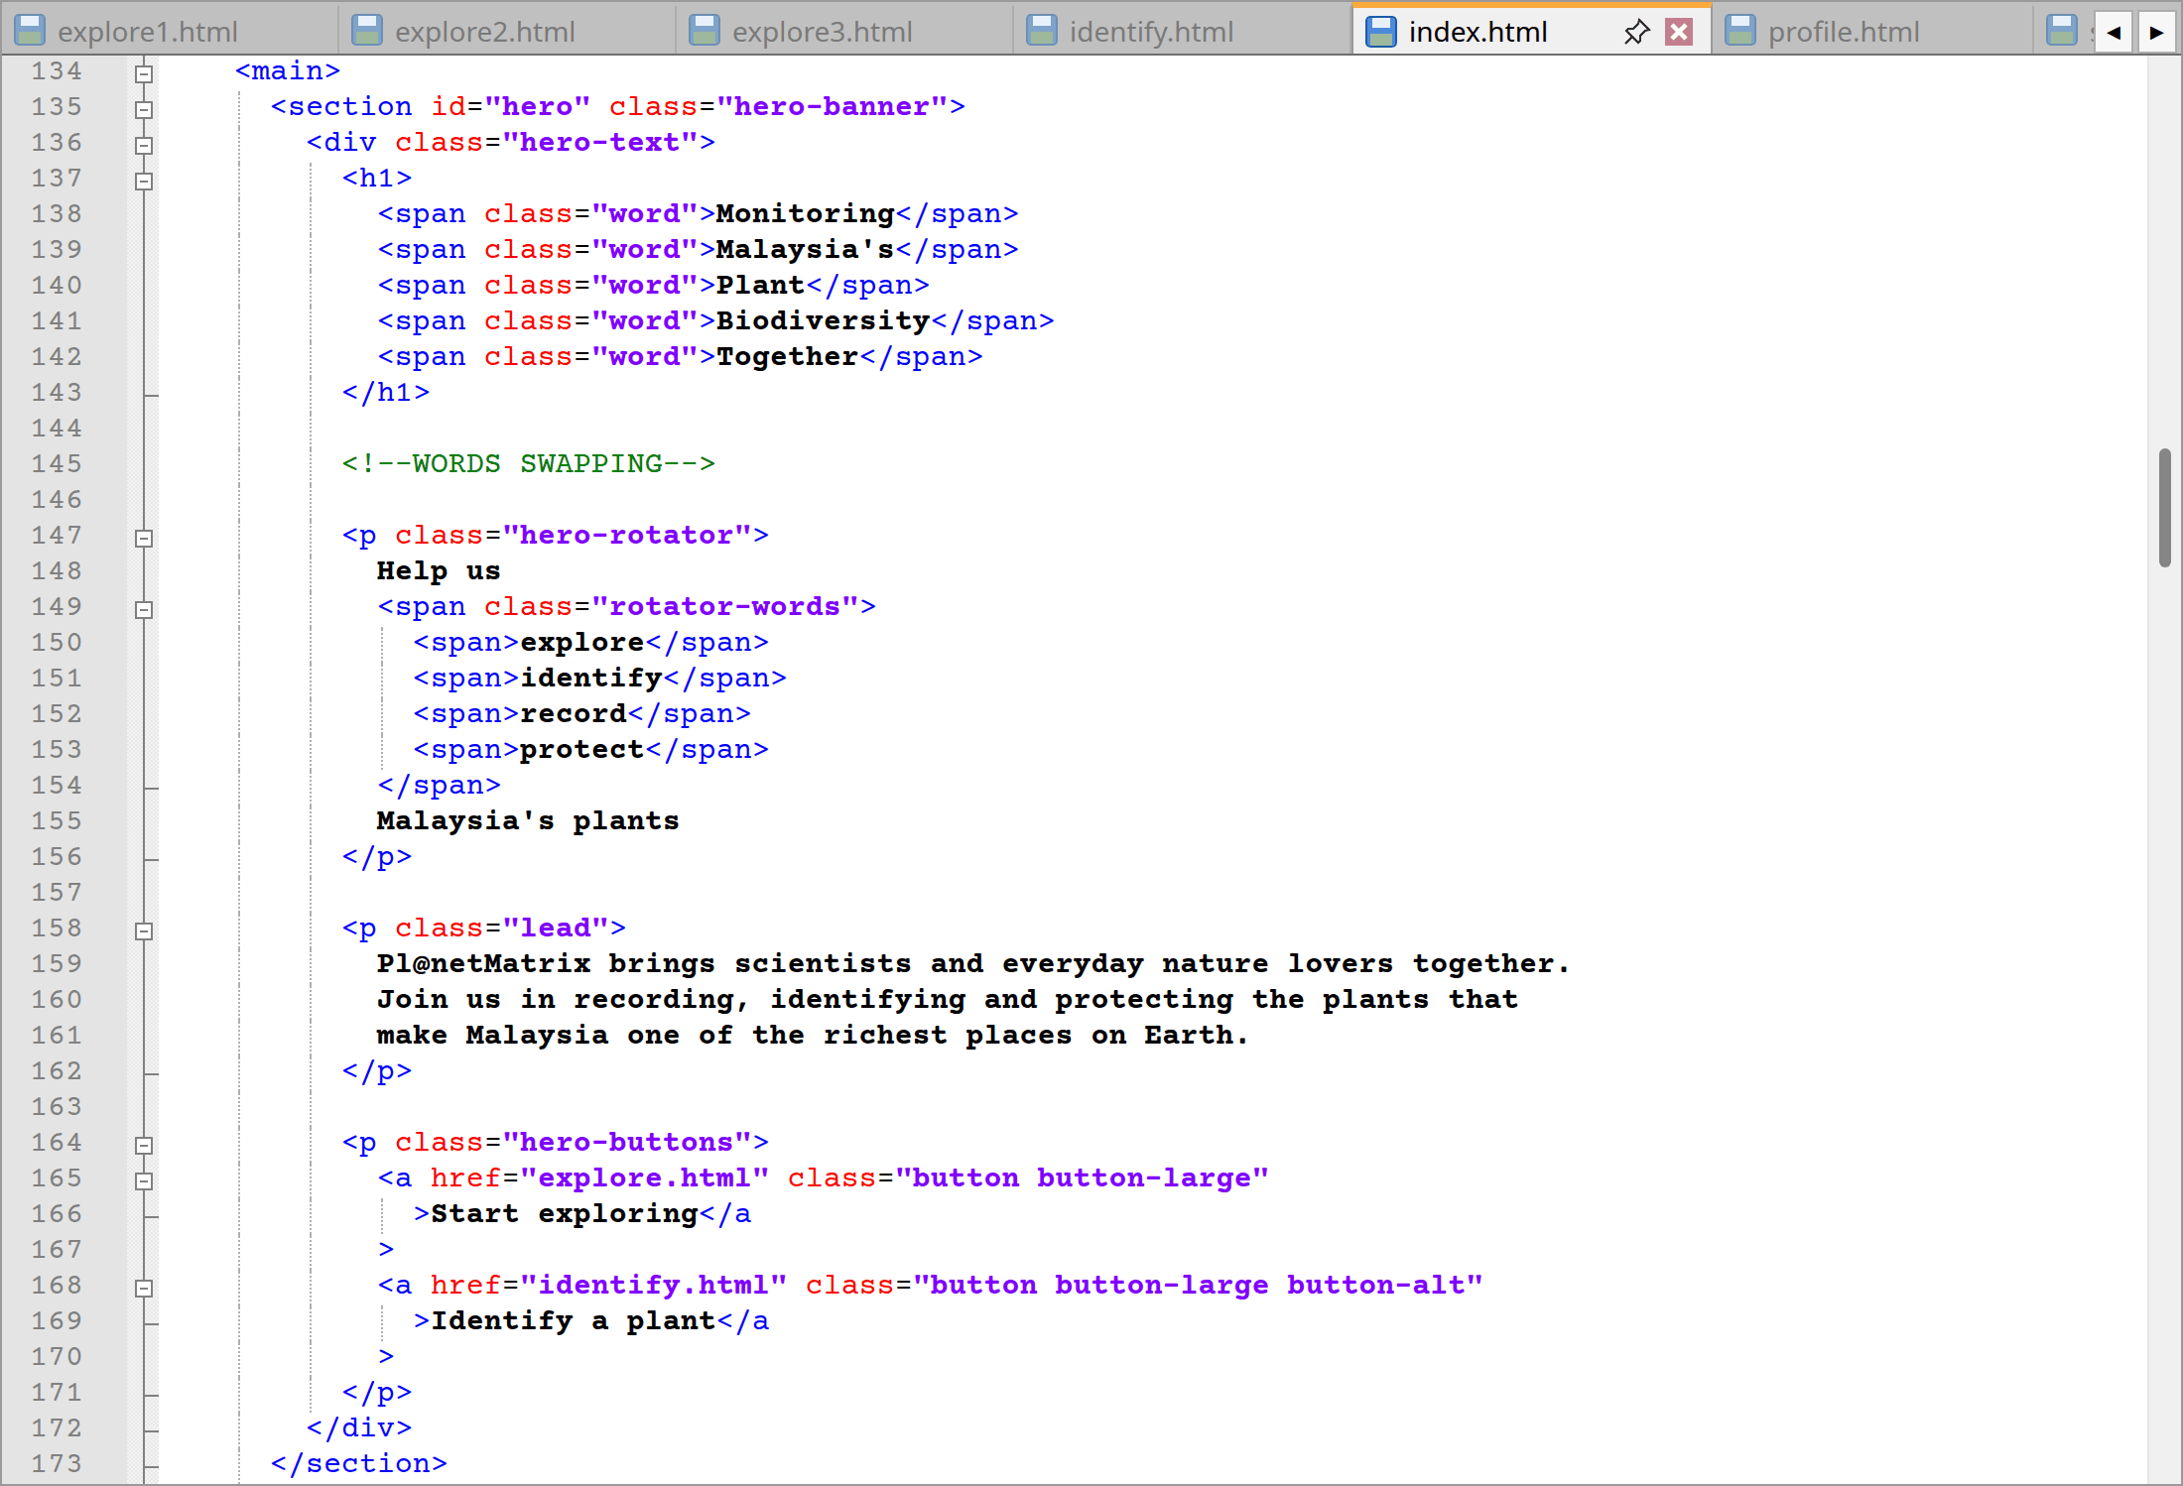
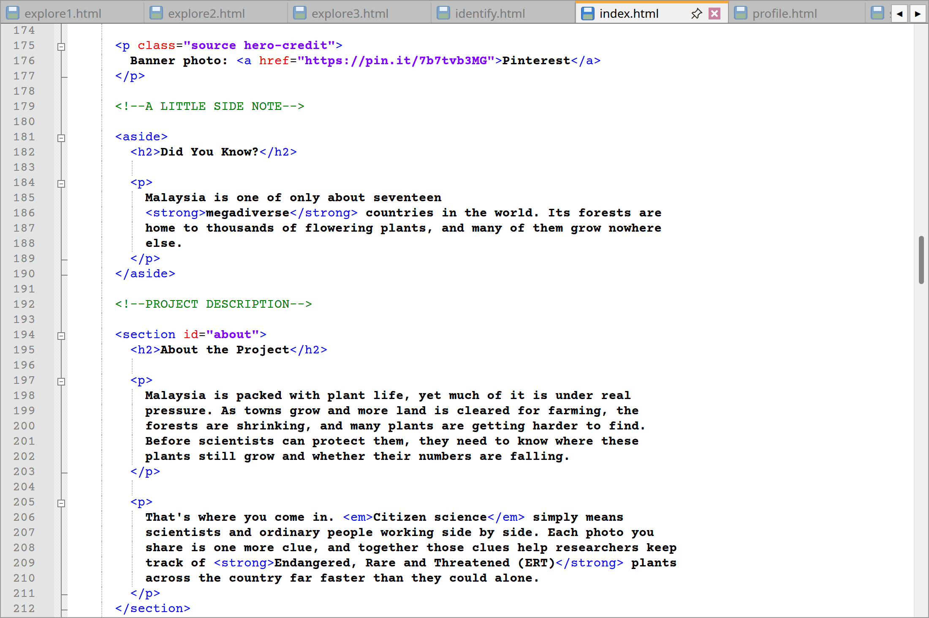
index.html code lines from 134 to 212
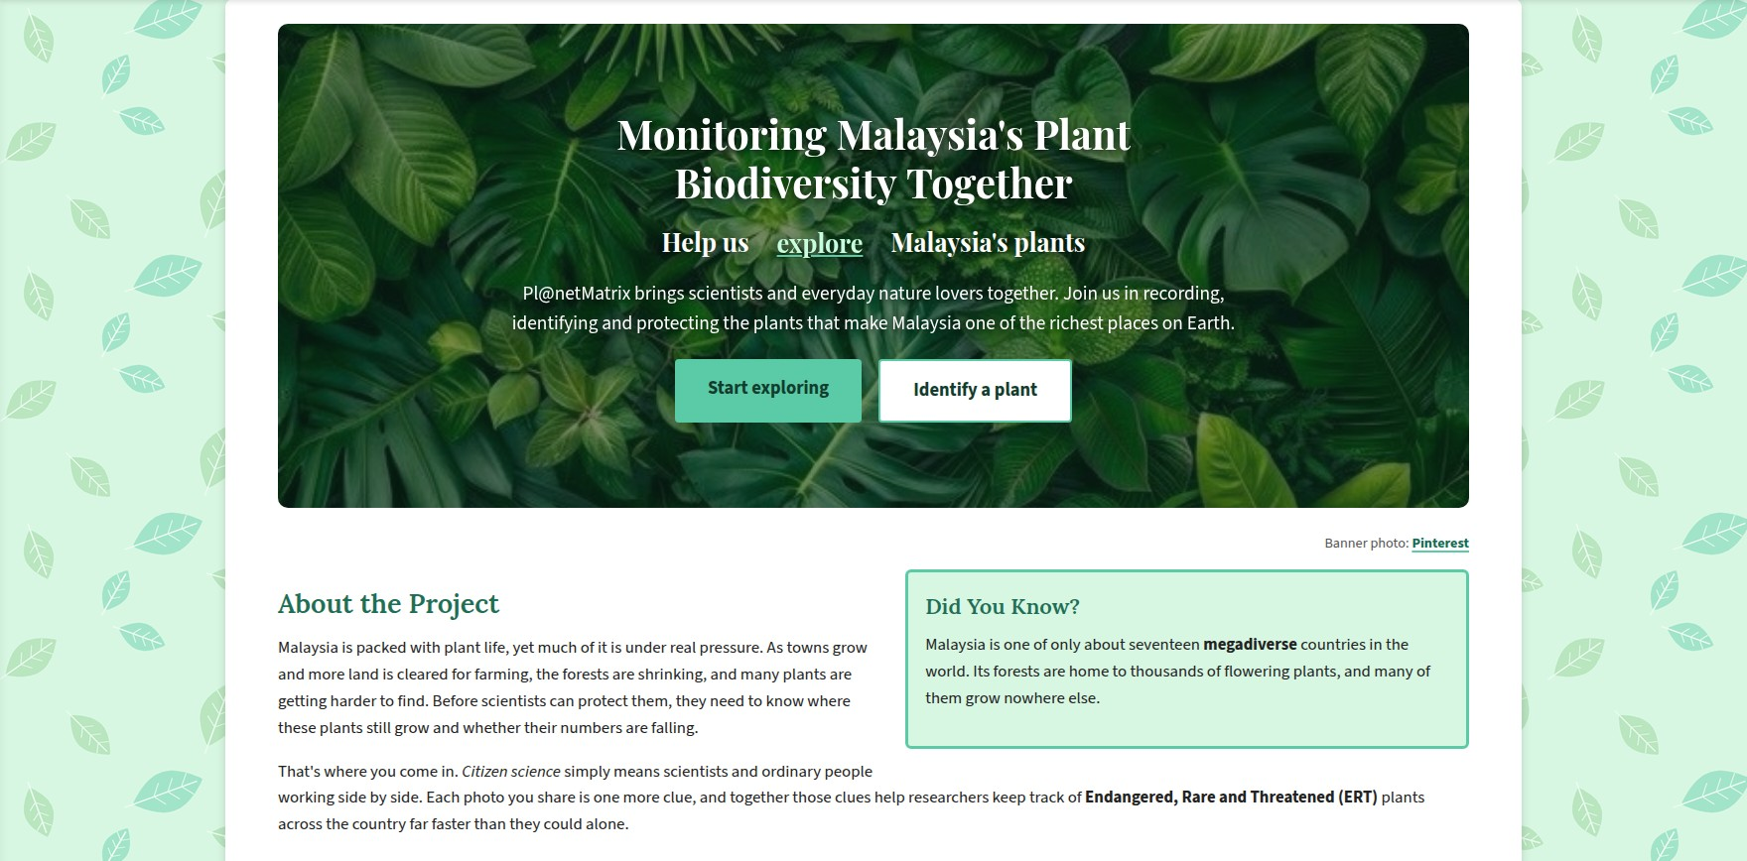
Website: Home page banner, side note and about section
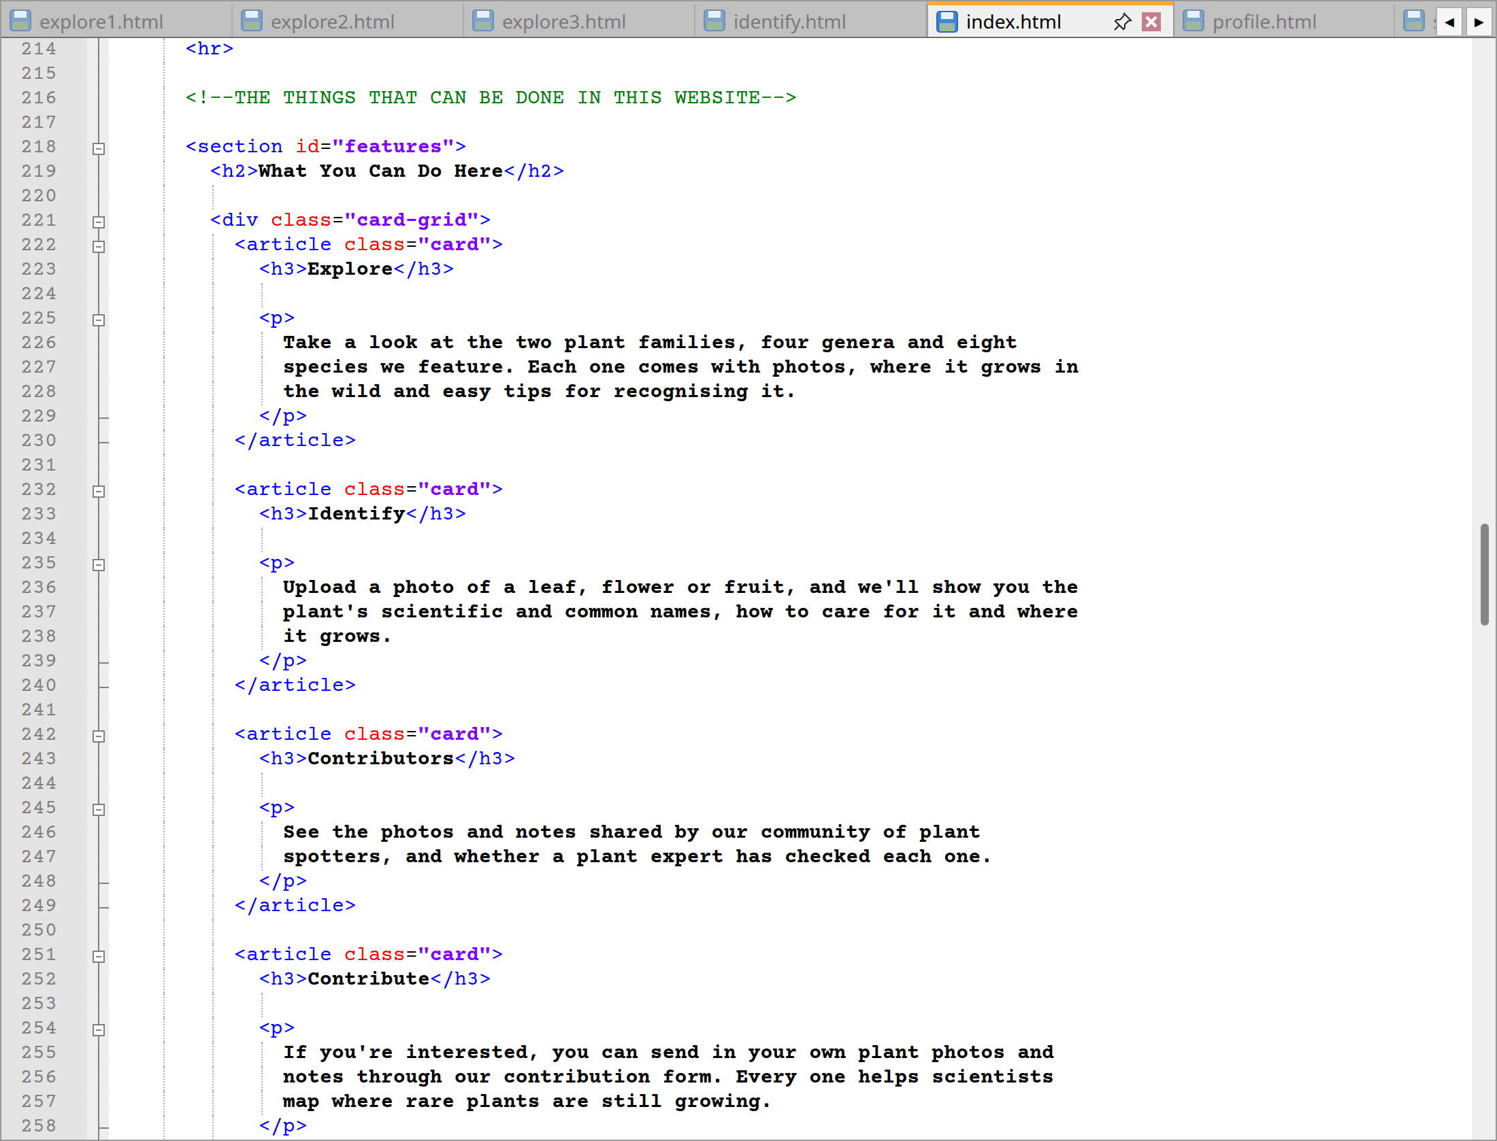
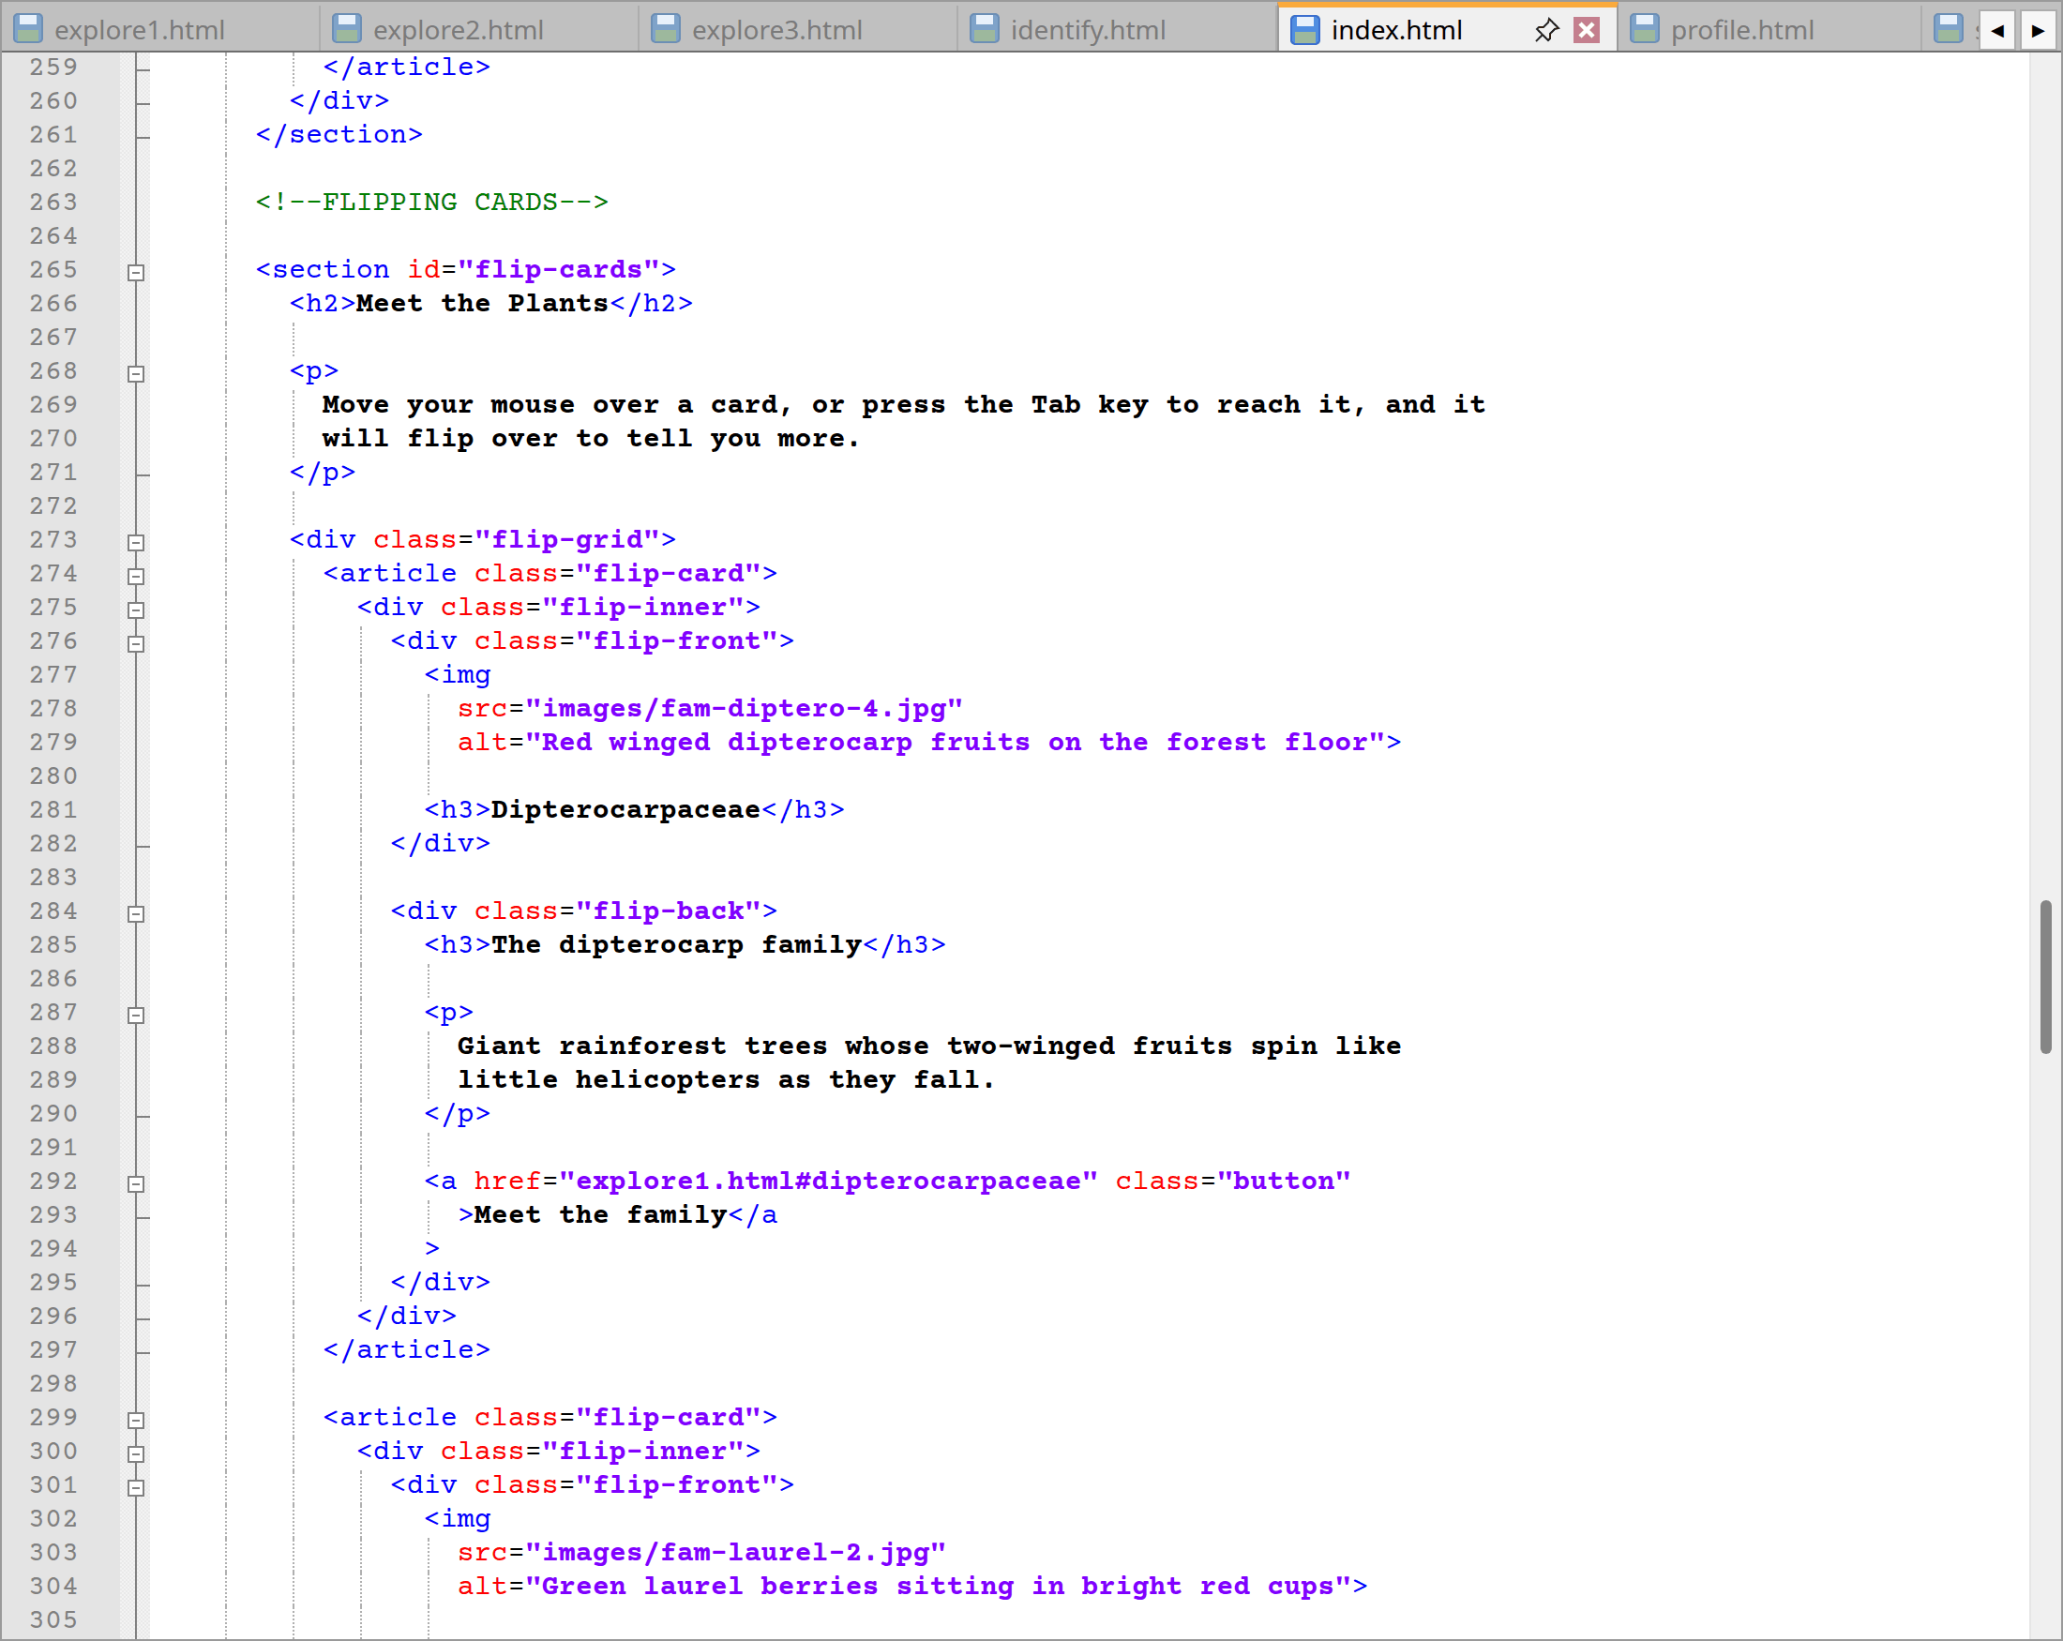
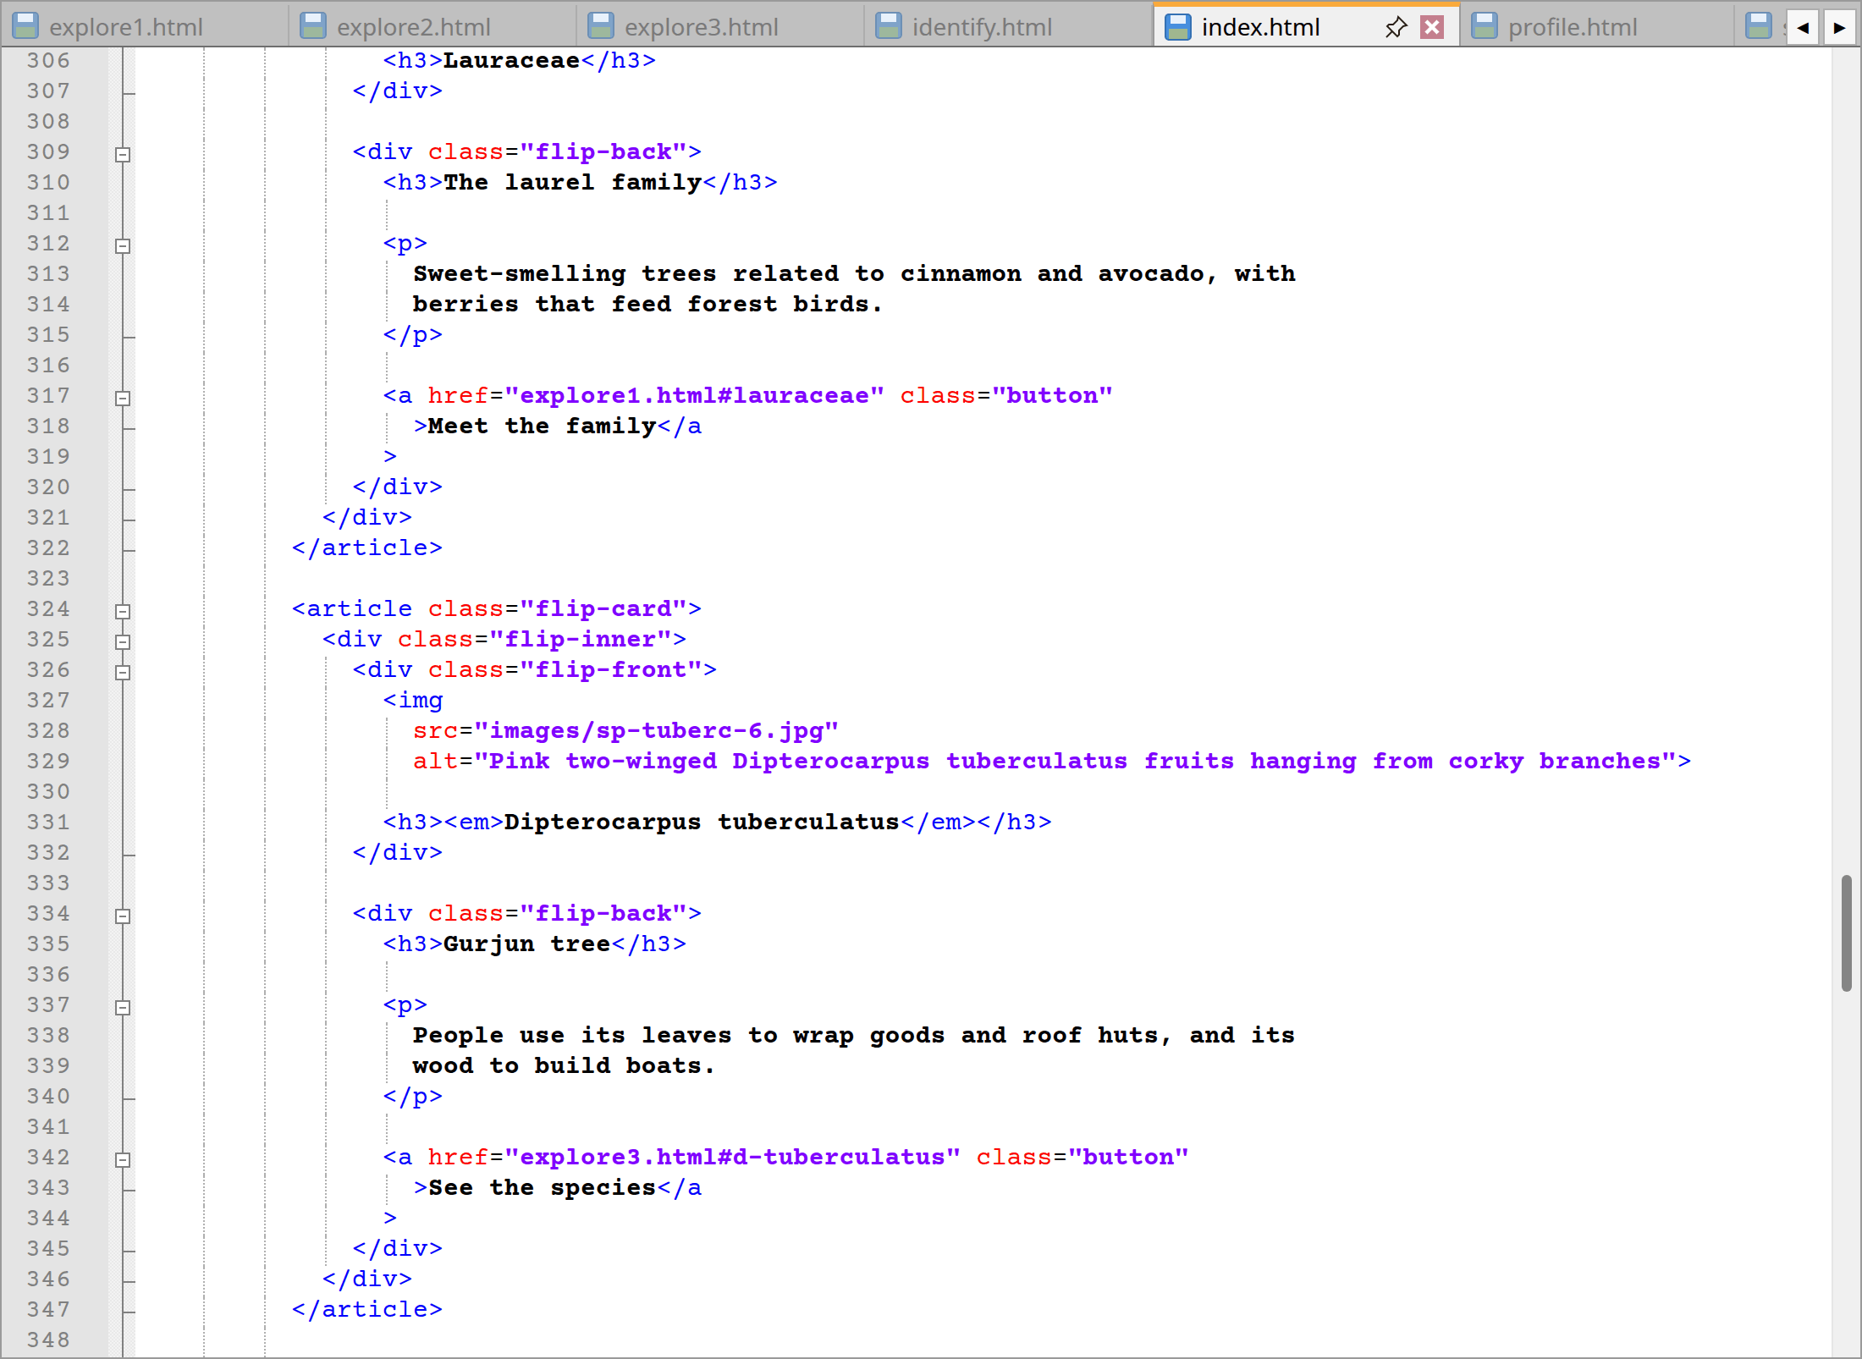
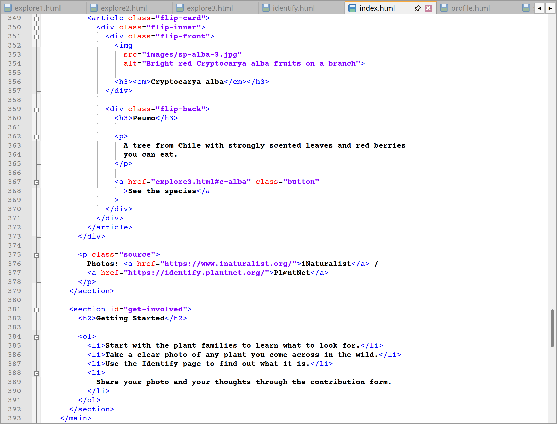
index.html code lines from 214 to 393
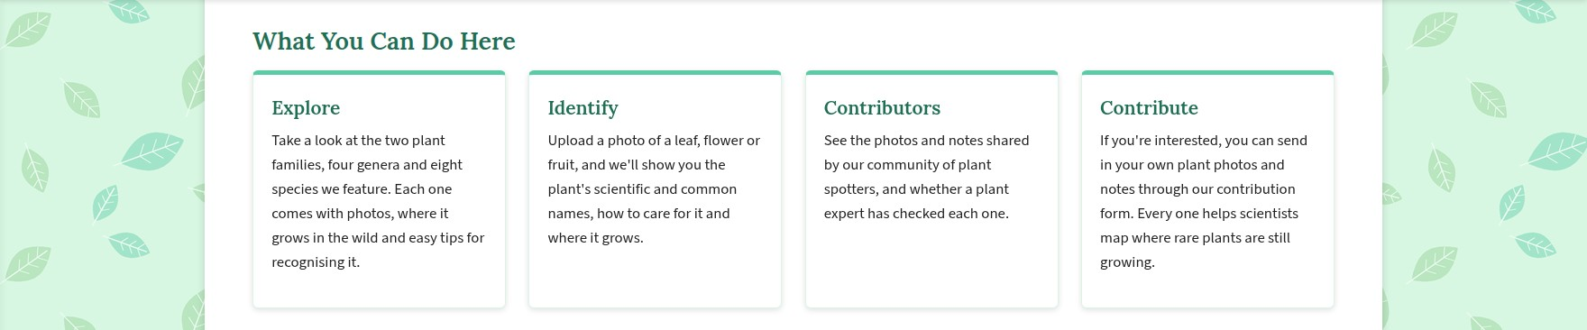
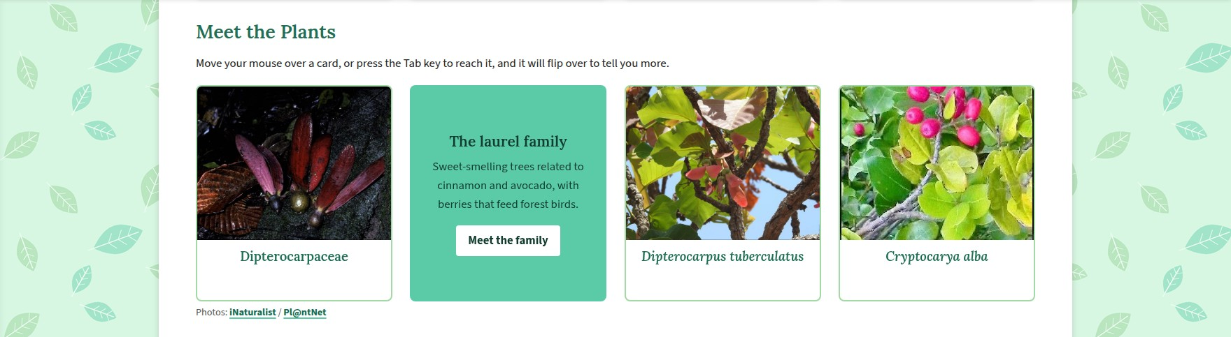

Website: Home page cards, flip cards and getting started
Lines | Explanation
134 | The contents that are unique to this page is contained within the <main> element, which also serves to let screen reader users go straight to it.
135–173 | I will also find that banner is a <section id="hero" class="hero-banner">. Moreover, all words are put into their own <span class="word"> for animation to occur word by word in the <h1> (from lines 137 to 143). Then, there is the <p class="hero-rotator"> (from the lines 147 to 155) with the text “Help us ___ Malaysia’s plants”, the four words explore, identify, record and protect are spans that get rotated by the CSS. However, a <p class="lead"> at lines 158-162 offers a summary sentence and two button styled links give the visitor some direction which are “Start exploring” or “Identify a plant”.
175–177 | Here is a credit for the banner photo with a link to where the image came from. This is how I credit all photographs on the site.
181–190 | Additionally, the <aside> tag has been used for the “Did You Know?” side note since it is related to the page but not part of the main text. It makes the point that Malaysia is one of some seventeen megadiverse countries, with <strong> emphasis on the latter term.
194–212 | Moreover, an <h2> marks off “About the Project” which is followed by a couple of paragraphs on the pressures facing Malaysian plants and the meaning of citizen science (marked with <em>). Besides that, “Endangered, Rare and Threatened (ERT)” is given <strong> treatment.
214 | Furthermore, a horizontal rule in the form of an <hr> is placed here to separate the sections.
218–261 | Under “What You Can Do Here” I will see four <article class="card"> elements for explore, identify, contributors and contribute each with an <h3> and a blurb and sitting inside a <div class="card-grid">. An article was chosen as each card stands alone.
265–379 | We will also find that “Meet the Plants” has four flip cards in a <div class="flip-grid">. The <article class="flip-card"> holds a <div class="flip-inner"> with the photo and name on the front and the common name, a fact and a link on the back.
381–392 | For “Getting Started” an ordered list is appropriate as the four steps should be done in order - start with the plant families, get a good photo, use the Identify page and share it through the contribution form.
Extra | Lastly, the header, menus and footer are no different from Section 2.1 earlier. There is no link to the home page in the main menu as the logo and site name will already do that.

2.3 Explorer page (explore.html)
Where the index page is regarded as the front door, the explorer is the considered as the main room. It can be considered as a mini plant encyclopedia that gives us the run down on the families, genera and species and shows us where they sit in the family tree before I head off to the three detailed pages. It is the most interactive of the lot, with a link map, several quizzes, a rating form, a photo gallery and flip cards.
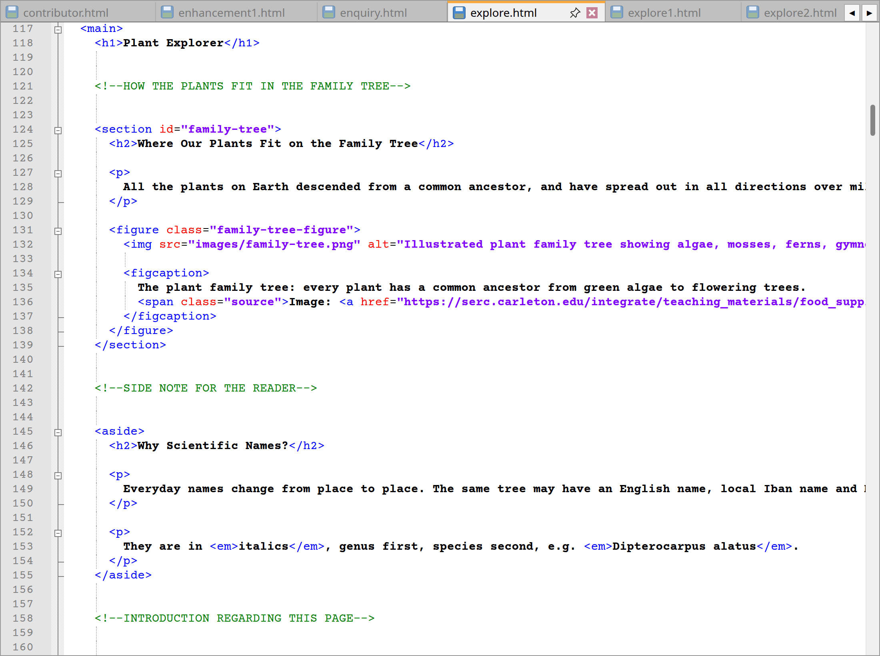
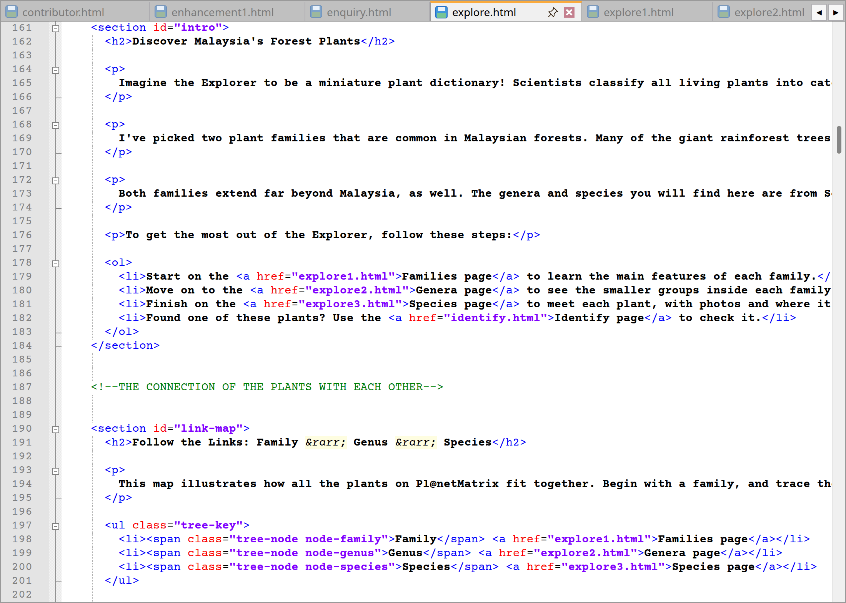
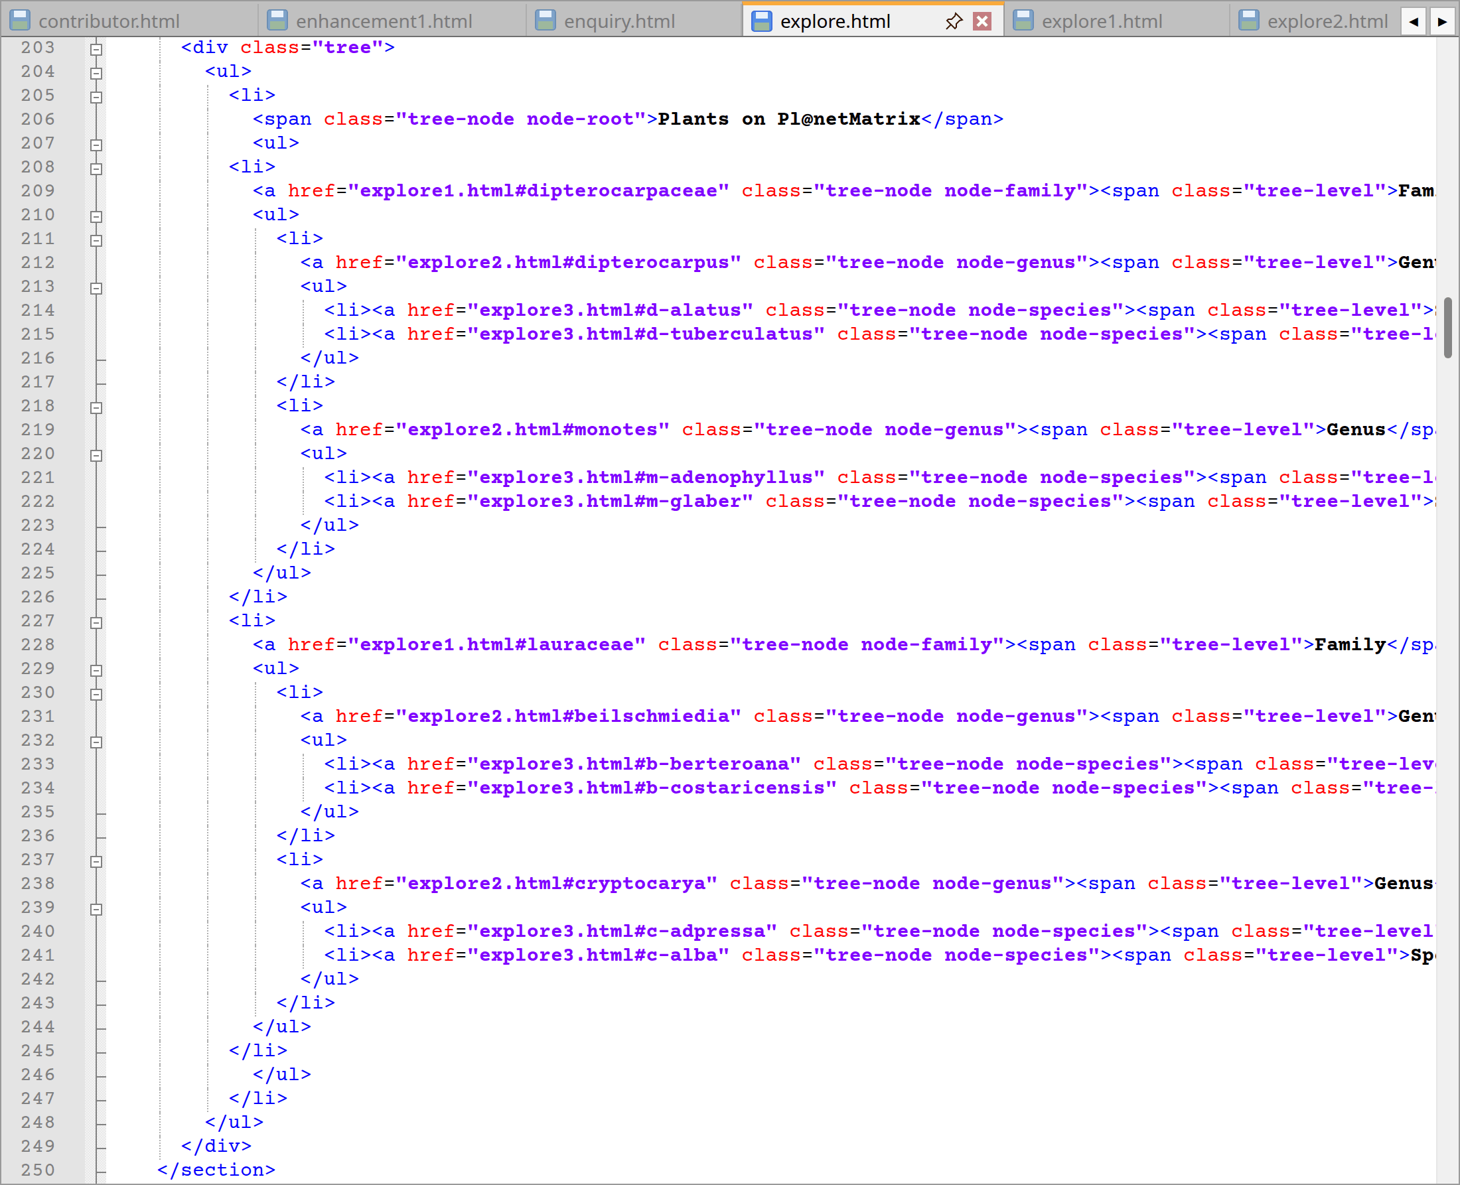
explore.html code lines from 117 to 250
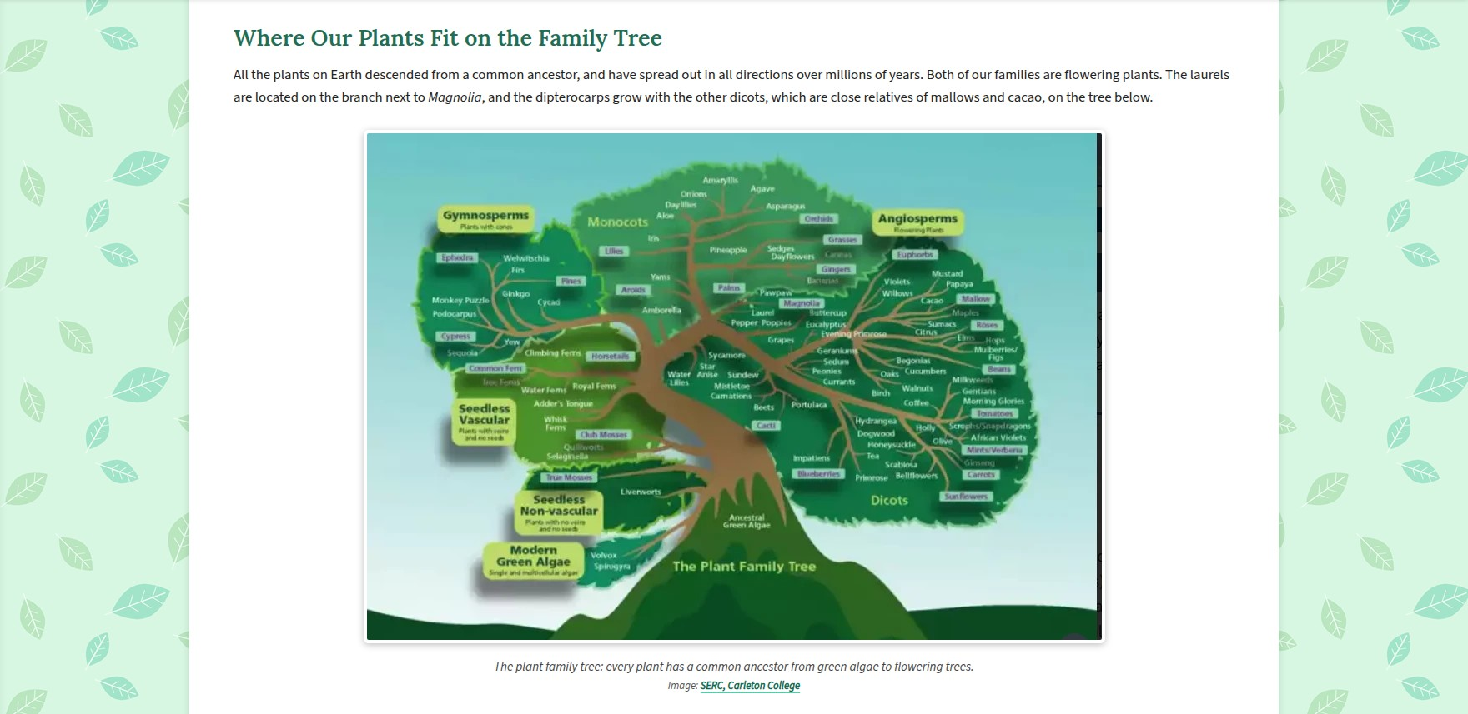
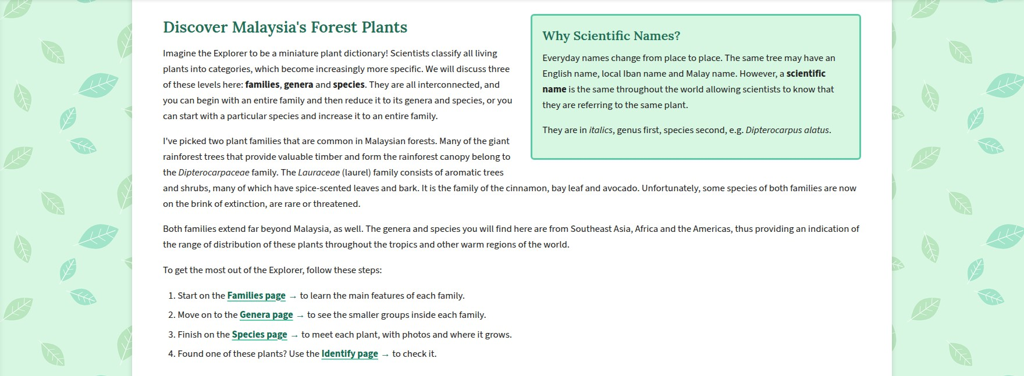
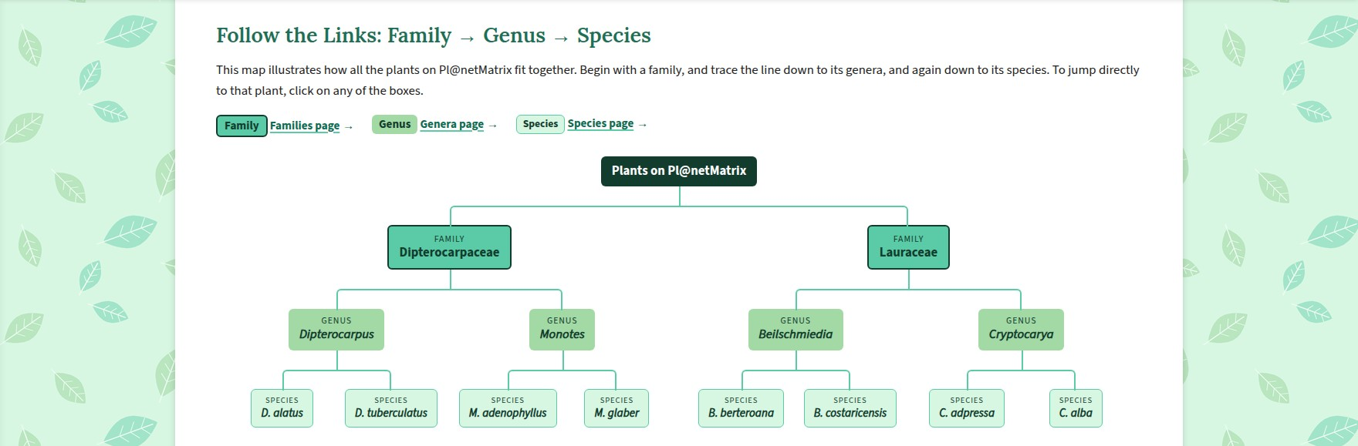
Website – Explorer family tree and link map
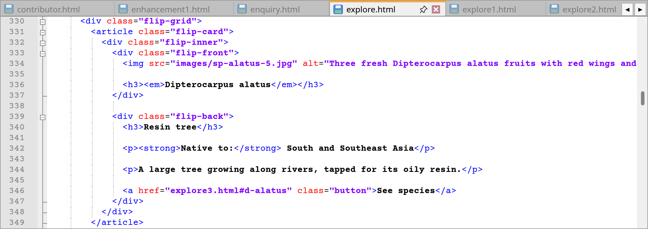
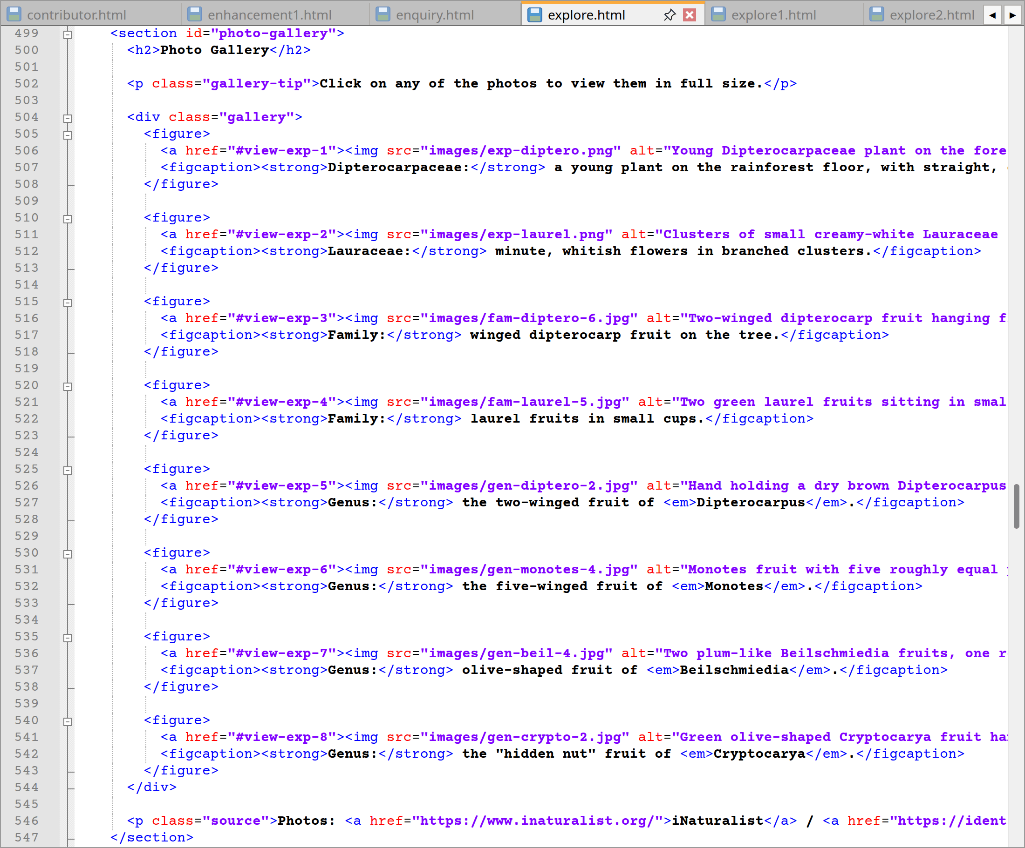
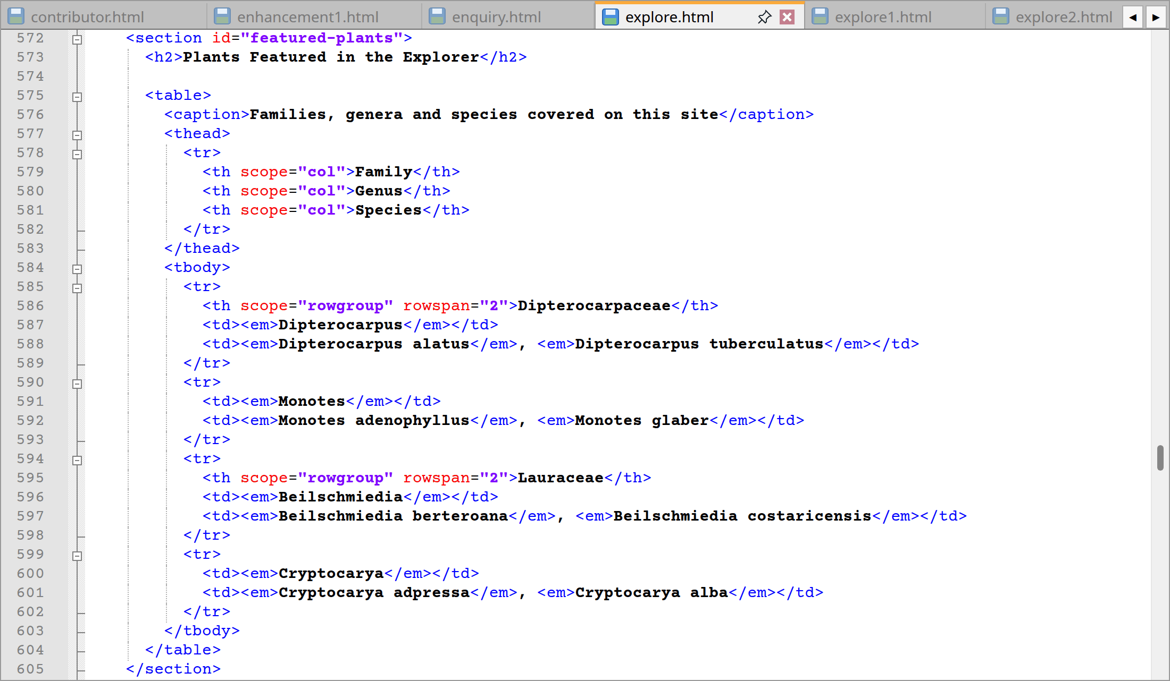
explore.html code lines from 330 to 349, 499 to 547 and 572 to 605
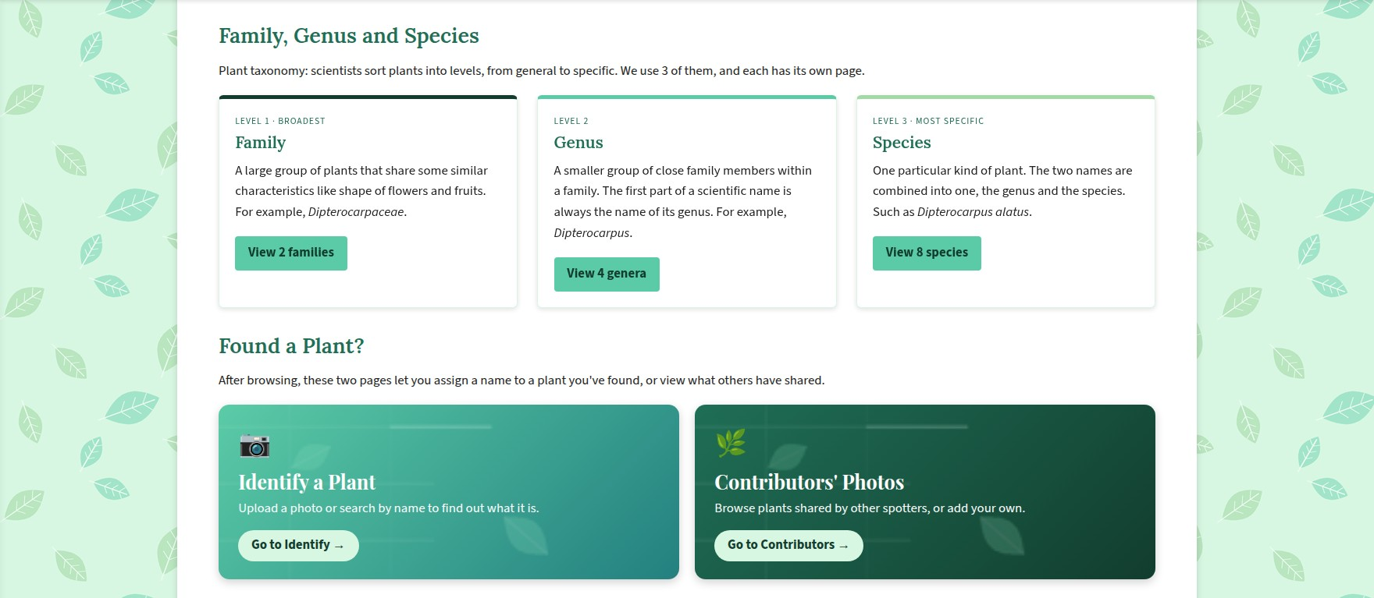
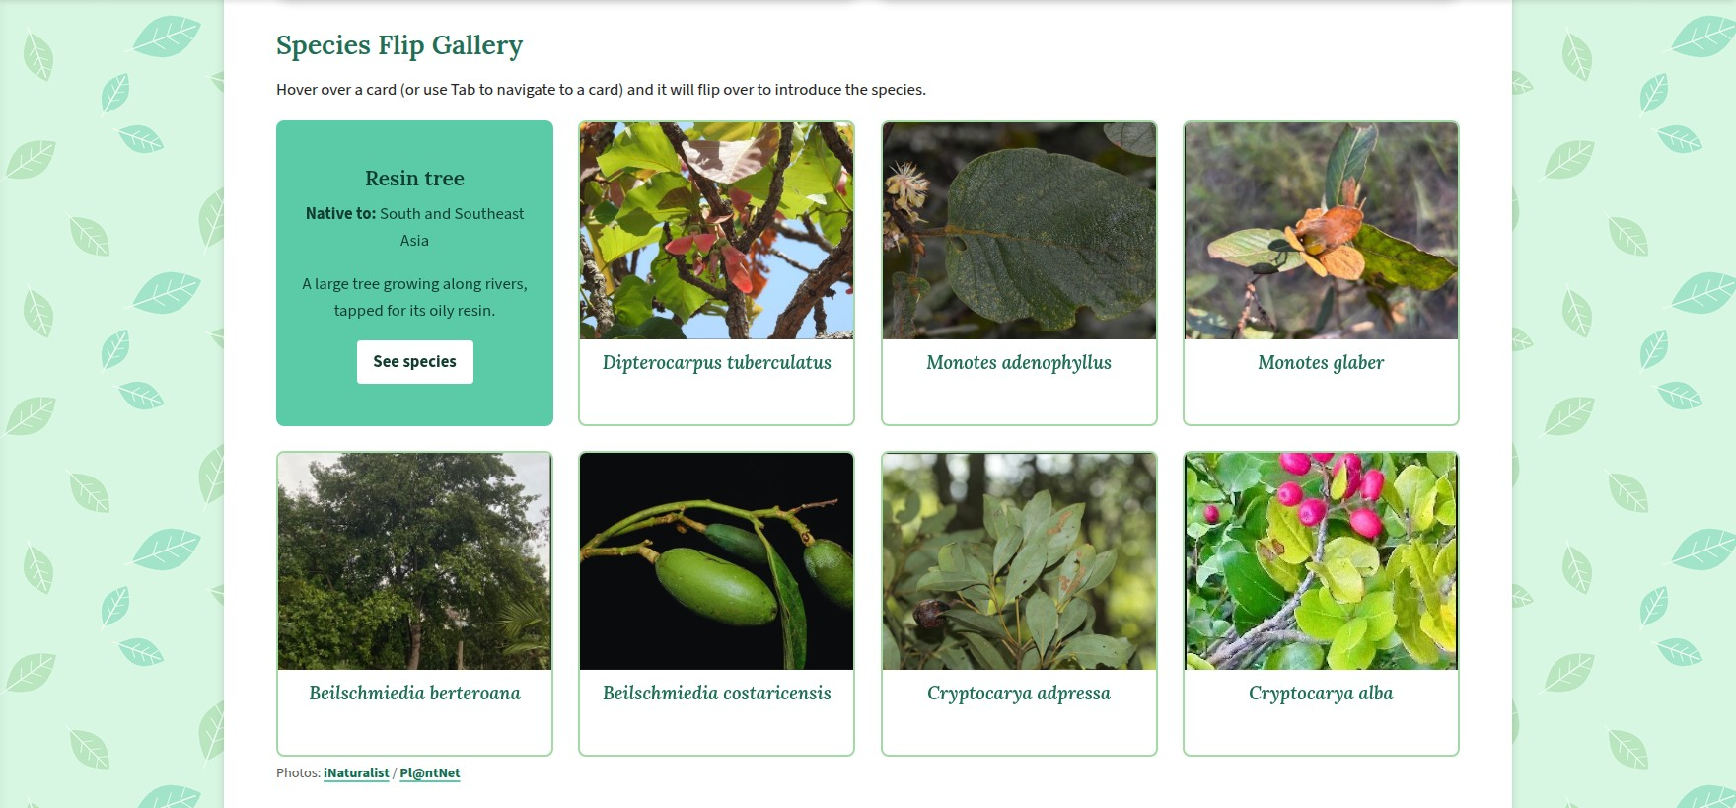
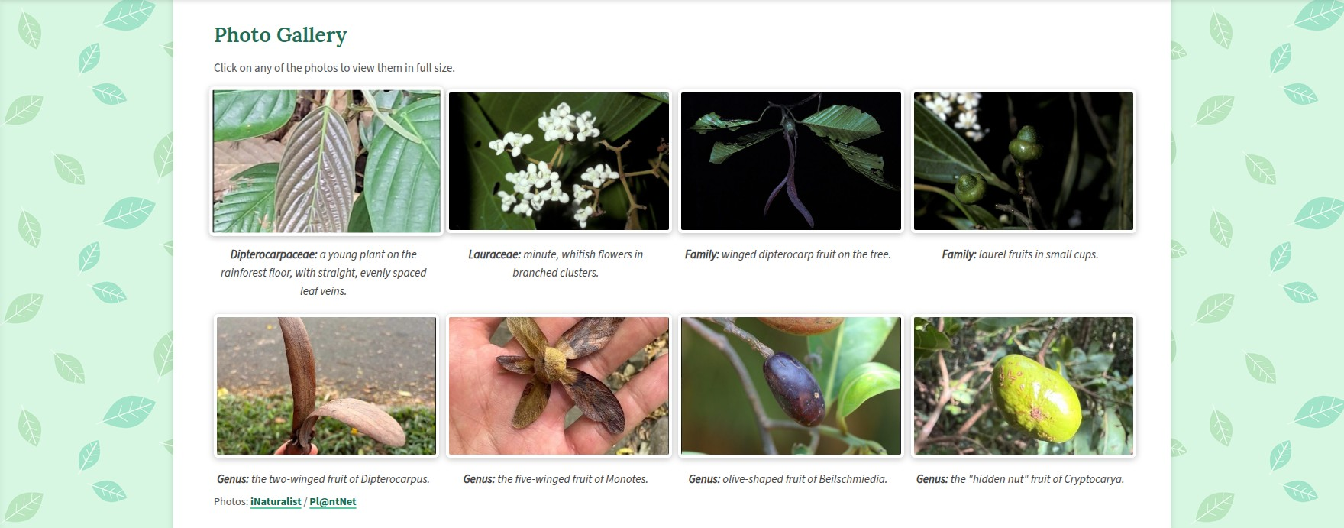
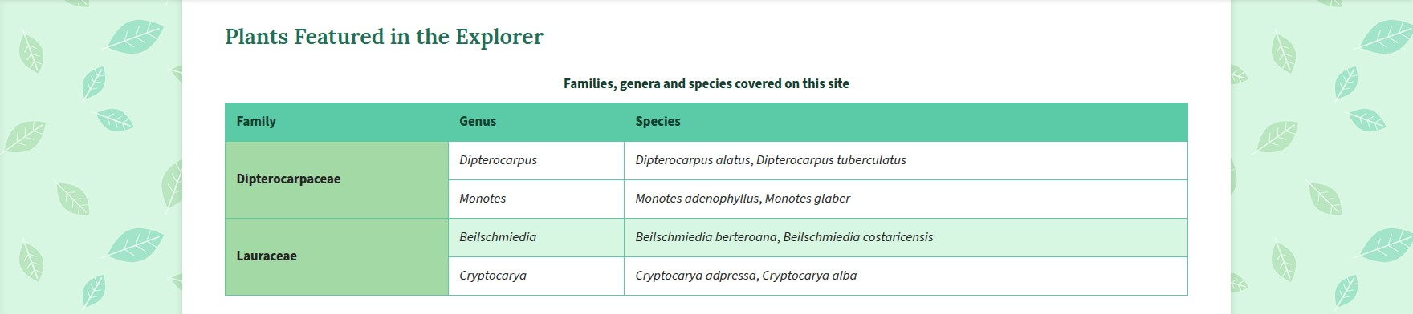
Website – Explorer cards, flip gallery, photo gallery and table
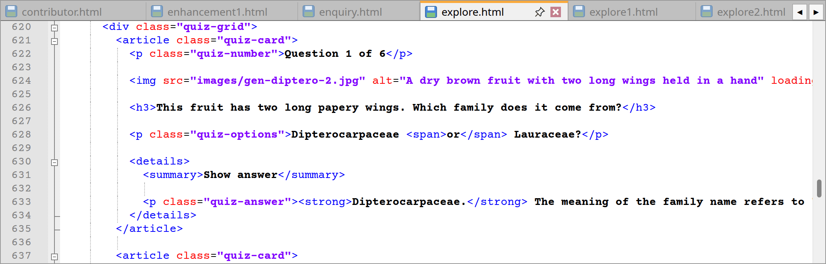
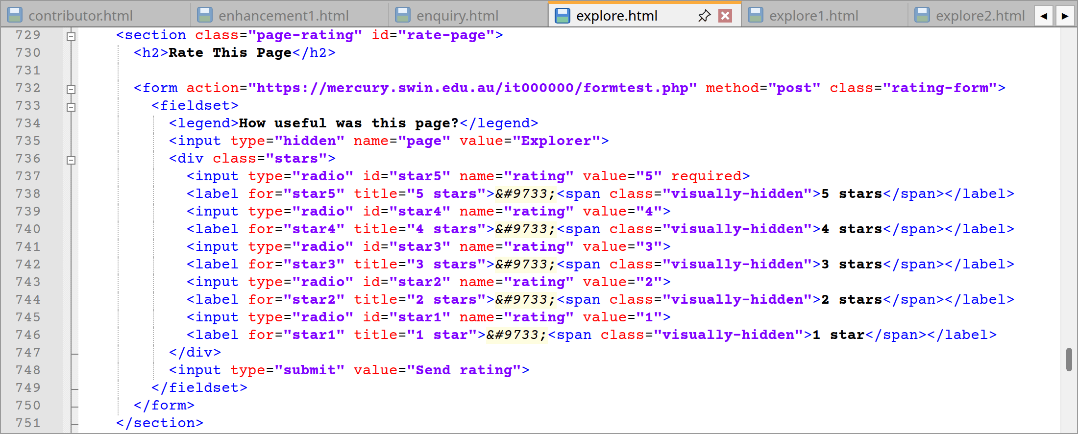
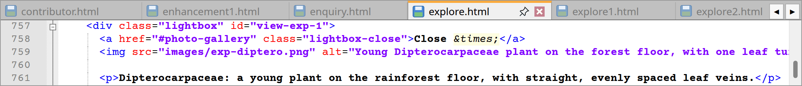
explore.html code lines from 620 to 637, 729 to 751 and 757 to 761
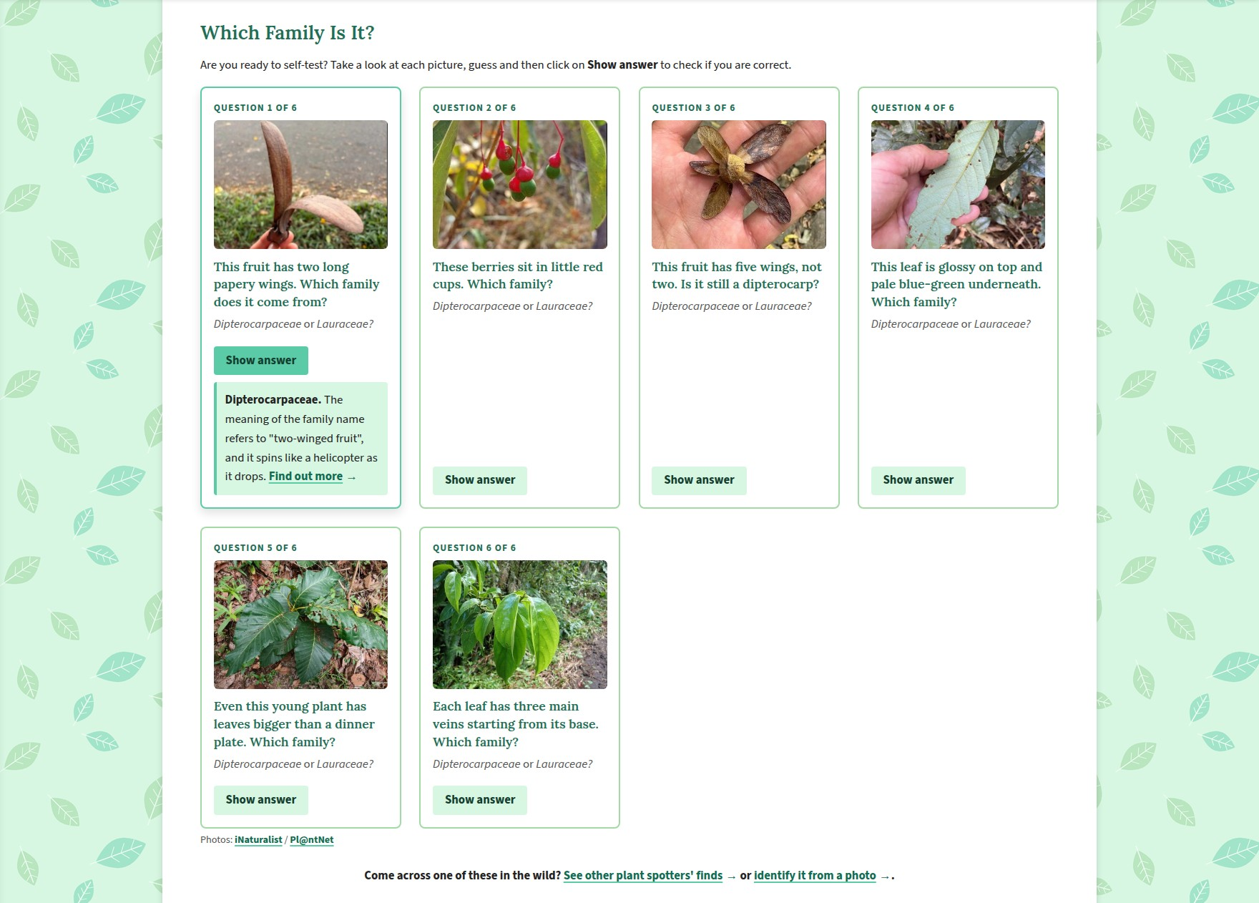

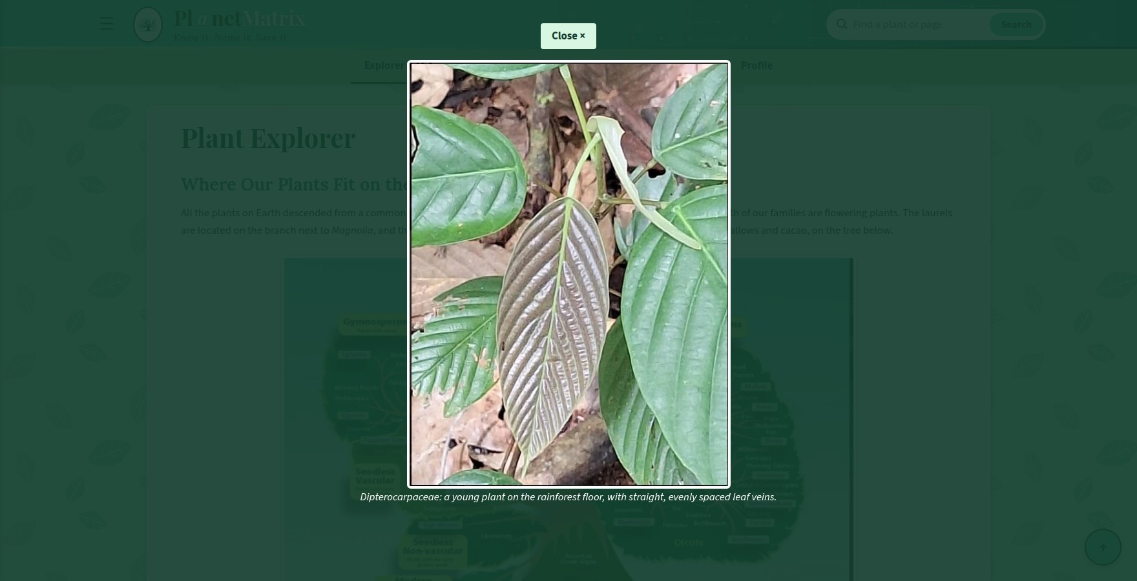
Website – Quiz, rating and an open photo
Lines | Explanation
118 | To start with, the page’s single <h1> reads “Plant Explorer”.
124–139 | Then, a paragraph describes the standing of the two families in the plant family tree. The accompanying image is in a <figure class="family-tree-figure"> with alt text to describe it, the caption and a source link are in the <figcaption>’s <span class="source">.
145–155 | Besides, in the “Why Scientific Names?” <aside>, it is noted that while a plant may have several common names, there is only one scientific name, i.e. the genus and species in italics.
161–184 | I will also find that three paragraphs make up the opening of the intro <section>. They put forward the explorer as a “plant dictionary” and cover the two families, noting that the genera and species come from the Americas, Africa or Southeast Asia. The 3 levels are in <strong> while the family names are set in <em>. An ordered list (<ol>) then follows the instruction to “follow these steps: to get the most out of the Explorer”. Additionally, I have used <ol> for the 4 steps (from lines 178 to 183) so the reader is led in sequence from the broadest level to an individual plant with each step pointing to the Families, Genera, Species or Identify page.
190–250 | For the link map, a <ul class="tree-key"> on lines 197 to 201 serves as the colour key. The tree itself (from lines 203 to 249) is built from 3 tiers of nested <ul> lists for the 2 families, their genera and species. Every box is an <a class="tree-node">, the class will be node-family, node-genus or node-species depending on the level, and it links straight to the plant’s section.
256–294 | Furthermore, the structure is uniform across the three <article class="card level-card"> elements under “Family, Genus and Species”. One will find a level label, a heading, an example sentence and a link to the relevant pages in each.
300–319 | In “Found a Plant?” there are two sizeable link tiles (<a class="quick-link">) for the contributors and identify pages. The whole tile is clickable and they are complete with an icon, title, description and a <span> tag for the “Go to” label.
325–493 | The Species Flip Gallery contains 8 flip cards having one for every species. On the front is the photo and the scientific name in <em> to turn it over and I will see the common name, where it is native, a brief fact and a button to “See species”.
499–547 | I will also discover that there are eight <figure> elements inside the <div class="gallery">. Each image is accompanied by a <figcaption> element that describes the image. They are all linked (href="#view-exp-1" and so on) to bring up the full-size version when clicked.
553–566 | Here a description list (<dl>) is well suited to the content here in “Key Terms” with the terms in <dt> and the definitions in <dd>.
572–605 | As for the table of featured plants, it has a <caption>, a <tbody> and a <thead> with scope="col" headings. The family name is given a <th scope="rowgroup" rowspan="2"> to cover the two rows of genera belonging to it.
613–723 | Moreover, a total of six <article class="quiz-card"> elements comprise the quiz. There is a question number, an <h3> for the question and its two options, and a picture with loading="lazy" for each. The answer is tucked away in a <details> element and it will not be seen until one clicks the <summary> that says “Show answer” at a point in which the link to the relevant explorer section is revealed.
729–751 | As for the rating form, it is set to method="post”. Within a <fieldset> and <legend> I will find a hidden input bearing the page name, then five radio buttons (name="rating") with their own <label>. These are put in descending order from 5 to 1 by design, allowing the CSS to do its work.
757–811 | Additionally, the gallery has eight <div class="lightbox"> elements, one per picture. The id of each corresponds to the thumbnail link and there is a close link along with the caption and full size image.
Extra | Again, the header, footer and menus are unchanged from Section 2.1, though the explorer link here is given class="current" to stand out.

2.4 Families, Genera and Species pages (explore1.html, explore2.html, explore3.html)
These three pages are linked with each other and share a common format to give the feel of three chapters in a single volume. Likewise, one will find a breadcrumb, heading and side note to begin with, then an “About This Page” area with some useful jump links, a brief identification guide and an “At a Glance” table. After that comes the plant itself in an <article>, all in the same sequence, before the page is concluded with a 1-2-3 bar to the other pages and full-size photo viewers.
I will find that they are always joined. A family leads to its genera and species, a genus to its family and species and so on such that a visitor can take any plant and follow it up or down the tree.
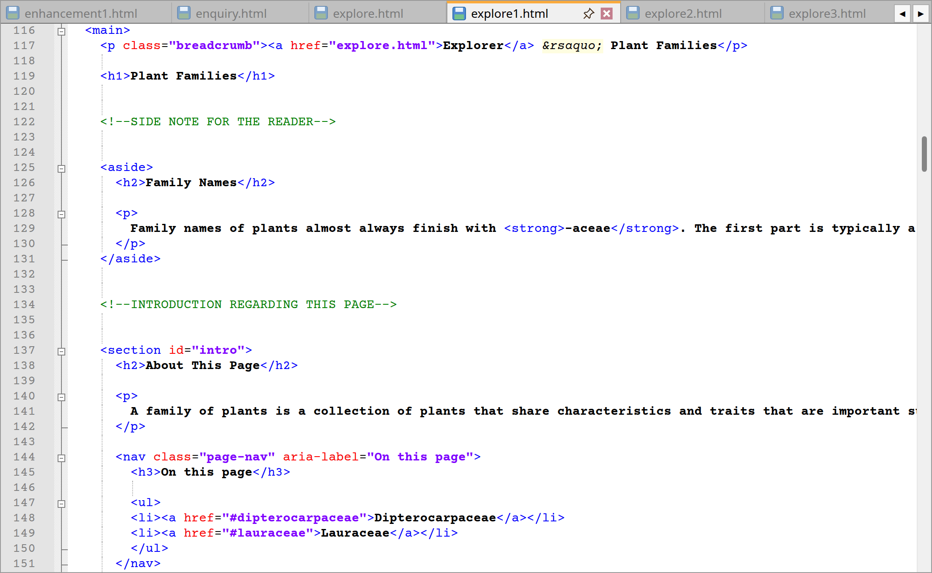
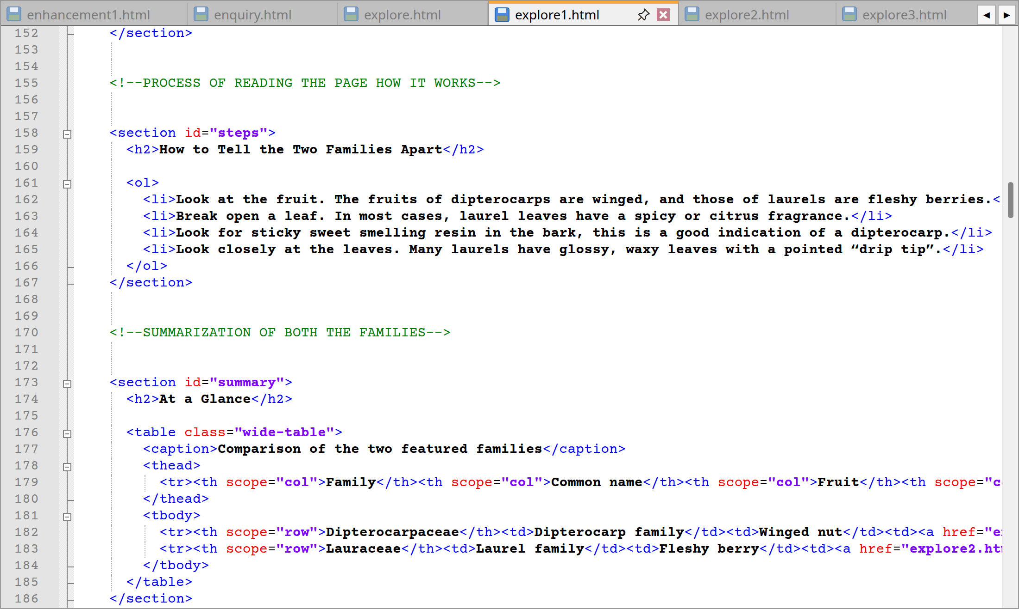
explore1.html code lines from 116 to 186
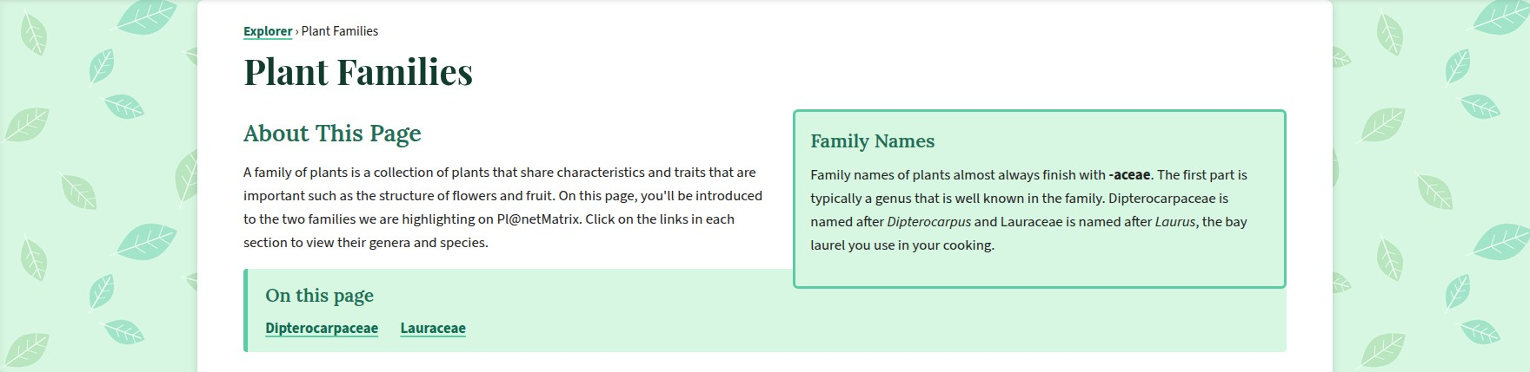
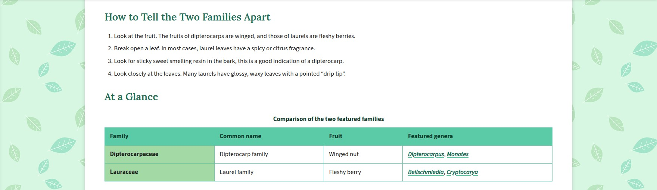
Website – Top of the Families page
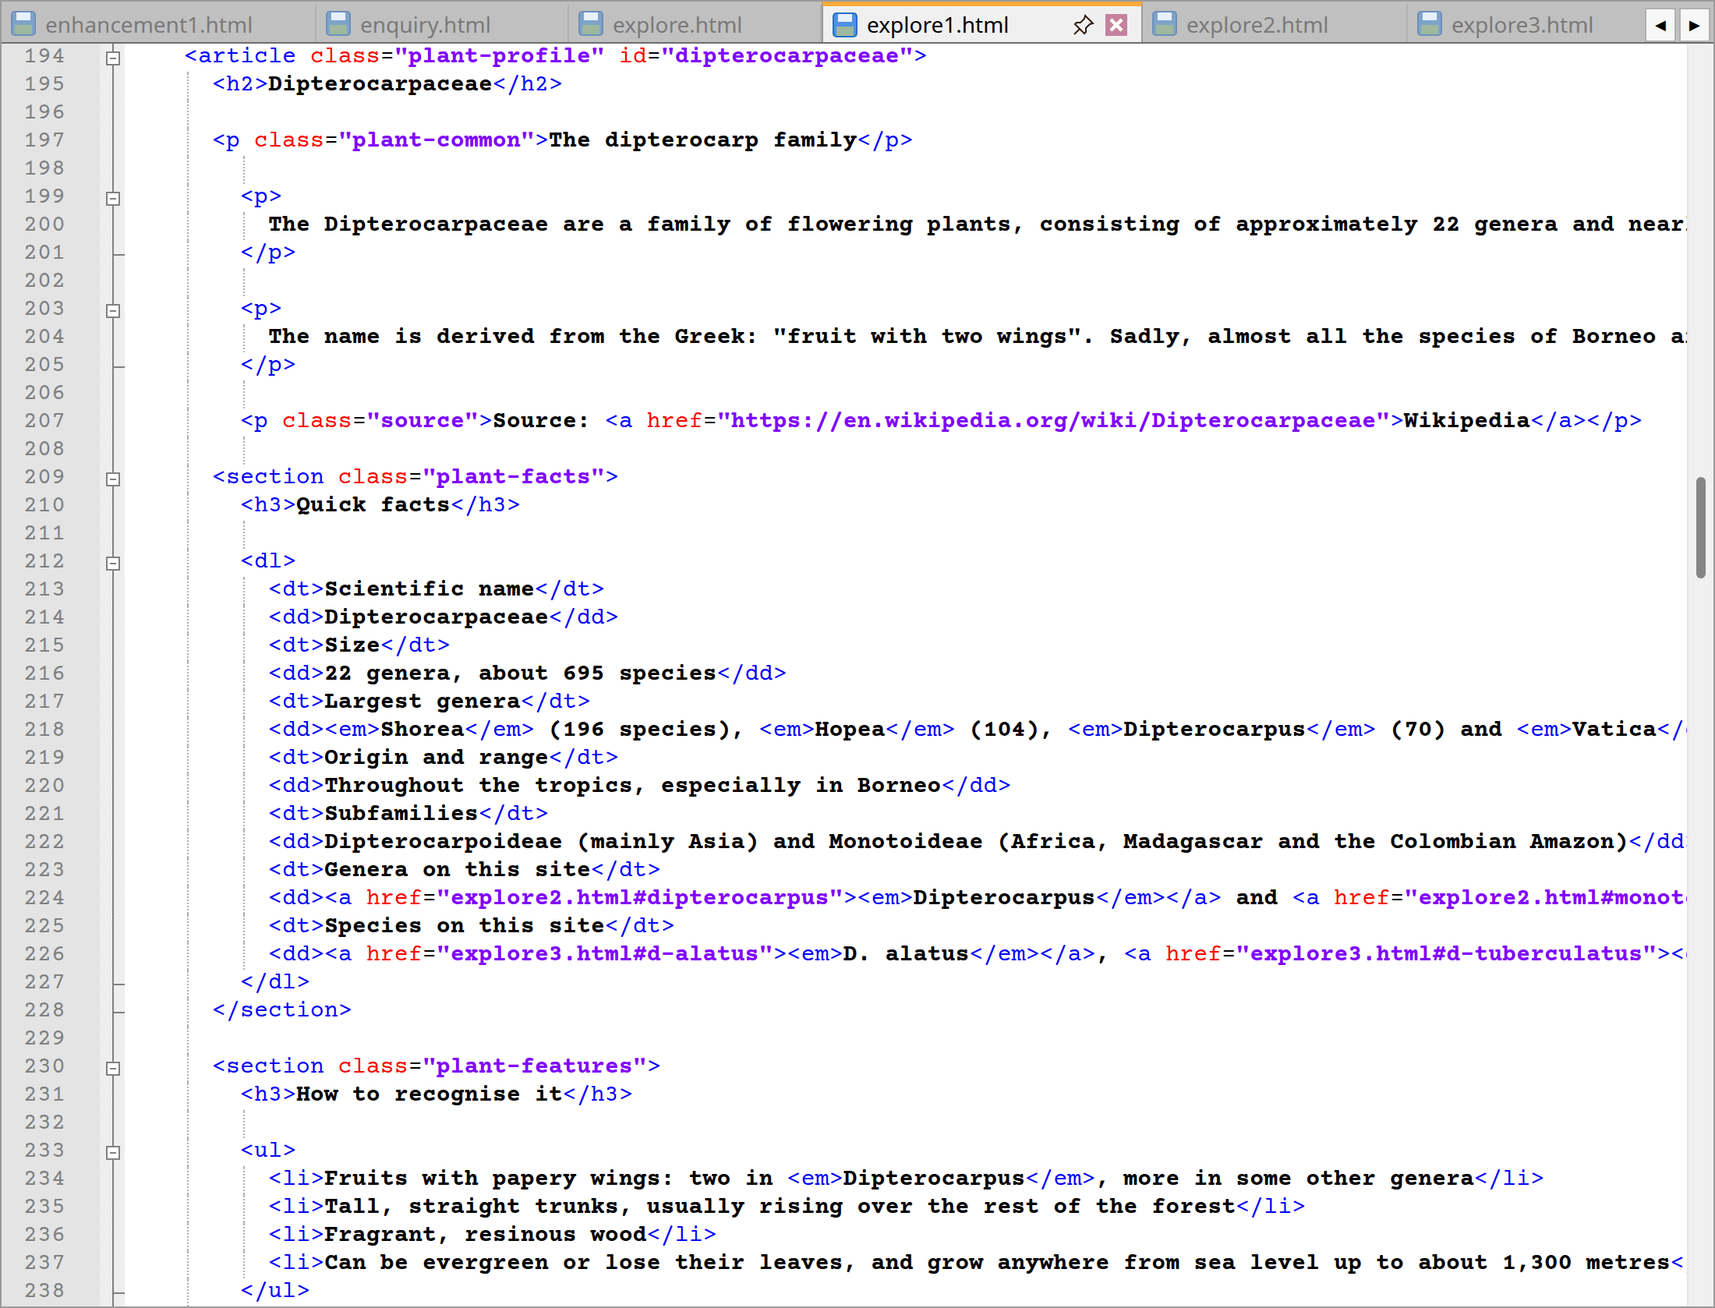
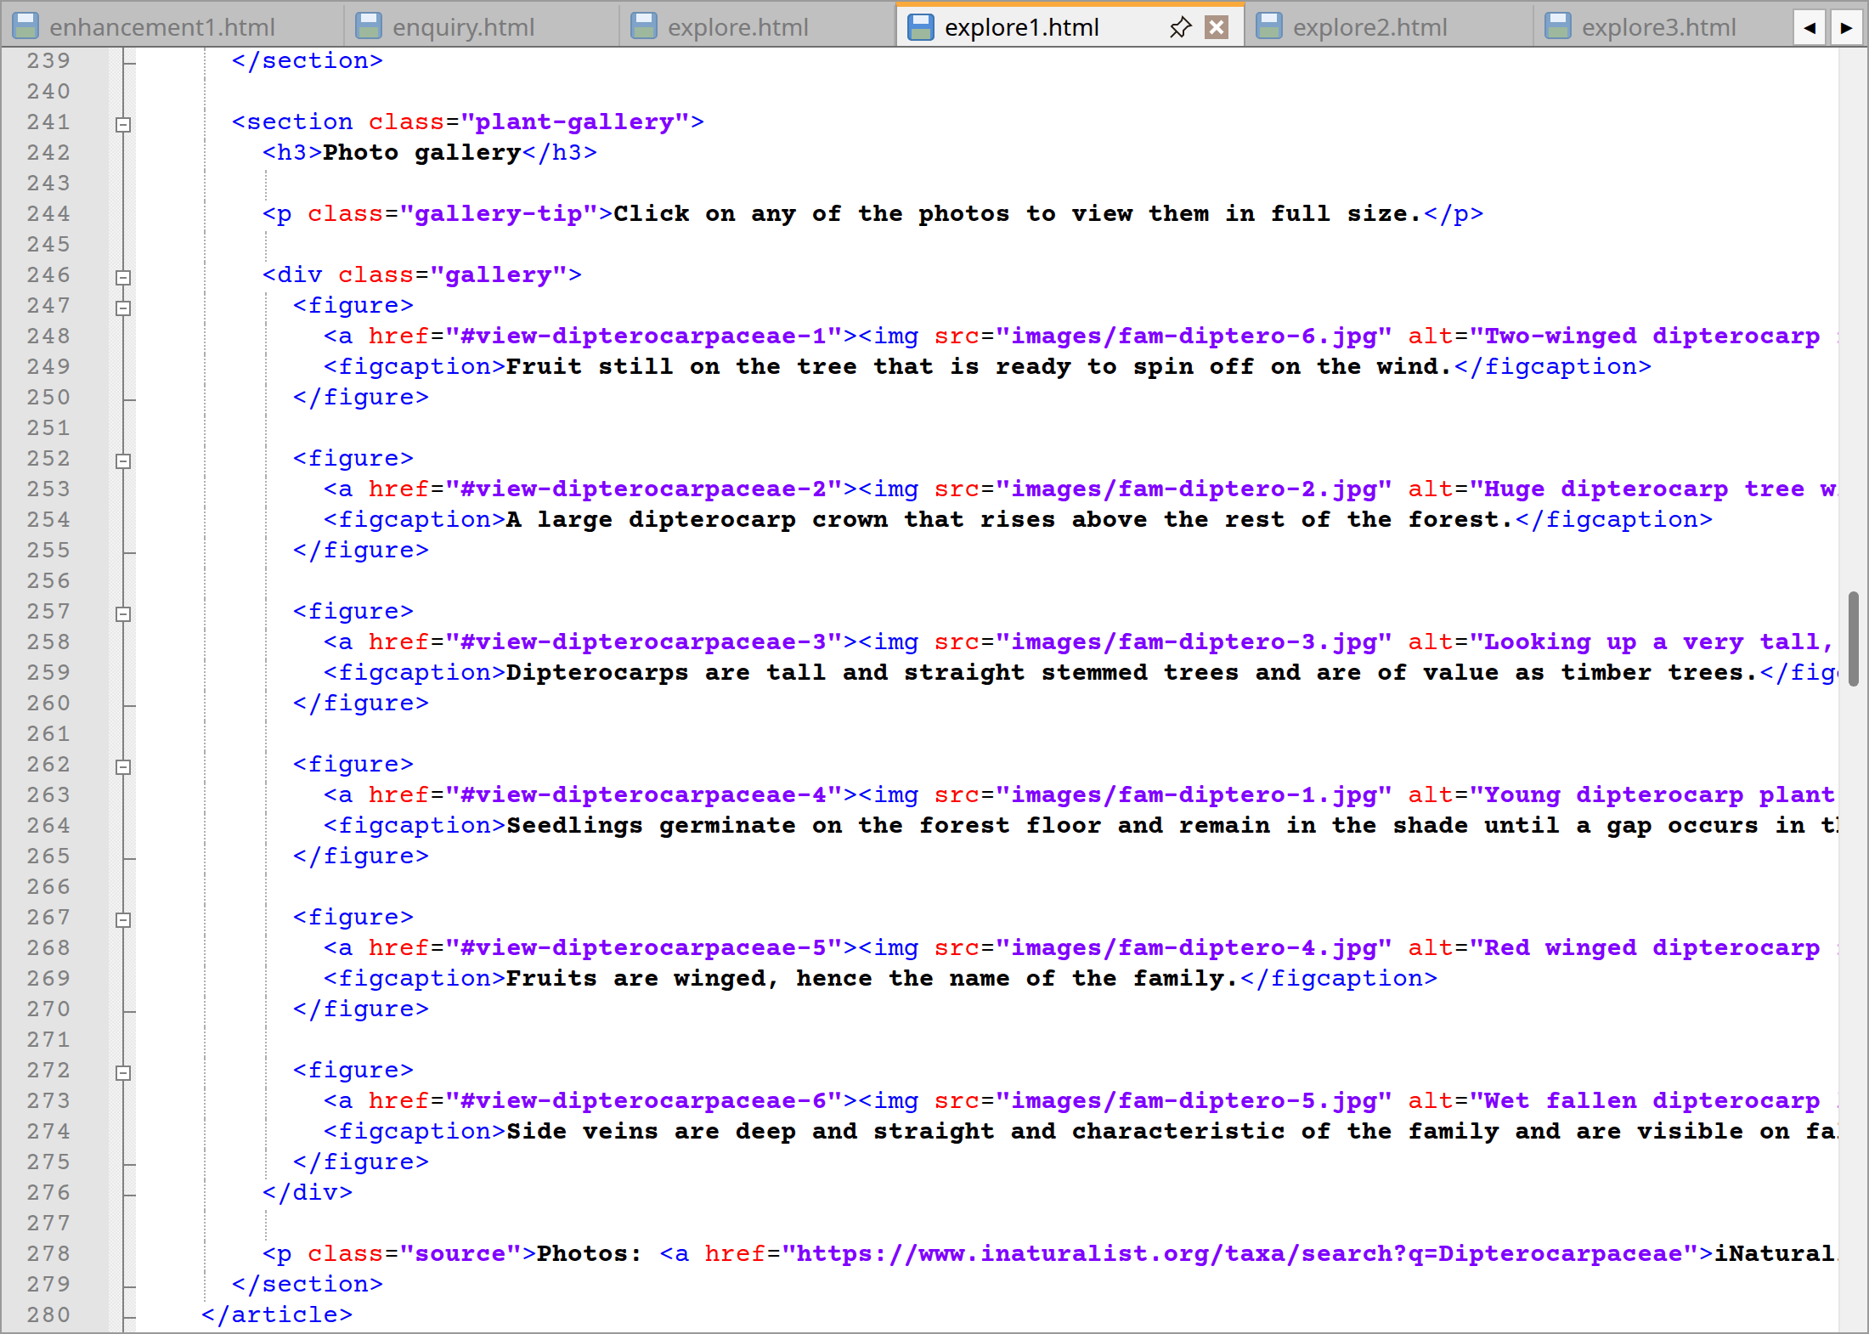
explore1.html code lines from 194 to 280
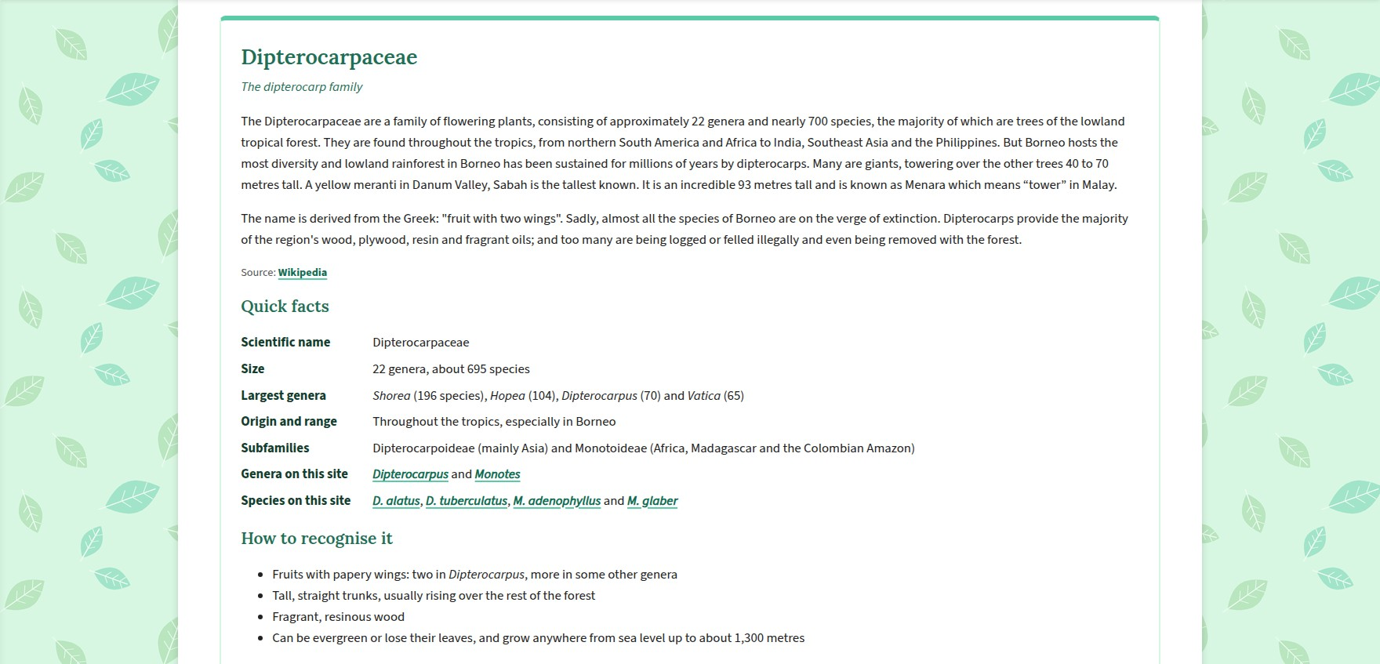
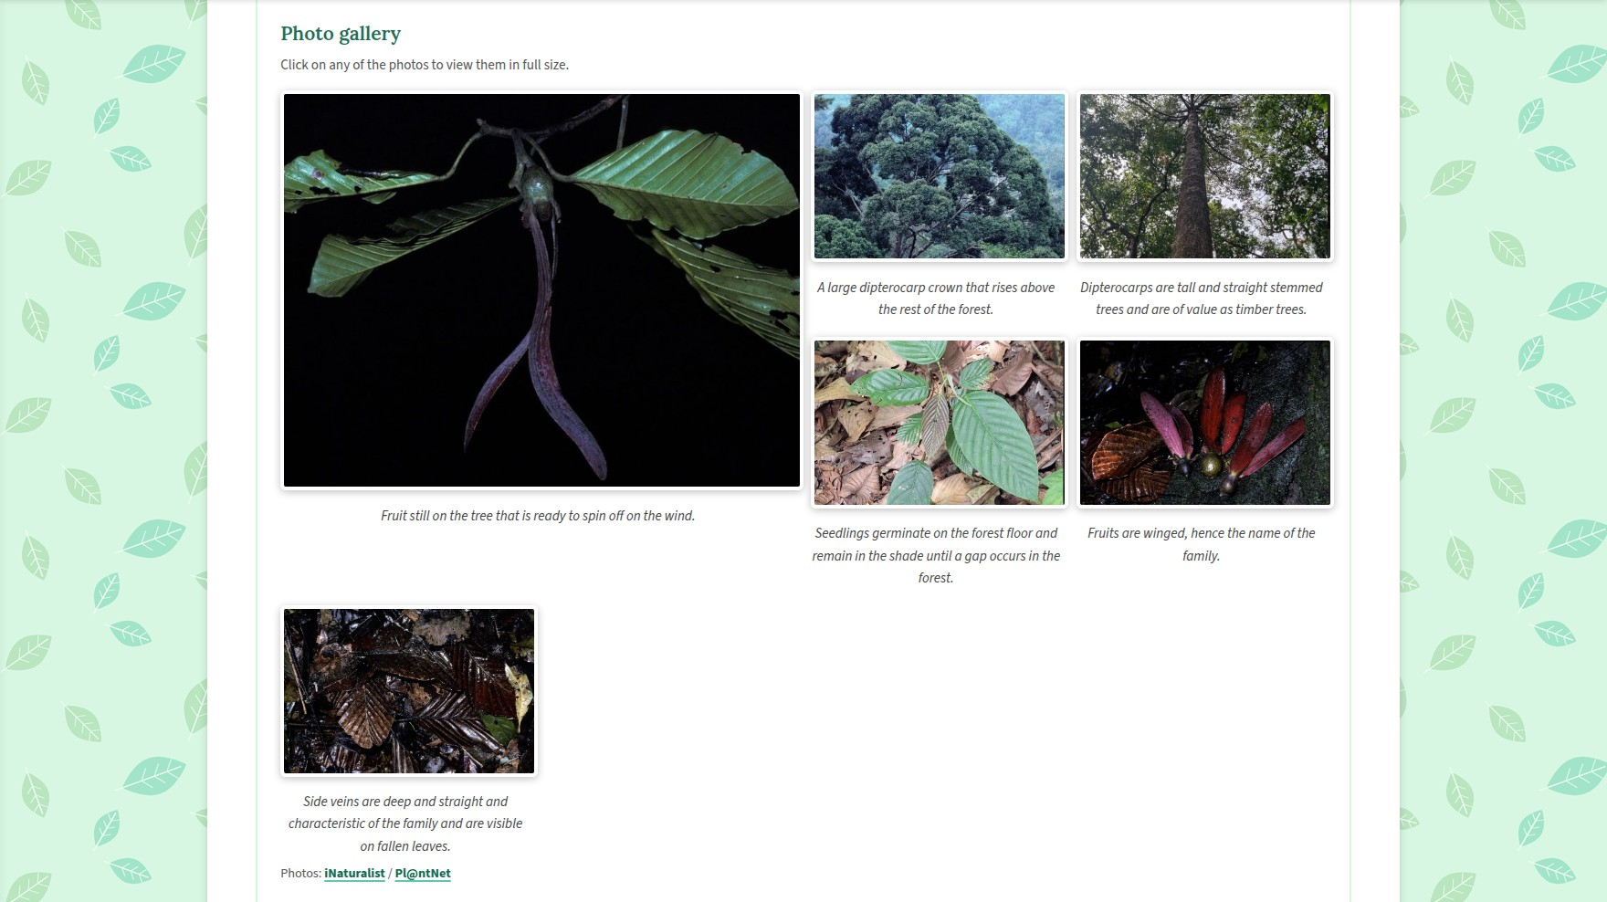
Website – Dipterocarpaceae profile
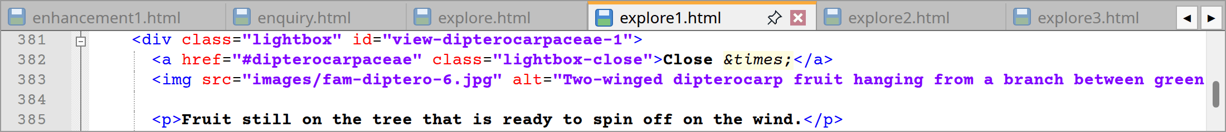
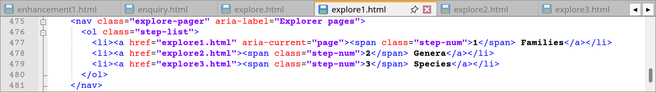
explore1.html code lines from 381 to 385 and 475 to 481
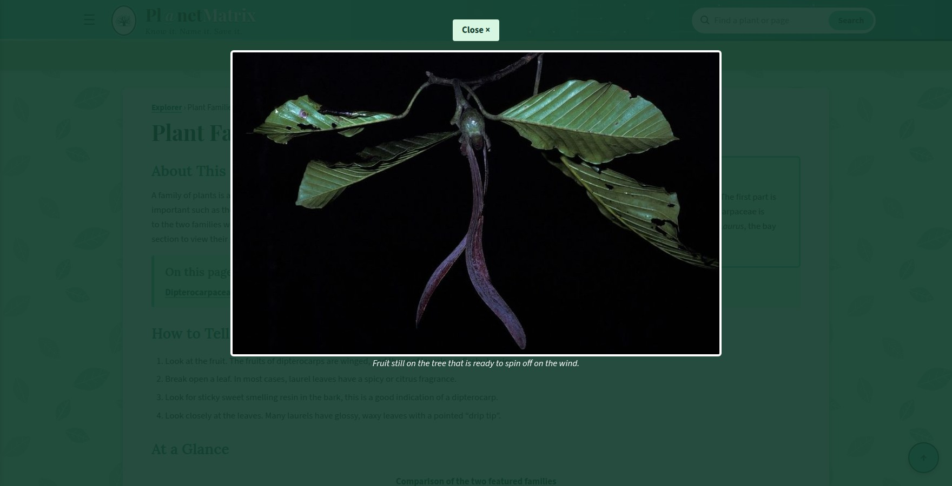
Website – Open photo and the 1-2-3 bar
Lines | Explanation
117 | At first, “Explorer › Plant Families” is the breadcrumb for this part of the explorer. So, a click on explorer returns the user to explore.html.
119 | The <h1> reads “Plant Families”.
125–131 | In the <aside> “Family Names” I explain how names like Dipterocarpaceae or Lauraceae come about by appending -aceae to a familiar genus.
137–152 | One can look under “About This Page” for what constitutes a plant family. To make navigating the length of the page simpler, there are jump links to #dipterocarpaceae and #lauraceae in a <nav class="page-nav"> with aria-label="On this page".
158–167 | Table 6 from lines 158 to 167 present an ordered list under the heading “How to Tell the Two Families Apart” with four distinct checks which are leaf shape, resin, the scent of crushed leaves and the fruit.
173–186 | Over in lines 173 to 186 one will find a <table class="wide-table"> or “At a Glance” which sets the two families side by side according to their common name, fruit and the genera on display. Thus, the family names are rendered as <th scope="row"> and the genera have links to the genera page.
194–280 | The jump links will take one to the Dipterocarpaceae profile (from lines 194 to 280) an <article class="plant-profile" id="dipterocarpaceae">. An <h2> gives the common name followed by two paragraphs of description and a source. There are three sections to be had which are plant-facts (from lines 209 to 228) having a description list of quick facts tied to species and genera, plant-features (from lines 230 to 239) for identification and a plant-gallery (from lines 241 to 279) of six full-size photographs.
282–375 | One can make easy comparisons with the Lauraceae profile (from lines 282 to 375) given it was put together in like fashion. Its gallery has seven photos and the quick facts will note the age of the family along with such well-known members as avocado and cinnamon.
381–470 | The 13 lightbox photos are covered in lines 381 to 470. The close link is designed to send the visitor back to the relevant section of the page rather than the top allowing them to pick up where they left off.
475–481 | To finish the page (from the lines 475 to 481) there is a <nav class="explore-pager"> with an ordered list of three numbered links for species, genera and families. The current page is made known via aria-current="page".
Extra | Similarly, as per Section 2.1, the header, menus and footer are standard.

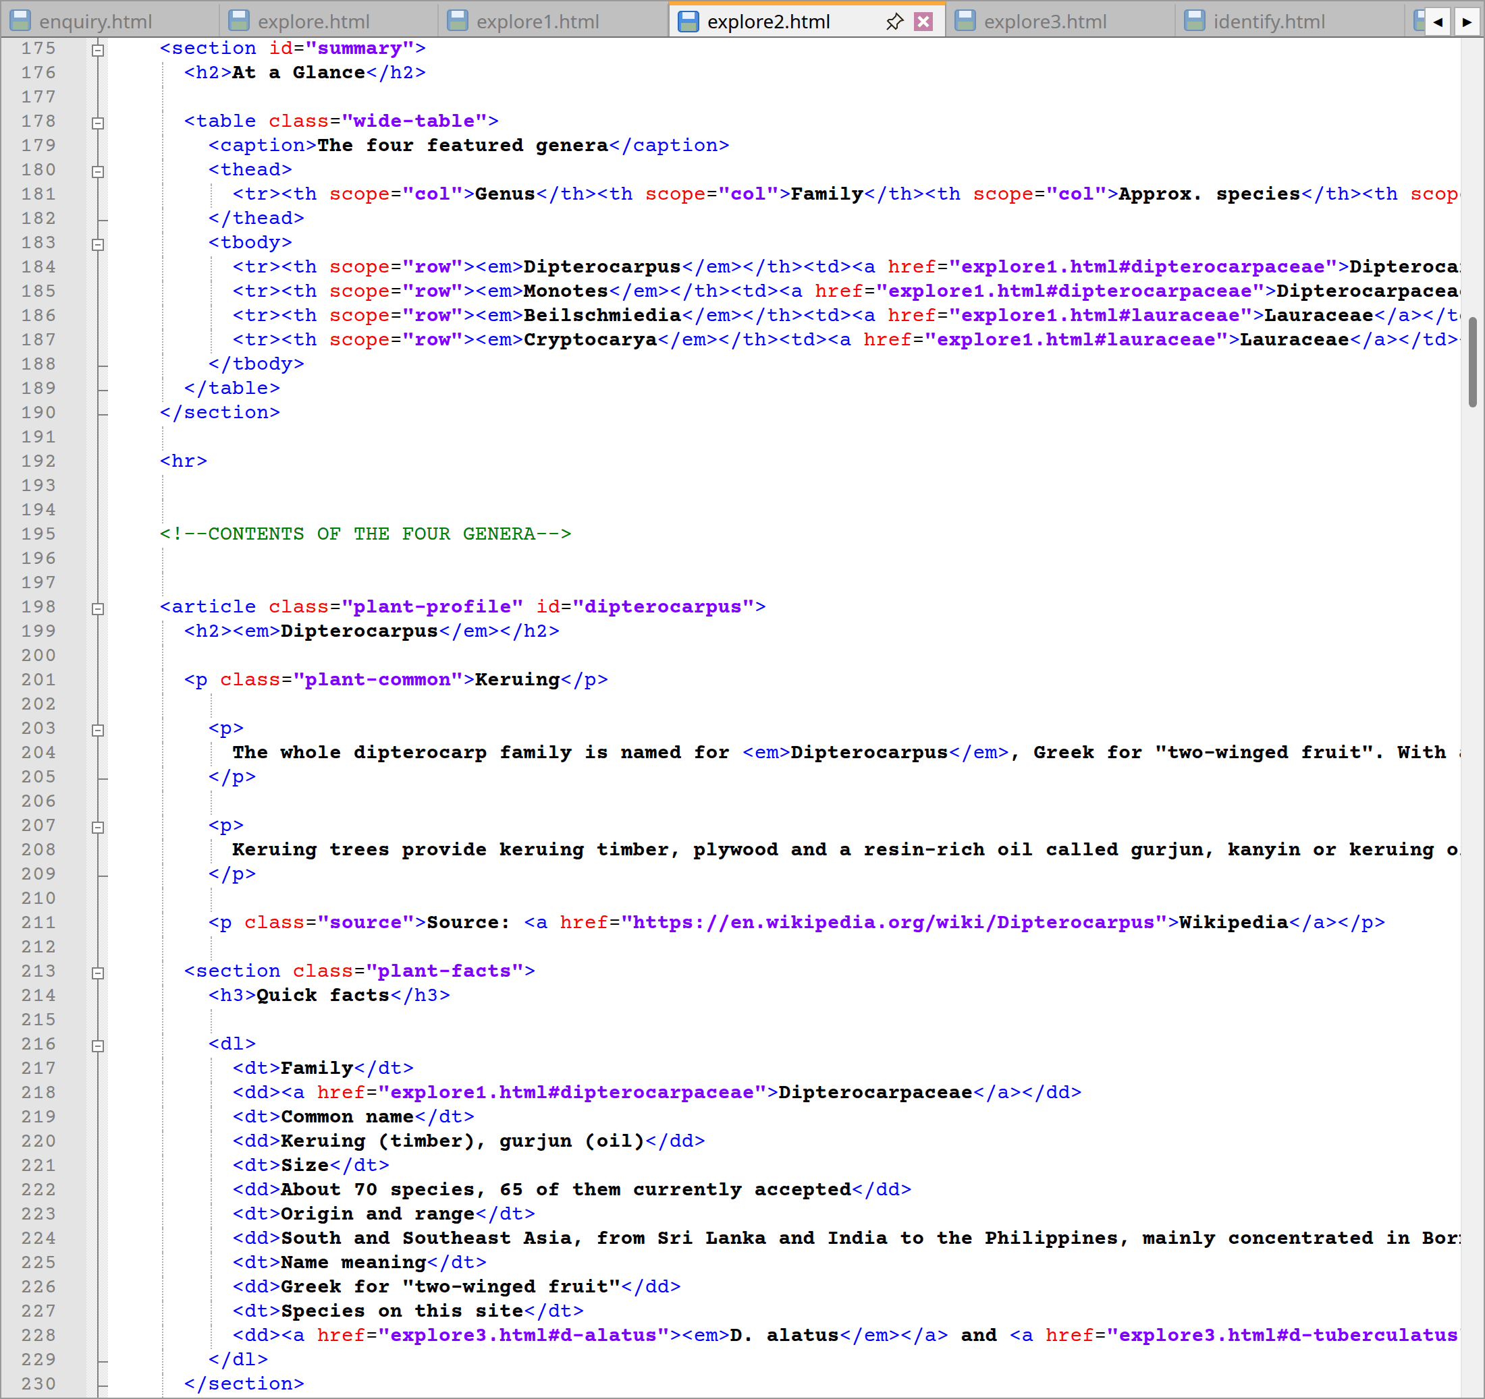
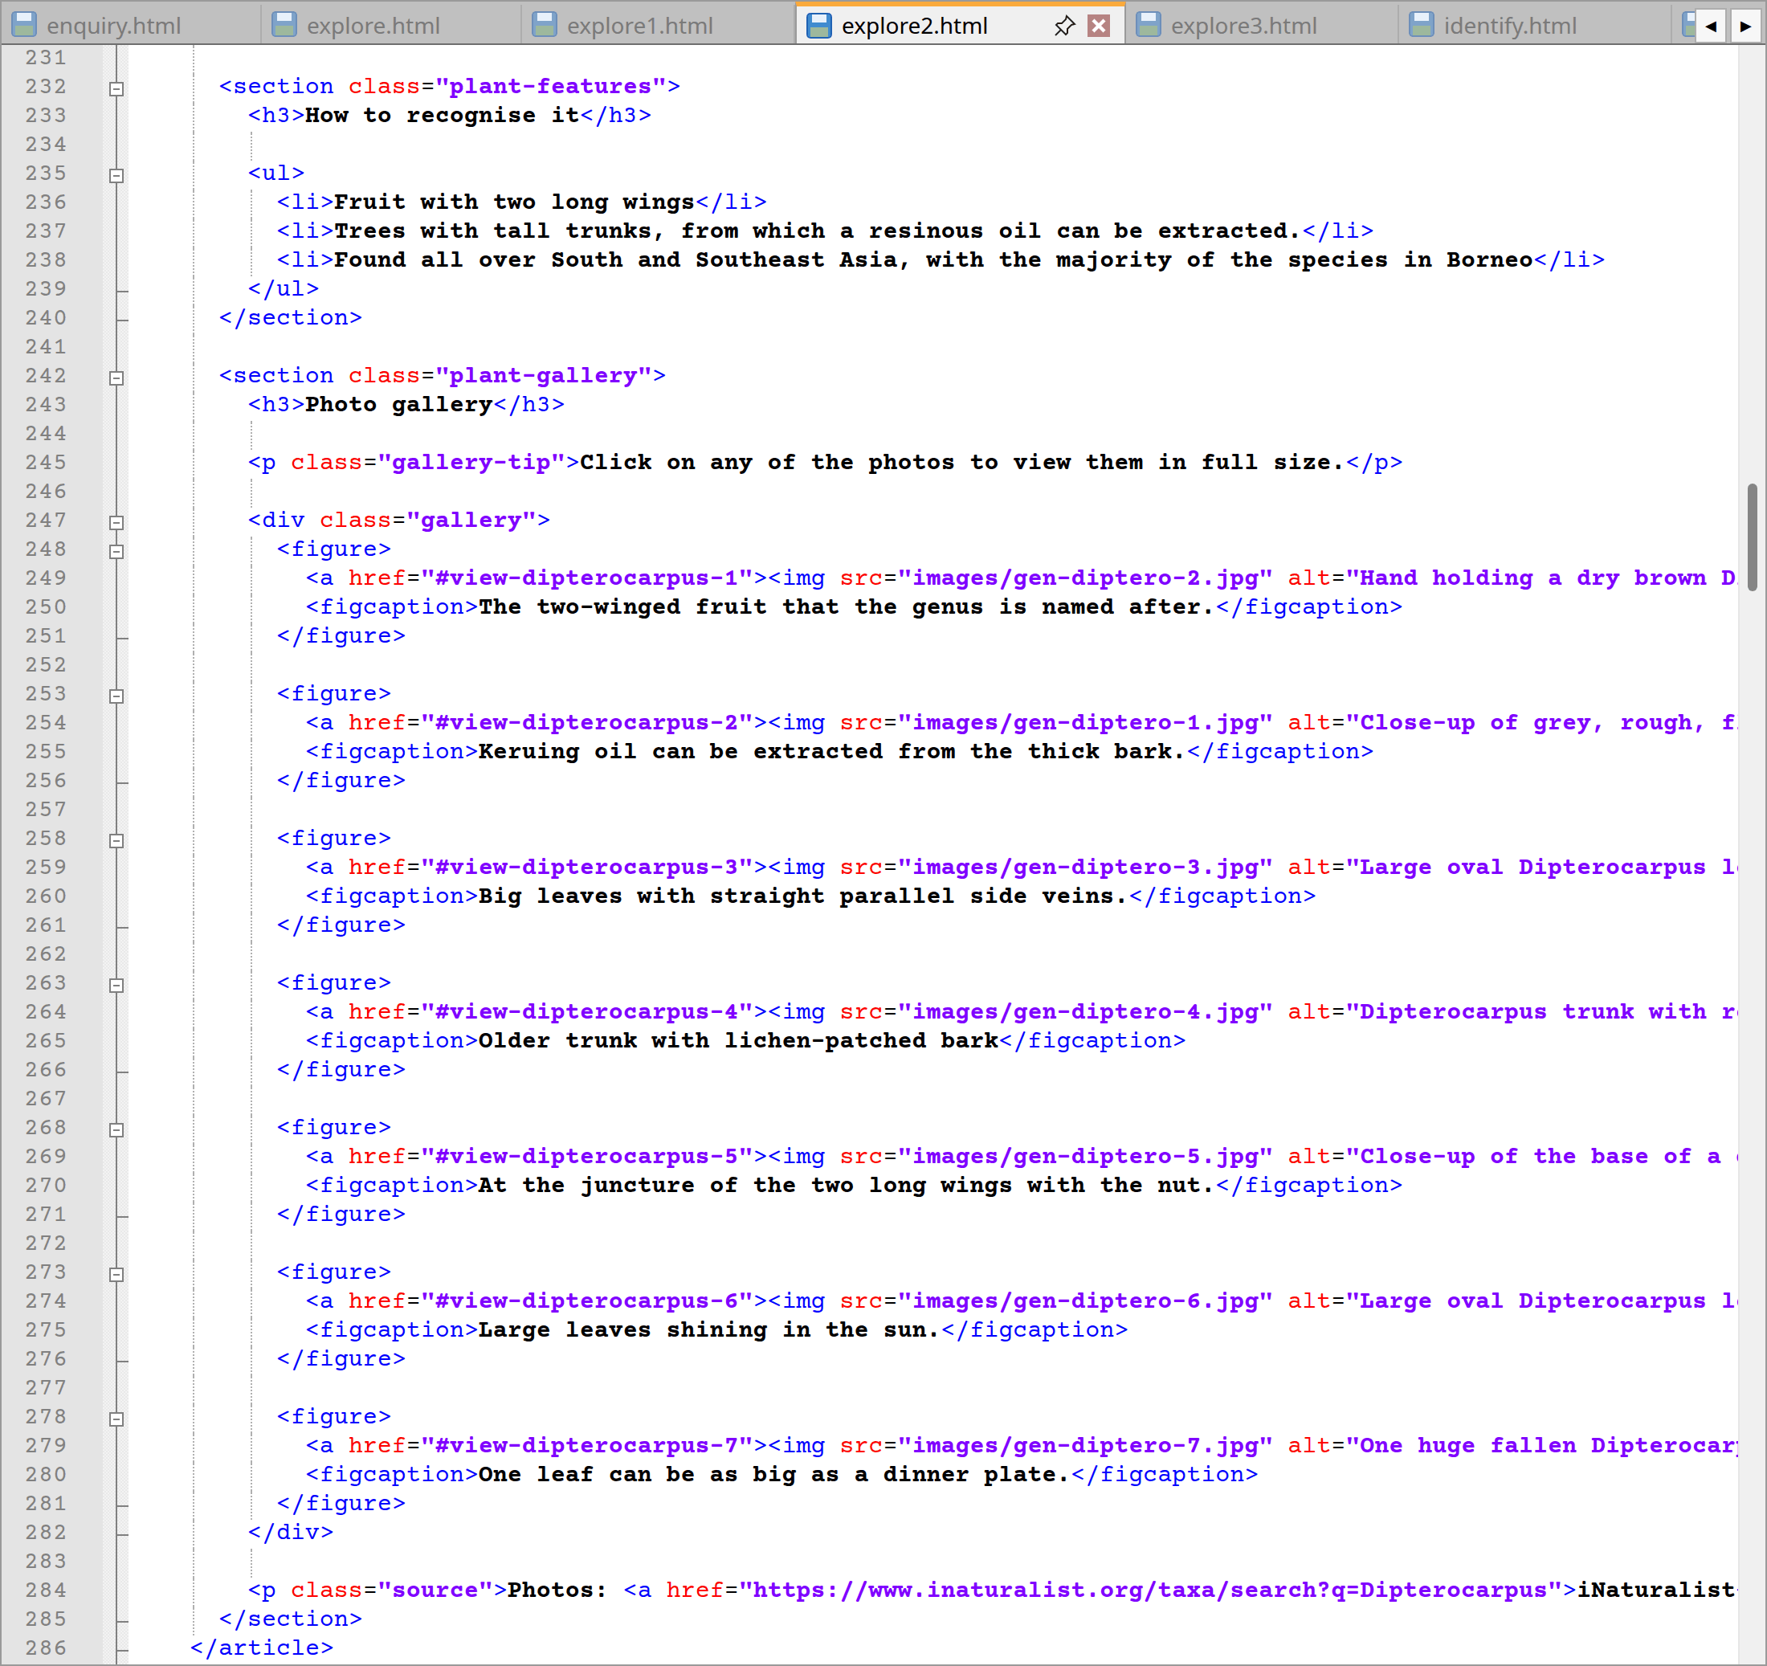
explore2.html code lines from 175 to 286
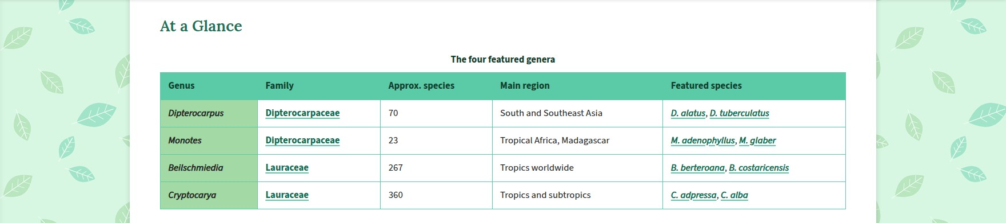
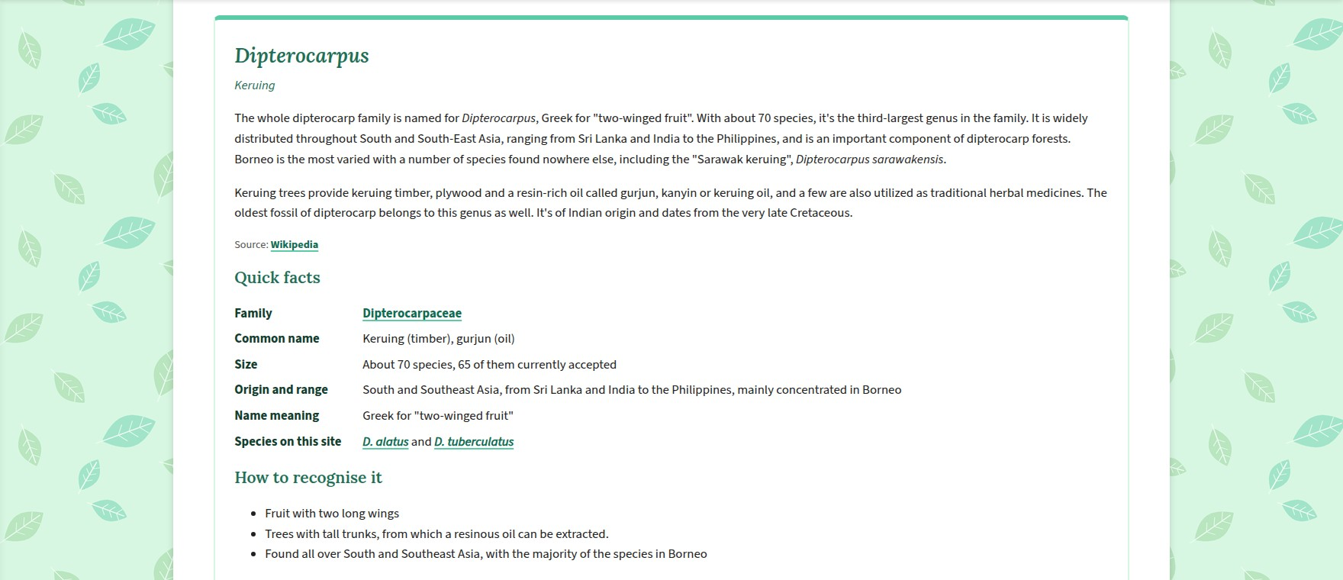
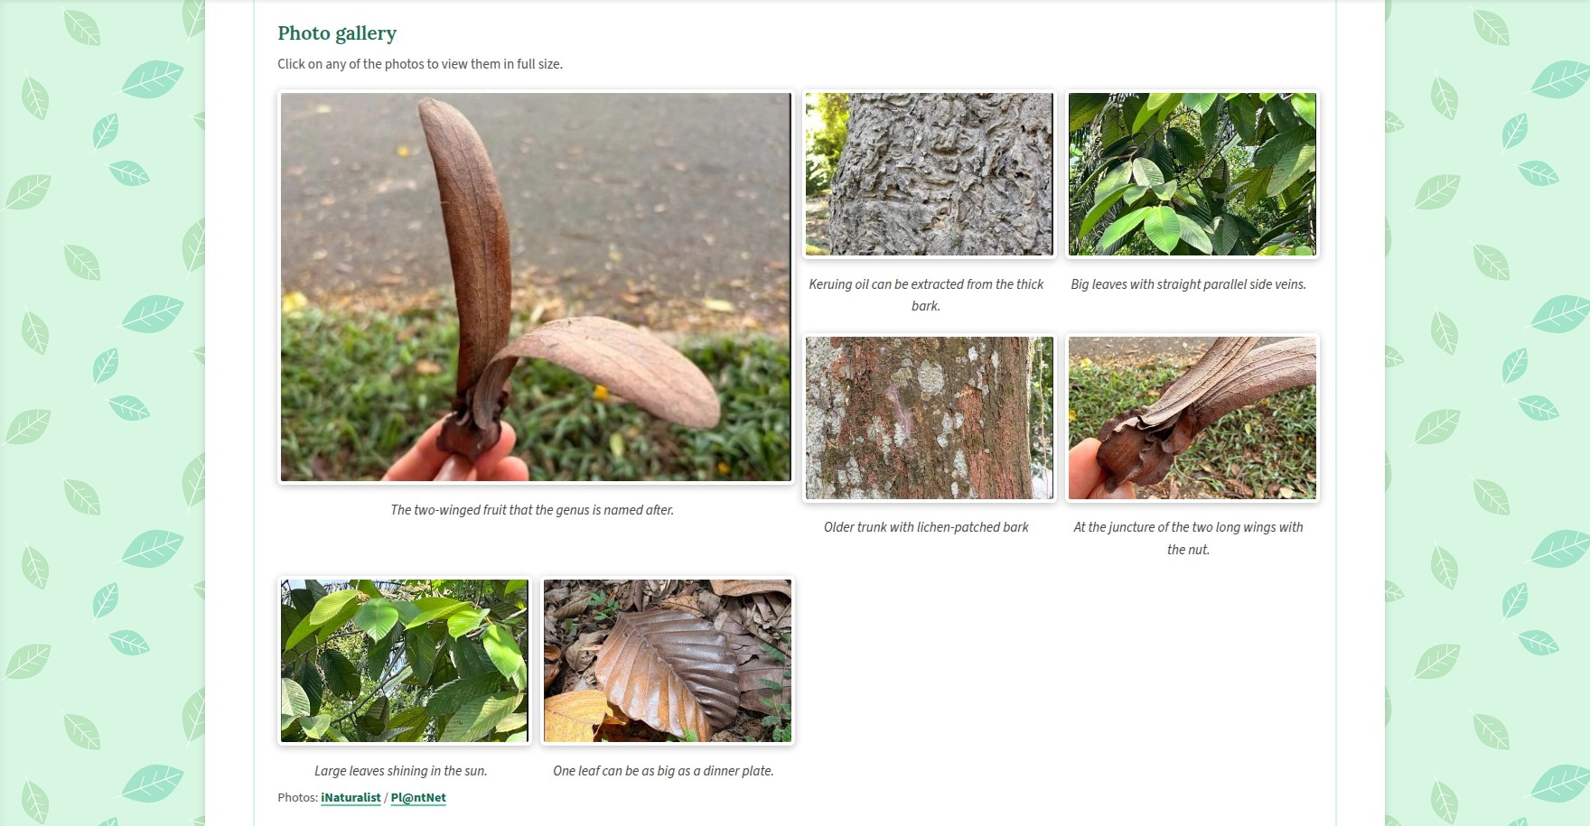
Website: Genera page table and Dipterocarpus profile
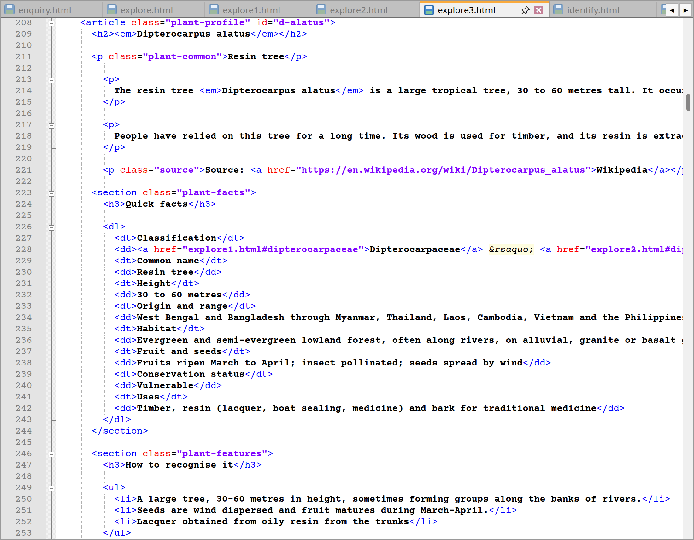
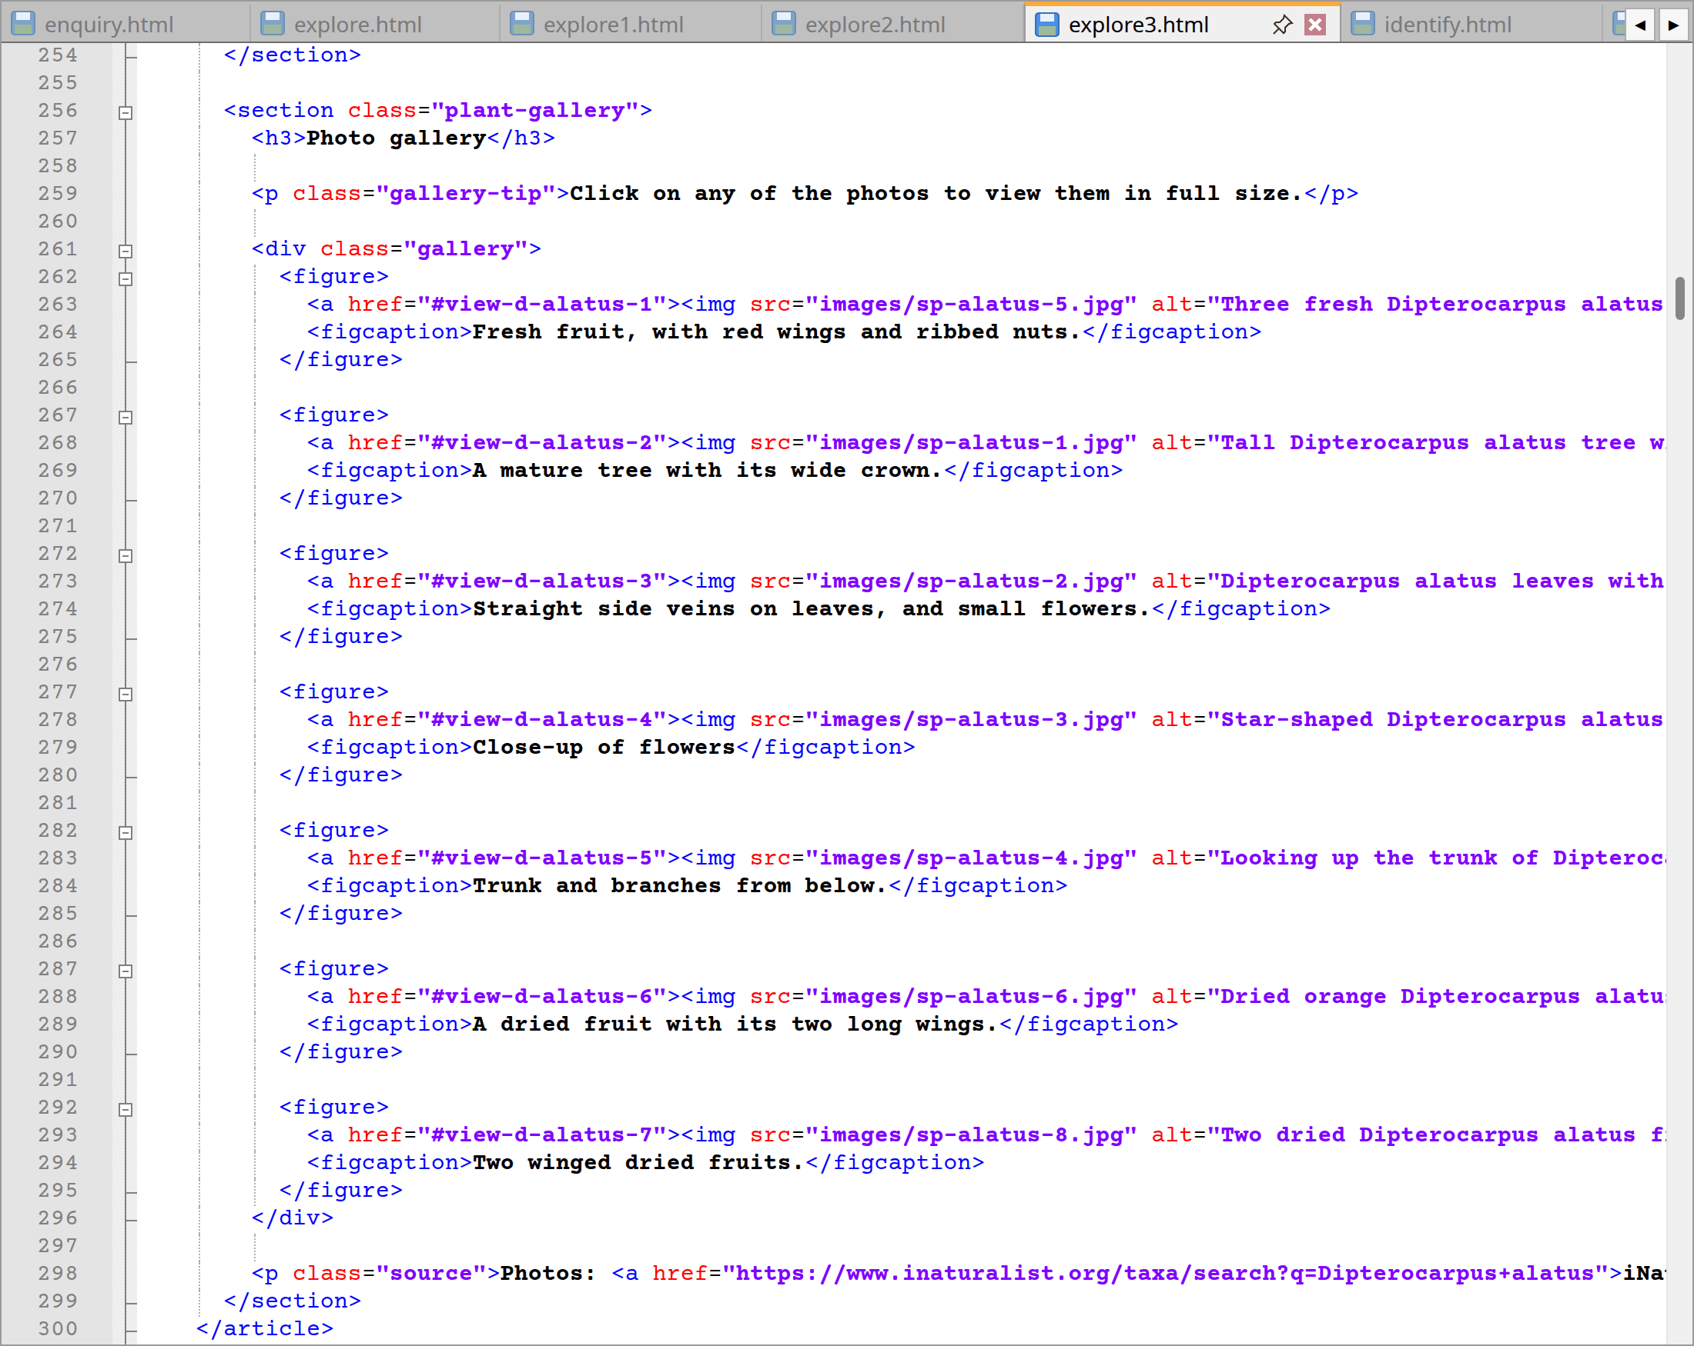
explore3.html code lines from 208 to 300
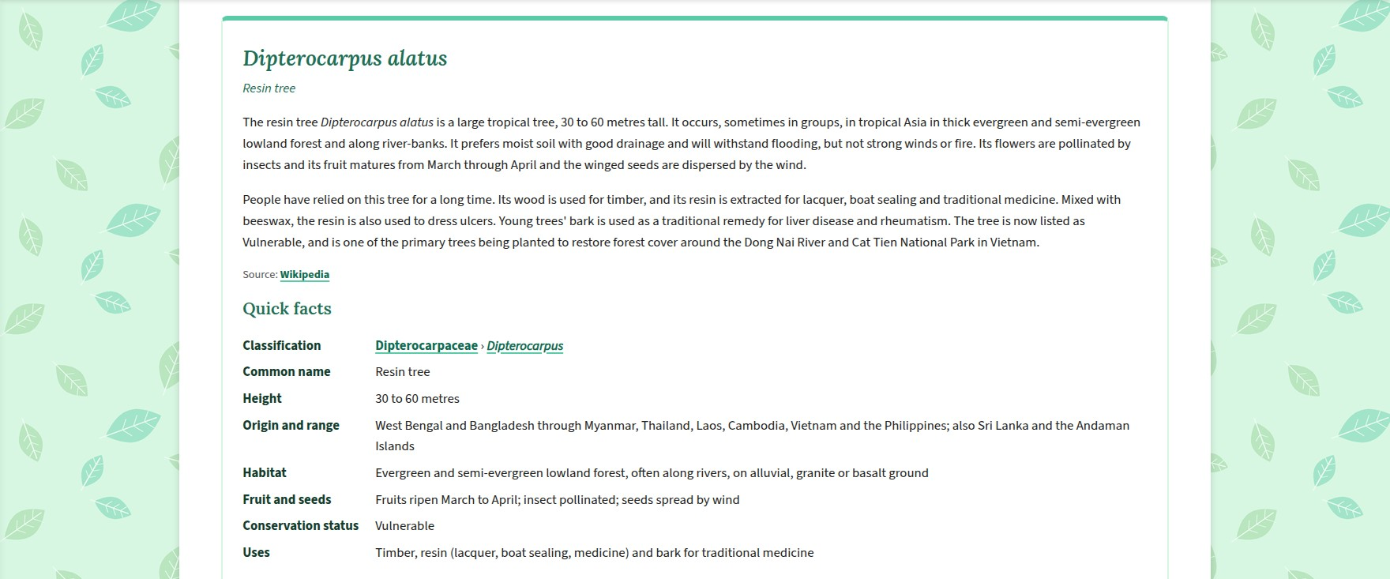
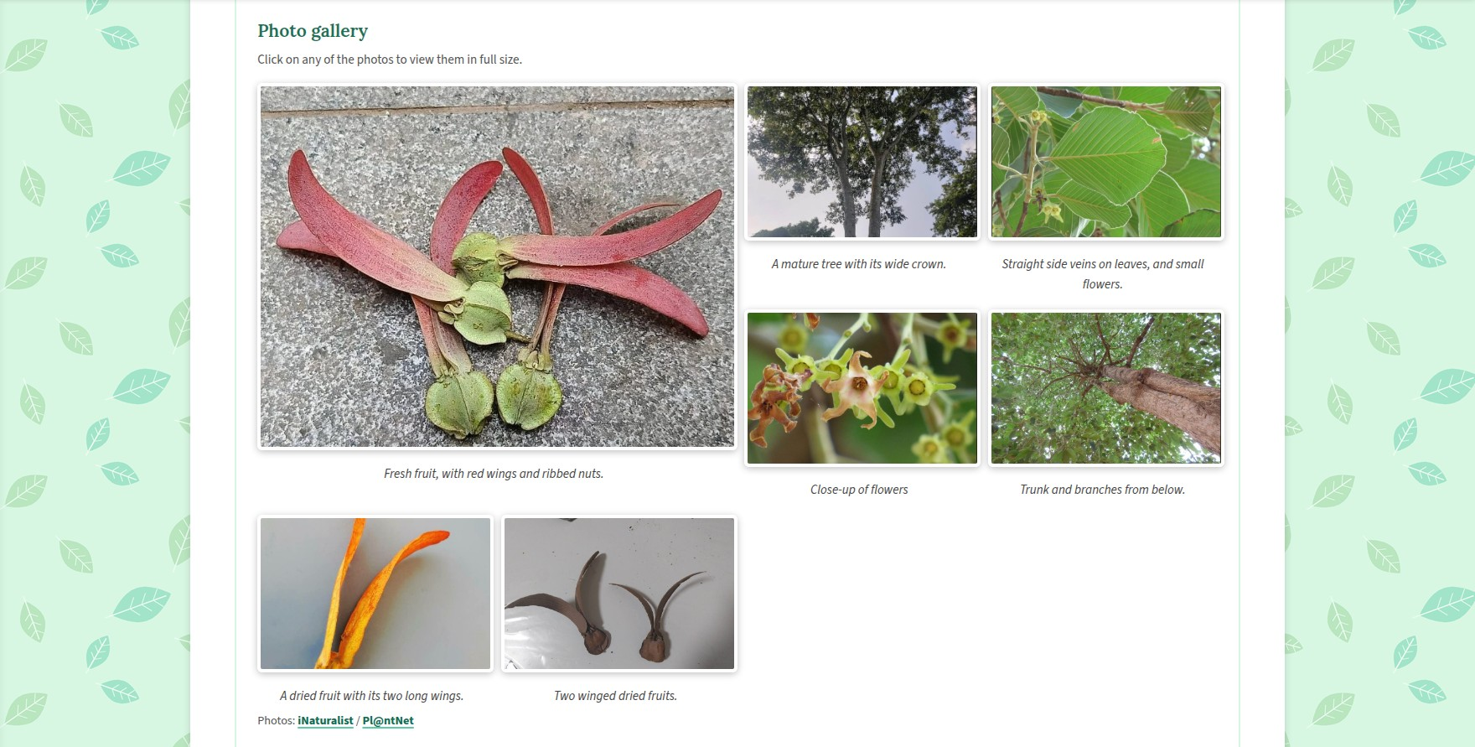
Website: Dipterocarpus alatus profile
Lines | Explanation
explore2.html 117–190 | Next up I turn on to Table 7 (explore2.html, 117-190), the breadcrumb and <h1> “Plant Genera” are accompanied by a side note on how some of these are named after people maybe it to honour a scientist or simply to describe the plant. An intro with jump links is followed by the “Four Questions to Identify the Genus” and an At a Glance table running through the 4 genera, their region, number of species and so forth.
explore2.html 198–556 | Again, if I look further down from line 198 to 556, the four <article class="plant-profile"> for Dipterocarpus, Monotes, Beilschmiedia and Cryptocarya can be found here. The quick facts there to provide the genus name’s meaning and a link to the species and family in question.
explore2.html 562–767 | Moreover, the lightboxes and a pager with genera marked as current come after (from the lines 562 to 767).
explore3.html 118–200 | Finally, explore3.html (from lines 118 to 200) has the breadcrumb and <h1> “Plant Species”. A side note on “Protecting Species” makes reference to the IUCN Red List and provides a link to the contribution form. Next comes the intro jump links for all 8 species, along with a 5-step field guide and an At a Glance table covering them.
explore3.html 208–931 | The site then presents eight species articles, running from Dipterocarpus alatus (from the lines 208 to 300) to Cryptocarya alba (from lines 841 to 931). Each of them has a quick facts list; the opening “Classification” line is a link to the relevant family and genus, while the remainder of the list details the species’ height, range, habitat, conservation status, uses and so on, as applicable.
explore3.html 937–1331 | After the lightboxes for the species pictures, one finds the pager. Being the most extensive part of the site, it is why the menu bar is fixed to the top of the page.
Extra | As per convention in biology, scientific names are set in <em> to render in italics. The header, footer and menus are the same as in Section 2.1.

2.5 Identify page (identify.html)
Here a visitor can see what information is available to put a name to the plant that they have photographed. Additionally, the page displays both the forms to be completed and an illustration of the kind of response to expect.
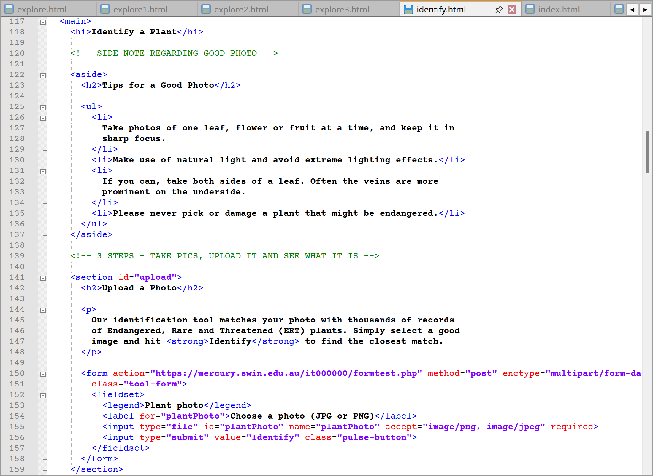
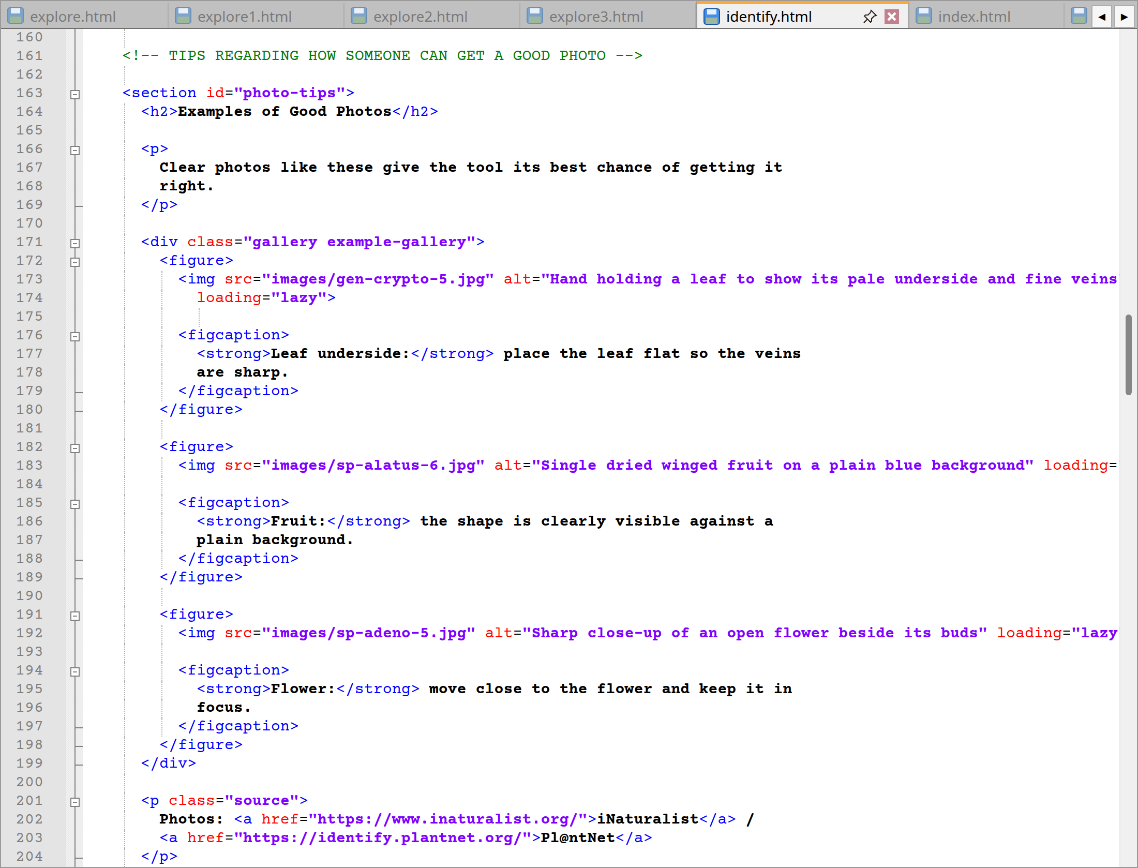
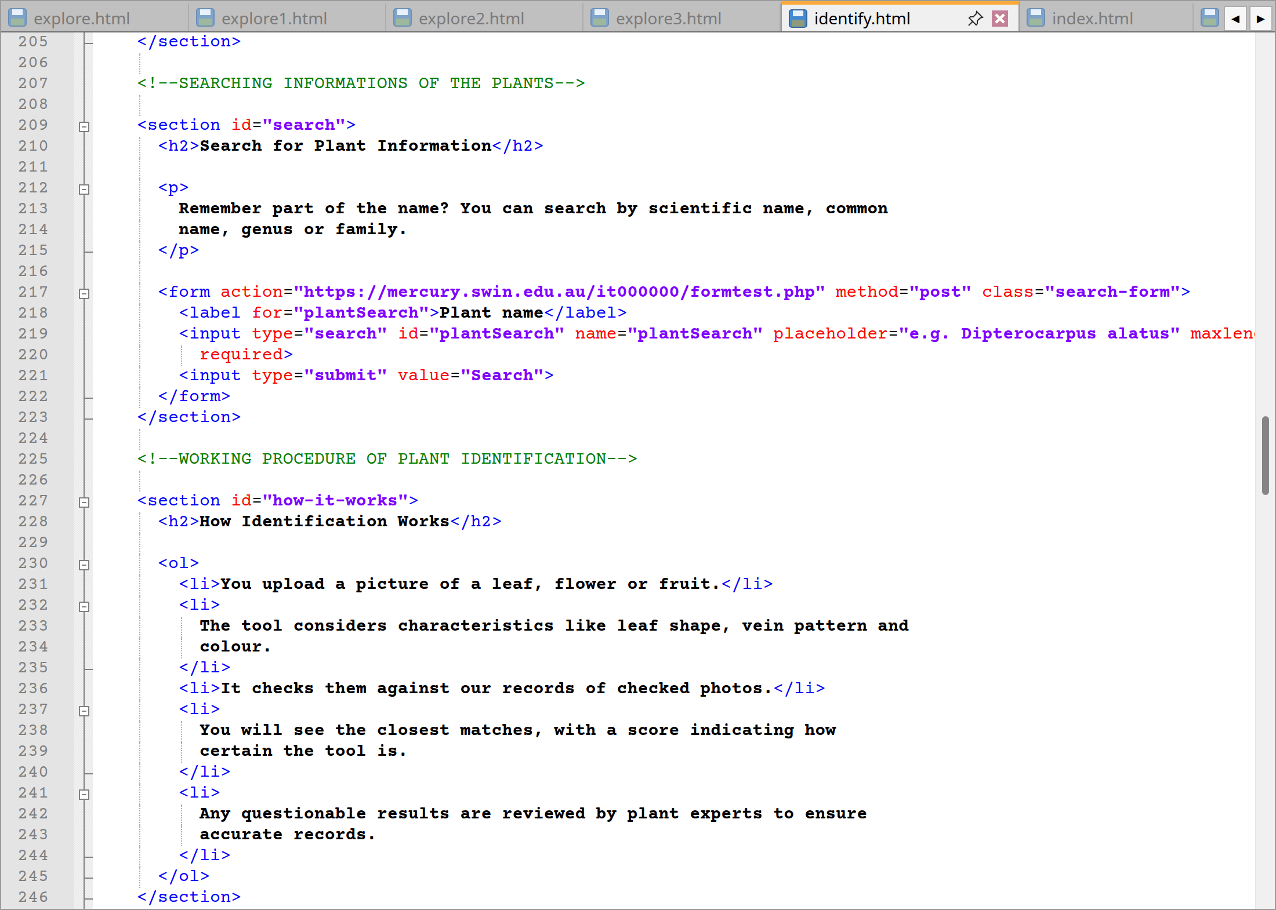
identify.html code lines from 117 to 246
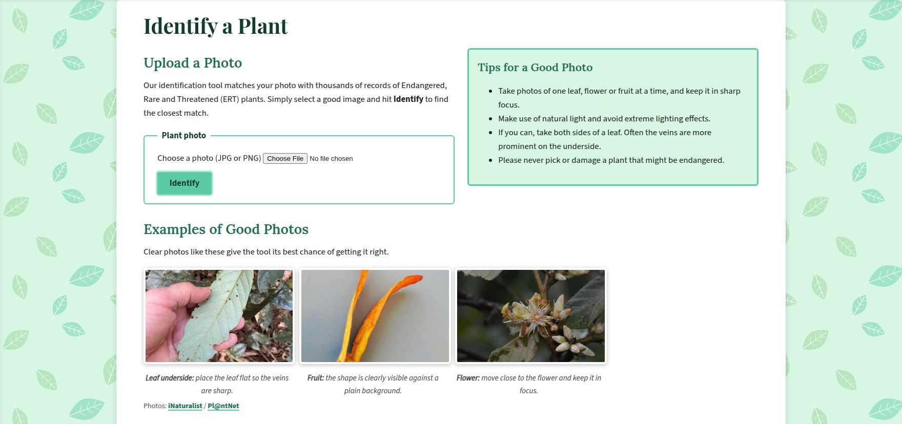

Website: Identify page upload, examples and search
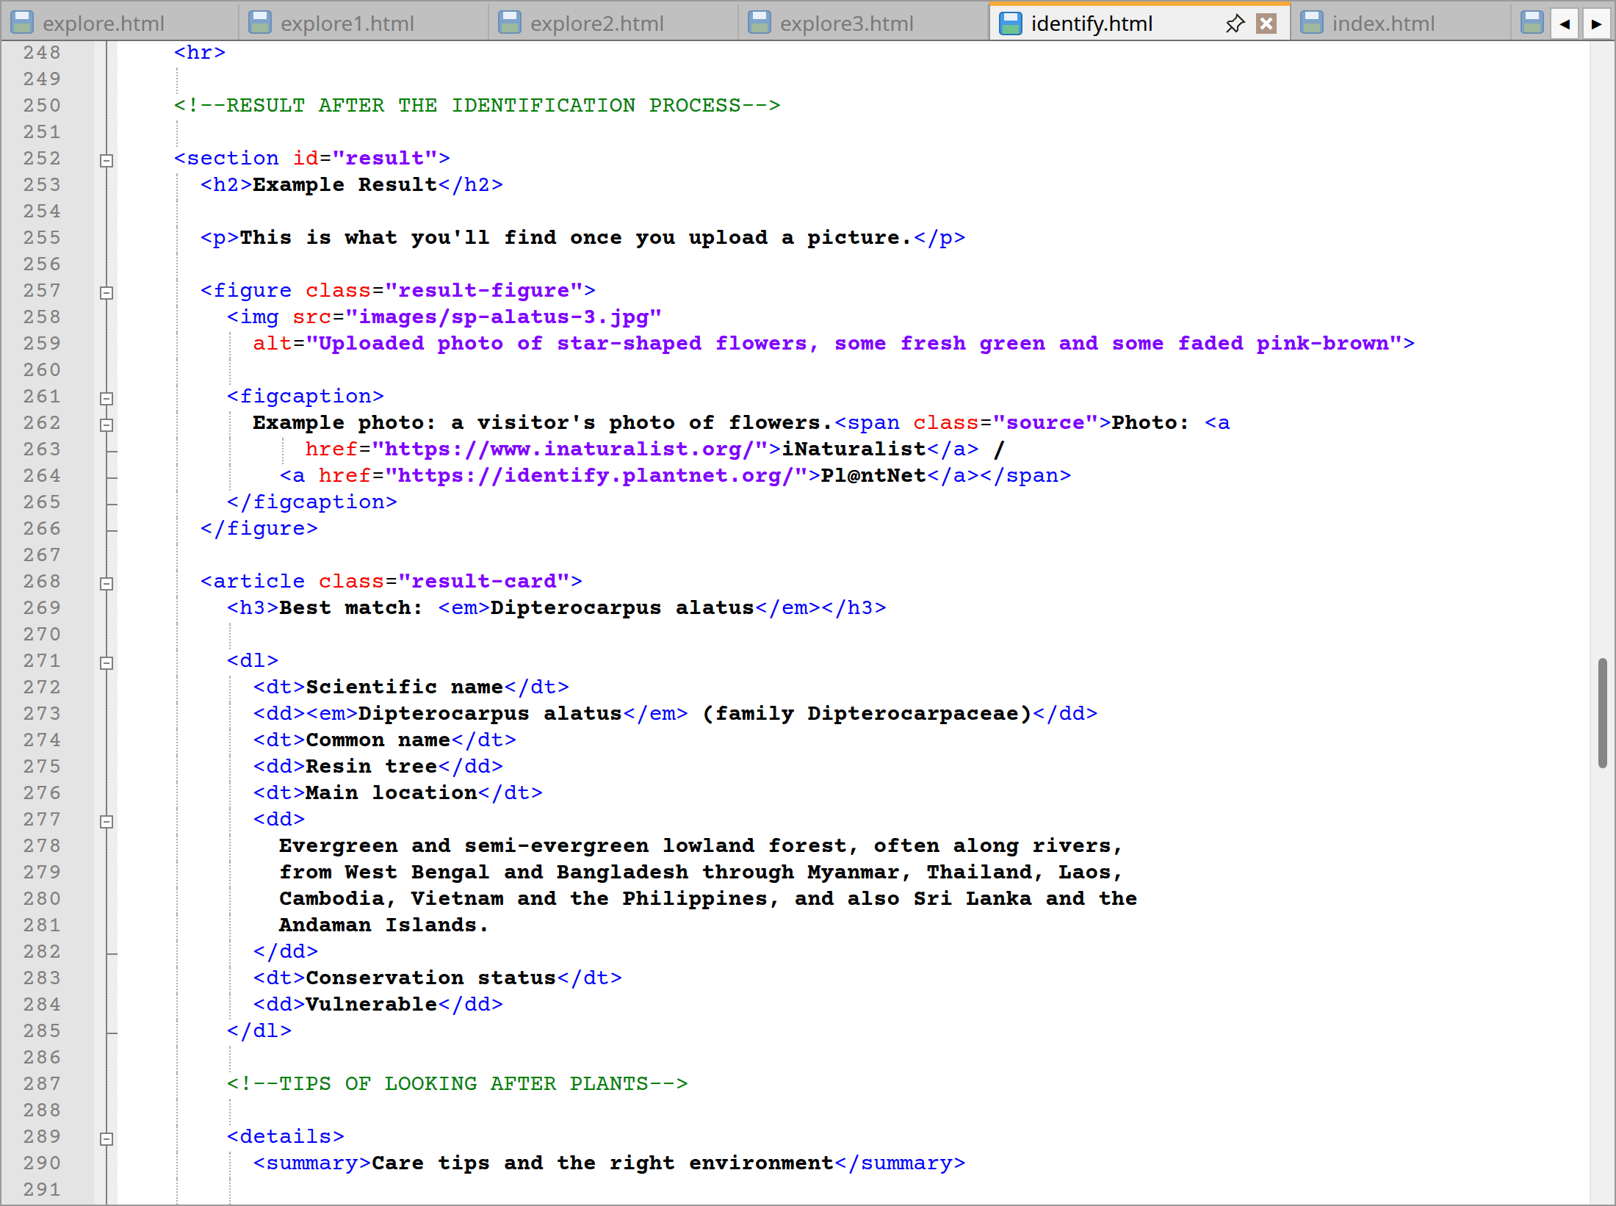
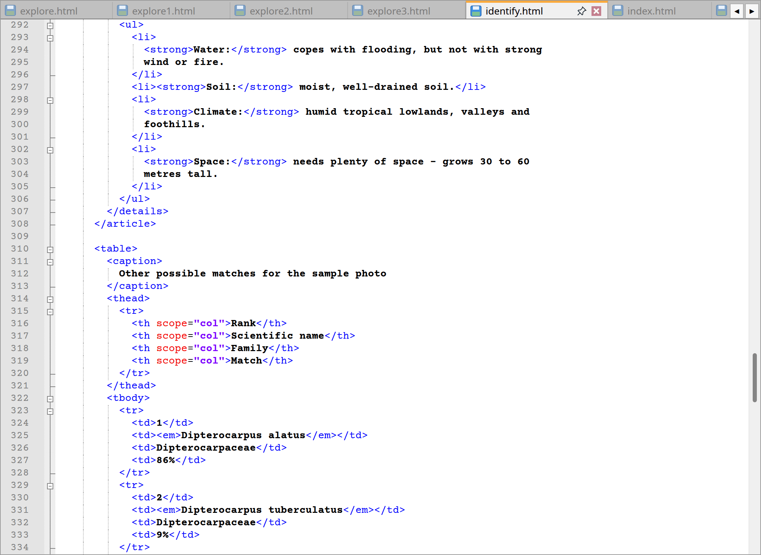
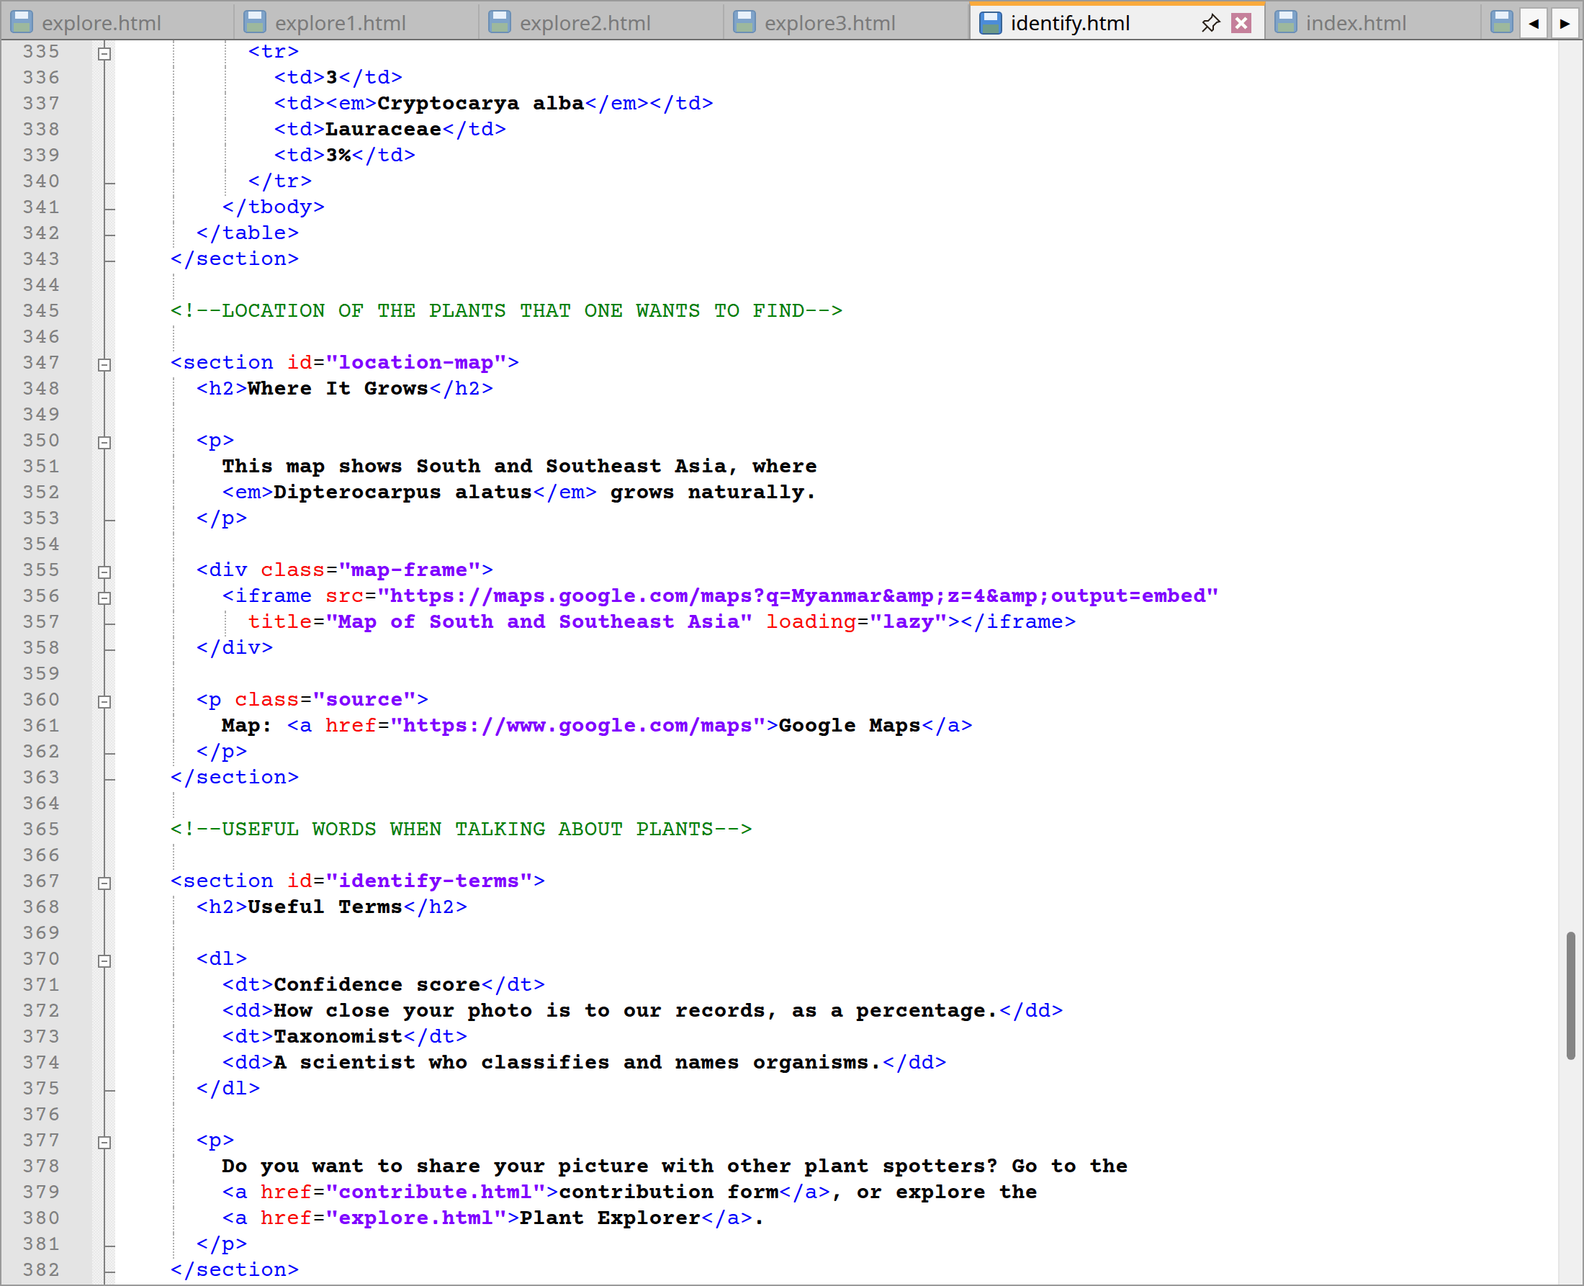
identify.html code lines from 248 to 382
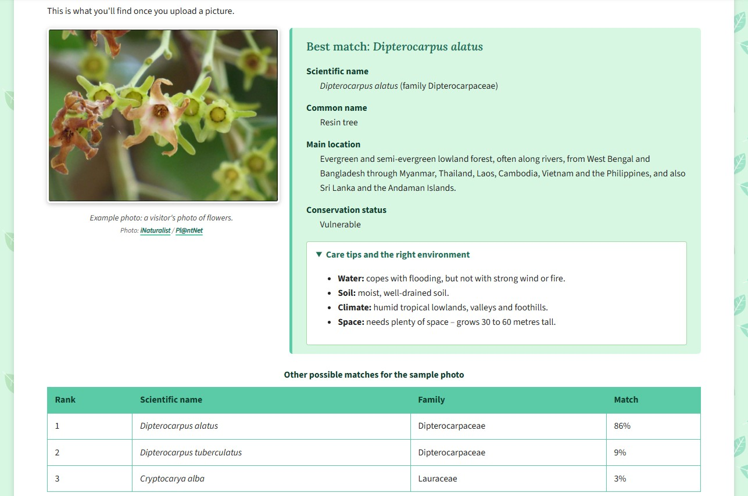
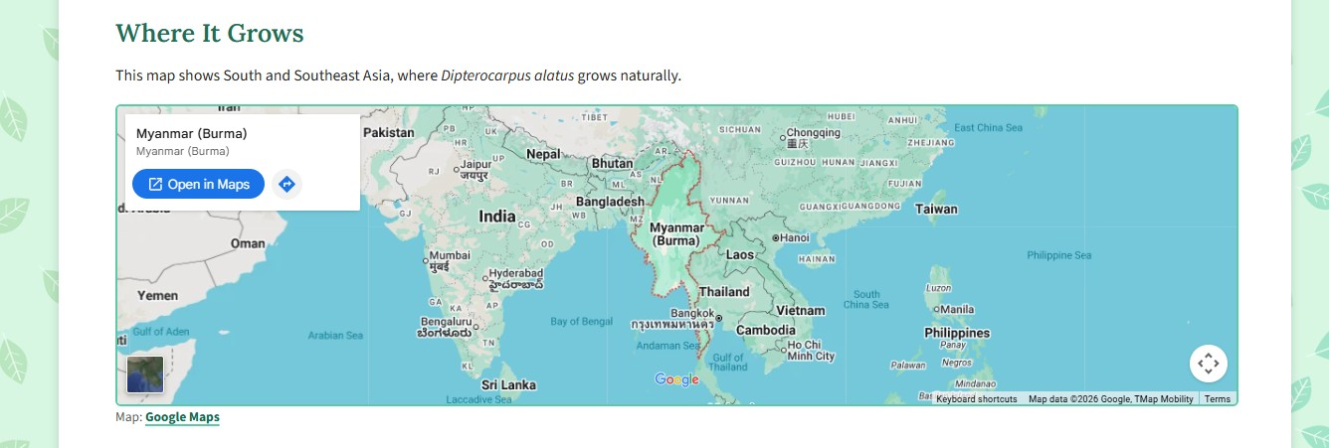
Website: Example result, care tips and map
Lines | Explanation
122–137 | To start, an <aside> with “Tips for a Good Photo” offers four pointers including the use of daylight and not to harm an endangered specimen.
141–159 | The upload form is of the method="post" type with enctype="multipart/form-data" as required for file uploads. A labelled file input within a <fieldset> and <legend> has accept="image/png, image/jpeg" and is marked required which means that the user must select an image and only an image. Additionally, the Identify button is given for the pulse-button class for the CSS effect.
163–205 | Three <figure> elements make up the “Examples of Good Photos” gallery by showing a leaf, fruit and flower with captions to explain their utility.
209–223 | There is also a second form for a name search, complete with a search button and a labelled input that is required and has a maxlength of 40.
227–246 | The process is laid out in an ordered list under “How Identification Works”, five steps from the initial photo upload through to expert verification of any doubtful results.
252–308 | Finally, the example result. The sample photo is in a <figure class="result-figure"> and the top match Dipterocarpus alatus in an <article class="result-card">. One will find a description list (code lines from 271 to 285) for the common and scientific names, location and conservation status. The care tips are hidden away in a <details> element so as not to be seen until the <summary> is clicked.
310–342 | The table provides other potential matches with columns for rank, scientific name and family. The match column applies a confidence score in the form of 86%, 9% or 3%.
347–363 | Under “Where It Grows” a google map is placed in an <iframe> within a <div class="map-frame">. A title is provided for screen readers as for loading, the “lazy” attribute ensures it does not load until the visitor has scrolled near it.
367–382 | “Useful Terms” is a brief description list with links to the explorer and the contribution form.
Extra | Similarly like last time description, Section 2.1 describes the header, menus and footer which are unchanged here too.

2.6 Contributors page (contributor.html)
Serving as my community gallery, this page has a number of features like nine picture cards in sequence, a table to sum up the pictures and their provenance, and a set of steps.
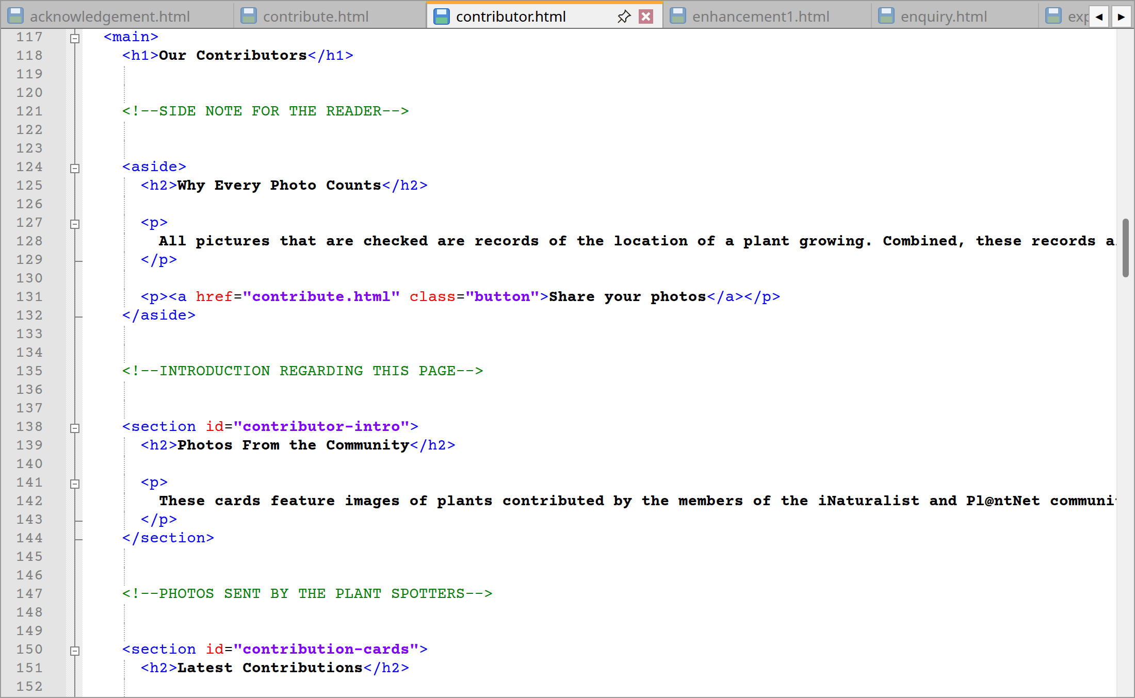
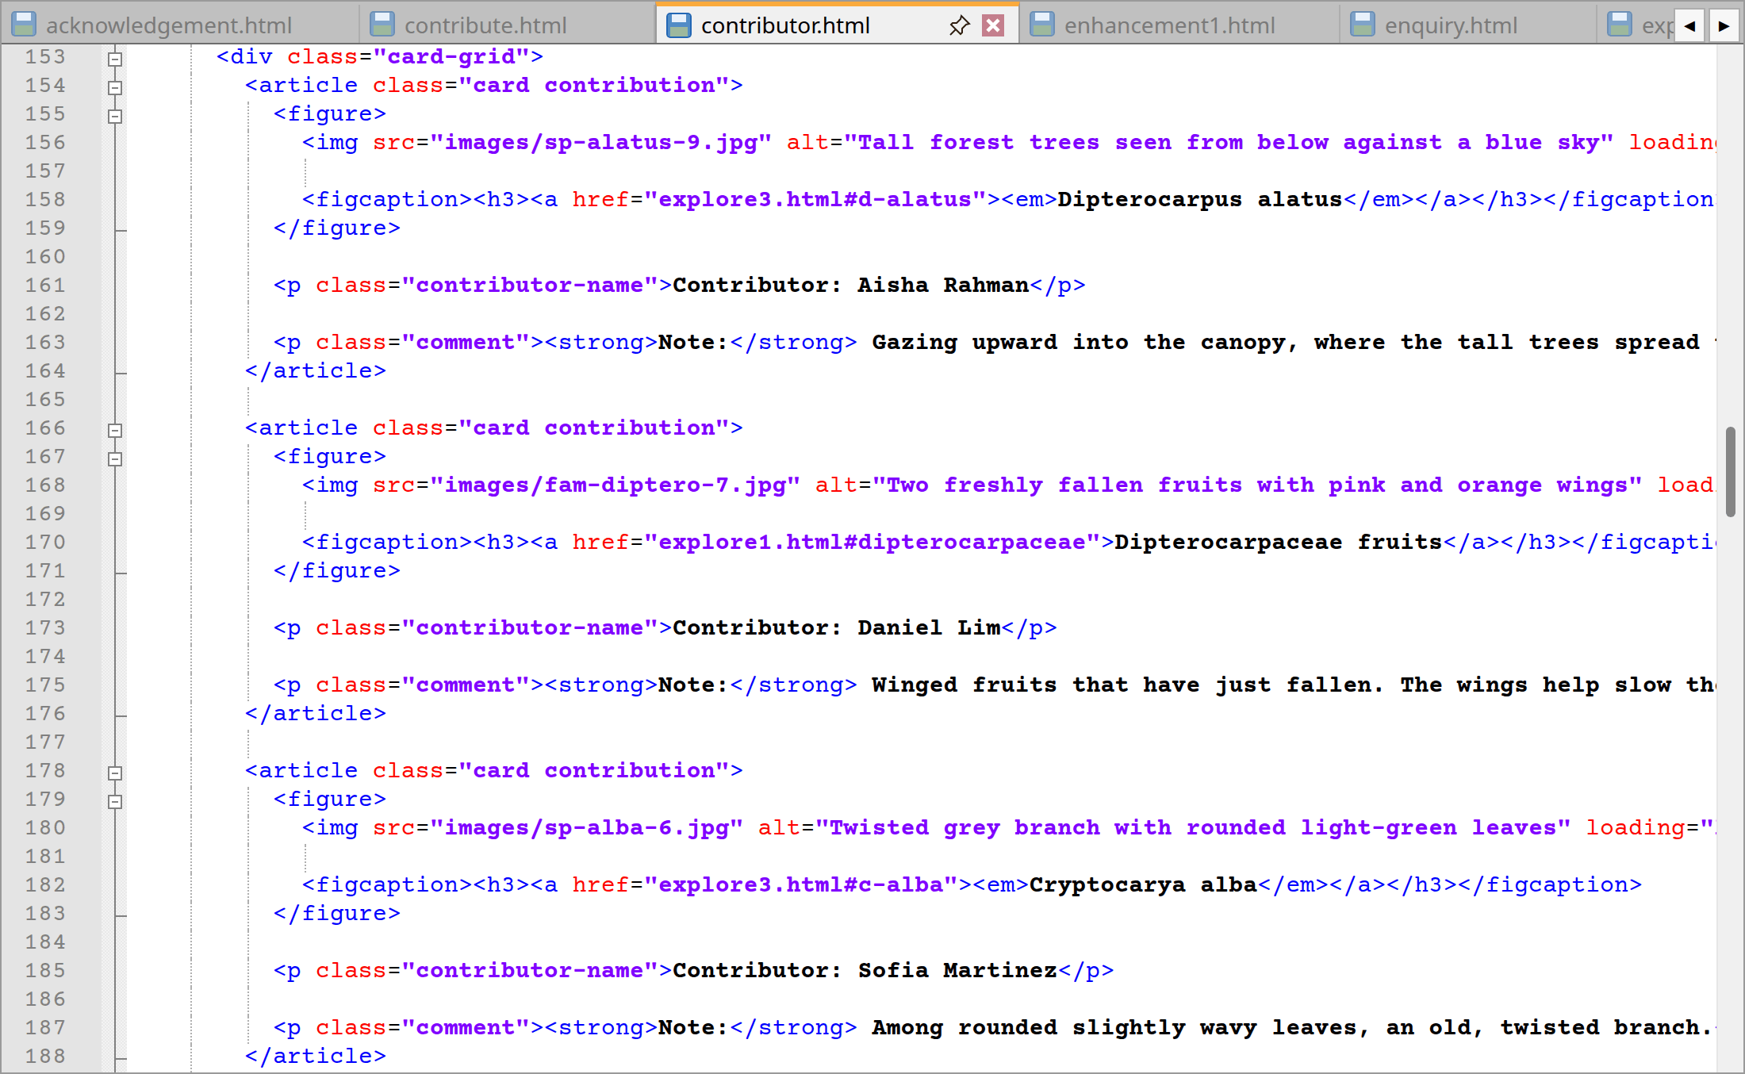
contributor.html code lines from 117 to 188
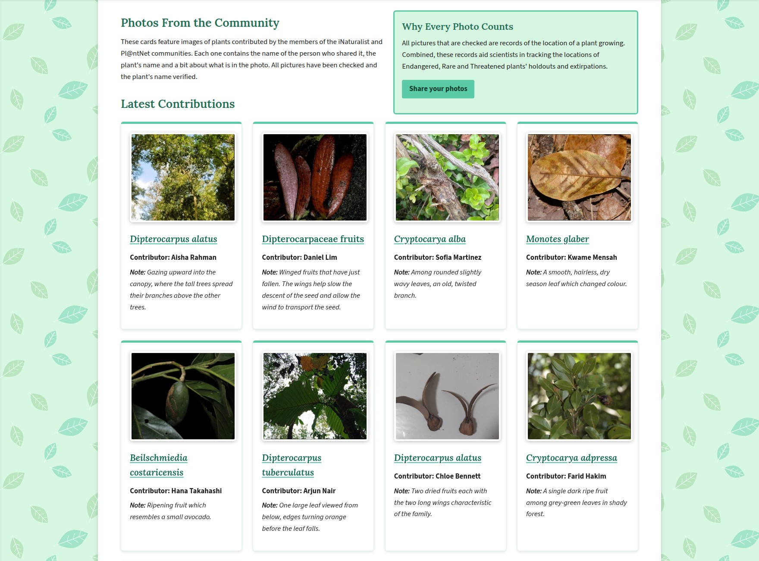
Website: Contributors page cards
Lines | Explanation
124–132 | In the <aside> “Why Every Photo Counts” one can read how scientists make use of the photos to map ERT plants before a link to the contribution form is offered.
138–144 | There is an introduction which makes it plain and simple that the images are from authentic source and come from the iNaturalist and Pl@ntNet.
150–262 | “Latest Contributions” is made up of 9 <article class="card contribution"> elements. They are all put together in the same way so they present well. Inside each is a <figure> with the photo and a <figcaption> where the plant’s name is an <h3> link along with a <p class="contributor-name"> and a <p class="comment"> describing the shot.
270–280 | There is also an ordered list of five under the heading “How a Photo Reaches This Gallery”.
286–295 | A description list for “Where Our Photos Come From” includes what iNaturalist and Pl@ntNet do and links to them.
301–328 | One will find a table of the number of pictures per family and a link to the contribution form.
Extra | Similarly, like last time, the header, menus and footer are same as per Section 2.1.

2.7 Contribute and Enquiry forms (contribute.html, enquiry.html)
These are the forms for visitors to put data into the project. Moreover, they have been made straightforward but also resistant to being filled in incorrectly. Both post to the Swinburne form test page and employ <fieldset> with <legend> for grouping. Every field has a corresponding <label> tied by for and id attributes allowing a click on the label to give focus to the field and be read by a screen reader. The form is not submitted until the information in every field is in order.
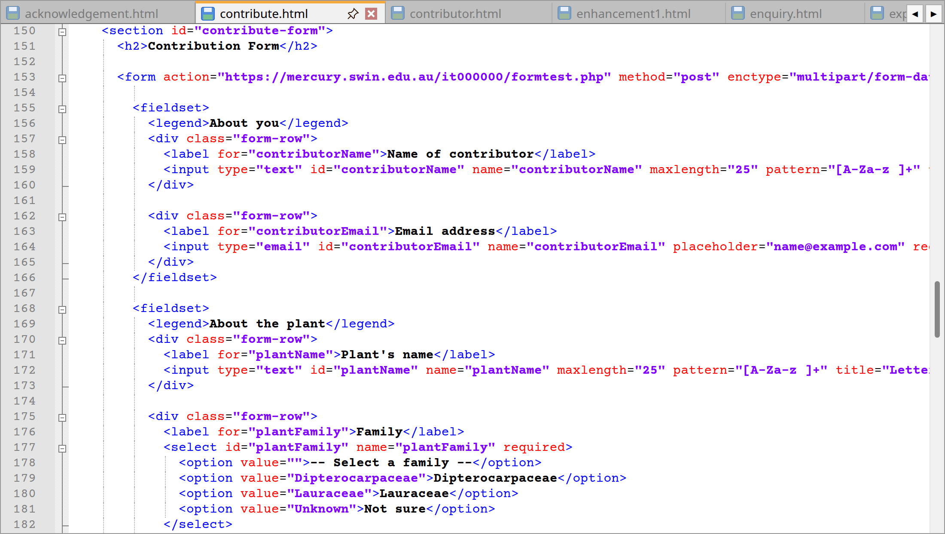
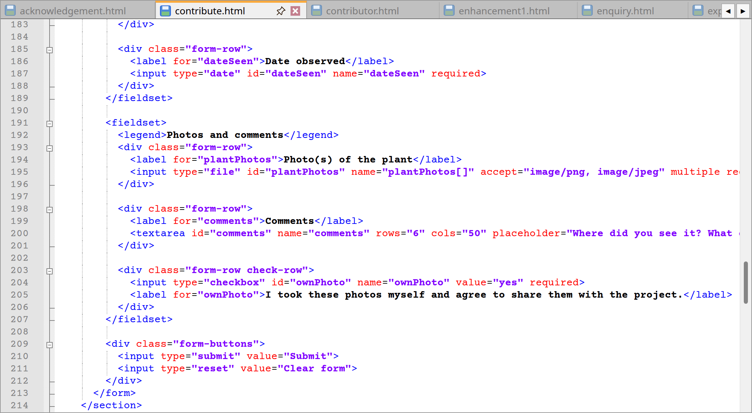
contribute.html code lines from 150 to 214
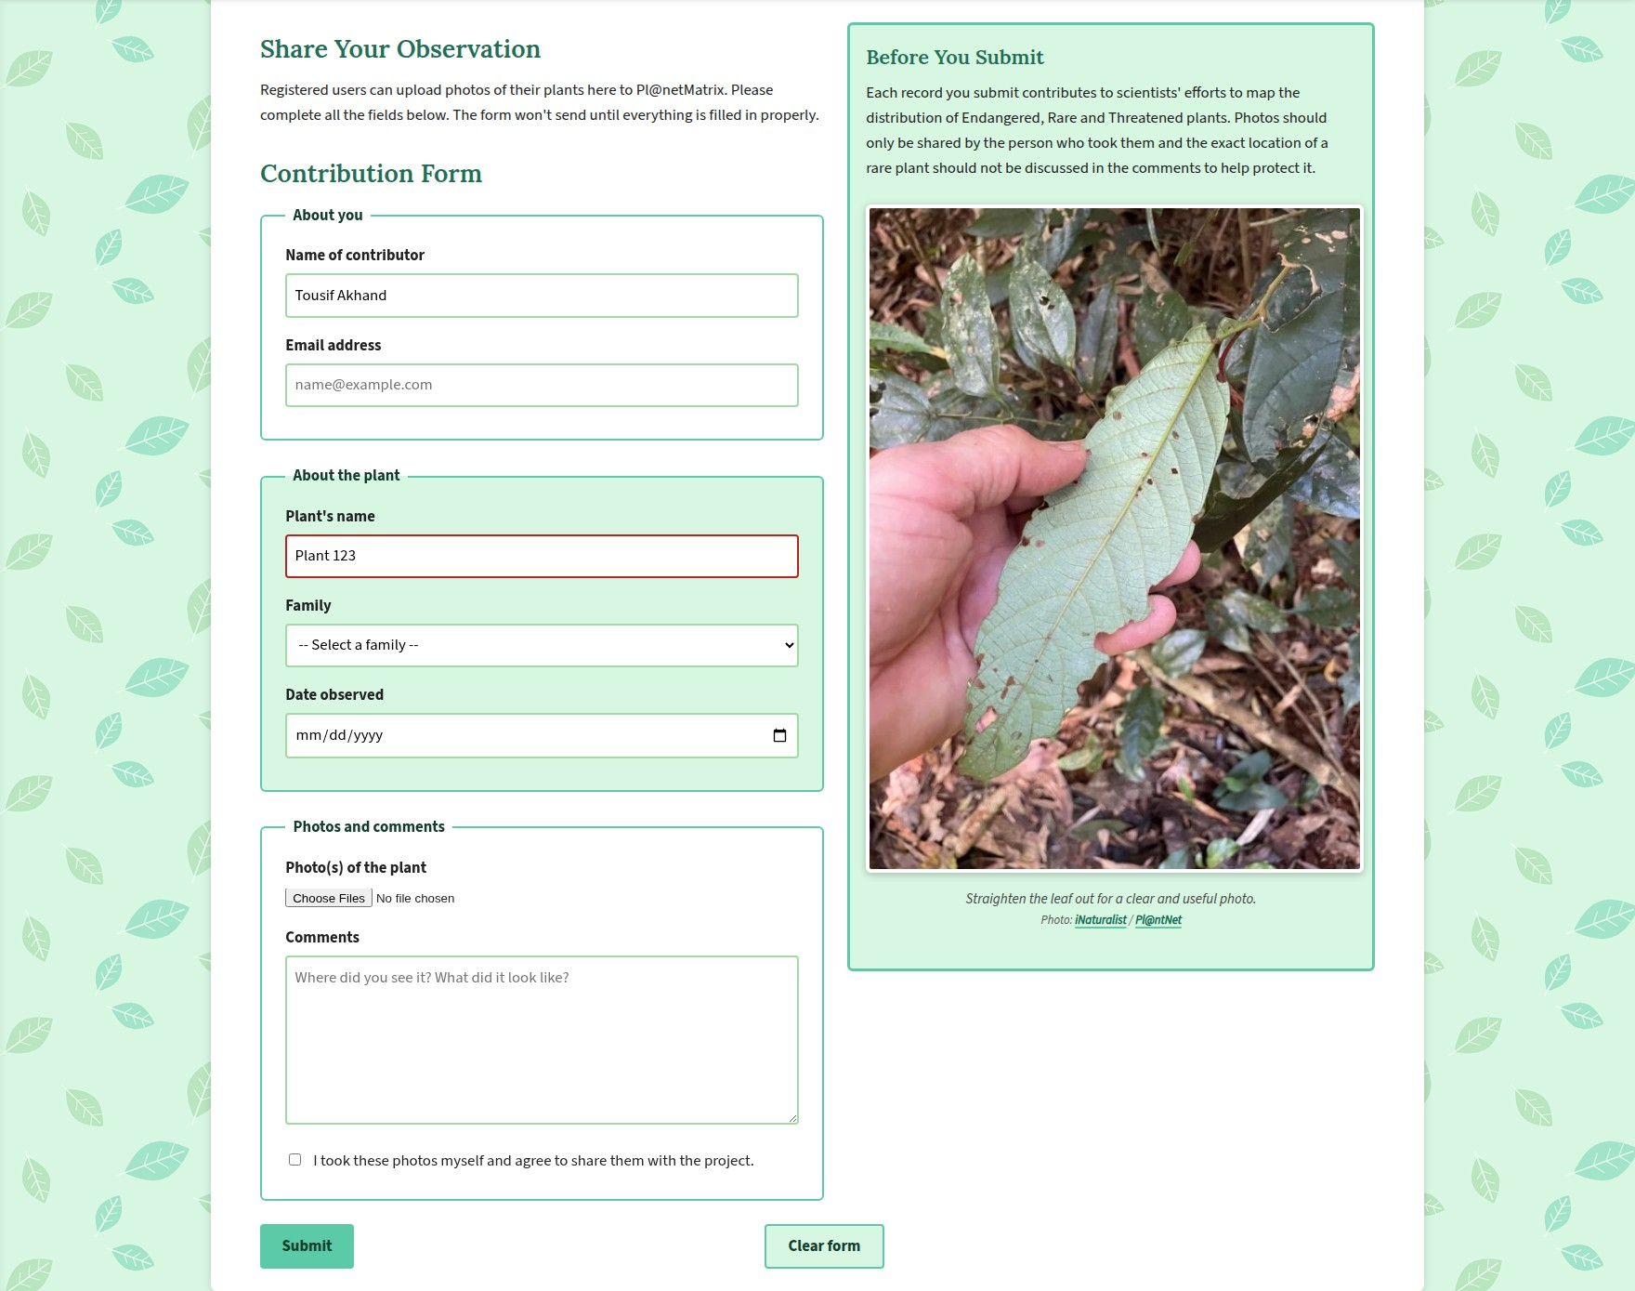
Website: Contribution form
Lines | Explanation
124–136 | Visitors are given some instruction in the <aside> “Before You Submit” to post only their own work and omit the exact location of rare specimens illustrated by a flat leaf.
153 | To get the photo from the form the <form> tag requires method="post" and enctype="multipart/form-data".
155–166 | For “About you”, the contributor’s name is type="text" with a pattern of “[A-Za-z ]+” and maxlength of 25. Should the rule be broken, the title will tell the visitor what is acceptable. The e-mail is type="email" so the browser can verify the format.
168–189 | “About the plant” follows suit for the name. The family is a <select> with required and an empty first option so an actual choice must be made and type="date" on the date observed brings up a calendar.
191–207 | “Photos and comments” have a file input that allows multiple selections, a <textarea> and a required checkbox for the visitor to vouch for the photos.
209–212 | There are two action buttons to clear and submit the data.
Extra | Identical to Section 2.1 for the header, menus and footer.

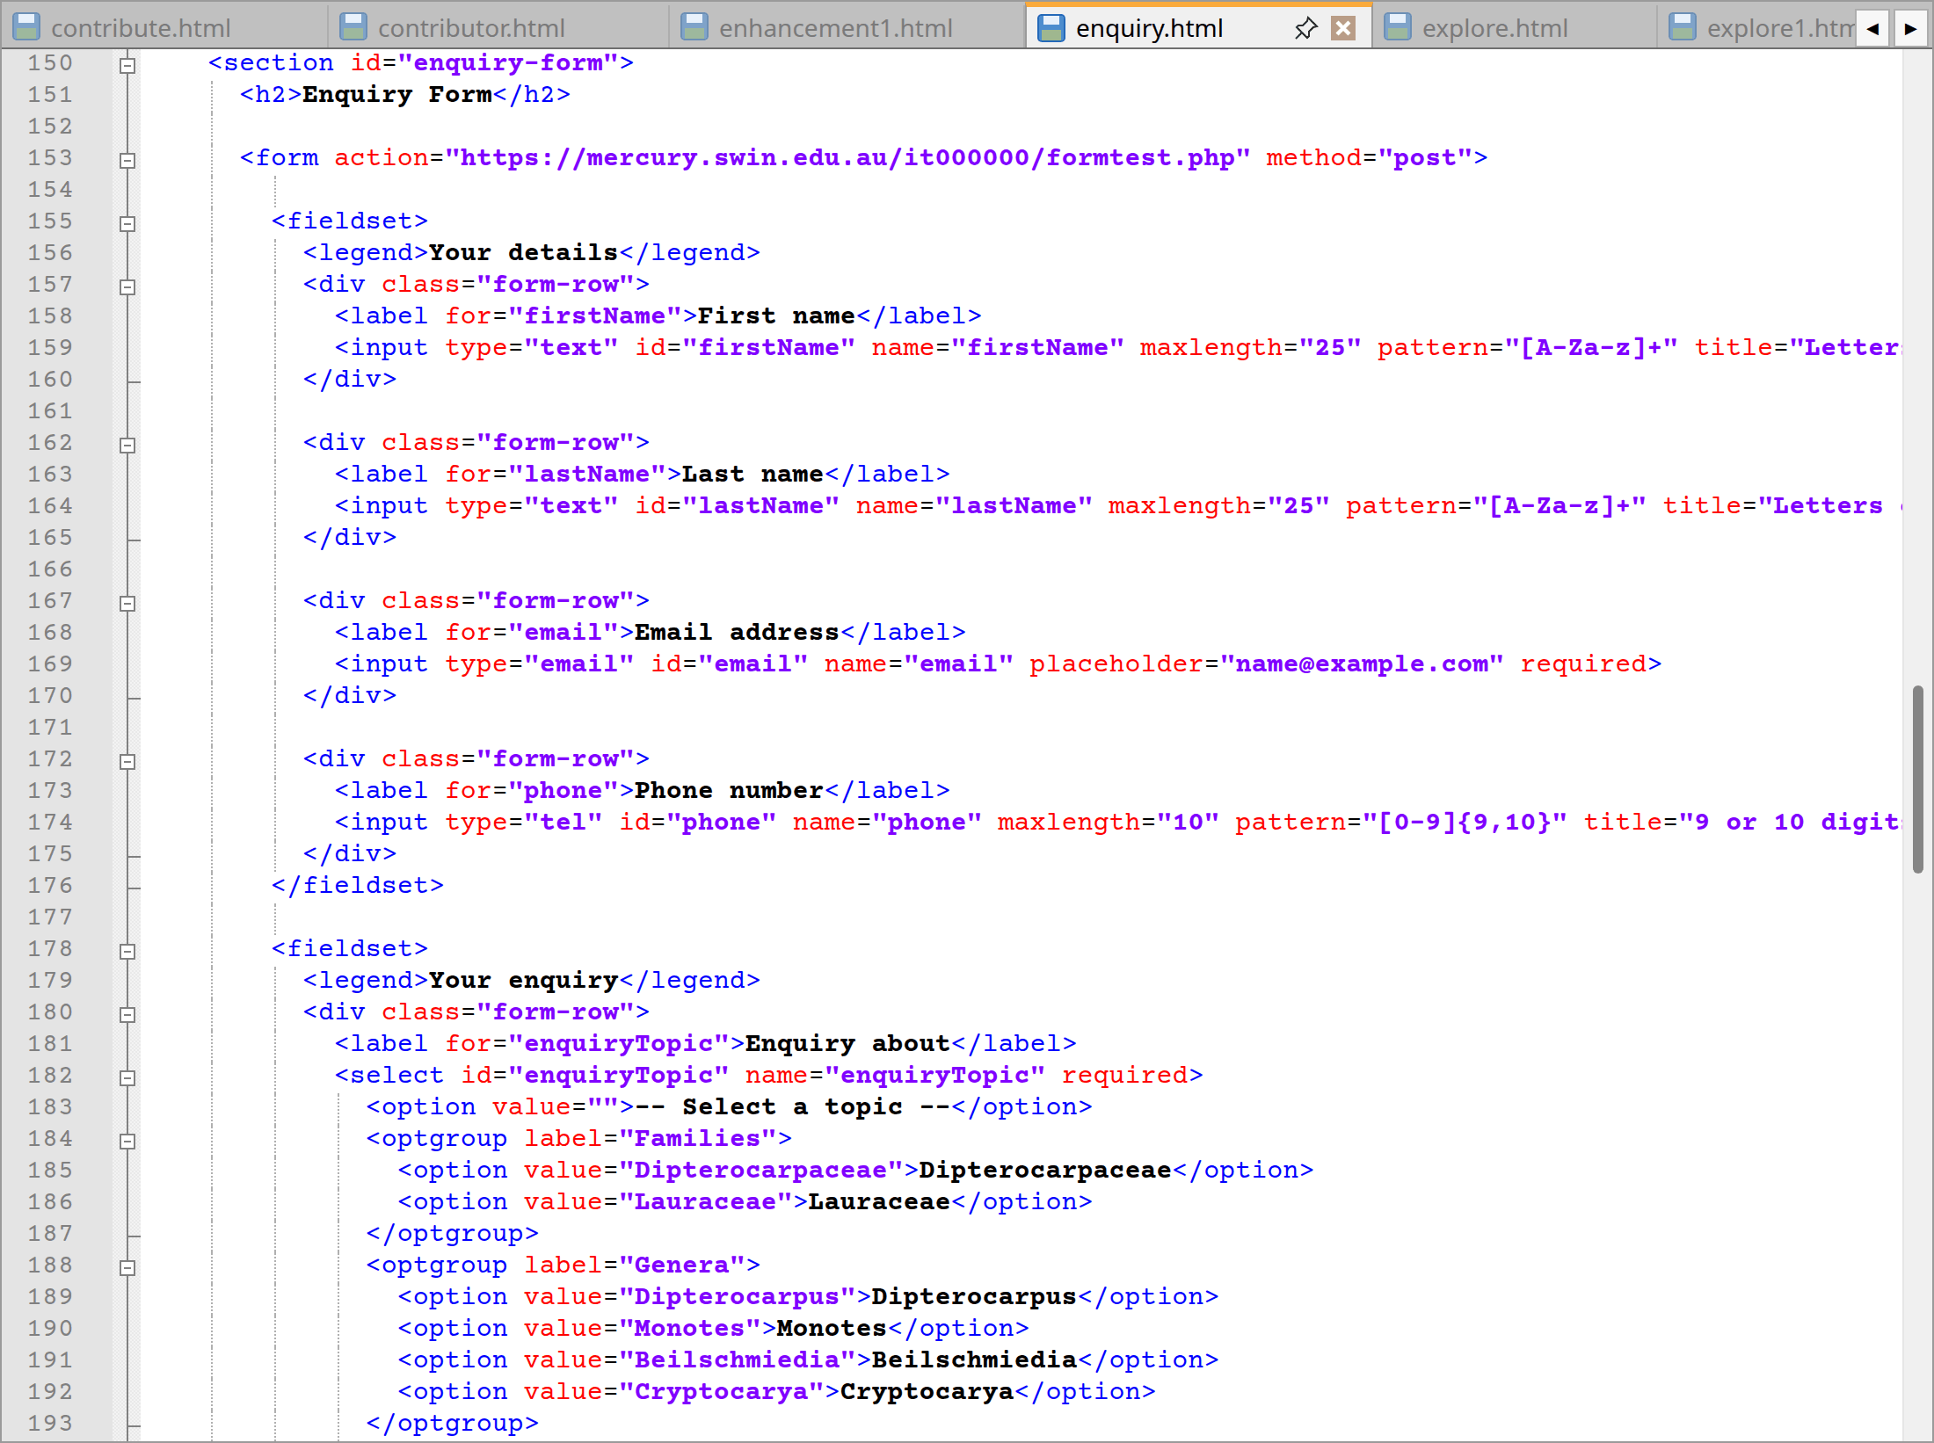
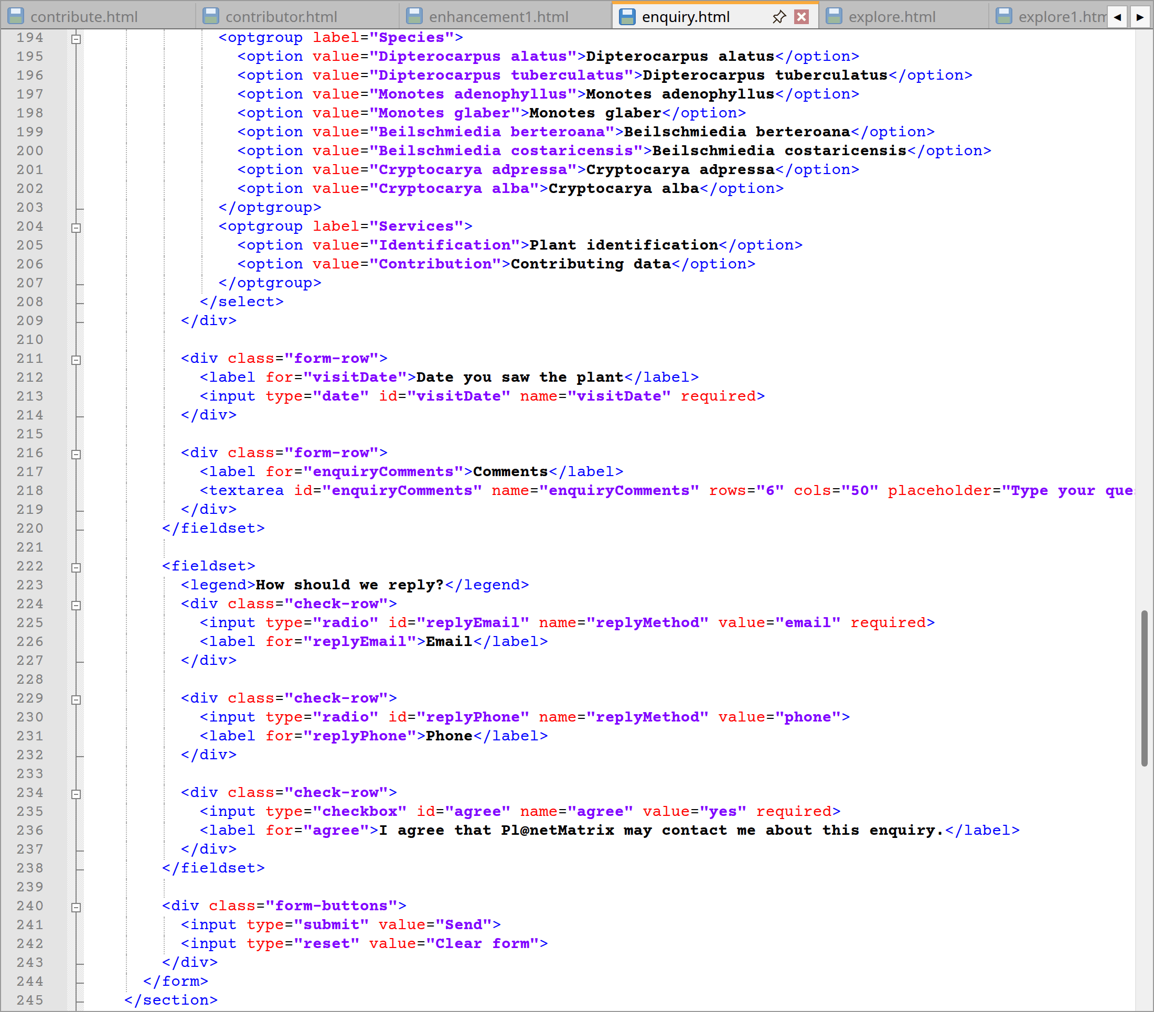
enquiry.html code lines from 150 to 245
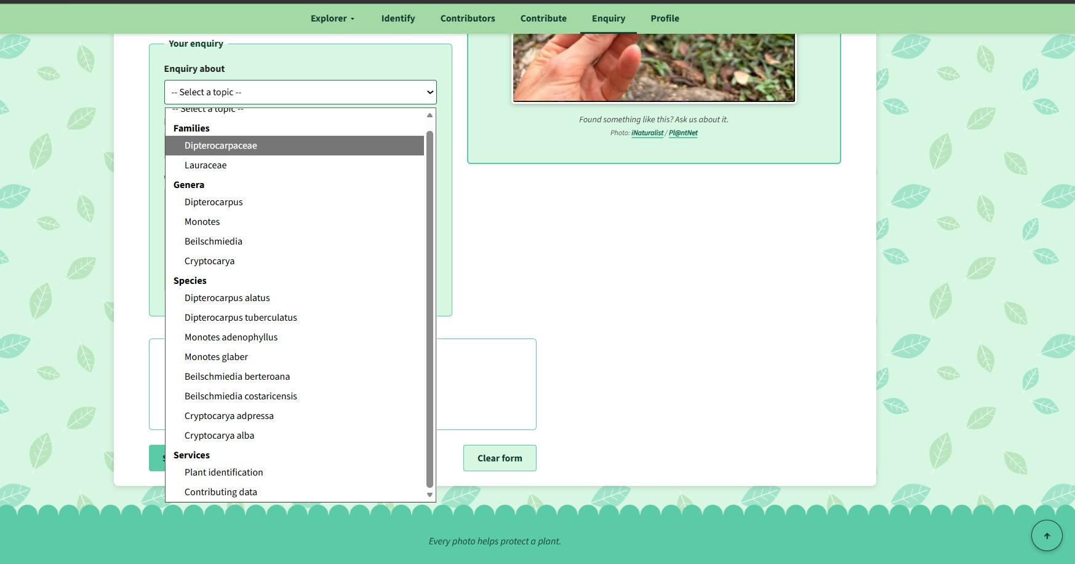
Website: Enquiry form with drop-down open
Lines | Explanation
124–136 | A winged fruit is pictured in the <aside> “Quick Answers” which has links to the identify and explorer pages.
153 | method="post" is used on the <form> no file is being sent so there is no need for an enctype.
155–176 | “Your details” asks for first and last name (letters only, 25 characters max), email and phone (type="tel", 9 or 10 digits).
178–220 | The “Your enquiry” <select> is broken down into four <optgroup> groups (Families, Genera, Species and Services) to make the 16 options easier to scan. Then comes the date of observation and a <textarea> for the question.
222–238 | For “How should we reply?” the user is presented with two radio buttons of name="replyMethod" and a required checkbox to agree to contact.
240–243 | Send and Clear form buttons can be found here.
Extra | Similarly, as in Section 2.1 for the header, menus and footer.

2.8 Profile page (profile.html)
This is little more than a personal card and then a table setting out my background and interests.
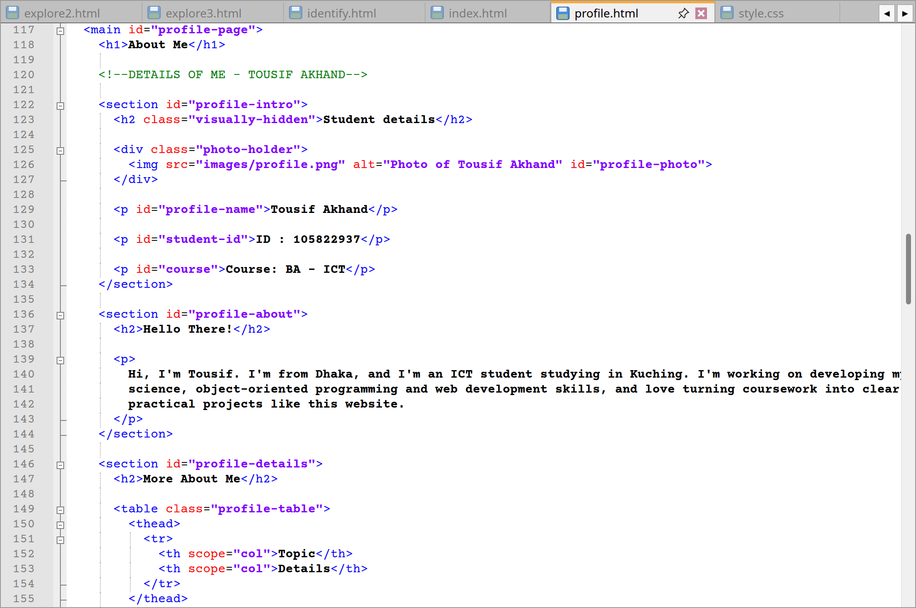
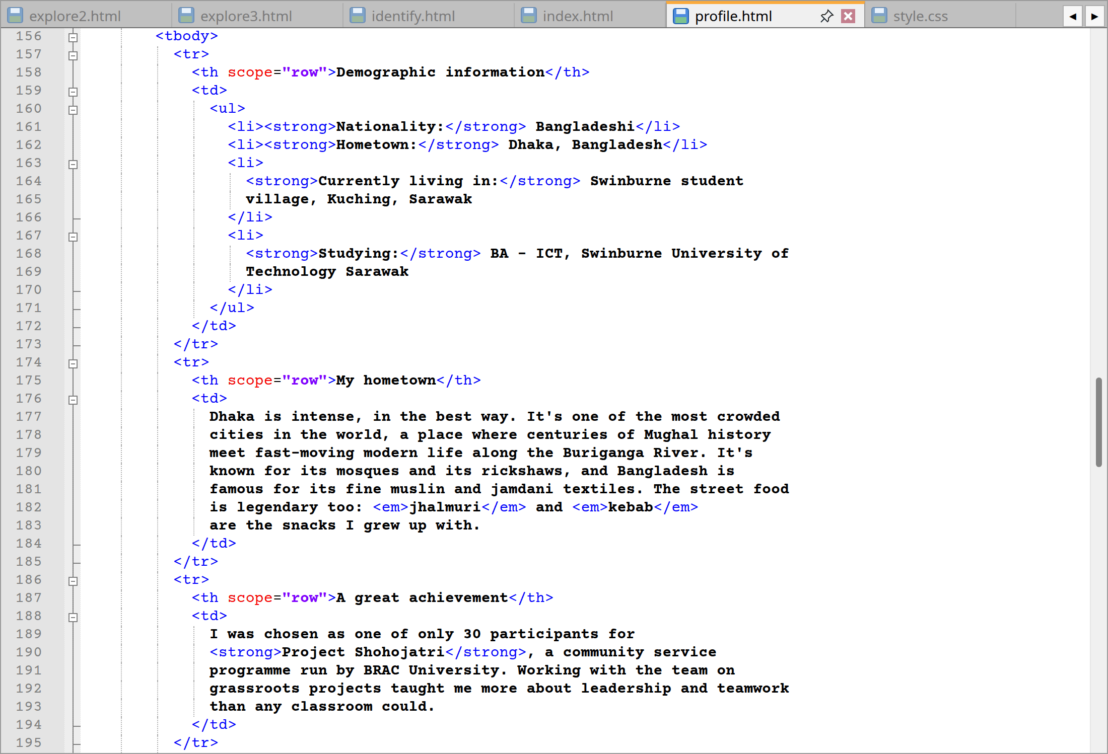
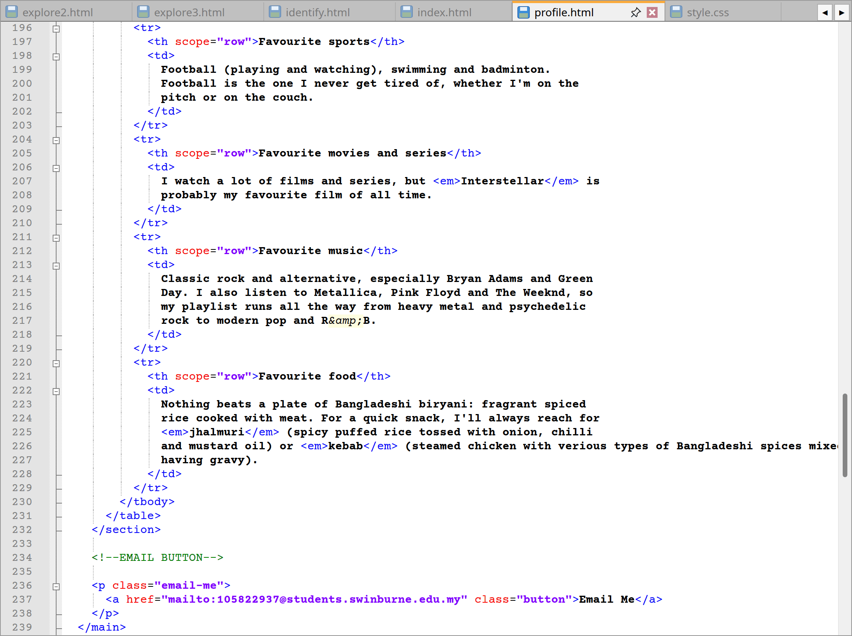
profile.html code lines from 117 to 239
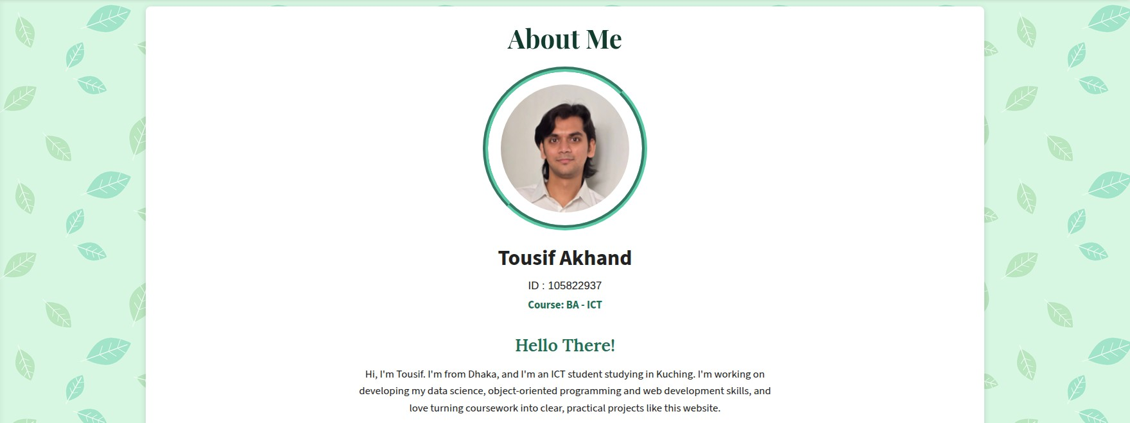
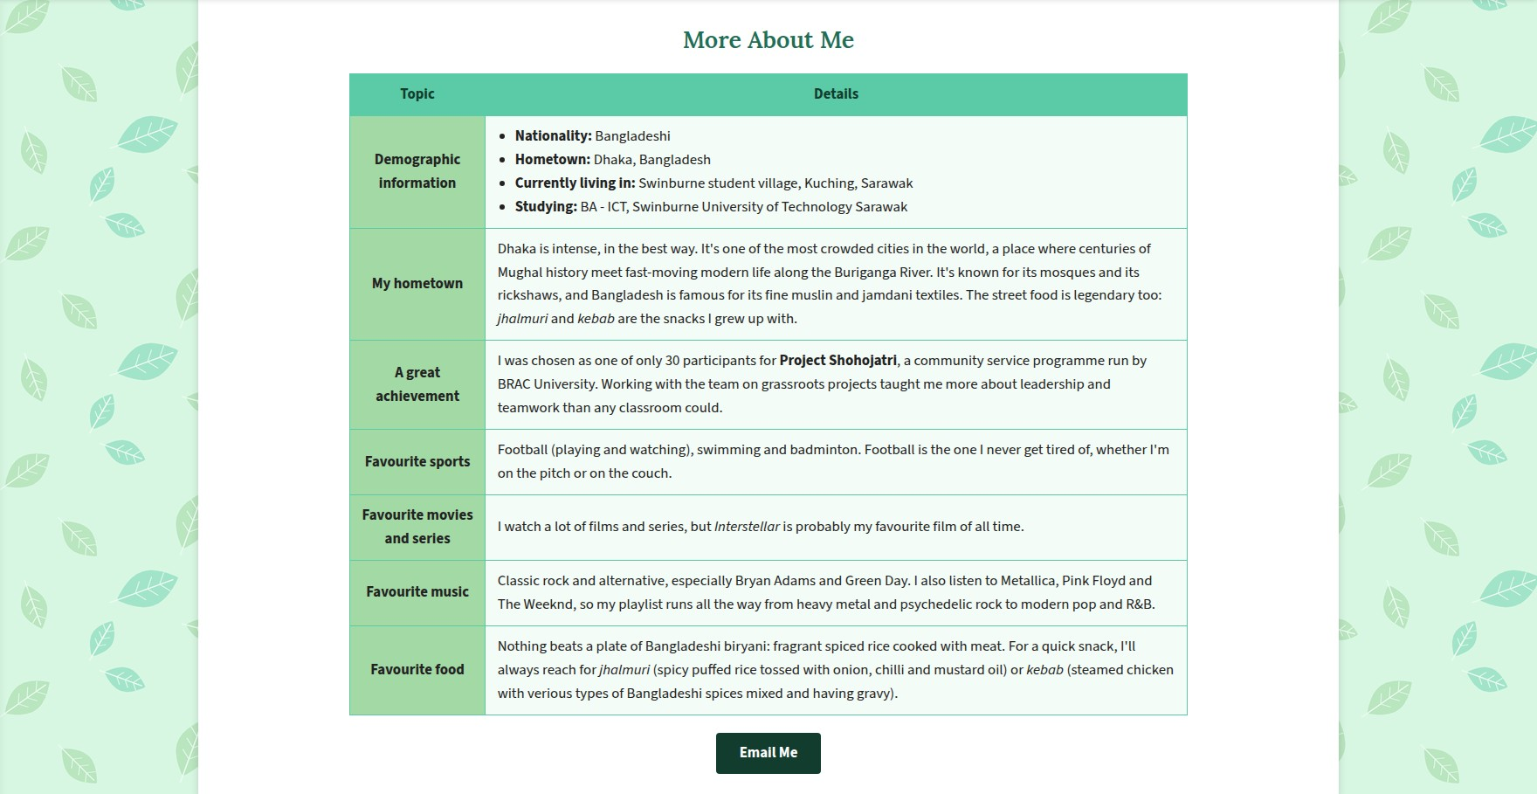
Website: Profile page
Lines | Explanation
117 | An id of “profile-page” is assigned to the <main> element for the purpose of centring the text on this page alone.
118 | The <h1> reads “About Me”.
122–134 | A visually-hidden <h2> provides a heading for screen readers in this part of the page. My photo is centred within a <div class="photo-holder"> and my name, student ID and course are presented in separate <p> tags, each with an id for styling purposes.
136–144 | I put in a brief paragraph under “Hello There!” to introduce myself as an ICT student from Dhaka now studying in Kuching.
146–232 | My demographic data is set out in a two-column <table class="profile-table"> with row labels in a <th scope="row"> table header. One can find my hometown of Dhaka, my favourite fare, films and music, as well as an achievement listed here. I have used the <em> tag for such words as Interstellar and jhalmuri.
236–238 | Then there is the Email Me button. Styled to resemble a button, a click on it uses a mailto: link to open a new email to my student address.
Extra | Similarly like last time, the footer, menus and header are as per Section 2.1.

2.9 Enhancements and Acknowledgements pages
These pages exist to support the site as a whole. Likewise, the former narrates the additional features while the latter is for giving credit.
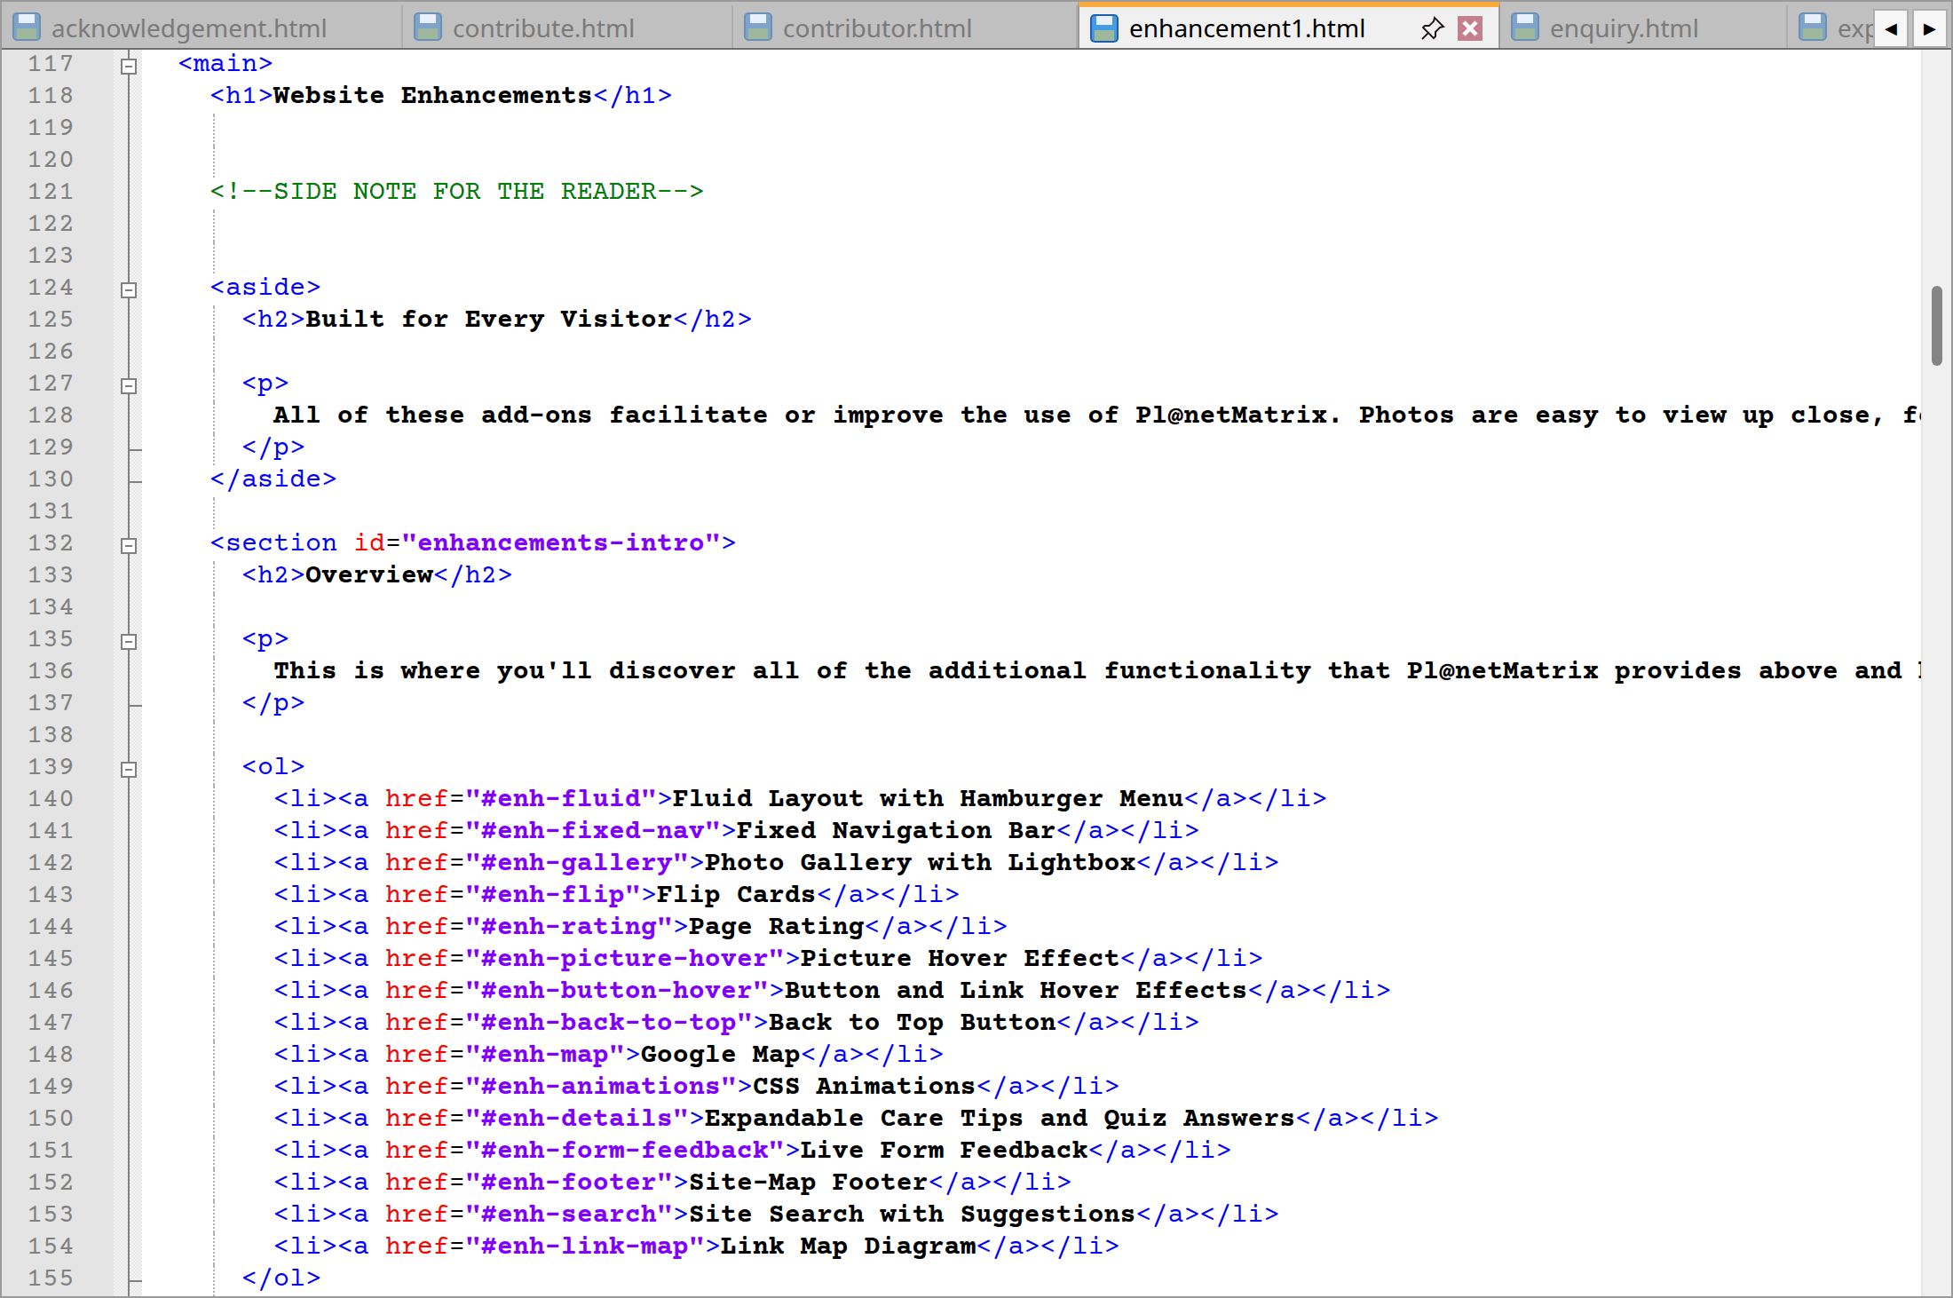
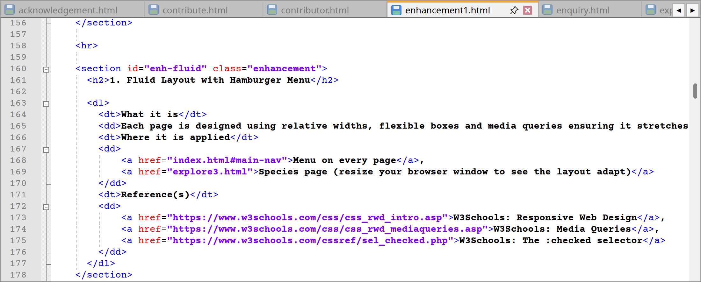
enhancement1.html code lines from 117 to 178
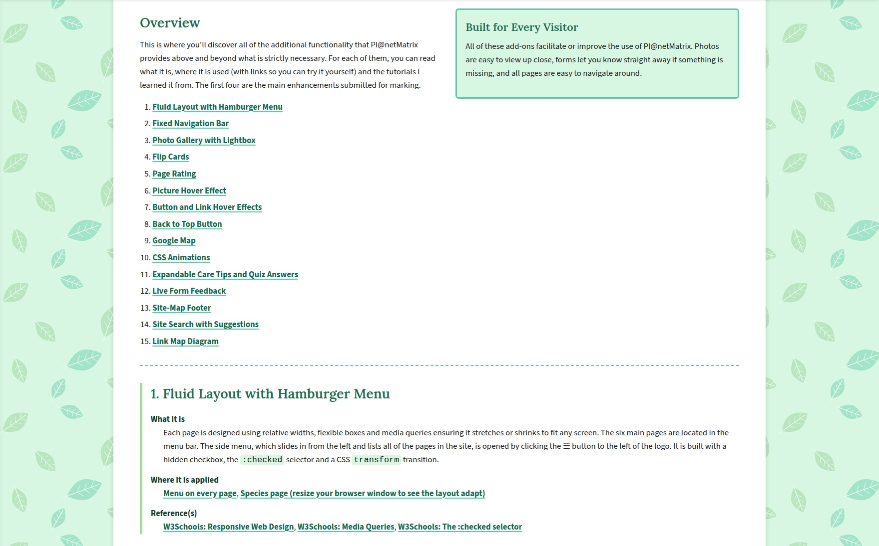
Website: Enhancements page
Lines | Explanation
124–130 | There is an <aside> titled “Built for Every Visitor”.
132–156 | An overview is provided along with an ordered list of jump links to the 15 enhancements, say #enh-fluid.
160–450 | Each enhancement has its own <section class="enhancement"> complete with a numbered <h2>. A description list follows with three headings: “What it is”, “Where it is applied” and “Reference(s)”. Any CSS names are enclosed in <code> tags.
456–530 | For a quick reference there is a summary table of the enhancements and where they are to be found.
Extra | Similarly, like last time, as in section 2.1, the header, menus and footer are the same.

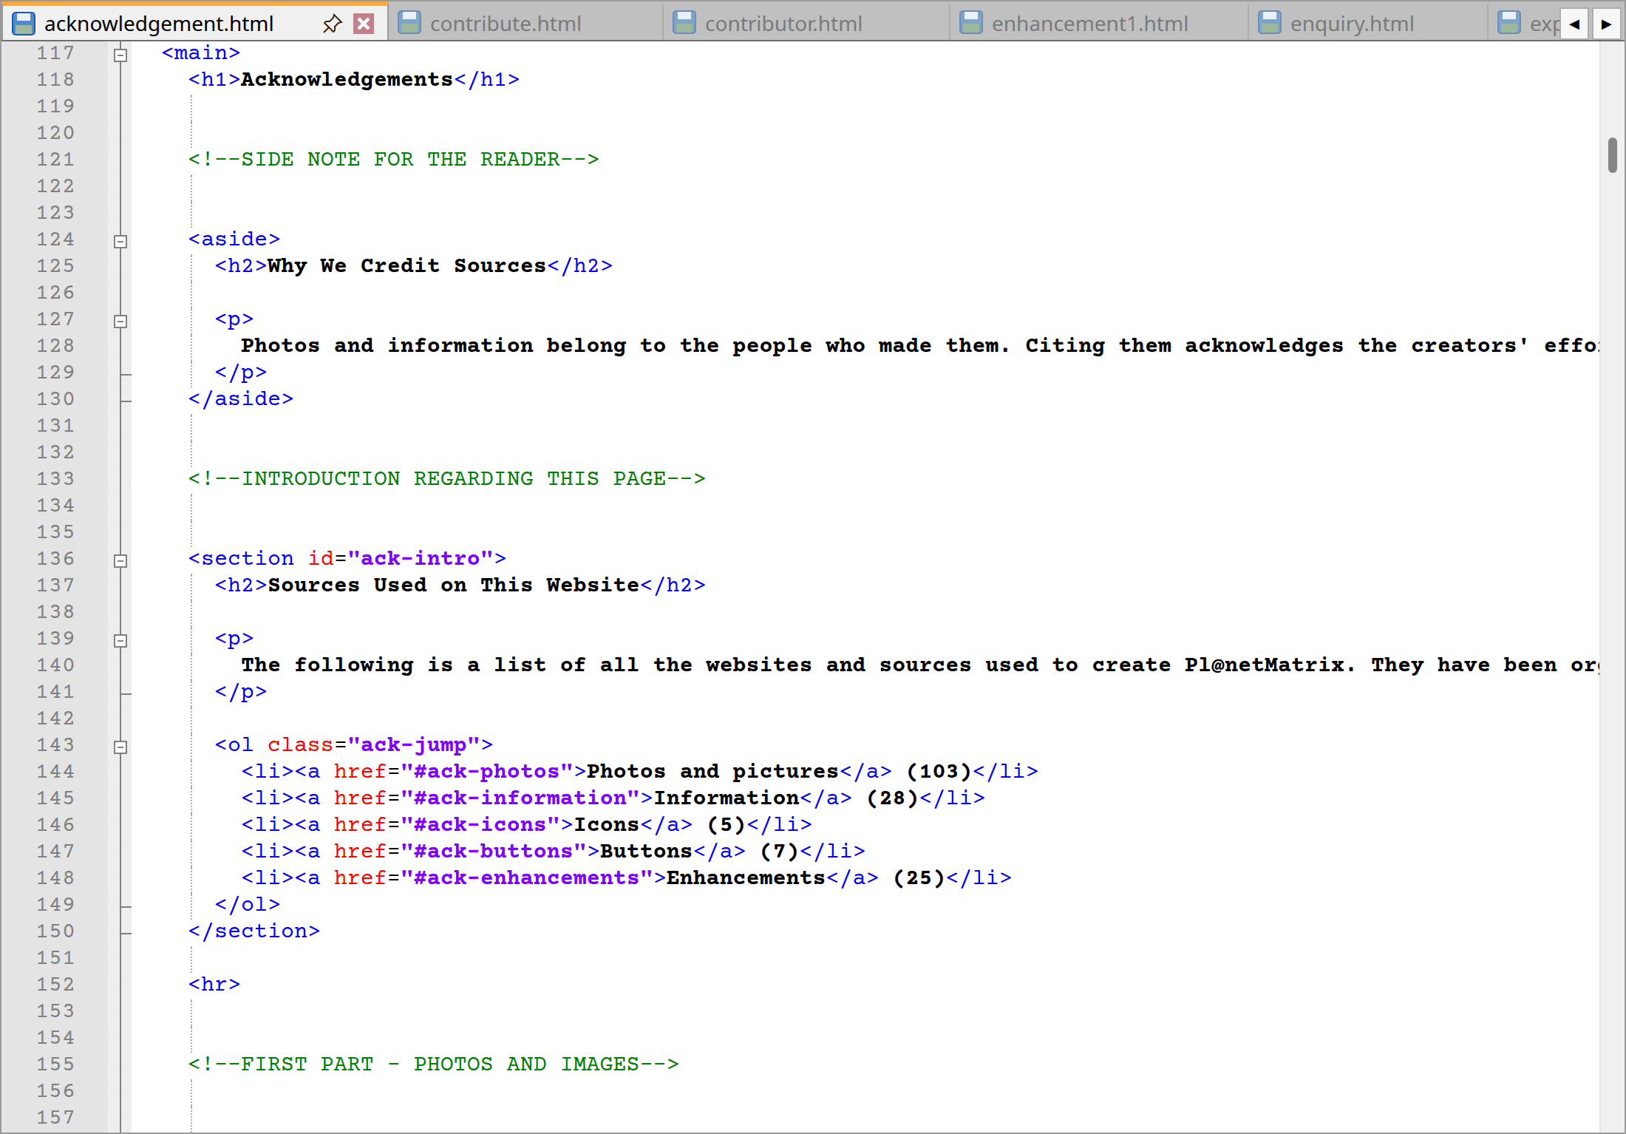
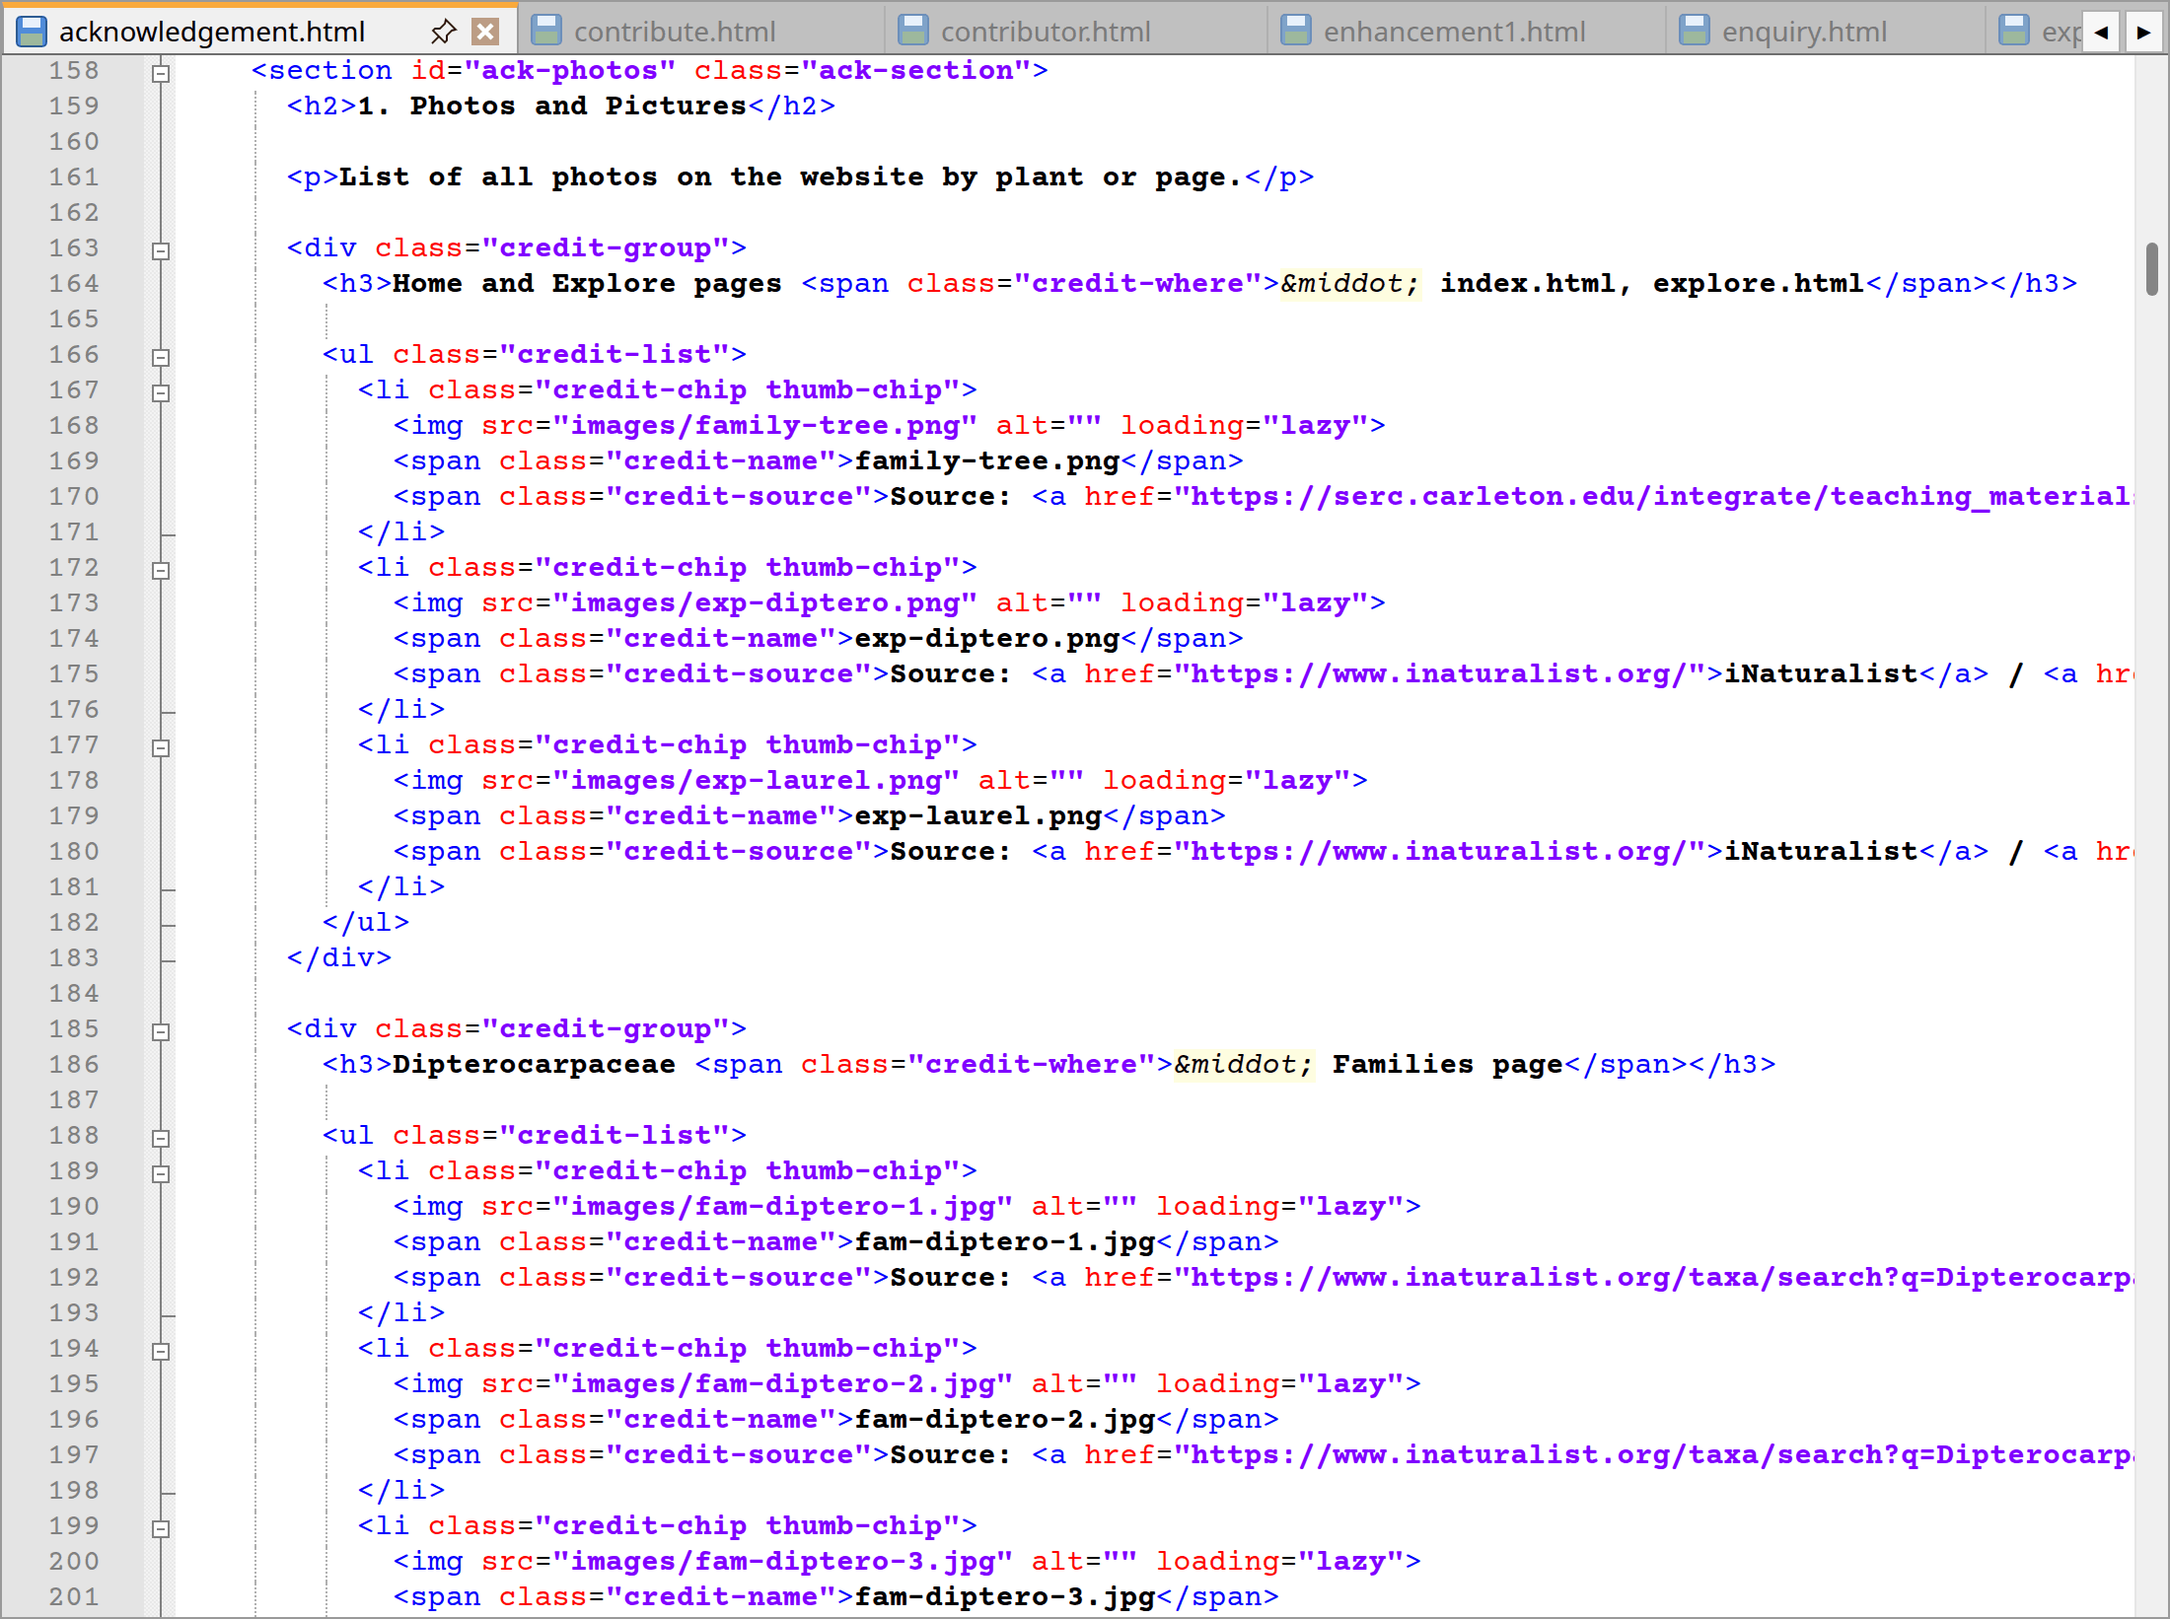
acknowledgement.html code lines from 117 to 201
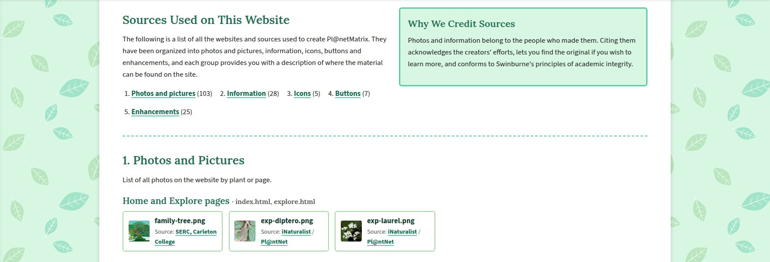
Website: Acknowledgements page
Lines | Explanation
124–130 | The <aside> “Why We Credit Sources” makes clear that rules are being followed on academic honesty and showing respect for the work of others by crediting them.
136–150 | Following the intro is a list of links to the five credit groups, indicating how many are in each.
158–789 | Under “1. Photos and Pictures” one will find all photos listed by file name in <div class="credit-group"> blocks whether by plant or page. Each is an <li class="credit-chip thumb-chip"> with a thumbnail, the file name and a source link.
795–946 | “2. Information” gives credit to the unit documents, google maps, fonts and W3School. Also not to mention the sites that are used for collecting plant data are iNaturalist, Pl@ntNet, Wikipedia and Plants of the World Online.
952–1053 | Logos, symbols and button styles are accounted for in “3. Icons” and “4. Buttons”.
1059–1184 | Credit is given in “5. Enhancements” for the tutorial behind each one.
1190–1230 | A table summarises the number of credits per section and their principal sources.
Extra | Identical to Section 2.1 in terms of the header, menus and footer.

2.10 Site map
Below is the site map for Pl@netMatrix. At the top is the home page (index.html) and from there one can see how all 12 pages are linked. The six main pages in the menu bar (Explorer, Identify, Contributors, Contribute, Enquiry and Profile) can be opened from anywhere. The Explorer has three child pages for the different levels of plant classification: Families (explore1.html), Genera (explore2.html) and Species (explore3.html). These sit below the Explorer in the diagram since they are reached through the drop-down in the menu bar, allowing a visitor to click down from a family to a species. The Enhancements and Acknowledgements are shaded grey with dashed lines because they are not in the main menu bar but are accessed from the side menu or footer.
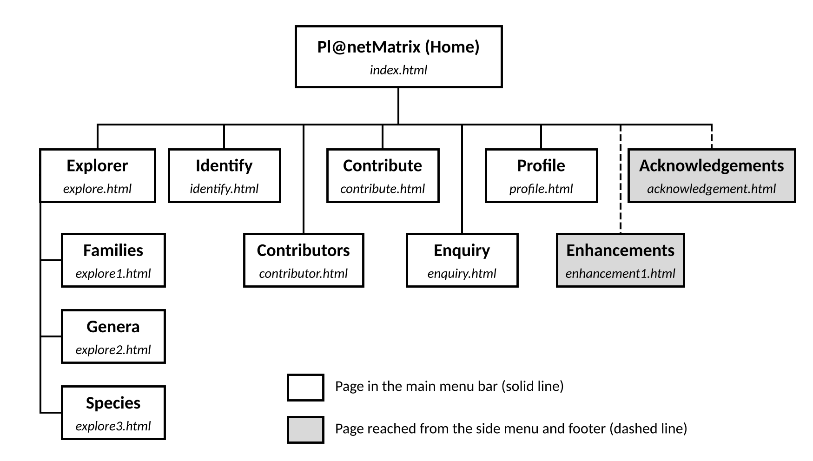
Site map of Pl@netMatrix
Then there is the side menu and the footer site map on every page both with links to the rest of the site and the logo in the header will always take one back to the home page. In short, a visitor is never more than a couple of clicks from any page.

3. Website Style (CSS)
The styling for Pl@netMatrix is kept in a single external stylesheet styles/style.css which is called from the <head> of the pages. I will not find any inline CSS or a <style> block. This approach avoids the risk of the 12 pages getting “out of sync”. Let’s say if I decide to alter the colour of the menu bar for instance, the change is reflected across the board.
Like any HTML file, this one opens with a header comment. One will find the FILE NAME, AUTHOR, STUDENT ID and UNIT there, along with a DESCRIPTION. I have also put in a COLOUR SCHEME to account for the 8 colours in use on the site, noting each by name and where it appears. The comment makes it plain that these values can be found and replaced to alter the site’s palette. From there the file is laid out in the natural order of the page - the header and menus, the content then the footer, forms, styles and any enhancements or animations. To make it easy to navigate when I return to a block later, I have put in a brief capitalised note to spell out its function above the sticky menu bar, for instance, it reads “STAYS AT THE TOP WHILE SCROLLING”.
The colour choices are six shades of green and teal. Headings and text in the menu and footer are in dark green (#123D2E), while subheadings and the open page in the Explorer steps are deep green (#1F6E56). Teal (#23807F) is at the right end of the header fade, mint (#5BCBA7) is for the borders and the header and footer themselves, and soft green (#A3D9A5) for the main menu and drop-downs. Light mint (#D8F7E3) serves as the background and for hover colours. White (#FFFFFF) is reserved for the content area, and red (#B3261E) is an alert for the user on form boxes if the value is wrong. For a plant site, greens are fitting and they keep the pages more cohesive and calm. As for typeface, I have used Playfair Display for the site name and main headings, Lora for sections and Source Sans 3 for the body, all from Google Fonts.
What follows are tables set in the order of the stylesheet. In the Code column one will see the CSS as it is in style.css and the Explanation column tells us why it is there and what it does on the page.
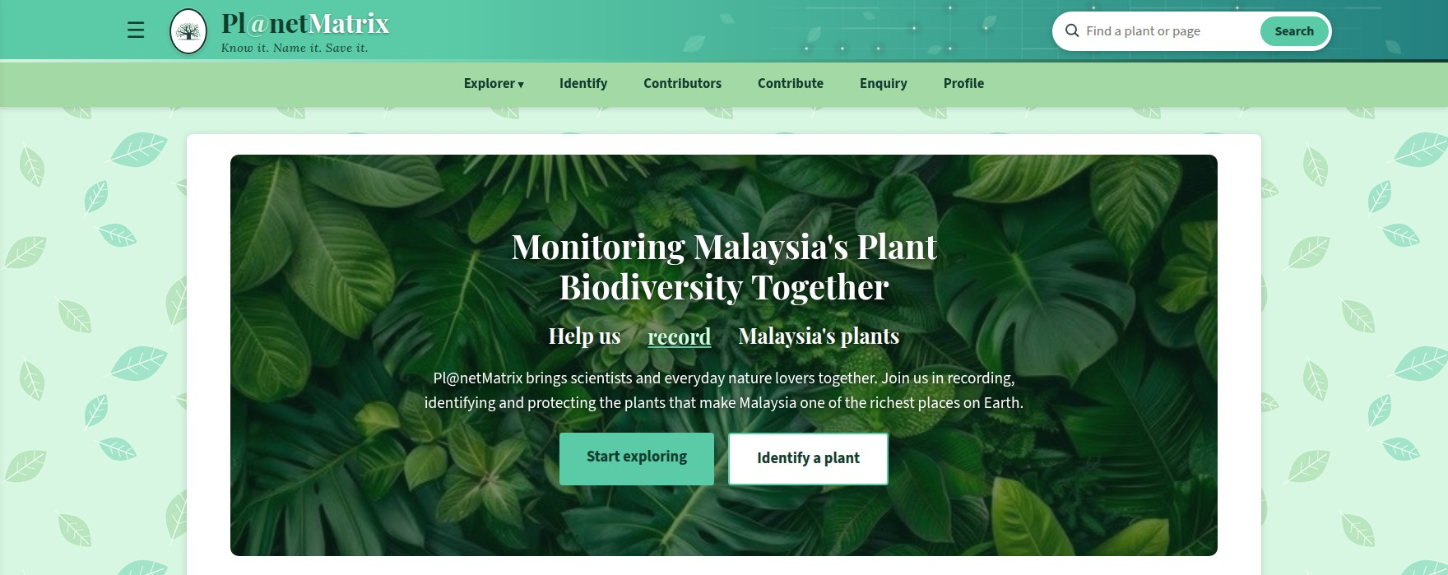
Website: Home page on desktop
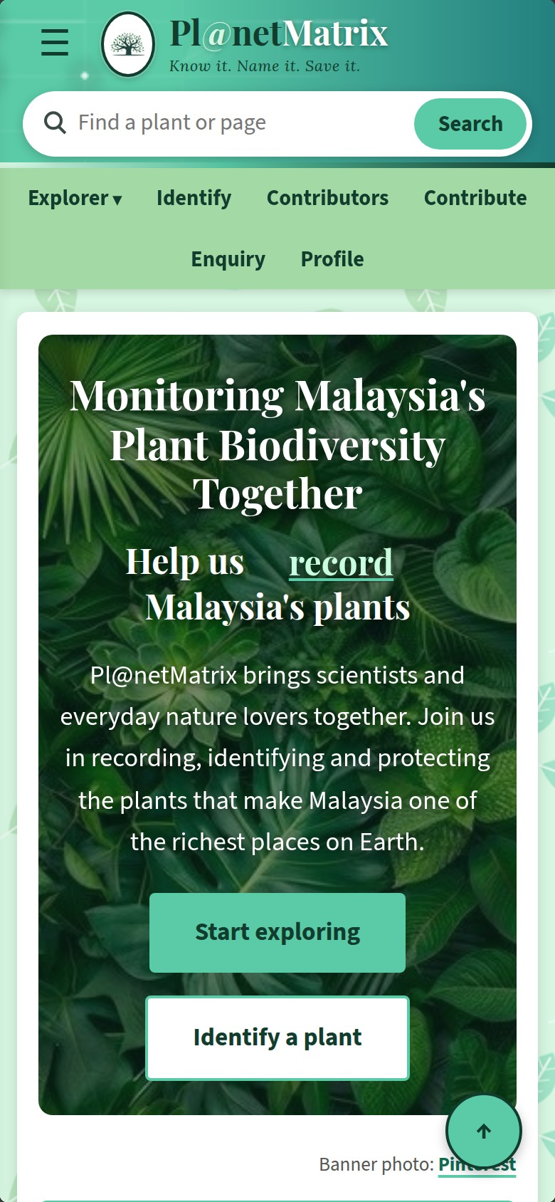
Website: Home page on a phone

3.1 Base styles
These are the fundamentals applied to every page before anything more specific is added. They govern the font and background, the white panel, headings and so forth.
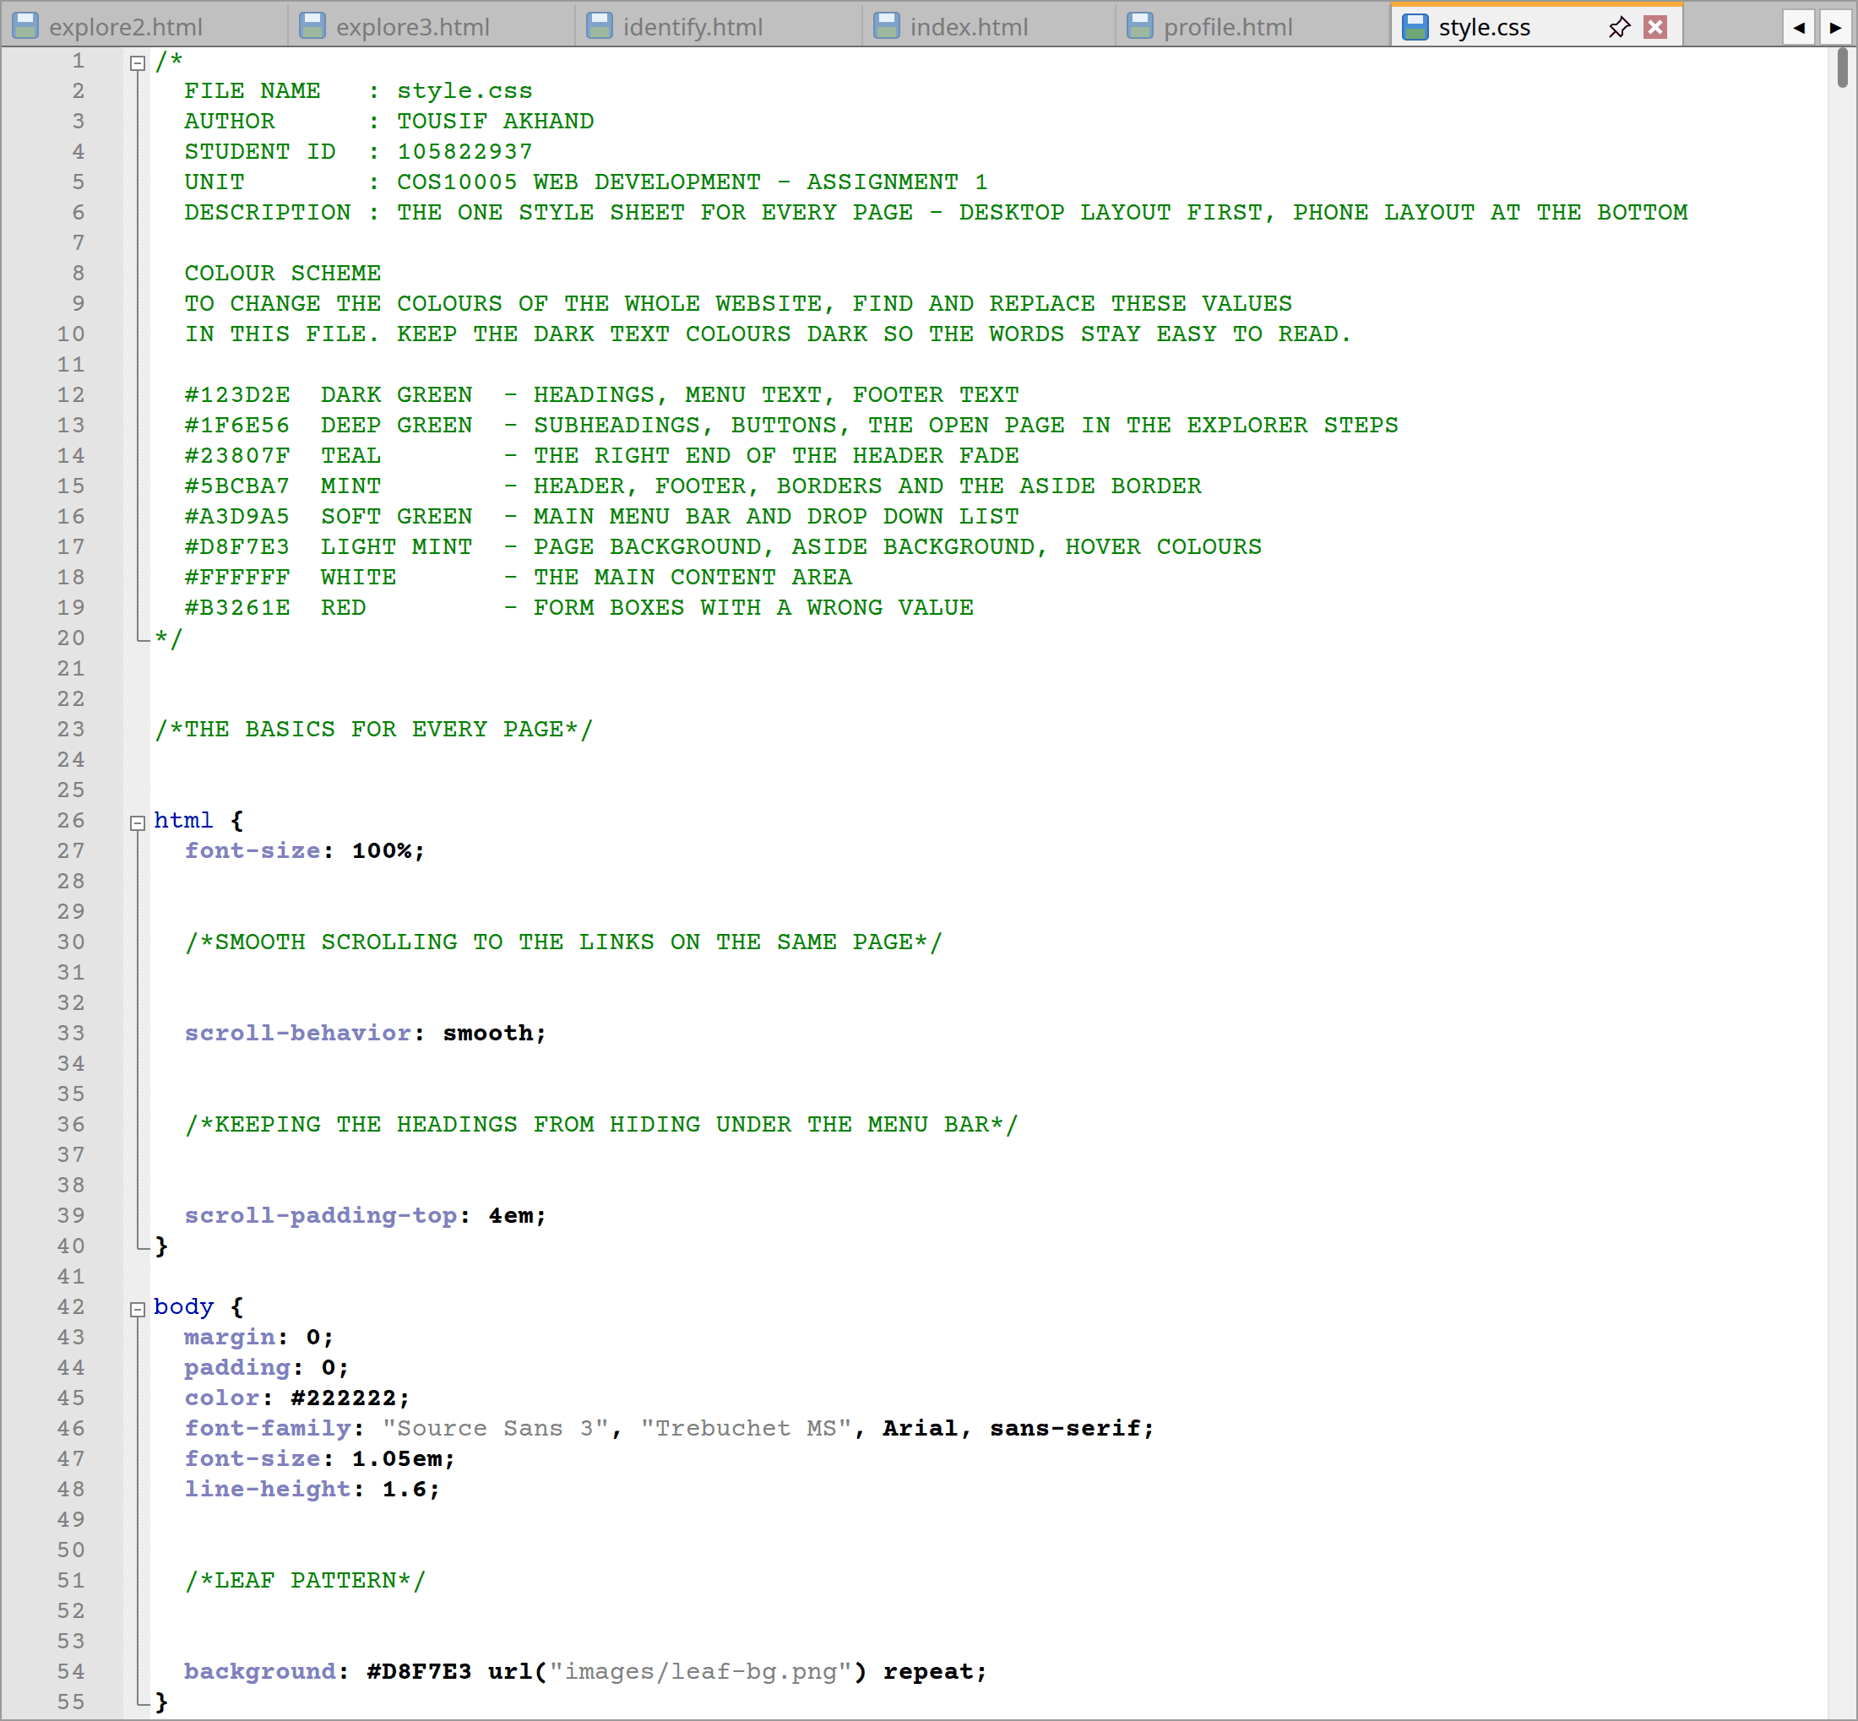
style.css code lines from 1 to 55

Number | Code | Explanation
1 | /*  FILE NAME : style.css  AUTHOR : TOUSIF AKHAND  STUDENT ID : 105822937  UNIT : COS10005 WEB DEVELOPMENT - ASSIGNMENT 1  DESCRIPTION : THE ONE STYLE SHEET FOR EVERY PAGE - DESKTOP LAYOUT FIRST, PHONE LAYOUT AT THE BOTTOM  COLOUR SCHEME  TO CHANGE THE COLOURS OF THE WHOLE WEBSITE, FIND AND REPLACE THESE VALUES  IN THIS FILE. KEEP THE DARK TEXT COLOURS DARK SO THE WORDS STAY EASY TO READ.  #123D2E DARK GREEN - HEADINGS, MENU TEXT, FOOTER TEXT  #1F6E56 DEEP GREEN - SUBHEADINGS, BUTTONS, THE OPEN PAGE IN THE EXPLORER STEPS  #23807F TEAL - THE RIGHT END OF THE HEADER FADE  #5BCBA7 MINT - HEADER, FOOTER, BORDERS AND THE ASIDE BORDER  #A3D9A5 SOFT GREEN - MAIN MENU BAR AND DROP DOWN LIST  #D8F7E3 LIGHT MINT - PAGE BACKGROUND, ASIDE BACKGROUND, HOVER COLOURS  #FFFFFF WHITE - THE MAIN CONTENT AREA  #B3261E RED - FORM BOXES WITH A WRONG VALUE  */ | The file starts with the usual comment block (FILE NAME, AUTHOR etc.) and the COLOUR SCHEME with hex codes. There is a reminder to keep the text colours dark for legibility so anyone opening the file knows at a glance what they are looking at. The three Google Fonts are not being loaded on this page instead, the pages make a separate request for them using a <link> element in the <head>, as illustrated in index.html (code lines from 23 to 25) and only for the weights that are needed. display=swap has been used so that a fallback font can be displayed while the font is being downloaded from Google, thus avoiding blank text.
2 | html {  font-size: 100%;  /*SMOOTH SCROLLING TO THE LINKS ON THE SAME PAGE*/  scroll-behavior: smooth;  /*KEEPING THE HEADINGS FROM HIDING UNDER THE MENU BAR*/  scroll-padding-top: 4em;  } | I have set font-size to 100% on the html element since everything else is in em, the site will scale up for those who want larger text. In-page links won’t jump about thanks to scroll-behavior: smooth and I put in a 4em scroll-padding-top so the sticky menu does not hide any headings.
3 | body {  margin: 0;  padding: 0;  color: #222222;  font-family: "Source Sans 3", "Trebuchet MS", Arial, sans-serif;  font-size: 1.05em;  line-height: 1.6;  /*LEAF PATTERN*/  background: #D8F7E3 url("images/leaf-bg.png") repeat;  } | To let the header and footer go to the edge, the body rule takes away the browser’s default margin. It also sets the line height to 1.6 and the font to Source Sans 3 in a soft black to be read. The background is light minty with a leaf pattern. If the image doesn't appear, the same rule will still make the page look correct but the colour will not appear.
4 | main {  display: block;  width: 86%;  max-width: 1200px;  margin: 2em auto;  padding: 1.5em 3%;  background-color: #ffffff;  border-radius: 8px;  box-shadow: 0 2px 10px rgba(0, 0, 0, 0.15);  }  /*KEEPING THE FLOATING SIDE NOTE INSIDE THE BOX*/  main::after {  content: "";  display: block;  clear: both;  } | The main element is a white content panel at 86 percent of the screen width but with max-width: 1200px it doesn't expand beyond that on a big screen. Auto margins put it in the centre and a shadow and rounded corners give it a card-like quality against the leaves. The clearfix in main::after puts an empty block below the floating side note so the panel extends down properly.
5 | h1 {  /*SEVERAL FONT SETTINGS IN ONE LINE*/  font: bold 2.4em/1.2 "Playfair Display", Georgia, serif;  color: #123D2E;  margin: 0 0 0.5em;  }  h2,  h3 {  font-family: Lora, Georgia, serif;  font-weight: 600;  color: #1F6E56;  }  h2 {  font-size: 1.6em;  margin: 1em 0 0.4em;  }  h3 {  font-size: 1.25em;  margin: 0 0 0.3em;  }  p {  margin: 0 0 1em;  }  .lead {  font-size: 1.15em;  } | For h1 I have used the shorthand for a bold 2.4em Playfair Display. Lora in dark green is for h2 and h3 at 1.6em and 1.25em respectively, stepping down with the heading level. A class lead gives the home page summary some size and there is a gap under paragraphs.
6 | main p a:not(.button),  main li a:not(.button):not(.tree-node),  main dd a,  main td a,  main th a,  main figcaption a {  font-weight: bold;  color: #0F6B52;  text-decoration: underline;  text-decoration-color: #5BCBA7;  text-decoration-thickness: 2px;  text-underline-offset: 3px;  border-radius: 3px;  transition: color 0.2s ease, background-color 0.2s ease;  } | This is to set the links apart from the body copy. It applies to those in lists, captions and the like but :not(.button) and :not(.tree-node) leave the buttons and map boxes alone. A thick mint underline and bold weight mean they are not merely colour coded which is better for someone with colour blindness. On focus or hover a pale mint background is added.
7 | main p:not(.breadcrumb) a[href$=".html"]:not(.button)::after,  main p:not(.breadcrumb) a[href*=".html#"]:not(.button)::after,  main li a[href$=".html"]:not(.button):not(.tree-node)::after,  main li a[href*=".html#"]:not(.button):not(.tree-node)::after {  content: "\2192";  display: inline-block;  margin-left: 0.25em;  transition: transform 0.2s ease;  }  /*THE ARROW MOVES FORWARD WHEN HOVERING OVER THE LINK*/  main p a:not(.button):hover::after,  main p a:not(.button):focus::after,  main li a:not(.button):not(.tree-node):hover::after,  main li a:not(.button):not(.tree-node):focus::after {  transform: translateX(4px);  } | Links that lead to another page have an arrow (→) pointing in the direction of the page to which the link goes. An arrow (→) is placed on links that lead to another page, distinguishing them from links that simply jump down on the page they are on. The matching is done by attribute selectors: a[href=".html"] matches links ending in .html and a[href=".html"] matches links that go to another part of the site. The ::after element is used to add the arrow and it's slightly pushed forward on mouseover with translateX(4px).
8 | hr {  clear: both;  margin: 2em 0;  border: 0;  border-top: 2px dashed #5BCBA7;  }  /*SIDE NOTE FOR THE READER*/  aside {  float: right;  width: 30vw;  margin: 0 0 1em 1.5em;  padding: 1em;  background-color: #D8F7E3;  border: 3px solid #5BCBA7;  border-radius: 6px;  }  aside h2 {  margin-top: 0;  font-size: 1.3em;  } | The aside rule creates side notes that float to the right taking up 30vw of screen and have a light mint color background, light mint border and rounded corners. The rest of the content wraps around like an attached note. Each of these notes will be followed by a dashed line in mint below it.
9 | ol {  padding-left: 1.5em;  }  ol li {  margin-bottom: 0.4em;  }  dl dt {  font-weight: bold;  color: #123D2E;  }  dl dd {  margin: 0 0 0.8em 1.5em;  } | These rules are for spacing of lists. Description lists use <dt> style for a key term or for a quick fact and it is bold and deep teal so that it can be used as a label for the <dd> style for the definition.

3.2 Header and navigation
This section of the stylesheet focuses on the elements needed to navigate across the site: the header bar and its logo and name, side and main menus including any drop down menus and the search box.
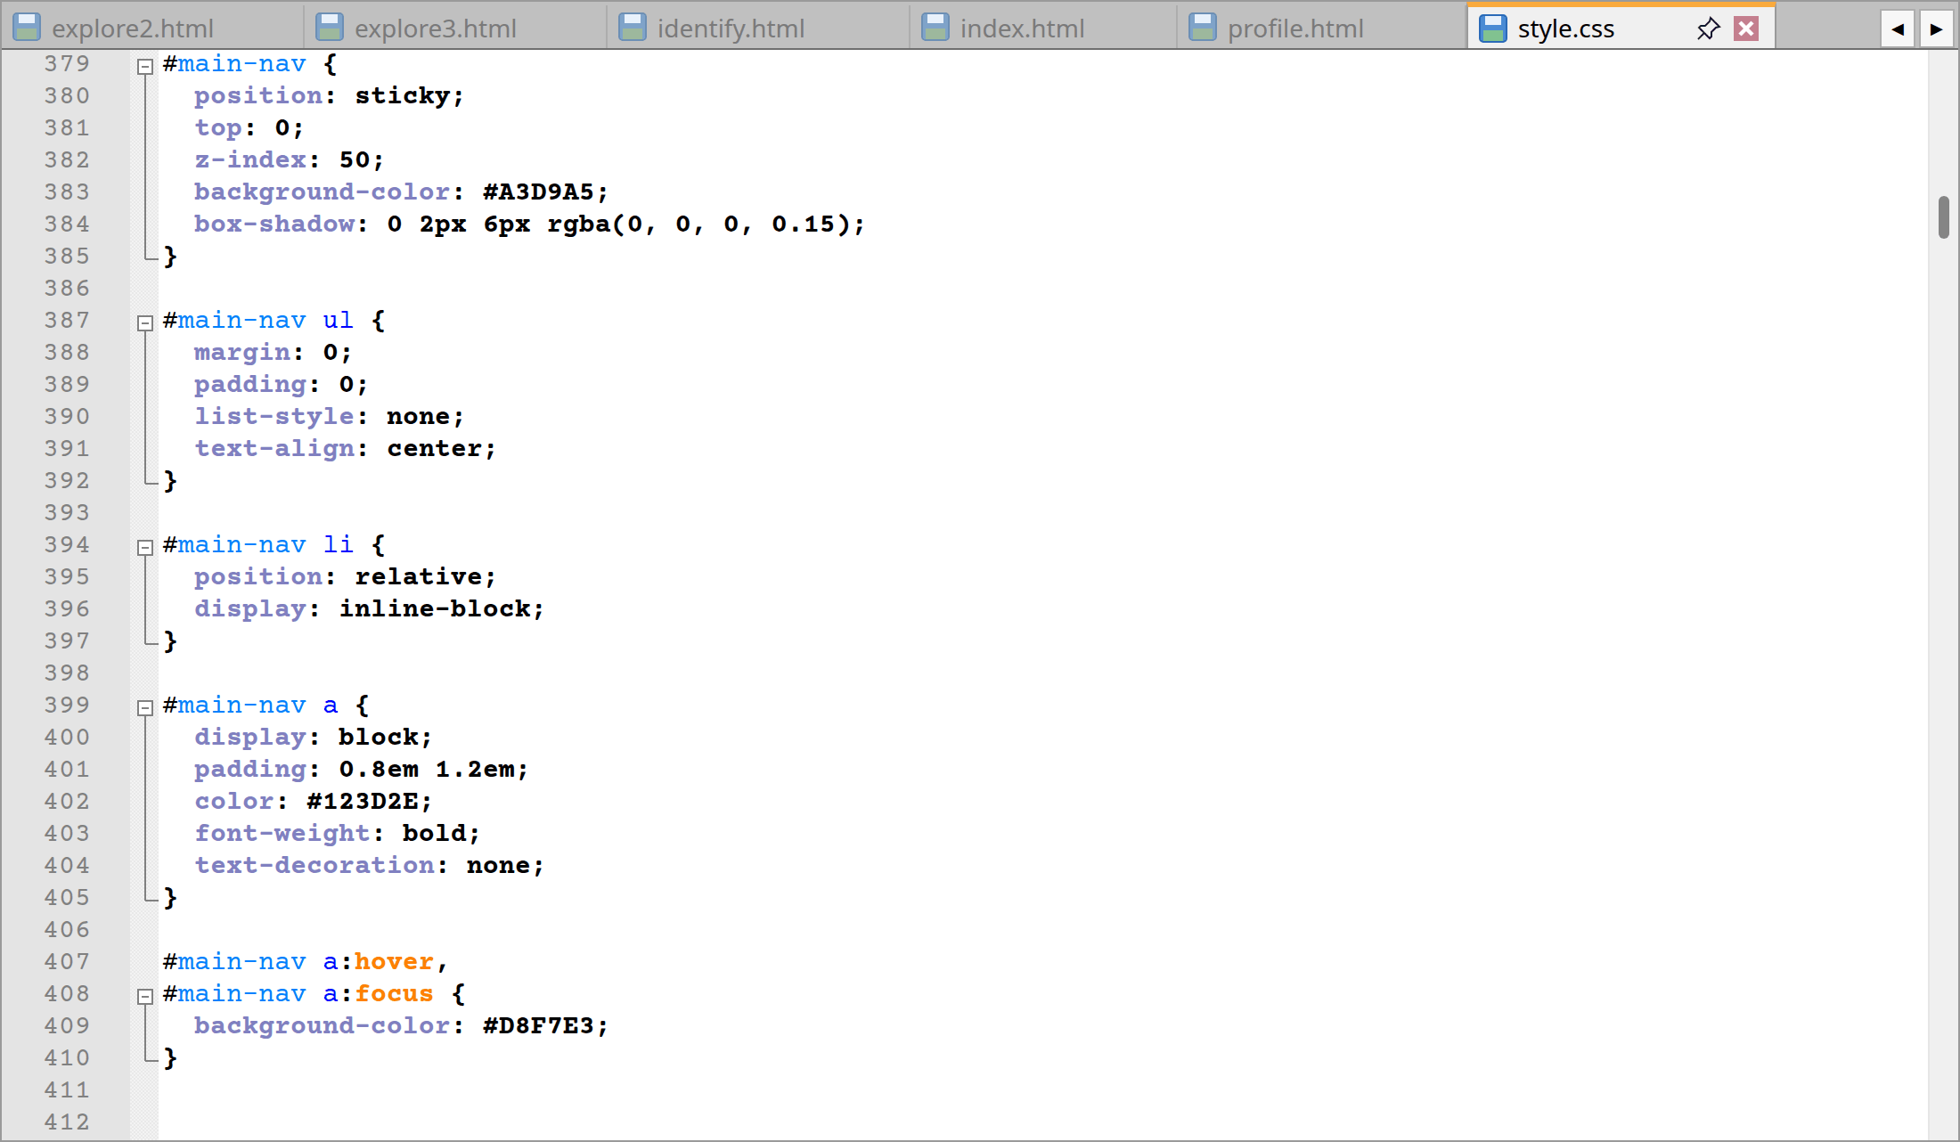
style.css code lines from 171 to 224 and 379 to 447
Website: Header and menu bar
Website: Side menu open
Number | Code | Explanation
1 | #site-header {  display: flex;  align-items: center;  gap: 1em;  padding: 0.55em 8%;  color: #123D2E;  /*LEAVES AND GRID LINES OVER A MINT TO TEAL FADE*/  background: url("images/header-bg.png") right center / auto 100% no-repeat,  linear-gradient(90deg, #5BCBA7 30%, #23807F);  background-color: #5BCBA7;  box-shadow: 0 2px 6px rgba(0, 0, 0, 0.18);  position: relative;  } | The button, the logo, the site name and the search box are aligned horizontally and centered between each other with display: flex and align-items: center. Two-layered background with leaf and grid image on right over mint to teal gradient (if it doesn't render it will be plain mint). position: relative is there so that the next rule can place a line along the bottom.
2 | #site-header::after {  content: "";  position: absolute;  right: 0;  bottom: 0;  left: 0;  height: 4px;  background: linear-gradient(90deg, #D8F7E3, #5BCBA7 40%, #123D2E);  } | A 4px gradient line is added after the header and runs down the bottom of the header to give a separation from the menu bar. It is a clean method, without adding unnecessary HTML.
3 | #site-logo {  display: block;  box-sizing: border-box;  width: 46px;  height: 56px;  padding: 4px;  object-fit: contain;  background-color: #ffffff;  border: 2px solid #123D2E;  border-radius: 50%;  box-shadow: 0 2px 5px rgba(0, 0, 0, 0.2);  animation: glow 3s ease-in-out infinite;  }  /*THE GLOW AROUND THE LOGO PULSES GENTLY*/  @keyframes glow {  0%,  100% {  box-shadow: 0 0 0 0 rgba(216, 247, 227, 0.2), 0 2px 5px rgba(0, 0, 0, 0.2);  }  50% {  box-shadow: 0 0 0 7px rgba(216, 247, 227, 0.55), 0 2px 5px rgba(0, 0, 0, 0.2);  }  } | The logo is centered in a white oval (border-radius: 50%) that has object-fit: contain to prevent the logo from being distorted. It has a deep teal border and some shadow for depth. Every three seconds a glow effect makes an appearance, the keyframes create a soft halo that pulses out and back around the logo.
4 | #logo {  margin: 0;  font: bold 1.9em/1.1 "Playfair Display", Georgia, serif;  }  /*SITE NAME IN TWO COLOURS WITH A MINT @*/  .logo-matrix {  color: #ffffff;  text-shadow: 0 1px 3px rgba(18, 61, 46, 0.6);  }  .logo-at {  color: #D8F7E3;  text-shadow: 0 1px 3px rgba(18, 61, 46, 0.6);  }  /*KNOW IT, NAME IT, SAVE IT*/  .logo-tagline {  display: block;  margin-top: 0.3em;  font: italic 400 0.45em Lora, Georgia, serif;  letter-spacing: 0.04em;  color: #123D2E;  }  #logo a {  color: #123D2E;  text-decoration: none;  } | The site name is displayed as a two-colour logo in bold Playfair Display: "Matrix" is white and the "@" is pale mint, the rest is deep teal and display: block removes the underline from the link.
5 | .menu-toggle {  position: absolute;  width: 1px;  height: 1px;  opacity: 0;  }  .menu-button {  display: block;  width: 1.8em;  height: 1.8em;  line-height: 1.8em;  font-size: 1.6em;  color: #123D2E;  text-align: center;  border-radius: 6px;  cursor: pointer;  transition: background-color 0.3s ease;  }  .menu-button:hover,  .menu-toggle:focus+.menu-button {  background-color: #D8F7E3;  }  .menu-toggle:focus+.menu-button {  outline: 2px solid #123D2E;  } | The checkbox is not hidden in the side menu (display: none) but is made 1px and fully transparent to ensure that the checkbox is still keyboard accessible. The is a square pointer-button with a light mint color tint when hovered over. If the checkbox has focus, e.g. when the focus is on the .menu-toggle + the .menu-button, an outline is set.
6 | .side-menu {  position: fixed;  top: 0;  left: 0;  z-index: 200;  box-sizing: border-box;  width: 280px;  max-width: 85vw;  height: 100vh;  padding: 1em 0;  overflow-y: auto;  background-color: #A3D9A5;  border-right: 3px solid #123D2E;  box-shadow: 4px 0 16px rgba(0, 0, 0, 0.3);  transform: translateX(-105%);  transition: transform 0.35s ease;  }  .menu-toggle:checked~.side-menu {  transform: translateX(0);  } | The side menu is attached to the top left side (z-index: 200) and is 280px wide, but will never be wider than 85% of the screen. It starts off-screen via translateX(-105%). Checking the box resets translateX(0) on a .menu-toggle:checked ~ .side-menu with a smooth 0.35s transition.
7 | .side-menu a {  display: block;  padding: 0.6em 1.2em;  font-weight: bold;  color: #123D2E;  text-decoration: none;  transition: background-color 0.2s ease, padding-left 0.2s ease;  }  .side-menu .side-sub a {  padding-left: 2.4em;  font-size: 0.9em;  font-weight: normal;  }  .side-menu a:hover,  .side-menu a:focus {  padding-left: 1.6em;  background-color: #D8F7E3;  }  .side-menu .side-sub a:hover,  .side-menu .side-sub a:focus {  padding-left: 2.8em;  }  .side-menu a.current {  background-color: #D8F7E3;  box-shadow: inset 4px 0 0 #123D2E;  } | Side menu links are full width blocks that move slightly to the right with more padding and change to a light mint colour on hover. The side-sub links are indented smaller and positioned underneath explorer and a dark bar indicates the left hand side of the page being viewed.
8 | .site-search {  position: relative;  display: flex;  align-items: center;  box-sizing: border-box;  margin-left: auto;  width: 30%;  max-width: 340px;  padding: 0.25em;  background-color: #ffffff;  border-radius: 24px;  box-shadow: 0 2px 8px rgba(0, 0, 0, 0.2);  transition: width 0.3s ease, max-width 0.3s ease, box-shadow 0.3s ease;  }  /*GETS WIDER AND BRIGHTER WHILE TYPING*/  .site-search:focus-within {  width: 36%;  max-width: 420px;  box-shadow: 0 0 0 3px #5BCBA7, 0 4px 12px rgba(0, 0, 0, 0.25);  } | Takes up 30% of the header (to a max of 340px), the white rounded search box is pushed right by margin-left: auto. When activated, the box will smoothly swell to 36% or 420px (depending on the maximum width) and a mint glow appears when the person clicks into the input.
9 | .site-search::before {  content: "";  position: absolute;  top: 50%;  left: 0.95em;  width: 0.6em;  height: 0.6em;  border: 2px solid #3A4A45;  border-radius: 50%;  transform: translateY(-65%);  pointer-events: none;  }  .site-search::after {  content: "";  position: absolute;  top: 57%;  left: 1.55em;  width: 0.42em;  height: 2px;  background-color: #3A4A45;  transform: rotate(45deg);  pointer-events: none;  } | The round lens with a border and the handle (thin line at 45°) are just done with pure CSS and pointer-events: none is set to trick the click into going through the input.
10 | #main-nav {  position: sticky;  top: 0;  z-index: 50;  background-color: #A3D9A5;  box-shadow: 0 2px 6px rgba(0, 0, 0, 0.15);  }  #main-nav ul {  margin: 0;  padding: 0;  list-style: none;  text-align: center;  }  #main-nav li {  position: relative;  display: inline-block;  }  #main-nav a {  display: block;  padding: 0.8em 1.2em;  color: #123D2E;  font-weight: bold;  text-decoration: none;  }  #main-nav a:hover,  #main-nav a:focus {  background-color: #D8F7E3;  }  /*UNDERLINE UNDER THE PAGE THAT IS OPEN*/  #main-nav a.current {  box-shadow: inset 0 -3px 0 #123D2E;  } | Position sticky and top:0 will keep the menu bar from scrolling off the top of the screen, while z-index:50 will have it above the scrolling content. The six inline block links are centred with spacing between each links. They also have a light mint color when mouse over and the current page is marked with an underlining at the inset.
11 | #main-nav .submenu {  display: none;  position: absolute;  top: 100%;  left: 0;  z-index: 10;  min-width: 11em;  text-align: left;  background-color: #A3D9A5;  box-shadow: 0 4px 8px rgba(0, 0, 0, 0.3);  }  #main-nav .submenu li {  display: block;  }  #main-nav .has-submenu:hover .submenu,  #main-nav .has-submenu:focus-within .submenu {  display: block;  } | The explorer submenu is set to display: none and is located below the link that has a leaf green background and shadow. Items that hover over will also appear if one of the links within it is focused, in addition to appearing when the mouse rolls over.

3.3 Pictures, cards, buttons and tables
What follows here are the default rules for the sort of elements found on most pages: tables, button links, cards and pictures with their captions.
style.css code lines from 636 to 766
Number | Code | Explanation
1 | figure {  margin: 1.5em 0;  text-align: center;  }  figure img {  max-width: 100%;  height: auto;  border: 4px solid #ffffff;  border-radius: 6px;  box-shadow: 0 2px 8px rgba(0, 0, 0, 0.25);  }  figcaption {  margin-top: 0.5em;  font-size: 0.9em;  font-style: italic;  color: #444444;  }  /*SMALL PHOTO CREDITS*/  .source {  display: block;  font-size: 0.85em;  color: #555555;  } | Figures will be aligned to the centre. I set the height: auto and max-width: 100% on images that have height: auto to keep them in their shape, especially on the smaller screen, and so that they don't get larger than their container. A white border, shadow and rounded corners make them look like a printed photo. I centre the figures. Any captions are in small italics, with .source handling the credit lines for the photos.
2 | .card-grid {  display: flex;  flex-wrap: wrap;  gap: 1.5em;  clear: both;  }  .card {  flex: 1 1 200px;  padding: 1.2em;  background-color: #ffffff;  border: 1px solid #D8F7E3;  border-top: 5px solid #5BCBA7;  border-radius: 6px;  box-shadow: 0 2px 6px rgba(0, 0, 0, 0.12);  transition: transform 0.3s ease, box-shadow 0.3s ease;  }  .card:hover {  transform: translateY(-5px);  box-shadow: 0 6px 14px rgba(0, 0, 0, 0.2);  } | The .card-grid will be flex and flex-wrap, which will cause the cards to sit side by side but wrap to a new line if they are in limited space. They will grow to any size they're given from 200px up (flex: 1 1 200px). They have a mint top border and a shadow that grows and lifts the card 5px on hover.
3 | .button {  display: inline-block;  padding: 0.5em 1em;  color: #123D2E;  font-weight: bold;  text-decoration: none;  background-color: #5BCBA7;  border-radius: 4px;  }  main a.button:hover,  main a.button:focus {  color: #123D2E;  background-color: #A3D9A5;  } | I will find links styled as the button class all over the site, for instance “Start exploring” or “See species”. They present as mint buttons with bold text and rounded edges, shifting to leaf green when in focus or hovered.
4 | table {  width: 100%;  border-collapse: collapse;  margin: 1em 0;  }  caption {  padding: 0.5em;  font-weight: bold;  color: #123D2E;  }  th,  td {  padding: 0.6em 0.8em;  border: 1px solid #5BCBA7;  text-align: left;  }  thead th {  color: #123D2E;  background-color: #5BCBA7;  }  tbody th {  background-color: #A3D9A5;  }  tbody tr:hover td {  background-color: #D8F7E3;  } | Tables are made to fill their box and I use border-collapse: collapse so adjacent borders read as one. The header cells are mint and row headers leaf green. To aid the visitor in reading across a long row, the one under the mouse is given a pale mint highlight.

3.4 Footer
The following rules put in place the footer’s wavy edge and link columns, styling the back to top button and providing the animated underlines.
style.css code lines from 772 to 881
Website: Footer
Table 18: Footer
Number | Code | Explanation
1 | footer {  position: relative;  clear: both;  box-sizing: border-box;  width: 100%;  margin-top: 3em;  padding: 2em 5% 1em;  color: #123D2E;  font-style: italic;  text-align: center;  background-color: #5BCBA7;  }  /*WAVY TOP EDGE OF THE FOOTER*/  footer::before {  content: "";  position: absolute;  top: -18px;  left: 0;  width: 100%;  height: 18px;  background: radial-gradient(circle at 18px 18px, #5BCBA7 17px, transparent 18px) repeat-x;  background-size: 36px 18px;  } | For the mint footer with its centred italic text, clear: both is used to keep it below any side note. The wavy top is produced by footer::before, an 18px strip with a radial-gradient circle repeated horizontally for a row of half-circles reminiscent of a leaf.
2 | .footer-columns {  display: grid;  grid-template-columns: repeat(auto-fit, minmax(150px, 1fr));  gap: 1.5em;  max-width: 1100px;  margin: 0 auto;  padding: 1.2em 0;  border-top: 1px solid rgba(18, 61, 46, 0.3);  border-bottom: 1px solid rgba(18, 61, 46, 0.3);  }  .footer-col h2 {  margin: 0 0 0.5em;  font-size: 1.05em;  font-style: normal;  color: #123D2E;  letter-spacing: 0.08em;  text-transform: uppercase;  } | grid-template-columns: repeat(auto-fit, minmax(150px, 1fr)) governs the link columns – in effect as many as can fit at 150px minimum. That puts all five in a row on a wide monitor and lets them wrap on a phone without further instruction. Headings are kept to a small size in caps.
3 | .footer-col a,  .footer-bottom a {  position: relative;  font-weight: normal;  text-decoration: none;  }  .footer-col a::after,  .footer-bottom a::after {  content: "";  position: absolute;  left: 0;  bottom: -2px;  width: 100%;  height: 2px;  background-color: #123D2E;  transform: scaleX(0);  transition: transform 0.3s ease;  }  .footer-col a:hover::after,  .footer-col a:focus::after,  .footer-bottom a:hover::after,  .footer-bottom a:focus::after {  transform: scaleX(1);  } | An ::after pseudo-element is applied to every footer link for the underline. It begins at scaleX(0), squashed down, but on hover or focus the transition allows it to open out from the centre to scaleX(1).
4 | .to-top {  position: fixed;  right: 1.2em;  bottom: 1.2em;  z-index: 60;  width: 2.6em;  height: 2.6em;  line-height: 2.6em;  font-size: 1.2em;  font-weight: bold;  color: #123D2E;  text-align: center;  text-decoration: none;  background-color: #5BCBA7;  border: 2px solid #123D2E;  border-radius: 50%;  box-shadow: 0 3px 8px rgba(0, 0, 0, 0.25);  transition: background-color 0.3s ease, transform 0.3s ease;  }  .to-top:hover,  .to-top:focus {  background-color: #A3D9A5;  transform: translateY(-3px);  } | Position: fixed keeps the back to top button anchored to the bottom right of the screen regardless of scrolling. The round mint button has a bold ↑ and will rise 3px and go leaf green if you put your cursor on it.

3.5 Forms
These are the rules for each field and the form sections being completed as well as to flag any errors to the user at once.
style.css code lines from 896 to 1016
Website: Contribution form with feedback

Number | Code | Explanation
1 | form {  max-width: 40em;  }  fieldset {  margin: 0 0 1.5em;  padding: 1em 1.5em;  border: 2px solid #5BCBA7;  border-radius: 6px;  transition: background-color 0.3s ease;  }  /*LIGHTING UP THE PART THAT IS BEING FILLED IN*/  fieldset:focus-within {  background-color: #D8F7E3;  }  legend {  padding: 0 0.5em;  font-weight: bold;  color: #123D2E;  }  .form-row {  margin-bottom: 1em;  }  .form-row label {  display: block;  margin-bottom: 0.3em;  font-weight: bold;  } | I cap forms at 40em to avoid fields running off a large display. A fieldset in focus will get a light mint background via fieldset:focus-within to make the area stand out while the rest have a mint border. Labels are in bold and sit above the field.
2 | input[type="text"],  input[type="email"],  input[type="tel"],  input[type="date"],  input[type="search"],  select,  textarea {  box-sizing: border-box;  width: 100%;  padding: 0.5em;  font: inherit;  border: 2px solid #A3D9A5;  border-radius: 4px;  background-color: #ffffff;  }  input:focus,  select:focus,  textarea:focus {  outline: none;  border-color: #1F6E56;  } | Inputs text areas and drop-downs are full width thanks to box-sizing: border-box, which precludes overflow from padding. font: inherit is in place to match the page. When focused the standard outline is swapped for a dark green border in keeping with the site.
3 | input:focus:invalid,  textarea:focus:invalid {  border-color: #B3261E;  }  input:focus:valid,  textarea:focus:valid {  border-color: #1F6E56;  } | Then there is the live feedback before submission. :invalid will pick up a field contravening an HTML rule such as a number in a name or a required field left blank, :valid is the opposite. This will in conjunction with :focus, cause the border of the field the visitor is working on to turn red or green.
4 | .form-buttons {  display: flex;  justify-content: space-between;  margin-top: 1em;  }  input[type="submit"],  input[type="reset"] {  padding: 0.6em 1.4em;  font: bold 1em "Source Sans 3", "Trebuchet MS", Arial, sans-serif;  color: #123D2E;  background-color: #5BCBA7;  border: 0;  border-radius: 4px;  cursor: pointer;  }  input[type="reset"] {  background-color: #D8F7E3;  border: 2px solid #5BCBA7;  }  input[type="submit"]:hover,  input[type="reset"]:hover {  background-color: #A3D9A5;  } | Just in order to maintain safety, the submit and clear buttons are actually wrapped in a flex container with justify-content: space-between; which places the submit button on the left side and the clear button to the opposite side. The solid mint of the submit contrasts with the paler, bordered clear to denote it as less significant.

3.6 Page styles
This covers the rules for elements found only on select pages, be it the home page banner, the identify result, the profile layout, the plant boxes and quizzes in explorer or the credit chips on Acknowledgements.

Home page
style.css code lines from 1562 to 1581
Website: Home page banner

Number | Code | Explanation
1 | .hero-banner {  display: flex;  align-items: center;  justify-content: center;  min-height: 420px;  margin-bottom: 1.5em;  padding: 2em 5%;  text-align: center;  background:  linear-gradient(rgba(10, 40, 28, 0.55), rgba(10, 40, 28, 0.55)),  #1F6E56 url("images/hero-banner.jpg") center / cover no-repeat;  border-radius: 10px;  overflow: hidden;  }  .hero-text {  max-width: 44em;  color: #ffffff;  text-shadow: 0 2px 8px rgba(0, 0, 0, 0.6);  } | The banner on the home page is at least 420px high and centred on both axes with the help of flexbox. A dark see-through gradient is laid over the background image to let the white text show with a dark green colour as a fallback.

Identify page
style.css code lines from 1030 to 1092
Website: Identify result and map

Number | Code | Explanation
1 | .search-form {  display: flex;  flex-wrap: wrap;  align-items: center;  gap: 0.6em;  }  .search-form label {  font-weight: bold;  }  .search-form input[type="search"] {  flex: 1 1 15em;  width: auto;  }  .result-figure {  float: left;  width: 35%;  margin: 0 1.5em 1em 0;  }  .result-card {  padding: 1em 1.5em;  background-color: #D8F7E3;  border-left: 6px solid #5BCBA7;  border-radius: 6px;  overflow: hidden;  } | On the Identify page the name search is a wrapping flex row; label, box and button will be on one line if room permits, otherwise they wrap. To the right of the example photo (which is floating left at 35%) is the result card, having a pale mint background and a mint bar to its left.
2 | details {  margin-top: 1em;  padding: 0.6em 1em;  background-color: #ffffff;  border: 2px solid #A3D9A5;  border-radius: 4px;  }  summary {  font-weight: bold;  color: #1F6E56;  cursor: pointer;  }  details[open] summary {  margin-bottom: 0.5em;  }  /*A MAP THAT FITS IN ANY SCREEN*/  .map-frame iframe {  display: block;  width: 100%;  height: 320px;  border: 3px solid #5BCBA7;  border-radius: 6px;  } | The <details> boxes for care tips and the quiz answers are bordered and padded, and the <summary> is bold and has a pointer cursor to indicate it's clickable. The Google Map iframe is of width: 100% which means that it will fill the box that it's in — no matter the screen size.

Profile page
style.css code lines from 1098 to 1194
Website: Profile page
Number | Code | Explanation
1 | #profile-page {  text-align: center;  }  /*A HEADING THAT ONLY THE SCREEN READERS READ OUT*/  .visually-hidden {  position: absolute;  width: 1px;  height: 1px;  overflow: hidden;  white-space: nowrap;  clip-path: inset(50%);  }  /*MY PICTURE IN THE CENTER*/  .photo-holder {  display: table;  margin: 0 auto 1em;  }  #profile-photo {  float: left;  width: 200px;  height: auto;  padding: 20px;  border: 8px groove #5BCBA7;  border-radius: 50%;  }  ...  .email-me {  margin: 1.2em 0 0.3em;  text-align: center;  }  .email-me .button {  padding: 0.6em 1.6em;  color: #ffffff;  font-style: normal;  background-color: #123D2E;  }  .email-me .button:hover,  .email-me .button:focus {  background-color: #1F6E56;  } | There is a focus on the profile page and .visually-hidden speeds up the addition of an extra heading to 1px so it is not visible but is still accessible to screen readers. The photo is in the middle with the border-radius: 50% and it's surrounded by a mint groove border. The Email Me button has a deep teal background with white lettering to draw attention to it.

Explorer pages
style.css code lines from 1372 to 1439
Website: Explorer page link map and flip cards
Website: Families page plant profile
Website: Explorer quizzes
Number | Code | Explanation
1 | .breadcrumb {  margin: 0 0 0.5em;  font-size: 0.9em;  }  /*THE LINKS*/  .page-nav {  margin: 1em 0;  padding: 0.8em 1.2em;  background-color: #D8F7E3;  border-left: 5px solid #5BCBA7;  border-radius: 4px;  }  .page-nav h3 {  margin: 0 0 0.4em;  }  .page-nav ul {  display: flex;  flex-wrap: wrap;  gap: 0.4em 1.5em;  margin: 0;  padding: 0;  list-style: none;  } | The breadcrumb is small on the explorer pages and the "On this page" box is a pale mint colour with a mint bar on the left. The wrapping flex row contains its links.
2 | .step-list {  display: flex;  flex-wrap: wrap;  justify-content: center;  align-items: center;  gap: 0.4em;  margin: 0;  padding: 0;  list-style: none;  }  /*KEEPING THE STEPS IN THE MIDDLE OF THE BOTTOM BAR*/  .explore-pager .step-list {  margin: 0 auto;  }  /*A SMALL ARROW BETWEEN EACH STEP*/  .step-list li+li::before {  content: "\203A";  margin-right: 0.4em;  color: #1F6E56;  font-weight: 700;  }  ...  .step-num {  display: inline-block;  width: 1.6em;  height: 1.6em;  line-height: 1.6em;  text-align: center;  font-size: 0.85em;  color: #ffffff;  background-color: #1F6E56;  border-radius: 50%;  } | The 1-2-3 bar is a centered flex row: li + li::before adds a › between the steps, and + selects an element that is immediately after another. The numbers are set within a dark-green circle of equal width and height with the border-radius: 50% property set.
3 | .plant-profile {  clear: both;  margin: 2em 0;  padding: 1.5em;  background-color: #ffffff;  border: 2px solid #D8F7E3;  border-top: 6px solid #5BCBA7;  border-radius: 8px;  }  .plant-profile h2 {  margin-top: 0;  }  .plant-common {  margin-top: -0.4em;  font-style: italic;  color: #1F6E56;  }  /*QUICK FACTS IN TWO COLUMNS*/  .plant-facts dl {  display: grid;  grid-template-columns: minmax(9em, max-content) 1fr;  gap: 0.4em 1em;  }  .plant-facts dd {  margin: 0;  } | The plants are white boxes with a thick border of mint. The quick facts list will have a display: grid, in two columns, the left column will be the width of the widest label, and the right column the rest of the space will be allocated, which causes the labels to align with the values.
4 | .quiz-grid {  display: grid;  grid-template-columns: repeat(auto-fill, minmax(260px, 1fr));  gap: 1.5em;  }  .quiz-card {  display: flex;  flex-direction: column;  padding: 1em;  background-color: #ffffff;  border: 2px solid #A3D9A5;  border-radius: 8px;  transition: border-color 0.3s ease, box-shadow 0.3s ease;  }  .quiz-card:hover {  border-color: #5BCBA7;  box-shadow: 0 6px 14px rgba(0, 0, 0, 0.12);  }  .quiz-number {  margin: 0 0 0.5em;  font-size: 0.8em;  font-weight: bold;  color: #1F6E56;  letter-spacing: 0.08em;  text-transform: uppercase;  }  .quiz-card img {  width: 100%;  height: 180px;  object-fit: cover;  border-radius: 6px;  }  .quiz-card h3 {  margin: 0.7em 0 0.3em;  font-size: 1.05em;  line-height: 1.4;  } | Quiz cards are displayed in a grid and the columns have a width of at least 260px. All the cards are aligned, the Show answer button is pushed to the bottom of every card. All the photos are cropped to 180px in height with object-fit: cover.
5 | .level-family {  border-top-color: #123D2E;  }  .level-genus {  border-top-color: #5BCBA7;  }  .level-species {  border-top-color: #A3D9A5;  }  .level-card .tree-level {  margin: 0;  color: #1F6E56;  } | The top border of the three level cards is a different colour to reflect the colour of the boxes found in the link map.
6 | .quick-links {  display: grid;  grid-template-columns: repeat(auto-fit, minmax(250px, 1fr));  gap: 1.2em;  margin: 1em 0;  }  main a.quick-link {  display: block;  padding: 1.4em 1.5em;  color: #ffffff;  text-decoration: none;  background: url("images/header-bg.png") right center / auto 100% no-repeat,  linear-gradient(135deg, #5BCBA7, #23807F);  background-color: #23807F;  border-radius: 14px;  box-shadow: 0 4px 12px rgba(0, 0, 0, 0.18);  transition: transform 0.25s ease, box-shadow 0.25s ease;  }  main a.quick-alt {  background: url("images/header-bg.png") right center / auto 100% no-repeat,  linear-gradient(135deg, #1F6E56, #123D2E);  background-color: #123D2E;  }  main a.quick-link:hover,  main a.quick-link:focus {  color: #ffffff;  transform: translateY(-5px);  box-shadow: 0 10px 20px rgba(0, 0, 0, 0.25);  } | The two "Found a Plant?" tiles are displayed together in a grid on wide screens and stacked in a grid on phones. The leaf picture is printed on each tile diagonally in white text on a gradient green background and all the tiles are raised with the mouse.

Contributors page
style.css code lines from 1500 to 1513
Website: Contributor cards
Number | Code | Explanation
1 | #contribution-cards .card-grid {  display: grid;  grid-template-columns: repeat(auto-fill, minmax(240px, 1fr));  }  .contribution figure {  margin: 0 0 0.8em;  }  .contribution img {  width: 100%;  height: 200px;  object-fit: cover;  } | All photos on contributors page are 200px tall and object-fit: cover and the cards are arranged evenly in a grid of at least 240px wide columns.

Acknowledgements page
style.css code lines from 2323 to 2357
Website: Acknowledgements page
Number | Code | Explanation
1 | .credit-list {  display: grid;  grid-template-columns: repeat(auto-fill, minmax(220px, 1fr));  gap: 0.8em;  margin: 0;  padding: 0;  list-style: none;  }  .credit-chip {  display: grid;  grid-template-columns: 1fr;  align-items: center;  column-gap: 0.7em;  padding: 0.5em 0.7em;  background-color: #ffffff;  border: 2px solid #A3D9A5;  border-radius: 6px;  transition: background-color 0.3s ease, border-color 0.3s ease, transform 0.2s ease;  }  .credit-chip:hover,  .credit-chip:focus-within {  background-color: #D8F7E3;  border-color: #5BCBA7;  transform: translateY(-2px);  }  .credit-chip img {  grid-row: span 2;  width: 48px;  height: 48px;  object-fit: cover;  border-radius: 4px;  } | On the Acknowledgements page, the credits are displayed in a grid with 220px wide (or larger) columns. They are called "chips," are round and illuminated with rounded corners and borders, and are "raised" when the mouse rolls over them. In the photo chip next to the source and file name, a thumbnail will be shown.

3.7 Screen sizes and accessibility
Most of the screen resizing is done by the flexible grids, and there are three media queries for the rest: one for the wider screens, one for the phones and one for those who don't like too much moving around.
style.css code lines from 2457 to 2500
style.css code lines from 2503 to 2733
Website: Home page on a phone
Website: Families page on a phone
Website: Species page on a phone
Website: Identify page on a phone
Number | Code | Explanation
1 | .gallery {  display: grid;  grid-template-columns: repeat(auto-fill, minmax(230px, 1fr));  gap: 1em;  }  .gallery figure {  margin: 0;  }  .gallery img {  width: 100%;  height: 180px;  object-fit: cover;  transition: transform 0.3s ease;  }  .gallery a:hover img,  .gallery a:focus img {  transform: scale(1.04);  } | The galleries use repeat(auto-fill, minmax(230px, 1fr)) so there will be as many 230px wide columns as will fit on the screen: 3 or 4 columns on laptop, 2 or 3 columns on tablet, 1 column on phone - no media query needed for this. The thumbnails overflow up a bit when hovered and have a height of 180px with object-fit: cover so that the rows are leveled.
2 | /*DESKTOP LAYOUT - SCREENS 701PX WIDE OR MORE*/  @media screen and (min-width: 701px) {  /*THE FIRST GALLERY PHOTO IS BIGGER*/  .plant-gallery .gallery figure:first-child {  grid-column: span 2;  grid-row: span 2;  }  .plant-gallery .gallery figure:first-child img {  height: 430px;  }  } | This media query applies only to screens which are wider than 700px. The first picture in each plant gallery will be 2 pictures wide and 1 picture tall in this screen so they will have 1 large main picture in each plant gallery. All images are maintained in their original size on phones since it works better on a phone screen.
3 | /*PHONE LAYOUT - SCREENS 700PX WIDE OR LESS*/  @media screen and (max-width: 700px) {  /*SLIGHTLY SMALLER TEXT ON A SMALL SCREEN*/  body {  font-size: 1em;  }  /*HEADER*/  /*LOGO AND NAME ON THE FIRST ROW, SEARCH BAR UNDERNEATH*/  #site-header {  flex-wrap: wrap;  gap: 0.6em;  padding: 0.5em 4%;  }  #site-logo {  width: 38px;  height: 46px;  }  #logo {  font-size: 1.5em;  }  .site-search,  .site-search:focus-within {  order: 3;  width: 100%;  max-width: none;  margin-left: 0;  } | This is the layout of the phone that starts with the first part. All the rules set within the @media screen and (max-width: 700px) declaration are effective for smaller devices like tablets and phones (700px wide or smaller) and they override the rules set in the previous blocks. Body text is now slightly smaller: 1em – this allows more text per line. The header is now set to flex-wrap: wrap, which causes the children of the header to wrap to a second line, and to have a reduced side padding. The logo is reduced to 38×46 pixels and the name of the site to 1.5em. The search box follows the Logo and Name and is set to 100% width and margin-left: 0 to create a new row across the screen below the Logo/Name rather than to the side of a narrow screen.
4 | /*MAIN MENU*/  /*SMALLER BUTTONS SO THE MENU FITS IN FEWER LINES*/  #main-nav a {  padding: 0.6em 0.7em;  font-size: 0.95em;  }  /*THE MAIN WHITE CONTENT AREA*/  /*USING ALMOST THE FULL WIDTH OF THE SCREEN*/  main {  width: auto;  margin: 1em 3%;  padding: 1em 4%;  }  /*HEADINGS AND BODY TEXT*/  h1 {  font-size: 1.8em;  }  h2 {  font-size: 1.35em;  }  h3 {  font-size: 1.15em;  }  /*SIDE NOTE FOR THE READER*/  /*TOO NARROW TO FLOAT SO IT SITS IN LINE AT FULL WIDTH*/  aside {  float: none;  width: auto;  margin: 0 0 1em;  } | The main menu links are shrunk in size on phones along with the font size, and the number of main menu rows is decreased. The width of the main white panel is changed to width: auto with small margins so that it takes up almost the full width of the screen rather than 86%. The smaller size of h1, h2 and h3 headings helps to prevent the long headings from being fragmentated into many short lines. The side notes are 30vw on desktop but on a phone they would be too narrow hence the float:none and width:auto aspect on the phone.
5 | /*TABLES*/  /*WIDE TABLES SCROLL SIDEWAYS INSTEAD OF STRETCHING THE PAGE*/  .wide-table {  display: block;  overflow-x: auto;  }  th,  td {  padding: 0.45em 0.55em;  font-size: 0.92em;  }  /*FOOTER WITH LINKS IN EVERY PAGES*/  footer {  padding: 2em 4% 1em;  }  /*QUICK LINKS IN TWO COLUMNS*/  .footer-columns {  grid-template-columns: repeat(2, 1fr);  gap: 1em;  }  /*FORMS*/  fieldset {  padding: 0.8em 1em;  }  /*IDENTIFY PAGE*/  /*RESULT IMAGE ABOVE THE TEXT INSTEAD OF NEXT TO IT*/  .result-figure {  float: none;  width: auto;  margin: 0 0 1em;  }  .map-frame iframe {  height: 240px;  } | The At a Glance tables (wide-table) now will be set to "overflow-x: auto" so that a wide table will scroll horizontally in its own window not the whole page when displayed on a small screen. The padding in all the cells of the table is decreased and the text size is slightly reduced too. There is less side padding in the footer and the footer columns are configured to grid-template-columns: repeat(2, 1fr) so that the 5 footer columns will fit nicely into 2 columns. The padding of fieldsets was decreased to give the forms more space. On the Identify page, the example photo no longer floats (float: none, width: auto) and is now above the result card, not to the side; and the Google Map is reduced to 240px.
6 | /*PROFILE PAGE*/  /*SMALLER PHOTO, STILL WITH THE GROOVE BORDER AND 20PX PADDING*/  #profile-photo {  width: 140px;  }  .profile-table {  width: 100%;  }  /*EXPLORER PAGES*/  /*QUICK FACTS STACKED INSTEAD OF TWO COLUMNS*/  .plant-facts dl {  grid-template-columns: 1fr;  gap: 0.1em;  }  /*FAMILY, GENERA AND SPECIES LINKS ARE SMALLER SO ALL THREE FIT IN ONE LINE*/  .explore-pager {  padding: 1em 0.5em;  }  body main ol.step-list li a:not(.button) {  gap: 0.3em;  padding: 0.25em 0.5em 0.25em 0.25em;  font-size: 0.85em;  white-space: nowrap;  }  .explore-pager .step-list {  flex: 1 1 100%;  gap: 0.25em;  margin: 0;  }  .step-list li+li::before {  margin-right: 0.25em;  } | The picture on my Profile page is resized to 140px width but still maintains the groove border and padding and the profile table is now a full width table (width: 100%). For the Explorer pages the quick facts list has changed to be grid-template-columns: 1fr, that is each label is above its value and not side by side - that would be too compact. The Families / Genera / Species line at the bottom is also slightly thinner and has less white space and padding: nowrap and .explore-pager .step-list is now flex: 1 1 100% for all 3 links to fit on 1 line on the phone.
7 | /*PHOTO GRIDS AND CARDS*/  /*ONE CARD IN EACH ROW (NO SQUEEZING)*/  .gallery,  #contribution-cards .card-grid,  .quiz-grid,  .quick-links,  .flip-grid,  .credit-list {  grid-template-columns: 1fr;  }  /*BANNER ON THE HOME PAGE*/  .hero-banner {  min-height: 300px;  padding: 1.5em 4%;  } | Finally, the photo galleries, contribution cards, the quiz cards, Found a Plant? tiles, the flip cards and the credit chips will be laid out in a grid of 1fr. This means that there's one card to a row, so nothing squeezes. In the home page banner, I will find a smaller min-height having 300px and less padding which will actually keep the heading banner and the buttons to a comparatively smaller screen without occupying too much wasted space. The last closing bracket is the end of the max-width: 700px media query on the line number 2733.
8 | @keyframes fadeUp {  from {  opacity: 0;  transform: translateY(15px);  }  to {  opacity: 1;  transform: translateY(0);  }  }  h1,  .card,  .result-card,  fieldset {  animation: fadeUp 0.8s ease-out both;  } | The fadeUp keyframes start an element off see-through 15px down and fade it up until it is fully visible positioned. This animation is used for the headings, cards, the result card and form fieldsets and gently fades them up as a page loads.
9 | @media (prefers-reduced-motion: reduce) {  h1,  .card,  .result-card,  fieldset,  .pulse-button,  #site-logo,  #logo-link:hover #site-logo {  animation: none;  }  html {  scroll-behavior: auto;  }  .hero-text .word,  .hero-text .lead,  .hero-buttons,  .rotator-words span {  animation: none;  }  .flip-inner {  transition: none;  }  } | Some may find the motion on screen a distraction and will opt to turn it down on their device. My media query for prefers-reduced-motion: reduce is there to accommodate that by disabling the smooth scrolling and flip card animations. The site is fully functional but there is no longer any movement.

3.8 CSS Markups
As Table 27 makes clear, it is a summary of the CSS applied across the Web site.
Table 27: Summary of the CSS by section
Section | Explanation
Base styles | html and body sets the font, font size, colours and leaf background as well as smooth scrolling and scroll padding for the sticky menu. Main sits in the centre of the page in a white panel up to 1200px wide with a clear fix for side notes. Text links are displayed in bold with a mint underline and with the use of attribute selectors links to other pages are displayed with an arrow (→) from ::after.
Header and navigation | The header is a flexbox row and it has a gradient background. A keyframes animation is applied to give this a glowing effect on the logo. The side menu is opened with the use of an unobtrusive checkbox :checked and the ~ selector and slides in using transform. The search box expands with the :focus-within pseudo-elements and the magnifying glass is dragged with pseudo-elements. The main menu will always be stuck in place. When the user rolls and puts focus into it then he drop down menu will pop-up
Pictures, cards and tables | Images are being applied with max-width: 100%. Cards are in a wrapping flex row and hover up when hovered. The borders of the tables have been collapsed and the table row that is under the mouse's rollover is highlighted and button links are mint.
Footer | The wavy edge is a radial-gradient that is repeated. The link columns are auto-fit minmax grid and the link underlines grow with scaleX. The back to top button is always in place in the corner.
Forms | :focus-within lights up fieldsets,: invalid and :valid highlights fields in red and green. Using flexbox to create separation between the Submit and Clear buttons.
Page styles | The home banner is a gradient over a picture. In the Identify result, a picture is floated next to a card. The round photo is placed in the centre of the Profile page. The Explorer pages are all designed with a grid to organize quick facts, galleries, quiz cards and quick links. The contributor cards and credit chips are based on the grids that use object-fit: cover.
Screen sizes and accessibility | If I use the Auto-fit and Auto-fill grids, they will fit the screen in the browser I am using. The reason is one of the gallery images is comparatively bigger when the screen becomes wider than 700px thanks to a min-width: 701px media query. At max-width: 700px: I will find that the layout of phone becomes activated: search box will be there to standalone, side notes will become more wide and wide tables will also scroll into the container and the grids will be one card wide per line. With a prefers-reduced-motion media query, I will see that the animations are turned off.

4. Key features (Enhancements)
Pl@netMatrix has 15 features in addition to the minimum needed. They are all listed on the Enhancements page with links to where they are used and to the tutorials I used to learn them. Each of these will be addressed in its own section below including a description of what it is, why I added it and a table of the HTML and CSS that I used.
Some of the features such as the sliding menu or the photo viewer and a star rating which are coded with CSS so I had to find a CSS selector that reacts to some user interaction. Most of them are based on four hacks: ticking an invisible checkbox (:checked), clicking a link that goes to another ID on the same page (:target), pointing with the mouse at an item (:hover) and tabbing with the keyboard to an item (:focus-within).

4.1 Fluid layout with a hamburger side menu
What it is: All pages are flexible and adaptable to the screen. The content panel is a percentage of screen width – the cards, galleries and footer columns are flexible grids or flex rows – the pictures are always contained within their boxes. Not to mention the ☰ at the left of the logo which slides over a side menu with a list of all the pages of the site.
Why I added it: It can be accessed on a laptop, tablet or phone and there should be no need to scroll sideways across the page. The side menu addresses other issues. The main pages (Explorer, Enhancements and Acknowledgements) would be hard to see on the main menu bar if there were more than 6. All of the pages are listed in the side menu so they don't clog the menu bar which helps particularly in a small browser window.
How it works: The layout will use relative units (percentages, em and vw), flexible grids (auto-fill and auto-fit) and flex rows that wrap and max-width on images all of which are covered in Section 3. The side menu should keep track of whether it is open or closed. In this case, the hidden checkbox handles this. On phones the page structure is altered. A max-width: 700px media query is in place to make sure the card grids, tables, side notes and search box will all fit. The label is strictly for the checkbox. A single click on it will check the box and cause the menu to come in.
index.html code lines from 35 to 56 and style.css code lines from 171 to 224
Website: Side menu closed and open
Table 28: Fluid layout with hamburger side menu
Number | Code | Explanation
1 | <input type="checkbox" id="menu-toggle" class="menu-toggle">  <label for="menu-toggle" class="menu-button" title="Open the menu"  >&#9776;<span class="visually-hidden"> Menu</span></label  >  <nav class="side-menu" aria-label="All pages">  <label for="menu-toggle" class="menu-close">&times; Close</label>  <p class="side-title">All pages</p>  <ul>  <li><a href="explore.html">Explorer</a></li>  <li class="side-sub"><a href="explore1.html">Families</a></li>  <li class="side-sub"><a href="explore2.html">Genera</a></li>  <li class="side-sub"><a href="explore3.html">Species</a></li>  <li><a href="identify.html">Identify</a></li>  <li><a href="contributor.html">Contributors</a></li>  <li><a href="contribute.html">Contribute</a></li>  <li><a href="enquiry.html">Enquiry</a></li>  <li><a href="profile.html">Profile</a></li>  <li><a href="enhancement1.html">Enhancements</a></li>  <li><a href="acknowledgement.html">Acknowledgements</a></li>  </ul>  </nav> | The HTML code below is for the side menu. Order of elements is important. The hidden checkbox (id="menu-toggle") is followed by the ☰ <label> that relates to it (for="menu-toggle") and then the side menu <nav>. The menu is listed in the code after the checkbox, so it is possible to use the ~ selector on the menu from the checkbox. The “× Close” text at the top of the menu will also be associated with this checkbox and a user clicking it will untick it and the menu will be pushed back down again. The navigation is done via a list in the menu with links to each page, and the class side-sub is applied to the 3 sub-pages of Explorer to indent them.
2 | .menu-toggle {  position: absolute;  width: 1px;  height: 1px;  opacity: 0;  } | This will cause the check box to not be visible. It will be absolutely positioned (not take any space), size: 1 px by 1 px, opacity: 0 I didn't use display: none since an element with display: none will not receive the keyboard focus and the keyboard user will be unable to open the menu. In this way, the checkbox is hidden but still functional and the ☰ button will have an outline when it is the focus.
3 | .side-menu {  position: fixed;  top: 0;  left: 0;  z-index: 200;  box-sizing: border-box;  width: 280px;  max-width: 85vw;  height: 100vh;  padding: 1em 0;  overflow-y: auto;  background-color: #A3D9A5;  border-right: 3px solid #123D2E;  box-shadow: 4px 0 16px rgba(0, 0, 0, 0.3);  transform: translateX(-105%);  transition: transform 0.35s ease;  }  .menu-toggle:checked~.side-menu {  transform: translateX(0);  } | This is where the Menu Animation is from. The side menu remains at the top left of the screen above any other element with z-index: 200 and it covers the entire screen. The first transform is translateX(-105%), which moves it 105% of its width to the left making it totally off screen. The .menu-toggle:checked ~ .side-menu CSS rule translatesX(0) when the checkbox is checked which puts the menu on the screen and max-width: 85vw will limit the menu size to 85% of the phone screen size so part of the screen will always be visible. The menu doesn't appear instantly. The transform is 0.35 seconds to move in and out.
4 | main {  display: block;  width: 86%;  max-width: 1200px;  margin: 2em auto;  padding: 1.5em 3%;  background-color: #ffffff;  border-radius: 8px;  box-shadow: 0 2px 10px rgba(0, 0, 0, 0.15);  } | The content of the fluid layout. This content panel is set to 86% of the screen width (sizing up/down with the screen), centred with auto margins, and max-width: 1200px so that it doesn't get wider than 1200px on a large screen causing the lines to be too long to read. In conjunction with the flexible grids on each page, this enables each page to fit the screen that it is presented on.
5 | /*SIDE NOTE FOR THE READER*/  /*TOO NARROW TO FLOAT SO IT SITS IN LINE AT FULL WIDTH*/  aside {  float: none;  width: auto;  margin: 0 0 1em;  }  ...  /*PHOTO GRIDS AND CARDS*/  /*ONE CARD IN EACH ROW (NO SQUEEZING)*/  .gallery,  #contribution-cards .card-grid,  .quiz-grid,  .quick-links,  .flip-grid,  .credit-list {  grid-template-columns: 1fr;  } | The other half of the fluid layout is the phone layout. The side notes no longer float within the max-width: 700px media query as they take the full width (float: none and width: auto) while the galleries, contribution cards, quiz cards, quick links, flip cards and credit chips are set to grid-template-columns: 1fr which displays them one card per row. That together with the relative widths and flexible grids makes it possible to have exactly the same HTML code used for a wide screen on a desktop and for a phone on a narrow screen

4.2 Fixed navigation bar
What it is: Main menu bar remains at the top of the screen as you scroll between any of the pages making all the main pages easy to access.
Why I added it: There are a few very lengthy pages on the website. There are eight plant profiles and over fifty images on the Species page and a quiz section, galleries and tables on the Explorer page. If the user isn't notified of a specific menu, he or she may have to scroll back to the top of the long page to go elsewhere on the site and may not remember where.
How it works: The position: sticky on the menu bar. The sticky element stays in its normal position until the page is scrolled to a specific point when the element will be stuck. In this instance it's the very top of the screen so the point is top: 0. There was one side effect that had to be fixed; jump links were scrolling headings under the trapped menu bar so I had to add some scroll-padding-top to create a spacing.
style.css code lines from 26 to 40 and 379 to 385
Website – Menu bar stuck to the top while scrolled down
Table 29: Fixed navigation bar
Number | Code | Explanation
1 | <nav id="main-nav" aria-label="Main menu">  <ul>  <li class="has-submenu">  <a href="explore.html">Explorer <span class="caret">&#9662;</span></a>  <ul class="submenu">  <li><a href="explore1.html">Families</a></li>  <li><a href="explore2.html">Genera</a></li>  <li><a href="explore3.html">Species</a></li>  </ul>  </li>  <li><a href="identify.html">Identify</a></li>  <li><a href="contributor.html">Contributors</a></li>  <li><a href="contribute.html">Contribute</a></li>  <li><a href="enquiry.html">Enquiry</a></li>  <li><a href="profile.html">Profile</a></li>  </ul>  </nav> | The HTML is the same main menu a <nav> element with id-main-nav that has a list of the six main pages and the Explorer drop-down is contained within. The sticky effect will not require any special code it will be done by CSS. It has an id that is used to select it in the css.
2 | #main-nav {  position: sticky;  top: 0;  z-index: 50;  background-color: #A3D9A5;  box-shadow: 0 2px 6px rgba(0, 0, 0, 0.15);  } | Position: sticky and top: 0 is used in the menu bar. The bar is positioned as usual below the header and as I scroll down, it stops moving and remains at the top. z-index: 50 will make the bar more visible than the content you are scrolling down through so the photographs and the cards will be scrolled under it. Under the bar, there is a soft shadow and the background of the bar is green making it seem as though the bar is floating over the page.
3 | html {  font-size: 100%;  /*SMOOTH SCROLLING TO THE LINKS ON THE SAME PAGE*/  scroll-behavior: smooth;  /*KEEPING THE HEADINGS FROM HIDING UNDER THE MENU BAR*/  scroll-padding-top: 4em;  } | This will solve the problem that is caused by the sticky bar. By setting scroll-padding-top to 4em the browser stops 4em short of the top so that the heading would appear underneath the sticky bar and scroll-behavior: smooth makes the drop down the page smooth which means the visitor can see where he will go.

4.3 Photo gallery with lightbox
What it is: There's a photo gallery on the Explorer page and there's a photo gallery for each family, genus and species on the explorer pages. If I click on any of the images, it is enlarged and there is a Close button at the top.
Why I added it: The lifeline of the image identification site is the image. A thumbnail might be enough for a gallery but the viewer wants to look at the vein pattern on a leaf or the wings on a fruit they need to view the photograph larger. With the light box they can do just that and then close the light box and return to the same location.
How it works: The thumbnails each contain a link to an id further down in the page. When a user clicks a link to a given element's id, the id is appended to the end of the page's URL and the element containing the id referenced is the "target". The :target pseudo-class can be used to display a particular lightbox while hiding the others.
explore.html code lines from 504 to 508 and 757 to 761 and style.css code lines from 1419 to 1470
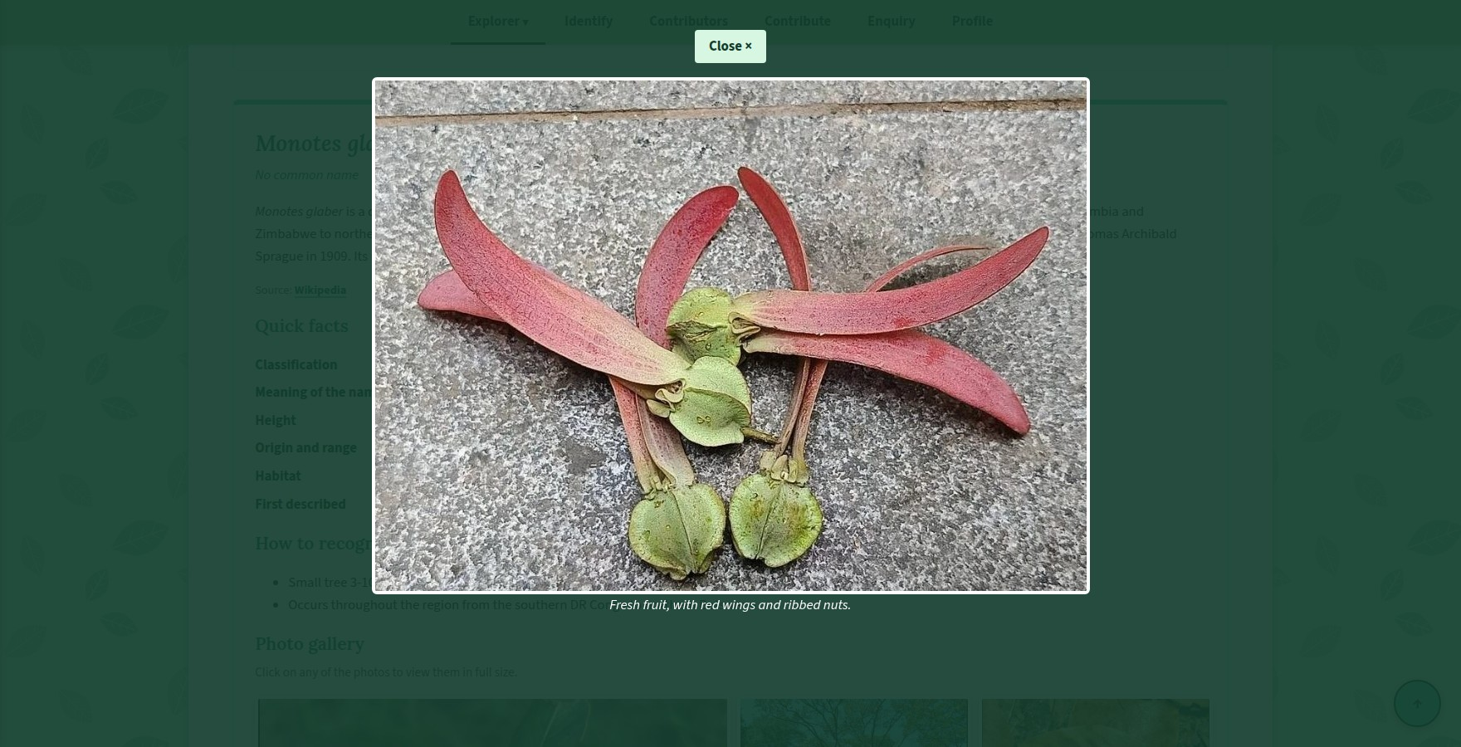
Website – Gallery and open lightbox
Table 30: Photo gallery with lightbox
Number | Code | Explanation
1 | <div class="gallery">  <figure>  <a href="#view-exp-1"><img src="images/exp-diptero.png" alt="Young Dipterocarpaceae plant on the forest floor, with one leaf turned over to show its silvery underside"></a>  <figcaption><strong>Dipterocarpaceae:</strong> a young plant on the rainforest floor, with straight, evenly spaced leaf veins.</figcaption>  </figure> | This is one of the pictures in the gallery. The <img> is surrounded by a link to the full-size view of the image: href="view-exp-1". The <figure> also has a <figcaption> which starts with a bold <label> and the description of the picture. All images on all galleries of the site are like that and each image is associated with its own id.
2 | <div class="lightbox" id="view-exp-1">  <a href="#photo-gallery" class="lightbox-close">Close &times;</a>  <img src="images/exp-diptero.png" alt="Young Dipterocarpaceae plant on the forest floor, with one leaf turned over to show its silvery underside">  <p>Dipterocarpaceae: a young plant on the rainforest floor, with straight, evenly spaced leaf veins.</p> | This is the full-size version of the above-mentioned photo, with the id = view-exp-1 that is the same <div> as the link above. It contains a "Close ×" link an image which is a larger version of this one with the same alt text and the caption text as a paragraph. Close is linked to the photo-gallery thus when clicked, the visitor is taken back to the gallery. Alternatively, on the Families, Genera and Species pages the Close link takes you back to the plant's own section.
3 | .gallery {  display: grid;  grid-template-columns: repeat(auto-fill, minmax(230px, 1fr));  gap: 1em;  }  .gallery figure {  margin: 0;  }  .gallery img {  width: 100%;  height: 180px;  object-fit: cover;  transition: transform 0.3s ease;  }  .gallery a:hover img,  .gallery a:focus img {  transform: scale(1.04);  } | This describes the thumbnails. The gallery can be resized to fit any screen resolution fitting as many columns as possible on the screen and at least 230px wide for each column and allocating the remaining space between the columns. All the thumbnails are 180px high and have the same width as their column object-fit: cover prevents the image from being stretched when it's displayed in the thumbnail. While the photos are in various shapes, this preserves the neatness and levelness of the rows. A thumbnail will be zoomed slightly when I hover over it.
4 | .lightbox {  display: none;  position: fixed;  top: 0;  left: 0;  z-index: 100;  box-sizing: border-box;  width: 100%;  height: 100%;  padding: 4vh 5%;  text-align: center;  background-color: rgba(18, 61, 46, 0.92);  }  .lightbox:target {  display: block;  }  .lightbox img {  display: block;  margin: 0 auto;  max-width: 100%;  max-height: 75vh;  border: 4px solid #ffffff;  border-radius: 6px;  } | This is the lightbox itself. Initially, all the lightboxes are set to display: none. All of it are being shown using position: fixed, width: 100% and height: 100%, as so the entire screen gets filled up when they are being displayed and z-index: 100 perfectly ensures that they are being displayed. Again, dark green is the background color having 0.92 transparency (rgba). The significant factor is .lightbox:target { display: block; } that will only show the lightbox with the id specified in the address after clicking its thumbnail. The big image is centred cannot be taller than 3/4 of the screen height (max-height: 75vh) and has a white border to ensure that the caption and Close button are always visible on the screen.

4.4 Flip cards
What it is: On each flip card is a picture of the plant and the plant name on the front. Pointing at a card results in a 3D flip of the card showing a brief fact and a link to that plant. On the Explorer page there are 8 flip cards while on the home page there are 4 flip cards.
Why I added it: I wanted something that people would want to delve into. Each card has a fact written on the back which encourages the visitor to move on to the next card and so on until at the end of the line the visitor has seen every species on the site. It also keeps the pages neat and tidy as the additional text is only shown when it is asked for.
How it works: The two sides of each card which are the front and the back and they are laid on top of each other. The back is already rotated 180 degrees and both sides are configured so they can't be seen from behind. The box with both sides of the card rotates 180 degrees when it is hovered to show the back of the card.
index.html code lines from 274 to 297 and style.css code lines from 2131 to 2193
Website – Flip card turned over
Table 31: Flip cards
Number | Code | Explanation
1 | <article class="flip-card">  <div class="flip-inner">  <div class="flip-front">  <img  src="images/fam-diptero-4.jpg"  alt="Red winged dipterocarp fruits on the forest floor">  <h3>Dipterocarpaceae</h3>  </div>  <div class="flip-back">  <h3>The dipterocarp family</h3>  <p>  Giant rainforest trees whose two-winged fruits spin like  little helicopters as they fall.  </p>  <a href="explore1.html#dipterocarpaceae" class="button"  >Meet the family</a  >  </div>  </div>  </article> | This is one flip card's HTML code. The <article class="flip-card"> is the outermost card. It contains <div class="flip-inner"> which is the component that is being flipped and it contains the two sides. The flip-front has a photo of the plant with alt text and the plant name in an <h3>. The flip-back has a heading at the top followed by a short fact in a paragraph and then a link styled as a button that goes to that plant on the Families or Species page. All flip cards on the site have this structure.
2 | .flip-card {  height: 310px;  perspective: 1000px;  }  .flip-inner {  position: relative;  width: 100%;  height: 100%;  transition: transform 0.7s ease;  transform-style: preserve-3d;  }  /*TURNS OVER WHEN HOVERING OR WITH KEYBOARD FOCUS*/  .flip-card:hover .flip-inner,  .flip-card:focus-within .flip-inner {  transform: rotateY(180deg);  } | The flip cards are shown in a grid of 230px wide columns as many as will fit on the screen. Each card is 310px tall and the perspective is set at 1000px giving the turn its 3D effect: the closer the viewer is perceived to be the stronger the effect. In addition to that the flip-inner box has transform-style: preserve-3d so that both sides of the card remain in 3D space during the flip animation and a 0.7 second transition so that the flipping becomes smooth. Following that the rule on lines 2148-2151 rotates the inner box 180 degrees vertically (rotateY(180deg)) when the card is hovered (:hover) or the button on its back has keyboard focus (:focus-within). So, it is vital to take the note that the :focus-within part means that not only mouse users but also keyboard users can flip the cards.
3 | .flip-front,  .flip-back {  position: absolute;  top: 0;  left: 0;  box-sizing: border-box;  width: 100%;  height: 100%;  overflow: hidden;  border-radius: 8px;  backface-visibility: hidden;  } | Both sides of the card are set at the very top left of the card and then sized to fit the whole width and height of the card so that the two sides overlap completely. The most crucial line is backface-visibility: hidden. It conceals each side when it is turned away from the viewer. On the contrary, let’s say if it is not there, the front face of the card would have been visible as a mirror image after the card was turned over.
4 | .flip-back {  display: flex;  flex-direction: column;  justify-content: center;  padding: 1.2em;  color: #123D2E;  text-align: center;  background-color: #5BCBA7;  transform: rotateY(180deg);  } | The rule transform: rotateY(180deg) is actually regarded as the back part of the card so it is primarily revolved away from viewer and just because of the visibility of the back face it is not visible when the page is loaded. When the whole card is rotated around 180°, the back part is also rotated along with it and finally ends up facing the viewer while the front part of the card is rotated away. Again, the background on the back side is of color mint and the heading fact and button are centred by using display: flex, flex-direction: column and justify-content: center.

4.5 Other enhancements
In addition to these 4 enhancements, there are more 11 ones: a page rating, a picture hover effect, hover effects for buttons and links, a back to top button, a Google Map, various CSS animation effects, expandable care tips and quiz answers, live feedback on forms, a site-map footer, a site search with suggestions and a link map diagram.
explore.html code lines from 736 to 748 and style.css code lines from 2246 to 2280
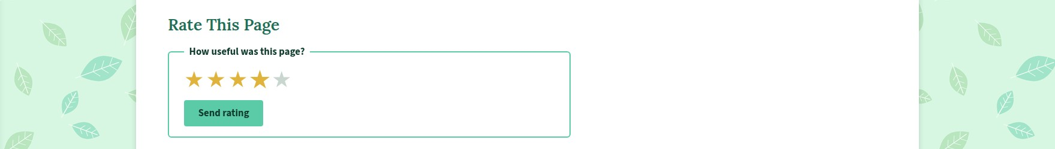
Website – Star rating
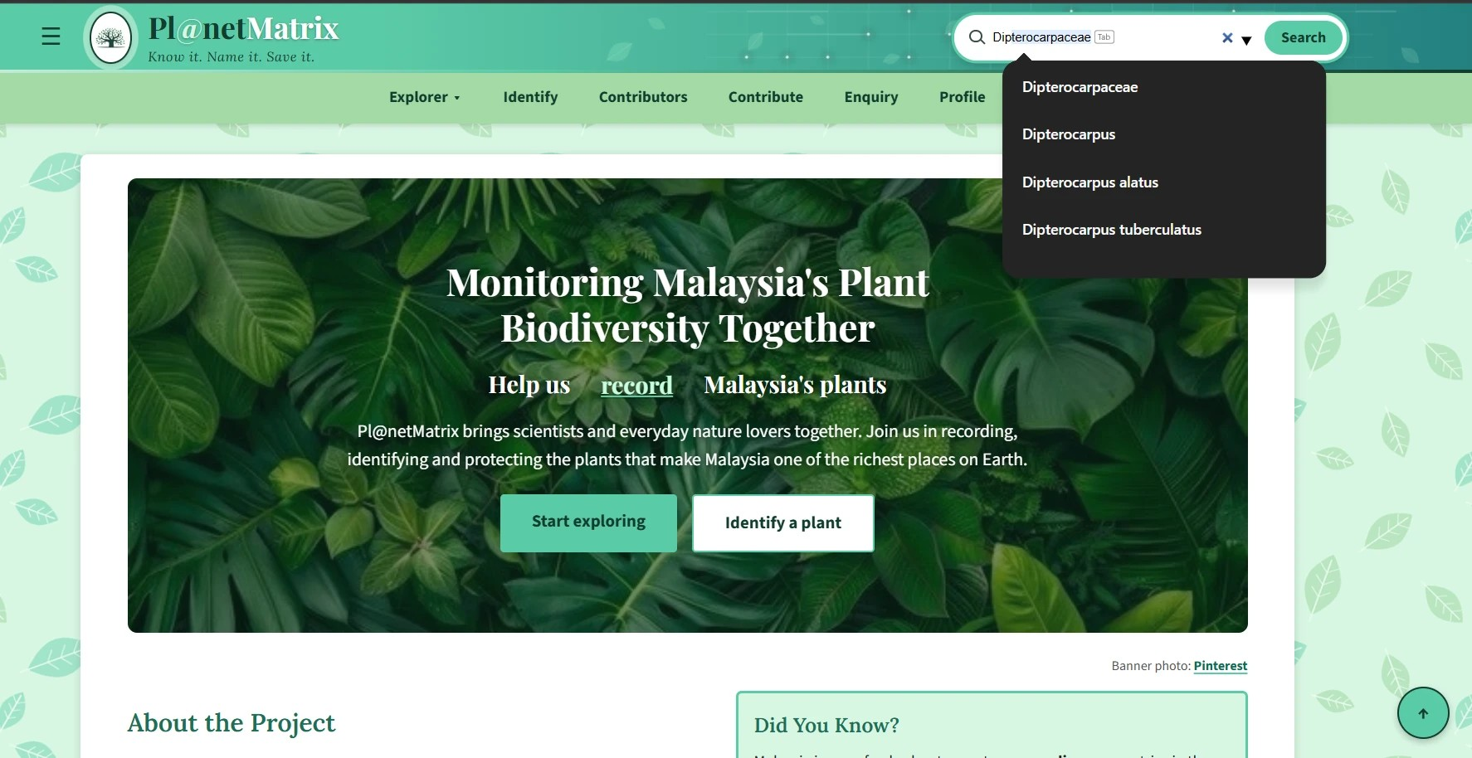
Website – Search suggestions
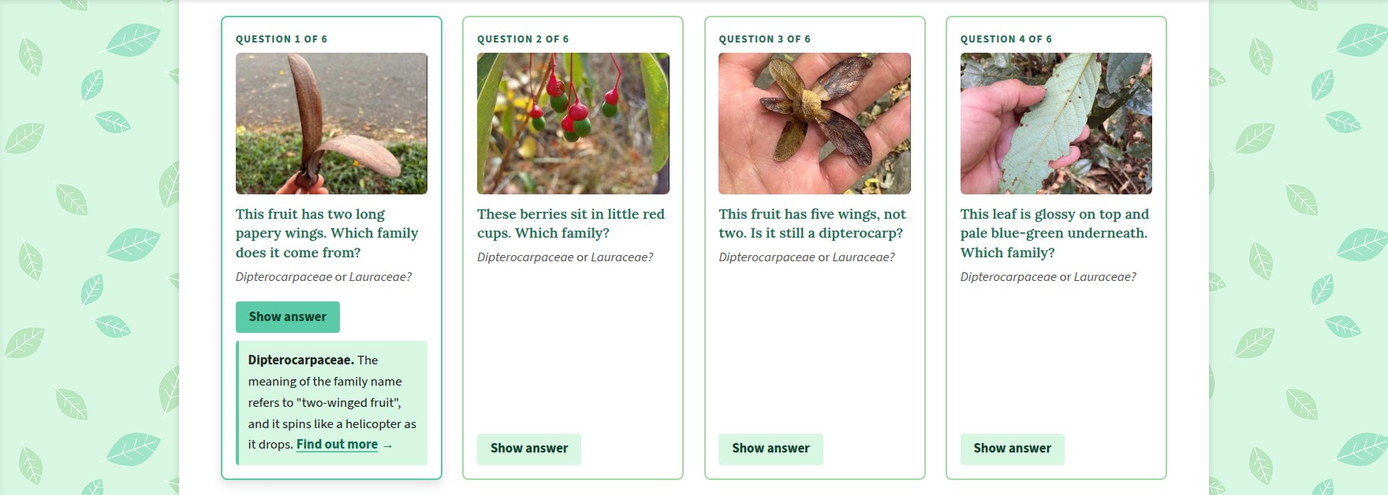
Website – Quiz answer opened
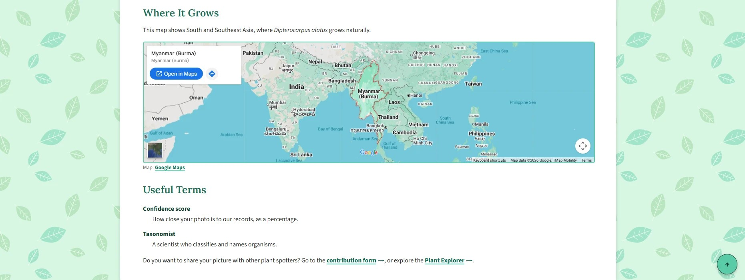
Website – Google Map and back to top button
Table 32: Other enhancements
Number | Code | Explanation
5 | <div class="stars">  <input type="radio" id="star5" name="rating" value="5" required>  <label for="star5" title="5 stars">&#9733;<span class="visually-hidden">5 stars</span></label>  <input type="radio" id="star4" name="rating" value="4">  <label for="star4" title="4 stars">&#9733;<span class="visually-hidden">4 stars</span></label>  <input type="radio" id="star3" name="rating" value="3">  <label for="star3" title="3 stars">&#9733;<span class="visually-hidden">3 stars</span></label>  <input type="radio" id="star2" name="rating" value="2">  <label for="star2" title="2 stars">&#9733;<span class="visually-hidden">2 stars</span></label>  <input type="radio" id="star1" name="rating" value="1">  <label for="star1" title="1 star">&#9733;<span class="visually-hidden">1 star</span></label>  </div>  <input type="submit" value="Send rating"> | As for the page rating in HTML, one will find 5 radio buttons within the <div class="stars">. They all share the name “rating” so as to ensure only a single option is ever selected. A <label> comes after each button to display the complete with a tooltip title and some visually hidden text for screen readers (“4 stars”, for instance). The order of the stars is deliberately reversed in the markup, running from 5 down to 1. This is necessary for the CSS on the following row to do its job given that selectors can only read forward.
6 | .stars {  display: inline-flex;  flex-direction: row-reverse;  gap: 0.2em;  margin-bottom: 0.8em;  }  .stars input {  position: absolute;  width: 1px;  height: 1px;  opacity: 0;  }  .stars label {  font-size: 2.2em;  line-height: 1;  color: #C9D6CF;  cursor: pointer;  transition: color 0.2s ease, transform 0.2s ease;  }  .stars label:hover,  .stars label:hover~label,  .stars input:checked~label {  color: #E0B43C;  }  .stars label:hover {  transform: scale(1.15);  }  .stars input:focus+label {  outline: 2px solid #1F6E56;  } | The CSS handles the presentation. A flex-direction: row-reverse does the trick of turning the stars around so they present themselves as 1 through 5 on the left to right side of the screen, despite the HTML being 5 to 1. The radio buttons are out of sight and the labels are rendered as large grey much like the menu checkbox. Then there is the matter of label:hover ~ label. Since the ~ selector is limited to elements that follow, and the code has the stars in reverse the ones that appear before the hovered star on screen are the ones that get lit up in gold when the fourth is pointed at. input:checked ~ label will make sure the selection stays put. The hovered star also gets a modest scale(1.15) bump in size.
7 | .family-tree-figure img,  .result-figure img {  transition: transform 0.4s ease, box-shadow 0.4s ease;  }  .family-tree-figure img:hover,  .result-figure img:hover {  transform: scale(1.02);  box-shadow: 0 8px 20px rgba(0, 0, 0, 0.3);  }  /*BUTTONS CHANGE COLOUR WHEN HOVERING*/  .button,  input[type="submit"],  input[type="reset"] {  transition: background-color 0.3s ease, transform 0.2s ease, box-shadow 0.2s ease;  }  .button:hover,  .button:focus,  input[type="submit"]:hover,  input[type="reset"]:hover {  transform: translateY(-2px);  box-shadow: 0 4px 10px rgba(0, 0, 0, 0.2);  } | Hover effects are applied to the picture and button as well. Put the mouse over the family tree or the Identify example photo and they will seem to come off the page with a deeper shadow and a bit more heft (scale(1.02)) the whole thing taking 0.4 seconds to transition. The buttons have their own transitions for colour and position; on hover they shift up 2px via translateY(-2px) and throw a shadow to let the user know they are active.
8 | main p:not(.breadcrumb) a[href$=".html"]:not(.button)::after,  main p:not(.breadcrumb) a[href*=".html#"]:not(.button)::after,  main li a[href$=".html"]:not(.button):not(.tree-node)::after,  main li a[href*=".html#"]:not(.button):not(.tree-node)::after {  content: "\2192";  display: inline-block;  margin-left: 0.25em;  transition: transform 0.2s ease;  }  /*THE ARROW MOVES FORWARD WHEN HOVERING OVER THE LINK*/  main p a:not(.button):hover::after,  main p a:not(.button):focus::after,  main li a:not(.button):not(.tree-node):hover::after,  main li a:not(.button):not(.tree-node):focus::after {  transform: translateX(4px);  } | Finally, the link arrows. Any text links in the body that go to another page are given a → by the ::after pseudo-element, courtesy of attribute selectors like a[href=".html"]. This way a visitor can distinguish them from internal page links which lack an arrow. If the link is focused or the cursor is over it the arrow will advance 4px.
9 | .to-top {  position: fixed;  right: 1.2em;  bottom: 1.2em;  z-index: 60;  width: 2.6em;  height: 2.6em;  line-height: 2.6em;  font-size: 1.2em;  font-weight: bold;  color: #123D2E;  text-align: center;  text-decoration: none;  background-color: #5BCBA7;  border: 2px solid #123D2E;  border-radius: 50%;  box-shadow: 0 3px 8px rgba(0, 0, 0, 0.25);  transition: background-color 0.3s ease, transform 0.3s ease;  }  .to-top:hover,  .to-top:focus {  background-color: #A3D9A5;  transform: translateY(-3px);  } | A round mint button with an upward arrow (↑) in the lower right of the screen serves as the back to top control. I have set the html element’s scroll-behavior to smooth, meaning a click will take the user gently back to the header instead of a hard jump, on hover it will turn leaf green and lift 3px. This is a useful feature for the lengthier Explorer pages.
10 | <div class="map-frame">  <iframe src="https://maps.google.com/maps?q=Myanmar&amp;z=4&amp;output=embed"  title="Map of South and Southeast Asia" loading="lazy"></iframe>  </div> | On the Identify page there is a Google Map presented as an <iframe>. It is centred on Myanmar to show where the example plant can be found with a broader view of South and Southeast Asia. A title has been added for screen reader accessibility and loading is set to “lazy” so the site does not slow down until the visitor is near it. The CSS allows it to fill its container.
11 | .hero-text .word {  display: inline-block;  /*HIDDEN UNTIL ITS TURN COMES*/  animation: wordRise 0.7s ease-out both;  }  .hero-text .word:nth-child(1) {  animation-delay: 0.2s;  }  .hero-text .word:nth-child(2) {  animation-delay: 0.5s;  }  .hero-text .word:nth-child(3) {  animation-delay: 0.8s;  }  .hero-text .word:nth-child(4) {  animation-delay: 1.1s;  }  .hero-text .word:nth-child(5) {  animation-delay: 1.4s;  } | The CSS animations. As for the home page heading, every word is inside a span and subject to the wordRise animation which fades them in and lifts them 30px. Thanks to nth-child rules applying a staggered delay from 0.2s to 1.4s. The words come up one by one to form the heading. I will see this kind of thing elsewhere on the site: the logo sways and glows under the mouse, the Identify button pulses, content fades up on load and the “Help us ___” phrase cycles through four options every couple of seconds. Of course, all such motion is disabled for those who prefer to do without it.
12 | <details>  <summary>Show answer</summary>  <p class="quiz-answer"><strong>Dipterocarpaceae.</strong> The meaning of the family name refers to "two-winged fruit", and it spins like a helicopter as it drops. <a href="explore1.html#dipterocarpaceae">Find out more</a></p>  </details>  </article> | The expandable quiz answers make use of the HTML5 <details> and <summary> tags. The <summary> (“Show answer”) is what is visible at first. Clicking it reveals the rest of the <details> and a second click puts it away again. The care tips are handled in like manner.
13 | fieldset:focus-within {  background-color: #D8F7E3;  }  ...  input:focus:invalid,  textarea:focus:invalid {  border-color: #B3261E;  }  input:focus:valid,  textarea:focus:valid {  border-color: #1F6E56;  } | There is live feedback on the forms. While the visitor is at the keyboard, :invalid and :valid rules will colour the border of the field red for any infractions such as a number in the name and green when the value is right. The fieldset:focus-within applies a pale mint background to whatever part of the form has their attention. One does not have to hit Submit to get that response.
14 | footer::before {  content: "";  position: absolute;  top: -18px;  left: 0;  width: 100%;  height: 18px;  background: radial-gradient(circle at 18px 18px, #5BCBA7 17px, transparent 18px) repeat-x;  background-size: 36px 18px;  }  ...  .footer-col a::after,  .footer-bottom a::after {  content: "";  position: absolute;  left: 0;  bottom: -2px;  width: 100%;  height: 2px;  background-color: #123D2E;  transform: scaleX(0);  transition: transform 0.3s ease;  }  .footer-col a:hover::after,  .footer-col a:focus::after,  .footer-bottom a:hover::after,  .footer-bottom a:focus::after {  transform: scaleX(1);  } | In the footer, a radial-gradient circle is repeated via footer::before to give the top edge a wavy appearance. Hovering over the links in the 5 column responsive grid (Section 3.4) triggers the ::after rules to grow an underline from nothing to full width.
15 | <input  type="search"  id="site-search-input"  name="q"  list="site-suggestions"  placeholder="Find a plant or page"  maxlength="40"  required>  <datalist id="site-suggestions">  <option value="Dipterocarpaceae"></option>  <option value="Lauraceae"></option>  <option value="Dipterocarpus"></option>  <option value="Monotes"></option> | The search box is linked to a <datalist> of suggestions by the list attribute. As text is entered the browser displays matches below for the visitor to select. The :focus-within pseudo-class is what expands and highlights the box while the magnifying glass is put in place with ::before and ::after (Section 3.2).
16 | .tree li::before,  .tree li::after {  content: "";  position: absolute;  top: 0;  right: 50%;  width: 50%;  height: 1.5em;  border-top: 2px solid #5BCBA7;  }  .tree li::after {  right: auto;  left: 50%;  border-left: 2px solid #5BCBA7;  } | Finally, the link map diagram on the Explorer is constructed from three tiers of nested lists. Pseudo-elements are placed on each item to form a T shape over the box with lines on top and to the left. The rules on lines 1936-1962 then trim the outer halves and round the corners of the first and last items in a row to give it the look of a family tree.

5. Conclusion
This report describes the HTML and CSS code that is the foundation of the citizen science website Pl@netMatrix for monitoring Malaysia's plant biodiversity. The HTML section went over each page in detail with line numbers based on my code: the shared head, header, menus and footer, the home page, the 4 Explorer pages, the Identify page, the Contributors page, the 2 forms, the Profile page and the 2 supporting pages. For the purpose of building this website Pl@netMatrix, I consistently used those elements which elaborates the contents in a well-mannered way. In addition, all form fields are labelled and HTML rules prevent bad data from being sent in any form field.
The CSS section showed that there is a single stylesheet for all 12 pages. It has a green colour scheme having the three fonts, a white content panel and leaf background, styles the header, menus and footer and adds touches to each page. Not only do the flexible grids size themselves to the screen with auto-fit and auto-fill but a media query makes the first image in the gallery larger on wider screens, a different media query rearranges all the pages for a phone-sized screen and a reduced-motion media query disables the animations for those who do not wish to see them. A total of fifteen enhancements were all covered in the last section.
My biggest learning point was how much can be achieved using HTML and CSS. I just needed to find the right selector: :checked for the side menu, :target for the lightbox and reversed stars with the ~ selector for the star rating. They all required some trial and error and a ton of reading on W3Schools but bit by bit I worked them out and that gave me a better grasp of how CSS selectors work than any one tutorial. I also learned that a big project is easier if you start by writing clean HTML, style everything in one well-commented stylesheet and credit pictures and sources from the beginning rather than at the end.

6. References
[1] Google, “Google Fonts,” Google. Accessed: Sep. 2026. [Online]. Available: https://fonts.google.com/
[2] iNaturalist, “iNaturalist,” iNaturalist. Accessed: Sep. 2026. [Online]. Available: https://www.inaturalist.org/
[3] Pl@ntNet, “Pl@ntNet Identify,” Pl@ntNet. Accessed: Sep. 2026. [Online]. Available: https://identify.plantnet.org/
[4] Royal Botanic Gardens, Kew, “Plants of the World Online,” POWO. Accessed: Sep. 2026. [Online]. Available: https://powo.science.kew.org/
[5] W3Schools, “CSS Tutorial,” W3Schools. Accessed: Sep. 2026. [Online]. Available: https://www.w3schools.com/css/
[6] W3Schools, “HTML Tutorial,” W3Schools. Accessed: Sep. 2026. [Online]. Available: https://www.w3schools.com/html/
[7] Wikipedia contributors, “Dipterocarpaceae, Lauraceae and related genus and species articles,” Wikipedia, The Free Encyclopedia. Accessed: Sep. 2026. [Online]. Available: https://en.wikipedia.org/

