Pl@netMatrix
Project Report
Name: Tousif Akhand
Student ID: 105822937

1. Introduction

1.1 About the project
Malaysia has an amazing range of plants, but a lot of them are now Endangered, Rare or Threatened (ERT). Scientists need to know where these plants still grow, and they can’t be everywhere at once. That’s where citizen science comes in. Ordinary people take photos of plants they find and share them, and scientists use that information.
For this assignment I built Pl@netMatrix, a website for this kind of citizen science project. It has twelve pages and is made only with HTML5 and CSS3, with no JavaScript. On the site you can learn about two plant families, four genera and eight species, try to identify a plant from a photo, look at photos other people have shared, send in your own plant records and ask questions. The slogan I came up with is “Know it. Name it. Save it.”

1.2 What this report is for
In this report I explain how I planned and built the website. I go through what each page does, how I used HTML and CSS, and which features I think make the site stand out, including the extra enhancements.

1.3 How this report is laid out
- Section 2 covers the content of the website: each page, how I used HTML, and a site map.
- Section 3 covers the style: the look of the site, how I used CSS, and screenshots.
- Section 4 explains the key features and all of the enhancements in detail.
- Section 5 sums things up and suggests what could be improved next.
The references are at the end.

2. Website content

2.1 The pages and what they do
There are twelve pages in total. They all share the same header, menu bar and footer, so it’s always easy to tell where you are and get to another page.

Home page (index.html)
This is the first page people see. At the top there’s a big banner with the heading “Monitoring Malaysia’s Plant Biodiversity Together” and two buttons, Start exploring and Identify a plant. Below that, there’s a short explanation of why Malaysia’s plants need help and what citizen science is. Feature cards point people to the main parts of the site, and four flip cards introduce some of the plants.

Explorer pages (explore.html, explore1.html, explore2.html, explore3.html)
The Explorer works like a small plant encyclopedia. The main Explorer page links to the three levels: Families, Genera and Species. As the case study asks, it also has two direct links to the Identify and Contributors pages, under the heading “Found a Plant?”. The page also has a family tree picture, a link map that shows how all the plants connect, a chart comparing the two families, a photo gallery, a star rating and a short quiz.
The Families, Genera and Species pages all follow the same layout. Each plant has its own box with its name, a description written in my own words, a link to where the information came from, a list of quick facts, some tips on how to recognise it, and a photo gallery. I picked two families (Dipterocarpaceae and Lauraceae), two genera from each family and two species from each genus. The pages link to each other, so you can go from a species up to its genus or family and back again.

Identify page (identify.html)
Here you can upload a photo of a plant or search for it by name. Since the site doesn’t have a server program yet, I added an example result to show what you would see: the scientific and common names, where the plant grows, care tips, other possible matches and a Google Map.

Contributors and Contribute pages (contributor.html, contribute.html)
The Contributors page shows nine photo cards of plants shared by plant spotters. Each card has the plant’s name, who shared it, a short note and a “Verified” label. There’s also a button that takes you to the Contribute page, where the contribution form is. The form asks for your name, email, the plant’s name and family, the date you saw it, your photos and a comment.

Enquiry page (enquiry.html)
This page has a form for asking questions about the plants. You fill in your name, email and phone number, pick a topic from a drop-down list (a family, genus or species), choose how you’d like to be contacted and write your question.

Profile, Enhancements and Acknowledgements pages
The Profile page is about me. It has my photo, name, student number and course, a short introduction, and a table with my hometown, an achievement I’m proud of and my favourite sports, films, music and food. The Email Me button is at the bottom of the page in the footer. The Enhancements page lists all sixteen extra features, with links to where they are used. The Acknowledgements page credits every photo, source, icon and tutorial I used.

2.2 How I used HTML
I wrote all the pages in HTML5 and kept the design completely separate, in the CSS file. There’s no styling inside the HTML. These are the main things I used:
- Page structure. Every page uses <header>, <nav>, <main>, <section>, <article>, <aside> and <footer>, so each part of the page has a clear job. Each plant profile is an <article>.
- Headings. Each page has one <h1>, then <h2> and <h3> headings in order underneath it.
- Lists, tables and figures. Ordered lists are used for step-by-step instructions, definition lists for quick facts and key words, and tables for summaries. Every photo is inside a <figure> with a <figcaption>, and every image has alt text.
- Forms. Both forms use <fieldset> and <legend> to group the questions. Every field has a <label> and is required. Names only accept letters, up to 25 characters, using maxlength and pattern. I used different input types such as email, tel, date, file, radio and checkbox, plus a <select> drop-down. The forms send their data to the unit’s test server.
- Links. Links like explore3.html#d-alatus take you straight to one plant on a page, and “On this page” lists help on the longer pages.
- Other HTML5 elements. <details> and <summary> hide care tips and quiz answers until you click, <datalist> gives search suggestions, and an <iframe> shows the Google Map.
- Meta data and comments. Every page has a title, character set, viewport, description, keywords and author. I also added short comments in plain words to explain each part of the code.

2.3 Site map
The site map shows how the pages connect. The menu bar links to the six main pages, and the Explorer drop-down leads to Families, Genera and Species. The Enhancements and Acknowledgements pages can be reached from the side menu and the footer on every page.
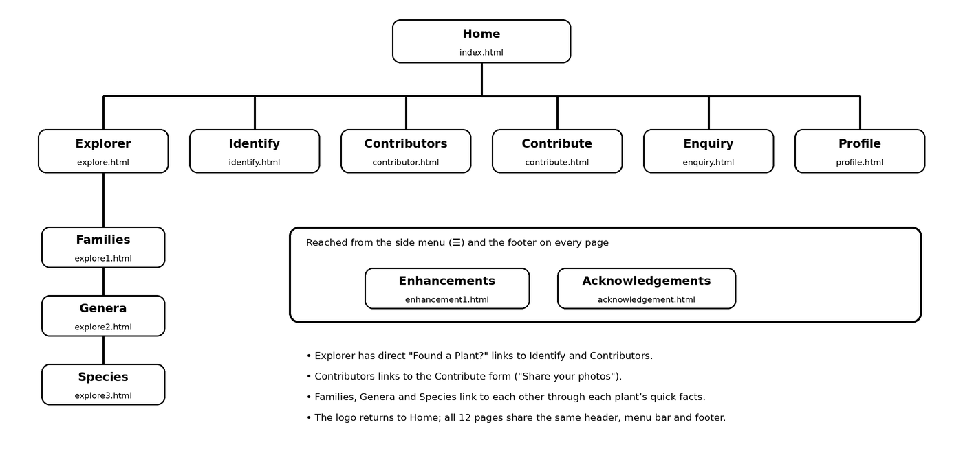
Figure 1: Site map of Pl@netMatrix

3. Website style

3.1 The look of the site
I wanted the site to feel calm and fresh, a bit like walking through a botanical garden. So I used greens throughout, with lots of white space to keep the text easy to read. The main colours are mint green (#5BCBA7) for the header and buttons, pale mint (#D8F7E3) for the background, leaf green (#A3D9A5) for the menu bar, and deep teal (#123D2E) and dark green (#1F6E56) for text and headings.
For the fonts I picked three free Google Fonts. Playfair Display is used for the site name and page titles, Lora for the other headings, and Source Sans 3 for the main text. Each one has a backup font in case it doesn’t load.
The header fades from mint to teal, with faint leaves and grid lines in the background. It has the round tree logo with a soft glow, the site name in two colours, the slogan, and the search box on the right.

Figure 2: The header with the logo, site name, slogan, search box and menu bar

3.2 How I used CSS
All the styling is in one file, styles/style.css. It starts with a comment that explains the file and lists the colour scheme, and each group of rules has a short comment so it’s easy to find things.
- Selectors. I used all the selector types from the brief: element (h1, p), class (.button), ID (#site-header), grouping (h2, h3), contextual (.plant-facts dl) and pseudo-classes (:hover). I also used some more advanced ones, like attribute selectors and the sibling selector (~).
- Menu. The menu bar has a leaf-green background, bold links, a line under the page you are on, and an Explorer drop-down that opens on hover or with the keyboard.
- Text. The <h1> uses the font shorthand, font: bold 2.4em/1.2 "Playfair Display", Georgia, serif. Colours and text alignment are set for headings, links and captions.
- Box model. Borders, padding, margins, rounded corners, shadows and a leaf background picture give each part of the page its shape.
- Liquid layout. Widths are in percentages and viewport units, and flexbox and CSS grid move things around when the window gets smaller or bigger.
- Brief requirements. The aside is 30% of the screen width (30vw), floats to the right and has a coloured border. The footer is the full width of the page, with italic, centred text.
- Animations. Six @keyframes animations bring the banner, cards and logo to life. A prefers-reduced-motion rule turns them off for people who prefer less movement.

3.3 Screenshots
Here are some screenshots of the finished design, taken on a desktop screen.
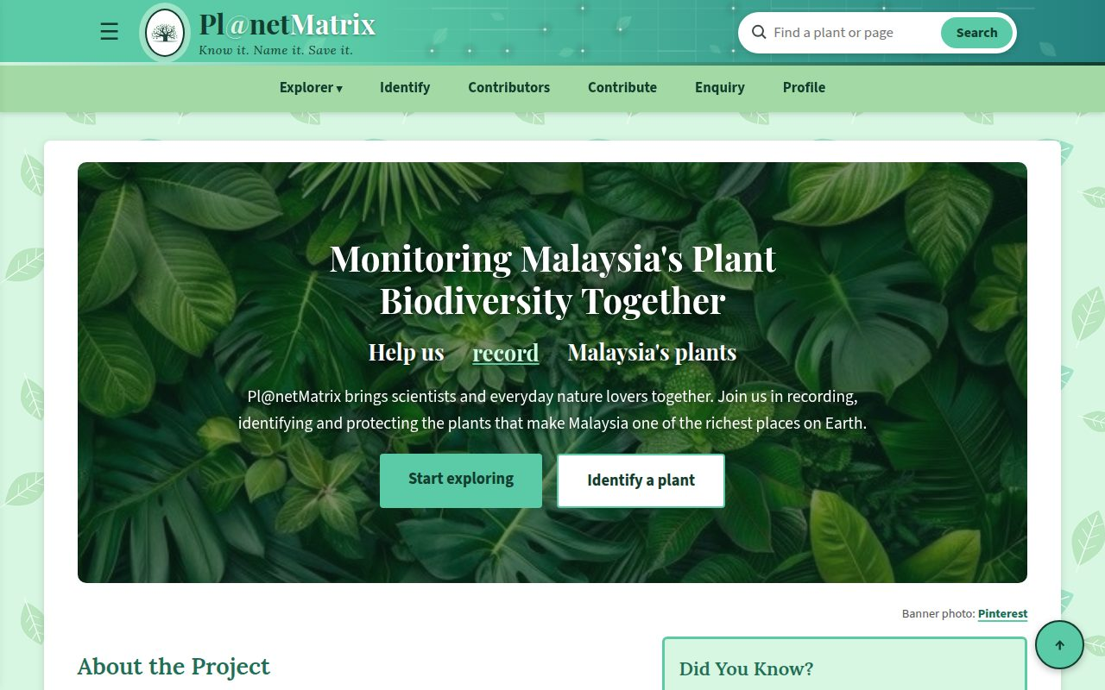
Figure 3: The Home page with the banner and side note
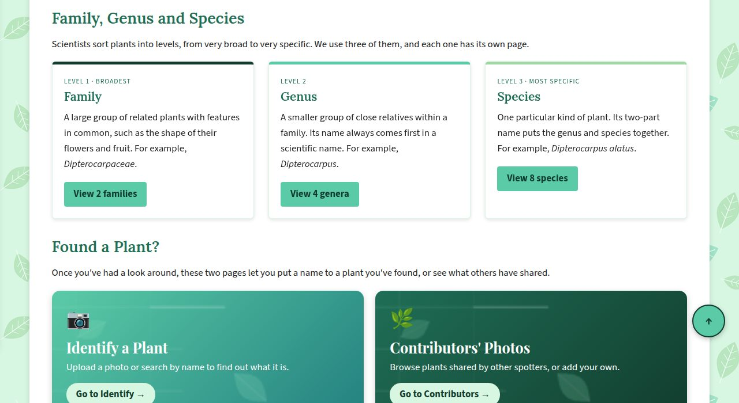
Figure 4: The Explorer page with the three levels and the “Found a Plant?” links
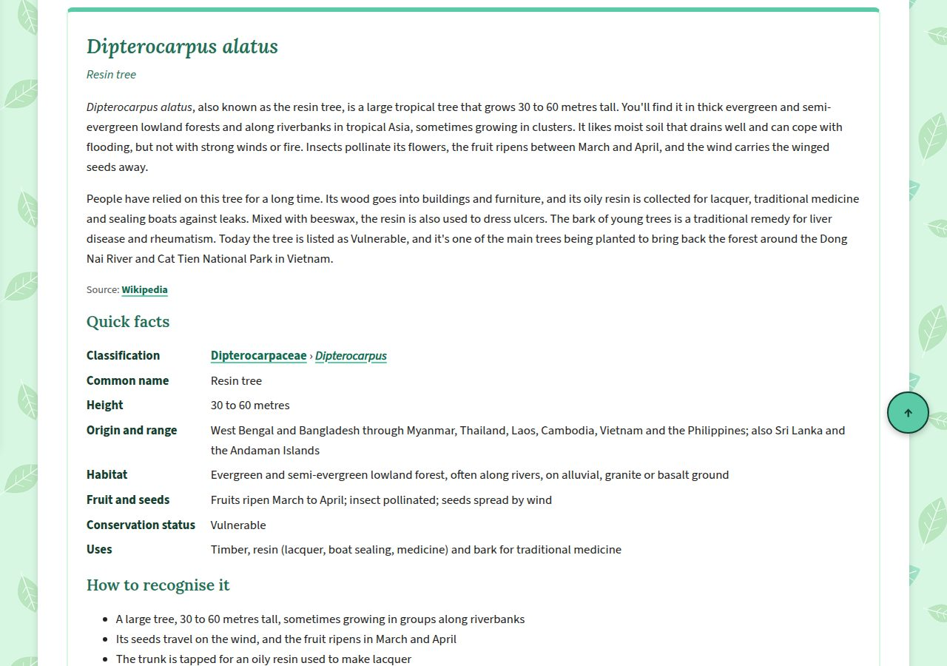
Figure 5: A species profile with its description, source and quick facts
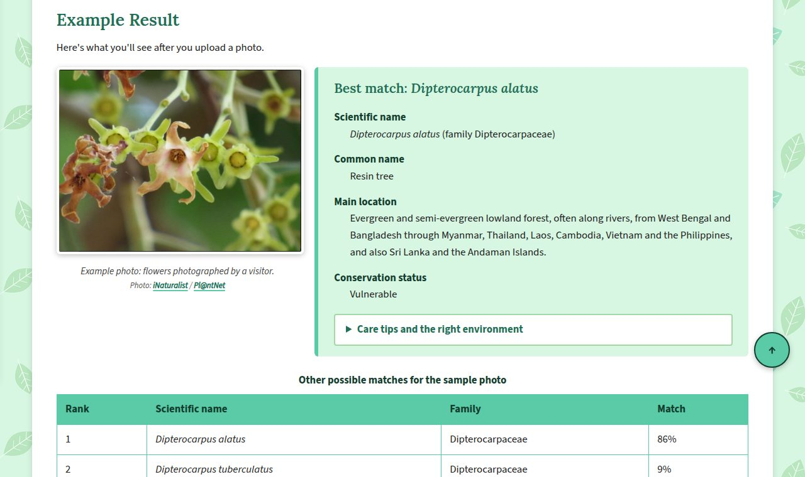
Figure 6: The example result on the Identify page
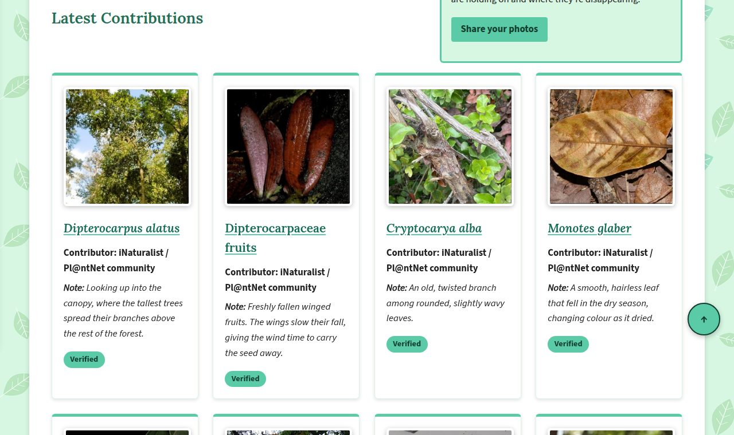
Figure 7: Photo cards on the Contributors page
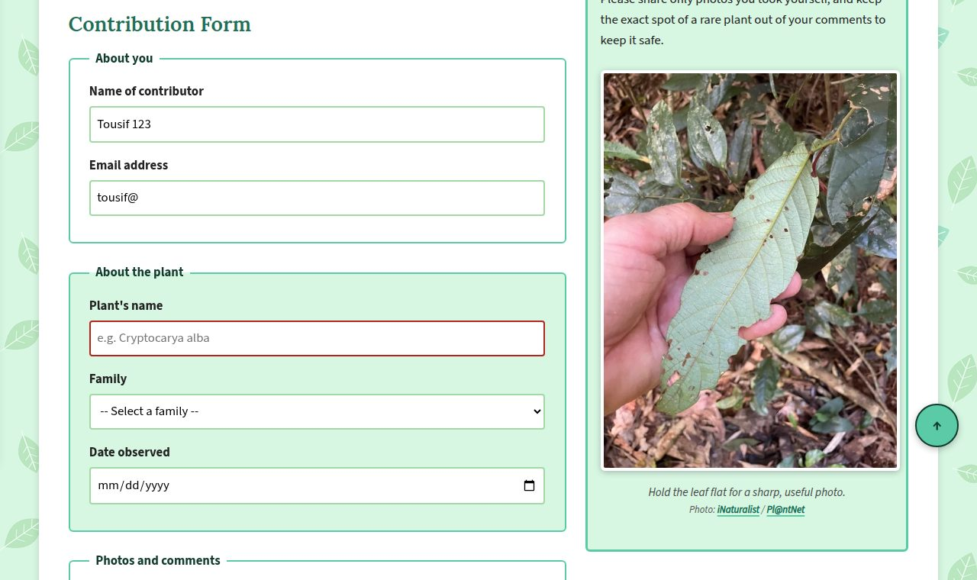
Figure 8: The contribution form showing red borders for entries that still need fixing
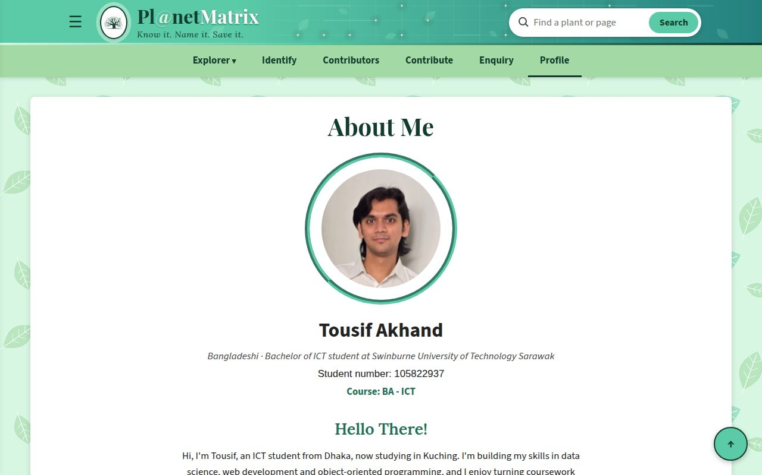
Figure 9: The Profile page

4. Key features and enhancements

4.1 What makes the site stand out
These are the things that run through the whole website:
- Everything is connected. All fourteen plants are linked to each other. From a species you can jump up to its genus or family, and from a family you can go down to every plant in it. The link map on the Explorer page shows all of this in one picture.
- You learn by doing. The Explorer page isn’t just text to read. You can compare the two families in a chart, follow the steps on how to tell them apart, and test yourself with a six-question quiz where the answers stay hidden until you click.
- The forms help you. Fields turn red when something isn’t right and green when it is, the section you’re filling in lights up, and you can’t send a form until every required field is filled in.
- Sources are always shown. Every plant description has a source link right under it, every gallery says where the photos came from, and the Acknowledgements page lists more than 170 credits.
- It’s easy to use. The writing is clear and simple, links are bold and easy to spot, everything works with the keyboard as well as the mouse, and animations switch off for anyone who has asked their device for less movement.
- No JavaScript. Every feature, including the sliding menu, photo viewer, flip cards and star rating, is made with HTML and CSS only.

4.2 My four main enhancements
The brief says up to four enhancements will be marked, so these are the four I’m putting forward. For each one I explain what it does, how I made it, where to find it and why it’s useful.

Enhancement 1: Fluid layout with a hamburger menu
- What it does. Every page stretches or shrinks to fit the window. There’s also a ☰ button next to the logo. Click it and a side menu slides in from the left with a list of all twelve pages.
- How I made it. Widths are in percentages, and flexbox and CSS grid rearrange the cards when the window changes size. The side menu uses a hidden checkbox. The ☰ button is the checkbox’s label, so clicking it ticks the box. The menu normally sits just off the left side of the screen using transform: translateX(-105%). When the box is ticked, the rule .menu-toggle:checked ~ .side-menu moves it back to translateX(0), and a transition makes it slide in smoothly. A “× Close” label unticks the box and the menu slides away again.
- Where to find it. The ☰ button is in the header of every page. To see the fluid layout, make your browser window narrower.
- Why it’s useful. The menu bar only has room for six pages. The side menu means every page, including Enhancements and Acknowledgements, is always one click away.

Enhancement 2: Fixed navigation bar
- What it does. The menu bar stays at the top of the screen while you scroll, so you never have to scroll back up to change pages.
- How I made it. The menu bar uses position: sticky with top: 0. It scrolls along with the page until it reaches the top of the window, then stays there. A z-index keeps it above the other content. I also added scroll-padding-top, so when you click a link to a section, the heading doesn’t end up hidden under the menu bar.
- Where to find it. On every page, but it’s most helpful on the long Species page.
- Why it’s useful. You can move around the site at any point without losing your place.

Enhancement 3: Photo gallery with a lightbox
- What it does. Every family, genus and species has its own photo gallery, and the Explorer page has one too. Click any photo and it opens full-screen over a dark background, with its caption and a Close button.
- How I made it. Each big photo is inside a hidden box with its own id, further down the page. Each small photo is a link to that id. When you click it, the address ends with that id, and the :target selector shows the box using display: block. The box uses position: fixed to cover the whole window. The Close link goes back to the plant’s section, so the box hides again.
- Where to find it. In the galleries on the Explorer, Families, Genera and Species pages.
- Why it’s useful. The small photos keep the pages neat, but you can still see the leaves, bark and fruit up close when you want to.

Enhancement 4: Flip cards
- What it does. Each flip card shows a plant photo on the front. When you hover over it, or reach it with the keyboard, it turns over in 3D to show a fun fact and a link to that plant.
- How I made it. Each card has a front and a back stacked on top of each other. The card has perspective: 1000px, which gives the flip some depth. On hover or focus, the inner part turns with transform: rotateY(180deg) and a smooth transition. The back starts already turned around, and both sides use backface-visibility: hidden, so you only see one side at a time.
- Where to find it. In “Meet the Plants” on the Home page (four cards) and in the Species Flip Gallery on the Explorer page (eight cards).
- Why it’s useful. It makes learning about the plants more fun, and people want to see what’s on the back.

4.3 My other enhancements
On top of the main four, I added twelve more features. They are all listed on the Enhancements page with links to where they are used.

5. Page rating
You can rate the Explorer page from one to five stars. The stars are radio buttons with the round buttons hidden and the labels shown as stars. I wrote the stars in the code from 5 down to 1, then flipped them on screen with flex-direction: row-reverse. This lets the sibling selector (~) light up every star up to the one you point at. The rating is sent to the test server like any other form.

6. Picture hover effect
When you point at a picture, it grows a little with transform: scale() and gets a deeper shadow, and gallery thumbnails zoom in slightly. A transition makes it smooth. It shows people the picture can be clicked. You can see it on the family tree and the galleries.

7. Button and link hover effects
Buttons like “Start exploring”, “Identify” and “Submit” change colour, lift up slightly and get a shadow when you point at them. Links in the text are bold with a thick mint underline. Links to other pages also get a small arrow at the end that moves forward on hover. The arrow is added with ::after, and the attribute selector a[href$=".html"] makes sure only links to other pages get it.

8. Back to top button
A round ↑ button sits in the bottom-right corner of every page. Clicking it takes you back to the top. It uses position: fixed so it stays in the corner, and scroll-behavior: smooth so the page glides up instead of jumping.

9. Google Map
The Identify page has a Google Map showing where the example plant grows. It’s added with an <iframe> inside a box that stretches to the width of the page.

10. CSS animations
On the Home page banner, the heading appears one word at a time, and the line “Help us ___ Malaysia’s plants” keeps changing between explore, identify, record and protect. Around the site, headings, cards and form sections fade up as the page opens, the logo glows softly and sways when you point at it, and the Identify button gently pulses. There are six @keyframes animations in total, and they all switch off for anyone who has turned on reduced motion.

11. Expandable care tips and quiz answers
On the Identify page, the care tips are inside a box that opens and closes with one click, which keeps the result short. The quiz answers on the Explorer page work the same way. Both use the HTML5 <details> and <summary> elements.

12. Live form feedback
While you fill in the forms, each field’s border turns red if the entry isn’t right yet and green once it is. This uses the :invalid and :valid selectors along with required, maxlength and pattern in the HTML. The :focus-within selector also highlights the section you’re working on. This way people can fix mistakes as they go.

13. Site-map footer
Every page ends with a footer that works like a site map. It has the line “Every photo helps protect a plant”, five columns of links to every part of the site, and a bottom bar with a Back to top link. CSS grid arranges the columns, the wavy edge along the top is drawn with a radial-gradient, and each link gets an underline that grows from the middle when you point at it.

14. Site search with suggestions
There’s a search box in the header of every page. As you type, it suggests plant names and pages using the HTML5 <datalist> element. When you click into the box, it gets wider and glows mint, using :focus-within and a transition. The magnifying glass icon is drawn with CSS instead of an image.

15. Link map diagram
The Explorer page has a tree diagram linking both families to their genera and species. In the code it’s just a nested list. The lines between the boxes are drawn with ::before and ::after, and each box links to that plant’s section.

16. Family comparison chart
This chart on the Explorer page compares the two families side by side: fruit, leaves, smell, size, seeds, range and uses. Each family has its own colour bar, every second row is shaded with :nth-child(even), and the row you point at lights up so it’s easy to read across.

5. Conclusion

5.1 Summary
Pl@netMatrix turns the case study into a twelve-page website for exploring, identifying and recording Malaysia’s rare plants. The HTML is well structured and kept separate from the design, and the CSS uses a wide range of selectors, a liquid layout and a calm green look. Sixteen enhancements, led by the hamburger menu, fixed navigation bar, photo lightbox and flip cards, make the site easier and more fun to use, and every source is credited.
Building it taught me how much you can do with just HTML and CSS, and how small things like clear wording and easy-to-spot links make a big difference to the people using a site.

5.2 Ideas for the future
- Real identification and search. In Assignment 2, JavaScript or a server program could match uploaded photos with real records and make the search work properly.
- More plants. The encyclopedia could grow to cover more of the families and genera in the PlantsData list.
- User accounts. Contributors could log in, see their own records and know when an expert has checked their photos.
- A live map. Checked sightings could show up as pins on a map, so people can see where rare plants still grow.
- A better phone layout. A separate stylesheet for phones would make the pages even easier to use on small screens.

References
Google. (n.d.). Google Fonts. https://fonts.google.com/
Google. (n.d.). Google Maps. https://www.google.com/maps
iNaturalist. (n.d.). iNaturalist. https://www.inaturalist.org/
ePlant AI. (n.d.). Beilschmiedia costaricensis. https://eplantai.com/plant/beilschmiedia-costaricensis
Pl@ntNet. (n.d.). Pl@ntNet identify. https://identify.plantnet.org/
Royal Botanic Gardens, Kew. (n.d.). Cryptocarya adpressa. Plants of the World Online. https://powo.science.kew.org/taxon/urn:lsid:ipni.org:names:77159775-1
Science Education Resource Center, Carleton College. (n.d.). Plant family tree [Image]. https://serc.carleton.edu/integrate/teachingmaterials/foodsupply/student_materials/805
Swinburne University of Technology Sarawak. (2026). Web Development Assignment 1: brief, case study and PlantsData [Unit documents].
W3Schools. (n.d.). HTML and CSS tutorials. https://www.w3schools.com/
Wikipedia. (n.d.). Dipterocarpaceae, Lauraceae, Dipterocarpus, Monotes, Beilschmiedia, Cryptocarya and species articles. https://en.wikipedia.org/

