Pl@netMatrix
A Citizen Science Website for Malaysia’s Rare Plants
Project Report · Web Development Assignment 1
Name: Tousif Akhand
Student ID: 105822937
Course: BA - ICT
University: Swinburne University of Technology Sarawak
Semester: Semester 2, 2026

Contents
1 Introduction
2 Website content
3 Website style
4 Key features and enhancements
5 Conclusion
References
Appendix A: All enhancements
Appendix B: The website on a phone

1. Introduction

1.1 About the project
Malaysia is one of only about seventeen “megadiverse” countries in the world, and its forests are home to thousands of plants found nowhere else. Many of them are now Endangered, Rare or Threatened (ERT), and before scientists can protect them, they need to know where these plants still grow. That’s a big job for a small team, which is why the case study asks for a citizen science website: a place where ordinary people can explore plants, identify what they find and share their photos with researchers.
My answer is Pl@netMatrix. It’s a twelve-page website built only with HTML5 and CSS3, with no JavaScript, as the brief requires. Visitors can browse two plant families, four genera and eight species in a small plant encyclopedia, upload a photo to identify a plant, look through photos shared by other plant spotters, send in their own records and ask questions through an enquiry form. Its slogan sums up the idea: Know it. Name it. Save it.

1.2 What this report is for
This report explains how I planned, built and styled the website. I’ll walk through what each page is for, show how I used HTML and CSS to build it, and highlight the features I’m most proud of, including the enhancements that go beyond the basic requirements. Along the way I’ll point out how the site meets the assignment brief and the case study.

1.3 How this report is organised
- Section 2, Website content, introduces every page, explains how I used HTML and includes a site map.
- Section 3, Website style, covers the look of the site, how I used CSS and screenshots of the design.
- Section 4, Key features and enhancements, highlights what makes the site stand out and explains my four main enhancements in detail.
- Section 5, Conclusion, sums up the project and suggests improvements for the future.
The references and two appendices, a full list of enhancements and the site on a phone, come at the end.

2. Website content

2.1 The pages and what they do
The website has twelve pages. Every one shares the same header, menu bar and footer, so visitors always know where they are and how to get somewhere else. The table below gives a quick overview, and the paragraphs that follow look at each page more closely.
Page | File | Purpose and main content
Home | index.html | Introduces the project, explains citizen science and leads visitors to the main features with cards, flip cards and a short how-to list.
Explorer | explore.html | The starting point of the plant encyclopedia: a family tree, a link map, the three levels, direct links to Identify and Contributors, a comparison chart, a photo gallery and a quiz.
Families | explore1.html | Profiles of the two families, Dipterocarpaceae and Lauraceae.
Genera | explore2.html | Profiles of four genera: Dipterocarpus, Monotes, Beilschmiedia and Cryptocarya.
Species | explore3.html | Profiles of eight species, two from each genus.
Identify | identify.html | Photo upload, name search, photo tips, an example result with care tips and a Google Map.
Contributors | contributor.html | Photo cards shared by plant spotters, how a photo reaches the gallery and where the photos come from.
Contribute | contribute.html | A form for registered users to send in plant photos and notes.
Enquiry | enquiry.html | A form for questions about plant families, genera and species.
Profile | profile.html | My photo, details, a table about me, a forest soundscape and an email link.
Enhancements | enhancement1.html | Every extra feature, where it’s used and how I learned it.
Acknowledgements | acknowledgement.html | Credits for every photo, text source, font and tutorial used.

Home page
The home page sets the scene. A leafy banner with the heading “Monitoring Malaysia’s Plant Biodiversity Together” sits at the top, with two clear buttons: Start exploring and Identify a plant. Below it, a short section explains why Malaysia’s plants need help and what citizen science means. Four feature cards then point to the Explorer, Identify, Contributors and Contribute pages, and four flip cards introduce some of the featured plants.

The Explorer pages
The case study describes the Explorer as a plant encyclopedia sorted into three levels: families, genera and species. I built it as four pages. The main Explorer page links to the three levels and, as the case study asks, gives two direct links to the Identify and Contributor pages. It also has a family tree picture, a link map showing how all fourteen plants connect, a side-by-side chart comparing the two families and a six-question quiz.
The Families, Genera and Species pages follow the same pattern, which makes them easy to read. Each plant has its own boxed profile with a common name, a description in my own words, a list of quick facts such as origin and classification, a few tips on how to recognise it and a photo gallery. The pages are linked in both directions, so from a species you can jump up to its genus or family and back down again. Following the PlantsData document, I chose two families, two genera for each family and two species for each genus.

Identify, Contributors and Contribute
The Identify page lets visitors upload a photo or search by name. Because the site has no server-side program yet, an example result shows what a visitor would see: the scientific and common names, where the plant grows, its conservation status, care tips that open with one click, a table of other possible matches and a Google Map. The Contributors page shows nine photo cards with the plant name, the contributor, a short note and a “Verified” label, plus a button that leads to the Contribute page. That page holds the contribution form.

Enquiry, Profile, Enhancements and Acknowledgements
The Enquiry page has a second form for questions about the plants. The Profile page introduces me, with my photo, student number, course, a table about my hometown, achievements and favourite things, and an Email Me button. Finally, the Enhancements page documents every extra feature, and the Acknowledgements page credits every source used on the site.

2.2 How I used HTML
I wrote every page in HTML5 and kept the content completely separate from the presentation: there are no style attributes in the HTML, and all styling lives in one stylesheet. Here are the main techniques I used.
- Semantic structure. Each page uses <header>, <nav>, <main>, <section>, <article>, <aside> and <footer>, so the purpose of every part is clear to browsers, screen readers and markers. Each plant profile is an <article>, and each part of a page is a <section> with its own heading.
- Headings in order. Every page has one <h1>, with <h2> and <h3> headings below it in the right order.
- Lists, tables and figures. Ordered lists hold step-by-step instructions, definition lists hold the quick facts and key terms, and tables summarise information such as the plants at a glance. Every photo sits in a <figure> with a <figcaption>, and every image has meaningful alt text.
- Forms with HTML5 validation. The contribution and enquiry forms are grouped with <fieldset> and <legend>. Every field is required, names accept up to 25 letters only through maxlength and pattern, and I used the right input types: email, tel, date, file, radio, checkbox and a <select> drop-down. Every input has a matching <label>. The forms send their data to the unit’s test server, and I checked that every field arrives.
- Links within and between pages. Fragment links such as explore3.html#d-alatus take visitors straight to a plant, and “On this page” lists help them jump around long pages.
- Interactive HTML5 elements. <details> and <summary> hide the care tips and quiz answers until clicked, <datalist> gives search suggestions, <audio> plays the forest soundscape and an <iframe> embeds the Google Map.
- Meta data and comments. Every page has a title, a character set, a viewport setting for phones, a description, keywords and an author, plus a centred banner comment at the top with my name, student ID and the file’s purpose. Inside the page, each part has its own short, centred comment, such as “Search box with plant suggestions”, and blank lines separate the main blocks so the code is easy to read.
Here’s a short example from the Species page showing how a plant profile is put together:
<article class="plant-profile" id="c-alba">
<h2><em>Cryptocarya alba</em></h2>
<p class="plant-common">Peumo, Chilean acorn</p>
<p>Cryptocarya alba, also called peumo ...</p>
<p class="source">Source: <a href="...">Wikipedia</a></p>
<section class="plant-facts"> <h3>Quick facts</h3> <dl> ... </dl> </section>
<section class="plant-gallery"> <figure> ... </figure> </section>
</article>

2.3 Site map
The site map below shows how the pages connect. The main menu bar links to six pages, the Explorer drop-down leads to the three levels, and the Enhancements and Acknowledgements pages are always one click away through the side menu and the footer.
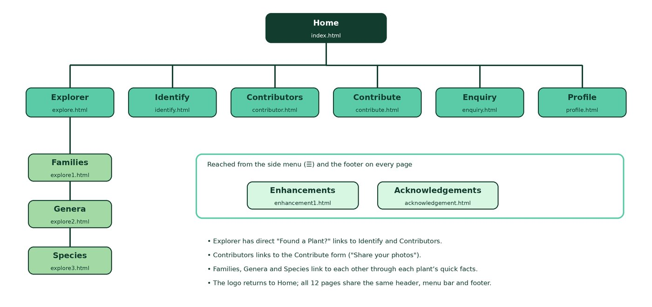
Figure 1. Site map of Pl@netMatrix.

3. Website style

3.1 The look and feel
I wanted Pl@netMatrix to feel calm, fresh and trustworthy, like a walk through a well-kept botanical garden. Everything is built around a palette of greens, with plenty of white space so the text is easy to read.
Colour | Code | Where it’s used
Mint green | #5BCBA7 | Header, buttons, table headings and accents
Pale mint | #D8F7E3 | Page background, side notes and highlights
Leaf green | #A3D9A5 | Menu bar, drop-down menu and row headings
Deep teal | #123D2E | Text on coloured areas and the site name
Dark green | #1F6E56 | Headings and links on white

For lettering, I chose three free Google Fonts that work well together. Playfair Display, an elegant serif, is used for the site name and page titles. Lora gives the section and plant headings the feel of a field guide, and Source Sans 3 keeps the main text clean and easy to read. The fonts are saved inside the website, so they still load without an internet connection.
The header is the first thing visitors see, so I gave it extra care. It fades from mint to teal behind faint leaves and grid lines, a nod to the “matrix” in the name. The oval logo has a soft glowing halo, the name is written in two colours with a mint “@”, and a small pill reading “Family · Genera · Species” links to the Explorer. The search box sits in a white rounded panel with its own Search button.

Figure 2. The header: oval logo, two-tone name, slogan, Explorer pill and search box.

3.2 How I used CSS
All the styling is in one file, styles/style.css, which holds around 360 rules across 2,340 lines. It starts with a comment block explaining the file and the colour scheme, and every group of rules has a short comment, such as /* Header */ or /* Phones (700px and narrower) */, so it’s easy to find your way around.

Selectors
I used every type of selector the brief asks for, plus several more advanced ones:
Selector type | Example from my CSS | What it does
Element | h1 { ... }, table { ... } | Styles every heading or table
Class | .plant-profile, .button | Styles a reusable component
ID | #site-header, #profile-photo | Styles one unique element
Grouping | h2, h3 { ... } | Shares one style between elements
Contextual | .plant-facts dl, main a | Styles elements inside another
Pseudo-classes | :hover, :focus, :checked, :target, :valid, :invalid, :nth-child() | React to the mouse, keyboard, forms and the address bar
Pseudo-elements | ::before, ::after | Draw extra shapes such as link-map lines and arrows
Attribute | input[type="text"], a[href$=".html"] | Style elements by their attributes
Combinators | .menu-toggle:checked ~ .side-menu | Style an element based on a sibling

Property groups and layout
- Menu. The menu bar has a leaf-green background, bold links, a highlighted current page and an Explorer drop-down that opens on hover or keyboard focus.
- Typography. The <h1> uses the font shorthand, font: bold 2.4em/1.2 "Playfair Display", Georgia, serif;, and every font has a safe fallback.
- Box model. Borders, padding, margins, rounded corners, shadows and a leaf background image give each section its shape.
- Liquid layout. Widths use percentages and vw, flexbox lines up the header and menu, and CSS grid arranges the galleries and cards so they reflow as the window changes size.
- Required styles. The aside is 30% of the viewport wide, floats right and has a coloured border, and the footer stretches the full page width with italic, centred text.
- Phones. A media query for screens 700px and narrower stacks the layout into one column, moves the search box below the logo and makes buttons easier to tap.
- Animation. Six @keyframes animations bring the banner words, cards and logo to life, and a prefers-reduced-motion rule switches them off for anyone who prefers less movement.
Here’s how the aside is styled to meet the brief:
aside {
float: right;
width: 30vw;
margin: 0 0 1em 1.5em;
padding: 1em;
background-color: #D8F7E3;
border: 3px solid #5BCBA7;
border-radius: 6px;
}

3.3 Screenshots of the design
These screenshots show the design across the site. Each was taken on a desktop screen 1280 pixels wide.
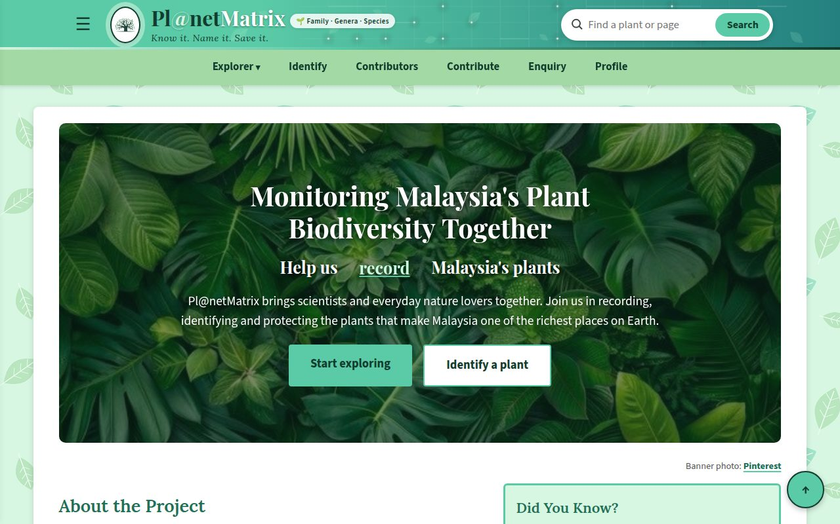
Figure 3. Home page with the animated banner and “Did You Know?” side note.
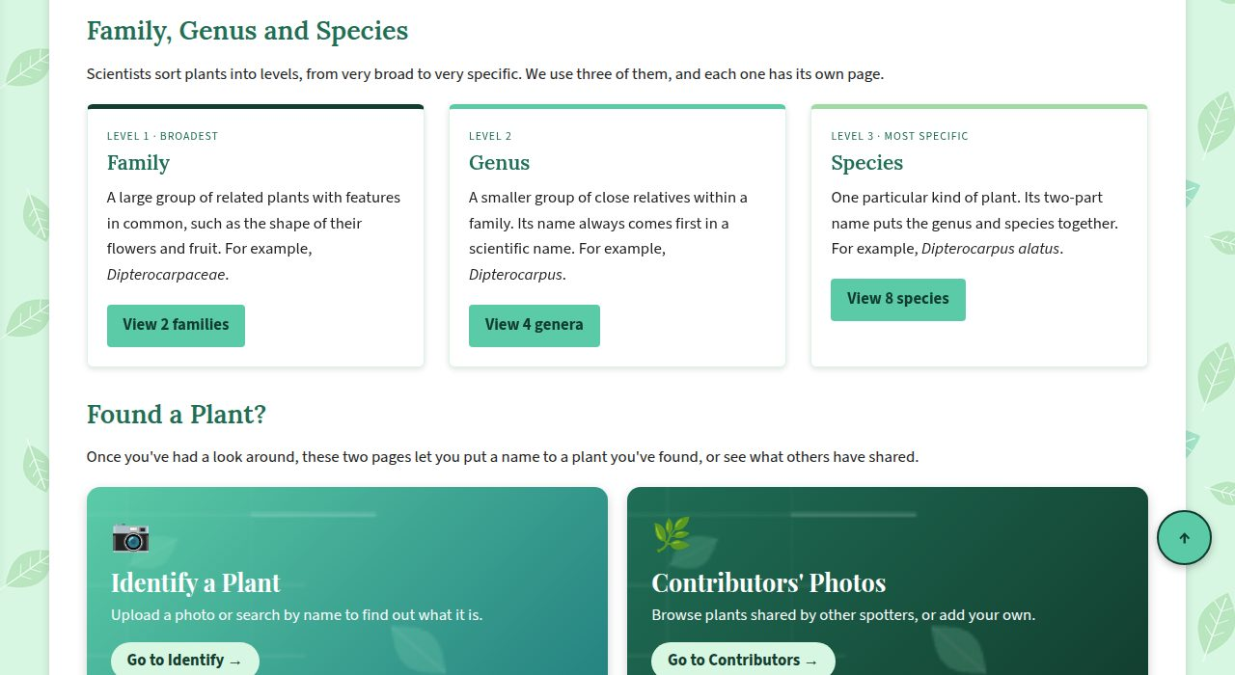
Figure 4. Explorer page: the three levels and the “Found a Plant?” links to Identify and Contributors.
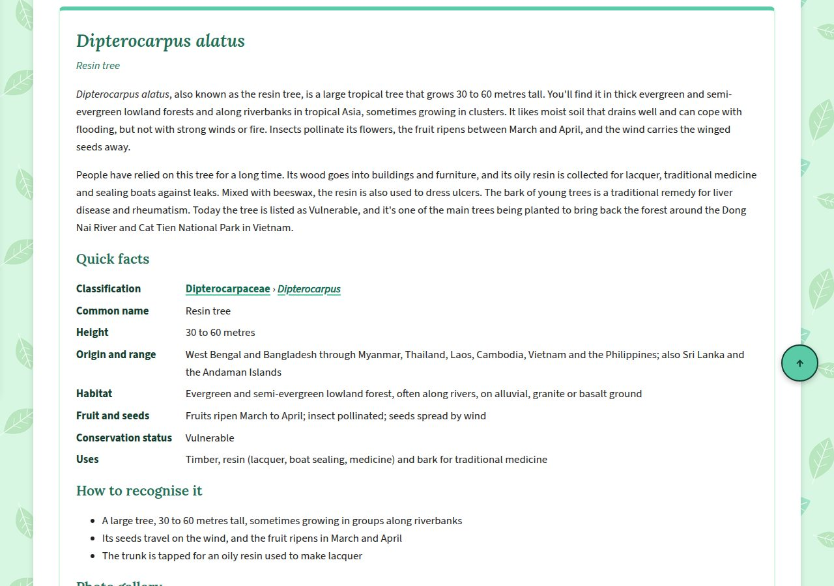
Figure 5. A species profile with its description, quick facts and recognition tips.
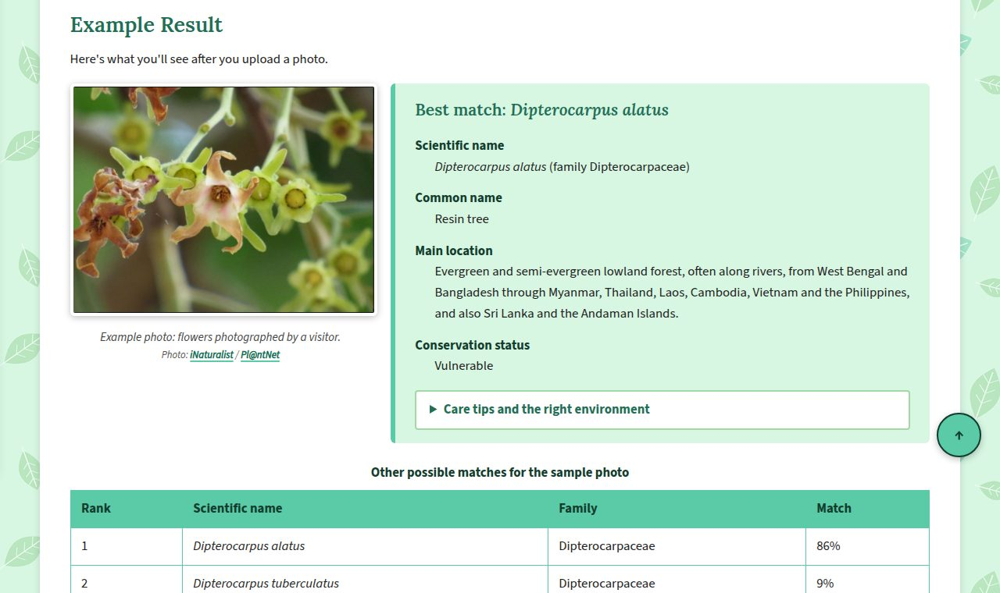
Figure 6. The Identify page’s example result, with care tips and other possible matches.
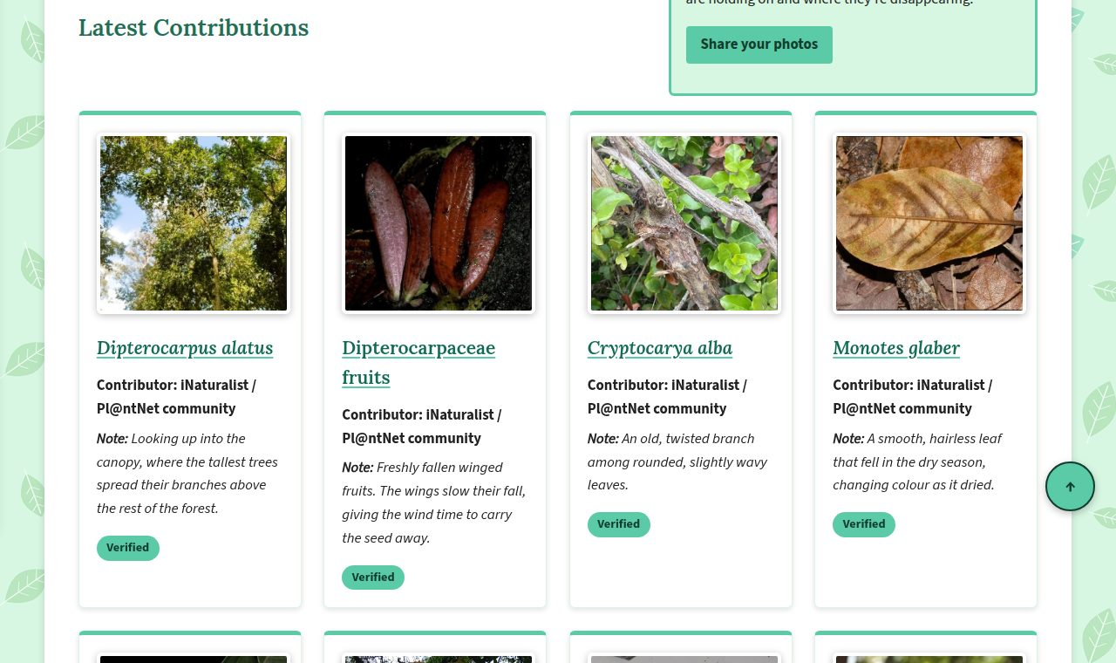
Figure 7. Photo cards on the Contributors page.
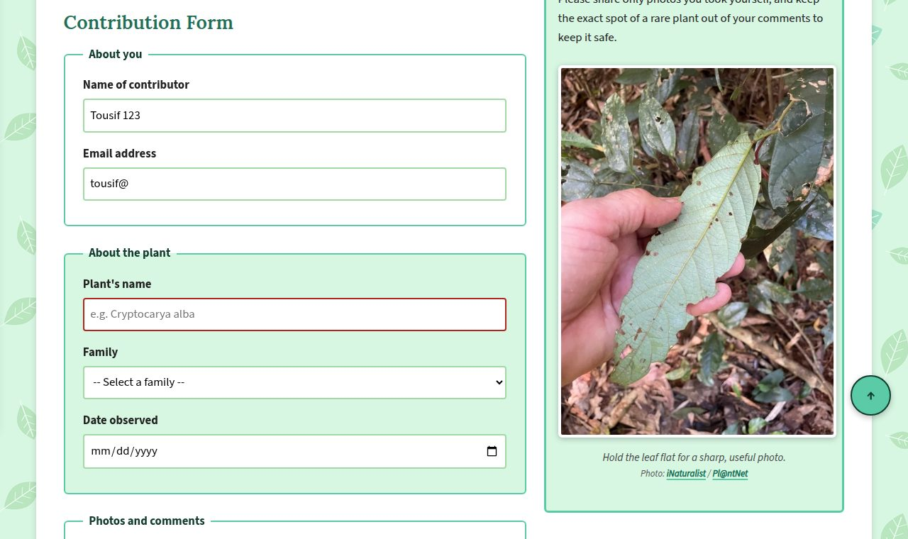
Figure 8. The contribution form giving live feedback: red borders show entries that still need fixing.
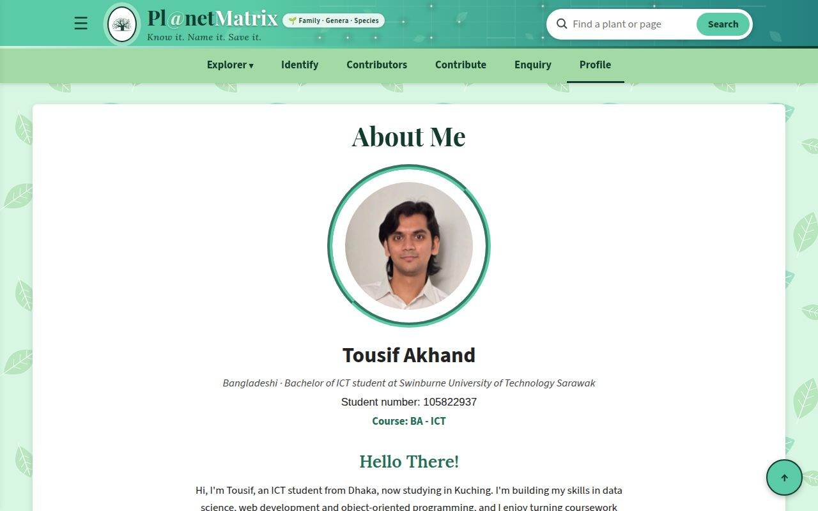
Figure 9. The Profile page.

4. Key features and enhancements

4.1 What makes the site stand out
- A connected plant encyclopedia. All fourteen plants link up and down between families, genera and species, and the link map shows the whole picture at a glance.
- Learning by doing. The comparison chart, the quiz and the “How to Tell the Two Families Apart” steps turn reading into something more hands-on.
- Friendly forms. Fields turn red or green as you type, the section you’re working on lights up, and phones bring up the right keyboard or a date picker.
- Honest about sources. Every plant description, photo, font and picture is credited in one place, the Acknowledgements page, which lists more than 150 credits with links back to each source.
- Comfortable for everyone. The text is written in clear, friendly English, links are bold and easy to spot, and the site works on phones, with the keyboard and with reduced motion.

4.2 My four main enhancements
The brief says up to four enhancements will be marked, so these are the four I’ve put forward. All of them work without any JavaScript.

Enhancement 1: Fluid layout with a hamburger menu
Every page stretches or shrinks to fit the screen. On top of that, the ☰ button to the left of the logo opens a side menu listing every page on the site. The trick is a hidden checkbox: the ☰ button is its label, so clicking it ticks the box. The side menu starts off-screen, and as soon as the box is ticked, a sibling selector slides it in.
.side-menu { transform: translateX(-105%); transition: transform 0.35s ease; }
.menu-toggle:checked ~ .side-menu { transform: translateX(0); }
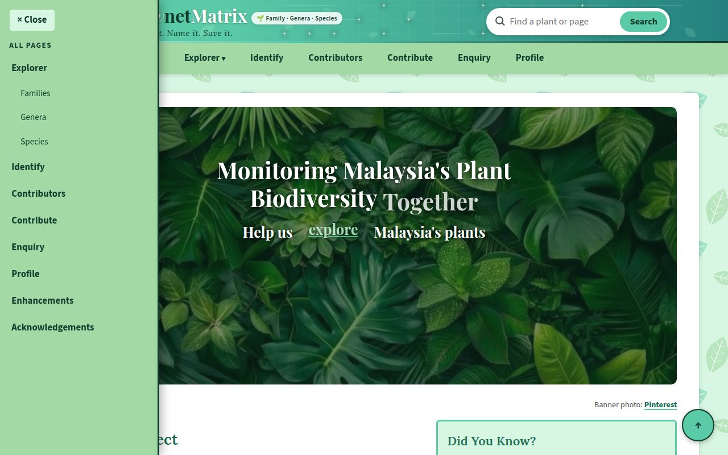
Figure 10. The side menu slides in from the left when the ☰ button is clicked.

Enhancement 2: Fixed navigation bar
The menu bar stays at the top of the screen as you scroll, which really helps on the long Species page. It uses position: sticky; top: 0;, so the bar scrolls normally until it reaches the top and then stays put. I also added scroll-padding-top so that headings don’t hide under the bar when you jump to a section.

Enhancement 3: Photo gallery with a lightbox
Every plant has its own photo gallery. Clicking a photo opens it full-screen over a dark background, with its caption and a Close button. Each thumbnail links to the id of a hidden viewer further down the page. When the address ends with that id, the :target selector shows the viewer, and the Close link points back to the gallery so the viewer hides again.
.lightbox { display: none; position: fixed; top: 0; left: 0; width: 100%; height: 100%; }
.lightbox:target { display: block; }
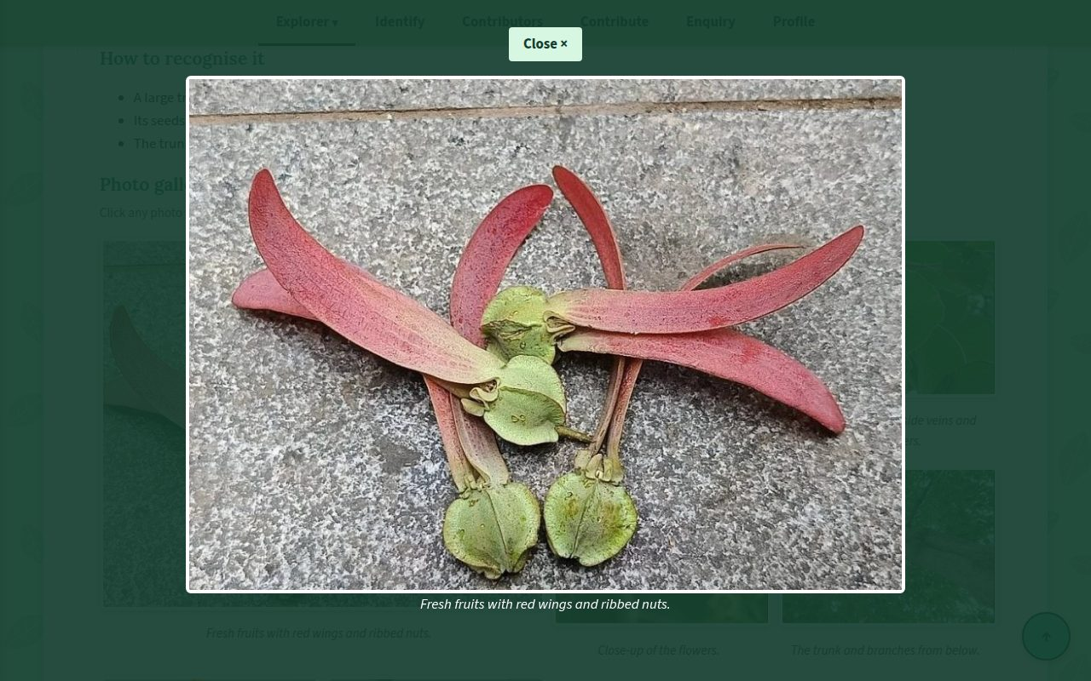
Figure 11. A photo opened in the lightbox viewer.

Enhancement 4: Flip cards
Flip cards show a plant photo on the front. When you move the mouse over one, or reach it with the keyboard, it turns over in 3D to reveal a fun fact and a link. The card gets depth from perspective, the inner part rotates with rotateY(180deg), and backface-visibility: hidden makes sure you only ever see one side at a time.
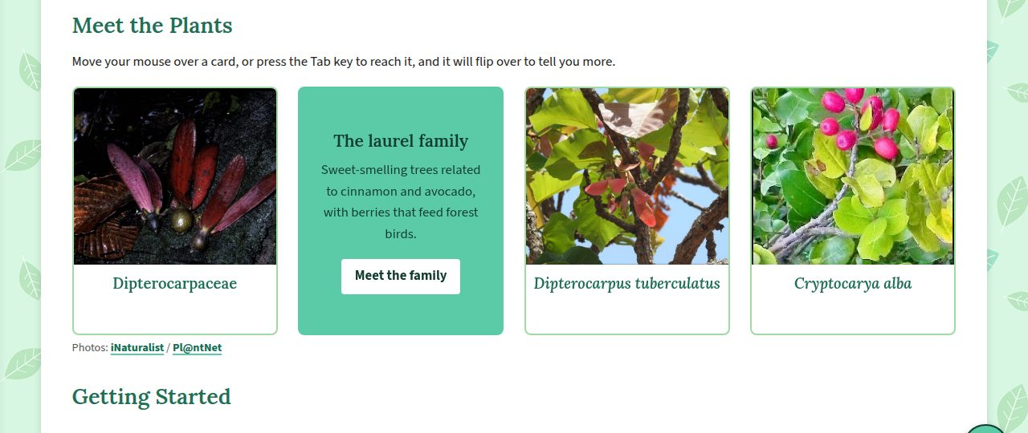
Figure 12. Flip cards on the home page, with the second card turned over.

4.3 Other enhancements
Beyond the main four, the site has fifteen more enhancements. They include a star rating, picture and link hover effects, a Back to top button, the Google Map, the forest soundscape, CSS animations, expandable care tips, live form feedback, a site-map footer, search suggestions, phone-friendly pages, the link map diagram, the family comparison chart and custom fonts with the branded header. Appendix A lists them all, and each is explained on the Enhancements page.

5. Conclusion

5.1 Summary
Pl@netMatrix brings the case study to life as a friendly, twelve-page website for exploring, identifying and recording Malaysia’s rare plants. The HTML is semantic, validated by the browser’s own form checks and completely separate from the styling. The CSS uses a wide range of selectors, a liquid layout that adapts to phones, and a calm green design. Nineteen enhancements, led by the hamburger menu, fixed navigation bar, photo lightbox and flip cards, make the site easier and more enjoyable to use, and every source is properly credited.
Building it taught me a lot, especially how far careful HTML and CSS can go on their own, and how much small details like clear wording, readable fonts and visible links matter to the people using a site.

5.2 Ideas for the future
- Real identification and search. In Assignment 2, JavaScript or a server program could compare uploaded photos with real records and search the plant pages properly.
- More plants. The encyclopedia could grow to include every family and genus on the PlantsData list, such as Vatica, Hopea and Endiandra.
- Accounts for contributors. Registered users could log in, see their own records and track when a plant expert has checked their photos.
- A live map. Verified sightings could appear as pins on a map, showing exactly where rare plants are still found.
- More choice for visitors. A light and dark theme switch, larger text options and a Malay-language version would make the site welcoming to even more people.

References
Google. (n.d.). Google Fonts. https://fonts.google.com/
Google. (n.d.). Google Maps. https://www.google.com/maps
iNaturalist. (n.d.). iNaturalist. https://www.inaturalist.org/
ePlant AI. (n.d.). Beilschmiedia costaricensis. https://eplantai.com/plant/beilschmiedia-costaricensis
Pl@ntNet. (n.d.). Pl@ntNet identify. https://identify.plantnet.org/
Royal Botanic Gardens, Kew. (n.d.). Cryptocarya adpressa. Plants of the World Online. https://powo.science.kew.org/taxon/urn:lsid:ipni.org:names:77159775-1
Science Education Resource Center, Carleton College. (n.d.). Plant family tree [Image]. https://serc.carleton.edu/integrate/teachingmaterials/foodsupply/student_materials/805
Swinburne University of Technology Sarawak. (2026). Web Development Assignment 1: brief, case study and PlantsData [Unit documents].
W3Schools. (n.d.). HTML and CSS tutorials. https://www.w3schools.com/
Wikipedia. (n.d.). Dipterocarpaceae, Lauraceae, Dipterocarpus, Monotes, Beilschmiedia, Cryptocarya and species articles. https://en.wikipedia.org/

Appendix A: All enhancements
# | Enhancement | Where to see it
1 | Fluid layout with hamburger menu | Every page (☰ button)
2 | Fixed navigation bar | Every page, best on the Species page
3 | Photo gallery with lightbox | Explore, Families, Genera and Species pages
4 | Flip cards | Home and Explore pages
5 | Page rating | Explore page
6 | Picture hover effect | Galleries and the family tree
7 | Button and link hover effects | Every page
8 | Back to top button | Every page
9 | Google Map | Identify page
10 | Music and audio | Profile page
11 | CSS animations | Home banner, cards, logo and Identify button
12 | Expandable care tips and quiz answers | Identify and Explore pages
13 | Live form feedback | Contribute and Enquiry forms
14 | Site-map footer | Every page
15 | Site search with suggestions | Header on every page
16 | Phone-friendly pages | Every page on a phone
17 | Link map diagram | Explore page
18 | Family comparison chart | Explore page
19 | Custom fonts and branded header | Header and text on every page

Appendix B: The website on a phone
On screens 700px wide or narrower, the layout stacks into a single column, the search box moves below the logo and the forms bring up the right keyboard.
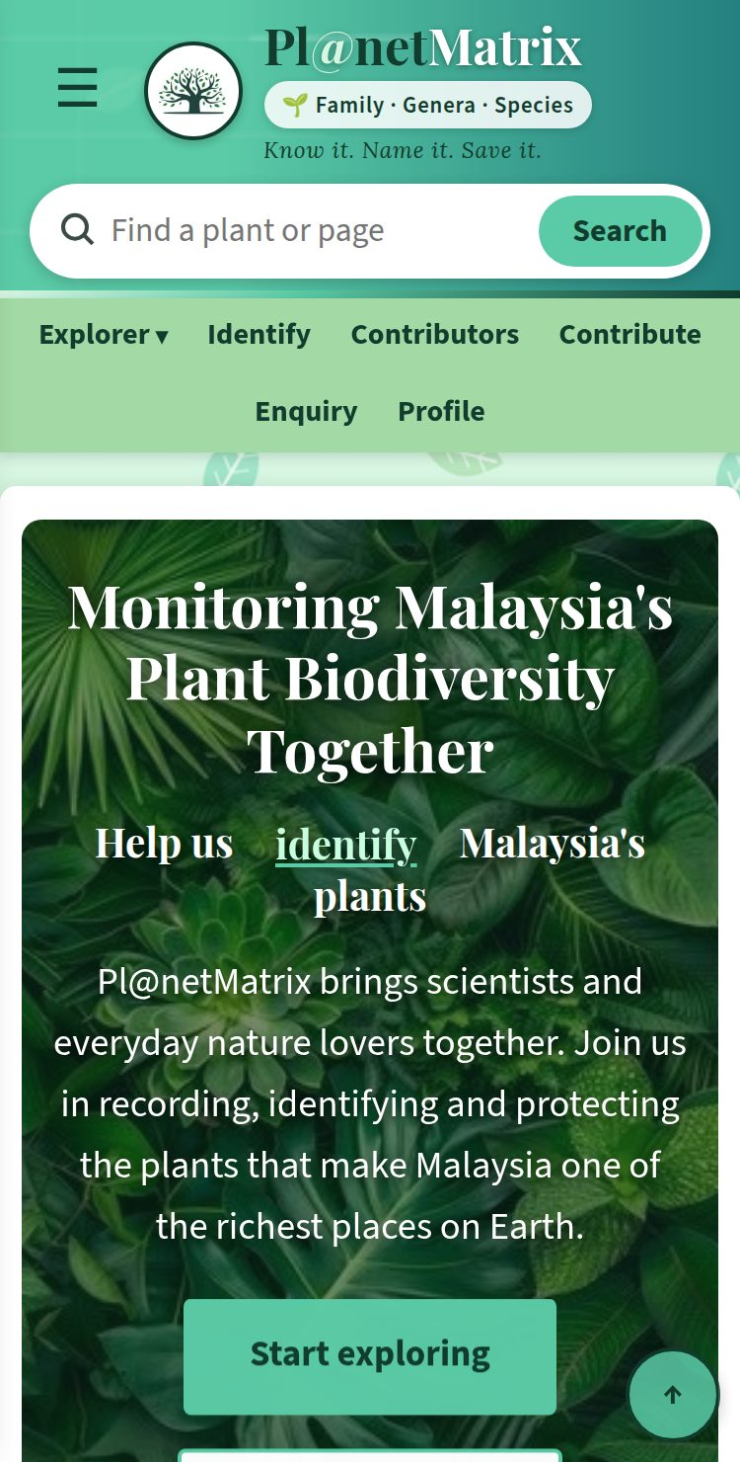 | 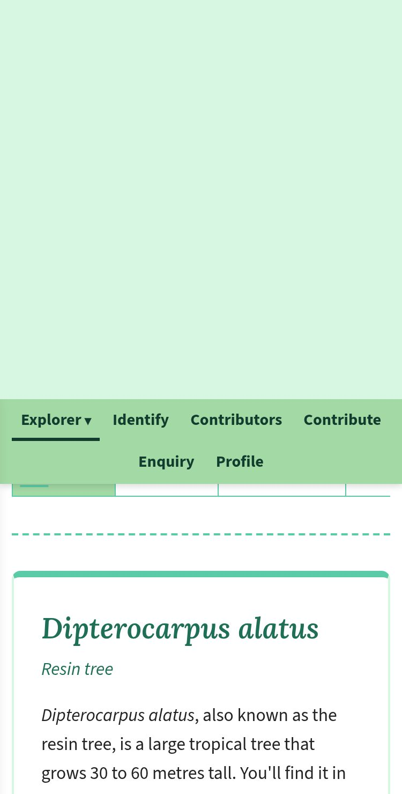 | 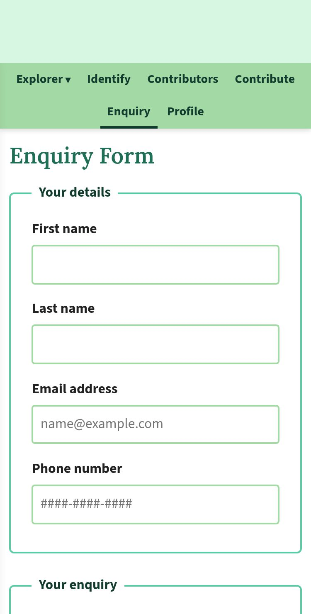
Figure 13. The Home page, a species profile and the enquiry form on a phone.

