

A job portal is a website, which helps in the recruitment process by bringing together both the

**Project Purpose**

employer and the job-seeking candidate. An employment website is a website that deals specifically with employment or careers. Many employment websites are designed to allow employers to post job. Through a job website a candidate can locate and fill out a job application or submit resumes over the Internet for the advertised position.

This project is aimed at developing an online search Portal for the Placement Details for job seekers. The system is an online application that can be accessed by employee with proper login details. This system can be used as an Online Job Portal for User. User logging should be able to see the jobs posted by the employees and upload their information in the form of a CV to apply for the jobs. Employee can post the job and it provides the employee with all the necessary privileges to access and modify the data intended for them.

# Project Goals and Objectives

The goals and objectives of the Online Job Portal are as follows:

1. Employee can post job on our system.
2. Employee can update delete posted jobs.
3. Job seekers can see the jobs posted by the employees and can apply them.

# Project Description

This project Online Job Portal has been developed on PHP and MySQL. The main objective for developing this project is to provide an online job search portal for job seekers about opportunities in different companies. It can manage Job Post, Job details etc. This system is very useful for users because they need to submit resumes through their account and all uploaded resumes are visible to employee who provide job opportunities. This project provides many features to manage all the data in very well manner.

The interior database has been selected as MySQL server. The MySQL server was a choice as it provides the constructs of high-level reliability and security. The total front end was conquered using the XAMPP server.

# Scope

Online job portal is a web application built in PHP. It provides the candidates ability to register to this application and search for jobs, apply jobs. Each candidate will have their own account with their own home page. On the other hand employee that are willing to publish the jobs for their company can register to the job portal and get their own account created and can post jobs to portal‘s database.

# System User

|  |  |
| --- | --- |
| Admin | * Can sell all the jobs * Can Update and Delete a job. * Can see all the employee and their details. |
| Employee | * Can Post Job. * Can Update and Delete Job. * Can see application and download |
| Job seeker | * Can See all Jobs * Can apply to the job |

**Database**

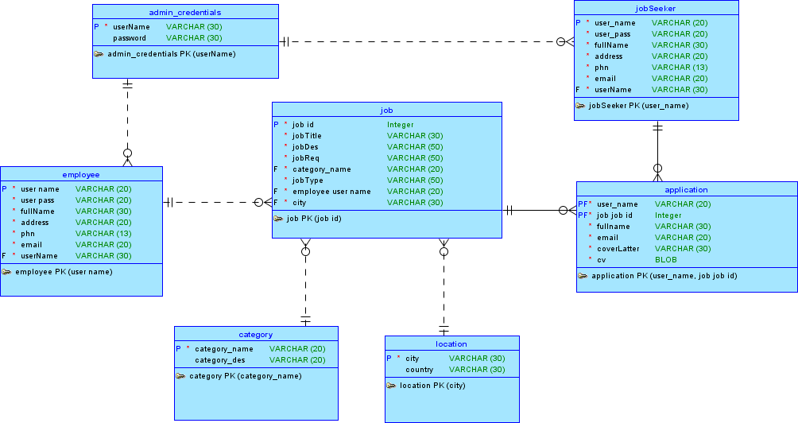

**Fig: Logical Model**

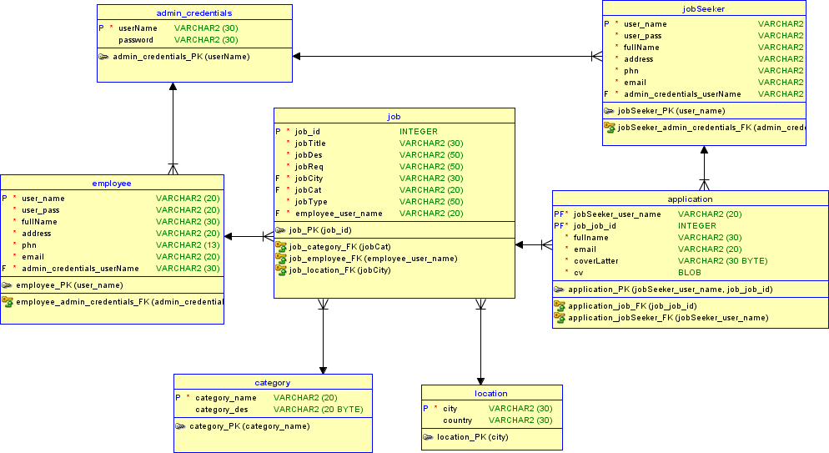

**Fig: ER Diagram**

# Process

* Sign in: For employee user for post a job they need to logged in to my system and for job seeker for search and apply to a job they need to logged into my system. And for accessing admin panel admin must be logged in to our system. In my system there is two type of user.

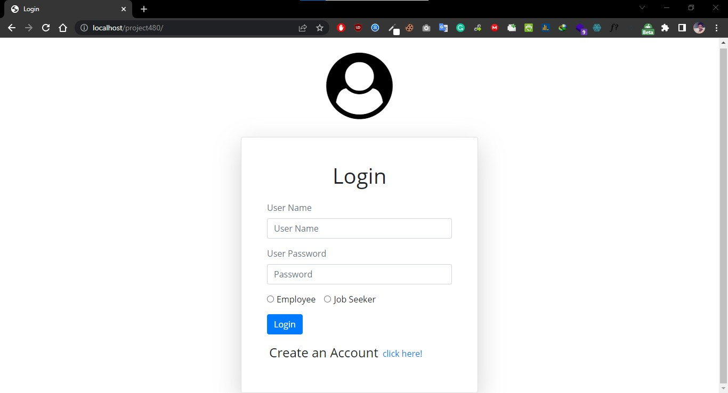

* Sign Up: For creating an account to my system user need to sign up.

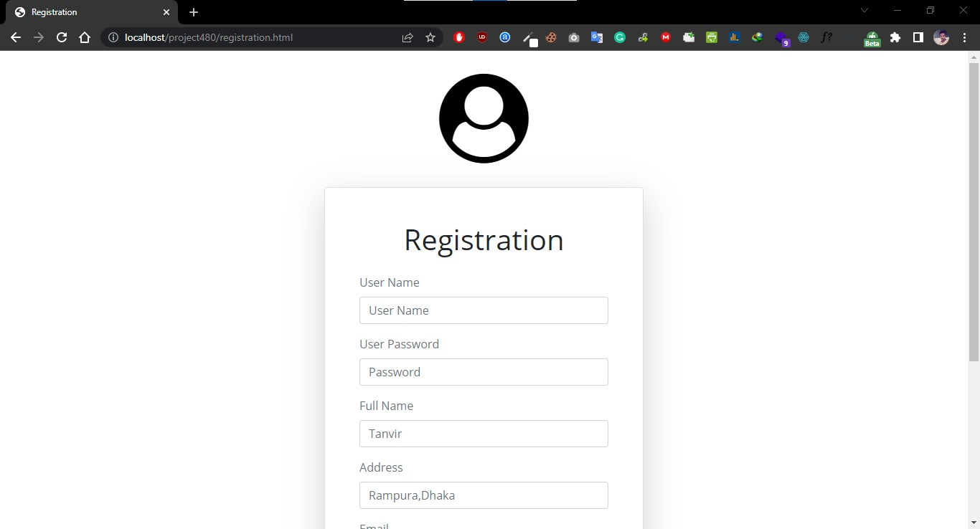

# For Admin

* Admin Dashboard: After sign in a user if the user is admin then the user can automatically se the admin dashboard by default.

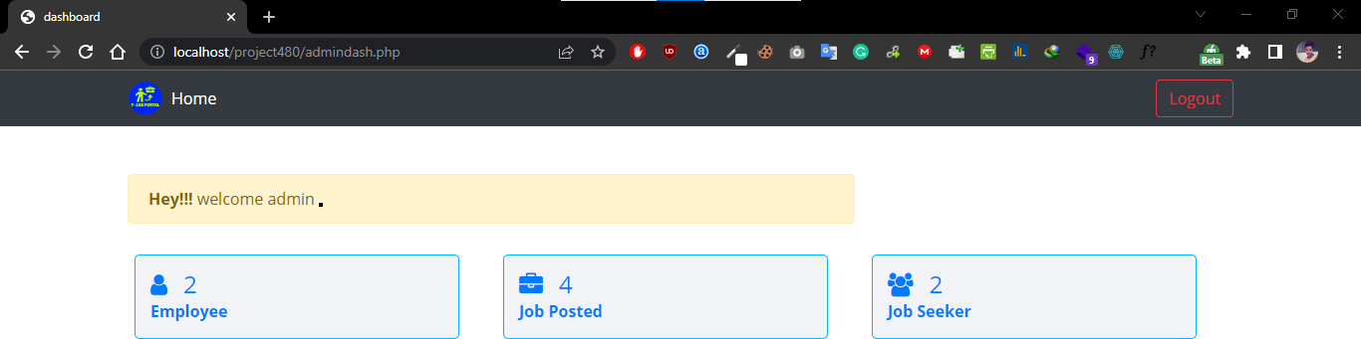

* Admin Dashboard: After login admin can see the existing employee, job seekers and posted job to the system. Admin can update job, employee and job seekers information.

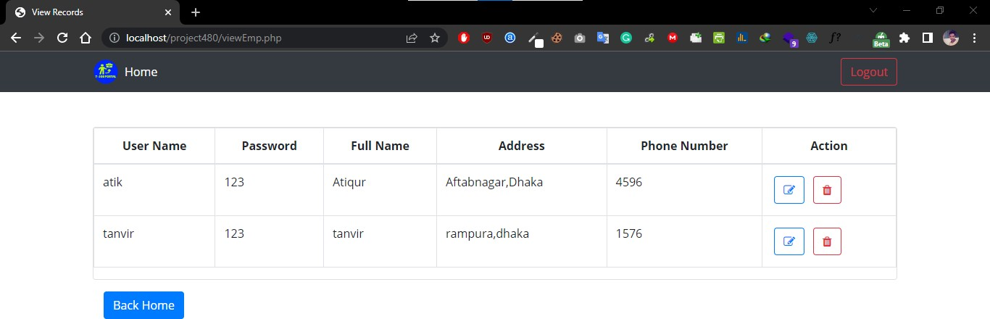

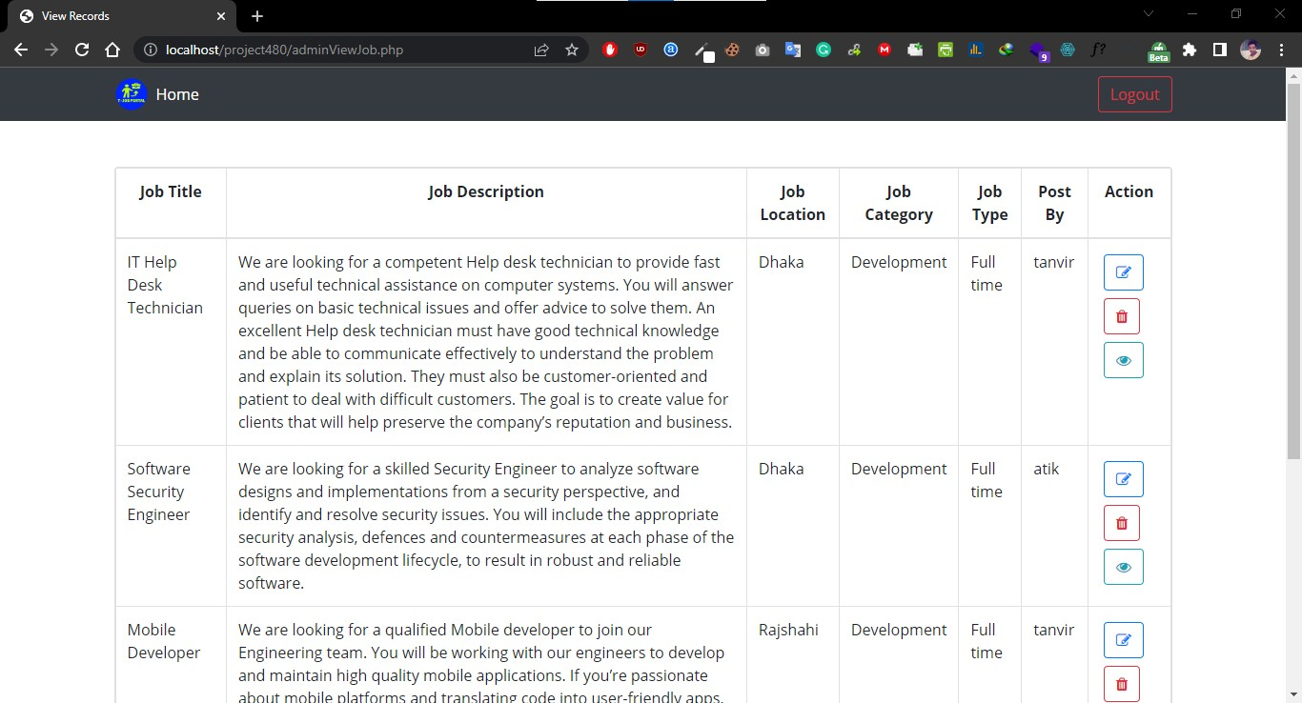

# For Employee

* Employee Dashboard: After sign in a user if the user is employee then the user can automatically se the employee dashboard by default.

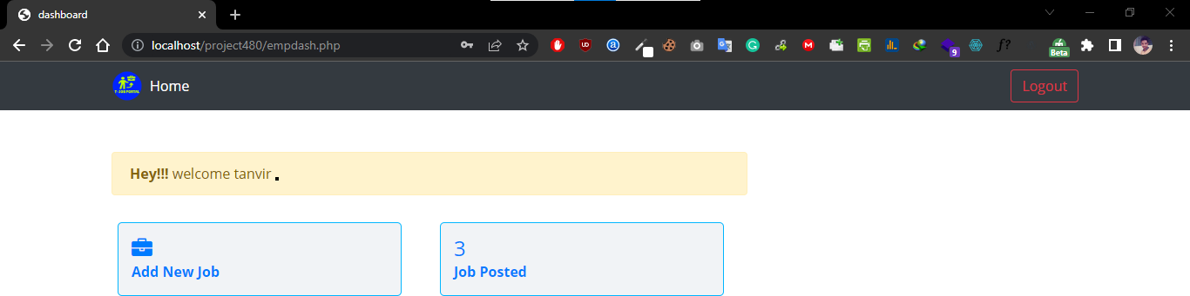

* Post Job: Employee can add new job.

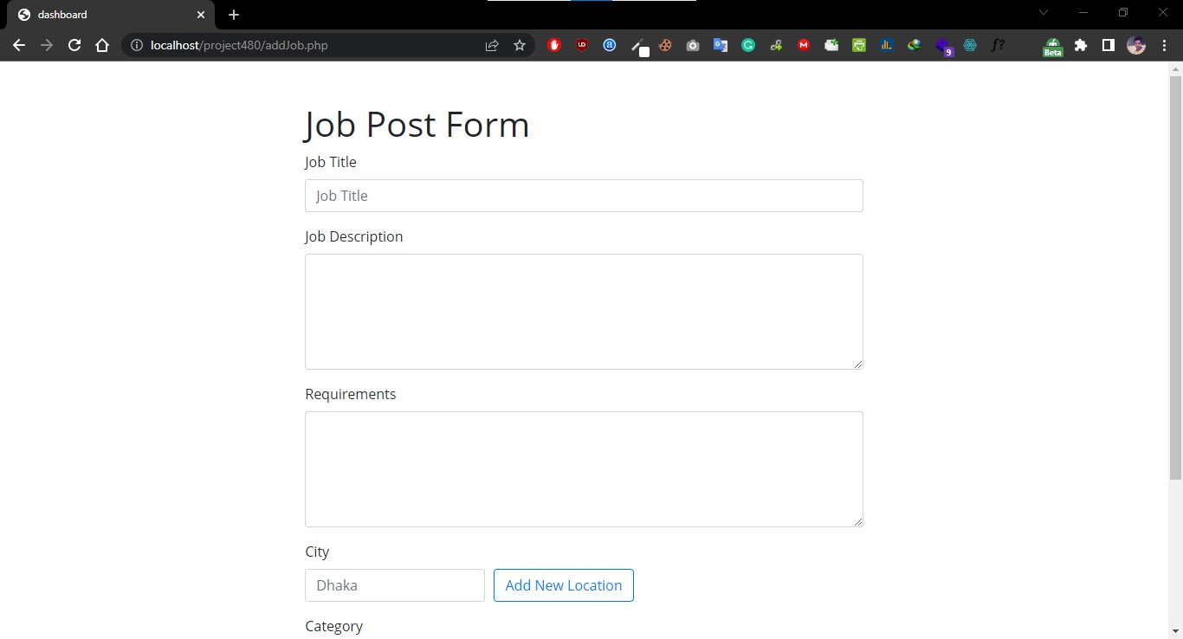

* Edit, Update and Delete: Employee can view posted jobs. They can also update and delete them.

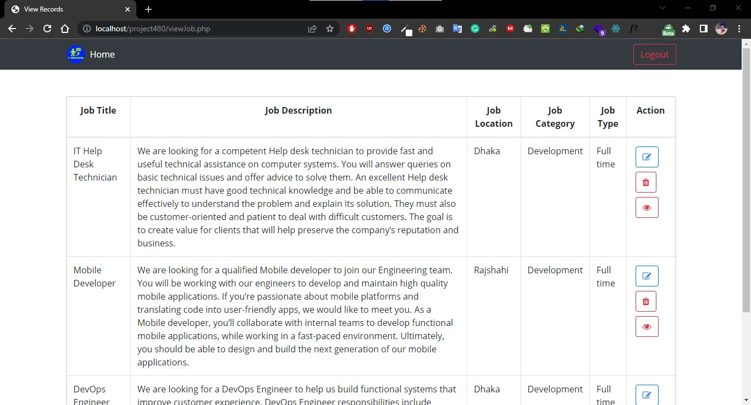

* View Applicants: Employee can see who are applied in a job. They also can download their cv.

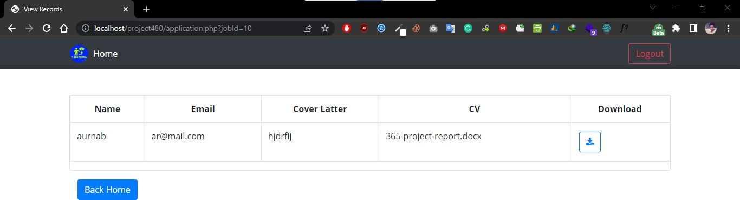

# Job Seekers

* Job seekers Dashboard: After sign in a user if the user is job seekers then the user can automatically se the job seekers dashboard by default where he/she can see jobs which are posted by employees.

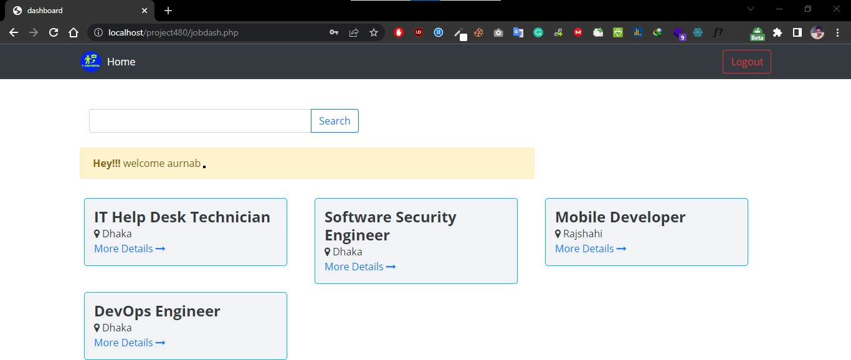

* Search: User can search the jobs.

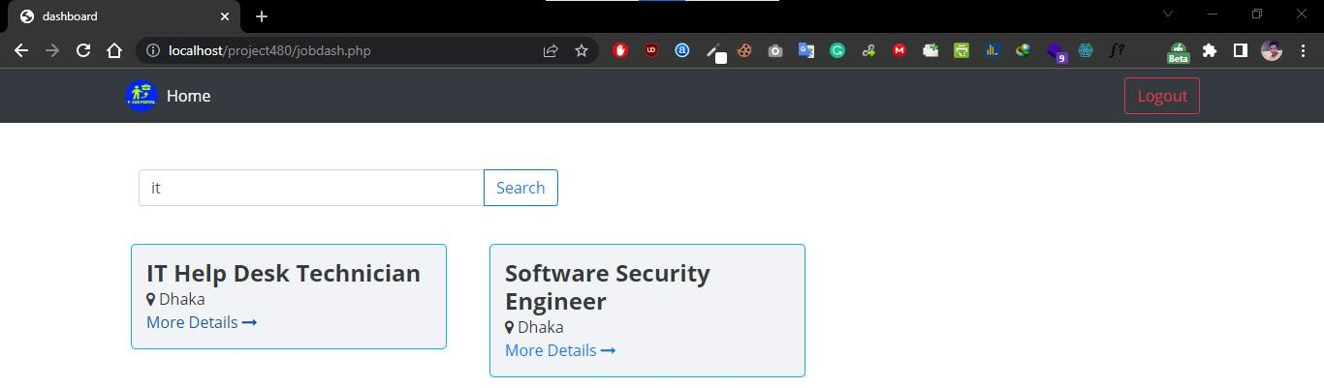

* Apply: User can also see details of any jobs and can apply to it.

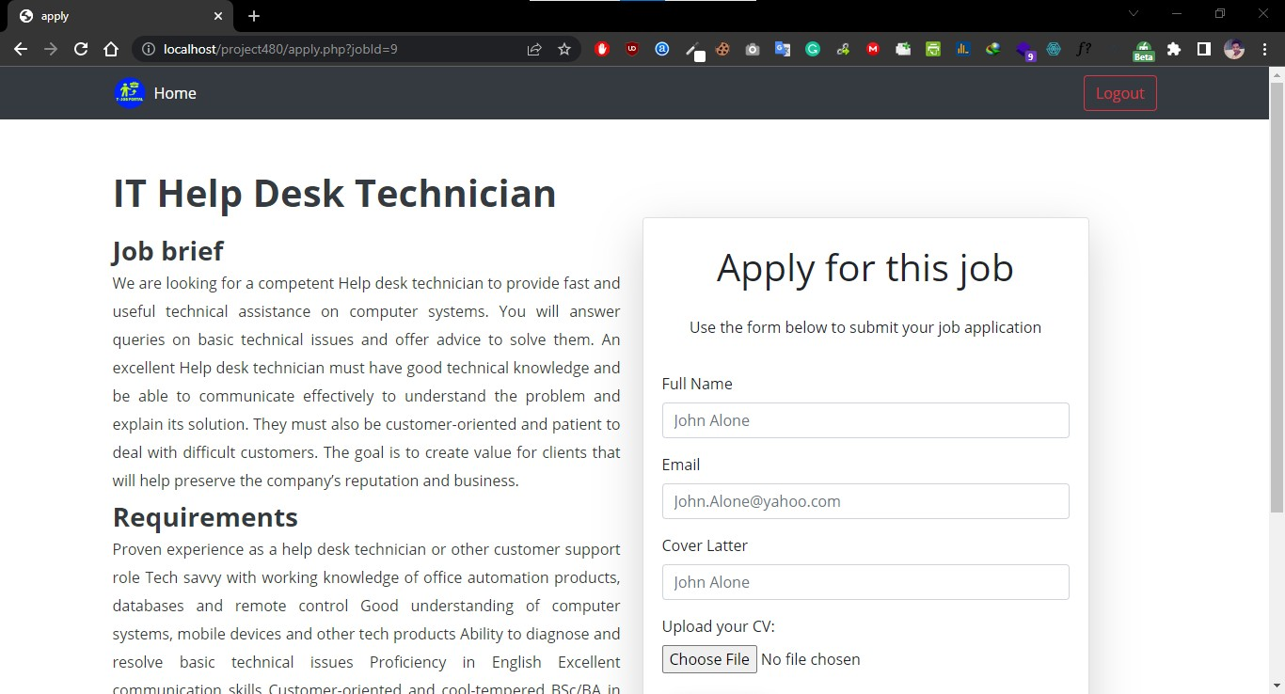

# Technology

Frontend : HTML, CSS

Backend : PHP

Database : MySQL