Multivariate forecasting of the total photovoltaic generation of a national grid without meteorological data: a cross-channel-attention PatchTST conditioned on cyclic covariates and solar geometry — application to the SENELEC grid (Senegal)
Abdoulaye FAYE^{1,*}, Alphousseyni NDIAYE¹
¹ Research Team in Energy Efficiency and Energy Systems, Doctoral School of Sciences and Techniques and Social Sciences (EDTSS), Alioune Diop University of Bambey (UADB), Senegal — * Corresponding author: abdoulaye7.faye@uadb.edu.sn

Abstract
Forecasting photovoltaic (PV) generation is essential for operating grids with high renewable penetration. Yet, in many African grids, on-site meteorological measurements are lacking. This paper studies the multivariate forecasting of the total PV generation of the SENELEC grid (Senegal; 11 plants, hourly log 2019–2023) without meteorology and without the plant productions as inputs. We propose PatchTST-CA-X, which combines a selective reversible normalisation, cross-channel attention per patch and conditioning of the forecasting head on deterministic covariates known over the horizon: cyclic encodings and solar geometry. Four configurations (patch length, history, channel handling, horizon) are evaluated one factor at a time, over 5 seeds, in terms of accuracy, robustness, drift over 30 days without re-training and efficiency. At the day-ahead horizon, the selected model (P = 12 h, L = 168 h) reaches an RMSE of 9.02 ± 0.10 MW (nRMSE = 0.204; R² = 0.974) over seven test months. This is 13.2 % lower than daily persistence (Diebold-Mariano, p = 0.003) and 2.0 % lower than a multi-output Ridge regression given the same future covariates, a gap that is not significant (p = 0.42). The degradation under 5 % noise on the covariates is +0.44 %, the 30-day drift is 0.58, and inference takes 2.9 ms. Ablations and explainability show that the gain comes from conditioning on future deterministic information, not from the past grid context nor from model complexity alone. Temporal cross-validation (5 folds) confirms a mean gain of 13.5 % over persistence.
Keywords: photovoltaic forecasting; PatchTST; Transformer; cyclic variables; solar geometry; cross-channel attention; long-term stability; SENELEC grid; West Africa

1. Introduction
The massive integration of photovoltaic (PV) plants is transforming the operation of power grids. Because it is inverter-connected and depends on cloudiness, PV generation reduces synchronous inertia and introduces fast variability that the operator must compensate with reserves [1–5]. Recent work shows that, beyond a certain integration rate, the resilience of a grid can degrade abruptly in the absence of storage and anticipation [6, 7]. Generation forecasting is therefore one of the first levers of safe and economic integration [10, 11].
The SENELEC grid (Senegal) illustrates these issues. About ten PV plants of a few tens of MWp each have been connected to the transmission grid since the mid-2010s. Their intermittency has been associated with more difficult frequency control and more frequent load shedding [12]. Admissible penetration rates have been estimated at between 16 and 24 % depending on the voltage level and the presence of storage [13, 14], and PV generation is among the main statistical determinants of the grid frequency [19, 20]. Yet the dispatch centre has no synchronous meteorological measurements at the sites; the only systematically available information is the hourly operating log.
The literature on PV forecasting with deep learning is abundant [23–30], but three limitations restrict its transfer to this context. First, it almost always assumes meteorological input variables [28, 38, 45]. Second, it deals with individual plants, not with the aggregated generation of a national grid, whose installed capacity changes with every commissioning. Third, evaluation protocols are heterogeneous: comparison with a naive baseline, dispersion across initialisations, robustness, the stability of performance over time and the inference cost are rarely measured together [24, 41, 51]. Patch Transformers, and PatchTST in particular [37], have renewed time-series forecasting and are beginning to be applied to photovoltaics [38–40]. Their channel-independence assumption is however debated as soon as informative covariates are available [42, 45].
This paper makes four contributions:
- A multivariate formulation without meteorology of forecasting the total PV generation of a national grid. The productions of the individual plants are excluded from the inputs (they are only used to build the target). The model combines the history of the target, the grid operating context (thermal, wind, import) and deterministic covariates: cyclic encodings and solar geometry computed for the barycentre of the fleet.
- A PatchTST-CA-X architecture that combines (i) a selective reversible normalisation, applied to the stochastic channels only; (ii) cross-channel attention per patch position, in which the target queries the covariates; (iii) conditioning of the forecasting head on the known future, since the deterministic covariates are available without error at any horizon.
- A decision-oriented evaluation protocol. Four configurations are studied one factor at a time (patch length, history, channel handling, horizon), each with 5 seeds. The protocol measures accuracy, robustness to noise, drift over 30 days of forecasting without re-training, efficiency, a temporal cross-validation and Diebold-Mariano tests. Everything is aggregated into a decision score.
- An explainability analysis (occlusion of channel groups, integrated gradients, attention weights) that quantifies what each family of covariates actually contributes. A channel with no physical link to irradiance (the day of week) serves as a negative control.
Section 2 presents the literature review. Section 3 describes the data, the architecture and the protocol. Section 4 reports the results, which Section 5 discusses. Sections 6 and 7 present the limitations and perspectives, and Section 8 concludes.

2. Literature review
The review covers 56 works selected from a corpus of 303 references compiled for this thesis. They are grouped into five axes, ranging from the physical problem (integrating photovoltaics into the grid) to the methodological tool (patch Transformers). For each axis, we identify what is established and what remains open for the grid under study. Table 1 summarises the 56 works: method, type of validation and contribution to the present study.

2.1 Large-scale photovoltaic integration and grid stability
The large-scale integration of inverter-based sources transforms grid dynamics. Shah et al. [1] review the stability challenges specific to large-scale photovoltaics. Kenyon et al. [2] show that asynchronous resources change grid control at the cycle and second time scales, and list the questions that remain open. The decline of synchronous inertia makes the frequency more sensitive to generation losses [3, 4]. Johnson et al. [5] treat rotational inertia as a full component of reliability when the share of variable generation is high. Two recent works published in general-science journals qualify this picture. Smith et al. [6] observe daily oscillations of resilience and a marked degradation during periods of clustered generation, which batteries are not sufficient to correct. Xu et al. [7] estimate at about 45 % the solar integration threshold beyond which, without storage, the probability of catastrophic failures rises. On the control side, the virtual synchronous machine [8] and virtual synchronous generators [9] aim to give inverters the behaviour of a rotating machine. Che et al. [10] summarise the strategies for mitigating variability (storage, flexibility, interconnections, virtual power plants). Yuan et al. [11] quantify, on an island grid, the joint benefit of forecasting and storage.
Takeaway for our study. All these works make generation forecasting an operational lever: it precedes the sizing of reserves, unit commitment and storage management. However, they do not address how the forecast itself is built.

2.2 The Senegalese grid and the West African context
Senegal has its own literature, mostly devoted to the impact of photovoltaics on grid operation. Abdoulaye et al. [12] analyse three years of frequency measurements: the intermittency of PV plants complicates frequency control and multiplies load shedding. Sarr et al. estimate the maximum PV penetration rate admissible by the SENELEC grid at 17.3 % (MV) and 16.4 % (HV) by 2020 [13]. This rate rises to about 24 % with storage and optimised plant siting [14]. Dieng et al. [15] show that secure operation with 57.7 % to 66.8 % of inverter-based resources remains possible if the generation loss does not exceed 5.2 % of total power. Fall et al. [16] study probabilistically sized reserves. Ba et al. [17] report recurrent congestion on some transmission lines at demand peaks by 2025–2030. Ndiaye et al. [18] quantify the effect of five PV plants (Bokhol, Mbour, Mékhé, Ten Mérina, Kahone) on voltage profiles and losses. Our previous works [19, 20], based on causality tests and principal component analysis, established that photovoltaic generation is among the main determinants of the SENELEC grid frequency. Bloomfield et al. [21] describe the Senegalese solar regime as remarkably constant, with maximum wind in the boreal spring. Ndiaye et al. [22] analyse the actual performance and the seasonal forecast of the Diass plant (23 MWp). Coulibaly et al. [56] propose a multilayer perceptron for short-term PV–wind forecasting on the SENELEC grid (R² = 0.89 against 0.85 for linear regression).
Takeaway for our study. The Senegalese works rely mostly on grid simulation (PowerFactory, optimal power flow) or statistical analysis. The only predictive contribution [56] uses an MLP without a strict temporal protocol or comparison with persistence. No study forecasts PV generation aggregated at grid level, in the presence of successive plant commissionings, with an attention-based model.

2.3 Reviews of renewable energy forecasting by machine learning
The reference reviews [23–26, 30] describe the shift from physical and statistical models to deep learning. Wang et al. [23], the most cited synthesis of the corpus, classify the deep architectures applied to renewable energy. Sharifzadeh et al. [25] compare neural networks, SVR and Gaussian processes. Aslam et al. [26] jointly cover load and generation in microgrids. Devaraj et al. [30] report, in the literature they survey, a mean MAPE of 10.29 % for solar. Recent systematic reviews refine this picture. Klaiber and Van Dinther [27] distinguish ten deep approaches across three application domains. Khouili et al. [28] find, over 26 PV forecasting articles, that LSTM (32.7 %) and CNN (28.8 %) dominate, that wavelet decomposition is the most frequent preprocessing, and that the input variables are almost always meteorological (temperature, pressure, humidity). Alazemi et al. [29] conclude that deep networks and ensembles are superior at capturing the autocorrelation of renewable series. Benti et al. [24] and Lin et al. [55] stress the persistent obstacles: uncertainty, data availability, interpretability and the "black box" nature of data-driven models. Liao et al. [52] approach the question through probabilistic modelling in support of stochastic optimisation.
Takeaway for our study. Two gaps recur from one review to the next. First, forecasts assume that local meteorological measurements or forecasts are available; second, evaluation protocols are not homogeneous. The stability of performance over time and the inference cost are almost never measured, although they are conditions for adoption by a grid operator.

2.4 Deep learning for PV and renewable forecasting
Methodological contributions mainly combine convolutional and recurrent layers. Alsafrani et al. [31] associate a dilated CNN with a bidirectional residual LSTM. Gangwar et al. [32] propose an improved GRU for joint load–generation forecasting. Khan et al. [33] design a lightweight ESN-CNN model to reduce computational complexity. Sankarananth et al. [34] couple neural networks and metaheuristics. Cheng et al. [35] integrate a stability constraint into a spatio-temporal CNN-LSTM framework and report a 14.1 % RMSE reduction relative to LSTM. Abdelsattar et al. [36] compare eight architectures on 4,200 records: TCN comes first (R² = 0.78) and a standard Transformer fails (R² = 0.07). This result indicates that a Transformer cannot be applied as is to a short solar series. Guo et al. [41] address incremental online updating and catastrophic forgetting: it is one of the few works to explicitly consider the drift of performance over time. Li et al. [50] use neural controlled differential equations to reduce the time lag of wind forecasts. Mamyrbayev et al. [51] evaluate their LSTM against persistence (−59.1 % error), a precaution few studies take.
Takeaway for our study. The reported gains are rarely measured against a naive baseline, and almost never over an operating horizon of several months without re-training. Yet, for an hourly solar series, daily persistence is a very hard baseline to beat; our study confirms it.

2.5 Patch Transformers: PatchTST and its variants
PatchTST [37] introduced two ideas: splitting the series into patches (sub-series) that serve as tokens for the Transformer encoder, and treating each channel independently with shared weights. It markedly improved long-term forecasting. Its transfer to energy is recent and fast. For photovoltaics, Lv et al. [38] combine anomaly detection, GAN-based feature extraction and PatchTST on six plants. Suresh [39] compares five Transformer variants on a 5 kW rooftop with cyclic temporal encodings, and adds adaptive conformal inference: PatchTST achieves the best accuracy, with a coverage rate of 86.2 %. El-kenawy et al. [40] optimise the feature selection and hyper-parameters of PatchTST with a metaheuristic. Lu et al. [42] (CT-PatchTST) explicitly reintroduce cross-channel correlations for long-term wind and solar forecasting in Denmark. For wind, Gao et al. [43] add a distribution-adaptive normalisation (Dish-TS). Zhao et al. [44] propose causal sample weighting (−13.3 % RMSE relative to PatchTST alone). Xu et al. [45] couple a PatchTST encoder with a GRU decoder refined by numerical weather prediction. For load, Zhang et al. [46] extend PatchTST to quantile regression, and Spencer et al. [47] show that PatchTST is better suited to transfer learning than the standard Transformer and Informer. Among generic developments, DiffTST [48] improves PatchTST with differential attention. CycleNet [49] explicitly models recurrent cycles with learnable periodic components, which confirms the value of explicit cyclic information. On interpretability, Anis et al. [53] apply LIME to stability prediction, and Babakhani et al. [54] combine a Transformer-based mixture of experts with built-in explanations.
Takeaway for our study. Three points are agreed upon: (i) the channel-independence assumption of PatchTST is called into question as soon as informative exogenous variables are available [42, 45]; (ii) periodic information benefits from being provided explicitly [39, 49]; (iii) distribution non-stationarity calls for adaptive normalisation [43].
None of these works, however, uses deterministic covariates known over the forecast horizon (solar geometry, future calendar encodings) to condition the forecasting head of PatchTST. Nor does any of them measure the drift of performance over one month of rolling forecasts without re-training.

2.6 Positioning of the study
This review brings out five gaps that the present work addresses:
- Grid scale. Forecasts concern a plant or a farm; the aggregated PV generation of a national grid, subject to successive plant commissionings, is not addressed, let alone on a Sahelian grid [12–22, 56].
- The absence of meteorological measurements. Almost all models assume meteorological data [28, 38, 45]. We study what can be achieved without them, using deterministic covariates (cycles and solar geometry) and the grid operating context.
- Channel handling. The contrast between independence (CI) and modelling dependencies between channels (CA) [37, 42] is rarely measured, and never in the case where the future of the covariates is known.
- Evaluation under operating conditions. Comparison with persistence, dispersion over several seeds, robustness to noise, drift over 30 days without re-training and inference cost are rarely brought together in one protocol [24, 41, 51].
- Interpretability. It is cited as an obstacle [24, 55] but rarely measured for Transformers in generation forecasting [53, 54].
Table 1. Synthesis of the 56 works of the review (axes: A stability and PV integration, B Senegal/Africa, C reviews of forecasting, D deep learning for PV/RE, E PatchTST and Transformers).
No. | Reference | Axis | Method / object | Data / validation | Contribution to this study
[1] | Shah et al., 2015 | A | Review of stability challenges of large-scale PV | Review | Motivation: PV variability threatens stability
[2] | Kenyon et al., 2020 | A | Review of stability/control with high inverter share | Review | Fast dynamics: need for anticipation
[3] | Seneviratne & Ozansoy, 2016 | A | Frequency response to the loss of a unit | Review | Link PV/wind penetration – reserve
[4] | Cheng et al., 2020 | A | Frequency control under low inertia | Review | Forecasting feeds frequency control
[5] | Johnson et al., 2019 | A | Rotational inertia and reliability | Simulation | Operational issue at high variable share
[6] | Smith et al., 2022 | A | Stability and resilience vs RE decentralisation | Real data | Daily oscillations of resilience
[7] | Xu et al., 2025 | A | Coupled climate–energy model, cascading failures | Real data (Puerto Rico) | Threshold ≈ 45 % solar without storage
[8] | Beck & Hesse, 2007 | A | Virtual synchronous machine | Concept | Control-side response (complementary)
[9] | Bevrani et al., 2014 | A | Virtual synchronous generators | Review | Control-side response (complementary)
[10] | Che et al., 2025 | A | Strategies to mitigate RE variability | Review, 10 countries | Forecasting = integration lever
[11] | Yuan et al., 2017 | A | Benefit of forecasting and storage (isolated grid) | Real data | Economic value of forecasting
[12] | Abdoulaye et al., 2020 | B | Impact of PV intermittency on frequency | 3 years of SENELEC measurements | PV-related load shedding in Senegal
[13] | Sarr et al., 2018 | B | Maximum PV penetration rate (PowerFactory) | SENELEC simulation | 17.3 % MV / 16.4 % HV (2020)
[14] | Sarr et al., 2020 | B | Optimisation of the PV penetration rate | SENELEC simulation | ≈ 24 % with storage
[15] | Dieng et al., 2025 | B | Voltage/frequency stability at 57–67 % inverters | DIgSILENT simulation | Constraint: loss < 5.2 % of power
[16] | Fall et al., 2024 | B | Probabilistically sized reserves | Real SENELEC data | Reserve ↔ forecast uncertainty
[17] | Ba et al., 2025 | B | Transmission congestion (OPF, N-1) 2025–2030 | Simulation | Growing RE pressure on the grid
[18] | Ndiaye M. et al., 2025 | B | Effect of 5 PV plants on voltage, flows, losses | DIgSILENT simulation | Same plants as the studied target
[19] | Faye et al., 2025a | B | Causality tests and PCA on stability | SENELEC data | PV is a determinant of frequency
[20] | Faye et al., 2025b | B | PCA on PV–wind frequency stability | SENELEC data | Total PV weighs on frequency
[21] | Bloomfield et al., 2022 | B | Variability and weather drivers of solar/wind | Reanalyses, Senegal/Kenya | Stable Senegalese solar regime
[22] | Ndiaye F.A. et al., 2025 | B | Actual performance and seasonal forecast of Diass | Real data (23 MWp) | Plant included in the target
[23] | Wang et al., 2019 | C | Review of deep learning for RE forecasting | Review | Reference framework of architectures
[24] | Benti et al., 2023 | C | Review of ML/DL for RE forecasting | Review | Obstacles: data, interpretability
[25] | Sharifzadeh et al., 2019 | C | Comparison of ANN, SVR, GPR | Comparative | Importance of simple baselines
[26] | Aslam et al., 2021 | C | Review of DL for load and RE (microgrids) | Review | Overview of architectures
[27] | Klaiber & Van Dinther, 2023 | C | Systematic review of DL for variable RE | Systematic review | 10 approaches, 3 domains
[28] | Khouili et al., 2025 | C | Systematic review of DL for PV forecasting | 26 articles | Mostly weather inputs; LSTM/CNN dominate
[29] | Alazemi et al., 2024 | C | Review of ML for RE integration | Systematic review | LSTM and ensembles recommended
[30] | Devaraj et al., 2021 | C | Review of big data and DL for energy forecasting | Review | Mean solar MAPE ≈ 10 %
[31] | Alsafrani et al., 2025 | D | Dilated CNN + bidirectional residual LSTM | Benchmark dataset | Convolutional–recurrent hybrids
[32] | Gangwar et al., 2024 | D | Improved RNN-GRU (uni/multivariate) | Simulation | Joint load/PV forecasting
[33] | Khan et al., 2022 | D | Lightweight ESN-CNN with residual connections | Benchmark datasets | Concern for computational efficiency
[34] | Sankarananth et al., 2023 | D | LSTM-RL, CNN-PSO (metaheuristics) | Simulation | Algorithmic hybridisation
[35] | Cheng et al., 2025 | D | Spatio-temporal CNN-LSTM under stability constraint | Real data | −14.1 % RMSE vs LSTM
[36] | Abdelsattar et al., 2025 | D | Comparison of 8 DL architectures | 4,200 real records | Standard Transformer: R² = 0.07
[37] | Nie et al., 2023 | E | PatchTST: patches + channel independence | Benchmark datasets | Base architecture of the study
[38] | Lv et al., 2026 | E | PatchTST + anomaly detection + GAN | 6 PV plants | PatchTST applied to short-term PV
[39] | Suresh, 2025 | E | Benchmark of 5 Transformers + conformal inference | 5 kW rooftop, 5 years | Cyclic encodings; PatchTST first
[40] | El-kenawy et al., 2026 | E | PatchTST + feature selection (SMOA) | Real data | Choice of PatchTST inputs
[41] | Guo et al., 2025 | D | Incremental PV model, catastrophic forgetting | n/a | Drift over time (rare in the corpus)
[42] | Lu et al., 2025 | E | CT-PatchTST: channel–time dependencies | Real data (Denmark) | Challenges channel independence
[43] | Gao et al., 2024 | E | ZS-DT-PatchTST (adaptive normalisation) | Experimental data | Non-stationarity → normalisation
[44] | Zhao et al., 2024 | E | CausalPatchTST + causal selection | 2 wind farms | −13.3 % RMSE vs PatchTST
[45] | Xu et al., 2025 | E | PatchTST-GRU seq2seq + NWP refinement | Wind farm | Contribution of weather forecasts (absent here)
[46] | Zhang et al., 2024 | E | Probabilistic QR-PatchTST | ASU campus | Probabilistic extension (perspective)
[47] | Spencer et al., 2025 | E | Transfer learning, 3 Transformers | 16 buildings | PatchTST transfers best
[48] | Yang et al., 2025 | E | DiffTST: differential attention | Benchmark datasets | Generic improvement of PatchTST
[49] | Lin et al., 2024 | E | CycleNet: learnable recurrent cycles | Benchmark datasets | Value of explicit cyclic information
[50] | Li et al., 2025 | D | Neural controlled differential equations | 4 wind farms | Correction of forecast lag
[51] | Mamyrbayev et al., 2025 | D | RF, XGBoost, LSTM vs persistence | 30 sites, 6 months | Explicit comparison with persistence
[52] | Liao et al., 2024 | C | Probabilistic modelling and stochastic optimisation | Review | Uncertainty for operation
[53] | Anis et al., 2026 | E | Explainable stability prediction (LIME) | Simulated dataset | Interpretability for operators
[54] | Babakhani et al., 2026 | E | Explainable Informer mixture of experts | 3 thermal load datasets | Explainable Transformers
[55] | Lin et al., 2025 | C | Review: data-driven / mechanistic / hybrid models | Review | "Black box" limitation of models
[56] | Coulibaly et al., 2025 | B | MLP for SENELEC PV–wind forecasting | SENELEC data | Only Senegalese predictive precedent
Written from the abstracts and records of the corpus; "n/a": not documented in the source.

3. Data and methodology

3.1 Data
The data come from the SENELEC hourly operating log, from 01/01/2019 to 09/05/2023 (38,160 hours; 288 hours missing, in eight jumps of one to three days). The log contains the production of the thermal units, of the Taiba Ndiaye wind farm, of imports (Manantali, Félou, SOMELEC) and of eleven photovoltaic plants. The target is the total PV generation of the grid (Figure 1). Its mean level rises by 47 % between 2019 and 2022 as plants are commissioned: Diass (June 2019), replacement of Kahone by ERS and Scaling Kahone (January 2021), Kael Touba (March 2021).
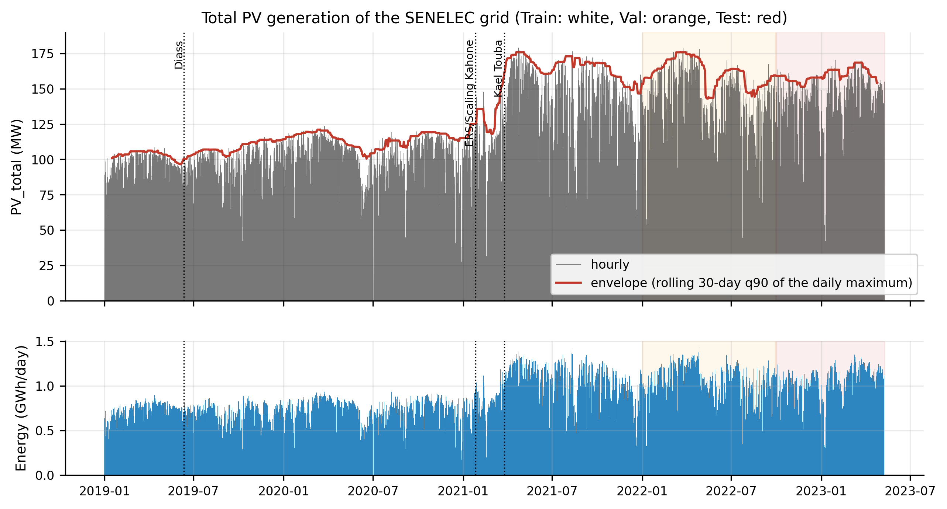
Figure 1. Hourly total PV generation of the SENELEC grid (2019–2023), apparent capacity envelope and daily energy. Orange and red backgrounds: validation and test periods; dotted lines: commissionings.

3.2 Target construction and preprocessing
The target is the sum of the eleven PV plants, built in three steps for each plant c. (i) Values above 1.2 times the 99.9 % quantile computed over the training period are treated as entry errors (107 values, up to 958 MW for a 20 MW plant). (ii) Outside the period of existence of the plant, production is zero. (iii) Gaps are imputed causally: linear interpolation up to 3 h, then the mean of the same hour over the previous seven days. Table 2 details these operations. The individual productions are never used as model inputs.
y(t) = Σ_{c=1..11} p̃_{c}(t) (1)
Table 2. Target construction: per-plant traceability.
Plant | Commissioning | Last record | Threshold (MW) | Clipped | Imputed gaps | Mean (MW)
PV-Mbour | 01/01/2019 | 09/05/2023 | 22.7 | 14 | 1032 | 3.97
PV-CICAD | 01/01/2019 | 11/04/2023 | 4.4 | 36 | 710 | 0.26
PV Kahone | 01/01/2019 | 25/01/2021 | 19.1 | 1 | 454 | 1.57
PV ERS Kahone | 26/01/2021 | 09/05/2023 | 18.1 | 13 | 244 | 1.97
PV Scaling Kahone | 26/01/2021 | 09/05/2023 | 39.3 | 1 | 779 | 3.21
PV Kael Touba | 26/03/2021 | 09/05/2023 | 30.2 | 1 | 200 | 2.80
PV-Bokhol | 01/01/2019 | 09/05/2023 | 23.1 | 11 | 901 | 4.16
PV Mékhé Mérina | 01/01/2019 | 09/05/2023 | 24.3 | 24 | 522 | 5.63
PV S Mekhe Santhiou | 01/01/2019 | 09/05/2023 | 25.2 | 0 | 1066 | 5.58
PV DIASS | 12/06/2019 | 09/05/2023 | 22.3 | 1 | 829 | 3.45
PV Sakal | 01/01/2019 | 09/05/2023 | 21.1 | 5 | 976 | 4.85

3.3 Covariates
Three families of covariates are built (twelve channels in total, target included). The cyclic encodings ensure continuity at the boundaries of the cycles (23:00 → 00:00, 31 December → 1 January). They are computed at the middle of each hour, for the hour h (T = 24), the day of year (T = 365.25) and the day of week (T = 7):
x_{sin}(t) = sin(2π·u(t)/T), x_{cos}(t) = cos(2π·u(t)/T) (2)
The solar geometry is computed with pvlib [62] at the approximate barycentre of the plants (14.9° N; 16.4° W). It includes the cosine of the apparent zenith angle θ_{z} (bounded at 0 at night) and the clear-sky global irradiance according to the Haurwitz model [61]:
GHI_{cs}(t) = 1098 · cos θ_{z}(t) · exp(−0.057 / cos θ_{z}(t)) (3)
A time offset δ between the log timestamps and solar time is estimated over the training period by maximising the correlation between the mean daily profile of the target and that of GHI_{cs} (δ = +0.50 h). These eight covariates are deterministic: they are known without error at any horizon. The grid context (aggregated thermal production, Taiba wind, Manantali import) serves as a proxy for the atmospheric state: net demand and the wind regime reflect cloudiness and advection. These three channels are used over the past window only. The aggregated log columns that include PV generation (total of units, interconnected grid) are excluded, to avoid any indirect leakage.

3.4 PatchTST-CA-X architecture
PatchTST [37] splits each channel of the input window of length L into N patches of length P, with a stride S = P/2:
N = ⌊(L − P) / S⌋ + 1 (4)
Each patch is projected into a space of dimension D = 64 and added to a position embedding and a channel-identity embedding. A two-layer Transformer encoder [58] (four heads, pre-normalisation), whose weights are shared across channels, then models the temporal dependencies. The proposed architecture (Figure 2) adds three elements:
- Selective RevIN. Reversible instance normalisation [57] is applied to the target and to the grid channels, whose level drifts with installed capacity. The deterministic covariates keep their global normalisation. Indeed, over a window of a few days the day of year barely changes: standardising it would erase the position in the year in favour of an artificial ramp. We observed this defect in a first version, where it showed up as an abnormal attribution of 24 % to the past day of year.
- Cross-channel attention (CA). At each patch position n, the token of the target channel serves as the query and the C channel tokens serve as keys and values: z'_{n} = LN(z_{n,0} + MHA(z_{n,0}, Z_{n}, Z_{n})). Under strict channel independence (CI), the head only receives the target token: the covariates then have no influence on the forecast, and the model is equivalent to a univariate PatchTST with shared weights.
- Known-future conditioning (X). The linear head produces a base forecast ŷ₀ ∈ R^{H}. For each step h, a perceptron with one hidden layer receives a context c = W·vec(z') ∈ R³², the eight deterministic covariates of instant t+h and ŷ₀(h), and produces an additive correction: ŷ(h) = ŷ₀(h) + g([c ; f(t+h) ; ŷ₀(h)]). A variant (g) adds a physical gate that sets the forecast to zero when cos θ_{z}(t+h) = 0.
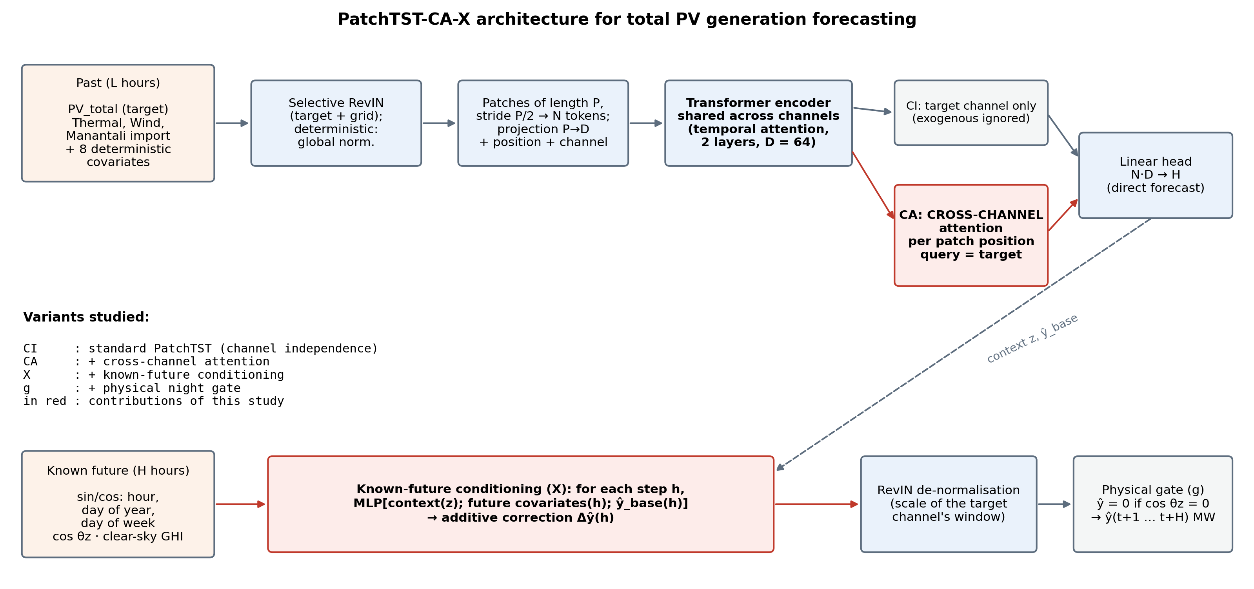
Figure 2. PatchTST-CA-X architecture. In red: proposed elements (cross-channel attention, conditioning on the future deterministic covariates). The CI variant (standard PatchTST) only uses the target token.

3.5 Experimental protocol
Strict temporal split, without shuffling: training from 01/01/2019 to 31/12/2021 (26,304 h), validation from 01/01/2022 to 30/09/2022 (6,552 h), test from 01/10/2022 to 09/05/2023 (5,304 h). Every operation fitted on the data (clipping thresholds, global normalisation, penalty of the Ridge baseline) is fitted on the training period only. A forecast origin t means that the last observed hour is t − 1; the model directly forecasts y(t), …, y(t+H−1).
Training. Squared loss; Adam (initial rate 10⁻³, halved after two epochs without improvement); batches of 128; gradient clipping at 1; at most 25 epochs; early stopping (patience 4) on the validation loss, with restoration of the best weights. At each epoch, 20 % of the hourly training origins are drawn at random, which guarantees that every hourly phase is seen. A fixed step of 3 h, for example, would only show 8 out of 24. Each configuration is trained with 5 seeds. The model is implemented in PyTorch [64].
One-factor-at-a-time design of experiments (Table 3). The value selected at one step is carried over to the next. The choice is made on the normalised decision score, among the variants that pass the noise test.
Table 3. Design of experiments.
Configuration | Factor | Values | Fixed parameters
1 | Patch length P | 12, 24, 48 h | L = 168 h, CA-X, H = 24 h
2 | History L | 96, 168, 336 h | P*, CA-X, H = 24 h
3 | Channel handling | CI, CI-X, CA, CA-X, CA-Xg | P, L, H = 24 h
4 | Horizon H | 1, 6, 12, 24, 168 h | P, L, channels*
*: value selected at the previous step.
Baselines. (i) Daily persistence: ŷ(t+h) = y(t+h−24), repeating the last observed day beyond 24 h. (ii) Mean of the last seven days at the same hour. (iii) Direct multi-output Ridge regression, whose inputs are the last L values of the target and the deterministic covariates of the H future steps; the penalty is chosen on the validation set. (iv) PatchTST-CI, the univariate equivalent.

3.6 Evaluation criteria and decision score
The metrics are computed over every hourly origin of the test set, all horizon steps combined:
RMSE = √( (1/n) Σ (ŷ_{i} − y_{i})² ), nRMSE = RMSE / ȳ (5)
MAE = (1/n) Σ |ŷ_{i} − y_{i}| (6)
complemented by R², the mean bias (MBE) and the nRMSE restricted to daytime hours. Robustness combines the standard deviation of the RMSE over the 5 seeds, σ, and the relative degradation of the RMSE when the exogenous channels (past and future) are perturbed by Gaussian noise with a standard deviation equal to 5 % of their training standard deviation. A degradation above 15 % leads to the rejection of the configuration. Long-term stability is evaluated by a 30-day rolling forecast without re-training, at the start of the test period. The ratio RMSE(D30)/RMSE(D1) depends on the cloudiness of two isolated days; we therefore use a smoothed ratio:
Drift = RMSE(D24…D30) / RMSE(D1…D7) (target < 1.2) (7)
Efficiency is measured by the inference time for one sample on one processor core (target < 100 ms) and by the size of the weights (< 50 MB). The decision score aggregates these criteria:
S = 0.4 / nRMSE + 0.3 / σ + 0.3 / Drift + bonus (8)
where the bonus is 0.1 per efficiency criterion met. The three terms have different scales: 1/σ, in particular, can dominate when σ is very small. We therefore also report a normalised score, in which each criterion is mapped to [0, 1] across the compared variants; this is the score that guides the selection. Equal accuracy against the baselines is tested with the Diebold-Mariano test [59], with the correction of Harvey et al. [60] and a long-run variance with H − 1 lags. Finally, the final configuration undergoes a temporal cross-validation (TimeSeriesSplit, 5 expanding-window folds covering 2019–2023, normalisation re-fitted at each fold), an ablation with a causal capacity index, and an explainability analysis: occlusion of channel groups, integrated gradients [63] and cross-channel attention weights.

4. Results

4.1 Exploratory analysis
The daily cycle dominates the series: the autocorrelation at lag 24 h is 0.97 on the training set, and the periodogram shows a peak at 24 h and its harmonic at 12 h (Figure 3). The amplitude is maximal from March to May and minimal during the rainy season (July–September). The linear correlation of the target with solar geometry reaches 0.94; with the grid channels, it does not exceed 0.31 in absolute value, and it is weaker still once the mean cycle is removed. Daily persistence is therefore a demanding baseline: RMSE = 10.39 MW and R² = 0.965 on the test set.
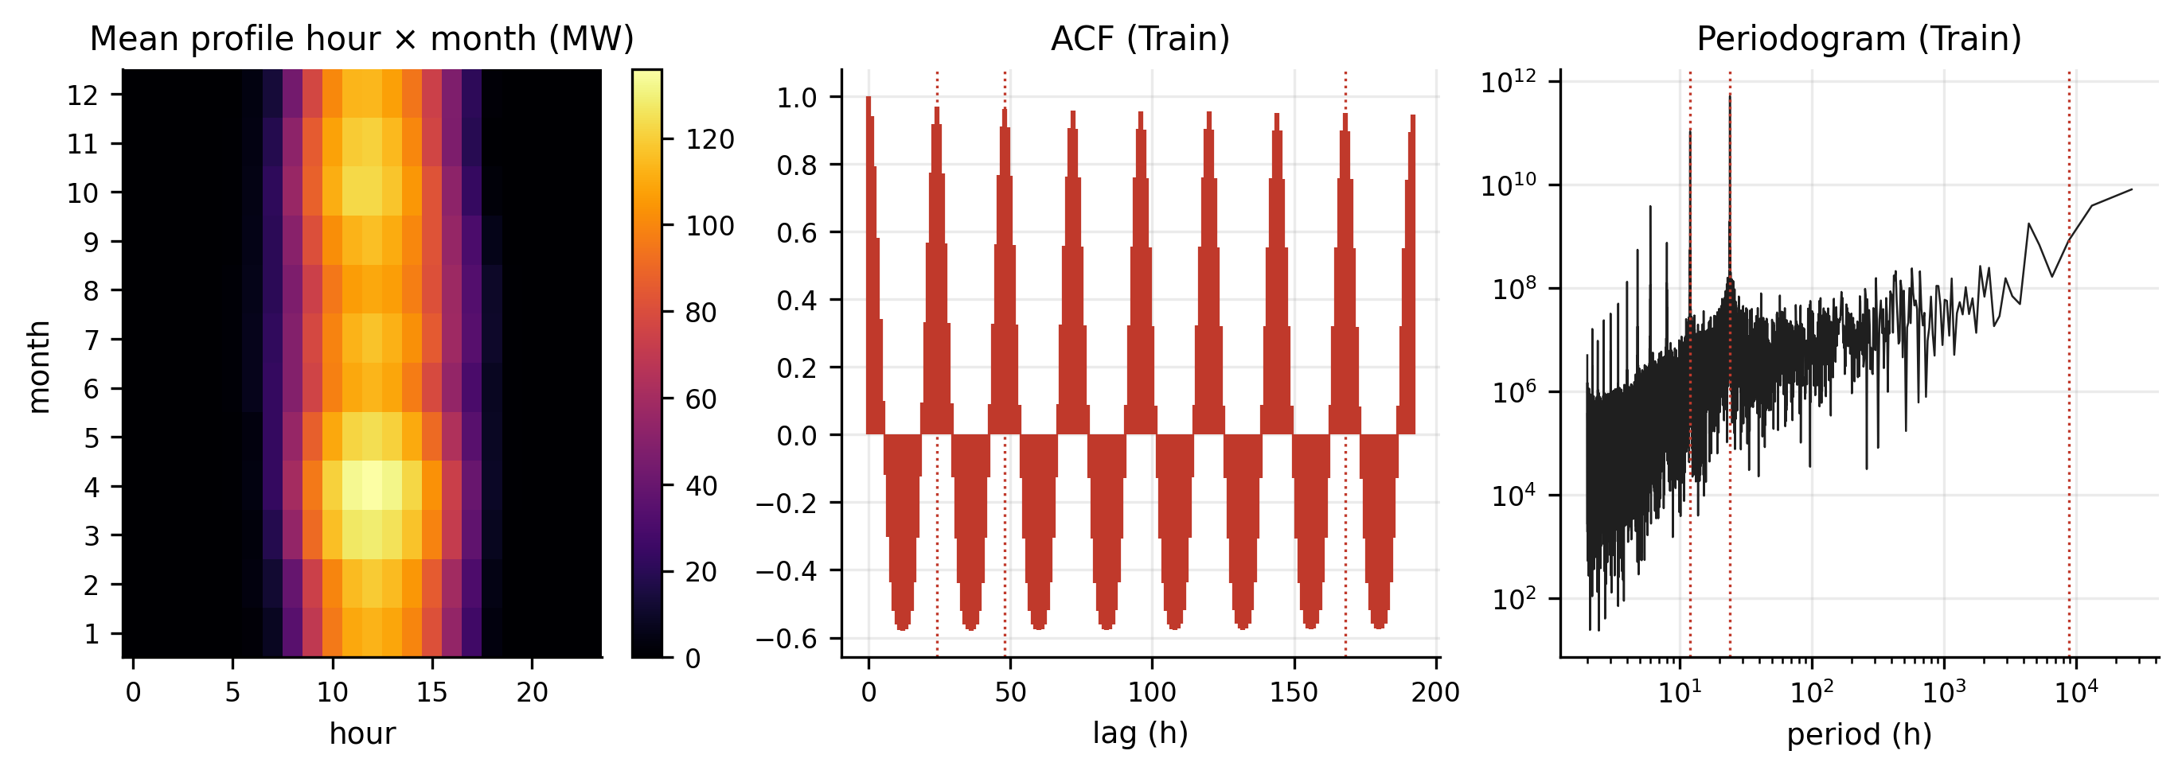
Figure 3. Mean hour × month profile, autocorrelation and periodogram of the target (training set).

4.2 Configuration 1 — patch length
The shorter the patch, the more accurate the forecast: RMSE = 9.02 MW for P = 12 h, 9.13 MW for P = 24 h and 9.20 MW for P = 48 h (Table 4). A 12 h patch separates the morning from the afternoon, which lets temporal attention relate homologous half-days from one day to the next. A 48 h patch, by contrast, mixes two days in the same token. The 12 h patch is also the most stable across seeds (σ = 0.097 MW), for an inference cost that remains low (2.9 ms). It is selected.
Table 4. Configuration 1 — influence of the patch length P (L = 168 h, CA-X, H = 24 h).
Variant | RMSE (MW) | σ (MW) | MAE (MW) | nRMSE | Gain vs pers. | Noise 5 % | Drift | Inf. (ms) | Param. | Norm. score
CAX_P12_L168_H24 | 9.02 | 0.097 | 5.21 | 0.204 | +13.2 % | +0.4 % | 0.58 | 2.9 | 186,625 | 0.800
CAX_P24_L168_H24 | 9.13 | 0.161 | 5.31 | 0.206 | +12.2 % | +0.6 % | 0.58 | 2.3 | 136,321 | 0.257
CAX_P48_L168_H24 | 9.20 | 0.103 | 5.26 | 0.208 | +11.5 % | +0.7 % | 0.55 | 1.6 | 112,321 | 0.374
Means over 5 seeds, every hourly origin of the test set (01/10/2022–09/05/2023). "Gain vs pers.": RMSE reduction relative to daily persistence at the same horizon. Highlighted row: selected variant.
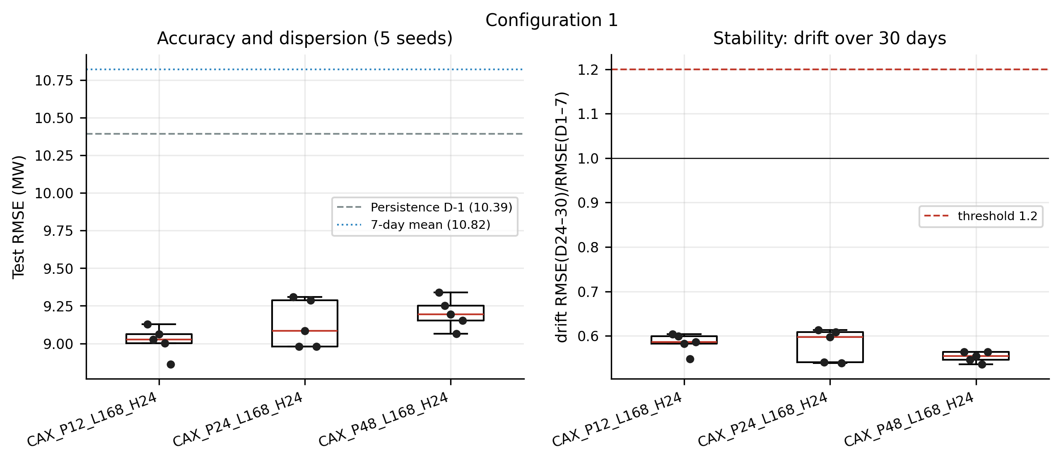
Figure 4. Configuration 1: rosary of the RMSE over 5 seeds (left) and drift over 30 days (right). Horizontal lines: baselines.

4.3 Configuration 2 — history
One week of history (L = 168 h) gives the best RMSE (9.02 MW), ahead of L = 96 h (9.29 MW) and L = 336 h (9.49 MW, Table 5). Extending the window to two weeks degrades accuracy and dispersion, and multiplies the inference time by 1.6. The useful information lies in the last few days (persistence of cloudiness); older context adds bygone weather regimes that attention must learn to ignore.
Table 5. Configuration 2 — influence of the history L (P = 12 h, CA-X, H = 24 h).
Variant | RMSE (MW) | σ (MW) | MAE (MW) | nRMSE | Gain vs pers. | Noise 5 % | Drift | Inf. (ms) | Param. | Norm. score
CAX_P12_L96_H24 | 9.29 | 0.074 | 5.36 | 0.210 | +10.6 % | +0.5 % | 0.58 | 2.5 | 142,849 | 0.568
CAX_P12_L168_H24 | 9.02 | 0.097 | 5.21 | 0.204 | +13.2 % | +0.4 % | 0.58 | 2.9 | 186,625 | 0.701
CAX_P12_L336_H24 | 9.49 | 0.146 | 5.56 | 0.215 | +8.6 % | +0.3 % | 0.62 | 4.7 | 288,769 | 0.100
Means over 5 seeds, every hourly origin of the test set (01/10/2022–09/05/2023). "Gain vs pers.": RMSE reduction relative to daily persistence at the same horizon. Highlighted row: selected variant.

4.4 Configuration 3 — channel handling
Configuration 3 (Table 6, Figure 5) is the most instructive. The standard PatchTST with independent channels (CI), equivalent to a univariate model, reaches 9.47 MW. Cross-channel attention alone (CA) improves it little (9.39 MW) and increases the dispersion across seeds (σ = 0.25 MW). Its degradation under noise is nil (-0.03 %): the model has learned to ignore the past exogenous channels. Conversely, known-future conditioning (X) brings most of the gain: 9.11 MW for CI-X (RMSE reduced by 3.8 % relative to CI), and 9.02 MW for CA-X (reduced by 4.8 %), with the lowest dispersion among the admissible multivariate variants (σ = 0.097 MW). The physical night gate (CA-Xg) leaves accuracy unchanged (9.02 MW), but it fails the robustness test: the RMSE rises by +112 % under noise, because noise on cos θ_{z} opens the gate at night and reveals night-time outputs that the network never learned to constrain. CA-X is selected.
Table 6. Configuration 3 — channel handling (P = 12 h, L = 168 h, H = 24 h). CI: independence; CA: cross-channel attention; X: known future; g: physical gate.
Variant | RMSE (MW) | σ (MW) | MAE (MW) | nRMSE | Gain vs pers. | Noise 5 % | Drift | Inf. (ms) | Param. | Norm. score
CI_P12_L168_H24 | 9.47 | 0.089 | 5.48 | 0.214 | +8.9 % | +0.0 % | 0.57 | 0.9 | 111,066 | 0.400
CIX_P12_L168_H24 | 9.11 | 0.191 | 5.40 | 0.206 | +12.3 % | +0.3 % | 0.61 | 1.1 | 169,147 | 0.524
CA_P12_L168_H24 | 9.39 | 0.248 | 5.66 | 0.212 | +9.7 % | -0.0 % | 0.59 | 2.5 | 128,544 | 0.172
CAX_P12_L168_H24 | 9.02 | 0.097 | 5.21 | 0.204 | +13.2 % | +0.4 % | 0.58 | 2.9 | 186,625 | 0.784
CAXg_P12_L168_H24 | 9.02 | 0.094 | 5.21 | 0.204 | +13.2 % | +112.0 % | 0.59 | 2.6 | 186,625 | 0.788 (rejected)
Means over 5 seeds, every hourly origin of the test set (01/10/2022–09/05/2023). "Gain vs pers.": RMSE reduction relative to daily persistence at the same horizon. Highlighted row: selected variant.
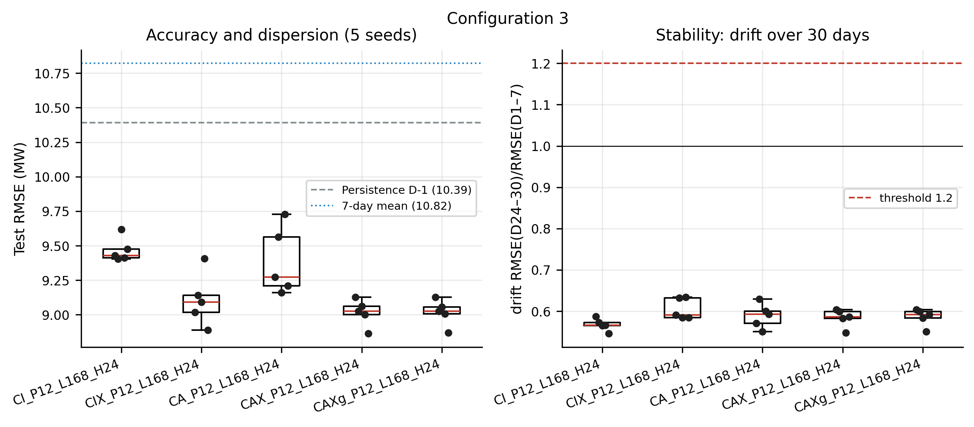
Figure 5. Configuration 3: rosary of the RMSE over 5 seeds and drift over 30 days for the five channel handlings.

4.5 Configuration 4 — forecast horizon
The error grows with the horizon (Table 7): 4.93 MW at 1 h, 7.74 MW at 6 h, 8.61 MW at 12 h, 9.02 MW at 24 h, 11.33 MW at 168 h. The gain relative to persistence, computed at the same horizon, is +52.5 % at 1 h, +25.4 % at 6 h, +17.1 % at 12 h, +13.2 % at 24 h, +17.9 % at 168 h. The gain is largest at very short range, where the immediate history is highly informative and daily persistence remains naive. Hourly persistence ŷ(t) = y(t−1) would be an even weaker baseline at 1 h (RMSE = 18.60 MW against 10.37 MW for daily persistence), because it ignores the sunrise and sunset ramps; this is why daily persistence serves as the baseline at every horizon. The gain persists at 168 h, a horizon at which the model approaches a conditional climatology built from the deterministic covariates. Comparing horizons means comparing different tasks: the horizon is therefore not chosen by the score, but set by the use case, namely day-ahead dispatch planning (H = 24 h).
Table 7. Configuration 4 — forecast horizon H (P = 12 h, L = 168 h, CA-X).
Variant | RMSE (MW) | σ (MW) | MAE (MW) | nRMSE | Gain vs pers. | Noise 5 % | Drift | Inf. (ms) | Param. | Norm. score
CAX_P12_L168_H1 | 4.93 | 0.743 | 3.39 | 0.111 | +52.5 % | +0.3 % | 0.58 | 2.9 | 146,858 | 0.500
CAX_P12_L168_H6 | 7.74 | 0.185 | 4.56 | 0.175 | +25.4 % | +0.4 % | 0.55 | 2.7 | 155,503 | 0.569
CAX_P12_L168_H12 | 8.61 | 0.055 | 5.04 | 0.194 | +17.1 % | +0.5 % | 0.58 | 2.6 | 165,877 | 0.571
CAX_P12_L168_H24 | 9.02 | 0.097 | 5.21 | 0.204 | +13.2 % | +0.4 % | 0.58 | 2.9 | 186,625 | 0.527
CAX_P12_L168_H168 | 11.33 | 0.096 | 6.79 | 0.256 | +17.9 % | +0.4 % | 0.60 | 3.0 | 435,601 | 0.382
Means over 5 seeds, every hourly origin of the test set (01/10/2022–09/05/2023). "Gain vs pers.": RMSE reduction relative to daily persistence at the same horizon. Highlighted row: selected variant.
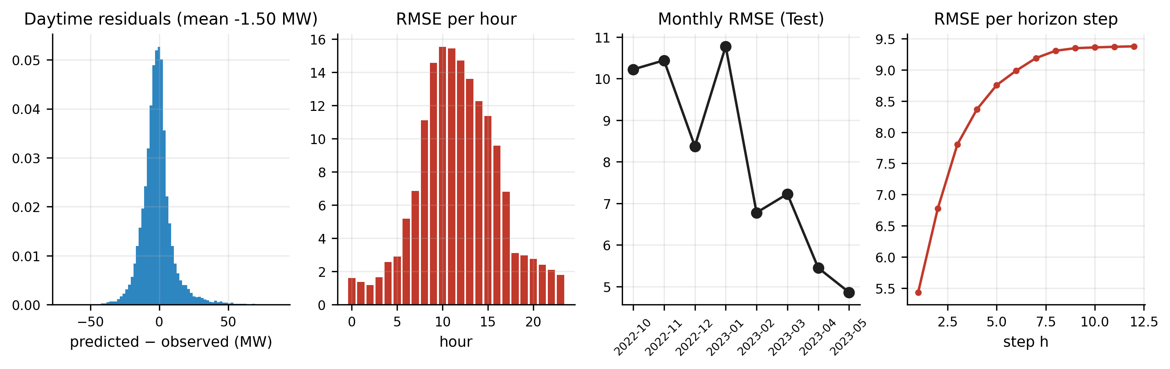
Figure 6. Configuration 4, best score: distribution of the residuals, RMSE per hour, per month and per horizon step.

4.6 Final model and comparison with the baselines
At the day-ahead horizon, the final model (CAX_P12_L168_H24) reaches an RMSE of 9.02 ± 0.10 MW, an nRMSE of 0.204 (0.215 over daytime hours only) and an R² of 0.974 (Table 8). It reduces the RMSE by 13.2 % relative to persistence, by 16.7 % relative to the mean of the last 7 days and by 2.0 % relative to the multi-output Ridge regression, which nevertheless has the same future covariates. The Diebold-Mariano tests reject equal accuracy against persistence (p = 0.003) and against the 7-day mean (p = 0.002). Against Ridge, however, the gap is not significant (p = 0.42); the mean of the forecasts of the 5 seeds (ensemble) reaches 8.88 MW, without becoming significantly better than Ridge either (p = 0.13). The MAE of the model (5.21 MW) is moreover higher than that of persistence (4.97 MW) and of Ridge (4.87 MW). Trained on a squared loss, the model targets the conditional expectation: it reduces the large errors of cloud-transition days, at the cost of small systematic errors on stable clear-sky days, which persistence reproduces exactly. The daytime residuals show a mean bias of -1.30 MW, and the night-time error is 1.87 MW (RMSE).
Table 8. Final model vs baselines at the day-ahead horizon (full test set, every hourly origin).
Model | RMSE (MW) | MAE (MW) | nRMSE | R² | MBE (MW) | DM | p
Persistence D-1 | 10.39 | 4.97 | 0.235 | 0.965 | 0.00 | -2.97 | 3.0e-03
7-day mean | 10.82 | 5.31 | 0.244 | 0.962 | -0.03 | -3.08 | 2.1e-03
Multi-output Ridge | 9.20 | 4.87 | 0.208 | 0.973 | -0.69 | -0.80 | 4.2e-01
PatchTST-CI (univariate) | 9.47 ± 0.09 | 5.48 | 0.214 | 0.971 | 0.46 | – | –
PatchTST-CA-X (proposed) | 9.02 ± 0.10 | 5.21 | 0.204 | 0.974 | -0.01 | ref. | ref.
DM: Diebold-Mariano statistic (HLN correction) of the proposed model against the baseline; negative = proposed model better.
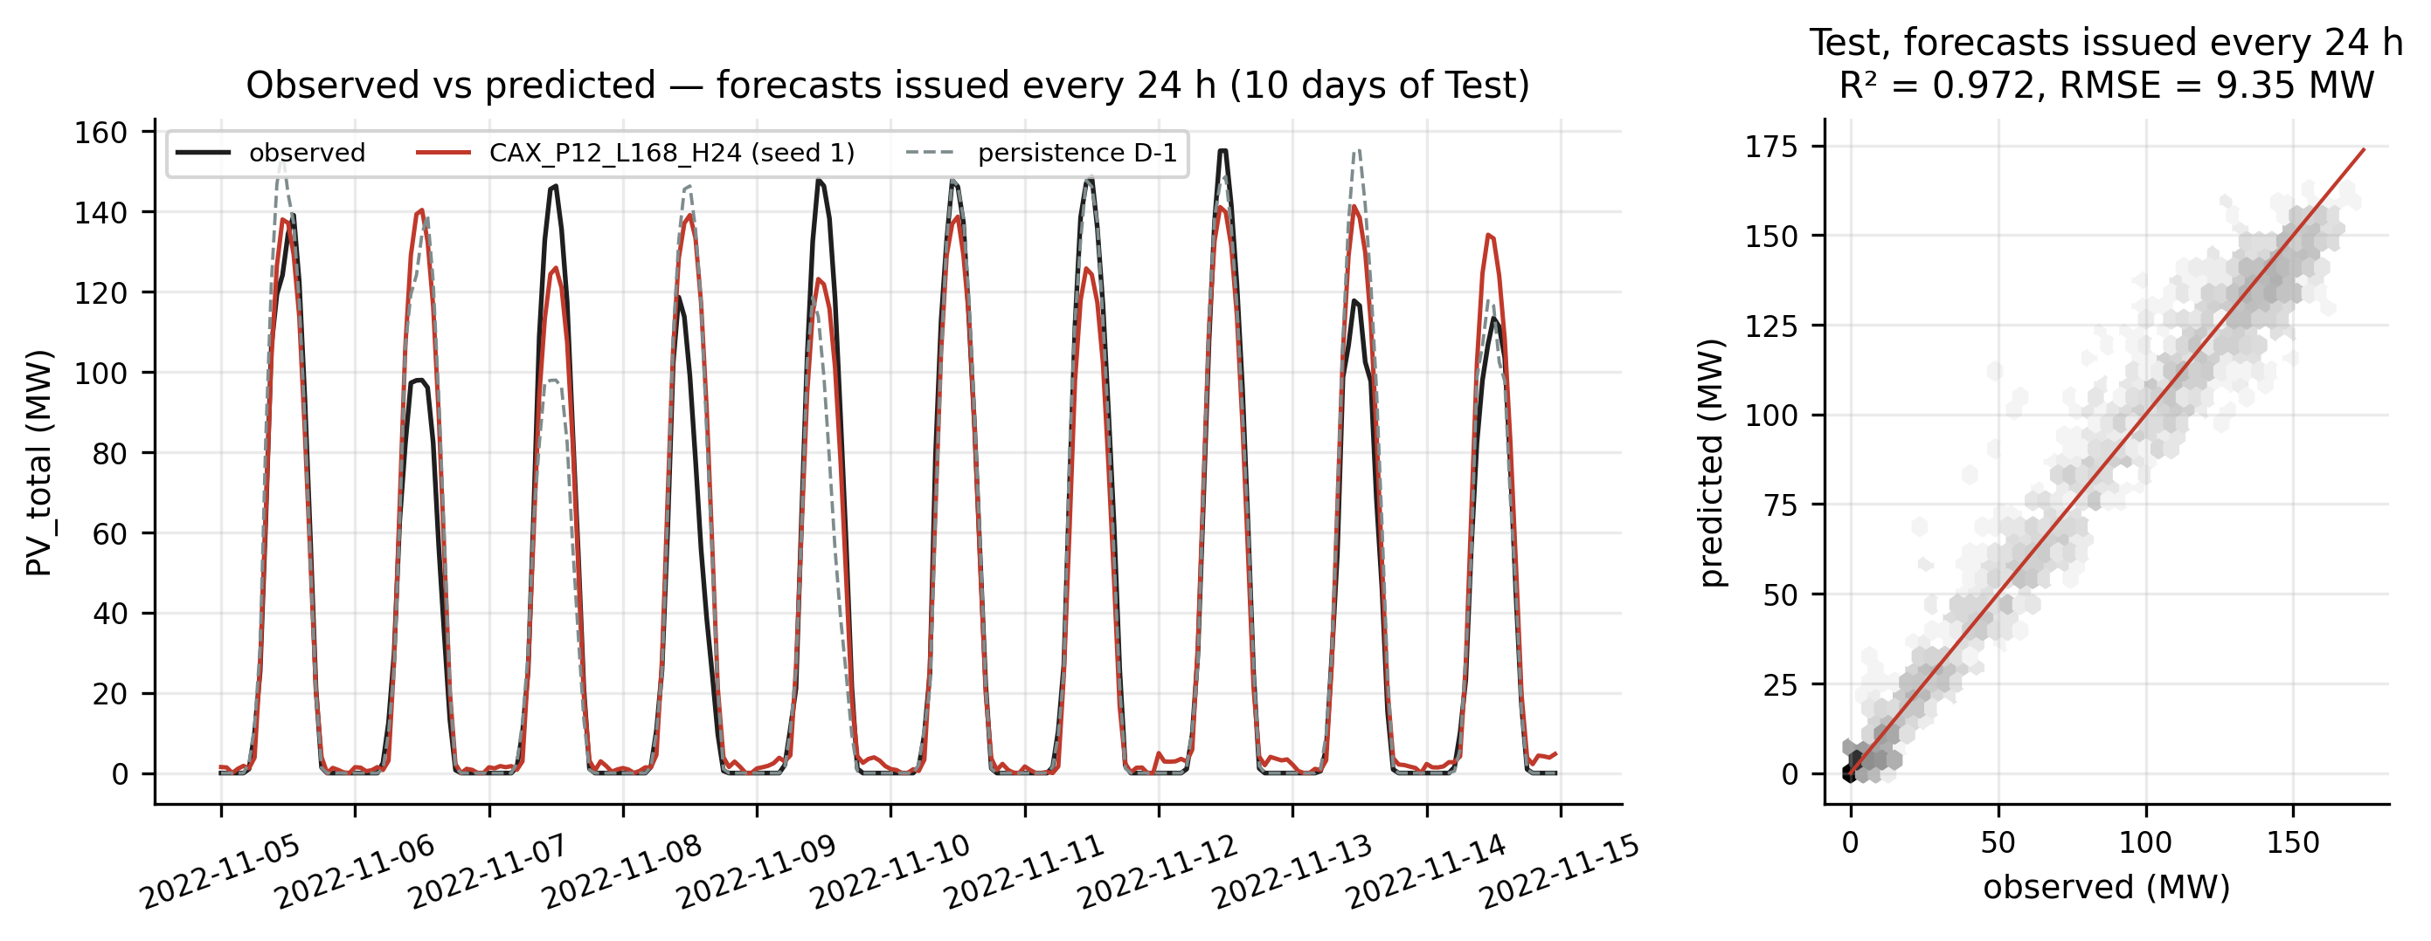
Figure 7. Day-ahead forecast issued at 00:00 (representative seed) vs observation and persistence over ten days of November 2022; scatter plot over the whole test set.
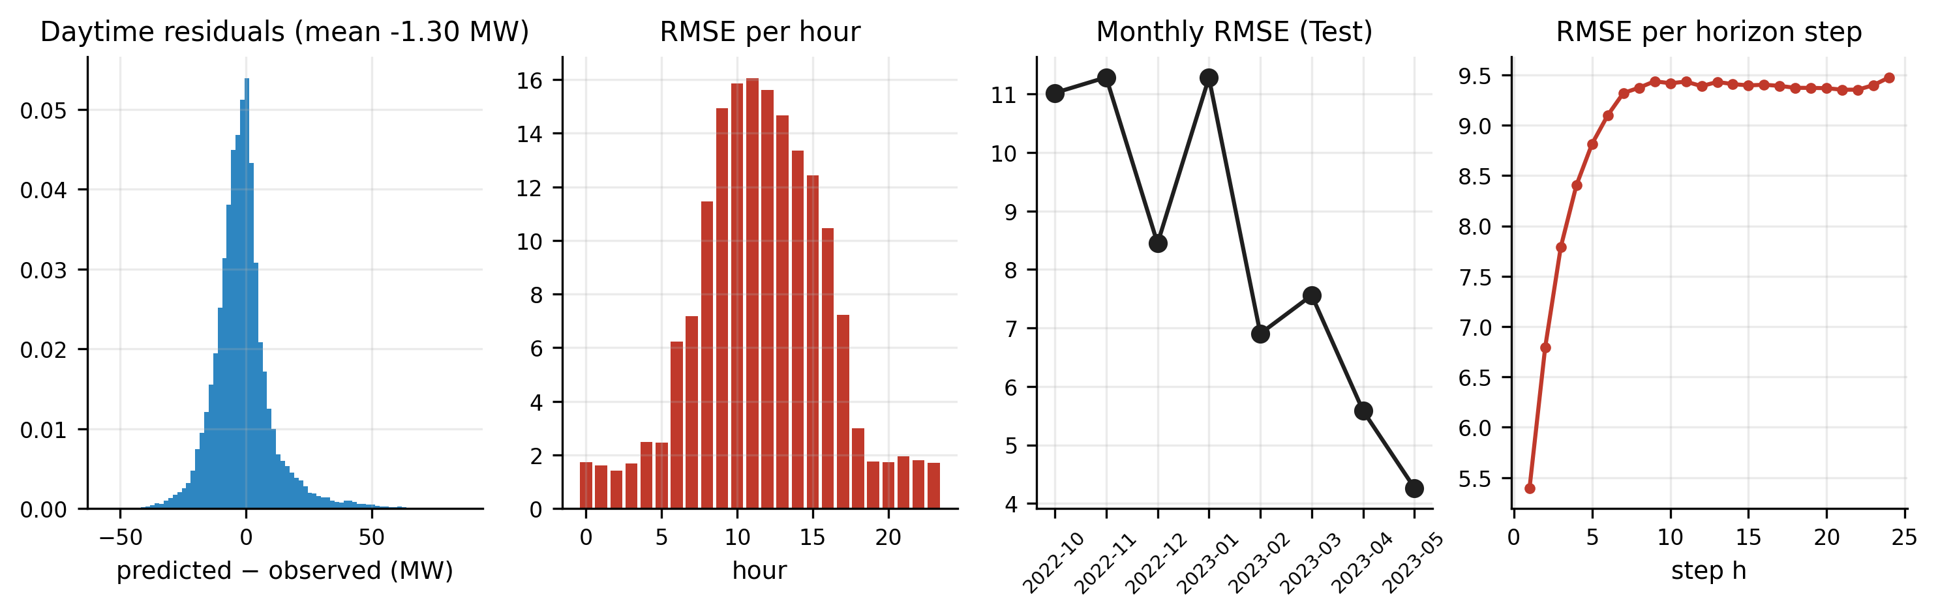
Figure 8. Residual diagnostics of the final model: daytime distribution, RMSE per hour, per month and per horizon step.

4.7 Robustness and temporal cross-validation
Over the 5 seeds, the standard deviation of the RMSE is 0.097 MW, i.e. 1.08 % of the RMSE. The degradation under noise grows steadily with the noise standard deviation: +0.44 % at 5 %, +1.71 % at 10 % and +6.44 % at 20 % (Figure 9). This remains far from the 15 % rejection threshold, which confirms that the forecast relies first on the target history and on the deterministic structure. The temporal cross-validation (Table 9), whose test blocks run from 2019-09 to 2023-05, gives a mean gain over persistence of +13.5 % ± 6.6 %, ranging from +2.4 % to +18.7 % depending on the fold. The gain is smallest for the first fold, trained on only eight months, then stabilises as soon as training covers at least one complete annual cycle: the model needs to see every season to outperform persistence.
Table 9. Temporal cross-validation (TimeSeriesSplit, 5 expanding-window folds, 1 seed).
Fold | Training | Test | RMSE | nRMSE | RMSE pers. | Gain
1 | 2019-01 → 2019-08 | 2019-09-23 → 2020-06-13 | 7.67 | 0.247 | 7.86 | +2.4 %
2 | 2019-01 → 2020-03 | 2020-06-14 → 2021-03-05 | 10.18 | 0.334 | 11.67 | +12.8 %
3 | 2019-01 → 2020-11 | 2021-03-06 → 2021-11-25 | 12.09 | 0.267 | 14.42 | +16.2 %
4 | 2019-01 → 2021-06 | 2021-11-26 → 2022-08-17 | 10.86 | 0.246 | 13.35 | +18.7 %
5 | 2019-01 → 2022-01 | 2022-08-18 → 2023-05-09 | 9.94 | 0.227 | 12.03 | +17.3 %

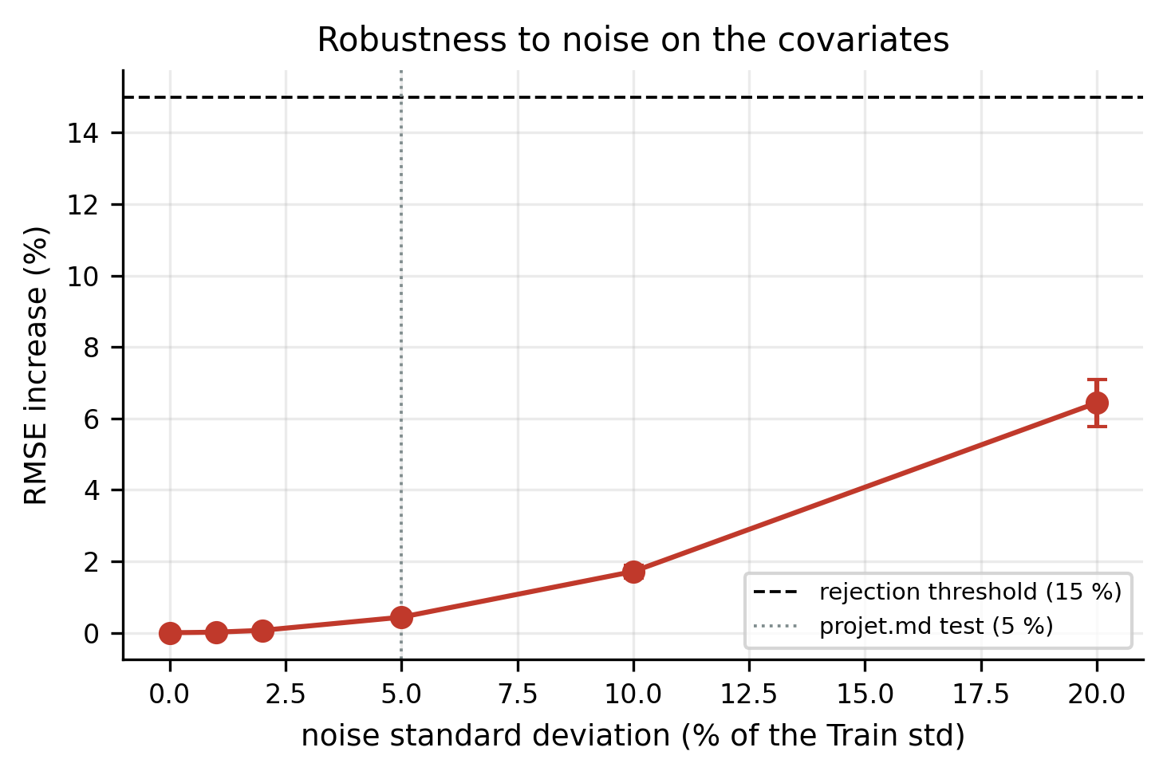
Figure 9. RMSE increase of the final model as a function of the standard deviation of the Gaussian noise injected into the covariates (mean ± standard deviation over 5 seeds).

4.8 Long-term stability
Over 30 days of forecasting without re-training, the drift is 0.58 (raw ratio D30/D1: 0.58), well below the target of 1.2 (Figure 10). The RMSE even decreases during the month, owing to the onset of the dry season in November: this is not a merit of the model, and the drift must always be read against the baseline. Over the calendar months of the test set (October 2022 to May 2023, the latter partial), the monthly RMSE of the model remains below that of persistence in 8 months out of 8, with no upward trend despite a gap of 9 to 16 months from the end of training.
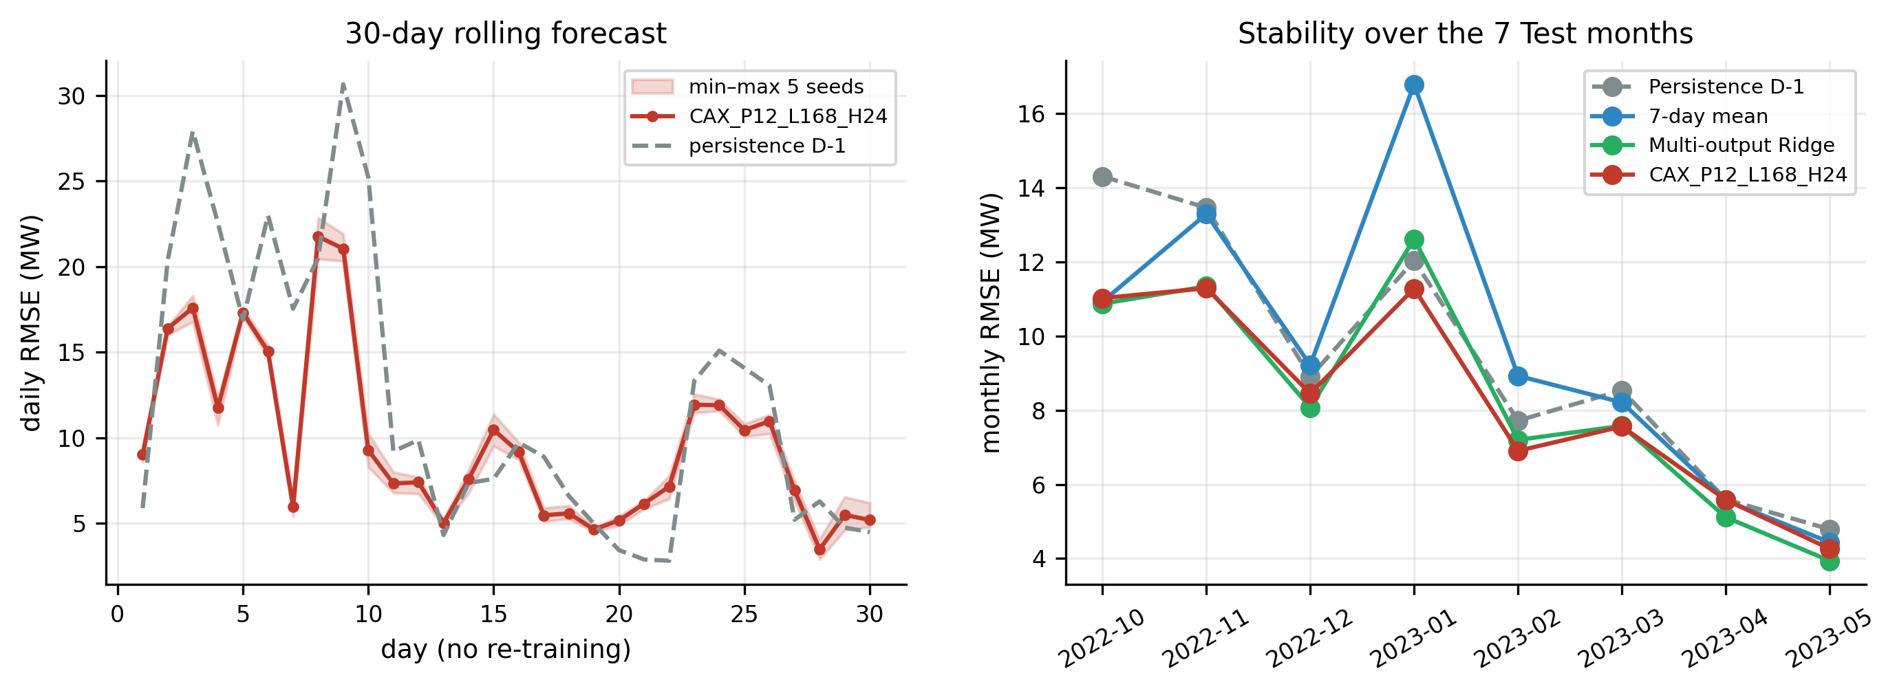
Figure 10. Stability: daily RMSE over 30 days without re-training (min–max envelope of the 5 seeds) and monthly RMSE over the test set, compared with the baselines.

4.9 "Capacity index" ablation
A variant learns the index k = y / C, where C is an apparent capacity estimated causally (99 % quantile of the daily maxima of the previous 30 days), then converts the forecast back to MW. It obtains 9.10 ± 0.17 MW, against 9.02 MW for the final model (+0.9 %). Selective RevIN normalisation therefore already absorbs the growth of the fleet: there is no need to model the installed capacity explicitly over this test period, during which no plant is commissioned.

4.10 Explainability
Occlusion of channel groups (Figure 11, left) clearly ranks the sources of information. Masking the target history increases the RMSE by +134 %; masking solar geometry, by +152 %; the hourly encoding, by +48 %; the seasonal encoding, by +4.4 %. The grid context (+0.1 %) and the day of week (-0.5 %), our negative control, have only a marginal effect. Integrated gradients (Figure 11, centre) confirm this ranking: the PV history carries 25 % of the attribution, and the future covariates (cos θ_{z}, clear-sky GHI, hourly encoding) 65 % in total, against 7.1 % for the three grid channels. The three methods do not say the same thing, and this divergence is instructive. Cross-channel attention gives its largest weight to the Taiba wind farm (15.1 %, for a uniform value of 8.3 %), and integrated gradients attribute a few per cent to the grid channels; yet masking these channels hardly changes the error. An attention weight or a local attribution measures where the model "looks", not what its forecast depends on: only occlusion, which measures the effect on the error, allows us to conclude that the grid context is useless here.
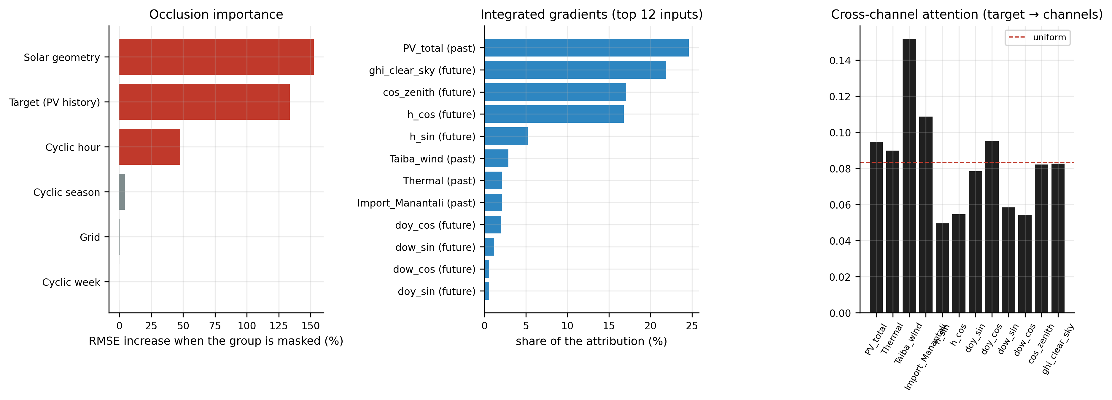
Figure 11. Explainability of the final model: occlusion importance, integrated gradients (top 12 inputs) and cross-channel attention.

4.11 Efficiency and decision score
The final model has 186,625 parameters (0.73 MB). A forecast takes 2.9 ms on a single processor core, and training takes on average 13 min on two cores. The efficiency targets (< 100 ms, < 50 MB) are therefore met by a wide margin. The raw decision score is 5.76.

5. Discussion

What the model really learns
The main lesson is that, without meteorological measurements, the added value of the covariates lies in their availability over the horizon, not in their presence in the past. The past grid channels are almost ignored: occlusion degrades the RMSE by only +0.1 %, and the CA variant without X is insensitive to noise. The deterministic covariates, on the other hand, bring most of the gain when they describe the forecast instant: an RMSE reduced by 3.8 % from CI to CI-X. This result qualifies the intuition, common in the literature [42, 45], that breaking channel independence is enough to exploit exogenous variables. Here, cross-channel attention only becomes useful in the presence of future conditioning (9.02 MW for CA-X against 9.11 MW for CI-X), where it mainly reduces the dispersion across seeds. It is, however, consistent with the works that provide periodic information explicitly to the model [39, 49].

A naive baseline that is hard to beat
The gain of 13.2 % over persistence looks modest, but it is statistically established, stable over time and confirmed by cross-validation. The aggregated generation of eleven dispersed plants smooths part of the cloud variability, and the Senegalese solar regime is regular [21]: persistence is therefore particularly good there (R² > 0.96). Many studies do not compare themselves with this baseline [31–34]; the few that do [51] report larger gains on noisier series. The most important outcome of this comparison, however, concerns Ridge: given the same future covariates, a linear regression reaches 9.20 MW, and the advantage of PatchTST-CA-X (2.0 %) is not significant (p = 0.42), while Ridge has a lower MAE. Without meteorological observations, most of the predictability is therefore linear in the recent history and in the future solar geometry: it is the injected information, not the capacity of the Transformer, that makes the difference. This finding puts into perspective the gains reported for deep architectures compared with weak baselines [31–36]. It also makes a well-specified linear model a mandatory baseline, just like persistence. The practical value of PatchTST-CA-X lies rather in its low dispersion, its robustness, its zero drift and its ability to accommodate, without changing the architecture, non-linear and noisy future covariates (numerical weather predictions) that Ridge would exploit poorly.

Operational relevance
With 2.9 ms per forecast, less than 1 MB of weights, zero drift over a month and high robustness to noise, the model can be integrated into dispatch without dedicated computing infrastructure. For the operator, a day-ahead error reduced by 1.4 MW in RMSE, for a fleet whose peak generation approaches 180 MW, translates directly into the spinning reserve to be committed [15, 16]. This benefit must be quantified by an economic study specific to the SENELEC grid.

"Hard" physical constraints
The failure of the physical gate in the robustness test shows that a physical constraint imposed at the output can make a model fragile when the variable that controls it is uncertain. The network learns to rely on the gate and no longer constrains its night-time outputs. A soft constraint, as a penalty in the loss, or a gate computed from the exact geometry rather than from a model input, would be preferable. More broadly, the physical hybridisation advocated by part of the literature [55] must be evaluated under perturbation, and not only in nominal accuracy.

6. Limitations
- Absence of meteorological data. The accuracy ceiling is set by the available information. Cloud transition days remain poorly forecast, and the error is concentrated between 09:00 and 15:00.
- A single grid and a single test period (seven months, from October to May, without a complete rainy season). Cross-validation covers other seasons, but with a single seed per fold.
- One-factor-at-a-time design. It does not capture interactions between factors (e.g. P × L); a joint search might find a better optimum.
- Point forecast. Uncertainty is not quantified, although it is needed for probabilistic reserve sizing [16, 46].
- Quality of the log. Clipping and imputation, although causal and traceable, rely on statistical thresholds; some plausible outliers may have been kept.
- Drift evaluated over 30 days in a favourable period (onset of the dry season); an evaluation over the following rainy season is still needed.

7. Perspectives
- Integrate numerical weather predictions (ERA5, GFS) or satellite data as noisy future covariates: the X architecture lends itself directly to this, and the noise protocol will measure the sensitivity.
- Make the forecast probabilistic (quantile regression [46], adaptive conformal inference [39]) to feed probabilistic reserve sizing.
- Replace the hard gate by a soft physical constraint, and test an explicit coupling with a clear-sky model (forecasting the clearness index).
- Transfer the model to other West African grids (WAPP), using the transfer strategies that work for PatchTST [47].
- Couple the forecast with the frequency stability of the SENELEC grid [19, 20], to assess its benefit in reserve and avoided load shedding.

8. Conclusion
We studied the forecasting of the total PV generation of the SENELEC grid in a realistic setting for an African operator: without meteorological measurements and without the individual productions as inputs. The PatchTST-CA-X architecture, which conditions the forecasting head on cyclic and solar covariates known over the horizon, reaches a day-ahead RMSE of 9.02 MW (13.2 % lower than persistence). It shows no drift over 30 days, resists noise and forecasts in a few milliseconds. The multi-criteria protocol (accuracy, robustness, stability, efficiency, cross-validation, explainability) shows where the gain really lies: in the deterministic future information, not in adding past exogenous channels; a Ridge regression given the same information does almost as well. The protocol, the code and the notebooks are provided to serve as a benchmark for future work on West African grids.

Data and code availability
The code (commented module, six executed notebooks, flowcharts) and the intermediate results are provided with the paper. The operating data belong to SENELEC and can be obtained from the operator upon reasoned request.

Acknowledgements
The authors thank SENELEC for providing the operating log.

References
[1] R. Shah, et al., A review of key power system stability challenges for large-scale PV integration, Renewable and Sustainable Energy Reviews (2015). https://doi.org/10.1016/j.rser.2014.09.027
[2] R.W. Kenyon, et al., Stability and control of power systems with high penetrations of inverter-based resources: An accessible review of current knowledge and open questions, Solar Energy (2020). https://doi.org/10.1016/j.solener.2020.05.053
[3] C. Seneviratne, C. Ozansoy, Frequency response due to a large generator loss with the increasing penetration of wind/PV generation – A literature review, Renewable and Sustainable Energy Reviews (2016). https://doi.org/10.1016/j.rser.2015.12.051
[4] Y. Cheng, et al., Smart frequency control in low inertia energy systems based on frequency response techniques: A review, Applied Energy (2020). https://doi.org/10.1016/j.apenergy.2020.115798
[5] S. Johnson, et al., Evaluating rotational inertia as a component of grid reliability with high penetrations of variable renewable energy, Energy (2019). https://doi.org/10.1016/j.energy.2019.04.216
[6] O. Smith, et al., The effect of renewable energy incorporation on power grid stability and resilience, Science Advances (2022). https://doi.org/10.1126/sciadv.abj6734
[7] L. Xu, et al., Quantifying cascading power outages during climate extremes considering renewable energy integration, Nature Communications (2025). https://doi.org/10.1038/s41467-025-57565-4
[8] H. Beck, R. Hesse, Virtual synchronous machine, in: 2007 9th International Conference on Electrical Power Quality and Utilisation, 2007. https://doi.org/10.1109/epqu.2007.4424220
[9] H. Bevrani, T. Ise, Y. Miura, Virtual synchronous generators: A survey and new perspectives, International Journal of Electrical Power & Energy Systems (2014). https://doi.org/10.1016/j.ijepes.2013.07.009
[10] E.E. Che, et al., The Impact of Integrating Variable Renewable Energy Sources into Grid-Connected Power Systems: Challenges, Mitigation Strategies, and Prospects, Energies (2025). https://doi.org/10.3390/en18030689
[11] S. Yuan, A.S. Kocaman, V. Modi, Benefits of forecasting and energy storage in isolated grids with large wind penetration – The case of Sao Vicente, Renewable Energy (2017). https://doi.org/10.1016/j.renene.2016.12.061
[12] M. Abdoulaye, et al., Impact of the Intermittency of Photovoltaic Power Plants on the Frequency Management: Case of the Senegalese Electricity Grid, Journal of Power and Energy Engineering (2020). https://doi.org/10.4236/jpee.2020.87005
[13] M. Sarr, et al., Determining the maximal penetration rate in photovoltaic power: case of SENELEC network in Senegal, in: 2018 International Conference on Smart Grid (icSmartGrid), 2018. https://doi.org/10.1109/isgwcp.2018.8634445
[14] M. Sarr, et al., Optimization of the Penetration Rate in Photovoltaic Power: Case of the Senegalese Electricity Network, in: 2020 8th International Conference on Smart Grid (icSmartGrid), 2020. https://doi.org/10.1109/icsmartgrid49881.2020.9144701
[15] N.K.D. Dieng, et al., Inverter-based resources dominated grid: voltage and frequency stability in a weakly interconnected power system, e-Prime – Advances in Electrical Engineering, Electronics and Energy (2025). https://doi.org/10.1016/j.prime.2025.100984
[16] M. Fall, et al., Impacts of probabilistically sized reserves on the operation of the Senegalese electrical grid, in: 2024 IEEE PES Innovative Smart Grid Technologies Europe (ISGT EUROPE), 2024. https://doi.org/10.1109/isgteurope62998.2024.10863728
[17] M.N. Ba, et al., Congestion assessment in a developing country’s power system amid energy transition: Case study of Senegal, in: 2025 IEEE PES/IAS PowerAfrica, 2025. https://doi.org/10.1109/powerafrica65840.2025.11289046
[18] M. Ndiaye, et al., Assessing the Effects of Decentralized Photovoltaic Power Plants on the Transmission Grid: A Senegal Case Study, in: 2025 IEEE Multi-conference on Natural and Engineering Sciences for Sahel’s Sustainable Development (MNE3SD), 2025. https://doi.org/10.1109/mne3sd67637.2025.11323233
[19] A. Faye, et al., Analysis of the Stability of the Electricity Network Integrating Renewable Energy Sources: Case Study of the Senelec Network, Senegal, in: 2025 13th International Conference on Smart Grid (icSmartGrid), 2025. https://doi.org/10.1109/icsmartgrid66138.2025.11071772
[20] A. Faye, et al., Principal Component Analysis for the Frequency Stability of the SENELEC Electricity Grid Integrating Solar PV and Wind Power Plants, in: 2025 14th International Conference on Renewable Energy Research and Applications (ICRERA), 2025. https://doi.org/10.1109/icrera66237.2025.11284275
[21] H. Bloomfield, C. Wainwright, N. Mitchell, Characterizing the variability and meteorological drivers of wind power and solar power generation over Africa, Meteorological Applications (2022). https://doi.org/10.1002/met.2093
[22] F.A. Ndiaye, et al., Analysis of real performance and seasonal prediction of a 23 MWp grid-connected photovoltaic plant in Senegal: Case of Diass, Energy for Sustainable Development (2025). https://doi.org/10.1016/j.esd.2025.101660
[23] H. Wang, et al., A review of deep learning for renewable energy forecasting, Energy Conversion and Management (2019). https://doi.org/10.1016/j.enconman.2019.111799
[24] N.E. Benti, M.D. Chaka, A. Semie, Forecasting Renewable Energy Generation with Machine Learning and Deep Learning: Current Advances and Future Prospects, Sustainability (2023). https://doi.org/10.3390/su15097087
[25] M. Sharifzadeh, A. Sikinioti-Lock, N. Shah, Machine-learning methods for integrated renewable power generation: A comparative study of artificial neural networks, support vector regression, and Gaussian Process Regression, Renewable and Sustainable Energy Reviews (2019). https://doi.org/10.1016/j.rser.2019.03.040
[26] S. Aslam, et al., A survey on deep learning methods for power load and renewable energy forecasting in smart microgrids, Renewable and Sustainable Energy Reviews (2021). https://doi.org/10.1016/j.rser.2021.110992
[27] J. Klaiber, C. Van Dinther, Deep Learning for Variable Renewable Energy: A Systematic Review, ACM Computing Surveys (2023). https://doi.org/10.1145/3586006
[28] O. Khouili, et al., Evaluating the impact of deep learning approaches on solar and photovoltaic power forecasting: A systematic review, Energy Strategy Reviews (2025). https://doi.org/10.1016/j.esr.2025.101735
[29] T. Alazemi, M. Darwish, M. Radi, Renewable energy sources integration via machine learning modelling: A systematic literature review, Heliyon (2024). https://doi.org/10.1016/j.heliyon.2024.e26088
[30] J. Devaraj, et al., A holistic review on energy forecasting using big data and deep learning models, International Journal of Energy Research (2021). https://doi.org/10.1002/er.6679
[31] A. Alsafrani, et al., Photovoltaic Power Forecasting for Sustainable Grid Integration: A Hybrid Deep Learning Approach, IEEE Access (2025). https://doi.org/10.1109/access.2025.3640216
[32] H. Gangwar, et al., Micro-Grid Renewable Energy Integration and Operational Optimization for Smart Grid Applications Using a Deep Learning, Electric Power Components and Systems (2024). https://doi.org/10.1080/15325008.2023.2296960
[33] Z.A. Khan, et al., Towards efficient and effective renewable energy prediction via deep learning, Energy Reports (2022). https://doi.org/10.1016/j.egyr.2022.08.009
[34] S. Sankarananth, et al., AI-enabled metaheuristic optimization for predictive management of renewable energy production in smart grids, Energy Reports (2023). https://doi.org/10.1016/j.egyr.2023.08.005
[35] M. Cheng, et al., A Spatiotemporal Deep Learning Framework for Joint Load and Renewable Energy Forecasting in Stability-Constrained Power Systems, Information (2025). https://doi.org/10.3390/info16080662
[36] M. Abdelsattar, et al., Comparative analysis of deep learning architectures in solar power prediction, Scientific Reports (2025). https://doi.org/10.1038/s41598-025-14908-x
[37] Y. Nie, N.H. Nguyen, P. Sinthong, J. Kalagnanam, A time series is worth 64 words: Long-term forecasting with transformers, in: Proc. 11th Int. Conf. Learn. Represent. (ICLR), 2023. https://doi.org/10.48550/arXiv.2211.14730
[38] X. Lv, et al., Patch Time Series Transformer-Based Short-Term Photovoltaic Power Prediction Enhanced by Artificial Fish, Energies (2026). https://doi.org/10.3390/en19010284
[39] V. Suresh, Benchmarking Transformer Variants for Hour-Ahead PV Forecasting: PatchTST with Adaptive Conformal Inference, Energies (2025). https://doi.org/10.3390/en18185000
[40] E.M. El-kenawy, et al., Feature selection and hyperparameter tuning in transformer-based deep learning models for photovoltaic power forecasting using the Swordfish Movement Optimization Algorithm (SMOA), International Journal of Electrical Power & Energy Systems (2026). https://doi.org/10.1016/j.ijepes.2025.111509
[41] Q. Guo, C. Zhao, X. Gao, An incremental photovoltaic power prediction model considering online updating and catastrophic forgetting, Solar Energy (2025). https://doi.org/10.1016/j.solener.2025.113787
[42] K. Lu, et al., CT-PatchTST: Channel-Time Patch Time-Series Transformer for Long-Term Renewable Energy Forecasting, in: Proc. ISCIPT 2025, IEEE, 2025. https://doi.org/10.1109/iscipt67144.2025.11265471
[43] Y. Gao, et al., Ultra-Short-Term Wind Power Prediction Based on the ZS-DT-PatchTST Combined Model, Energies (2024). https://doi.org/10.3390/en17174332
[44] H. Zhao, et al., CPTCFS: CausalPatchTST incorporated causal feature selection model for short-term wind power forecasting of newly built wind farms, International Journal of Electrical Power & Energy Systems (2024). https://doi.org/10.1016/j.ijepes.2024.110059
[45] S. Xu, et al., A PatchTST-GRU based heterogeneous seq2seq model with numerical weather prediction refinement for multi-step wind power forecasting, Scientific Reports (2025). https://doi.org/10.1038/s41598-025-00741-9
[46] W. Zhang, et al., Probabilistic load forecasting for integrated energy systems based on quantile regression patch time series Transformer, Energy Reports (2024). https://doi.org/10.1016/j.egyr.2024.11.057
[47] R. Spencer, et al., Transfer learning on transformers for building energy consumption forecasting – A comparative study, Energy and Buildings (2025). https://doi.org/10.1016/j.enbuild.2025.115632
[48] S.Q. Yang, et al., DiffTST: Diff Transformer for Multivariate Time Series Forecast, IEEE Access (2025). https://doi.org/10.1109/access.2025.3563070
[49] S. Lin, et al., CycleNet: Enhancing time series forecasting through modeling periodic patterns, in: Adv. Neural Inf. Process. Syst. 37 (NeurIPS), 2024. https://doi.org/10.48550/arXiv.2409.18479
[50] C. Li, B. Xiao, Q. Yuan, Ultra-short-term wind power prediction algorithm based on bidirectional neural controlled differential equations, Electric Power Systems Research (2025). https://doi.org/10.1016/j.epsr.2025.111479
[51] O. Mamyrbayev, et al., Optimizing Renewable Energy Integration Using IoT and Machine Learning Algorithms, International Journal of Industrial Engineering and Management (2025). https://doi.org/10.24867/ijiem-375
[52] Z. Liao, J. Kally, S. Ru, Probabilistic modeling of renewable energy sources in smart grids: A stochastic optimization perspective, Sustainable Cities and Society (2024). https://doi.org/10.1016/j.scs.2024.105522
[53] G. Anis, et al., Smart and transparent grid stability prediction for efficient energy management using explainable AI, Energy Strategy Reviews (2026). https://doi.org/10.1016/j.esr.2026.102083
[54] P. Babakhani, et al., An Explainable Transformer-Based Mixture of Experts for Heat Load Forecasting, IEEE Access (2026). https://doi.org/10.1109/access.2026.3656258
[55] Y. Lin, et al., Advancing AI-Enabled Techniques in Energy System Modeling: A Review of Data-Driven, Mechanism-Driven, and Hybrid Modeling Approaches, Energies (2025). https://doi.org/10.3390/en18040845
[56] G. Coulibaly, et al., Machine learning algorithm for short-term forecasting of energy production from renewable energy sources (PV-Wind) connected to the electricity grid for greater resilience: Case study, the Senelec network, Senegal, in: 2025 14th International Conference on Renewable Energy Research and Applications (ICRERA), 2025. https://doi.org/10.1109/icrera66237.2025.11283993
[57] T. Kim, J. Kim, Y. Tae, C. Park, J.-H. Choi, J. Choo, Reversible instance normalization for accurate time-series forecasting against distribution shift, in: Proc. 10th Int. Conf. Learn. Represent. (ICLR), 2022.
[58] A. Vaswani, N. Shazeer, N. Parmar, J. Uszkoreit, L. Jones, A.N. Gomez, Ł. Kaiser, I. Polosukhin, Attention is all you need, in: Adv. Neural Inf. Process. Syst. 30 (NeurIPS), 2017.
[59] F.X. Diebold, R.S. Mariano, Comparing predictive accuracy, Journal of Business & Economic Statistics 13 (1995) 253–263. https://doi.org/10.1080/07350015.1995.10524599
[60] D. Harvey, S. Leybourne, P. Newbold, Testing the equality of prediction mean squared errors, International Journal of Forecasting 13 (1997) 281–291. https://doi.org/10.1016/S0169-2070(96)00719-4
[61] B. Haurwitz, Insolation in relation to cloudiness and cloud density, Journal of Meteorology 2 (1945) 154–166. https://doi.org/10.1175/1520-0469(1945)002<0154:IIRTCA>2.0.CO;2
[62] W.F. Holmgren, C.W. Hansen, M.A. Mikofski, pvlib python: a python package for modeling solar energy systems, Journal of Open Source Software 3 (2018) 884. https://doi.org/10.21105/joss.00884
[63] M. Sundararajan, A. Taly, Q. Yan, Axiomatic attribution for deep networks, in: Proc. 34th Int. Conf. Mach. Learn. (ICML), PMLR 70, 2017, pp. 3319–3328.
[64] A. Paszke et al., PyTorch: An imperative style, high-performance deep learning library, in: Adv. Neural Inf. Process. Syst. 32 (NeurIPS), 2019.

