Step-by-step method
Multivariate forecasting of the total PV generation of the SENELEC grid with PatchTST
Abdoulaye FAYE — UADB / EDTSS
Methodological document accompanying the notebooks

Purpose of the document
This document describes step by step the procedure followed to build, evaluate and select a PatchTST model forecasting the total photovoltaic generation of the SENELEC grid, according to the specification projet.md. For each step, it states what is done, why, where the code is and how to check it. It is intended both for the reader who wants to understand the method and for the one who wants to reproduce it.
Deliberate deviation from `projet.md`. The specification describes a univariate problem; the request then evolved towards a multivariate forecast without the individual PV productions as input variables, with cyclic variables. Since the log contains no meteorological data, the 5 % noise test "on the weather" is applied to all the exogenous covariates.

Step 0 — Project organisation
Table A. Tree of the deliverables.
Item | Content
data/ | energie.xlsx (hourly log), projet.md (specification)
src/patchtst_pv.py | commented core module: data, covariates, PatchTST, training, metrics, protocol, score
src/analysis.py | baselines (persistence, mean, Ridge), DM tests, figures, cross-validation, XAI
src/run_experiments.py | runs configurations 1 → 4 in sequence (one factor at a time)
notebooks/00 … 05 | EDA; one configuration per notebook; final model
figures/ | all figures (300 dpi PNG), including the flowcharts flow_config1…4
tables/ | comparison tables (CSV) and Excel summary workbook
models/best_patchtst.pt | weights of the final model + configuration + normalisation parameters
cache/ | results per configuration and per seed (forecasts, weights, learning histories)

Reproducing the study. (1) python src/run_experiments.py trains and evaluates every configuration (several hours on CPU); (2) notebooks 00 to 05 can then be executed in order: they read the cache. Deleting a folder cache/<configuration>/ re-runs its training.

Step 1 — Loading and checking the data (notebook 00)
The log covers 38,160 hours, from 01/01/2019 to 09/05/2023. The hourly grid is completed for the 288 missing hours (eight jumps of one to three days): windowing requires a regular grid. Why: deleting these hours would shift every window that contains them.

Step 2 — Construction of the target PV_total
The target is the sum of the eleven PV plants. For each plant: (a) clipping above 1.2 × the 99.9 % quantile of the training period; (b) zero value outside the period of existence; (c) causal imputation of gaps. Code: build_target, impute_series.
Table B. Traceability of the target construction, per plant.
Plant | Commissioning | Last record | Threshold (MW) | Clipped | Imputed gaps | Mean (MW)
PV-Mbour | 01/01/2019 | 09/05/2023 | 22.7 | 14 | 1032 | 3.97
PV-CICAD | 01/01/2019 | 11/04/2023 | 4.4 | 36 | 710 | 0.26
PV Kahone | 01/01/2019 | 25/01/2021 | 19.1 | 1 | 454 | 1.57
PV ERS Kahone | 26/01/2021 | 09/05/2023 | 18.1 | 13 | 244 | 1.97
PV Scaling Kahone | 26/01/2021 | 09/05/2023 | 39.3 | 1 | 779 | 3.21
PV Kael Touba | 26/03/2021 | 09/05/2023 | 30.2 | 1 | 200 | 2.80
PV-Bokhol | 01/01/2019 | 09/05/2023 | 23.1 | 11 | 901 | 4.16
PV Mékhé Mérina | 01/01/2019 | 09/05/2023 | 24.3 | 24 | 522 | 5.63
PV S Mekhe Santhiou | 01/01/2019 | 09/05/2023 | 25.2 | 0 | 1066 | 5.58
PV DIASS | 12/06/2019 | 09/05/2023 | 22.3 | 1 | 829 | 3.45
PV Sakal | 01/01/2019 | 09/05/2023 | 21.1 | 5 | 976 | 4.85

Check: notebook 00 asserts that the normalisation is computed on the training period only and that no individual PV column, nor any total that contains it, enters the model.
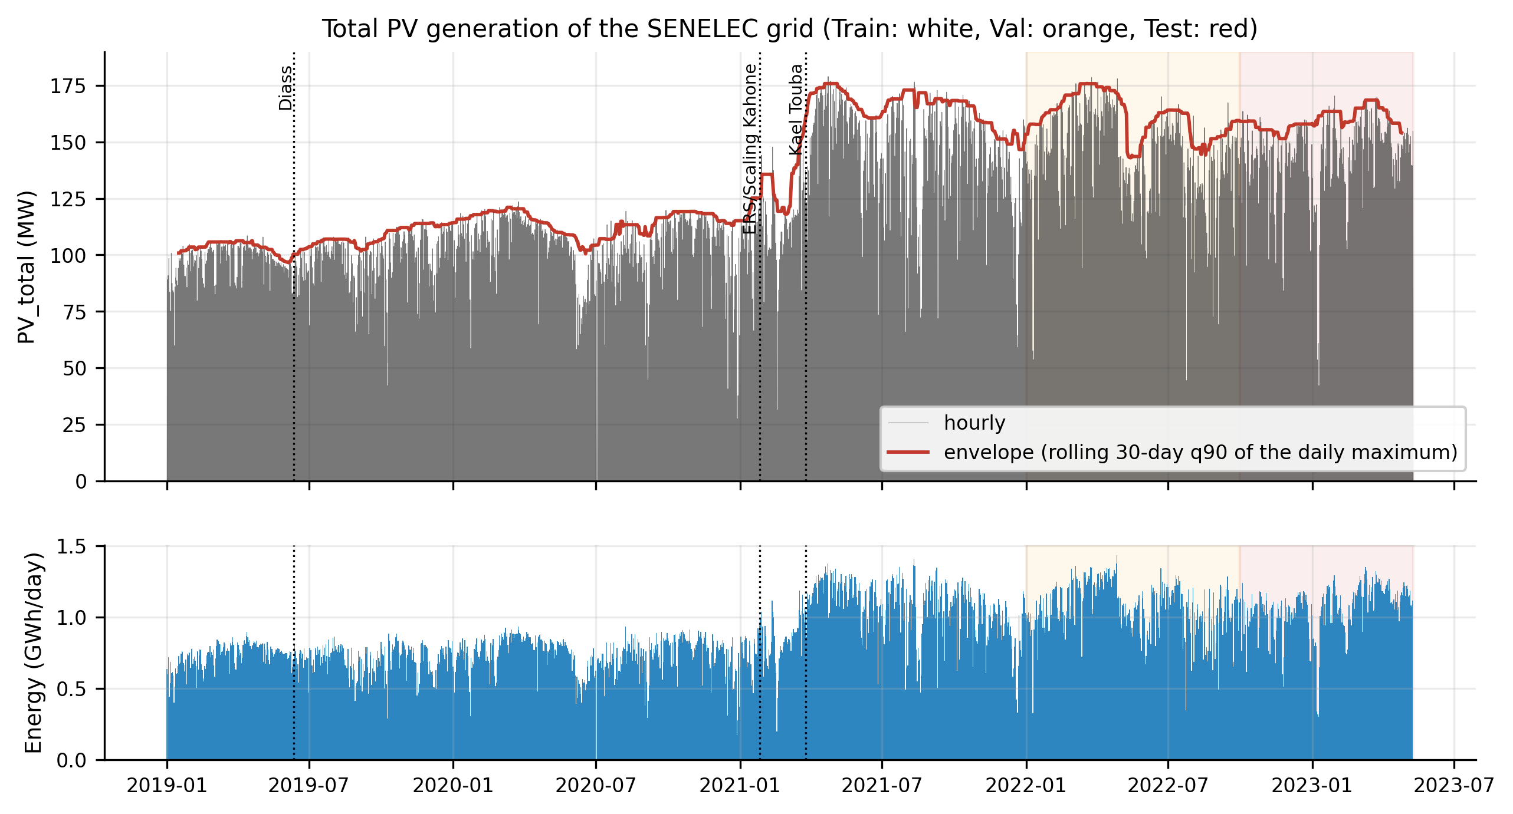
Figure A. Target series, capacity envelope and temporal split.

Step 3 — Exploratory analysis
- Seasonality: dominant 24 h cycle (ACF(24) ≈ 0.97 on training), 12 h harmonic, annual modulation.
- Non-stationarity: mean production grows by 47 % between 2019 and 2022 (commissionings).
- Correlations: strong with solar geometry (≈ 0.94), weak with the grid context once the mean cycle is removed.
- Consequence: day-ahead persistence will be a hard baseline to beat.
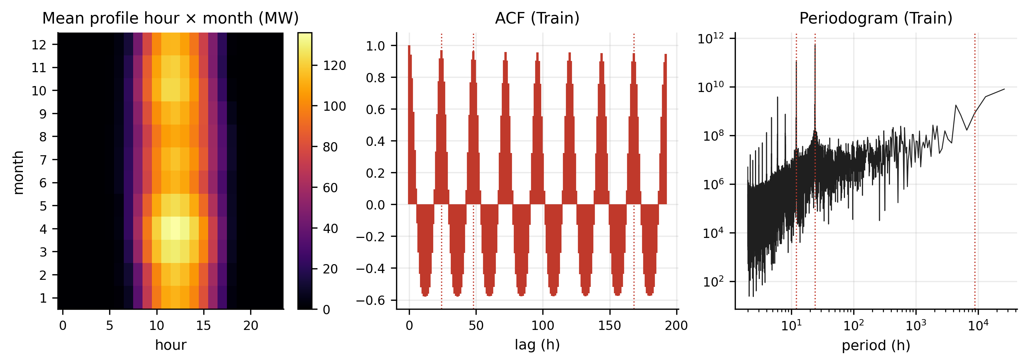
Figure B. Hour × month profile, autocorrelation and periodogram.

Step 4 — Covariates
Twelve channels: the target; three grid channels (aggregated thermal, Taiba wind, Manantali import); six cyclic encodings (sin/cos of the hour, day of year, day of week); two solar-geometry variables (cos θz, Haurwitz clear-sky irradiance, pvlib). The offset between timestamps and solar time is estimated on training: 0.50 h. Code: cyclic_covariates, solar_covariates, estimate_offset, grid_covariates.
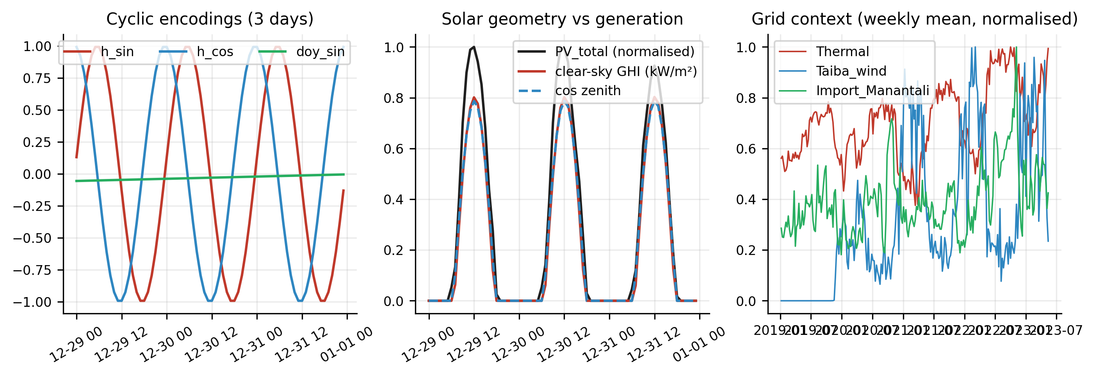
Figure C. Cyclic covariates, solar geometry and grid context.

Step 5 — Temporal split and normalisation
Train: 01/01/2019 → 31/12/2021 (26,304 h); Validation: 01/01/2022 → 30/09/2022 (6,552 h); Test: 01/10/2022 → 09/05/2023 (5,304 h). No shuffling. The global normalisation is fitted on Train; inside the model, a reversible normalisation (RevIN) is applied window by window to the stochastic channels only.
Correction made during the study. A first version applied RevIN to every channel. Over a 7-day window, the day of year barely changes: standardising it erased the season and created an artificial ramp. Integrated gradients revealed it (24 % of the attribution on past doy_sin). All the results presented were recomputed after the correction.

Step 6 — PatchTST model and variants
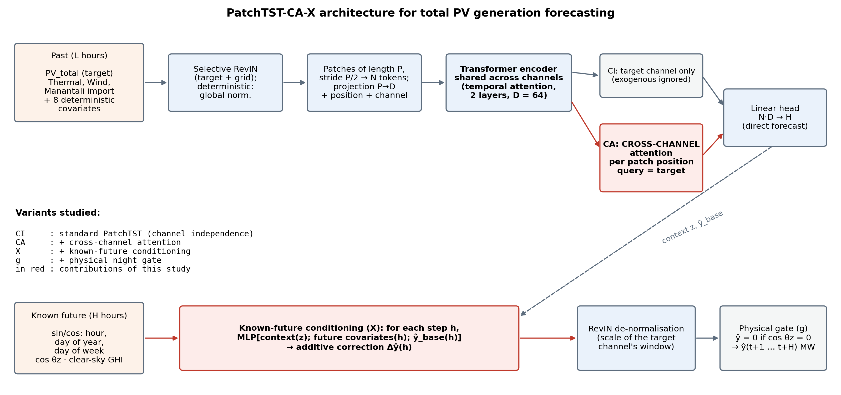
Figure D. PatchTST-CA-X architecture and CI / CA / X / g variants.
Class PatchTST of the module. Patches of length P (stride P/2) are projected to dimension 64; a 2-layer Transformer encoder is shared across channels. CI: only the target feeds the head; CA: cross-channel attention at each patch position; X: step-by-step correction by the future deterministic covariates; g: physical night gate.

Step 7 — Training and evaluation protocol
- Training on Train, early stopping on Val (patience 4, at most 25 epochs), 20 % of the hourly origins drawn at each epoch, 5 seeds.
- Accuracy over every hourly origin of the Test set: RMSE, MAE, nRMSE = RMSE/mean, R², MBE.
- Robustness: standard deviation over 5 seeds; 5 % Gaussian noise on the exogenous channels (rejected if the RMSE rises by more than 15 %).
- Stability: 30-day rolling forecast without re-training; drift = RMSE(D24–30)/RMSE(D1–7) (target < 1.2), raw D30/D1 ratio reported.
- Efficiency: inference time for one sample on one core (< 100 ms); weight size (< 50 MB).
- Score = 0.4/nRMSE + 0.3/σ + 0.3/drift + bonus; selection on the normalised score (criteria mapped to [0, 1]).
- Diebold-Mariano tests against persistence and the 7-day mean.

Step 8 — Configuration 1 — patch length P (notebook 01)
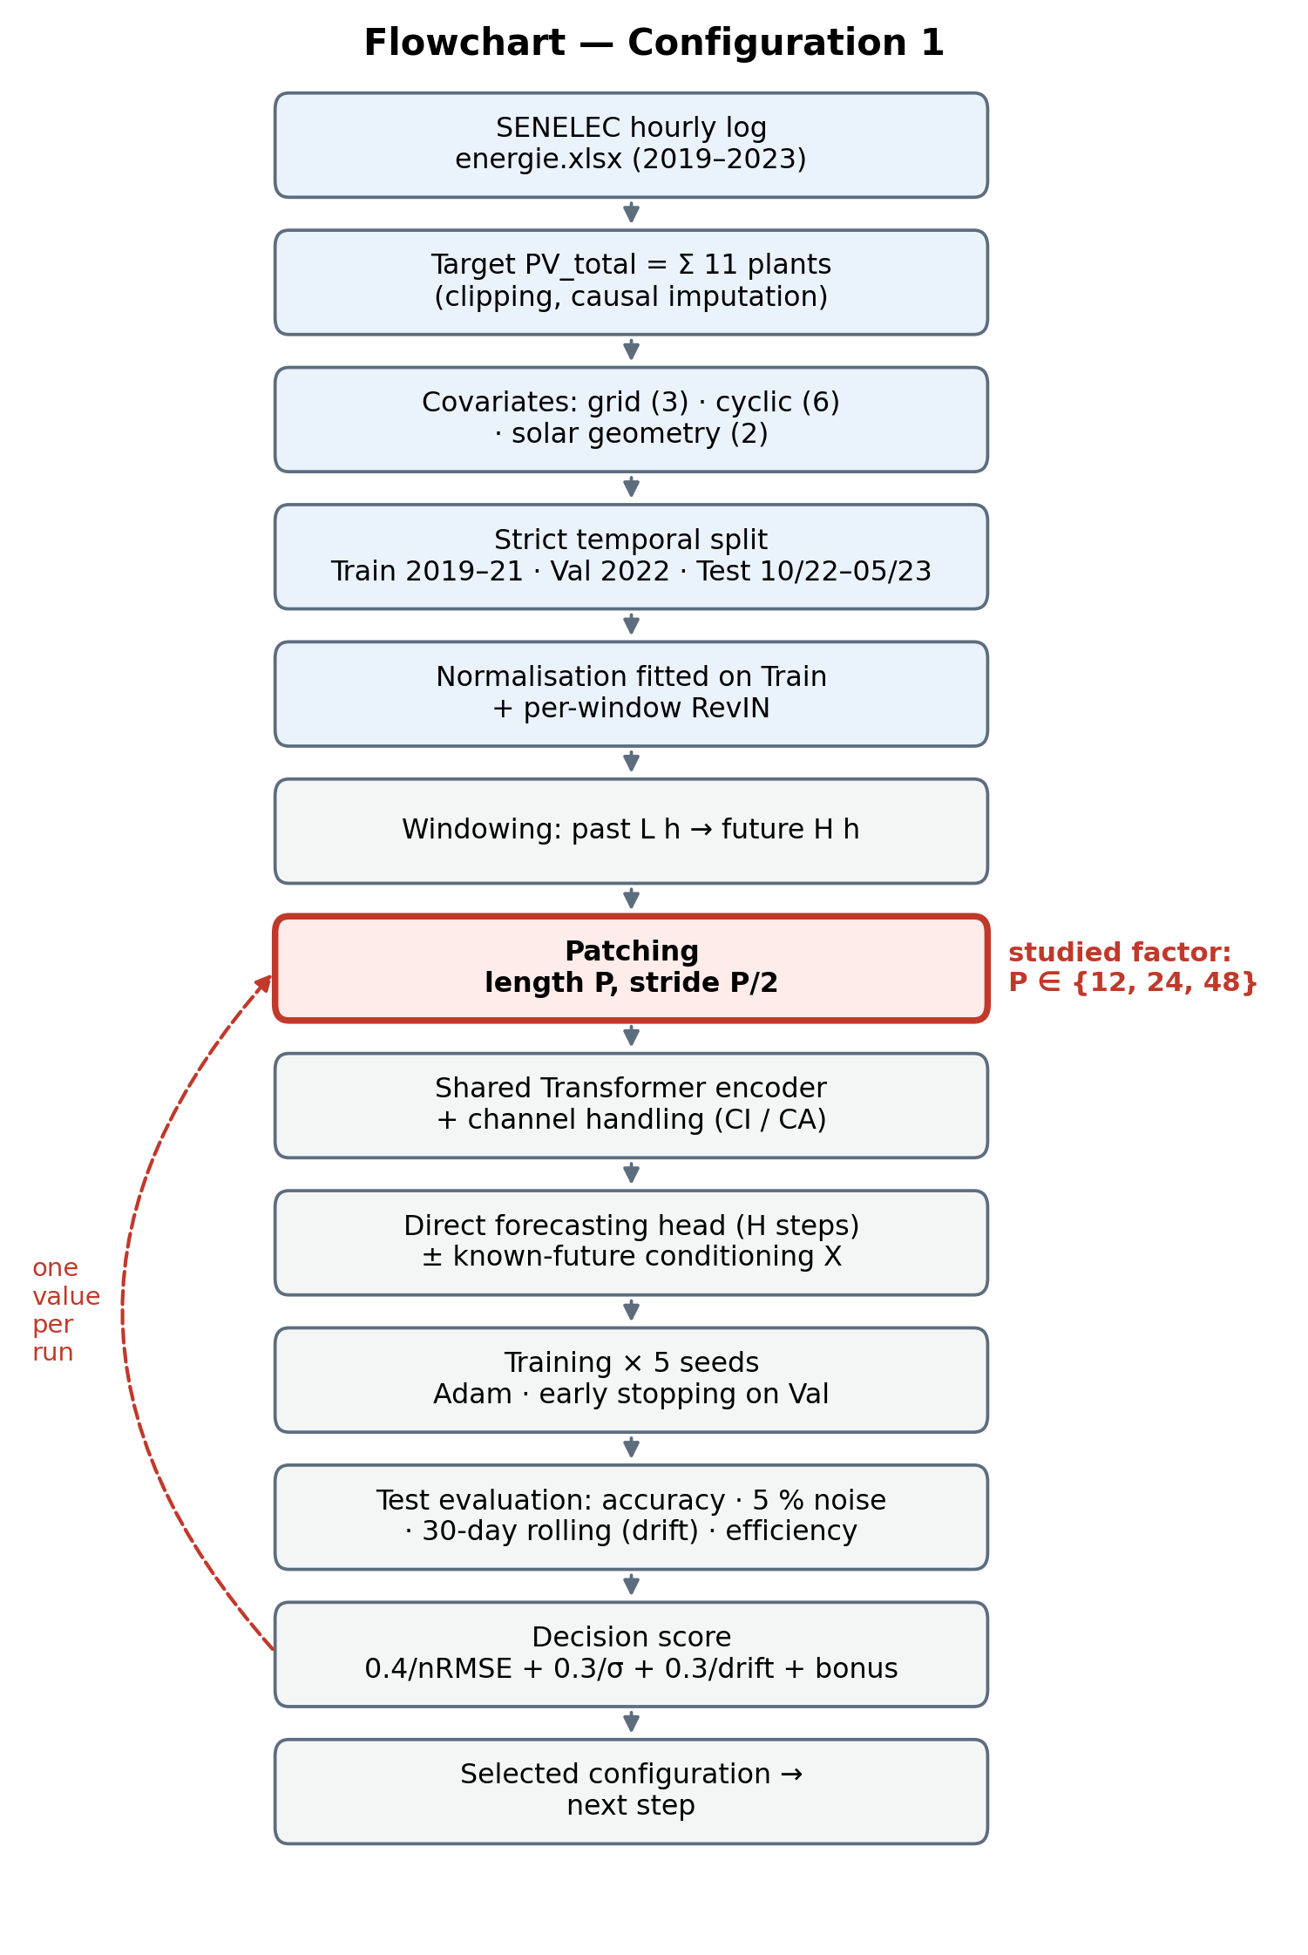
Figure E. Flowchart of configuration 1.
Table C. Results of configuration 1 (mean over 5 seeds).
Configuration | RMSE (MW) | σ (MW) | nRMSE | Noise 5 % | Drift | Inference (ms) | Norm. score
PatchTST-CAX_P12_L168_H24 | 9.02 | 0.097 | 0.204 | 0.4 % | 0.58 | 2.9 | 0.800
PatchTST-CAX_P24_L168_H24 | 9.13 | 0.161 | 0.206 | 0.6 % | 0.58 | 2.3 | 0.257
PatchTST-CAX_P48_L168_H24 | 9.20 | 0.103 | 0.208 | 0.7 % | 0.55 | 1.6 | 0.374
Persistence D-1 | 10.39 | 0.000 | 0.235 | – | – | – | –
7-day mean | 10.82 | 0.000 | 0.244 | – | – | – | –
Highlighted row: selected configuration (PatchTST-CAX_P12_L168_H24). Persistence and 7-day mean: same test origins.
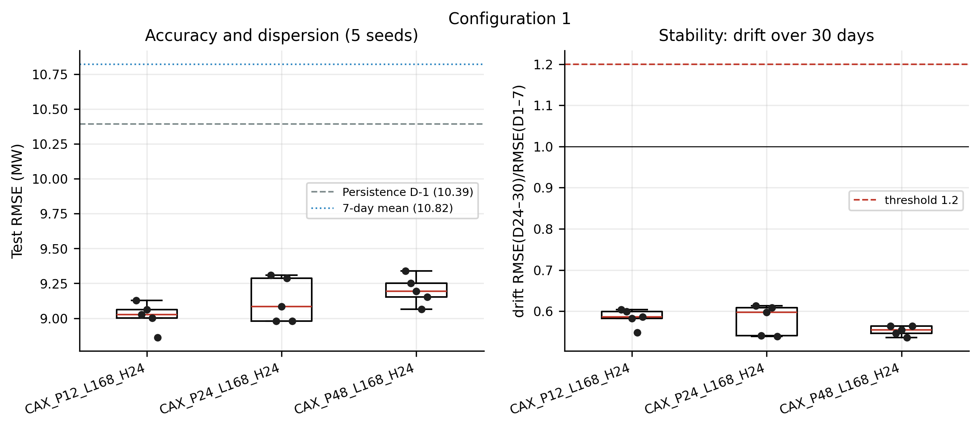
Figure Ebis. Seed rosary and drift — configuration 1.
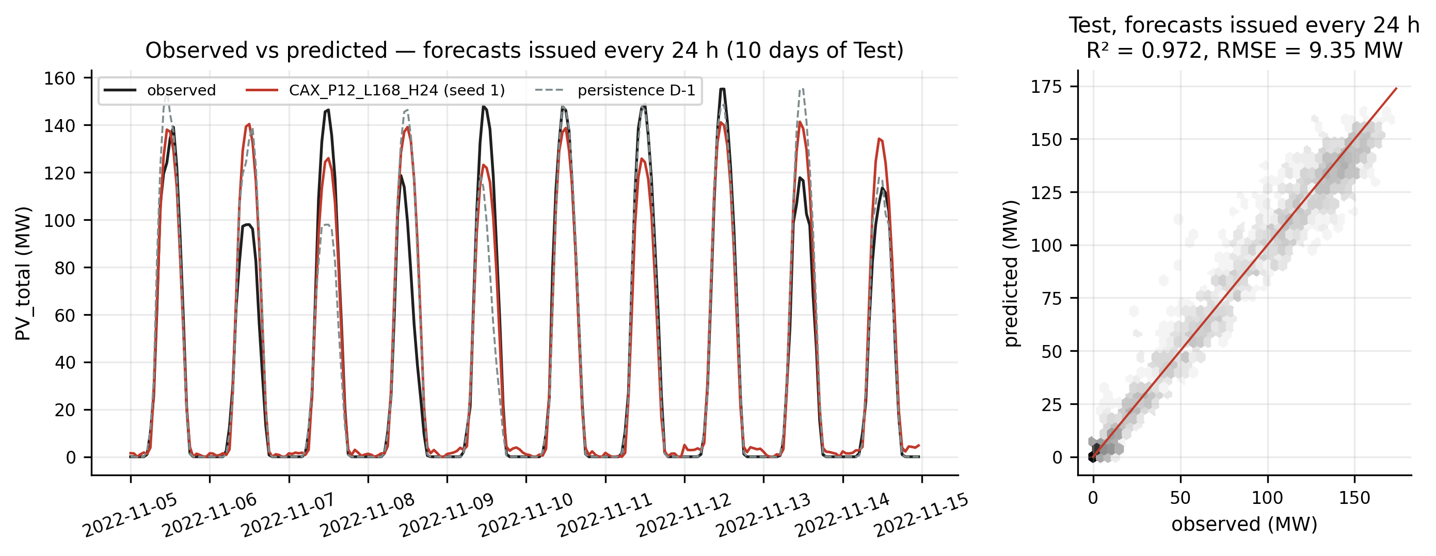
Figure Eter. Observed vs predicted — best model of configuration 1.

Step 9 — Configuration 2 — history L (notebook 02)
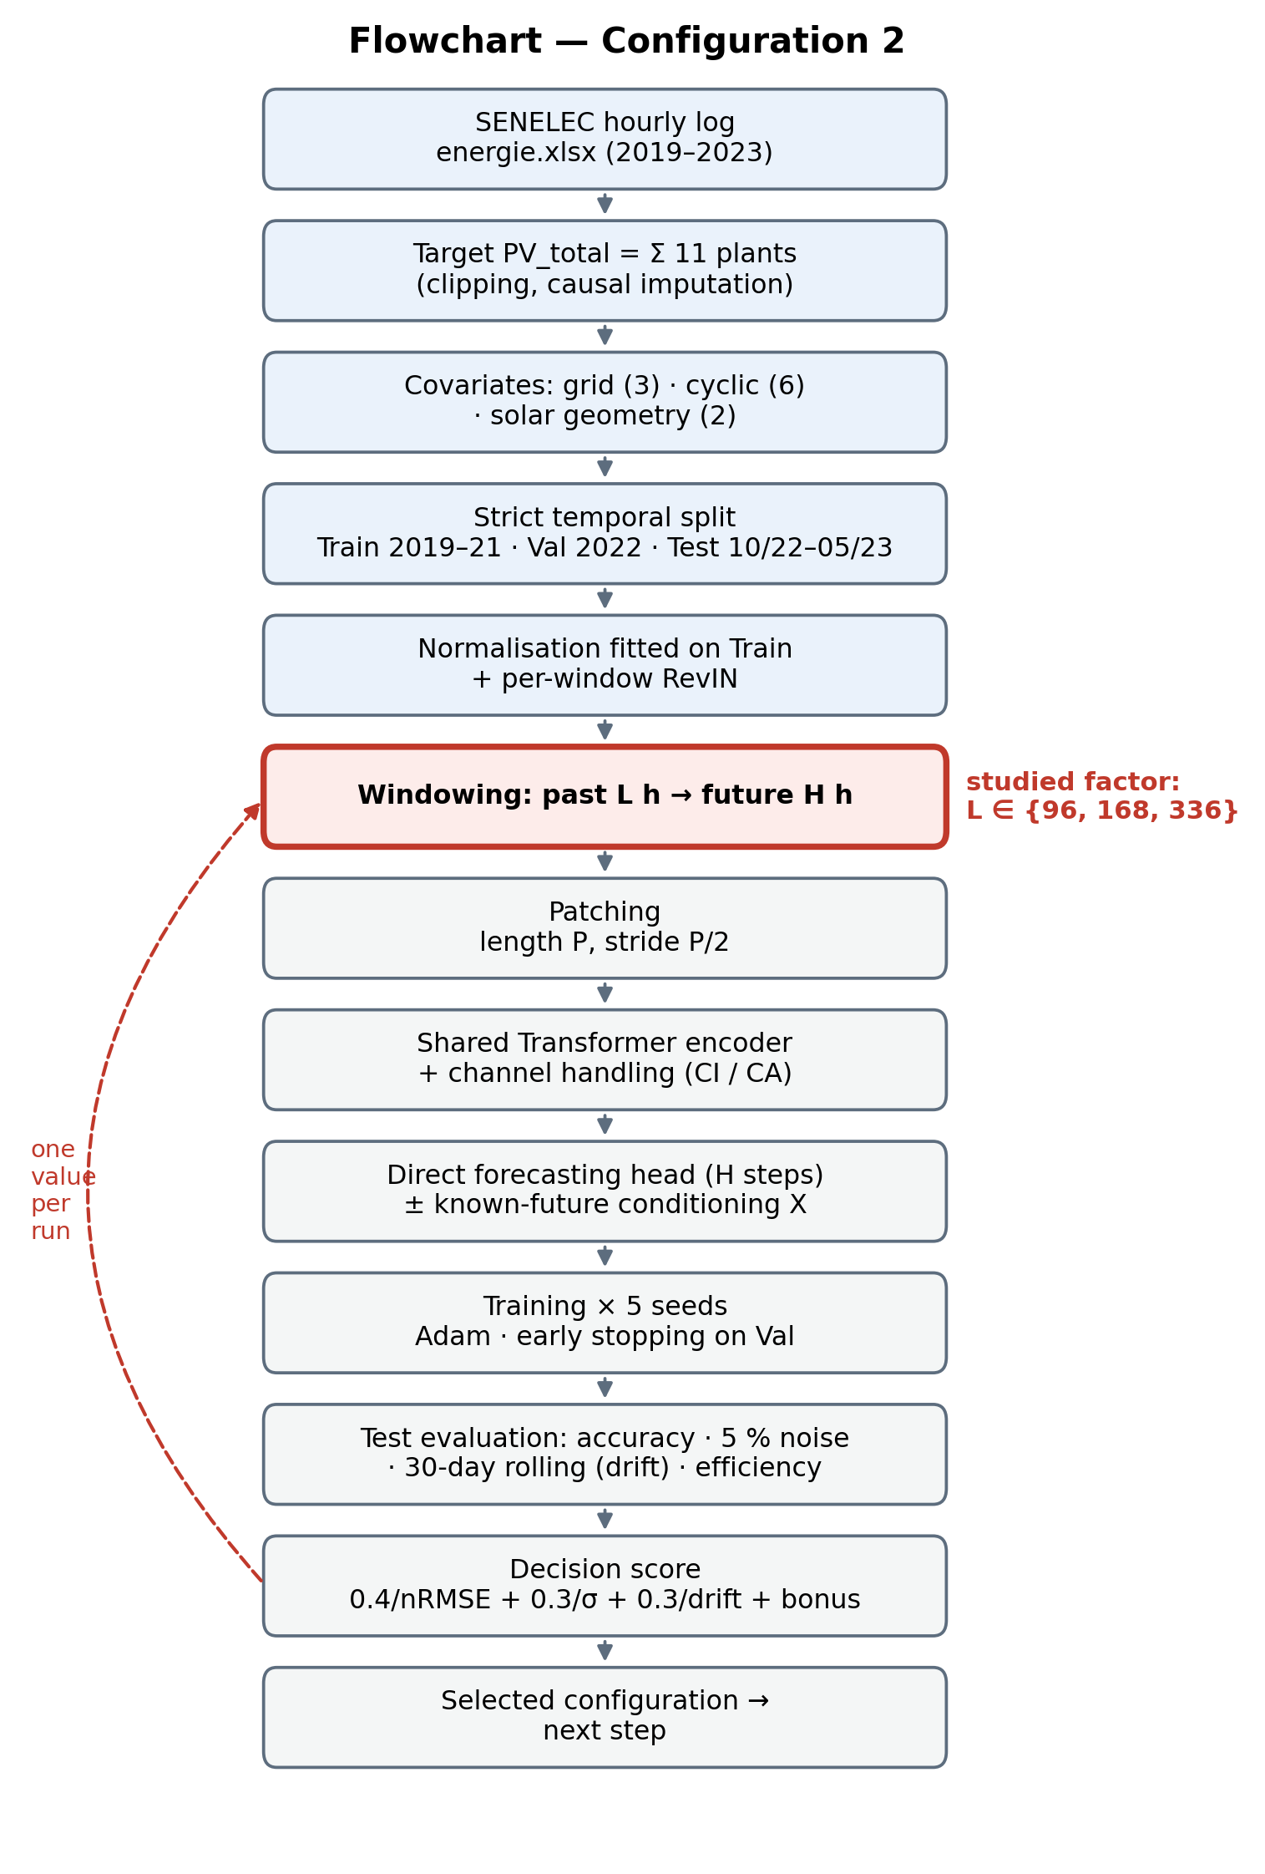
Figure F. Flowchart of configuration 2.
Table D. Results of configuration 2 (mean over 5 seeds).
Configuration | RMSE (MW) | σ (MW) | nRMSE | Noise 5 % | Drift | Inference (ms) | Norm. score
PatchTST-CAX_P12_L96_H24 | 9.29 | 0.074 | 0.210 | 0.5 % | 0.58 | 2.5 | 0.568
PatchTST-CAX_P12_L168_H24 | 9.02 | 0.097 | 0.204 | 0.4 % | 0.58 | 2.9 | 0.701
PatchTST-CAX_P12_L336_H24 | 9.49 | 0.146 | 0.215 | 0.3 % | 0.62 | 4.7 | 0.100
Persistence D-1 | 10.39 | 0.000 | 0.235 | – | – | – | –
7-day mean | 10.82 | 0.000 | 0.244 | – | – | – | –
Highlighted row: selected configuration (PatchTST-CAX_P12_L168_H24). Persistence and 7-day mean: same test origins.
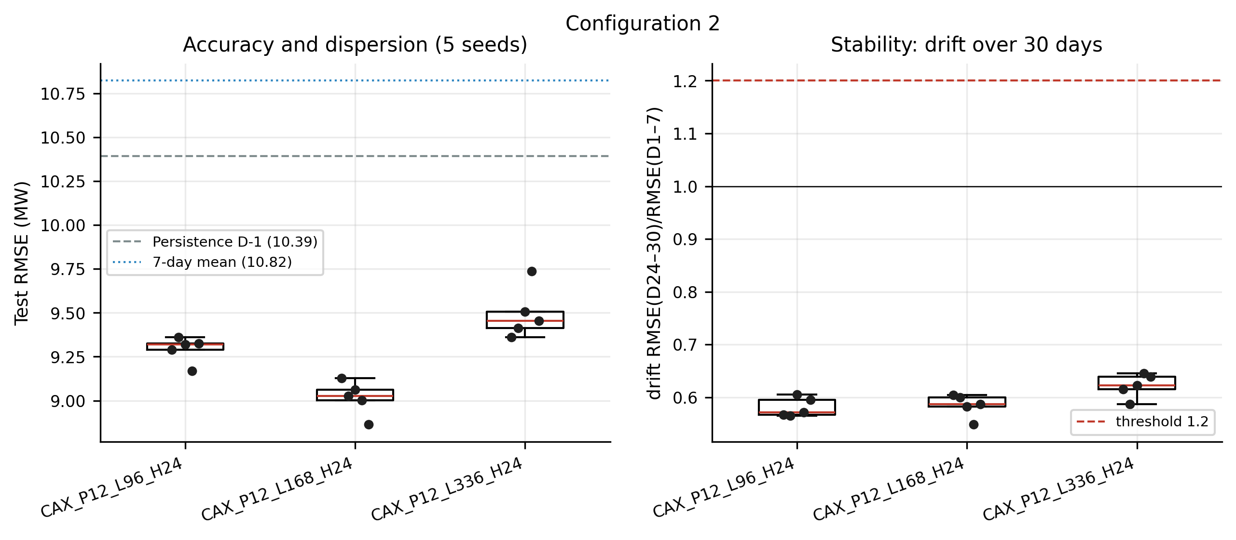
Figure Fbis. Seed rosary and drift — configuration 2.
Figure Fter. Observed vs predicted — best model of configuration 2.

Step 10 — Configuration 3 — channel handling (notebook 03)
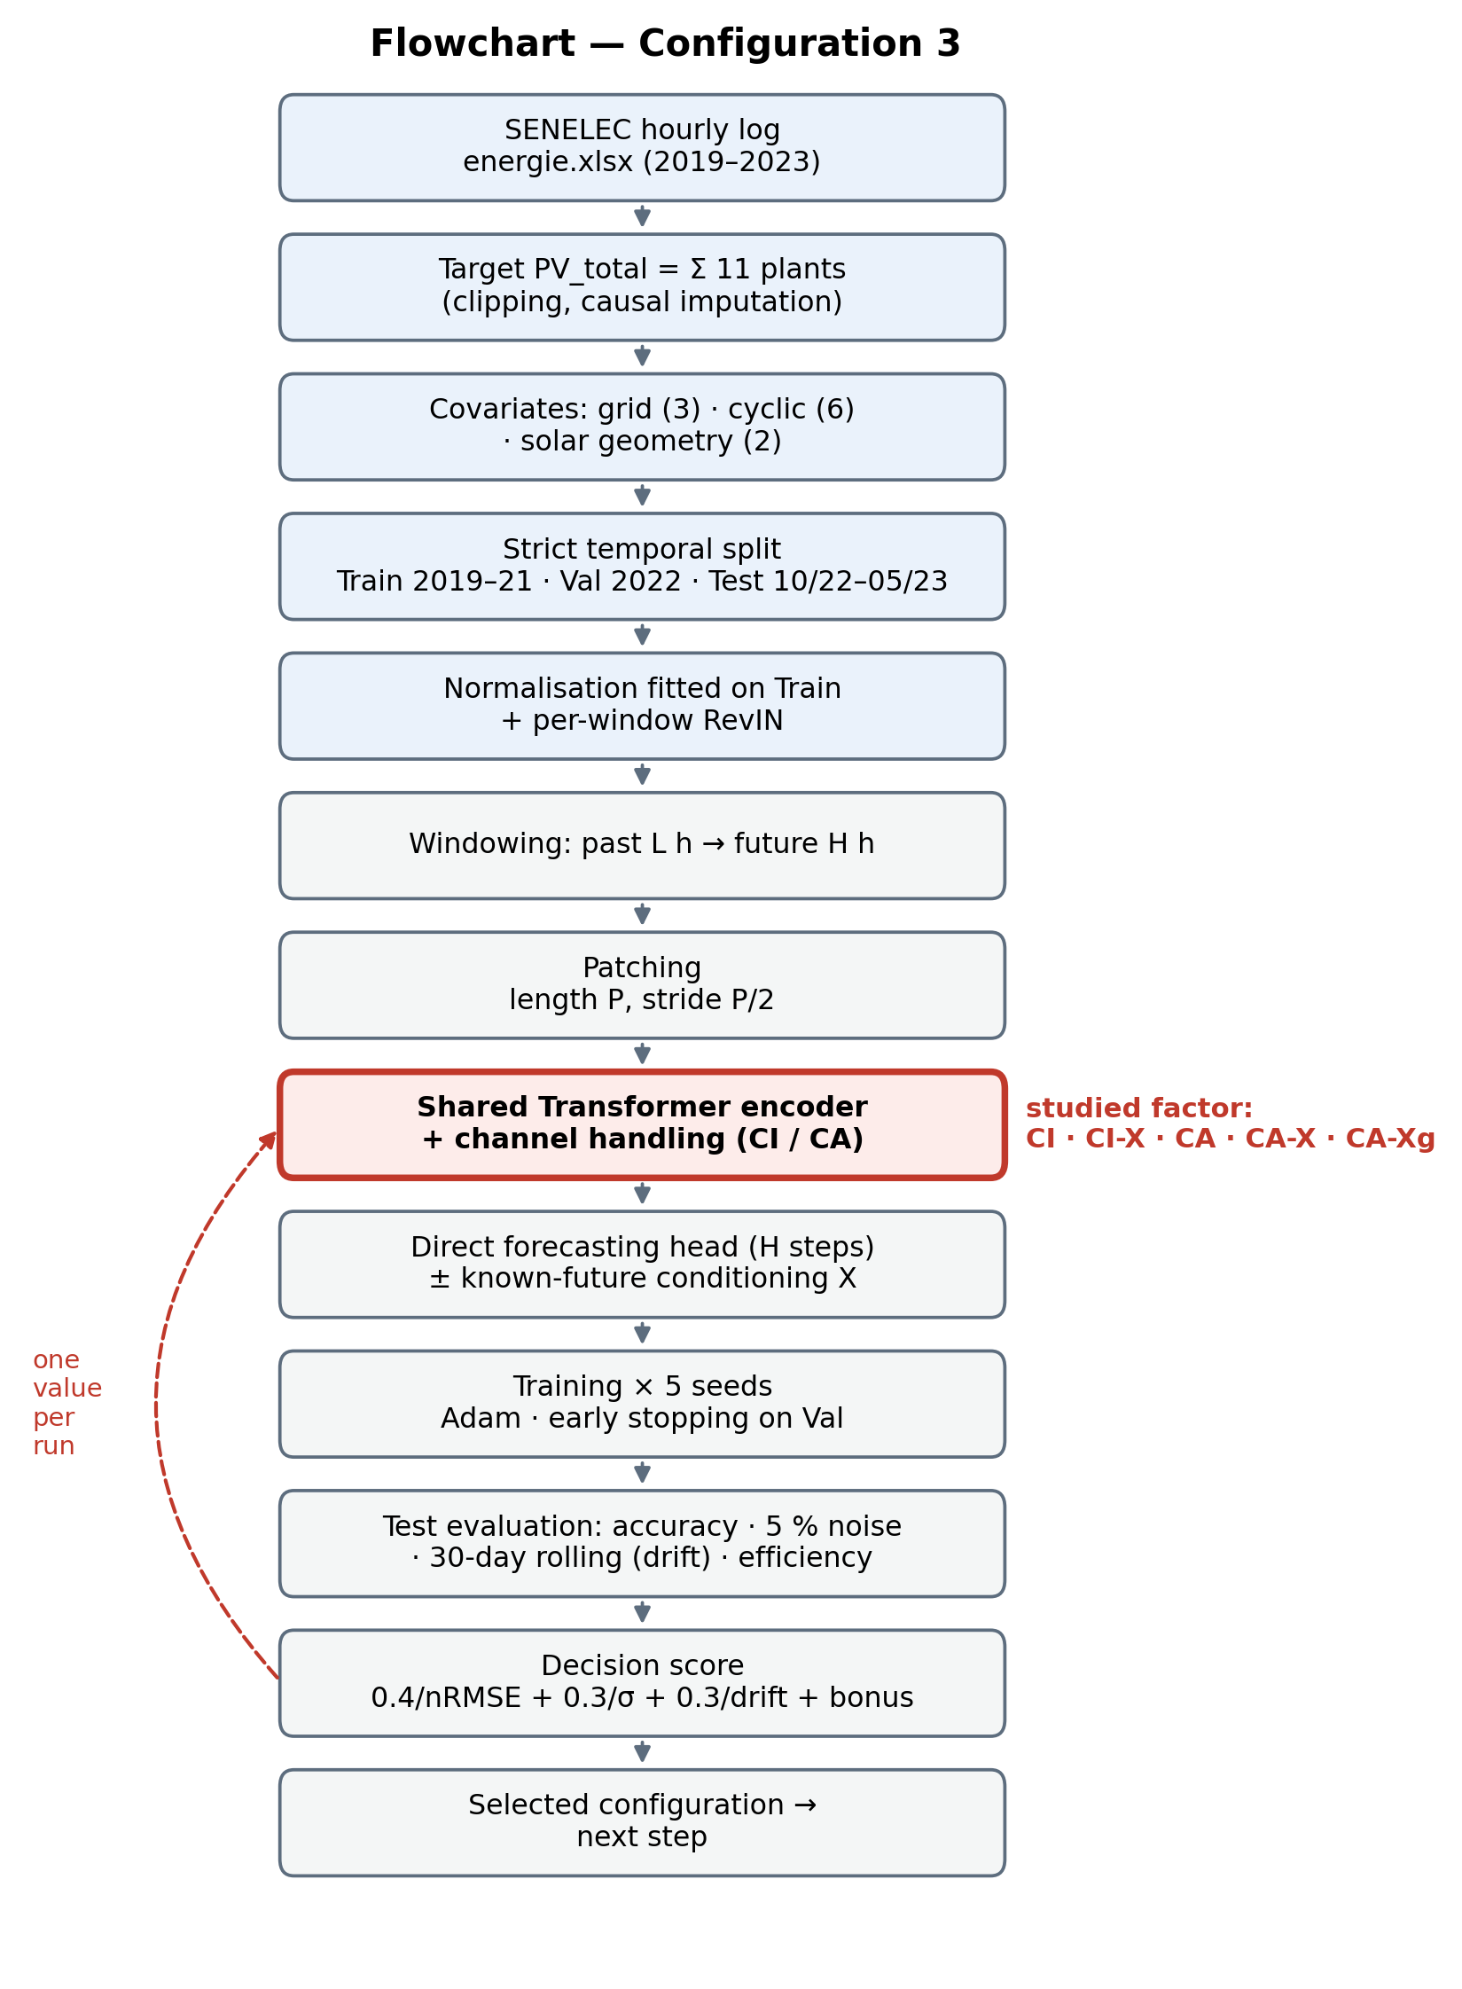
Figure G. Flowchart of configuration 3.
Table E. Results of configuration 3 (mean over 5 seeds).
Configuration | RMSE (MW) | σ (MW) | nRMSE | Noise 5 % | Drift | Inference (ms) | Norm. score
PatchTST-CI_P12_L168_H24 | 9.47 | 0.089 | 0.214 | 0.0 % | 0.57 | 0.9 | 0.400
PatchTST-CIX_P12_L168_H24 | 9.11 | 0.191 | 0.206 | 0.3 % | 0.61 | 1.1 | 0.524
PatchTST-CA_P12_L168_H24 | 9.39 | 0.248 | 0.212 | -0.0 % | 0.59 | 2.5 | 0.172
PatchTST-CAX_P12_L168_H24 | 9.02 | 0.097 | 0.204 | 0.4 % | 0.58 | 2.9 | 0.784
PatchTST-CAXg_P12_L168_H24 | 9.02 | 0.094 | 0.204 | 112.0 % | 0.59 | 2.6 | 0.788
Persistence D-1 | 10.39 | 0.000 | 0.235 | – | – | – | –
7-day mean | 10.82 | 0.000 | 0.244 | – | – | – | –
Highlighted row: selected configuration (PatchTST-CAX_P12_L168_H24). Persistence and 7-day mean: same test origins.
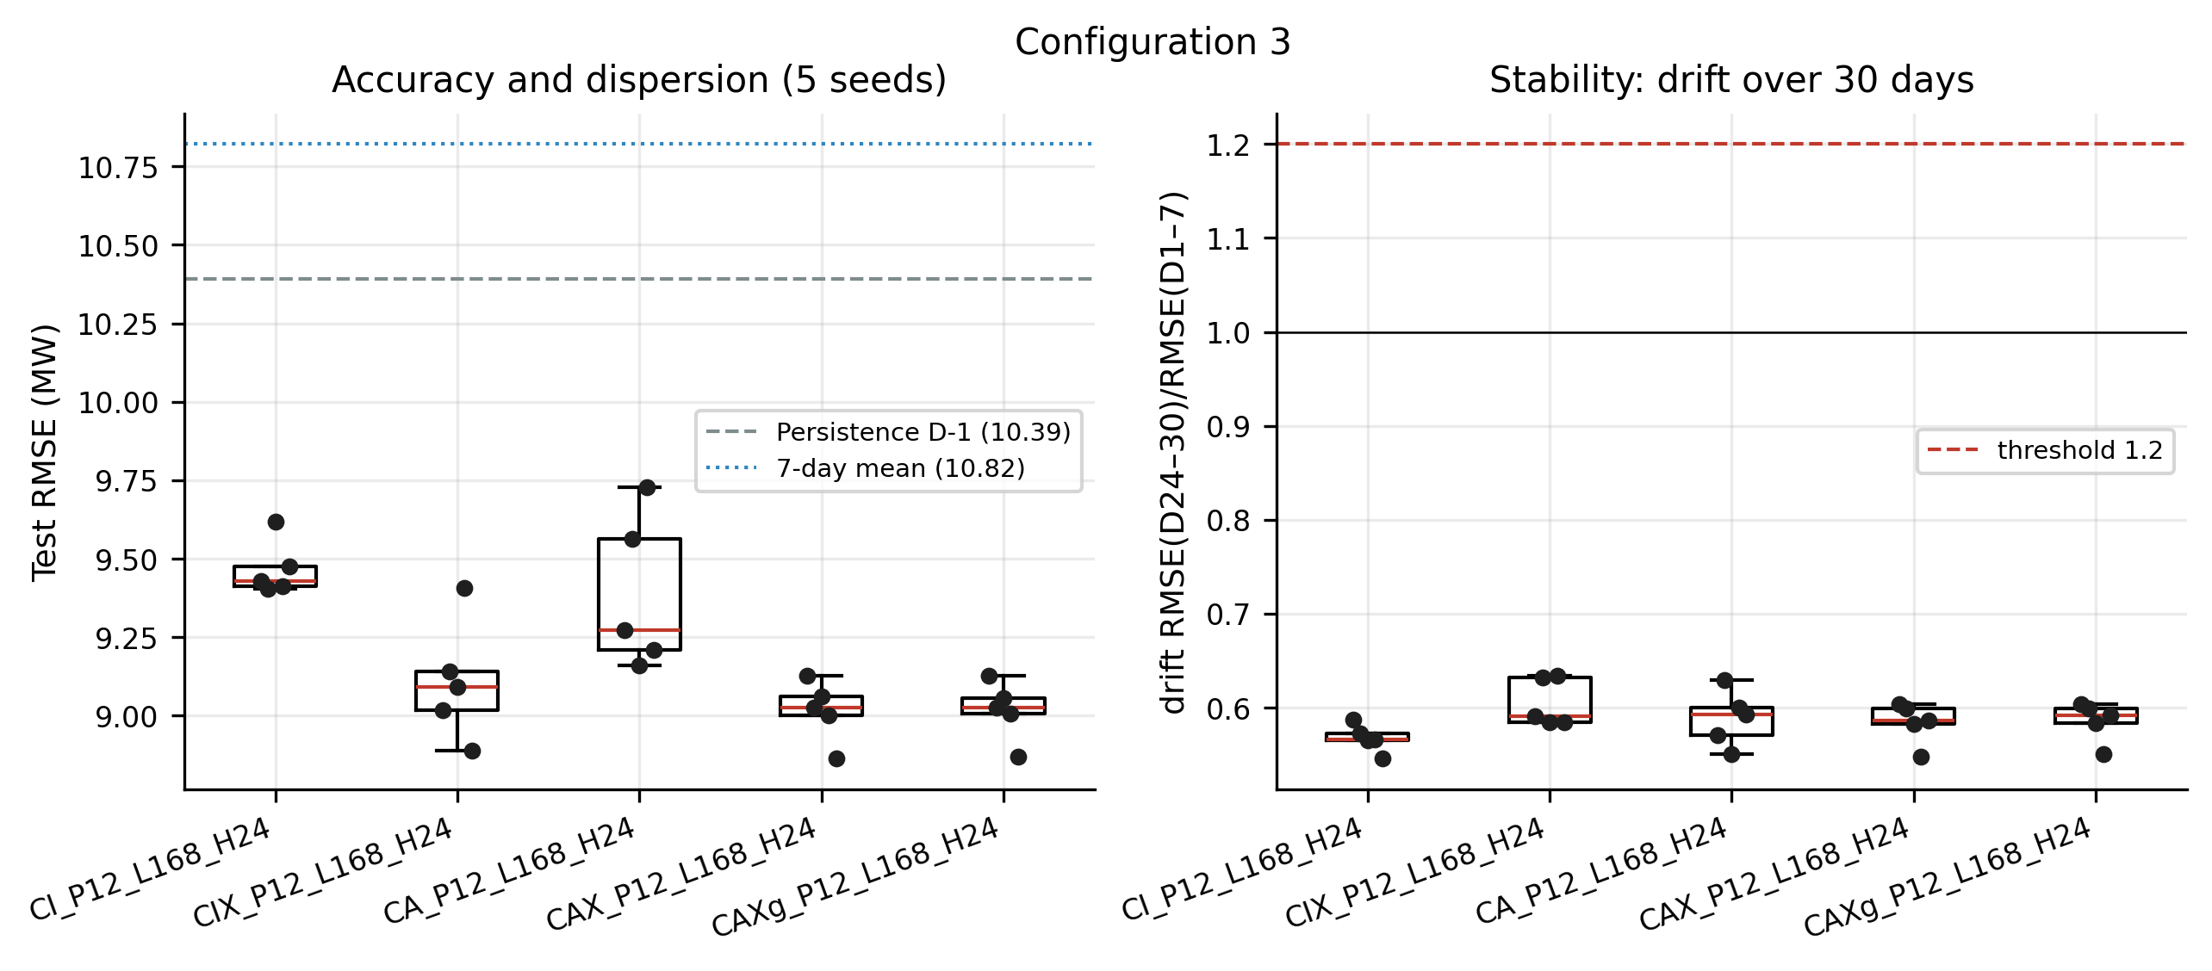
Figure Gbis. Seed rosary and drift — configuration 3.
Figure Gter. Observed vs predicted — best model of configuration 3.

Step 11 — Configuration 4 — horizon H (notebook 04)
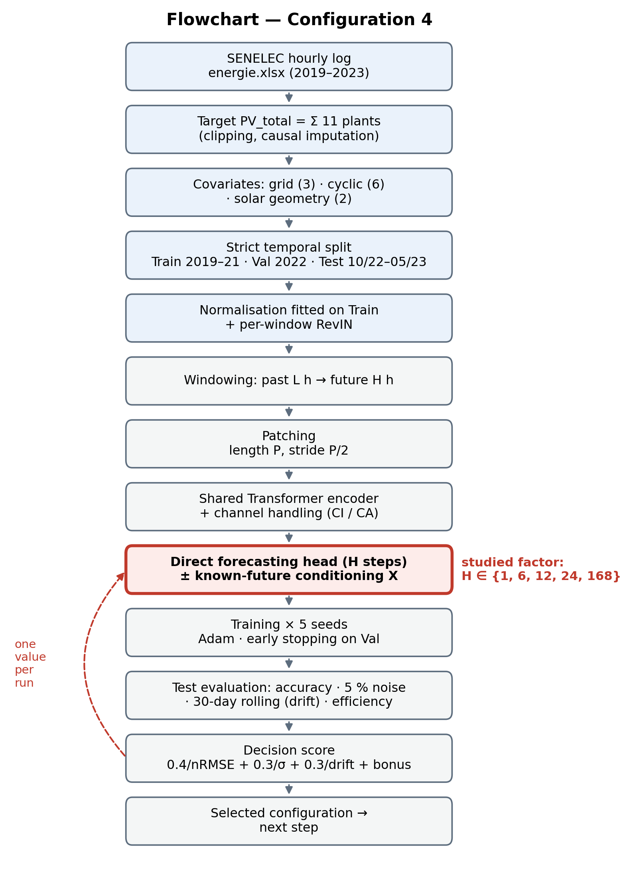
Figure H. Flowchart of configuration 4.
Table F. Results of configuration 4 (mean over 5 seeds).
Configuration | RMSE (MW) | σ (MW) | nRMSE | Noise 5 % | Drift | Inference (ms) | Norm. score
PatchTST-CAX_P12_L168_H1 | 4.93 | 0.743 | 0.111 | 0.3 % | 0.58 | 2.9 | 0.500
PatchTST-CAX_P12_L168_H6 | 7.74 | 0.185 | 0.175 | 0.4 % | 0.55 | 2.7 | 0.569
PatchTST-CAX_P12_L168_H12 | 8.61 | 0.055 | 0.194 | 0.5 % | 0.58 | 2.6 | 0.571
PatchTST-CAX_P12_L168_H24 | 9.02 | 0.097 | 0.204 | 0.4 % | 0.58 | 2.9 | 0.527
PatchTST-CAX_P12_L168_H168 | 11.33 | 0.096 | 0.256 | 0.4 % | 0.60 | 3.0 | 0.382
Highlighted row: best score (PatchTST-CAX_P12_L168_H12); the final horizon remains day-ahead (24 h), set by the use case.
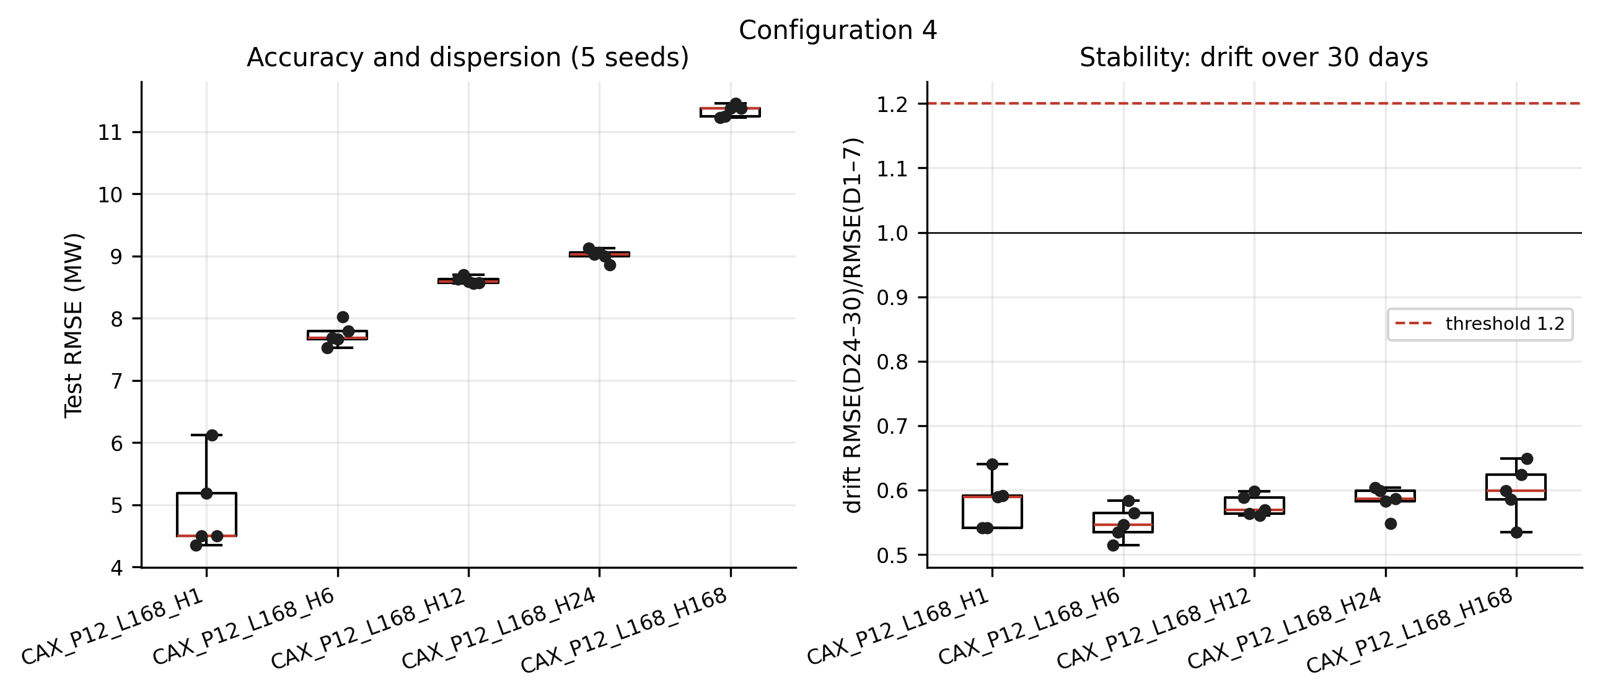
Figure Hbis. Seed rosary and drift — configuration 4.
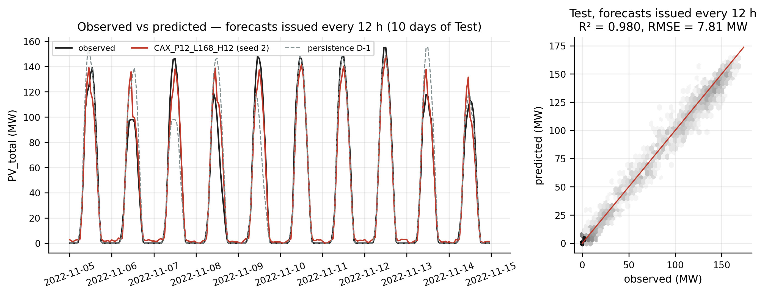
Figure Hter. Observed vs predicted — best model of configuration 4.

Step 12 — Final model (notebook 05)
The architecture selected in configurations 1 to 3 is evaluated at the operational day-ahead horizon (24 h). The horizon is not chosen by the score, because comparing horizons means comparing different tasks. Notebook 05 adds: comparison with Ridge and with the univariate PatchTST, a noise-robustness curve, monthly RMSE, a 5-fold TimeSeriesSplit cross-validation, the "capacity index" ablation, explainability, and saving to models/best_patchtst.pt. The saved seed is chosen on the validation loss, never on the test set.
Table G. Final model vs baselines (day-ahead horizon, full test set).
Model | RMSE (MW) | MAE (MW) | nRMSE | R² | MBE (MW)
Persistence D-1 | 10.39 | 4.97 | 0.235 | 0.965 | 0.00
7-day mean | 10.82 | 5.31 | 0.244 | 0.962 | -0.03
Multi-output Ridge | 9.20 | 4.87 | 0.208 | 0.973 | -0.69
PatchTST-CI_P12_L168_H24 (mean 5 seeds) | 9.47 | 5.48 | 0.214 | 0.971 | 0.46
PatchTST-CAX_P12_L168_H24 (mean 5 seeds) | 9.02 | 5.21 | 0.204 | 0.974 | -0.01
Diebold-Mariano: final model better than persistence (p = 0.003) and than the 7-day mean (p = 0.002); gap with Ridge not significant (p = 0.42).
Table H. TimeSeriesSplit cross-validation (5 folds).
Fold | Training | Test | RMSE | RMSE pers. | Gain
1 | 2019-01 → 2019-08 | 2019-09-23 → 2020-06-13 | 7.67 | 7.86 | 2.4 %
2 | 2019-01 → 2020-03 | 2020-06-14 → 2021-03-05 | 10.18 | 11.67 | 12.8 %
3 | 2019-01 → 2020-11 | 2021-03-06 → 2021-11-25 | 12.09 | 14.42 | 16.2 %
4 | 2019-01 → 2021-06 | 2021-11-26 → 2022-08-17 | 10.86 | 13.35 | 18.7 %
5 | 2019-01 → 2022-01 | 2022-08-18 → 2023-05-09 | 9.94 | 12.03 | 17.3 %

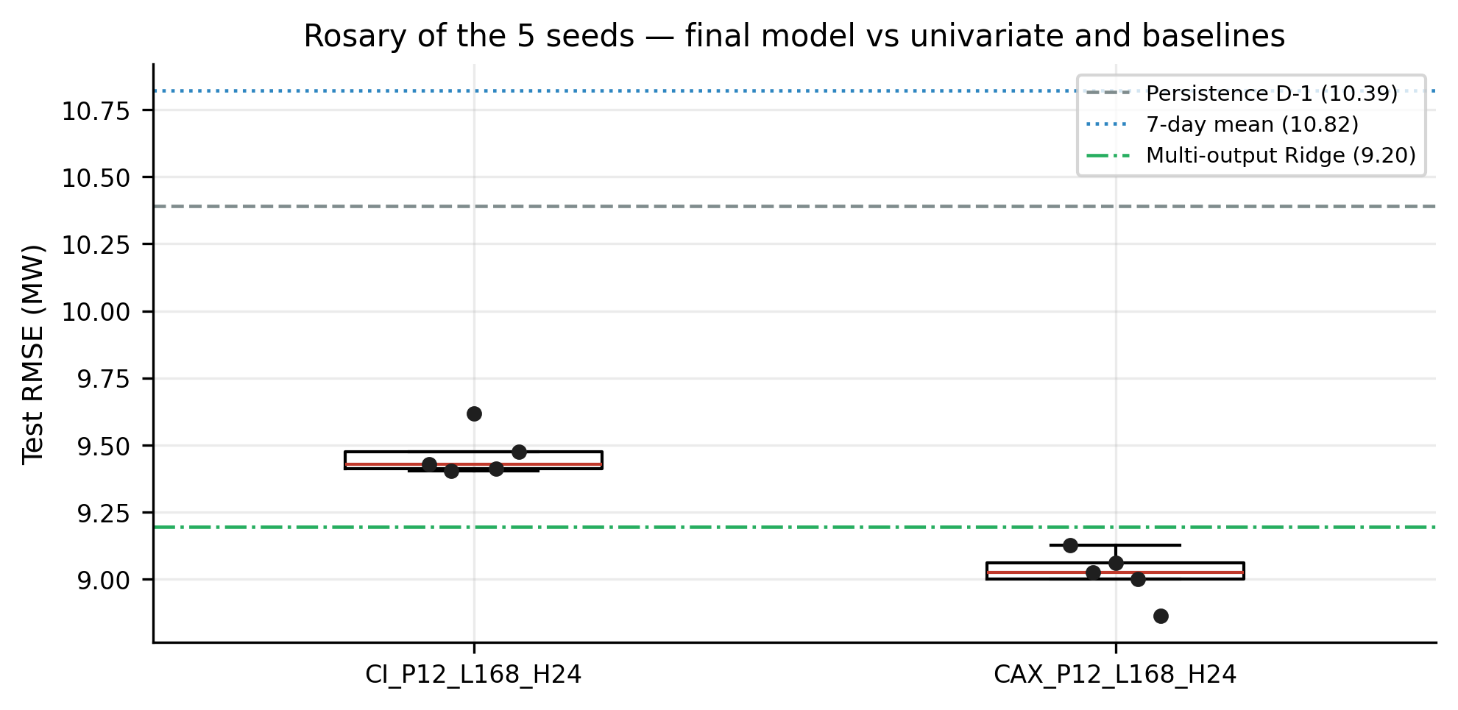
Figure I. Rosary of the 5 seeds of the final model and of the univariate PatchTST, with the baselines.
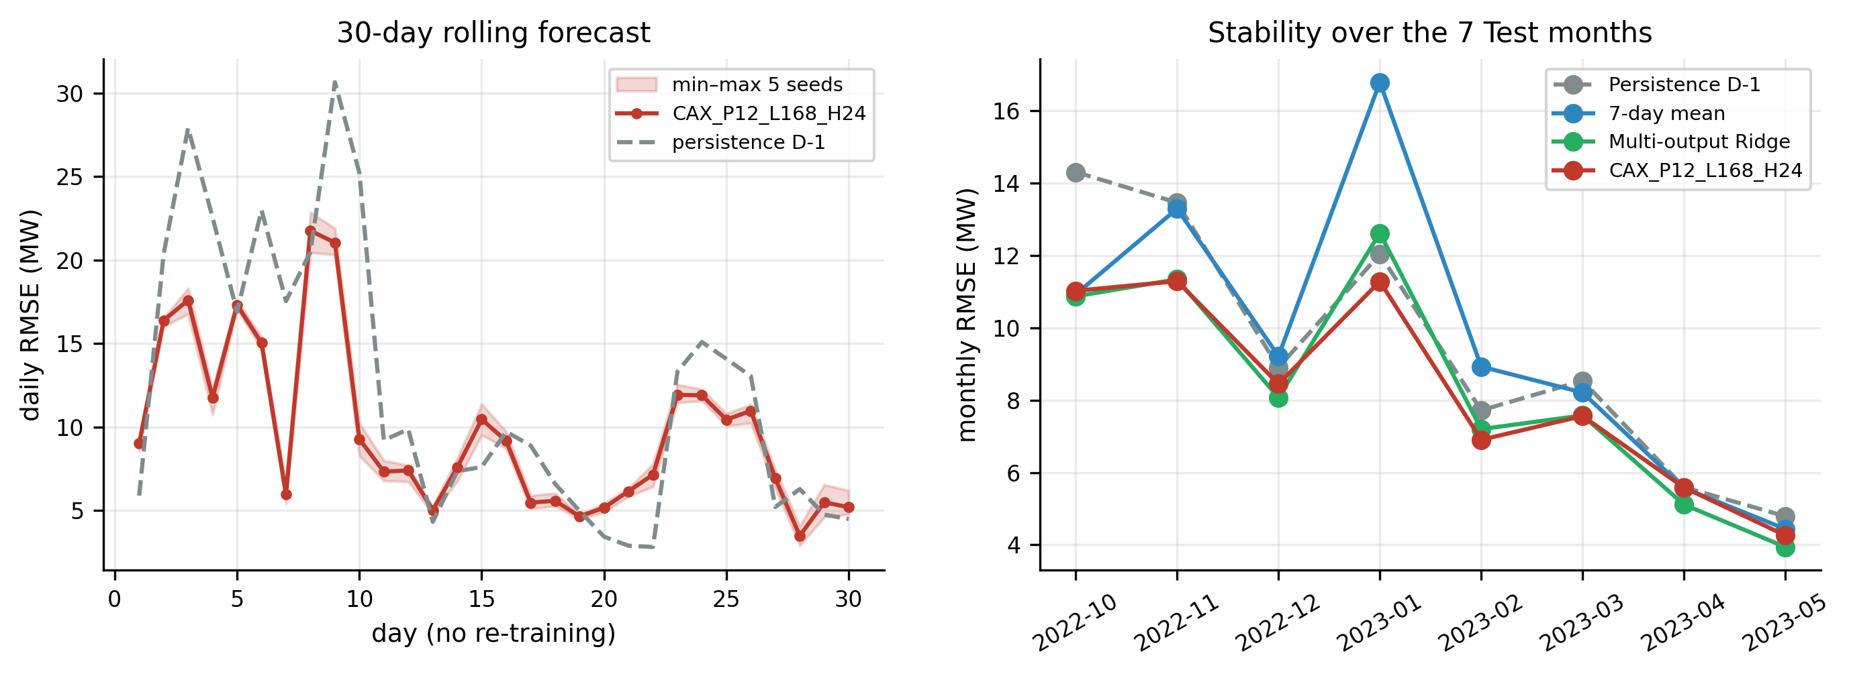
Figure J. 30-day rolling forecast without re-training and monthly RMSE over the test set.
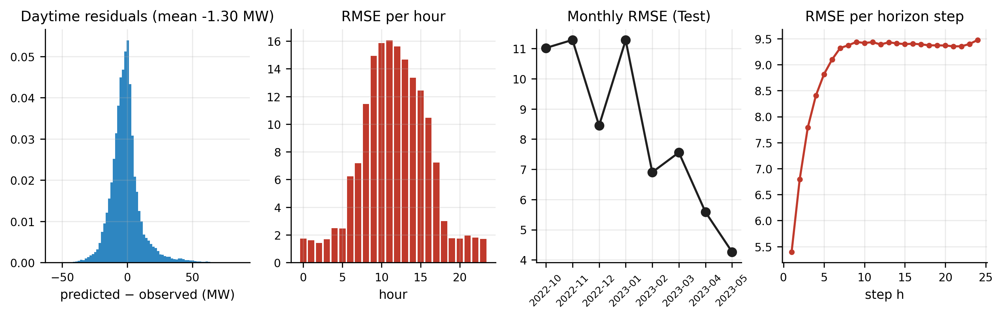
Figure K. Residuals of the final model.
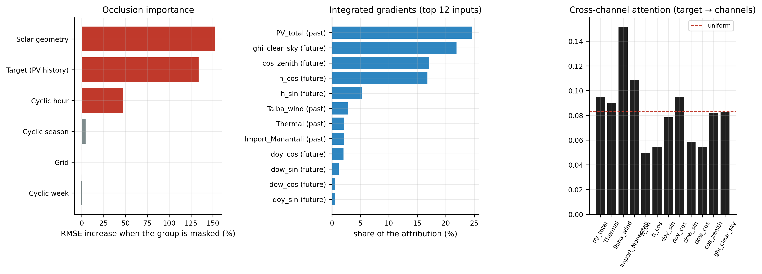
Figure L. Explainability: occlusion, integrated gradients, cross-channel attention.

Step 13 — Quality checks
- End-to-end execution of every notebook (nbclient), with embedded outputs and figures.
- Anti-leakage assertions: order of the segments, normalisation on Train, forbidden columns absent.
- Reloading best_patchtst.pt and checking identical forecasts.
- Tables of the paper regenerated from the cached forecasts (no number typed by hand).

