SERVER WEB

Amadeo Claramunt Giner

FUNCTIONS:

Server.h:

* int init(int port): initialize the server and charge all the web content.
* char* readFile(const char* file_path, int * out_put_size): read the text files and write in a buffer, return the buffer and his size.
* char* readImage(const char* file_path, int * out_put_size):read the image files and write in a buffer, return the buffer and his size.

FUNCTIONALITY:

* First initialize the socket.
* Accept the connections.
* Read the web browser petition and write it in a buffer.
* Take the necessary information of the petition.
* read the files requested and send it.

USER MANUAL:

You can run the program TcpServer.exe from the windows console with the option to specify the port to listen, if you don't specify the port will be 8080.

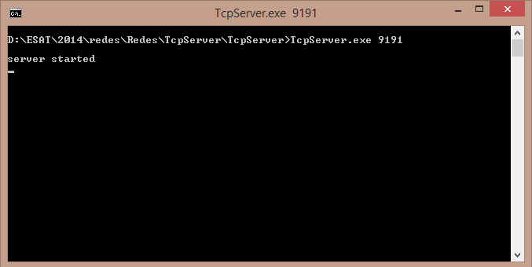

You can access to the web writing in the web browser: 127.0.0.1:”port number”

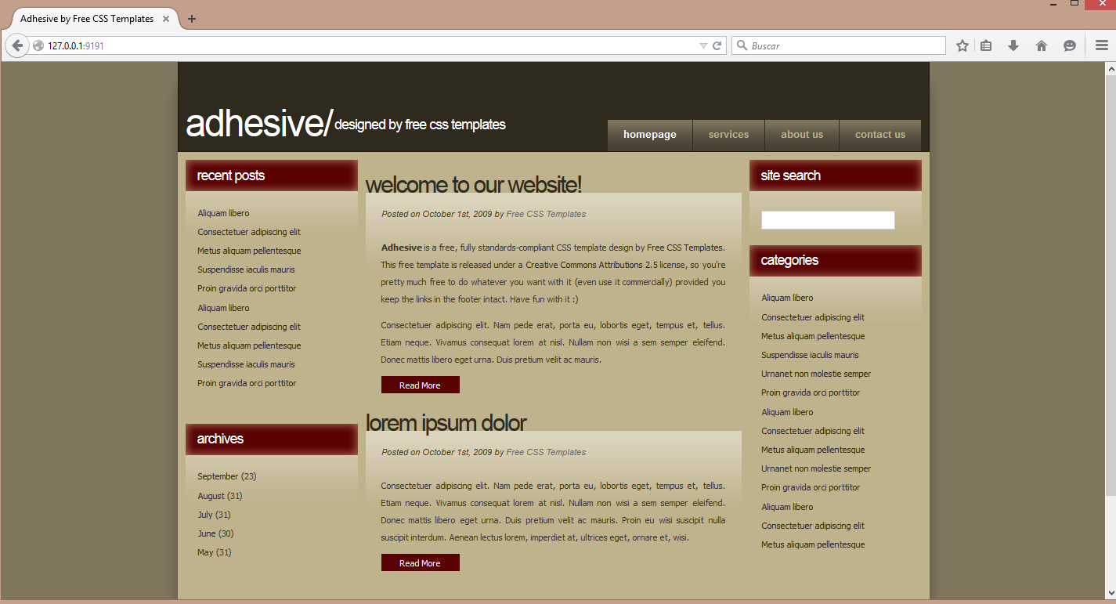

or using the virtual hosts:

www.dominio1.com:”port number”:



www.dominio2.com:”port number”:

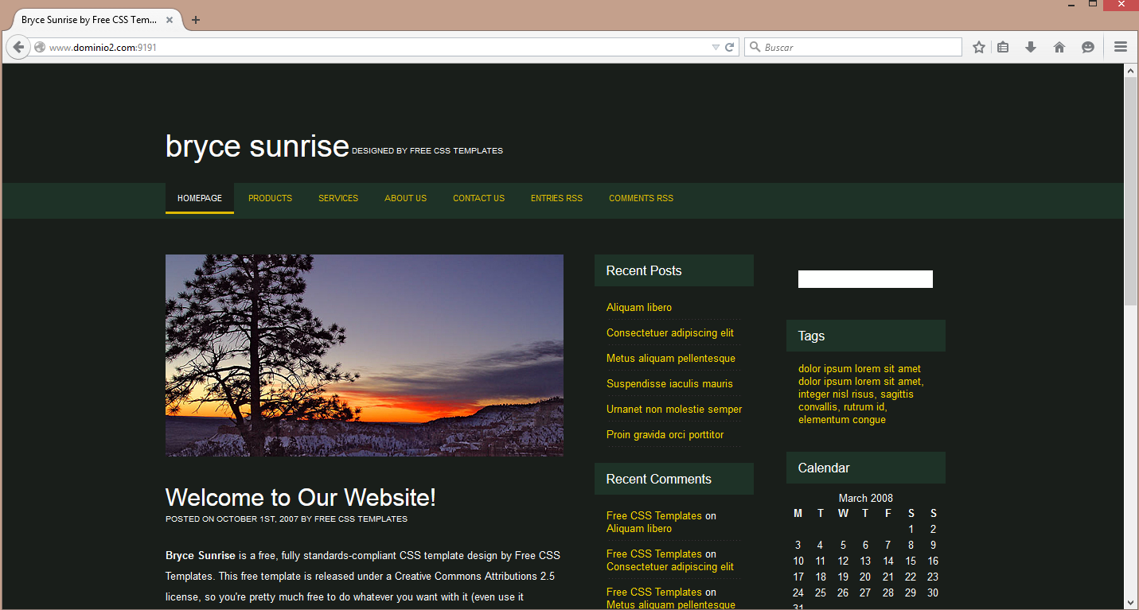

If the web requested doesn't exist send a error web:

