# **webpost**

# Created on February 12 2018

# **Table of Contents**

1.0. Login

2.0. Profile

3.0. store

4.0. productdetails

5.0. client-product details

6.0. client-store

7.0. admin-approve list

8.0. admin-promotion ads

9.0. admin- search keyword list for ads

10.0. Home

11.0. searched home

12.0. show ADS

# **1.0. Login**

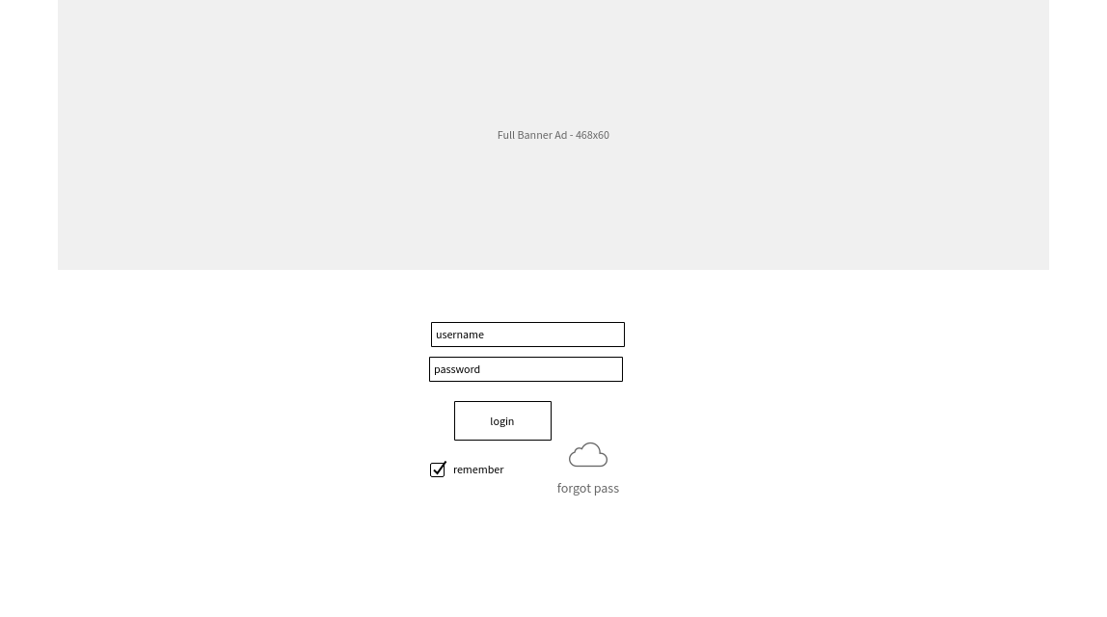

# **2.0. Profile**

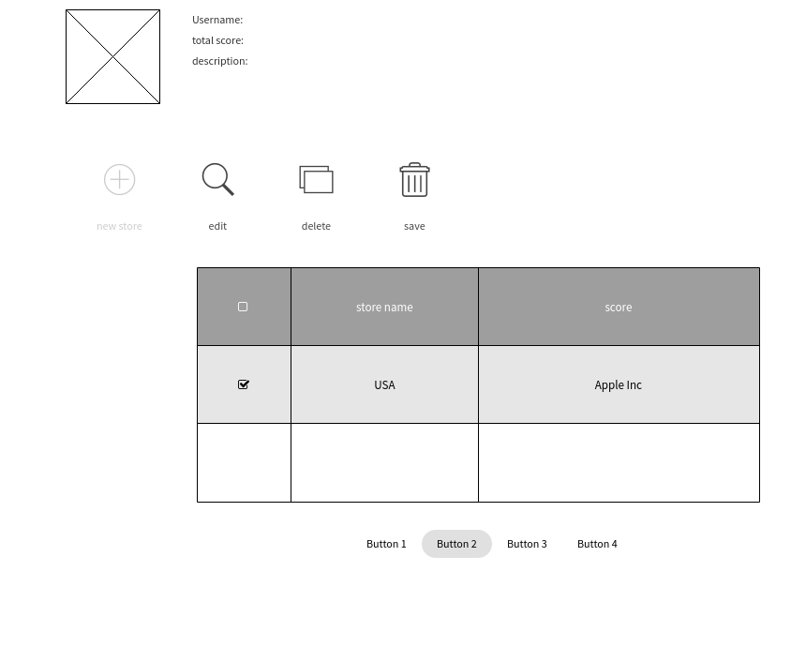

# **3.0. store**

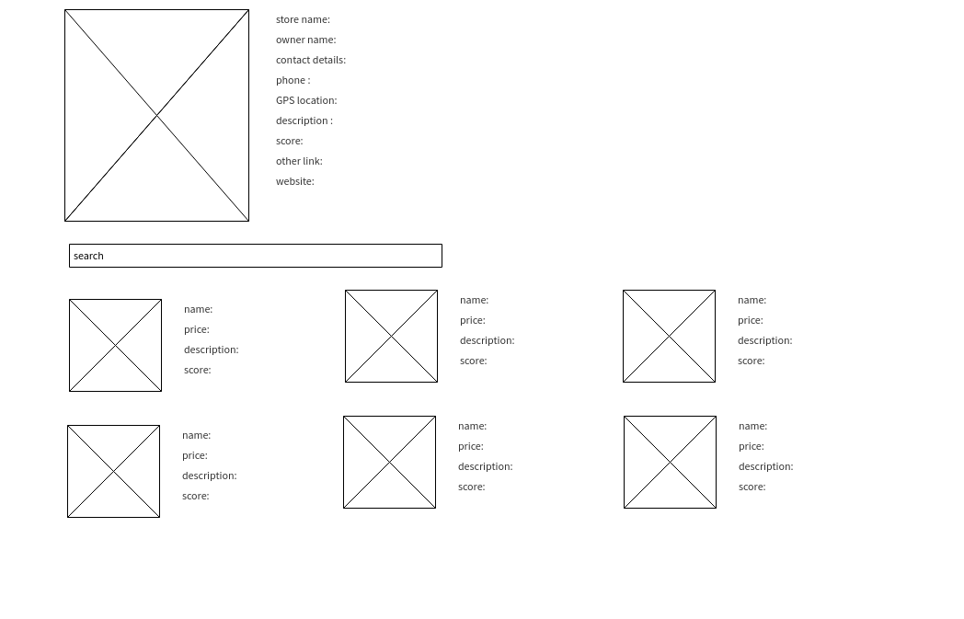

# **4.0. productdetails**

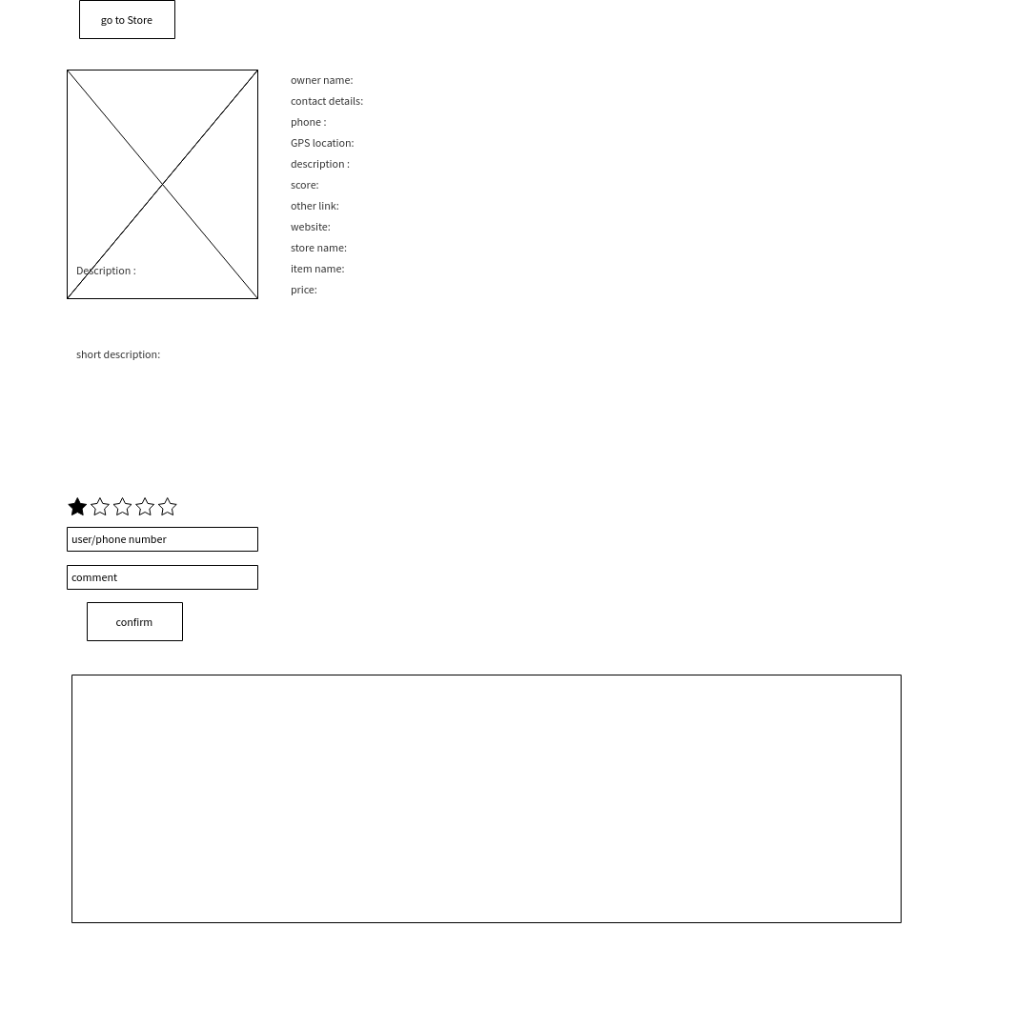

# **5.0. client-product details**

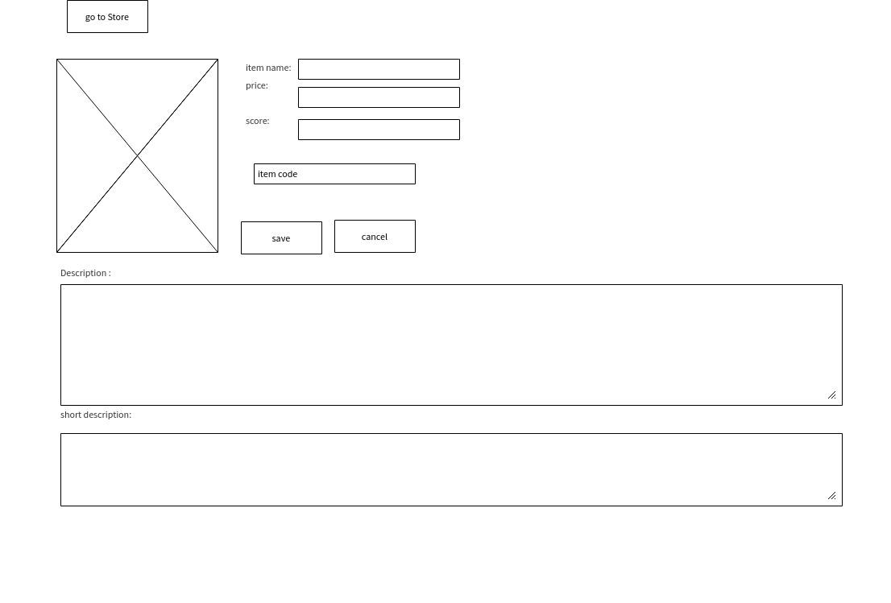

# **6.0. client-store**

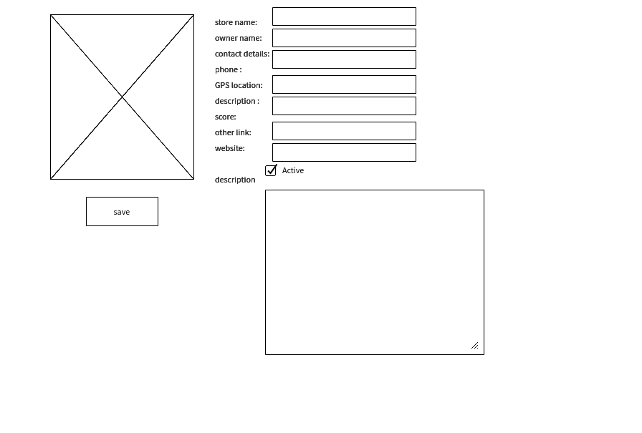

# **7.0. admin-approve list**

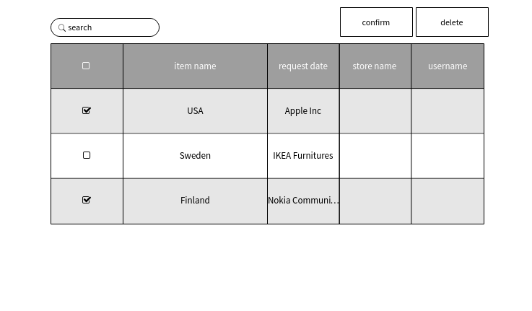

# **8.0. admin-promotion ads**

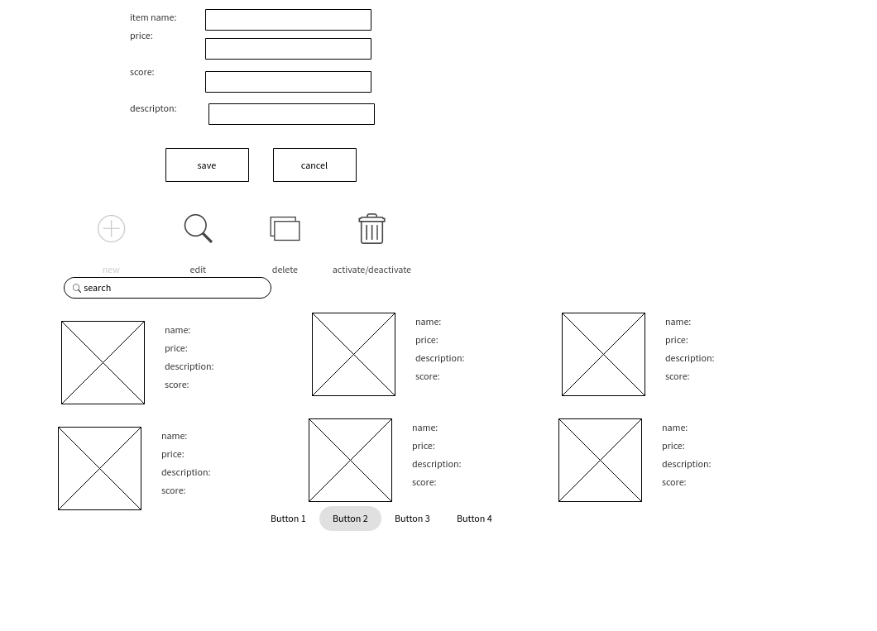

# **9.0. admin- search keyword list for ads**

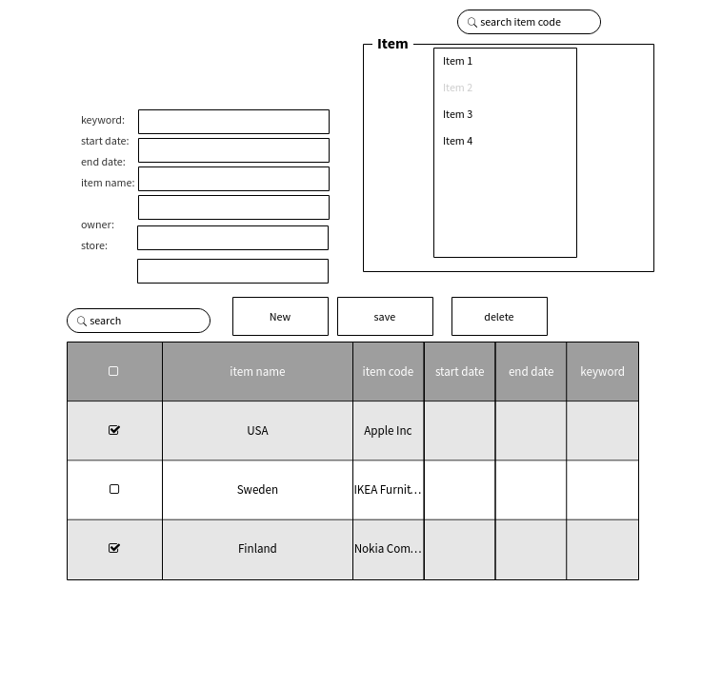

# **10.0. Home**

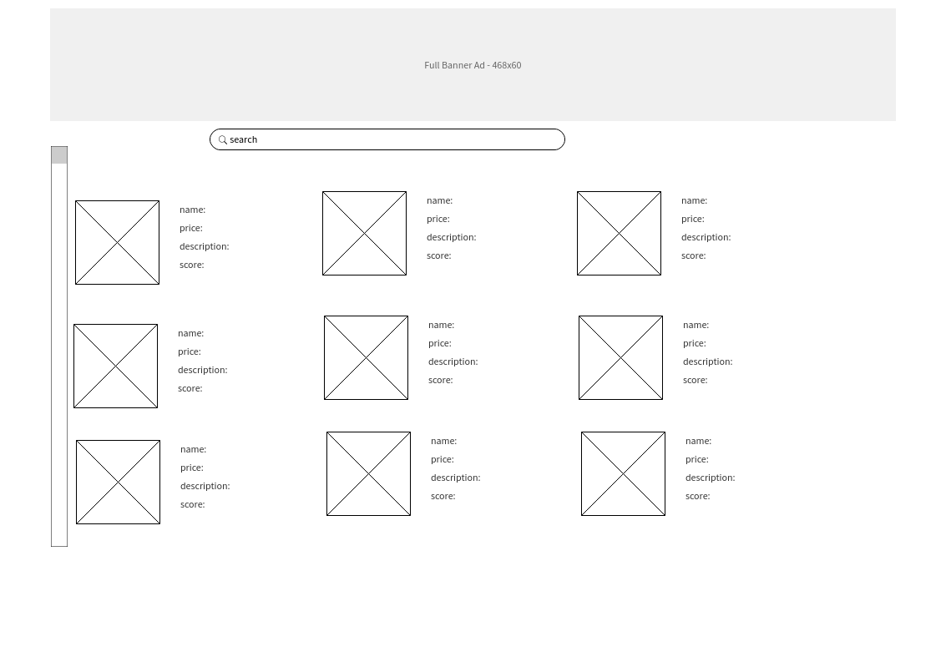

# **11.0. searched home**

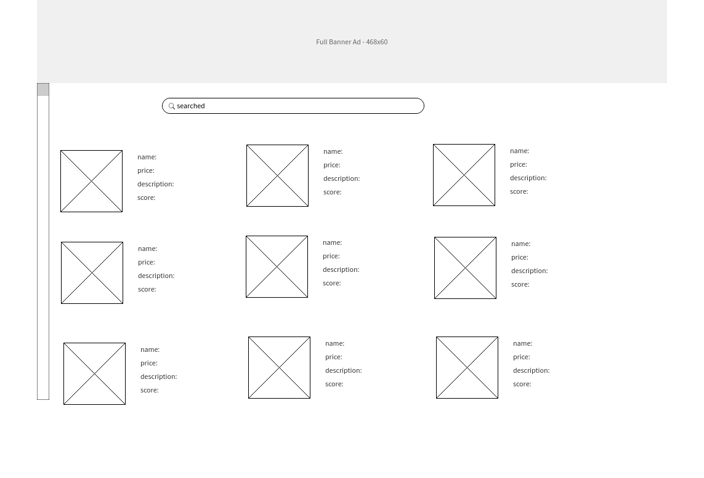

# **12.0. show ADS**

