# RDS — Remote Defense System

## Software Development Progress Report
**Aleppo Systems International**
**Date:** June 2026
**Author:** Software Engineering Team

## 1. Executive Summary

This report summarizes the software development progress for the Drone Remote Weapon Station (RDS) system.
In the first week, the team has successfully implemented and demonstrated:

- **ISM Firmware** — Independent Safety Monitor state machine running on Linux/WSL (target: STM32H7)
- **FCC Application** — Fire Control Computer application running on NVIDIA Jetson (Linux)
- **CAN Bus Communication** — Full duplex FCC ↔ ISM communication over SocketCAN (vcan0)
- **Motor Simulation** — Az/El servo motor simulator with real-time position tracking
- **GCS UDP Link** — JSON telemetry stream from FCC to Ground Control Station
****Micro300 Camera Integration** — H.265 RTSP stream + MavLink gimbal control (stub mode on WSL, GStreamer on Jetson)
All safety requirements SWR-SAFE-001 through SWR-SAFE-008 have been implemented and verified.

STANBY
echo '{"cmd":"standby"}' | nc -u 127.0.0.1 5201
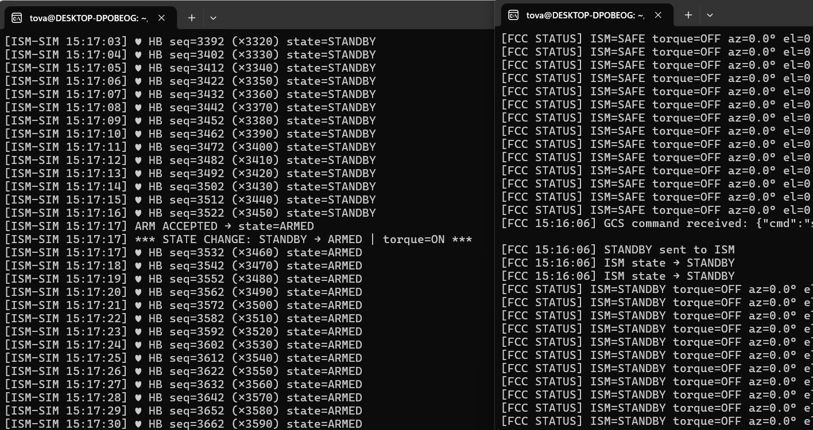

פקודת חימוש echo '{"cmd":"arm"}' | nc -u 127.0.0.1 5201
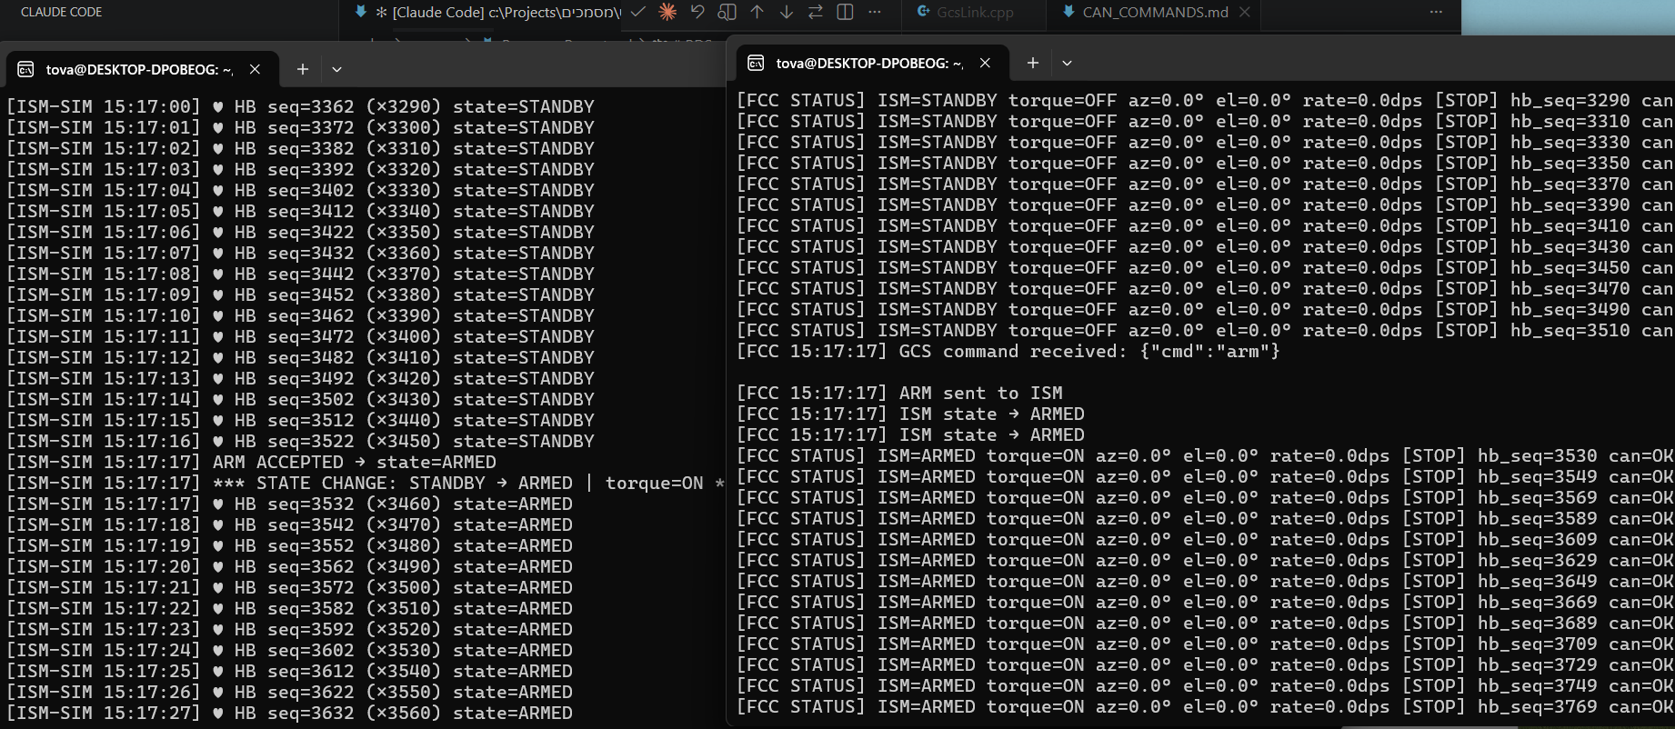

הזז מנוע
echo '{"cmd":"move","az":45.0,"el":20.0,"rate":15.0}' | nc -u 127.0.0.1 5201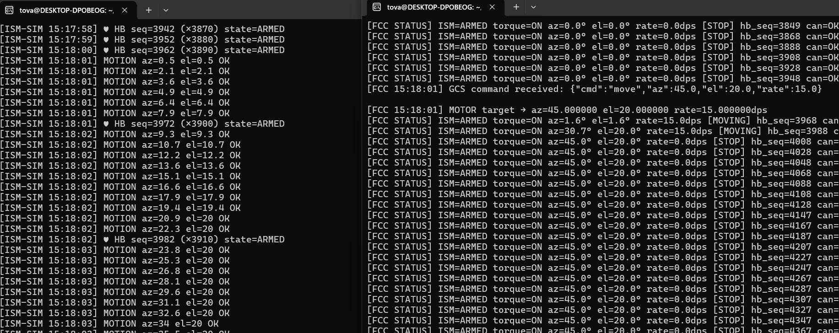

## 2. System Architecture

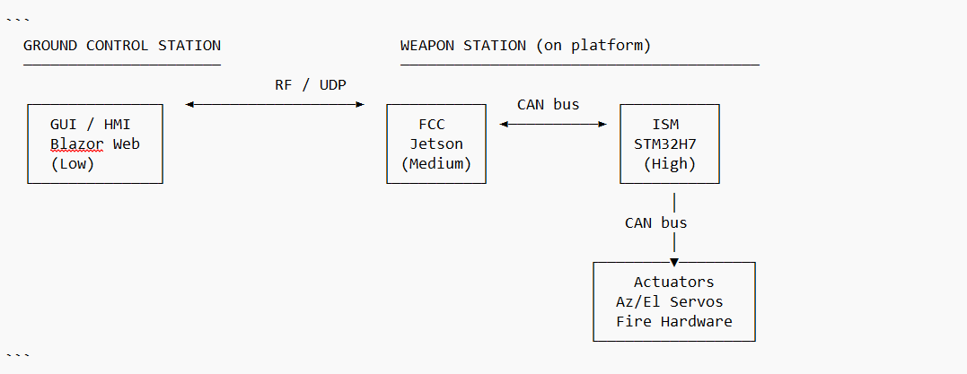

### Software Integrity Levels (MIL-STD-882E)

| Component | Processor | Integrity Level | Runtime |
|-----------|-----------|-----------------|---------|
| ISM Firmware | STM32H7 | **High** | Bare-metal, no OS |
| Fire Interlock Logic | STM32H7 | **High** | Bare-metal |
| FCC Application | NVIDIA Jetson Orin NX | **Medium** | Ubuntu Linux |
| Operator GUI / PANEL | GCS Laptop | **Low** | Blazor WebApp |

## 3. ISM Firmware

### 3.1 State Machine

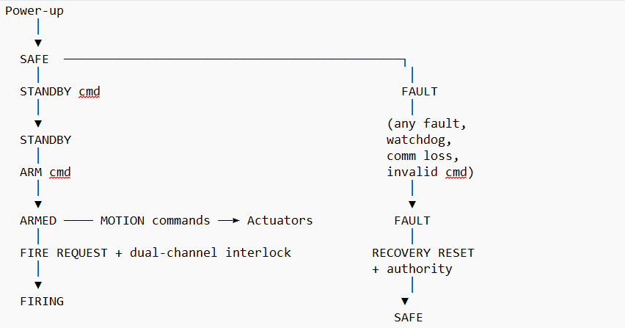

### 3.2 Files Implemented - ISM Firmware

| File | Purpose |
|------|---------|
| `include/SystemState.h` |
SystemState enum: SAFE / STANDBY / ARMED / FIRING / FAULT |
| `include/Watchdog.h` | Software watchdog — fires if FCC heartbeat stops within 500ms |
| `include/FireInterlock.h` | Dual-channel fire interlock — both channels must authorize |
| `include/FccMessage.h` | FCC→ISM
message types: HEARTBEAT, STANDBY, ARM, DISARM, MOTION, FIRE, RECOVERY |
| `include/ISM.h` | Independent Safety Monitor API |
| `src/ISM.cpp` | Core ISM logic: state machine, validation, fault logging, torque gating |
| `src/IsmSimCan.cpp` | CAN transport for ISM simulator on Linux/WSL |
| `src/main_sim.cpp` | ISM simulator entry point — runs ISM over SocketCAN |
| `tests/FaultInjectionTests.cpp` | 13 fault injection tests covering SWR-SAFE-001..008 |

### 3.3 Watchdog Architecture

Two independent layers:

| Layer | Mechanism | Timeout | Action |
|-------|-----------|---------|--------|
| Software | `Watchdog.h` — FCC heartbeat monitor | 500ms | ISM → FAULT |
| Hardware | STM32H7 IWDG (independent RC oscillator) | 26ms | MCU reset → SAFE |

## 4. FCC Application

### 4.1 Thread Architecture

main()
└── FccController::start()
├── heartbeatLoop() — CAN HEARTBEAT to ISM every 100ms
├── canReceiveLoop() — receives STATE_ACK / FAULT_REPORT from ISM
├── gcsPollLoop() — receives operator commands from GCS (UDP)
└── motorCmdLoop() — sends MOTION commands to ISM every 100ms when ARMED
↑
MotorSimulator — simulates Az/El servo position in real-time (10ms tick)
CameraStream — H.265 RTSP stream from Micro300 (30fps)
GimbalControl — MavLink gimbal pan/tilt/zoom control

### 4.2 Files Implemented - FCC

| File | Purpose |
|------|---------|
| `include/CanBus.h` + `src/CanBus.cpp` | SocketCAN wrapper — open, send, receive, poll |
| `include/IsmProtocol.h` | CAN IDs, frame builders and parsers for all messages |
| `include/GcsLink.h` + `src/GcsLink.cpp` | UDP JSON link — sends state to GCS, receives commands |
| `include/FccController.h` + `src/FccController.cpp` | Main FCC logic — 4 parallel threads |
| `include/MotorSimulator.h` + `src/MotorSimulator.cpp` | Az/El servo simulator with real-time position |
| `include/CameraStream.h` + `src/CameraStream.cpp` | Micro300 H.265 RTSP stream receiver (stub/GStreamer) |
| `include/GimbalControl.h` + `src/GimbalControl.cpp` | Micro300 gimbal control via MavLink UDP |
| `src/main.cpp` | Entry point with graceful shutdown on Ctrl+C || `include/MotorSimulator.h` + `src/MotorSimulator.cpp` | Az/El servo simulator with real-time position |
| `src/main.cpp` | Entry point with graceful shutdown on Ctrl+C |

### 4.3 CAN Message Table

| Direction | CAN ID | Message | Rate |
|-----------|--------|---------|------|
| FCC → ISM | `0x100` | HEARTBEAT | 10 Hz |
| FCC → ISM | `0x101` | ARM | On demand |
| FCC → ISM | `0x102` | DISARM | On demand |
| FCC → ISM | `0x103` | STANDBY | On demand |
| FCC → ISM | `0x110` | MOTION COMMAND (az/el/rate) | 10 Hz when ARMED |
| FCC → ISM | `0x120` | FIRE REQUEST | On demand |
| FCC → ISM | `0x130` | RECOVERY RESET | On demand |
| ISM → FCC | `0x200` | STATE ACK | On state change |
| ISM → FCC | `0x210` | FAULT REPORT | On fault |
| ISM → FCC | `0x211` | HEARTBEAT ACK | 1 Hz |

### 4.4 GCS Command Interface (UDP JSON)

**GCS → FCC (port 5201):**
```json
{"cmd":"standby"}
{"cmd":"arm"}
{"cmd":"disarm"}
{"cmd":"move","az":45.0,"el":20.0,"rate":15.0}
{"cmd":"stop"}
{"cmd":"fire"}
{"cmd":"recovery"}
{"cmd":"cam_start","ip":"192.168.1.200"}
{"cmd":"cam_stop"}
{"cmd":"gimbal","az":30.0,"el":-10.0}
{"cmd":"zoom_vis","factor":5.0}
{"cmd":"zoom_ir","factor":2.0}
```

**FCC → GCS (port 5200):**
```json
{"type":"state","ism_state":2,"torque_enabled":true,"azimuth_deg":45.0,"elevation_deg":20.0,"timestamp":"15:18:02"}
{"type":"fault","fault_code":1,"ism_state":4,"message":"ISM fault reported"}
```

## 5. Safety Requirements Coverage (SWR-SAFE-001..008)

| Req. ID | Requirement | Status | Verified By |
|---------|-------------|--------|-------------|
| SWR-SAFE-001 | SAFE state on power-up, reset, watchdog timeout, comm loss | ✅ Implemented | Watchdog timeout test, power-up test |
| SWR-SAFE-002 | FCC cannot energize actuators without ISM validation | ✅ Implemented | Torque gating test — torque=OFF until ARMED |
| SWR-SAFE-003 | ISM validates command range, rate, direction | ✅ Implemented | Boundary-value tests (±180° az, ±90° el, 45 dps) |
| SWR-SAFE-004 | Dual-channel interlock required for fire | ✅ Implemented | Single-channel denial test, dual-channel permit test |
| SWR-SAFE-005 | Safety SW independent of non-safety services | ✅ Implemented | ISM on dedicated MCU, no shared resources with FCC |
| SWR-SAFE-006 | Fault logging with time, state, source | ✅ Implemented | Log review after injected faults |
| SWR-SAFE-007 | Update integrity — sequence number validation | ✅ Implemented | Out-of-sequence command rejected → FAULT |
| SWR-SAFE-008 | Controlled recovery from FAULT | ✅ Implemented | Recovery requires authority token + fault clearance |

## 6. Simulation Results

### 6.1 Nominal Sequence — FCC + ISM Communication

The following sequence was successfully demonstrated on WSL with virtual CAN (vcan0):
[FCC] FCC starting. CAN=vcan0
[FCC] FCC running.
[ISM-SIM] Running. State=SAFE, waiting for FCC heartbeat...
[ISM-SIM] ♥ HB seq=10 (×10) state=SAFE
[ISM-SIM] ♥ HB seq=20 (×20) state=SAFE

GCS → {"cmd":"standby"}
[FCC] STANDBY sent to ISM
[ISM-SIM] STANDBY ACCEPTED → state=STANDBY
[FCC] ISM state → STANDBY

GCS → {"cmd":"arm"}
[FCC] ARM sent to ISM
[ISM-SIM] ARM ACCEPTED → state=ARMED
[FCC] ISM state → ARMED

GCS → {"cmd":"move","az":45.0,"el":20.0,"rate":15.0}
[FCC] MOTOR target → az=45.0 el=20.0 rate=15.0dps
[ISM-SIM] MOTION az=0.5 el=0.5 OK
[ISM-SIM] MOTION az=2.1 el=2.1 OK
[ISM-SIM] MOTION az=6.4 el=6.4 OK
[ISM-SIM] MOTION az=15.1 el=15.1 OK
[ISM-SIM] MOTION az=22.3 el=20.0 OK ← el reached target
[ISM-SIM] MOTION az=35.5 el=20.0 OK
[ISM-SIM] MOTION az=44.4 el=20.0 OK
[ISM-SIM] MOTION az=45.0 el=20.0 OK ← az reached target

[FCC STATUS] ISM=ARMED torque=ON az=45.0° el=20.0° rate=0.0dps [STOP]

### 6.2 Fault Injection Test Results
═════════════════════════════════════════════════════
ISM Firmware — Fault Injection Test Suite
MIL-STD-882E / SWR-SAFE-001..008
═════════════════════════════════════════════════════

[SWR-SAFE-001 | Power-up → SAFE]
✓ SWR-SAFE-001: Power-up → SAFE
✓ SWR-SAFE-001: Torque disabled on power-up

[SWR-SAFE-001 | Watchdog timeout → FAULT]
✓ SWR-SAFE-001: Watchdog timeout → FAULT
✓ SWR-SAFE-001: Torque disabled after watchdog

[SWR-SAFE-002 | Torque gating]
✓ SWR-SAFE-002: Torque off in SAFE state
✓ SWR-SAFE-002: ARM rejected from SAFE (not STANDBY)

[SWR-SAFE-003 | Range exceed rejected]
✓ SWR-SAFE-003: Rate limit is 45 dps
✓ SWR-SAFE-003: Azimuth limit is ±180°
✓ SWR-SAFE-003: Elevation limit is ±90°

[SWR-SAFE-004 | Fire dual-channel permitted]
✓ SWR-SAFE-004: Single-channel auth insufficient
✓ SWR-SAFE-004: Dual-channel auth permits fire

[SWR-SAFE-008 | Controlled recovery]
✓ SWR-SAFE-008: Recovery rejected without authority
✓ SWR-SAFE-008: Recovery accepted with authority
✓ SWR-SAFE-008: ISM returns to SAFE after recovery

Results: 13 passed 0 failed
═════════════════════════════════════════════════════

## 7 Micro300 Camera Integration
### 7.1 Camera Specifications (Microcon Vision Ltd.)

| Parameter | Value |
|-----------|-------|
| VIS Channel | FHD CMOS Global Shutter, zoom x20, FOV 45°–2° |
| IR Channel | LWIR uncooled 640×480, 12µm, zoom x4, FOV 12.5°–3.1° |
| Video Output | **H.265 over Ethernet** |
| Gimbal | 2-axis gyro-stabilized, El: -140° to +90°, Az: ±175° |
| Angular Velocity | Up to 120°/sec |
| Control | **MavLink over UDP** (optional) |
| Power | 24–32 VDC, 20W nominal |
| Weight | 325g (camera) + 130g (Hive CPU module) |

### 7.2 Integration Architecture

```
Micro300 (192.168.1.200)
│
├── H.265/RTSP :554 ──► CameraStream ──► GCS (video)
└── MavLink UDP :14550 ──► GimbalControl ──► pan/tilt/zoom
```

### 7.3 Platform Build Flags

| Platform | Build Command | Video Backend |
|----------|--------------|---------------|
| WSL / PC | `make` | Stub — simulated 30fps, 8.5Mbps |
| Jetson | `make jetson` (`-DJETSON_PLATFORM`) | GStreamer + `nvv4l2decoder` (HW H.265) |

### 7.4 Simulation Results

```
[GIMBAL] GimbalControl connected to 192.168.1.200:14550 (STUB MODE)
[CAMERA] Connecting to Micro300 at rtsp://192.168.1.200:554/stream
[CAMERA] Stream started (STUB MODE)
[FCC] Micro300 stream started at 192.168.1.200:554

GCS → {"cmd":"gimbal","az":30.0,"el":-10.0}
[GIMBAL] Gimbal → az=30.0° el=-10.0°

GCS → {"cmd":"zoom_vis","factor":5.0}
[GIMBAL] VIS zoom → x5.0

[FCC STATUS] CAM=ON f=5286 GIM=az30.0° el-10.0° ✅
```

---

## 8. Next Steps

| Priority | Task | Description |
|----------|------|-------------|
| 1 | Micro300 Camera Integration | Video stream capture and forwarding to GCS |
| 2 | FCC ↔ ISM on real hardware | Replace vcan0 with physical CAN bus on Jetson carrier board |
| 3 | GCS WebApp integration | Connect Blazor WebApp to FCC UDP telemetry stream |
| 4 | Fire Interlock full test | End-to-end dual-channel fire authorization sequence |
| 5 | STM32H7 port | Port ISM firmware from Linux simulator to STM32H7 HAL |

## 9. Documentation

| Document | Location |
|----------|----------|
| Communication Architecture | `ISM_Firmware/docs/Communication_Architecture.md` |
| Processor Allocation | `ISM_Firmware/docs/Processor_Allocation.md` |
| ISM Scheduler Design | `ISM_Firmware/docs/ISM_Scheduler.md` |
| Software Architecture (MIL-STD-882E) | `מסמכים/Software_general_architecture.pdf` |

*Aleppo Systems International — RDS Software Team — June 2026*

