Hacks #1
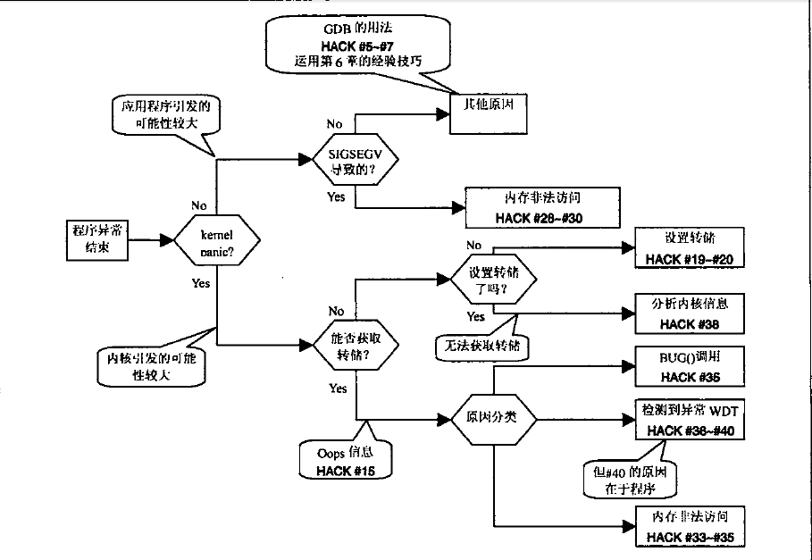
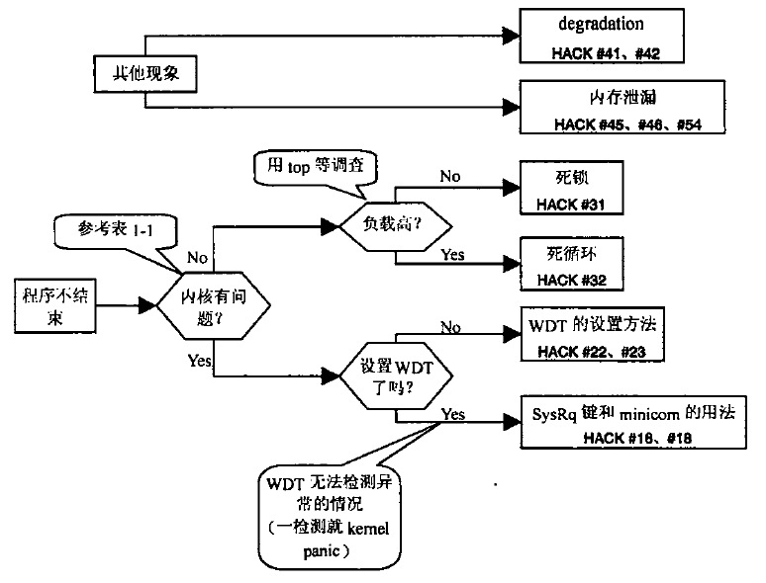
内核有问题的现象
区分方法 | 结果
ps | 显示中途停止，状态为D
ping | 不返回响应
键盘 | 键盘无法输入
kill -9 | 无法结束程序
strace | 无法附加(attach)到进程（无响应）
gdb | 无法附加(attach)到进程（无响应）
查看内核信息 | softlockup等有输出结果
Hacks #4
启用内核转储
$ ulimit -c #显示转储文件大小上限
0
$ ulimit -c unlimited
Hacks #15
Oops信息
Unable to handle kernel NULL pointer dereference at 0000000000000000 RIP: [<ffffffff881d0002>]:demo:init_oopsdemo+0x2/0xe
错误信息 RIP:[错误发生地址]:错误发生函数+偏移/函数长度
PGD c0004000 PUD 18b52067 PMD 0
Oops:0002 [1] SMP PREEMPT
Oops:错误号 [与页面有关的Oops信息显示次数] 支持SMP 支持抢占
last sysfs file:/block/dm-1/range
最后打开的sysfs文件
CPU 1
Modules linked in:...
相关模块:...
Pid:2473 comm:insmod Not tainted (2.6.22.6 #36)
内核污染原因：私有驱动加载（P）
PC is at s3c2410fb_probe+0x18/0x560
LR is at platform_drv_probe+0x20/0x24
pc : [<c001a70c>]
lr : [<c01bf4e8>]
psr: a0000013
sp : c0481e64 ip : c0481ea0 fp : c0481e9c
r10: 00000000 r9 : c0024864 r8 : c03c420c
r7 : 00000000 r6 : c0389a3c r5 : 00000000 r4 : c036256c
r3 : 00001234 r2 : 00000001 r1 : c04c0fc4 r0 : c0362564
Flags: NzCv IRQs on FIQs on Mode SVC_32 Segment kernel
Control: c000717f Table: 30004000 DAC: 00000017
Process swapper (pid: 1, stack limit = 0xc0480258)
Stack: (0xc0481e64 to 0xc0482000)
1e60:c02b1f70 00000020 c03625d4 c036256c c036256c 00000000 c0389a3c
1e80: c0389a3c c03c420c c0024864 00000000 c0481eac c0481ea0 c01bf4e8 c001a704
1ea0: c0481ed0 c0481eb0 c01bd5a8 c01bf4d8 c0362644 c036256c c01bd708 c0389a3c
1ec0: 00000000 c0481ee8 c0481ed4 c01bd788 c01bd4d0 00000000 c0481eec c0481f14
1ee0: c0481eec c01bc5a8 c01bd718 c038dac8 c038dac8 c03625b4 00000000 c0389a3c
1f00: c0389a44 c038d9dc c0481f24 c0481f18 c01bd808 c01bc568 c0481f4c c0481f28
1f20: c01bcd78 c01bd7f8 c0389a3c 00000000 00000000 c0480000 c0023ac8 00000000
1f40: c0481f60 c0481f50 c01bdc84 c01bcd0c 00000000 c0481f70 c0481f64 c01bf5fc
1f60: c01bdc14 c0481f80 c0481f74 c019479c c01bf5a0 c0481ff4 c0481f84 c0008c14
1f80: c0194798 e3c338ff e0222423 00000000 00000001 e2844004 00000000 00000000
1fa0: 00000000 c0481fb0 c002bf24 c0041328 00000000 00000000 c0008b40 c00476ec
1fc0: 00000000 00000000 00000000 00000000 00000000 00000000 00000000 00000000
1fe0: 00000000 00000000 00000000 c0481ff8 c00476ec c0008b50 c03cdf50 c0344178
Backtrace:
[<c001a6f4>] (s3c2410fb_probe+0x0/0x560) from [<c01bf4e8>] (platform_drv_
probe+0x20/0x24)
[<c01bf4c8>] (platform_drv_probe+0x0/0x24) from [<c01bd5a8>] (driver_probe_
device+0xe8/0x18c)
[<c01bd4c0>] (driver_probe_device+0x0/0x18c) from [<c01bd788>] (__driver_
attach+0x80/0xe0)
r8:00000000 r7:c0389a3c r6:c01bd708 r5:c036256c r4:c0362644
[<c01bd708>] (_ _driver_attach+0x0/0xe0) from [<c01bc5a8>] (bus_for_each_
dev+0x50/0x84)
r5:c0481eec r4:00000000
[<c01bc558>] (bus_for_each_dev+0x0/0x84) from [<c01bd808>] (driver_attach+
0x20/0x28)
r7:c038d9dc r6:c0389a44 r5:c0389a3c r4:00000000
[<c01bd7e8>] (driver_attach+0x0/0x28) from [<c01bcd78>] (bus_add_driver+
0x7c/0x1b4)
[<c01bccfc>] (bus_add_driver+0x0/0x1b4) from [<c01bdc84>] (driver_register+
0x80/0x88)
[<c01bdc04>] (driver_register+0x0/0x88) from [<c01bf5fc>] (platform_driver_
register+0x6c/0x88)
r4:00000000
[<c01bf590>] (platform_driver_register+0x0/0x88) from [<c019479c>] (s3c2410fb_
init+0x14/0x1c)
[<c0194788>] (s3c2410fb_init+0x0/0x1c) from [<c0008c14>] (kernel_init+0xd4/
0x28c)
[<c0008b40>] (kernel_init+0x0/0x28c) from [<c00476ec>] (do_exit+0x0/0x760)
Code: e24cb004 e24dd010 e59f34e0 e3a07000 (e5873000)
Kernel panic - not syncing: Attempted to kill init!
#45 Valgrind

$valgrind --tool=memcheck(默认) --leak-check=yes program

