https://software.intel.com/sites/landingpage/pintool/docs/62141/Pin/html/index.html
Pin类似JIT编译器，针对可执行文件。对指令插桩，取代原指令位置。

Pintool包含两个部分，插入桩代码和执行分析代码

Pintool注册插桩回调函数，检查生成的代码，检查静态属性，决定是否调用分析函数。
分析函数收集数据。
Pintool还可以注册通知回调函数。
Pin和可执行文件共享内存空间和资源。
插桩一次执行，分析多次执行。

Instrumentation Granularity
trace instrumentation ：以trace为单位\
trace：一个入口，多个无条件(包括call/ret)出口
基本块BBL：一个入口，一个出口
TRACE_AddInstrumentFunction API call
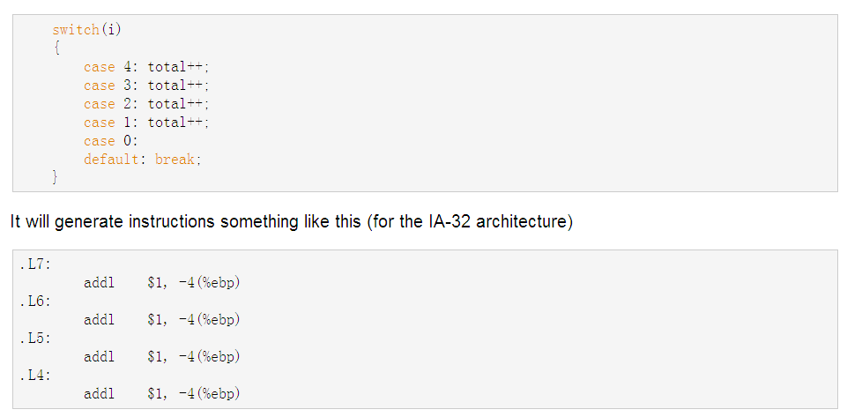
一般BBL的概念会认为这分别是四个基本快，但是Pin认为有.L7~.L4、.L6~.L4、.L5~.L4、.L4这样四个基本块。
Pin是运行时识别BBL的。Sequence of instructions that is always entered at the top and may have multiple exits. If Pin detects a jump to an instruction in the middle of a trace, it will create a new trace beginning at the target.

instruction instrumentation
INS_AddInstrumentFunction API call

Image instrumentation：inspect and instrument an entire image
A Pintool can walk the sections, SEC, of the image, the routines, RTN, of a section, and the instructions, INS of a routine. Instrumentation can be inserted so that it is executed before or after a routine is executed, or before or after an instruction is executed.
好像是可以routine粒度也可以指令粒度
IMG_AddInstrumentFunction API call
Image instrumentation depends on symbol information to determine routine boundaries hence PIN_InitSymbols must be called before PIN_Init

Routine instrumentation：inspect and instrument an entire routine
A Pintool can walk the instructions of a routine. There is not enough information available to break the instructions into BBLs. Instrumentation can be inserted so that it is executed before or after a routine is executed, or before or after an instruction is executed.
RTN_AddInstrumentFunction API call.
Instrumentation of routine exits does not work reliably in the presence of tail calls or when return instructions cannot reliably be detected.
Managed platforms support

Pin支持多种可执行文件包括managed binaries(可能指JIT编译环境下的代码吧)。Pin能够区分JITted code和其它动态生成的代码。要求JIT compiler of the running managed platform支持Jit Profiling API。

RTN_IsDynamic()
用于识别动态生成的代码。只有使用Jit Profiling API的函数会被标记为生态生成的。

Pintool能使用RTN_AddInstrumentFunction API对Jitted函数进行插桩。

设置环境变量 INTEL_JIT_PROFILER32 and INTEL_JIT_PROFILER64 to appropriate pinjitprofiling dynamic library
1. For Windows:
set INTEL_JIT_PROFILER32=<The Pin kit full path>\ia32\bin\pinjitprofiling.dll
set INTEL_JIT_PROFILER64=<The Pin kit full path>\intel64\bin\pinjitprofiling.dll
2.For Linux:
setenv INTEL_JIT_PROFILER32 <The Pin kit full path>/ia32/bin/libpinjitprofiling.so
setenv INTEL_JIT_PROFILER64 <The Pin kit full path>/intel64/bin/libpinjitprofiling.so

Add the knob support_jit_api to the Pin command line as Pin tool option:
<Pin executable> <pin options> -t <Pin tool> -support_jit_api <Other Pin tool options> -- <Test application> <Test application options>
符号
Pin使用符号对象(SYM)访问函数名。SYM只提供程序内函数符号的信息(其它例如数据符号就不行)。
在win中使用dbghelp.dll(在插桩过的进程中使用会有问题)

在linux中使用libelf.so或libdwarf.so

PIN_InitSymbols首先必须被调用
分析函数中对浮点的支持
对多线程应用的插桩
在多线程应用中避免死锁

Instruction Address Trace (Instruction Instrumentation)
Pin allows you to pass the instruction pointer, current value of registers, effective address of memory operations, constants, etc. For a complete list, see IARG_TYPE.

Memory Reference Trace (Instruction Instrumentation)
We only instrument instructions that read or write memory. We also use INS_InsertPredicatedCall instead of INS_InsertCall to avoid generating references to instructions that are predicated when the predicate is false.
指令级插桩

// 分析函数

// 插桩函数

// 结束函数

int main(int argc, char * argv[])
{
// Initialize pin
// 由main传来的argc和argv
if (PIN_Init(argc, argv)) return Usage();

// 注册指令级插桩函数，参数一为函数名，参数二传给插桩函数的参数二
INS_AddInstrumentFunction(Instruction, 0);

// 注册程序结束时的函数，参数一为函数名，参数二传给结束函数的参数二
PIN_AddFiniFunction(Fini, 0);

// 启动程序
PIN_StartProgram();

return 0;
}

插桩函数的类型：
typedef VOID(* LEVEL_PINCLIENT::INS_INSTRUMENT_CALLBACK)(INS ins, VOID *v)
VOID Instruction(INS ins, VOID *v)
{
// 注册分析函数
// IPOINT_BEFORE:对所有指令都有效
// IPOINT_AFTER:valid only when a fall-through exists (i.e. Calls and unconditional branches will fail).
// IPOINT_TAKEN_BRANCH:invalid for non-branches.
// 后面填写传给analysis_func()的参数类型，以IARG_END结尾
INS_InsertCall(ins, IPOINT_BEFORE, (AFUNPTR)analysis_fun, ..., IARG_END);
}

结束函数的类型：
typedef VOID(* LEVEL_PINCLIENT::FINI_CALLBACK)(INT32 code, VOID *v)
两个参数不知道。
修改程序指令
你可以插入一个分析routine来模拟指令，再用INS_Delete()移除原来的指令，也可以插入直接(INS_InsertDirectJump)或间接分支(INS_InseretIndirectJump)。
指令可用INS_RewriteMemoryOperand修改。
Note that in all of the cases where an instruction is modified, the modification is only made after all of the instrumentation routines have been executed. Therefore all of the instrumentation routines see the original, un-modified instruction.(好像是说被修改的指令先不执行，执行后面的)
高级调试器扩展
不用修改GDB或VS就能扩展调试功能。

Linux

