主要的漏洞：
1) stack ovefrow: Aleph One. Smashing the stack for fun and profit. Phrack Magazine, 49(14), 1996.
2) heap foverow: Anonymous. Once upon a free(). Phrack Magazine, 57(9), 2001.
3) integer foverow: blexim. Basic integer overows. Phrack Magazine, 60(10), 2002.
format string: gera. Advances in format string exploitation. Phrack Magazine, 59(12), 2002.

保护方法：
1) W㈩X (Writable XOR Executable) security model:
① PaX Team. http://pax.grsecurity.net/.
② Microsoft. Data Execution Prevention (DEP).
http://support.microsoft.com/kb/875352/EN-US/, 2006.
2) shadow stack:
① T. Chiueh and F.-H. Hsu. RAD: A compile-time solution to buffer overow attacks. In International Conference on Distributed Computing Systems, pages 409{417. IEEE Computer Society, 2001.
② Vendicator. Stack Shield: A "stack smashing" technique protection tool for Linux. http://www.angelfire.com/sk/stackshield.
③ M. Frantzen and M. Shuey. StackGhost: Hardware facilitated stack protection. In SSYM'01: Proceedings of the 10th conference on USENIX Security Symposium, pages 55{66. USENIX Association, 2001.

攻击方法：
1) conventional stack smashing: Aleph One. Smashing the stack for fun and profit. Phrack Magazine, 49(14), 1996.
2) return-into-libc: Solar Designer. "return-to-libc" attack. Bugtraq, 1997.
3) JOP: Tyler Bletsch, Xuxian Jiang, Vince Freeh, and Zhenkai Liang. Jump-oriented programming: A new class of code-reuse attack. In Proceedings of the 6th Symposium on Information, Computer and Communications Security (ASIACCS), 2011.

Instrumentation:
1) Probe-based instrumentation used in DynInst [9], Vulcan [23] or DTrace [10]
2) Jit-based instrumentation frameworks like Valgrind [46], DynamoRIO [7], and Pin [42]

jit-based DBI frameworks: C.-K. Luk, R. Cohn, R. Muth, H. Patil, A. Klauser, G. Lowney, S. Wallace, V. J. Reddi, and K. Hazelwood. Pin: Building customized program analysis tools with dynamic instrumentation. In PLDI'05: Proceedings of the 2005 ACM SIGPLAN conference on Programming language design and implementation, pages 190{200. ACM, June 2005.

Lazy Binging on Ubuntu 10.04
On our tested Ubuntu system, lazy binding is enforced by a combination of the functions dl_rtld_di_serinfo and dl_make_stackexecutable, which are both part of the dynamic linker library linux-ld.so. After dl_rtld_di_serinfo resolves the function's address, it transfers control to the code of dl_make_stackexecutable by a jump instruction.

ROP Defend
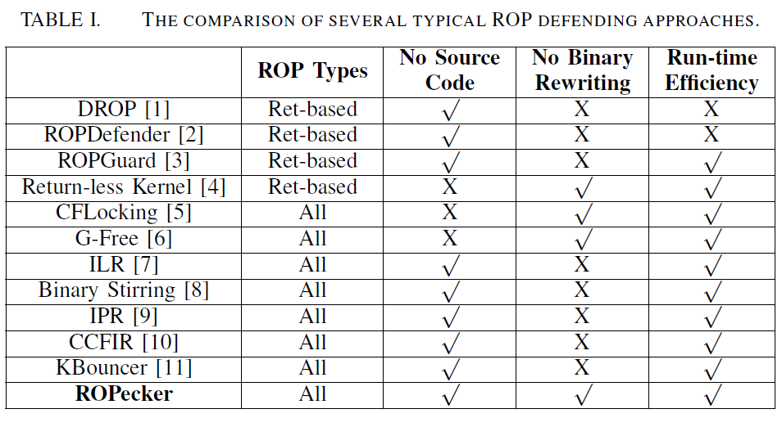

ROP compiler Q [17].

LBR
a looped buffer to store the sources and destinations of the most recently executed branch instructions.
e.g., the Intel i5 only has 16 register pairs for recording the branches.
The LBR functionality is disabled by default, and can only be enabled/disabled through certain Model Specific Registers (MSRs).

SLOC: 源代码行(Source Lines Of Code)

enum x86_pf_error_code {
PF_PROT = 1 << 0, protection fault
PF_WRITE = 1 << 1, write access
PF_USER = 1 << 2, user-mode access
PF_RSVD = 1 << 3, use of reserved bit detected
PF_INSTR = 1 << 4, fault was an instruction fetch
};

分支类型：
- 静态控制转移：地址在指令中
- 间接控制流转移：地址在内存中

间接分支：分支地址由寄存器或内存中数据指定。因为就算编译器找到了这条分支，但是它不知道在这条分支之前的操作是否有修改寄存器或内存单元的值(模拟又是相当耗时的过程)，所以说这个分支的地址只有运行时执行到它才会知道。

Predicate function：断言函数，即返回bool值的函数。

动态类型语言：在运行时检查数据类型的语言。程序员不需要指明其类型。例如Python。

chunck与block的区别
A chunk is an independently executable sequence of statements. A block is just a sequence of statements. The difference is that a chunk can be executed independently of other chunks.
All chunks are blocks (sequences of statements), but not all blocks are chunks.

抛出异常和栈展开(stack unwinding)
抛出异常时，将暂停当前函数的执行，开始查找匹配的catch子句。首先检查throw本身是否在try块内部，如果是，检查与该try相关的catch子句，看是否可以处理该异常。如果不能处理，就退出当前函数，并且释放当前函数的内存并销毁局部对象，继续到上层的调用函数中查找，直到找到一个可以处理该异常的catch。这个过程称为栈展开（stack unwinding）。当处理该异常的catch结束之后，紧接着该catch之后的点继续执行。

ret-to-lib：攻击利用有限(将用一整个函数代码)；对x64无效(x64通过寄存器传参)。

