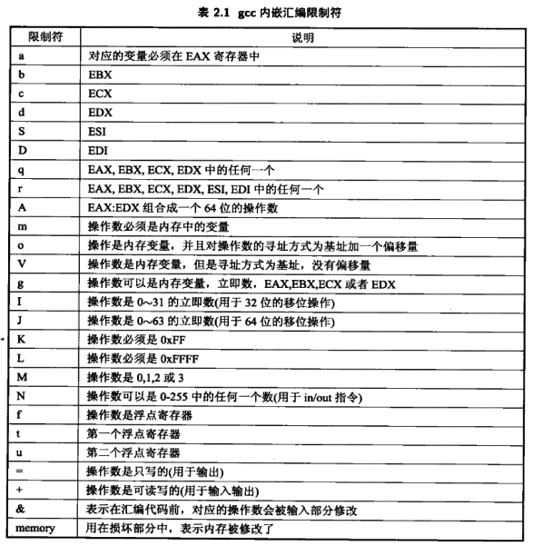
2.3 同步与互斥
2.3.1 原子操作
linux-2.6.32.4\include\linux\types.h
typedef struct {
volatile int counter;
} atomic_t;

linux-2.6.32.4\arch\x86\include\asm\atomic_32.h
static inline void atomic_dec(atomic_t *v)
{
asm volatile(LOCK_PREFIX "decl %0"
: "+m" (v->counter));
}
2.3.2 信号量
linux-2.6.32.4\kernel\semaphore.c
down(struct semaphore *sem)函数被弃用，请用down_interruptible()或down_killable()
down_interruptible(): Attempts to acquire the semaphore. If no more tasks are allowed to acquire the semaphore, calling this function will put the task to sleep. If the sleep is interrupted by a signal, this function will return -EINTR. If the semaphore is successfully acquired, this function returns 0. 如果睡眠被信号中断，则返回错误。
down_killable(): 如果睡眠被fatal signal中断，则返回错误。

/*down和up不用成对存在*/
void up(struct semaphore *sem)
{
unsigned long flags;

spin_lock_irqsave(&sem->lock, flags);
if (likely(list_empty(&sem->wait_list)))
sem->count++;
else
__up(sem);
spin_unlock_irqrestore(&sem->lock, flags);
}
EXPORT_SYMBOL(up);
2.3.3 自旋锁
1) 自旋锁定义
linux-2.6.32.4\include\linux\spinlock_types.h
typedef struct {
raw_spinlock_t raw_lock;
#ifdef CONFIG_GENERIC_LOCKBREAK //可抢占？
unsigned int break_lock;
#endif
#ifdef CONFIG_DEBUG_SPINLOCK
unsigned int magic, owner_cpu;
void *owner;
#endif
#ifdef CONFIG_DEBUG_LOCK_ALLOC
struct lockdep_map dep_map;
#endif
} spinlock_t;

linux-2.6.32.4\arch\x86\include\asm\spinlock_types.h
typedef struct raw_spinlock {
unsigned int slock;
} raw_spinlock_t;

2) 初始化自旋锁
linux-2.6.32.4\include\linux\spinlock.h
#ifdef CONFIG_DEBUG_SPINLOCK
extern void __spin_lock_init(spinlock_t *lock, const char *name,
struct lock_class_key *key);
# define spin_lock_init(lock) \
do { \
static struct lock_class_key __key; \
\
__spin_lock_init((lock), #lock, &__key); \
} while (0)

#else
# define spin_lock_init(lock) \
do { *(lock) = SPIN_LOCK_UNLOCKED; } while (0)
#endif

linux-2.6.32.4\include\linux\spinlock_types.h
#define __SPIN_LOCK_UNLOCKED(lockname) \
(spinlock_t) { .raw_lock = __RAW_SPIN_LOCK_UNLOCKED, \
SPIN_DEP_MAP_INIT(lockname) }

# define SPIN_DEP_MAP_INIT(lockname)

linux-2.6.32.4\arch\x86\include\asm\spinlock_types.h
#define __RAW_SPIN_LOCK_UNLOCKED { 0 }

上面替换宏（没有DEBUG_SPINLOCK）：
*(lock)={0};

- 申请自旋锁
linux-2.6.32.4\include\linux\spinlock.h
#define spin_lock_irq(lock) _spin_lock_irq(lock)

linux-2.6.32.4\kernel\spinlock.c
#ifndef _spin_lock_irq
void __lockfunc _spin_lock_irq(spinlock_t *lock)
{
__spin_lock_irq(lock);
}
EXPORT_SYMBOL(_spin_lock_irq);
#endif

linux-2.6.32.4\include\linux\spinlock_api_smp.h
static inline void __spin_lock_irq(spinlock_t *lock)
{
local_irq_disable();
preempt_disable();
spin_acquire(&lock->dep_map, 0, 0, _RET_IP_);
LOCK_CONTENDED(lock, _raw_spin_trylock, _raw_spin_lock);
}

linux-2.6.32.4\include\linux\lockdep.h
#ifdef CONFIG_LOCK_STAT
...
#else /* CONFIG_LOCK_STAT */
...
#define LOCK_CONTENDED(_lock, try, lock) \
lock(_lock)
#endif /* CONFIG_LOCK_STAT */

linux-2.6.32.4\include\linux\spinlock.h
#ifdef CONFIG_DEBUG_SPINLOCK
#else
# define _raw_spin_lock(lock) __raw_spin_lock(&(lock)->raw_lock)

linux-2.6.32.4\arch\x86\include\asm\spinlock.h
static __always_inline void __raw_spin_lock(raw_spinlock_t *lock)
{
__ticket_spin_lock(lock);
}

#if (NR_CPUS < 256)
static __always_inline void __ticket_spin_lock(raw_spinlock_t *lock)
{
short inc = 0x0100;

asm volatile (
LOCK_PREFIX "xaddw %w0, %1\n"
"1:\t"
"cmpb %h0, %b0\n\t"
"je 2f\n\t"
"rep ; nop\n\t"
"movb %1, %b0\n\t"
/* don't need lfence here, because loads are in-order */
"jmp 1b\n"
"2:"
: "+Q" (inc), "+m" (lock->slock)
:
: "memory", "cc");
}

linux-2.6.32.4\include\linux\spinlock_api_smp.h
#ifdef __always_inline__spin_lock_irq
#define _spin_lock_irq(lock) __spin_lock_irq(lock)
#endif

linux-2.6.32.4\include\linux\spinlock_api_up.h
#define _spin_lock_irq(lock) __LOCK_IRQ(lock)

#define __LOCK_IRQ(lock) \
do { local_irq_disable(); __LOCK(lock); } while (0)

#define __LOCK(lock) \
do { preempt_disable(); __acquire(lock); (void)(lock); } while (0)

linux-2.6.32.4\include\linux\compiler.h
# define __acquire(x) (void)0

spin_lock_irqsave，spin_unlock_irqrestore：释放自旋锁时根据原先的终端许可情况确定是否开启中断，而不是盲目地开启中断。
2.3.4 RCU机制
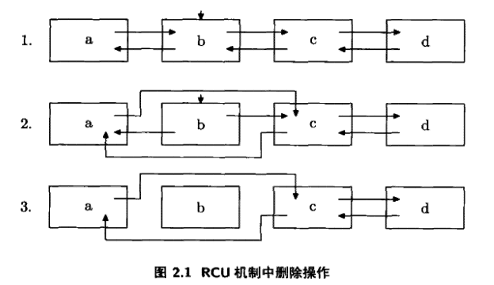
- 原始状态，一个写操作决定要删除b；
- 将a、c链接，而经过b对a、c的引用仍然有效；
- 适当的时机，用RCU回调函数将b删除。
适当的时机：在RCU回调函数注册之后，所有CPU都至少完成一次进程切换。

- 读操作
linux-2.6.32.4\include\linux\rcupdate.h
static inline void rcu_read_lock(void)
{
__rcu_read_lock();
__acquire(RCU); //给sparse语法检测器用的
rcu_read_acquire();
}

#ifdef CONFIG_DEBUG_LOCK_ALLOC
#else
# define rcu_read_acquire() do { } while (0)
# define rcu_read_release() do { } while (0)
#endif

linux-2.6.32.4\kernel\rcutree_plugin.h
/* Just increment ->rcu_read_lock_nesting*/
void __rcu_read_lock(void)
{
ACCESS_ONCE(current->rcu_read_lock_nesting)++;
barrier(); /* needed if we ever invoke rcu_read_lock in rcutree.c */
}
EXPORT_SYMBOL_GPL(__rcu_read_lock);

rcu_read_lock_nesting_bh()：bh表示软中断。

- RCU回调
linux-2.6.32.4\kernel\rcutree.h
/* Per-CPU data for read-copy update. */
struct rcu_data {...}

回调函数注册
linux-2.6.32.4\kernel\rcutree_plugin.h
/* Queue a preemptable-RCU callback for invocation after a grace period. */
void call_rcu(struct rcu_head *head, void (*func)(struct rcu_head *rcu))
{
__call_rcu(head, func, &rcu_preempt_state);
}
EXPORT_SYMBOL_GPL(call_rcu);

linux-2.6.32.4\kernel\rcutree.c
static void __call_rcu(struct rcu_head *head, void (*func)(struct rcu_head *rcu),
struct rcu_state *rsp)
{
unsigned long flags;
struct rcu_data *rdp;
//设置RCU的回调函数
head->func = func;
head->next = NULL;

smp_mb(); /* Ensure RCU update seen before callback registry. */

/*
* Opportunistically note grace-period endings and beginnings.
* Note that we might see a beginning right after we see an
* end, but never vice versa, since this CPU has to pass through
* a quiescent state betweentimes.
*/
local_irq_save(flags);
//获得当前CPU的rcu_data
rdp = rsp->rda[smp_processor_id()];
rcu_process_gp_end(rsp, rdp);
check_for_new_grace_period(rsp, rdp);
//把回调函数加入到队列中
/* Add the callback to our list. */
*rdp->nxttail[RCU_NEXT_TAIL] = head;
rdp->nxttail[RCU_NEXT_TAIL] = &head->next;

/* Start a new grace period if one not already started. */
if (!rcu_gp_in_progress(rsp)) {
unsigned long nestflag;
struct rcu_node *rnp_root = rcu_get_root(rsp);

spin_lock_irqsave(&rnp_root->lock, nestflag);
rcu_start_gp(rsp, nestflag); /* releases rnp_root->lock. */
}
//如果回调函数太多，就尝试请求调度
/*
* Force the grace period if too many callbacks or too long waiting.
* Enforce hysteresis, and don't invoke force_quiescent_state()
* if some other CPU has recently done so. Also, don't bother
* invoking force_quiescent_state() if the newly enqueued callback
* is the only one waiting for a grace period to complete.
*/
if (unlikely(++rdp->qlen > rdp->qlen_last_fqs_check + qhimark)) {
rdp->blimit = LONG_MAX;
if (rsp->n_force_qs == rdp->n_force_qs_snap &&
*rdp->nxttail[RCU_DONE_TAIL] != head)
force_quiescent_state(rsp, 0);
rdp->n_force_qs_snap = rsp->n_force_qs;
rdp->qlen_last_fqs_check = rdp->qlen;
} else if ((long)(ACCESS_ONCE(rsp->jiffies_force_qs) - jiffies) < 0)
force_quiescent_state(rsp, 1);
local_irq_restore(flags);
}
当CPU经历一次进程切换时，会调用rcu_qsctr_inc()函数标记这一动作。在时钟中断发生时，中断会检查RCU回调函数队列。
linux-2.6.32.4\kernel\timer.c
void update_process_times(int user_tick)
{
...
rcu_check_callbacks(cpu, user_tick);
...
}

linux-2.6.32.4\kernel\rcutree.c
void rcu_check_callbacks(int cpu, int user)
{
if (!rcu_pending(cpu))
return; /* if nothing for RCU to do. */
//如果非空
if (user ||
(idle_cpu(cpu) && rcu_scheduler_active &&
!in_softirq() && hardirq_count() <= (1 << HARDIRQ_SHIFT))) {

/*
* Get here if this CPU took its interrupt from user
* mode or from the idle loop, and if this is not a
* nested interrupt. In this case, the CPU is in
* a quiescent state, so note it.
*
* No memory barrier is required here because both
* rcu_sched_qs() and rcu_bh_qs() reference only CPU-local
* variables that other CPUs neither access nor modify,
* at least not while the corresponding CPU is online.
*/

rcu_sched_qs(cpu);
rcu_bh_qs(cpu);

} else if (!in_softirq()) {

/*
* Get here if this CPU did not take its interrupt from
* softirq, in other words, if it is not interrupting
* a rcu_bh read-side critical section. This is an _bh
* critical section, so note it.
*/

rcu_bh_qs(cpu);
}
rcu_preempt_check_callbacks(cpu);
raise_softirq(RCU_SOFTIRQ);
}
2.3.5 percpu变量
当某个CPU的就绪进程个数为0或大于某个阈值时，启动负载均衡机制来平衡各个CPU的运行队列。
- percpu变量定义：DEFINE_PER_CPU(long, var)=0;
linux-2.6.32.4\include\linux\percpu-defs.h
#define DEFINE_PER_CPU(type, name) \
DEFINE_PER_CPU_SECTION(type, name, "")

#if defined(ARCH_NEEDS_WEAK_PER_CPU) || defined(CONFIG_DEBUG_FORCE_WEAK_PER_CPU)
#else
#define DEFINE_PER_CPU_SECTION(type, name, sec) \
__PCPU_ATTRS(sec) PER_CPU_DEF_ATTRIBUTES \
__typeof__(type) per_cpu__##name
#endif
→
#define DEFINE_PER_CPU_SECTION(type, name, sec) \
__attribute__((section(PER_CPU_BASE_SECTION sec))) \
__typeof__(type) per_cpu__##name

linux-2.6.32.4\include\asm-generic\percpu.h
#ifndef PER_CPU_BASE_SECTION
#ifdef CONFIG_SMP
#define PER_CPU_BASE_SECTION ".data.percpu"
#else
#define PER_CPU_BASE_SECTION ".data"
#endif
#endif

section表示将变量__typeof__(type) per_cpu__##name即long per_cpu_var放到.data.percpu数据区（3.3节）。

- percpu变量访问
#ifdef CONFIG_SMP
#define per_cpu(var, cpu) \
(*SHIFT_PERCPU_PTR(&per_cpu_var(var), per_cpu_offset(cpu)))
#else /* ! SMP */
#define per_cpu(var, cpu) (*((void)(cpu), &per_cpu_var(var)))
#endif /* SMP */

#define SHIFT_PERCPU_PTR(__p, __offset) RELOC_HIDE((__p), (__offset))

linux-2.6.32.4\include\linux\compiler-gcc.h
#define RELOC_HIDE(ptr, off) \
({ unsigned long __ptr; \
__asm__ ("" : "=r"(__ptr) : "0"(ptr)); \
(typeof(ptr)) (__ptr + (off)); })
__p为per_cpu_var的地址，__offset由setup_per_cpu_areas()函数计算得到，表示运行时复制的percpu数据区的首地址和编译时首地址的差值，两个参数相加得到正确的percpu地址。
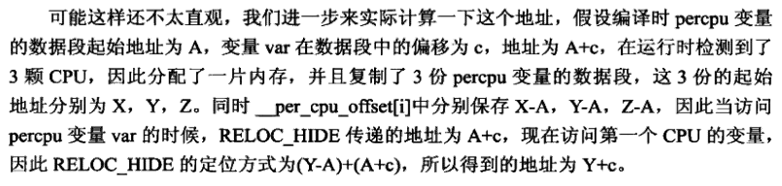
2.4 内存屏障
当完成对内存的写入操作之后，读取出来的有可能是旧数据。
2.4.1 编译时引起的内存屏障
编译器可能会将某一变量分配给寄存器，读变量时不及时更新而读了旧数据。可以使用volatile关键字。但是如果这类变量比较多，则使用：barrier();
linux-2.6.32.4\include\linux\compiler-gcc.h
#define barrier() __asm__ __volatile__("": : :"memory")
它告诉编译器内存已被修改，必须刷新内存及相应的寄存器。这个过程发生在编译阶段。
2.4.2 缓存引起的内存屏障
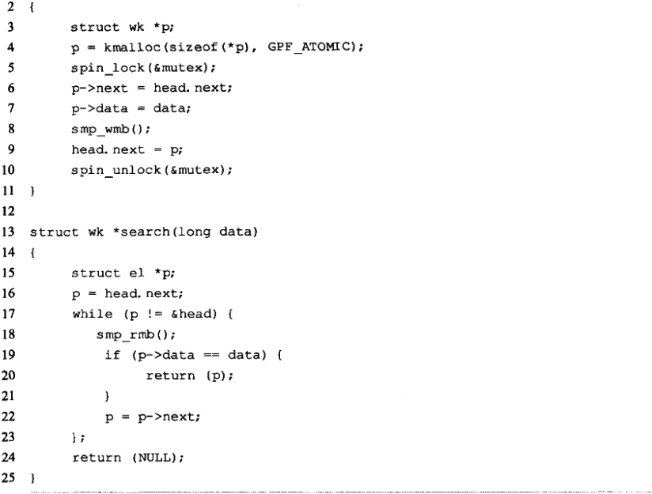
CPU0调用insert()函数，在缓存创建p，并修改缓存中的p->next、p->data和head.next，但是还没写入内存；CPU1访问head，于是先将head.next写回内存。此时CPU2调用search()函数：
①CPU2未对head缓存，于是将内存中新的head读入，可是head.next是旧的或错的。
②CPU2以对head缓存，则head是旧的。

1) 内存屏障机制
linux-2.6.32.4\include\asm-generic\system.h
#define mb() asm volatile ("": : :"memory")
#define rmb() mb()
#define wmb() asm volatile ("": : :"memory")
#ifdef CONFIG_SMP
#define smp_mb() mb()
#define smp_rmb() rmb()
#define smp_wmb() wmb()
#else
#define smp_mb() barrier()
#define smp_rmb() barrier()
#define smp_wmb() barrier()
#endif

linux-2.6.32.4\arch\x86\include\asm\system.h
#ifdef CONFIG_X86_32
/*
* Some non-Intel clones support out of order store. wmb() ceases to be a
* nop for these.
*/
#define mb() alternative("lock; addl $0,0(%%esp)", "mfence", X86_FEATURE_XMM2)
#define rmb() alternative("lock; addl $0,0(%%esp)", "lfence", X86_FEATURE_XMM2)
#define wmb() alternative("lock; addl $0,0(%%esp)", "sfence", X86_FEATURE_XMM)
#else
#define mb() asm volatile("mfence":::"memory")
#define rmb() asm volatile("lfence":::"memory")
#define wmb() asm volatile("sfence" ::: "memory")
#endif
2.4.3 乱序执行引起的内存屏障
超标量处理器的流水线会引起内存屏障。
lfence：当CPU遇到lfence指令时，停止相关流水线，直到lfence之前对内存进行读取操作的指令完成。
sfence：当CPU遇到sfence指令时，停止相关流水线，直到sfence之前对内存进行写入操作的指令完成。
mfence：当CPU遇到mfence指令时，停止相关流水线，直到mfence之前对内存进行读写操作的指令完成。
2.5 函数调用规约
- C：调用者将参数从右到左入栈，通过EAX或EDX:EAX返回
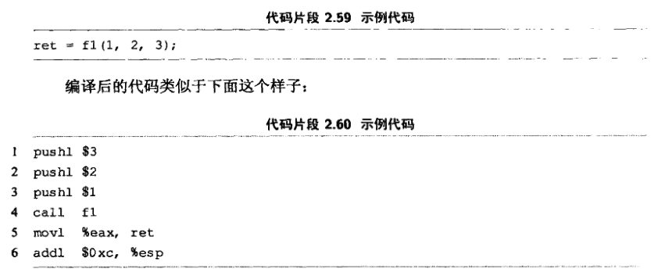
- Fastcall：调用者默认将前两个参数存入ECX、EDX，其它压入栈，通过EAX或EDX:EAX返回。
- Pascal：参数从左到右入栈，通过EAX或EDX:EAX返回。
__attribute__((regparm(3)))：强制要求前三个参数存入EAX、ECX、EDX。
ret $n：被调者清除参数。好处：减少代码体积。
addl $n,%esp：调用者清除参数。好处：支持变参函数；但是每个被调者都要有这条指令（相对上面）
3.2 内核编译过程分析
make bzIamge
linux-2.6.32.4\arch\x86\Makefile
# Default kernel to build
all: bzImage
bzImage: vmlinux
$(Q)$(MAKE) $(build)=$(boot) $(KBUILD_IMAGE)
$(Q)mkdir -p $(objtree)/arch/$(UTS_MACHINE)/boot
$(Q)ln -fsn ../../x86/boot/bzImage $(objtree)/arch/$(UTS_MACHINE)/boot/$@

linux-2.6.32.4\Makefile
#定义了一些要编译的子目录
init-y := init/
drivers-y := drivers/ sound/ firmware/
net-y := net/
libs-y := lib/
core-y := usr/
#把目录最后的“/”去掉，把所有目录列表赋给vmlinux-dirs。patsubst和filter为内部函数，用于替换和过滤
vmlinux-dirs := $(patsubst %/,%,$(filter %/, $(init-y) $(init-m) \
$(core-y) $(core-m) $(drivers-y) $(drivers-m) \
$(net-y) $(net-m) $(libs-y) $(libs-m)))
vmlinux-init := $(head-y) $(init-y)
vmlinux-main := $(core-y) $(libs-y) $(drivers-y) $(net-y)
vmlinux-all := $(vmlinux-init) $(vmlinux-main)
vmlinux-lds := arch/$(SRCARCH)/kernel/vmlinux.lds
export KBUILD_VMLINUX_OBJS := $(vmlinux-all)
all: vmlinux
vmlinux: $(vmlinux-lds) $(vmlinux-init) $(vmlinux-main) vmlinux.o $(kallsyms.o) FORCE
vmlinux.o: $(modpost-init) $(vmlinux-main) FORCE
$(call if_changed_rule,vmlinux-modpost)

scritpts/Makefile.build：对指定目录进行编译
所有指定为obj-m的c都编译成o，再链接成build-in.o。

linux-2.6.32.4\scripts\Kbuild.include
ifneq ($(KBUILD_NOCMDDEP),1)
# Check if both arguments has same arguments. Result is empty string if equal.
# User may override this check using make KBUILD_NOCMDDEP=1
arg-check = $(strip $(filter-out $(cmd_$(1)), $(cmd_$@)) \
$(filter-out $(cmd_$@), $(cmd_$(1))) )
endif

# Find any prerequisites that is newer than target or that does not exist.
# PHONY targets skipped in both cases.
any-prereq = $(filter-out $(PHONY),$?) $(filter-out $(PHONY) $(wildcard $^),$^)

# Usage: $(call if_changed_rule,foo)
# Will check if $(cmd_foo) or any of the prerequisites changed,
# and if so will execute $(rule_foo).
if_changed_rule = $(if $(strip $(any-prereq) $(arg-check) ), \
@set -e; \
$(rule_$(1)))

all:
ls
和
all:
@ls
区别：前者会把ls命令先输出来，后者不会

分析Makefile的方法：使用echo命令输出相关变量的值；使用Makefile的函数error来观察一个ifdef是否成立；使用目标重定义根据make的警告信息来定位一个目标的位置；使用find，grep，make -d --debug等命令来收集信息等。

3.3 内核链接脚本分析
linux-2.6.32.27\arch\x86\kernel\vmlinux.lds
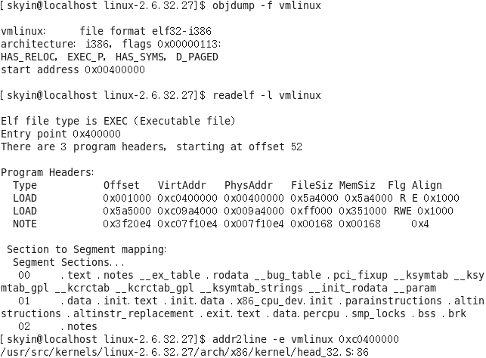
这里显示入口地址是0x00400000。又可知startup_32在arch/x86/kernel/head_32.S中定义。

linux-2.6.32.27/arch/x86/kernel/vmlinux.lds
//规定了输出的目标文件格式
OUTPUT_FORMAT("elf32-i386", "elf32-i386", "elf32-i386")
//规定了目标文件的运行平台
OUTPUT_ARCH(i386)
//目标文件的入口地址
ENTRY(phys_startup_32)
jiffies = jiffies_64;
//目标文件的代码段、数据段的读、写、执行属性
PHDRS {
text PT_LOAD FLAGS(5); /* R_E */
data PT_LOAD FLAGS(7); /* RWE */
note PT_NOTE FLAGS(0); /* ___ */
}
SECTIONS
{
//设置起始地址。“.”表示当前地址计数，这里计算得到0xC0400000
. = 0xC0000000 + ((0x400000 + (0x400000 - 1)) & ~(0x400000 - 1));
//startup_32在arch/x86/kernel/head_32.S中定义，是代码段的第一个指令所在地址
phys_startup_32 = startup_32 - 0xC0000000;
//等于0x00400000，这个表示保护模式之前的代码起始地址就是4M位置

linux-2.6.32.27/.vmlinux.cmd
cmd_vmlinux := ld -m elf_i386 --emit-relocs --build-id -o vmlinux-T arch/x86/kernel/vmlinux.lds arch/x86/kernel/head_32.o arch/x86/kernel/head32.o arch/x86/kernel/head.o arch/x86/kernel/init_task.o init/built-in.o --start-group usr/built-in.o arch/x86/built-in.o kernel/built-in.o mm/built-in.o fs/built-in.o ipc/built-in.o security/built-in.o crypto/built-in.o block/built-in.o lib/lib.a arch/x86/lib/lib.a lib/built-in.o arch/x86/lib/built-in.o drivers/built-in.o sound/built-in.o firmware/built-in.o arch/x86/pci/built-in.o arch/x86/power/built-in.o arch/x86/video/built-in.o net/built-in.o --end-group .tmp_kallsyms3.o
链接的第一个文件就是arch/x86/kernel/head_32.o

arch/x86/boot/setup.bin被合并到vmlinux的最前面，通过setup.elf.cmd可知setup.elf的链接脚本是setup.ld，该脚本中ENTRY指定的入口是_start，使用ld -M参数可知_start位于arch/x86/boot/header.S中，内核被boot loader加载后，将跳转到_start处，进入内核继续执行。
4.2 实模式setup阶段
boot loader跳转到_start。
linux-2.6.32.4\arch\x86\boot\header.S
...
hdr:
/*该扇区之后的实模式代码占用几个扇区*/
setup_sects: .byte 0 /* Filled in by build.c */
root_flags: .word ROOT_RDONLY
syssize: .long 0 /* Filled in by build.c */
ram_size: .word 0 /* Obsolete */
vid_mode: .word SVGA_MODE
root_dev: .word 0 /* Filled in by build.c */
boot_flag: .word 0xAA55

# offset 512, entry point

.globl _start
_start:
/*硬编码跳转到start_of_setup*/
.byte 0xeb # short (2-byte) jump
.byte start_of_setup-1f
1:
...
/*32位保护模式代码的入口点*/
code32_start:
.long 0x100000 # 0x100000 = default for big kernel
...
start_of_setup:
...
# Force %es = %ds
#boot loader在跳转过来的时候已经把DS设为setup加载的基地址
movw %ds, %ax
movw %ax, %es
cld
...
movw $_end, %dx
...
# We will have entered with %cs = %ds+0x20, normalize %cs so
# it is on par with the other segments.
pushw %ds
pushw $6f
lretw #这里返回跳到后面标号6，是为了将CS设为DS
6:
# Check signature at end of setup
cmpl $0x5a5aaa55, setup_sig
jne setup_bad

# Zero the bss
movw $__bss_start, %di
movw $_end+3, %cx
xorl %eax, %eax
subw %di, %cx
shrw $2, %cx
rep; stosl
# Jump to C code (should not return)
calll main

_end在linux-2.6.32.27\arch\x86\kernel\vmlinux.lds
/* BSS */
. = ALIGN((1 << 12));
.bss : AT(ADDR(.bss) - 0xC0000000) {
...
}
. = ALIGN((1 << 12));
.brk : AT(ADDR(.brk) - 0xC0000000) {
...
}
.end : AT(ADDR(.end) - 0xC0000000) {
_end = .;
}

linux-2.6.32.4\arch\x86\boot\main.c
void main(void)
{
/* First, copy the boot header into the "zeropage" */
//将位于第一个扇区的参数复制到boot_params变量中
copy_boot_params();

/* End of heap check */
init_heap();

/* Make sure we have all the proper CPU support */
if (validate_cpu()) {
puts("Unable to boot - please use a kernel appropriate "
"for your CPU.\n");
die();
}

/* Tell the BIOS what CPU mode we intend to run in. */
set_bios_mode();

/* Detect memory layout */
detect_memory();

/* Set keyboard repeat rate (why?) */
keyboard_set_repeat();

/* Query MCA information */
query_mca();

/* Query Intel SpeedStep (IST) information */
query_ist();

/* Query APM information */
#if defined(CONFIG_APM) || defined(CONFIG_APM_MODULE)
query_apm_bios();
#endif

/* Query EDD information */
#if defined(CONFIG_EDD) || defined(CONFIG_EDD_MODULE)
query_edd();
#endif

/* Set the video mode */
set_video();

/* Parse command line for 'quiet' and pass it to decompressor. */
if (cmdline_find_option_bool("quiet"))
boot_params.hdr.loadflags |= QUIET_FLAG;

/* Do the last things and invoke protected mode */
go_to_protected_mode();
}

linux-2.6.32.4\arch\x86\include\asm\bootparam.h
struct boot_params {
...
struct setup_header hdr; /* setup header */ /* 0x1f1 */
struct e820entry e820_map[E820MAX]; /* 0x2d0 */
} __attribute__((packed));

ld -M >filename
Print a link map to the standard output.
太强大了！
5 内存管理
linux-2.6.32.63\arch\x86\include\asm\bootparam.h
struct boot_params {
...
//e820entry数组中的有效项目的个数
__u8 e820_entries; /* 0x1e8 */
...
//数组中每一项代表一个内存快
struct e820entry e820_map[E820MAX]; /* 0x2d0 */
...
} __attribute__((packed));

linux-2.6.32.63\arch\x86\include\asm\e820.h
struct e820entry {
__u64 addr; /* start of memory segment */
__u64 size; /* size of memory segment */
__u32 type; /* type of memory segment */
} __attribute__((packed));

