5.1.1 Pairs
defined in <utility>
namespace std {
template <typename T1, typename T2>
struct pair {
// member
T1 first;
T2 second;
...
};
}
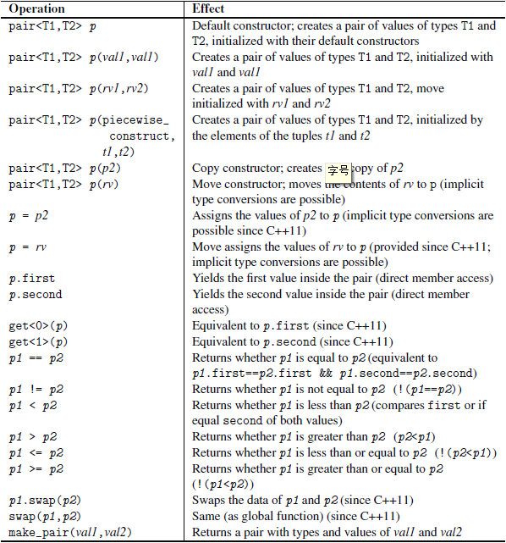
make_pair()：定义pair的便捷函数
std::make_pair(42,7.77)
相当于
std::pair<int,float>(42,7.77)
5.1.2 Tuples
<tuple>
namespace std {
template <typename... Types>
class tuple;
}
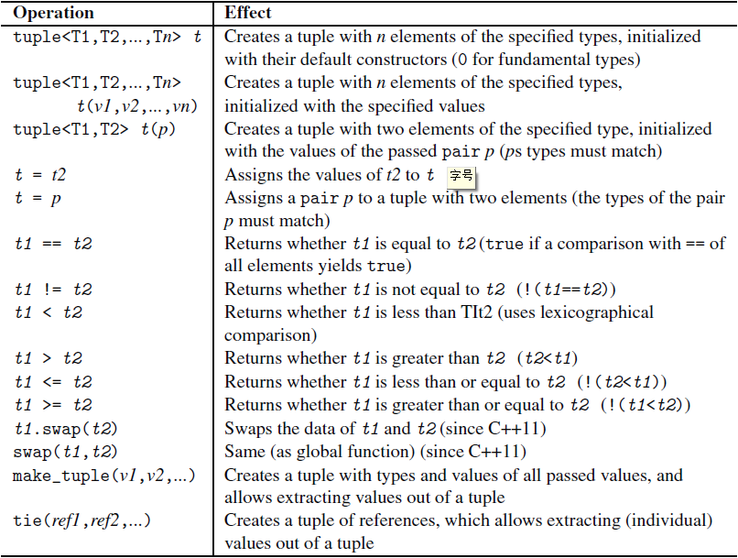
make_tupe()的使用和make_pair()一样。
std::tuple <int,float,std::string> t(77,1.1,"more light");
int i;
float f;
std::string s;
// assign values of t to i, f, and s:
std::make_tuple(std::ref(i),std::ref(f),std::ref(s)) = t;
//上面这个用法，应该使用下面的tie()函数
std::tie(i,f,s) = t;

Additional Tuple Features
• tuple_size<tupletype>::value yields the number of elements.
• tuple_element<idx,tupletype>::type yields the type of the element with index idx (this
is the type get() returns).
• tuple_cat() concatenates multiple tuples into one tuple.
5.2 Smart Pointers
1. Class shared_ptr for a pointer that implements the concept of shared ownership. Multiple
smart pointers can refer to the same object so that the object and its associated resources get released
whenever the last reference to it gets destroyed. To perform this task in more complicated
scenarios, helper classes, such as weak_ptr, bad_weak_ptr, and enable_shared_from_this,
are provided.
2. Class unique_ptr for a pointer that implements the concept of exclusive ownership or strict
ownership. This pointer ensures that only one smart pointer can refer to this object at a time.
However, you can transfer ownership. This pointer is especially useful for avoiding resource
leaks, such as missing calls of delete after or while an object gets created with new and an
exception occurred.
5.2.1 Class shared_ptr
可以有多个smart pointer指向同一个对象。当最后一个smart pointer被释放的时候，对象极其资源才被自动释放。

Using Class shared_ptr
<memory>
shared_ptr<string> pNico(new string("nico"));
shared_ptr<string> pNico{new string("nico")};
shared_ptr<string> pNico = make_shared<string>("nico");
不允许赋值(assign)初始化
shared_ptr<string> pNico4;
pNico4 = new string("nico"); // ERROR: no assignment for ordinary pointers
pNico4.reset(new string("nico")); // OK

然后就可以使用->和*了

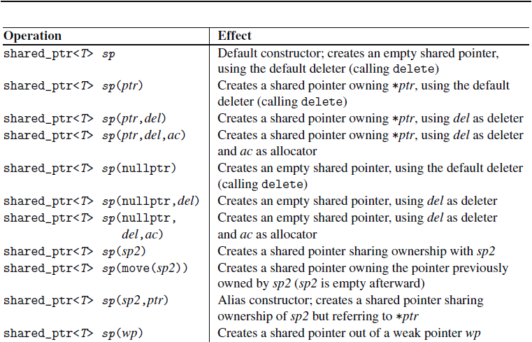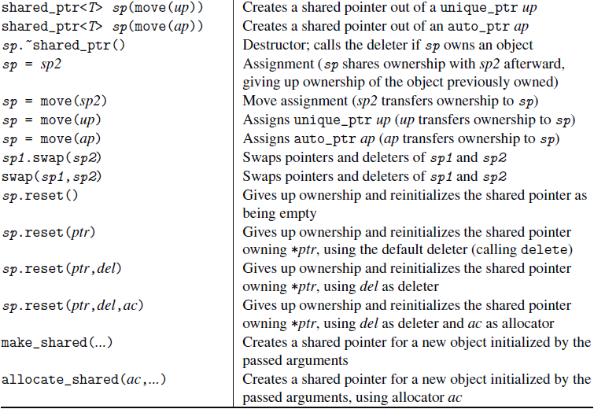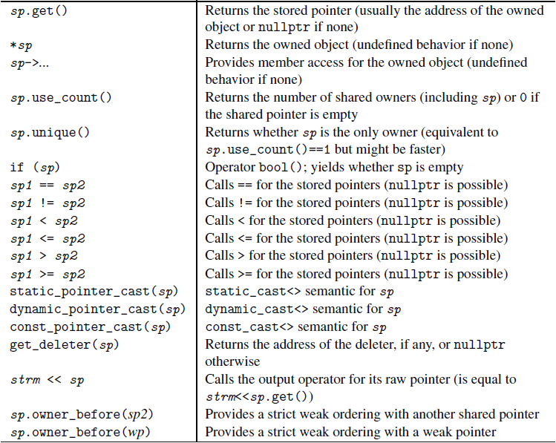

5.2.2 Class weak_ptr
shared_ptr的两个问题：
- 有两个对象分别通过shared_ptr彼此引用，然后你想释放这两个对象，但是无法释放。
- shared_ptr指向不属于自己的对象，shared_ptr的生命周期比对象长，会产生use after release错误。

weak_ptr用于指向不属于自己的对象。当对象被释放，weak_ptr自动指向null

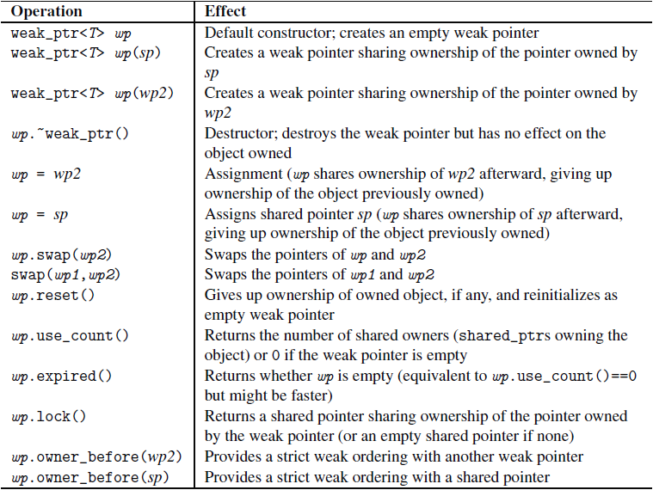

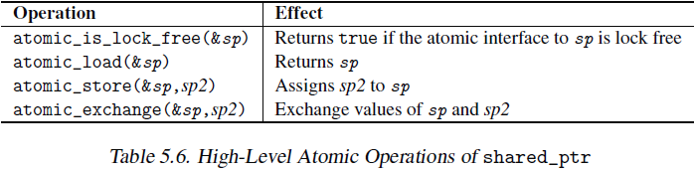
5.2.5 Class unique_ptr
初始化unique_ptr
std::unique_ptr<std::string> up(new std::string("nico"));

std::unique_ptr<int> up = new int; // ERROR
std::unique_ptr<int> up(new int); // OK

拥有权(ownership)的转移
std::string* sp = new std::string("hello");
std::unique_ptr<std::string> up1(sp);
std::unique_ptr<std::string> up2(sp); // ERROR: up1 and up2 own same data

// initialize a unique_ptr with a new object
std::unique_ptr<ClassA> up1(new ClassA);
// copy the unique_ptr
std::unique_ptr<ClassA> up2(up1); // ERROR: not possible
// transfer ownership of the unique_ptr
std::unique_ptr<ClassA> up3(std::move(up1)); // OK

// initialize a unique_ptr with a new object
std::unique_ptr<ClassA> up1(new ClassA);
std::unique_ptr<ClassA> up2; // create another unique_ptr
up2 = up1; // ERROR: not possible
up2 = std::move(up1); // assign the unique_ptr
// - transfers ownership from up1 to up2

// initialize a unique_ptr with a new object
std::unique_ptr<ClassA> up1(new ClassA);
// initialize another unique_ptr with a new object
std::unique_ptr<ClassA> up2(new ClassA);
up2 = std::move(up1); // move assign the unique_ptr
// - delete object owned by up2
// - transfer ownership from up1 to up2

std::unique_ptr<ClassA> ptr; // create a unique_ptr
ptr = new ClassA; // ERROR
ptr = std::unique_ptr<ClassA>(new ClassA); // OK, delete old object
// and own new

赋值nullptr也可
up = nullptr; // deletes the associated object, if any

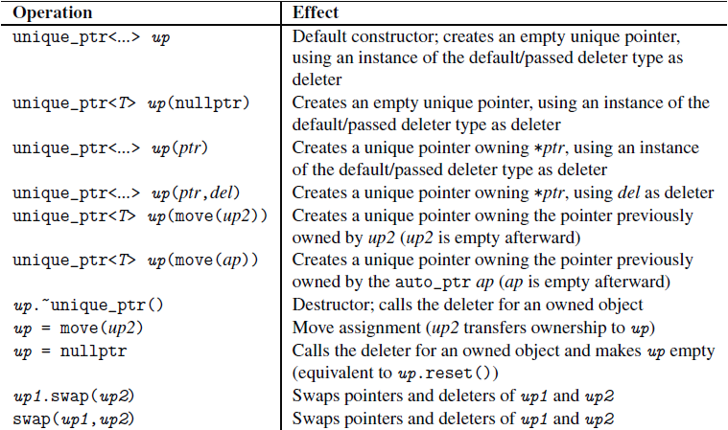
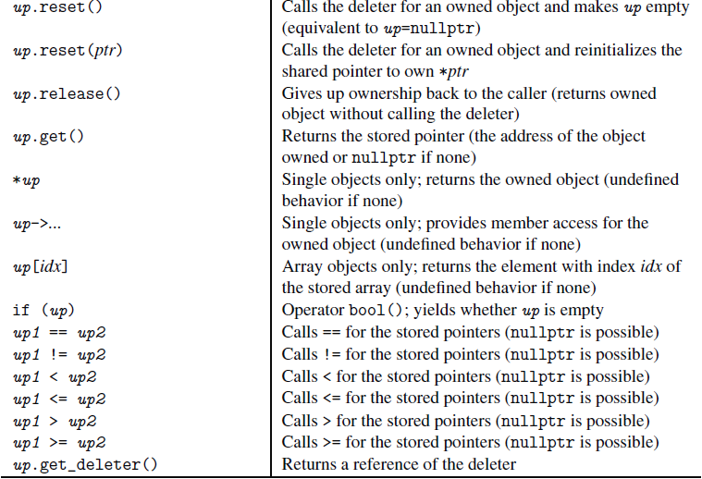
5.2.7 Class auto_ptr
5.2.8 Final Words on Smart Pointers
As we have seen, C++11 provides two concepts of a smart pointer:
1. shared_ptr for shared ownership
2. unique_ptr for exclusive ownership
The latter replaces the old auto_ptr of C++98, which is deprecated now.
5.3 Numeric Limits
整数极值定义于<climits> and <limits.h>，浮点数极值定义于<cfloat> and <float.h>。
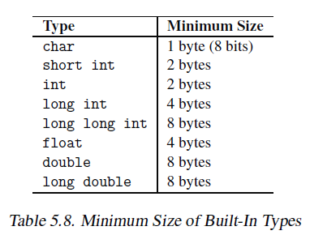

Class numeric_limits<>

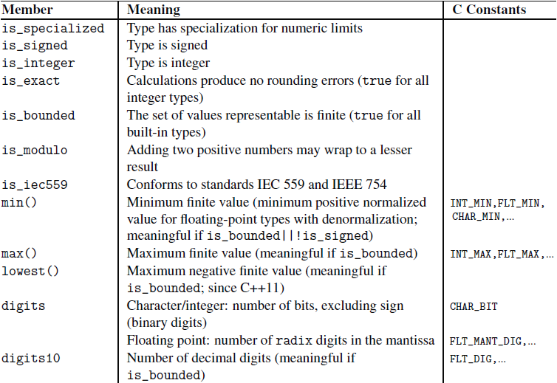
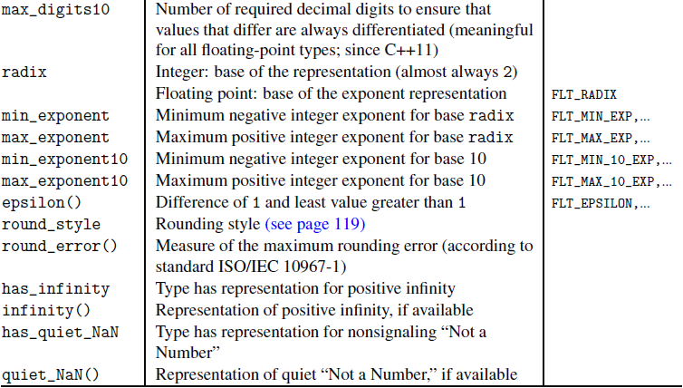
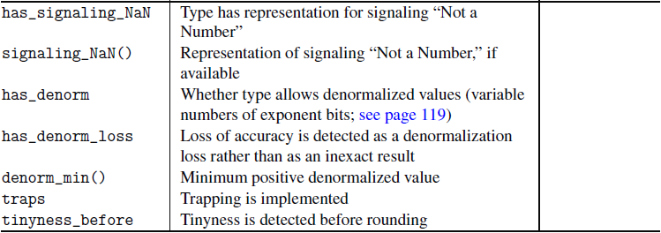

a possible full specialization of the numeric limits for type float
namespace std {
template<> class numeric_limits<float> {
public:
// yes, a specialization for numeric limits of float does exist
static constexpr bool is_specialized = true;
inline constexpr float min() noexcept {
return 1.17549435E-38F;
}
inline constexpr float max() noexcept {
return 3.40282347E+38F;
}
inline constexpr float lowest() noexcept {
return -3.40282347E+38F;
}
static constexpr int digits = 24;
static constexpr int digits10 = 6;
static constexpr int max_digits10 = 9;
static constexpr bool is_signed = true;
static constexpr bool is_integer = false;
static constexpr bool is_exact = false;
static constexpr bool is_bounded = true;
static constexpr bool is_modulo = false;
static constexpr bool is_iec559 = true;
static constexpr int radix = 2;
inline constexpr float epsilon() noexcept {
return 1.19209290E-07F;
}
static constexpr float_round_style round_style = round_to_nearest;
inline constexpr float round_error() noexcept {
return 0.5F;
}
static constexpr int min_exponent = -125;
static constexpr int max_exponent = +128;
static constexpr int min_exponent10 = -37;
static constexpr int max_exponent10 = +38;
static constexpr bool has_infinity = true;
inline constexpr float infinity() noexcept { return ...; }
static constexpr bool has_quiet_NaN = true;
inline constexpr float quiet_NaN() noexcept { return ...; }
static constexpr bool has_signaling_NaN = true;
inline constexpr float signaling_NaN() noexcept { return ...; }
static constexpr float_denorm_style has_denorm = denorm_absent;
static constexpr bool has_denorm_loss = false;
inline constexpr float denorm_min() noexcept { return min(); }
static constexpr bool traps = true;
static constexpr bool tinyness_before = true;
};
}

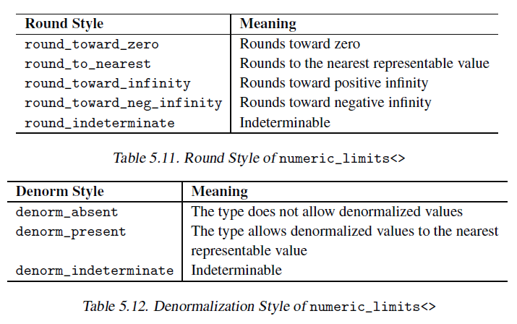
round：舍入
5.4 Type Traits and Type Utilities
5.4.1 Purpose of Type Traits
<type_traits>
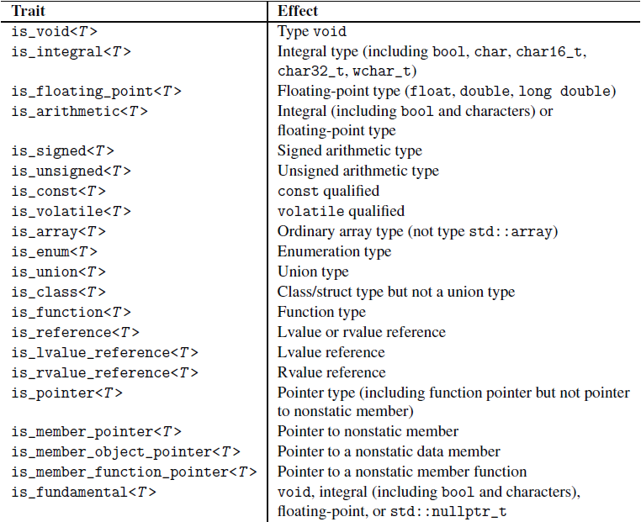
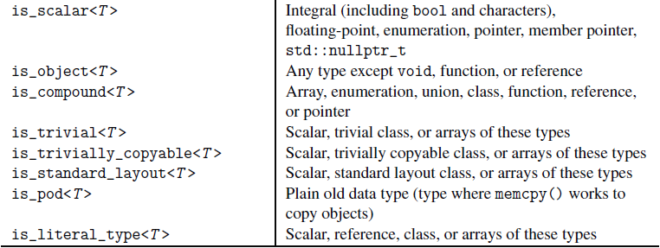
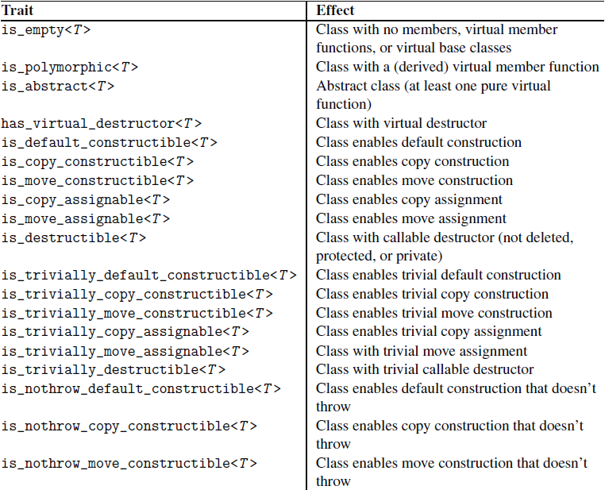
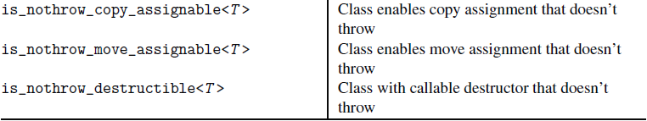
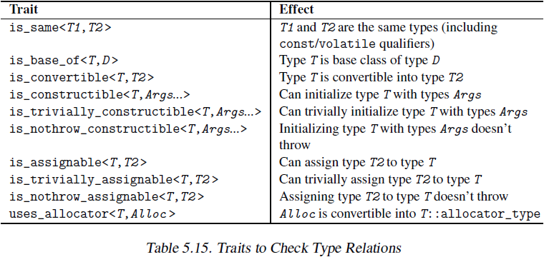
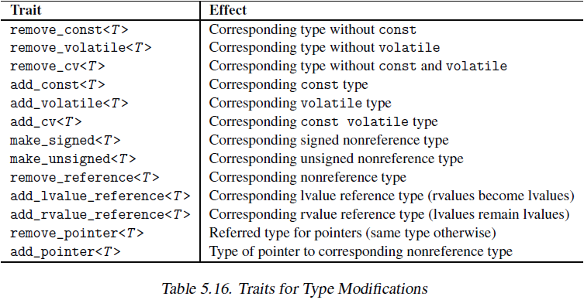
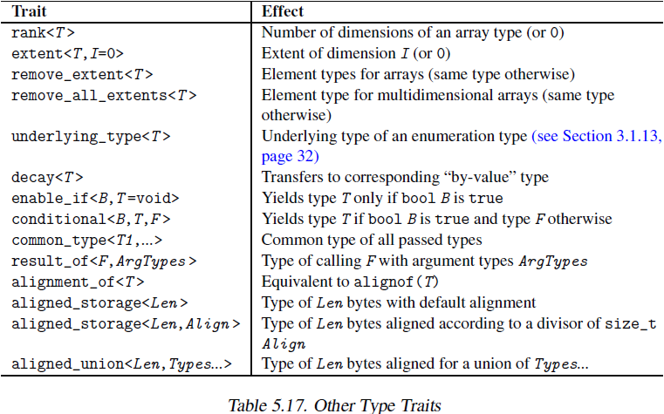
5.4.3 Reference Wrappers
<functional>
5.5 Auxiliary Functions
process minimum and maximum, swap values, or provide supplementary comparison operators.

5.5.1 Processing the Minimum and Maximum
<algorithm>
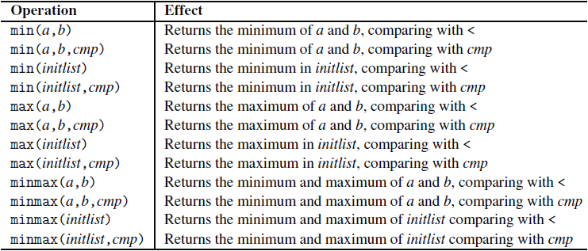

5.5.2 Swapping Two Values
<utility>

5.5.3 Supplementary Comparison Operators
<utility>
namespace std {
namespace rel_ops {
template <typename T>
inline bool operator!= (const T& x, const T& y) {
return !(x == y);
}
template <typename T>
inline bool operator> (const T& x, const T& y) {
return y < x;
}
template <typename T>
inline bool operator<= (const T& x, const T& y) {
return !(y < x);
}
template <typename T>
inline bool operator>= (const T& x, const T& y) {
return !(x < y);
}
}
}
5.6 Compile-Time Fractional Arithmetic with
Class ratio<>
<ratio>
namespace std {
template <intmax_t N, intmax_t D = 1>
class ratio {
public:
typedef ratio<num,den> type;
static constexpr intmax_t num;
static constexpr intmax_t den;
};
}

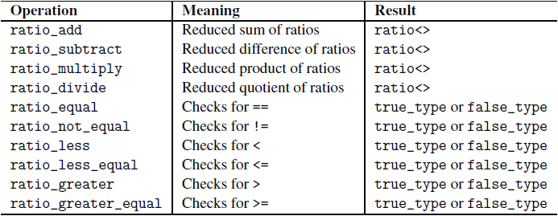
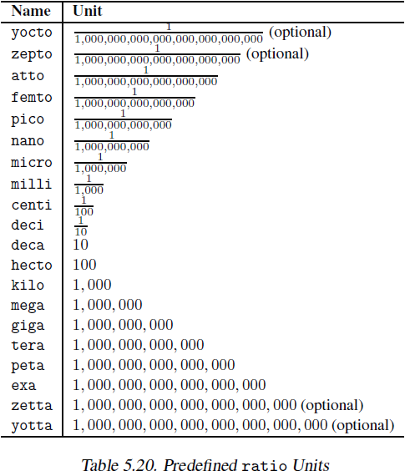
5.7 Clocks and Timers
5.8 Header Files <cstddef>, <cstdlib>, and <cstring>

5.8.1 Definitions in <cstddef>
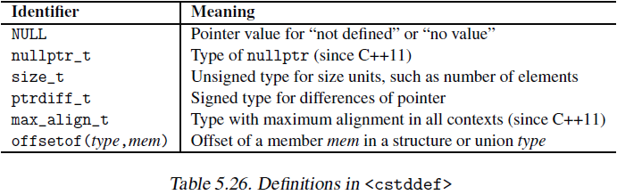

5.8.2 Definitions in <cstdlib>
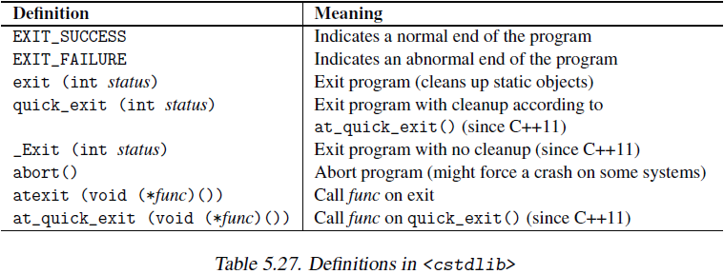

5.8.3 Definitions in <cstring>
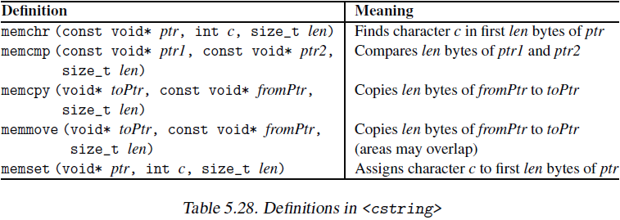
6.1 STL Components
Containers + Iterators + Algorithms
6.2 Containers
1. Sequence containers(序列容器)：array, vector, deque, list, and forward_list
2. Associative containers(关联式容器)：set, multiset, map, and multimap
3. Unordered (associative) containers(无序的关联式容器)：unordered_set, unordered_multiset, unordered_map, and unordered_multimap

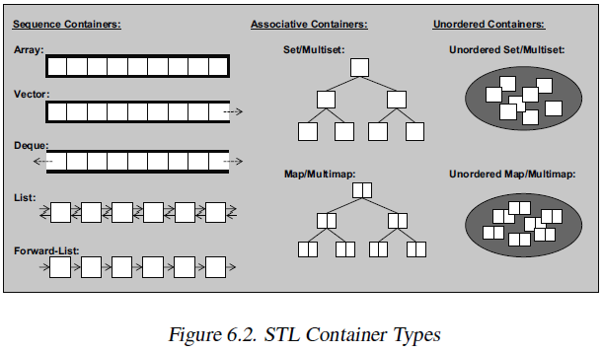

7.1.2 Container Operations
所有容器的公共操作：
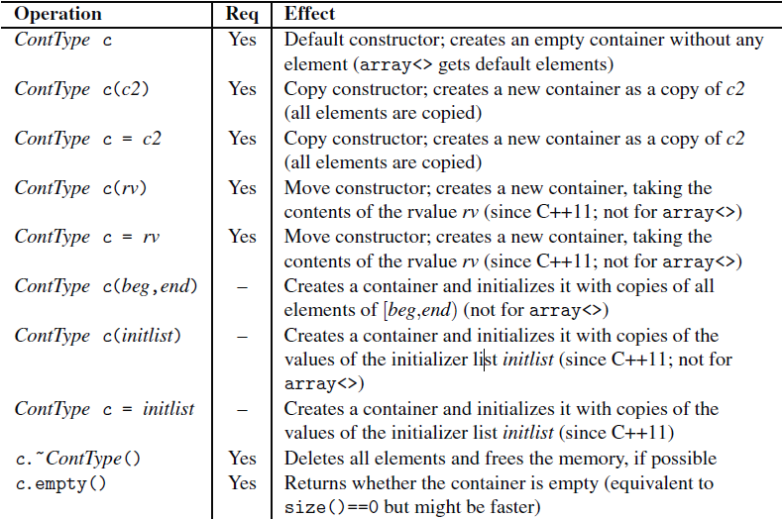
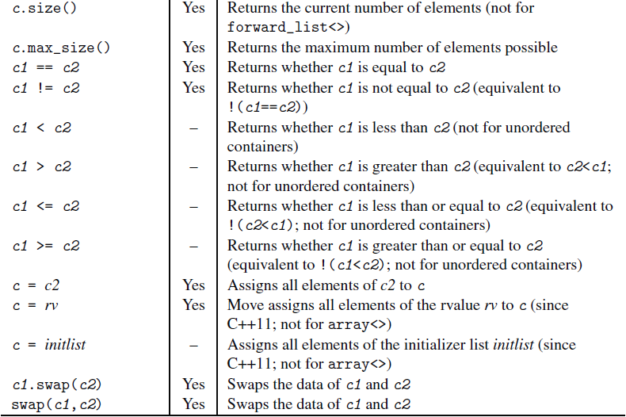
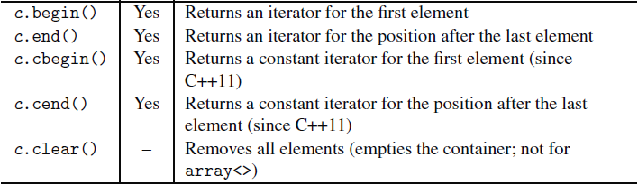
7.2 Arrays
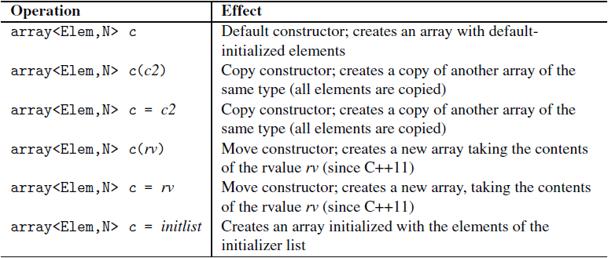
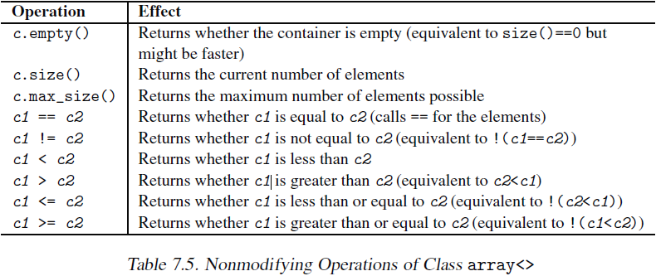
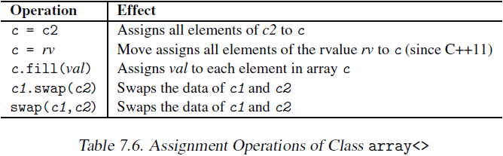
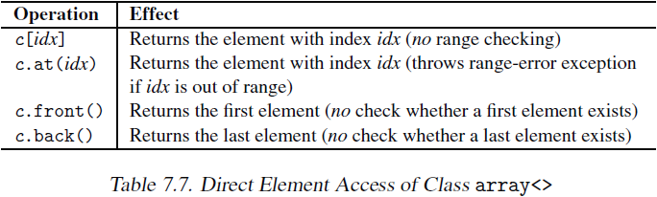
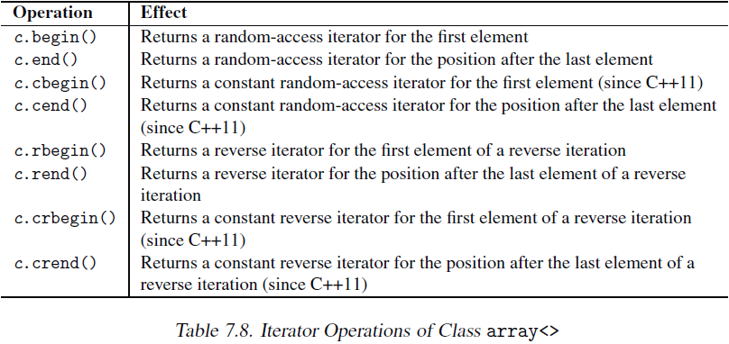
7.3 Vectors
<vector>
11.2.2 string类操作函数
构造函数
析构函数
=, assign()
swap()
+=, append(), push_back()
insert
erase
clear
resize
replace
+
==, !=, <, <=, >, >=, compare()
size(), length
max_size
empty
capacity
reserve()
[], at()
>>, getline
<<
size_t copy(char* cstr, size_t len, size_t pos = 0) | 复制cstr的子串给s，返回真正复制的长度
const char* c_str() | 返回const char*
data() | 同上
substr()
搜寻函数(find)
begin(), end()
rbegin(), rend()
get_allocator()
构造函数和析构函数
string s | 生成空串
string s(s2) | 生成s2的副本
string s(s2, stridx) | 从s2字串值的索引stridx开始创建s
string s(s2, stridx, strlen) | 从s2字串值的索引sreidx起长度为strlen创建s
string s(cstr) | 以C字串创建s
string s(cstr, cstrlen) | 以C字串的前cstrlen个字符创建s
string s(num, c) | 以num个字符c创建s
string s(beg, end) | 以string迭代器的区间内字符创建s
s.~string() | 销毁s，释放内存
在string类的字符串，'\0'不表示结尾，和其它字符地位相同。

