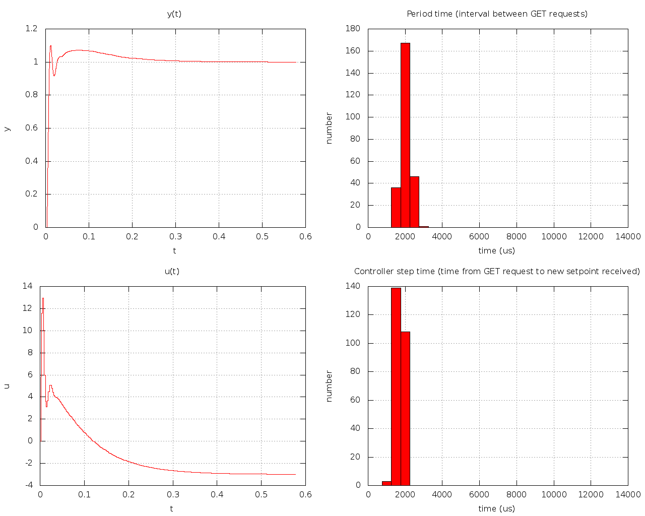
Plot from part1

Using the ping command we had some idea on how long it would take for a message to get from one node to the other, so our period should at least be longer than that, but not very much longer. The lower period the more presise the controller will be. With that as a starting point for what the period should be, we still had to try a couple of values around that number to find a period we were happy with.

Plot from part2

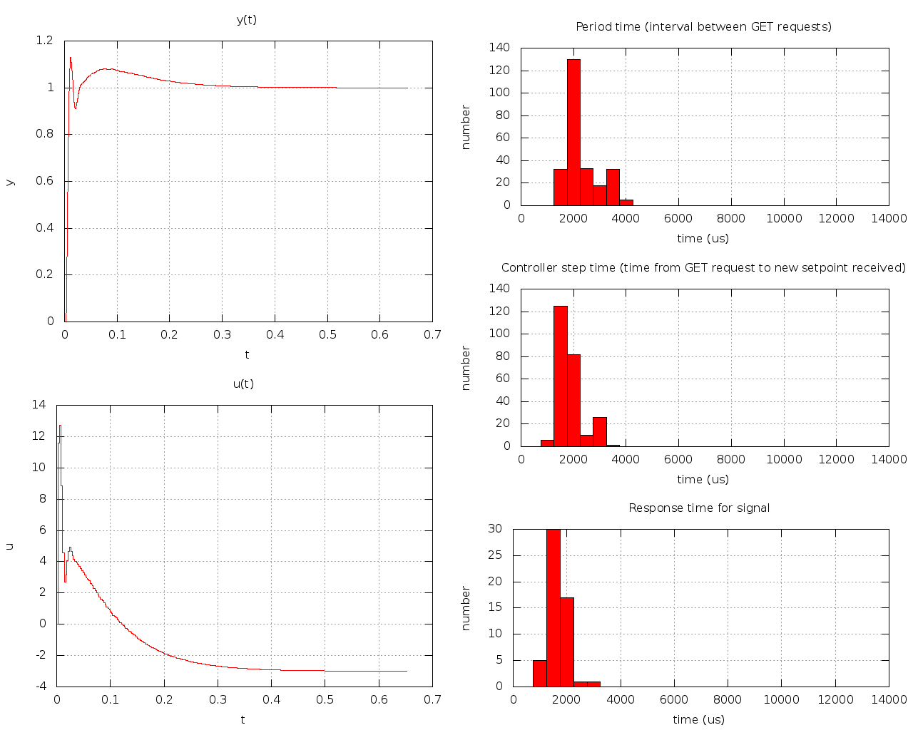
We get more variation on the period between some of the get messages. The same can be said for the graph over time from get to new setpoint. This is not suprising as we now have to do more on the target.

