**Assignment on Institute Information Management System**

**Problem Statement -**

A higher education institute is in a need of an information management system. The organization wants to keep track of their business and the progress of each student. The organization is currently managing all this information on papers. There are multiple experts working on managing students, courses, teachers, classrooms scheduling, and exam scheduling. In addition, they want to keep track of marks for each student for assignments, exams (mid semester, end-semester) and projects. A group of students need to submit a project proposal and work on the project once the proposal is accepted and submit the final project for the evaluation. Each project has an evaluation (pass, fail, exceptional). Each course is assigned a several graders(IA)and a teaching assistance (TA). Each of them has their office hoursalong with the office locationstored in the system so that students can search for them to contact them. Students can register for many courses and one course is taught by only one instructor. There are no sections defined yet so that one course has only one section.

**1. Design the above system using Entity-Relationship model.**

A - Following is the E-R Diagram representation of the Institute Information Management System as per the above mentioned problem statement -

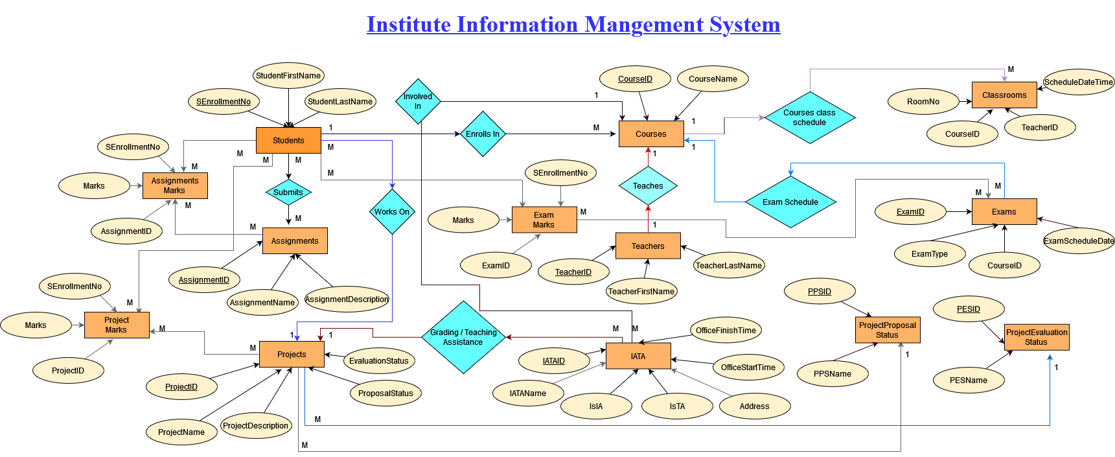

-- Entities are highlighted in rectangles filled with light orange color

-- Attributes are highlighted in ellipses filled with light yellow color

-- Relations are highlighted in rhombus filled with light blue color

-- PrimaryKey relations are highlighted in solid underline

-- Relationships like 1-to-1 , 1-to-Many , Many-to-1 , Many-to-Many are highlighted in text format of 1 and M.

-- IATA entity contains the data of Graders (IA) and Teaching Assistants (TA).

**2. Convert the E-R model into relations**

a. Each of the entity must have its own relations and relationships may or may not have a dedicated relation.

b. You must clearly define the primary keys and foreign keys of each relation.

A - Following are the relations which have been highlighted in the above E-R diagram

Students (SEnrollmentNo , StudentFirstName , StudentLastName)

Assignments (AssignmentID , AssignmentName , AssignmentDescription)

StudentsAssignments (SEnrollmentNo , AssignmentID)

AssignmentMarks (SEnrollmentNo , AssignmentID , Marks )

ProjectProposalStatus (PPSID , PPSName)

ProjectEvaluationStatus (PESID , PESName) -- PESName can take 3 values - pass , fail , exceptional

Projects (ProjectID , ProjectName , ProjectDescription , ProposalStatus , EvaluationStatus)

Projects.EvaluationStatus = ProjectEvaluationStatus.PESID ,

Projects.ProposalStatus = ProjectProposalStatus.PPSID

StudentsProjects (SEnrollmentNo , ProjectID)

ProjectMarks (SEnrollmentNo , ProjectID , Marks)

Courses (CourseID , CourseName)

StudentsCourses (SEnrollementNo , CourseID)

Teachers (TeacherID , TeacherFirstName , TeacherLastName)

TeacherCourses (TeacherID , CourseID)

Classrooms (RoomNo , CourseID , TeacherID , ScheduleDateTime)

Exams (ExamID , ExamType , CourseID , ExamScheduleDate)

ExamType attribute can take 2 values = Mid-Semester , End-Semester

ExamMarks (SEnrollmentNo , ExamID , Marks)

IATA (IATAID , IATAName , IsIA , IsTA , Address , OfficeStartTime , OfficeFinishTime)

CoursesIATA ( CourseID , IATAID )

ProjectsIATA ( ProjectID , IATAID )

**3. Normalize the resulting relational schema resulted in section.**

Following normal forms are already performed on the relational schema resulted in earlier section -

1NF -

1. Each table cell should contain a single value.

2. Each record needs to be unique.

2NF -

1. Be in 1NF.

2. Every non-key attribute is fully dependent on primary key.

3NF -

1. Be in 2NF.

2. Has no transitive functional dependencies.

**4. You must state the assumptions that you made during the design process.**

1. Considered that IA and TA are working on weekdays only so did not consider the working days and calendar concept while designing the E-R diagram.

2. Considered Teachers , IA , TA as 3 different entities.

3. As each course has 1 section so did not consider the section part while designing the E-R diagram.

4. Not highlighted the foreign key relationships in the above E-R diagram to avoid confusion.

5. ForeignKey relationships have been highlighted in the relations part with the dotted underline.

6. PrimaryKey relationships have been highlighted in the E-R diagram with the solid underline.

7. IATA entity contains the data of Graders (IA) and Teaching Assistants (TA).

8. Considered instructor as a teacher from the Teachers entity.

9. Considered that IATA are also providing the grading/teaching assistance on the projects as well to the students.

10. Single entities are defined with the plural form of the object ending with s.

11. Kept only few relevant attributes ( which are related to other entities ) in every entity to make the diagram representation simple and easily understandable.