Data Flow Diagram Report
E-Commerce Web Application

Software Engineering Lab | Version 1.0

Group Members
Iftekhar Sourav — 23524202107
Musfiqur Rahman Sama — 23524202117
Towfiq Omar Rakin — 23524202131
Zarin Tasnim Rahman Tuly — 23524202139

1. Introduction
A Data Flow Diagram (DFD) is a graphical representation that shows how data moves through a system. It illustrates the processes that transform data, the data stores where information is held, the external entities that supply or receive data, and the data flows connecting all these elements.

This report presents the Level 0 (Context Diagram) and Level 1 DFDs for the E-Commerce Web Application, derived directly from the functional requirements (FR1–FR28) documented in the SRS v1.0. The Yourdon-DeMarco notation is used throughout, with circles representing processes.

2. External Entities
The following external entities interact with the E-Commerce Web Application system:

Entity | Type | Description
Guest / Registered User | Primary | Unauthenticated visitor or authenticated customer who browses products, manages a cart, and places orders.
Admin User | Primary | Privileged user who manages products and inventory via the admin panel.
Database | Secondary | Relational data store (SQLite/PostgreSQL) that persists all user, product, cart, and order records.

3. Data Stores
Four logical data stores hold the persistent state of the application:

Store | ID | Contents
User Store | D1 | id, username, email, hashed password
Product Store | D2 | id, name, description, price, stock quantity, image
Cart Store | D3 | Cart (user FK), CartItem (cart FK, product FK, quantity)
Order Store | D4 | Order (user FK, total, date, status), OrderItem (order FK, product FK, qty, price)

4. Level 0 DFD — Context Diagram

4.1 Description
The Context Diagram (Level 0 DFD) represents the entire E-Commerce Web Application as a single process bubble (0.0). It shows the high-level data flows between the system and its external entities: the Guest/Registered User, the Admin User, and the Database.

Key data flows at this level include:
- User → System: Registration Info, Login Credentials, Cart/Order Requests
- System → User: Product Info, Order Confirmation, Order History, Error Messages
- Admin → System: Product Management Data, Stock Update Info
- System → Admin: Inventory Status, System Reports, Action Confirmations
- System ↔ Database: Persist Data (write) and Retrieve Data (read) for all entities

4.2 Diagram
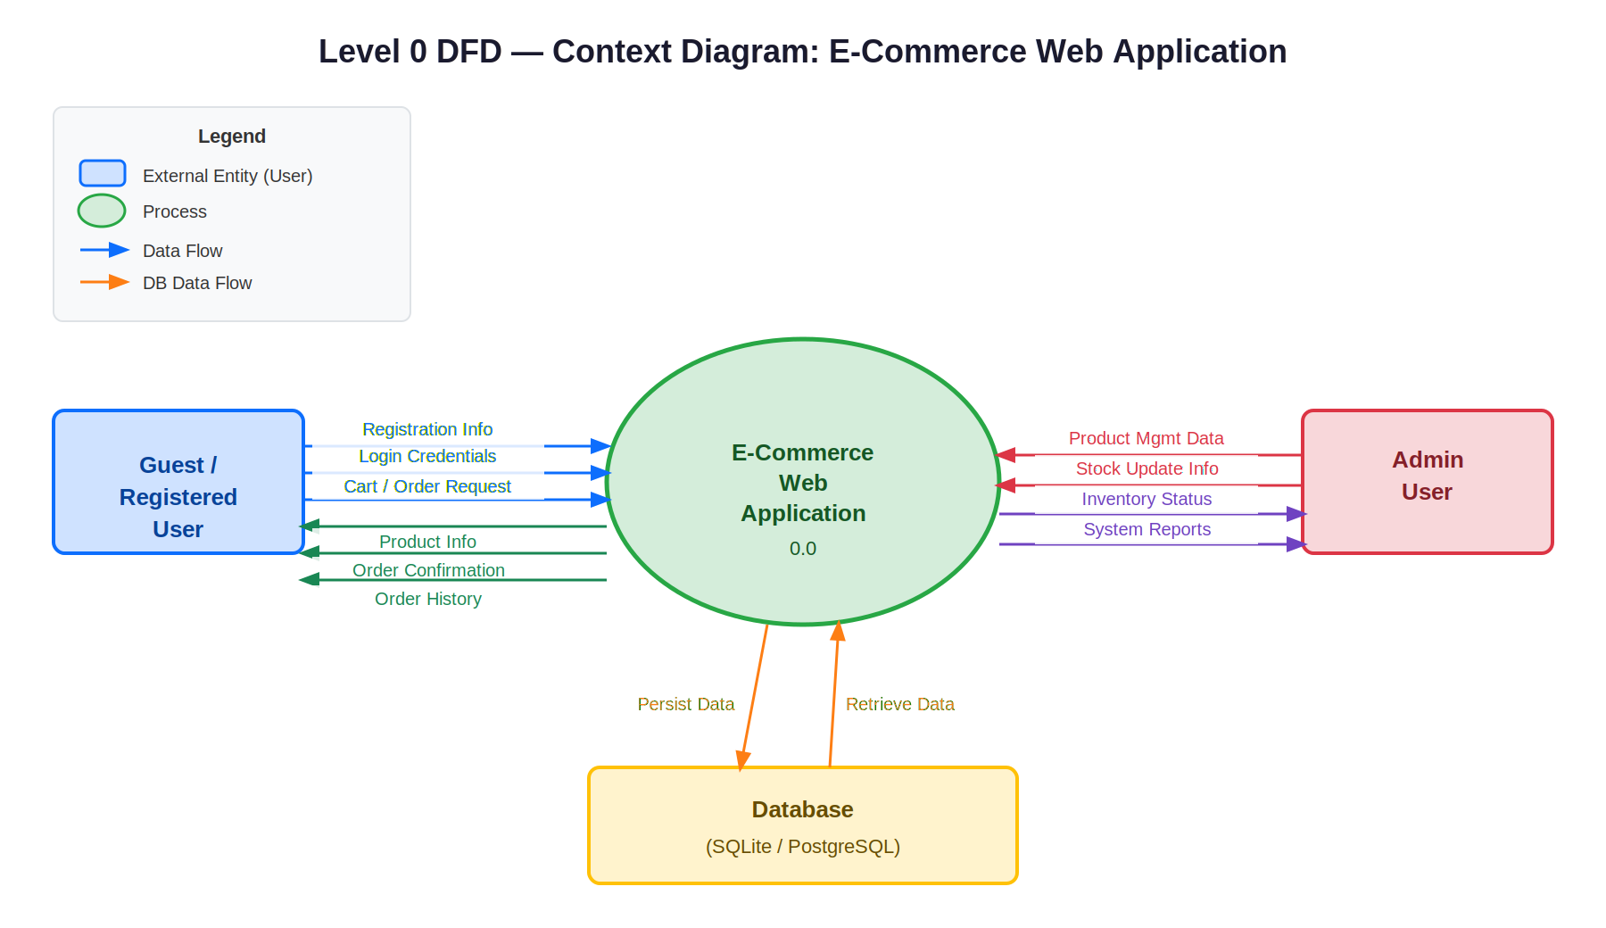
Figure 1: Level 0 DFD — Context Diagram for E-Commerce Web Application

5. Level 1 DFD — Process Decomposition

5.1 Description
The Level 1 DFD decomposes the central process (0.0) from the Context Diagram into five sub-processes, each corresponding to a functional module of the application. Each process reads from and writes to the appropriate data stores, and interacts with the relevant external entities.

5.2 Process Summary

Process ID | Process Name | Description | SRS References
1.0 | User Authentication | Handles registration, login, and logout. Validates credentials against the User Store and manages session state. | FR1–FR8
2.0 | Browse Products | Retrieves and displays the product listing and product detail pages from the Product Store. | FR13–FR16
3.0 | Cart Management | Allows logged-in users to add, remove, and update cart items. Reads/writes Cart and CartItem records. Calculates dynamic totals. | FR17–FR21
4.0 | Order Processing | Handles checkout (creates Order/OrderItem records, decrements stock), and retrieves order history with statuses. | FR22–FR28
5.0 | Admin Product Management | Allows admin users to create, edit, and delete products and update inventory. Reads/writes the Product Store. | FR9–FR12

5.3 Data Flow Summary

Data Flow | From | To | Data Description
Registration Info | User | P1.0 | Username, email, password
Login Credentials | User | P1.0 | Username and password
Auth Session / Error | P1.0 | User | Session token or error message
Store/Retrieve User | P1.0 | D1 ↔ P1.0 | User record read and written
Browse Request | User | P2.0 | Page/product browse request
Product Info | P2.0 | User | Product list and detail view data
Product List/Details | D2 | P2.0 | All product records
Cart Actions | User | P3.0 | Add/remove/update requests
Cart Summary/Total | P3.0 | User | Cart contents and computed total
Cart Data | D3 ↔ P3.0 | D3 ↔ P3.0 | CartItem reads and updates
Checkout Request | User | P4.0 | Order placement request
Order Confirmation | P4.0 | User | Order ID, items, total, status
Cart Items (Checkout) | P3.0 | P4.0 | Cart contents passed to checkout
Store/Read Order | P4.0 | D4 ↔ P4.0 | Order and OrderItem records
Decrement Stock | P4.0 | D2 | Stock quantity update after order
Product CRUD Data | Admin | P5.0 | New/updated/deleted product data
Action Confirmation | P5.0 | Admin | Success/failure message
Write/Read Product | P5.0 | D2 ↔ P5.0 | Product record CRUD operations

5.4 Diagram

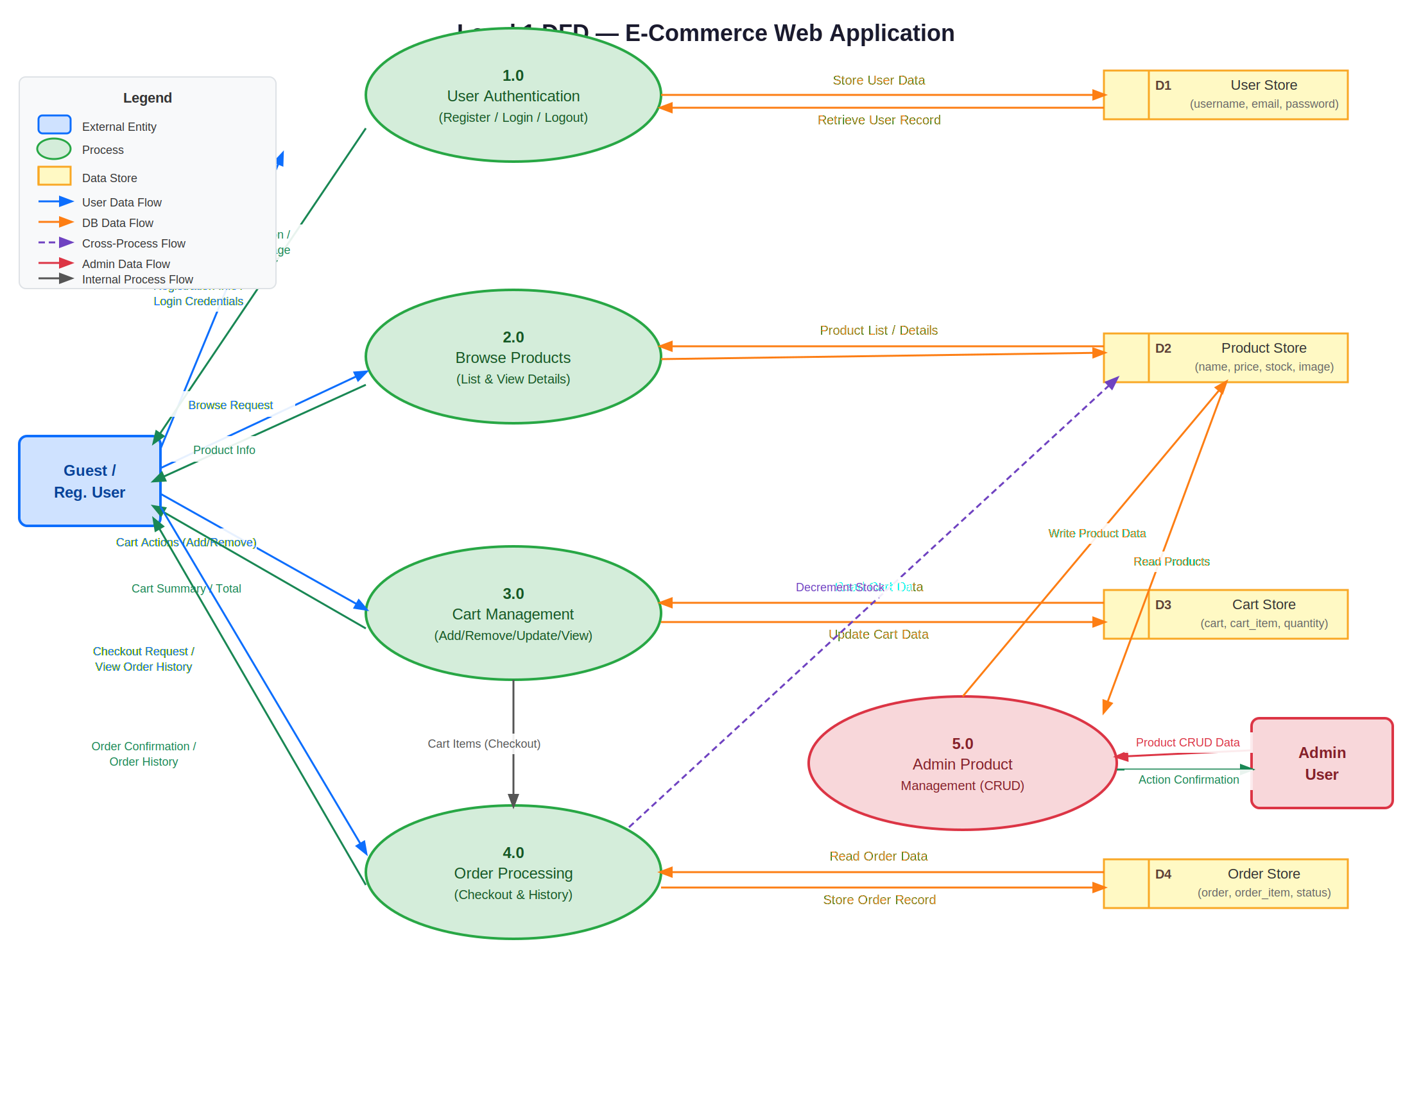
Figure 2: Level 1 DFD — Process Decomposition for E-Commerce Web Application

6. Summary
The two-level DFD provides a complete, layered view of how data flows through the E-Commerce Web Application:

- The Level 0 Context Diagram establishes system boundaries and shows all external interactions at a glance.
- The Level 1 Decomposition maps all 28 functional requirements (FR1–FR28) across five distinct, cohesive processes — each directly corresponding to a Django application module.
- The four data stores (D1–D4) reflect the six database entities defined in the SRS logical model (User, Product, Cart, CartItem, Order, OrderItem).
- Authentication is a cross-cutting concern: Processes 3.0, 4.0, and 5.0 all depend on an established session created by Process 1.0, consistent with the include relationships identified in the Use Case Diagram.

The DFDs confirm that the system design is modular, traceable to the SRS, and well-suited to the Django MVT architecture adopted by the team.

