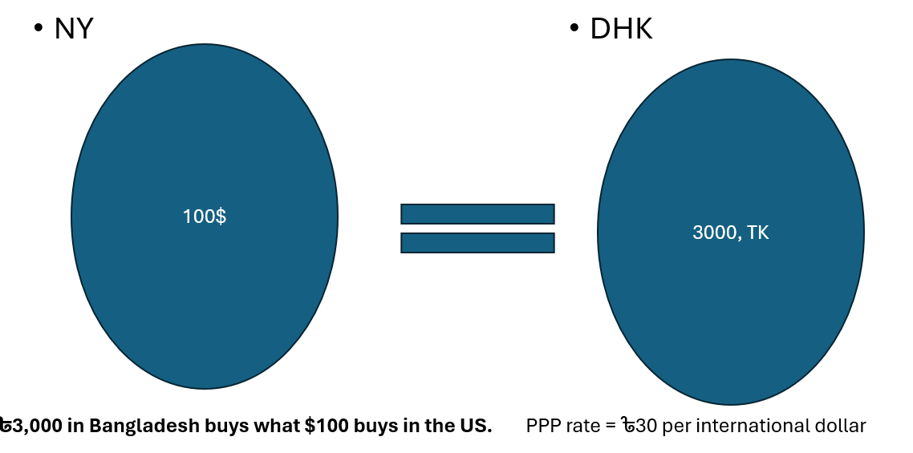

- If $100 ↔ ৳3,000, then $1 ↔ ? taka
- To get the cost per $1, we divide:
- ৳3,000 ÷ 100 = ৳30
- $1 (international dollar) has the same purchasing power as ৳30 in Bangladesh.
- That’s why we divide: we’re converting from a “100-dollar basket” to a “1-dollar basket.”
- PPP rate = (Bangladesh price of the basket) / (US price of the basket).
PPP is not “based on the currency market price.” It’s based on local prices of goods and services (what people pay in shops), and it’s used as a conversion factor.
wo different “markets” people mix up
- Market exchange rate (FX): how currencies trade (USD/BDT) in financial markets.
- PPP rate: how prices compare for the same basket of goods/services in each country.
So PPP is built from product/service prices, not FX markets.
PPP is just a conversion rate (like “taka per international dollar”).
GDP in PPP terms can be:
- Nominal (current price) PPP GDP
= Nominal GDP in local currency ÷ PPP rate
This is what “GDP in 2023” usually is (a level in a single year with no base-year stated).
- Real (constant price) PPP GDP
= Real GDP (constant prices) converted using PPPs (often “constant PPPs”)
This will usually mention a base year (e.g., 2017 prices) or “constant.”
✅ Rule to identify:
- If it says “GDP in 2023” with no base year → it’s nominal level, just expressed using PPP conversion.
- If it says “constant prices / base year / real” → it’s real.
- One clean sentence to remember
- PPP is a conversion rate built from price surveys that equalizes what money can buy, so GDP comparisons reflect real purchasing power instead of exchange rates.
Bangladesh example (how to read it)
- PPP GDP (1,547 bn) tells you:
“Bangladesh’s total production, valued at a common price level, is equivalent to 1,547 bn international dollars.”
- Exchange-rate GDP (422 bn) tells you:
“At market FX, Bangladesh’s output converted to USD is 422 bn.”
Yes. That “1 international dollar = 30 taka” is the bridge between Bangladesh’s GDP in taka and Bangladesh’s GDP in PPP dollars.
Step 1: Start from GDP in local currency (taka)
Bangladesh’s GDP is first measured in BDT (taka) inside Bangladesh (using local prices).
Call it:
GDP_BDT
(we don’t need the exact number to understand the mechanism)

Step 2: Convert GDP_BDT into PPP dollars using the PPP rate
If PPP rate = 30 taka per international dollar, then:
$$GDP(PPP \$)=\frac{GDP_BDT}{30}$$
Why divide?
Because “30 taka buys what 1 international dollar buys.”
So every block of 30 taka of GDP becomes 1 international dollar of GDP.

Step 3: Convert GDP_BDT into exchange-rate USD using the market FX rate
If the market exchange rate were (example):
110 taka per USD
then:
$$GDP(FX USD)=\frac{GDP_BDT}{110}$$

Step 4: Why PPP GDP is larger than FX GDP (Bangladesh case)
Because 30 is smaller than 110, dividing by 30 gives a bigger number than dividing by 110.
So:
- PPP conversion → bigger GDP in “international dollars”
- FX conversion → smaller GDP in USD
This matches your Databook box:
- PPP GDP ≈ 1,547 bn
- Exchange-rate GDP ≈ 422 bn

A very clear numerical demonstration (using your Databook numbers)
We can reverse-engineer the implied relationship:
$$\frac{GDP(PPP)}{GDP(FX)}≈\frac{1547}{422}$$
Now compute it:
- 422 × 3 = 1266
- 422 × 0.6 = 253.2 → total 1519.2
- remaining 1547 − 1519.2 = 27.8
- 27.8 / 422 ≈ 0.0659
So ratio ≈ 3.6659 (about 3.7×)
Meaning:
Bangladesh’s PPP GDP is about 3.7 times its exchange-rate USD GDP.
That implies:
$$\frac{FX rate}{PPP rate}≈3.7$$
So if PPP rate were 30 taka per int-$, FX would be about:
- 30 × 3.7 ≈ 111 taka per USD
That’s exactly the intuition: FX rate is much “higher” (more taka per dollar) than the PPP rate, because prices in Bangladesh are lower.

One sentence you can remember
PPP GDP is GDP in taka divided by the “basket” exchange rate; FX GDP is GDP in taka divided by the currency market exchange rate. Bangladesh’s PPP GDP is bigger because the basket rate (PPP) is much smaller than the FX rate.

Totally fair — PPP is confusing because people keep explaining it like math. Let’s do it with a story you already understand.
The simplest way to “feel” PPP
Imagine there is ONE identical “shopping basket”
It includes normal stuff:
- rice + chicken + vegetables
- a bus ride
- a haircut
- a doctor visit
- rent for a small room
- phone plan
Now we ask one question:
How much does this exact basket cost in each country?
Example (not exact, just to understand)
- In the US (New York): the basket costs $100
- In Bangladesh: the same basket costs ৳3,000
So we can say:
✅ ৳3,000 in Bangladesh buys what $100 buys in the US.
That means the “fair comparison exchange rate” for everyday buying is:
PPP rate = ৳30 per international dollar
(because ৳3,000 ÷ 100 = ৳30)
This is NOT the market FX rate. It’s a “basket exchange rate.”

Now apply it to GDP (this is the key leap)
GDP is basically the total value of everything produced.
If Bangladesh’s GDP is, say, ৳46,410,000,000,000 (example local currency number),
Convert using PPP (basket rate)
GDP(PPP) = GDP in taka ÷ (taka per international dollar)
So:
- divide by ৳30 (PPP rate) → you get a big international-$ value
Because things are cheap in Bangladesh, each international dollar represents a lot of local goods/services.
Convert using FX (market exchange rate)
If the market FX is, say, ৳110 per USD,
then GDP(FX USD) = GDP in taka ÷ 110 → much smaller.

This explains your Databook Bangladesh numbers
You saw:
- GDP in 2023: 1,547 (PPP-based)
- (exchange rate based): 422 (market FX USD)
Interpretation:
1,547 (PPP) means:
“If Bangladesh’s total production is priced using a common global price yardstick, it’s equivalent to $1.547 trillion worth of output.”
422 (exchange-rate based) means:
“If you convert Bangladesh’s GDP to USD using the market exchange rate, it’s $422 billion.”
Same Bangladesh. Same year.
Just two different “conversion rates”:
- PPP conversion (basket rate)
- FX conversion (market rate)

The one-line explanation you can keep
PPP is like converting money using “how much it buys” instead of “what the currency trades at.”

One more super-clear analogy (height vs weight)
- Exchange-rate USD is like comparing countries using currency markets (can be distorted)
- PPP is like comparing using real buying power (closer to daily reality)

If you answer just this one question, I can tailor the explanation perfectly:
When you say “Bangladesh GDP compared with Japan,” do you mean:
- “Who can buy more goods/services at home?” → PPP
- “Who has more USD to pay for imports/debt?” → exchange-rate USD
1) Nominal GDP (current prices)

Meaning: The value of all final goods and services produced in a year, measured at prices of that same year.

If you say “GDP in 2023” without any extra words, it usually means nominal GDP in local currency.

If you convert it to USD using the market exchange rate, it becomes nominal GDP in USD (exchange-rate based).

✅ Good for:

international payments capacity

debt/FX risk discussions

trade/investor perspective

⚠️ Weakness:

jumps when exchange rates move (even if the real economy didn’t change much)

2) Real GDP (constant prices)

Meaning: GDP adjusted for inflation, so it reflects changes in output/volume, not price changes.

“Real GDP growth” means: did the economy produce more stuff, after removing inflation?

✅ Good for:

growth analysis over time (2020→2023)

productivity analysis (output changes)

⚠️ Not directly about PPP; it’s about inflation adjustment over time.

3) PPP GDP (Purchasing Power Parity)

Meaning: GDP converted to “international dollars” using a rate that equalizes purchasing power, not market exchange rates.

A PPP conversion asks:

“How much would this country’s output be worth if priced at a common set of prices?”

So PPP is best when comparing economic size and living standards across countries.

✅ Good for:

comparing countries fairly

comparing “size” without exchange-rate distortions

per-capita comparisons (living standards proxy)

⚠️ Weakness:

not the dollars you can actually use internationally (not an FX amount)

depends on PPP estimates (from ICP), updated periodically

The clean way to remember
A) Nominal vs Real = time comparison

Nominal: current prices (includes inflation)

Real: constant prices (removes inflation)

B) Exchange-rate USD vs PPP = cross-country comparison

Exchange-rate USD: uses market FX, reflects international purchasing power in dollars

PPP: uses PPP rate, reflects domestic purchasing power and real size

They answer different questions.

Your Bangladesh example (why it matters)

In the Databook country profile you showed:

GDP in 2023 = 1,547 (this aligns with PPP GDP)

(exchange rate based) = 422 (this is nominal GDP converted at market FX)

So both are “USD”, but they represent different concepts.

Which one should your dashboard use?

If your Summary card is “Total GDP across economies” for comparing size → PPP is sensible

If your audience expects “USD you can spend internationally” → use exchange-rate based nominal USD

Best practice: show both (PPP + exchange-rate based) clearly labeled

If you want, tell me who the main audience is (SG/MOFA vs general public vs researchers), and I’ll recommend the safest dashboard wording and which indicator(s) to show.

