# Logical Schema

Settings Table (id, website title, website logo)

Queries Table (id, first name, last name, email, phone, description, timestamp)

Users Table (id, name, email, phone, password, role, image, timestamp)

Connections Table (id, status, plan, subscription id, subscription stated, subscription ends, price)

Subscriptions Table (id, plan, price, subscription ends, timestamp)

Dues Table (id, plan, price, name, subscription id, subscription stated, subscription ends, amount, status, timestamp)

Payments Table (id, status, method, plan, price, total price, name, email, billing address, bkash number, bkash transaction id, billing phone number, timestamp)

Complains Table (id, user id, name, email, description, timestamp)

# Tables

## Settings Table

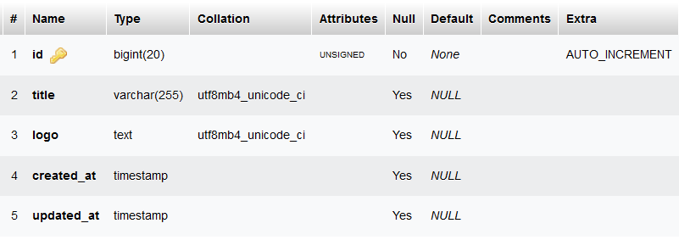

## Queries Table

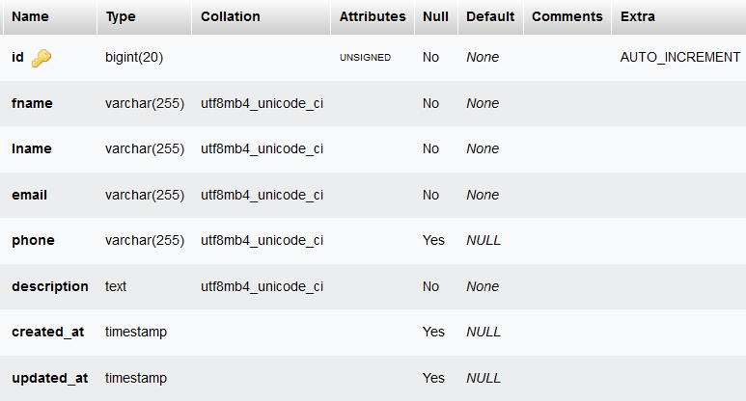

## Users Table

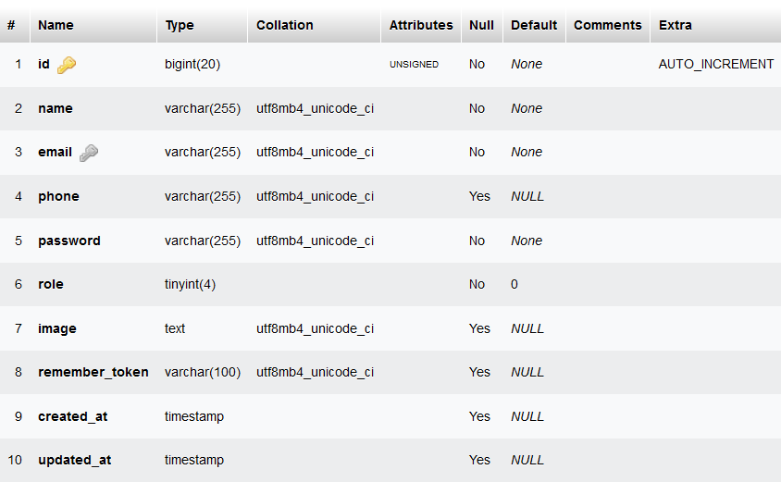

## Connections Table

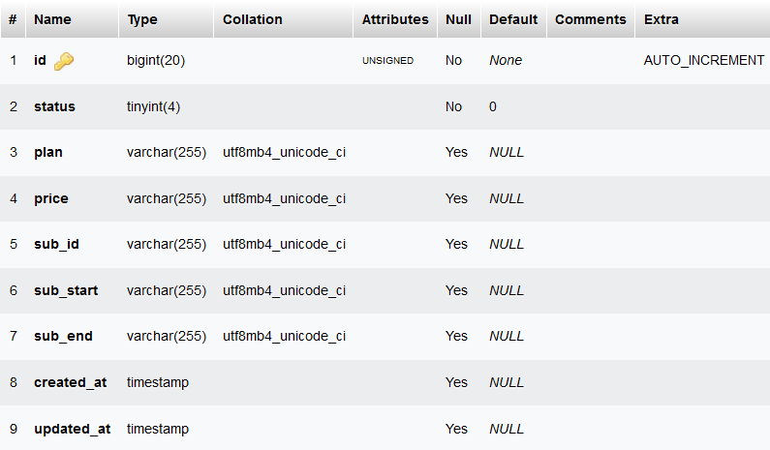

## Subscriptions Table

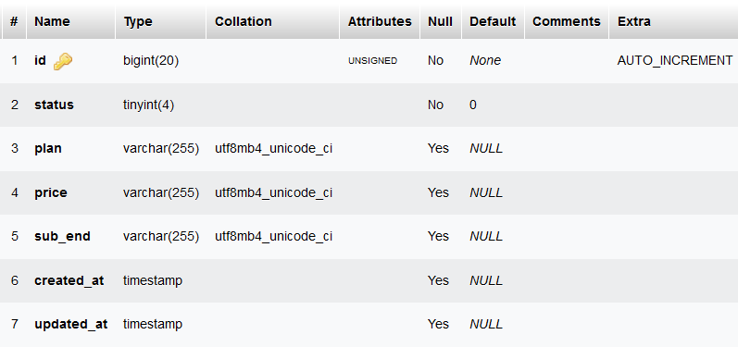

## Dues Table

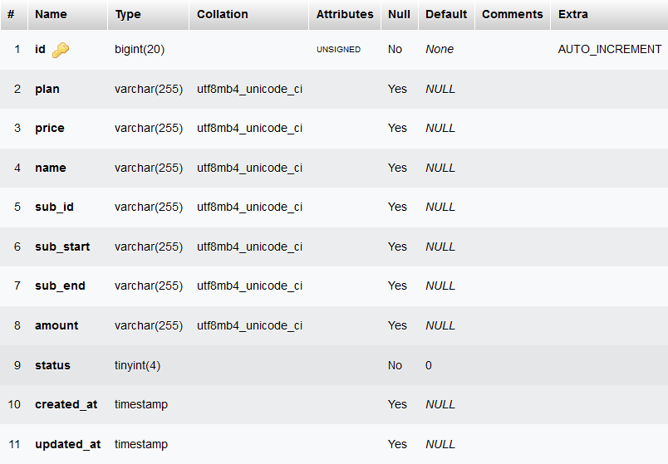

## Payments Table

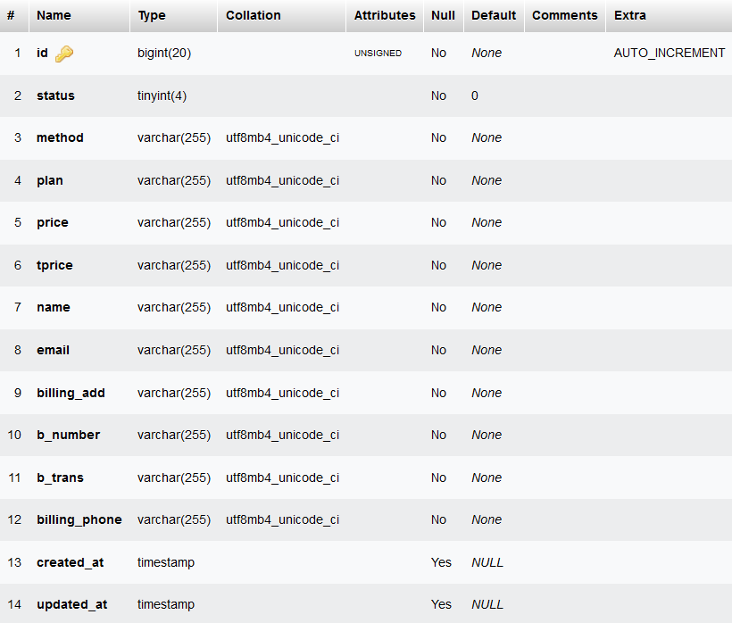

## Complains Table

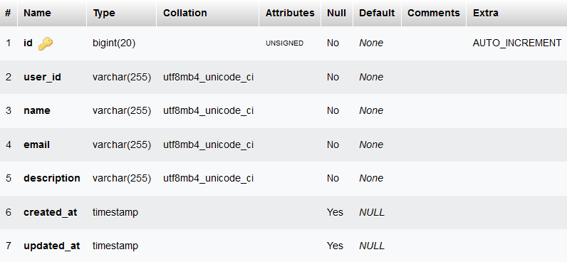

# Diagrams

## Use Case

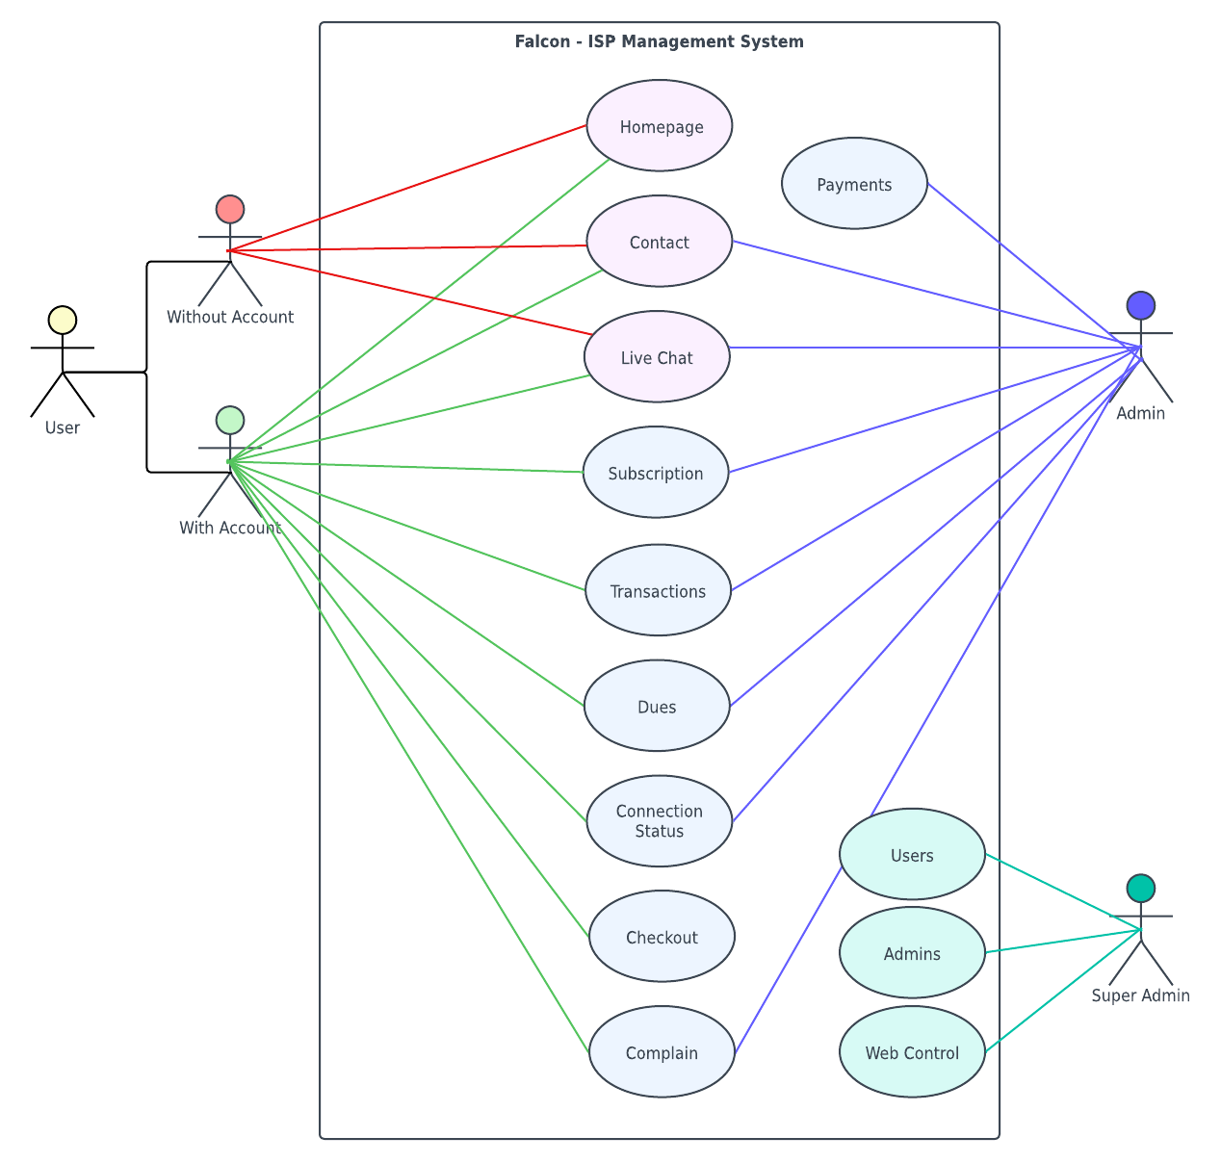

## DFD Level 0

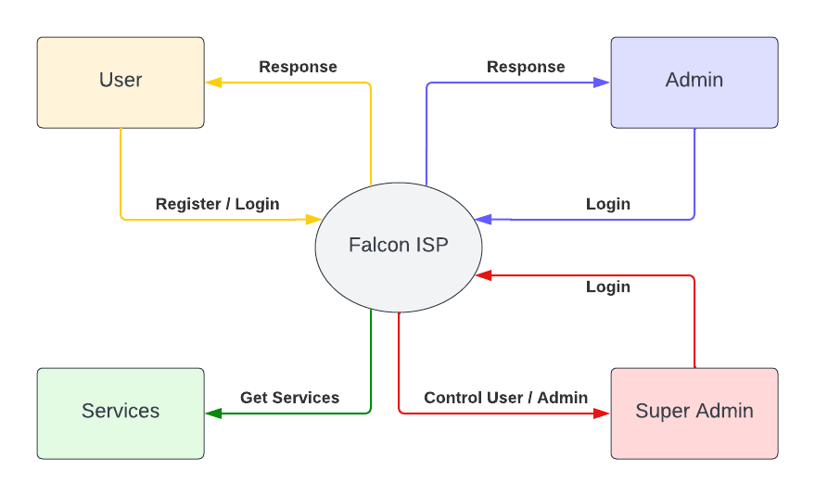

## DFD Level 1

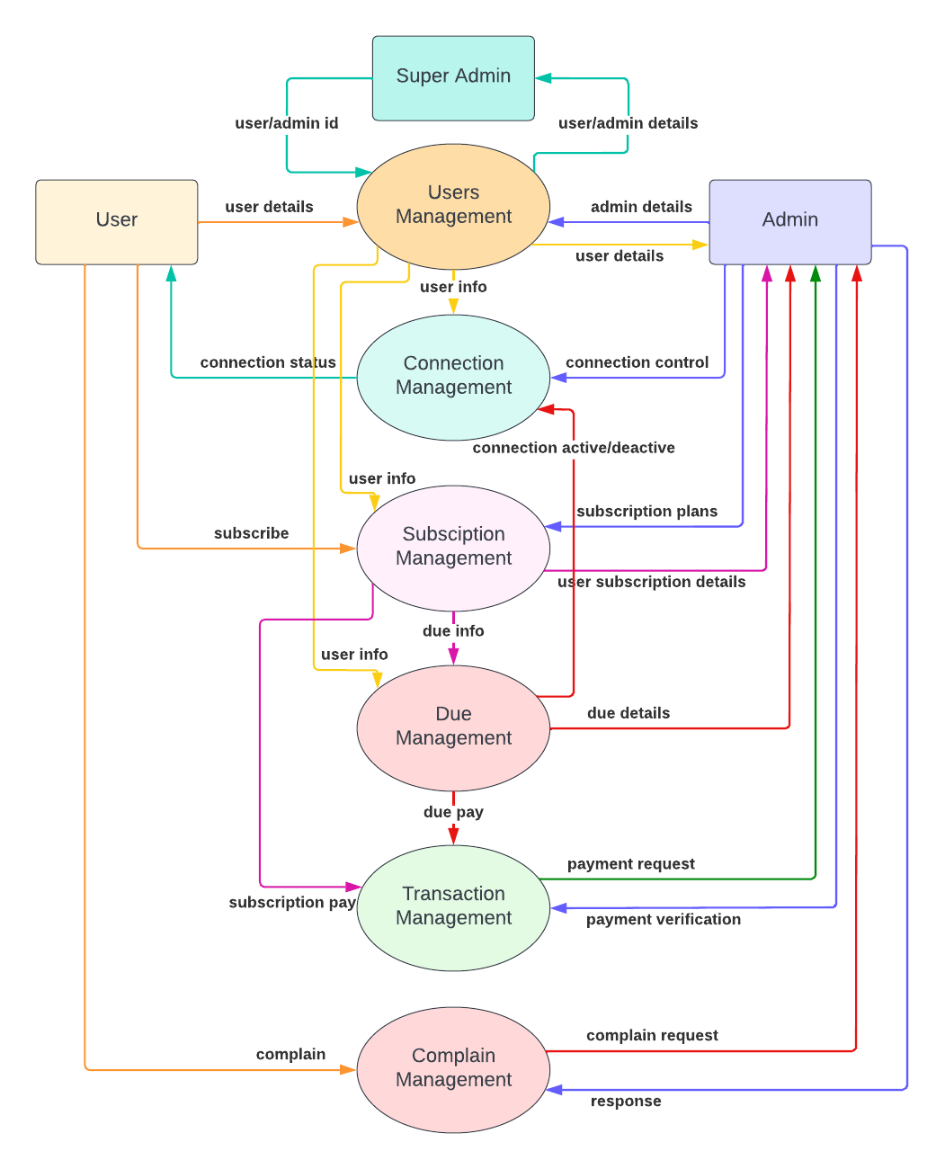

## DFD Level 2

