# CSE 441

## Lab 2 – Bui Hoang Huy – 203120001

### Question 1: Backend

I’m using Java - Springboot3 for backend because I’m more familiar with it than ASP.NET.  
**How to start my backend: (ensure install jdk 21, mysql)**

* Step 1: Create the database call “bookstore”, fix the **username and password of MySQL** in **src/main/resources/application.yaml**
* Step 2: Run the backend, then go to Swagger Link: “localhost:8080/bookstore/swagger-ui/index.html”
* Step 3: Get the token using “/auth/login”
* Step 4: Verify the apis under **“book-controller”.**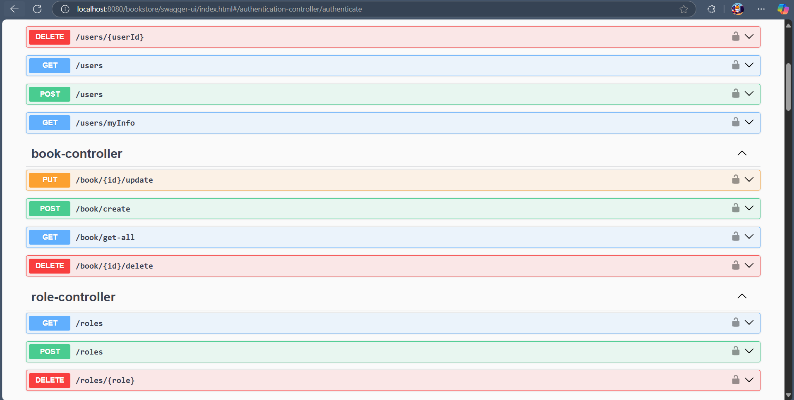

### Question 3: Tax Calculator UI

### Question 4: Calculator App

