# **CHAPTER FOUR**

1. **How often do you use web-based public services?**

|  |  |  |  |  |  |  |
| --- | --- | --- | --- | --- | --- | --- |
| Gender | How often do you use web-based public services? | | | | | Total |
| Daily | Weekly | Monthly | Rarely | Never |
| Male | 2 | 1 | 9 | 13 | - | 25 (50%) |
| Female | 1 | 2 | 7 | 15 | - | 25 (50%) |
| Total | 3(6%) | 3 (6%) | 16 (32%) | 28 (56%) | - | 100% |

*Table 4.1: Rate of using web based public services*

The survey indicates that among males, 8% use web-based public services daily, 4% weekly, 36% monthly, and 52% rarely, with none reporting "Never." Similarly, for females, 4% use these services daily, 8% weekly, 28% monthly, and 60% rarely, with no respondents indicating "Never."

Overall, 6% of individuals use web-based public services daily, 6% weekly, 32% monthly, and 56% rarely, with no respondents reporting "Never." The findings highlight that most individuals, regardless of gender, rarely access web-based public services.

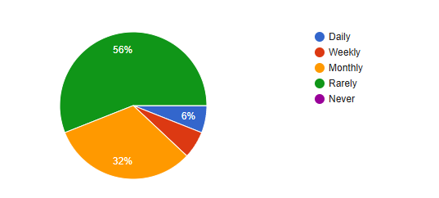

**6%**

*Chart 4.1: Rate of using web based public services*

|  |  |  |  |  |  |  |  |
| --- | --- | --- | --- | --- | --- | --- | --- |
| Gender | Which web-based public services have you used? | | | | | | Total |
| Birth and death registration | Passport and visa services | Tax filing | Utility bill payment | Land record services | Other |
| Male | 5 | 6 | - | 7 | 7 | - | 25 (50%) |
| Female | 8 | 4 | - | 9 | 4 | - | 25 (50%) |
| Total | 13 (26%) | 10 (24%) | - | 16 (32%) | 11 (22%) |  | 100% |

1. **Which web-based public services have you used?**

*Table 4.2: Most used web based public services*

The survey of 50 individuals reveals varying usage of web-based public services. Among males, 20% used birth and death registration, 24% passport and visa services, 28% utility bill payment, and 28% land record services, with no usage of tax filing services. For females, 32% used birth and death registration, 16% passport and visa services, 36% utility bill payment, and 16% land record services, with no tax filing usage.

Overall, utility bill payment (32%) and birth and death registration (26%) are the most utilized services, while tax filing services remain unused.

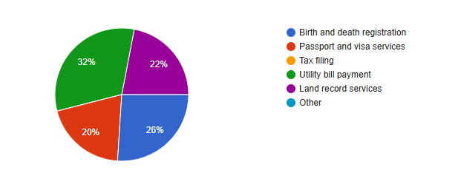

*Chart 4.2: Most used web based public services*

1. **How easy is it to access web-based public services?**

|  |  |  |  |  |  |  |
| --- | --- | --- | --- | --- | --- | --- |
| Gender | How easy is it to access web-based public services? | | | | | Total |
| Very Easy | Easy | Neutral | Difficult | Very Difficult |
| Male | 1 | 12 | 10 | 2 | - | 25 (50%) |
| Female | 1 | 7 | 9 | 8 | - | 25 (50%) |
| Total | 2 (6%) | 19 (38%) | 19 (38%) | 10 (20%) | - | 100% |

*Table 4.3: How easy is it to access web-based public services*

The survey reveals that among males, 4% find accessing web-based public services "Very Easy," 48% find it "Easy," 40% are "Neutral," 8% find it "Difficult," and none find it "Very Difficult." Among females, 4% find it "Very Easy," 28% find it "Easy," 36% are "Neutral," and 32% find it "Difficult," with no responses for "Very Difficult."

Overall, 6% of respondents find accessing web-based services "Very Easy," 38% find it "Easy," 38% are "Neutral," and 20% find it "Difficult." This indicates that while many find these services easy to access, a notable portion experiences challenges.

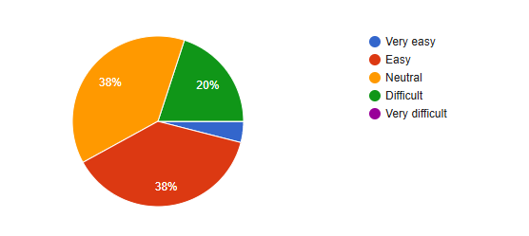

4%

*Chart 4.3: How easy is it to access web-based public services*

1. **Do you have access to a reliable internet connection?**

|  |  |  |  |
| --- | --- | --- | --- |
| Gender | Do you have access to a reliable internet connection? | | Total |
| Yes | No |
| Male | 18 | 7 | 25 (50%) |
| Female | 19 | 6 | 25 (50%) |
| Total | 37 (74%) | 13 (26%) | 100% |

*Table 4.4: Reliable internet connection*

The survey shows that among males, 72% have access to a reliable internet connection, while 28% do not. Similarly, among females, 76% have reliable internet access, whereas 24% do not.

Overall, 74% of respondents reported having access to a reliable internet connection, while 26% do not, indicating that most individuals have internet access, though a significant minority face connectivity issues.

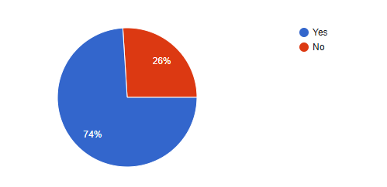

*Chart 4.4: Reliable internet connection*

1. **What device do you primarily use to access these services?**

|  |  |  |  |  |  |  |
| --- | --- | --- | --- | --- | --- | --- |
| Gender | What device do you primarily use to access these services? | | | | | Total |
| Smartphone | Tablet | Laptop | Desktop Computer | Other |
| Male | 13 | 1 | 9 | 2 | - | 25 (50%) |
| Female | 12 | 2 | 11 | - | - | 25 (50%) |
| Total | 25 (50%) | 3 (6%) | 20 (40%) | 2 (4%) | - | 100% |

*Table 4.5: Primary devices to access web based service*

The survey indicates that among males, 52% primarily use smartphones, 4% use tablets, 36% use laptops, and 8% use desktop computers, with no responses for "Other." Among females, 48% use smartphones, 8% use tablets, 44% use laptops, and none use desktop computers or other devices.

Overall, 50% of respondents primarily use smartphones, 6% use tablets, 40% use laptops, and 4% use desktop computers. This highlights that smartphones are the most commonly used device for accessing web-based services across both genders.

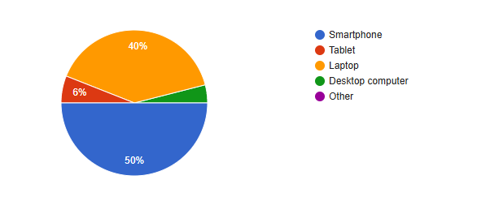

4%

*Chart 4.5: Primary devices to access web based service*

1. **How would you rate the user-friendliness of the web-based public services?**

|  |  |  |  |  |  |  |
| --- | --- | --- | --- | --- | --- | --- |
| Gender | How would you rate the user-friendliness of the web-based public services? | | | | | Total |
| Very user-friendly | User- friendly | Neutral | Not user-friendly | Very difficult to use |
| Male | 3 | 7 | 6 | 9 | - | 25 (50%) |
| Female | 2 | 9 | 7 | 7 | - | 25 (50%) |
| Total | 5 (10%) | 16 (32%) | 13 (26%) | 16 (32%) | - | 100% |

*Table 4.6: Rate the user-friendliness of the web-based public service*

The survey shows that among males, 12% rated web-based public services as "Very user-friendly," 28% as "User-friendly," 24% as "Neutral," and 36% as "Not user-friendly." No respondents selected "Very difficult to use."

Among females, 8% rated the services as "Very user-friendly," 36% as "User-friendly," 28% as "Neutral," and 28% as "Not user-friendly," with no responses for "Very difficult to use."

Overall, 10% of respondents found the services "Very user-friendly," 32% "User-friendly," 26% "Neutral," and 32% "Not user-friendly." This suggests that while some respondents find the services user-friendly, a significant portion faces challenges in usability.

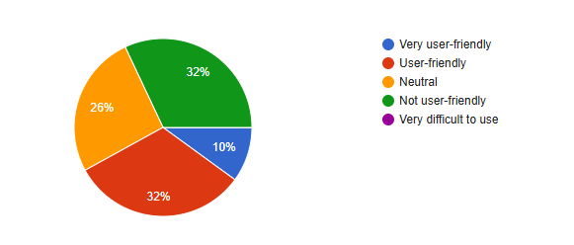

*Chart 4.6: Rate the user-friendliness of the web-based public service*

1. **Have you encountered any technical issues while using these services?**

|  |  |  |  |
| --- | --- | --- | --- |
| Gender | Have you encountered any technical issues while using these services? | | Total |
| Yes | No |
| Male | 12 | 13 | 25 (50%) |
| Female | 15 | 10 | 25 (50%) |
| Total | 27 (54%) | 23 (46%) | 100% |

*Table 4.7: Encountered any technical issues while using these services*

The survey shows that among males, 48% have encountered technical issues while using web-based public services, and 52% have not. Among females, 60% have faced technical issues, while 40% have not.

Overall, 54% of respondents have experienced technical issues, and 46% have not. This suggests that a majority of users face technical difficulties when using these services.

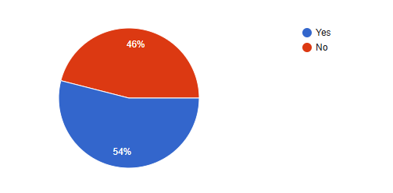

*Chart 4.7:* *Encountered any technical issues while using these services*

1. **Overall, how satisfied are you with the web-based public services?**

|  |  |  |  |  |  |  |
| --- | --- | --- | --- | --- | --- | --- |
| Gender | Overall, how satisfied are you with the web-based public services? | | | | | Total |
| Very Satisfied | Satisfied | Neutral | Dissatisfied | Very Dissatisfied |
| Male | 2 | 8 | 10 | 5 | - | 25 (50%) |
| Female | 1 | 10 | 10 | 3 | 1 | 25 (50%) |
| Total | 3 (6%) | 18 (36%) | 20 (40%) | 8 (16%) | 1 (2%) | 100% |

*Table 4.8: Overall satisfaction with the web-based public services*

The survey reveals that among males, 8% are "Very Satisfied," 32% are "Satisfied," 40% are "Neutral," 20% are "Dissatisfied," and no one is "Very Dissatisfied." Among females, 4% are "Very Satisfied," 40% are "Satisfied," 40% are "Neutral," 12% are "Dissatisfied," and 4% are "Very Dissatisfied."

Overall, 6% of respondents are "Very Satisfied," 36% are "Satisfied," 40% are "Neutral," 16% are "Dissatisfied," and 2% are "Very Dissatisfied." This indicates that most users are either satisfied or neutral with the services, while a smaller portion expresses dissatisfaction.

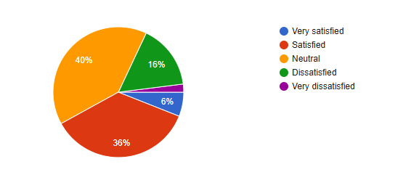

2%

*Chart 4.8: Overall satisfaction with the web-based public services*

1. **How satisfied are you with the response time of these services?**

|  |  |  |  |  |  |  |
| --- | --- | --- | --- | --- | --- | --- |
| Gender | How satisfied are you with the response time of these services? | | | | | Total |
| Very Satisfied | Satisfied | Neutral | Dissatisfied | Very Dissatisfied |
| Male | 2 | 10 | 5 | 7 | 1 | 25 (50%) |
| Female | 1 | 10 | 6 | 6 | 2 | 25 (50%) |
| Total | 3 (6%) | 20 (40%) | 11 (22%) | 13 (26%) | 3 (6%) | 100% |

*Table 4.9: Satisfaction with the response time of the web-based public services*

The survey shows that among males, 8% are "Very Satisfied," 40% are "Satisfied," 20% are "Neutral," 28% are "Dissatisfied," and 4% are "Very Dissatisfied." Among females, 4% are "Very Satisfied," 40% are "Satisfied," 24% are "Neutral," 24% are "Dissatisfied," and 8% are "Very Dissatisfied."

Overall, 6% of respondents are "Very Satisfied," 40% are "Satisfied," 22% are "Neutral," 26% are "Dissatisfied," and 6% are "Very Dissatisfied." This suggests that while a significant portion of users are satisfied, many express dissatisfaction with the response time of these services.

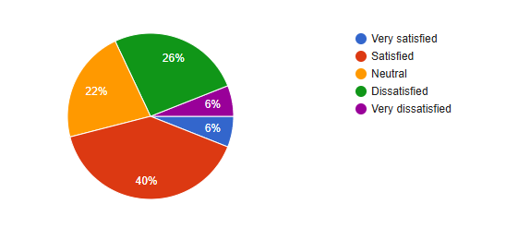

*Chart 4.9: Satisfaction with the response time of the web-based public services*

1. **How satisfied are you with the accuracy of the information provided?**

|  |  |  |  |  |  |  |
| --- | --- | --- | --- | --- | --- | --- |
| Gender | How satisfied are you with the response time of these services? | | | | | Total |
| Very Satisfied | Satisfied | Neutral | Dissatisfied | Very Dissatisfied |
| Male | 3 | 9 | 8 | 5 | - | 25 (50%) |
| Female | 2 | 8 | 7 | 8 | - | 25 (50%) |
| Total | 5 (10%) | 17 (34%) | 15 (30%) | 13 (26%) | - | 100% |

*Table 4.10: Satisfaction with the accuracy of the information provided*

The survey reveals that among males, 12% are "Very Satisfied," 36% are "Satisfied," 32% are "Neutral," and 20% are "Dissatisfied," with no responses for "Very Dissatisfied." Among females, 8% are "Very Satisfied," 32% are "Satisfied," 28% are "Neutral," 32% are "Dissatisfied," and no one reported being "Very Dissatisfied."

Overall, 10% of respondents are "Very Satisfied," 34% are "Satisfied," 30% are "Neutral," and 26% are "Dissatisfied." This indicates that a majority of users are satisfied or neutral about the response time, but a notable portion is dissatisfied.

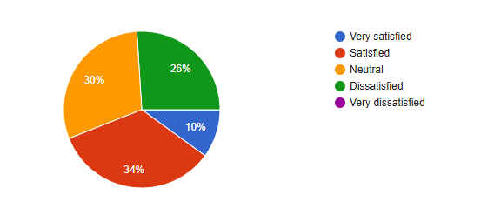

*Chart 4.10: Satisfaction with the accuracy of the information provided*

1. **How satisfied are you with the customer support provided for these services?**

|  |  |  |  |  |  |  |
| --- | --- | --- | --- | --- | --- | --- |
| Gender | How satisfied are you with the customer support provided for these services? | | | | | Total |
| Very Satisfied | Satisfied | Neutral | Dissatisfied | Very Dissatisfied |
| Male | 2 | 7 | 8 | 8 | - | 25 (50%) |
| Female | 1 | 9 | 7 | 8 | - | 25 (50%) |
| Total | 3 (6%) | 16 (32%) | 15 (30%) | 16 (32%) | - | 100% |

*Table 4.11: Satisfaction with the customer support provided for these services*

The survey indicates that among males, 8% are "Very Satisfied," 28% are "Satisfied," 32% are "Neutral," and 32% are "Dissatisfied," with no responses for "Very Dissatisfied." Among females, 4% are "Very Satisfied," 36% are "Satisfied," 28% are "Neutral," and 32% are "Dissatisfied," with no responses for "Very Dissatisfied."

Overall, 6% of respondents are "Very Satisfied," 32% are "Satisfied," 30% are "Neutral," and 32% are "Dissatisfied." This suggests that while some users are satisfied with customer support, a significant portion remains dissatisfied.

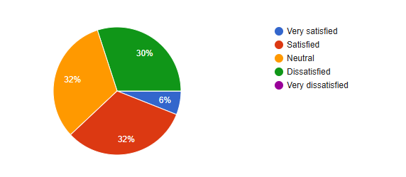

*Chart 4.11: Satisfaction with the customer support provided for these services*

1. **Do you feel that web-based public services have made accessing public services easier?**

|  |  |  |  |  |  |  |
| --- | --- | --- | --- | --- | --- | --- |
| Gender | Do you feel that web-based public services have made accessing public services easier? | | | | | Total |
| Strongly Agree | Agree | Neutral | Disagree | Strongly Disagree |
| Male | 3 | 12 | 7 | 3 | - | 25 (50%) |
| Female | 1 | 11 | 9 | 3 | 1 | 25 (50%) |
| Total | 4 (8%) | 23 (46%) | 16 (32%) | 6 (12%) | 1 (2%) | 100% |

*Table 4.12: Accessing public services easier rate*

The survey reveals that among males, 12% "Strongly Agree," 48% "Agree," 28% are "Neutral," 12% "Disagree," and no one "Strongly Disagrees" with the statement that web-based public services have made accessing public services easier. Among females, 4% "Strongly Agree," 44% "Agree," 36% are "Neutral," 12% "Disagree," and 4% "Strongly Disagree."

Overall, 8% of respondents "Strongly Agree," 46% "Agree," 32% are "Neutral," 12% "Disagree," and 2% "Strongly Disagree." This indicates that a majority of respondents believe that web-based public services have made accessing public services easier, although some remain neutral or disagree.

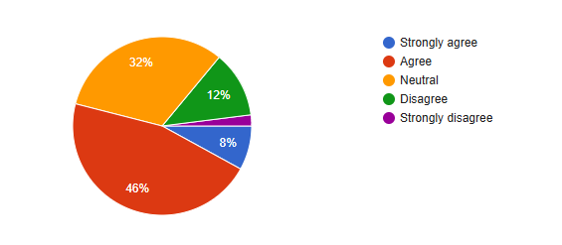

2%

*Chart 4.12: Accessing public services easier rate*

1. **Do you feel these services have reduced the need for in-person visits to government offices?**

|  |  |  |  |  |  |  |
| --- | --- | --- | --- | --- | --- | --- |
| Gender | Do you feel these services have reduced the need for in-person visits to government offices? | | | | | Total |
| Strongly Agree | Agree | Neutral | Disagree | Strongly Disagree |
| Male | 3 | 12 | 6 | 3 | 1 | 25 (50%) |
| Female | 2 | 13 | 7 | 3 | - | 25 (50%) |
| Total | 5 (10%) | 25 (50%) | 13 (26%) | 6 (12%) | 1 (2%) | 100% |

*Table 4.13: Reduced the need for in-person visits to government offices*

The survey indicates that among males, 12% "Strongly Agree," 48% "Agree," 24% are "Neutral," 12% "Disagree," and 4% "Strongly Disagree" that web-based public services have reduced the need for in-person visits to government offices. Among females, 8% "Strongly Agree," 52% "Agree," 28% are "Neutral," 12% "Disagree," and no one "Strongly Disagrees."

Overall, 10% of respondents "Strongly Agree," 50% "Agree," 26% are "Neutral," 12% "Disagree," and 2% "Strongly Disagree." This suggests that a majority of users feel that these services have effectively reduced the need for in-person visits to government offices, though some remain neutral or disagree.

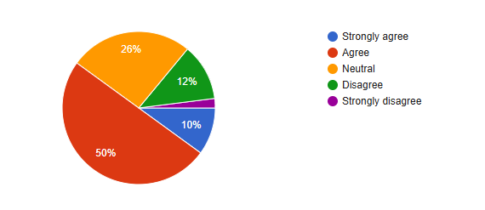

2%

*Chart 4.13: Reduced the need for in-person visits to government offices*

1. **Do you believe web-based public services have reduced the cost of accessing government services?**

|  |  |  |  |  |  |  |
| --- | --- | --- | --- | --- | --- | --- |
| Gender | Do you believe web-based public services have reduced the cost of accessing government services? | | | | | Total |
| Strongly Agree | Agree | Neutral | Disagree | Strongly Disagree |
| Male | - | 16 | 6 | 3 | 2 | 25 (50%) |
| Female | 1 | 13 | 6 | 4 | - | 25 (50%) |
| Total | 1 (2%) | 29 (58%) | 12 (22%) | 7 (14%) | 2 (4%) | 100% |

*Table 4.14: Reduced the cost of accessing government services*

The survey shows that among males, 64% "Agree," 24% are "Neutral," 12% "Disagree," and 8% "Strongly Disagree" with the statement that web-based public services have reduced the cost of accessing government services. Among females, 4% "Strongly Agree," 52% "Agree," 24% are "Neutral," 16% "Disagree," and no one "Strongly Disagrees."

Overall, 2% of respondents "Strongly Agree," 58% "Agree," 22% are "Neutral," 14% "Disagree," and 4% "Strongly Disagree." This indicates that most users believe that web-based public services have successfully reduced the cost of accessing government services, though some remain neutral or disagree.

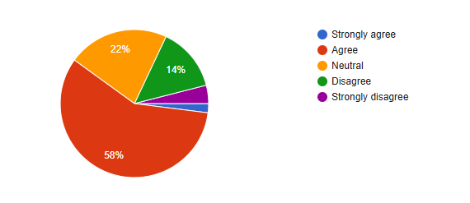

2%

4%

*Chart 4.14: Reduced the cost of accessing government services*