Gopalganj Science and Technology University, Gopalganj-8100



**A REPORT ON**

**Rural Education System & The Quality of Education**

**Course No: PAD 453**

**Course Title: Internship**

**\**

**Submitted By**

Student ID: 19PAD046

Year: 4th

Semester: 2nd

Session: 2019-2020

Department of Public Administration, GSTU, Gopalganj

**Submitted To**

Department of Public Administration,

Faculty of Social Science,

GSTU, Gopalganj

***Date of Submission:*** *25thFebruary, 2025*

**Table of Contents**

**Acknowledgment** i

**Summary** i

**1. Introduction:** 1

**2. Overview of the Study Area:** 2

**3. Research Methodology:** 3

**4. Session Overview** 4

**5. Key Findings and Observations** 6

**6. Recommendations for Improvement:** 7

**7. Conclusion:** 7

# **Acknowledgment**

I would like to express my sincere gratitude to the Bangladesh Academy for Rural Development (BARD) for giving me the opportunity to participate in this internship program. I am thankful to my university for selecting me for this program. I also appreciate the support and cooperation of my group members and the villagers who shared their valuable experiences and insights with us.

# **Summary**

This report presents my experiences during the internship on "Poverty Eradication and Rural Development" at BARD, Cumilla. The main objective of the internship was to assess the state of rural education, identify key challenges affecting education quality, and propose effective solutions. Our team conducted a field study in Madhyam Bijoypur village, where we collected data through surveys, interviews, and direct observations. The findings highlight major challenges such as inadequate school infrastructure, shortage of trained teachers, low student attendance, lack of learning materials, and limited parental awareness. Based on our research, we suggest improving school infrastructure, increasing teacher training programs, enhancing digital education, and strengthening government and community support for rural education. This internship provided valuable insights into the real-life challenges of rural education and the importance of sustainable interventions for long-term improvements.

# **1. Introduction:**

Rural education refers to the teaching and learning process that takes place in schools located in rural or remote areas. It focuses on providing quality education to students in villages and less-developed regions, where access to educational resources, infrastructure, and trained teachers is often limited. Education plays a crucial role in overall rural development by reducing poverty, improving livelihood opportunities, and ensuring social progress. However, rural education faces multiple challenges, including inadequate school infrastructure, a shortage of competent teachers, poor student retention, and limited access to technology. Additionally, factors such as socio-economic conditions, cultural norms, and lack of parental awareness further hinder educational progress in rural areas. Despite various governmental and non-governmental initiatives aimed at improving rural education, significant gaps remain. Many students struggle to continue their education due to financial constraints, lack of proper learning materials, and outdated teaching methodologies. Furthermore, limited exposure to digital learning tools and modern education techniques places rural students at a disadvantage compared to their urban counterparts. Addressing these challenges requires a multi-faceted approach that includes infrastructural development, teacher training, policy reform, and community engagement. This internship provided an opportunity to explore the realities of rural education through field research and direct interaction with students, teachers, and parents. Our study aimed to analyze the quality of education in Madhyam Bijoypur village and identify measures to improve educational outcomes in rural areas. By closely examining the existing conditions and engaging with local stakeholders, we were able to gain a deeper understanding of the barriers to quality education and propose potential solutions tailored to the needs of the community.

# **2. Overview of the Study Area:**

Village Name: Madhyam Bijoypur

Location: Cumilla Sadar Dakshin Upazila

Population: Approximately 2,500 registered voters

Educational Institutions:

* 1 Primary School
* 1 High School
* 1 Women’s College
* 1 Madrasa

Economic Activities: Predominantly farming, small-scale businesses, and labor work

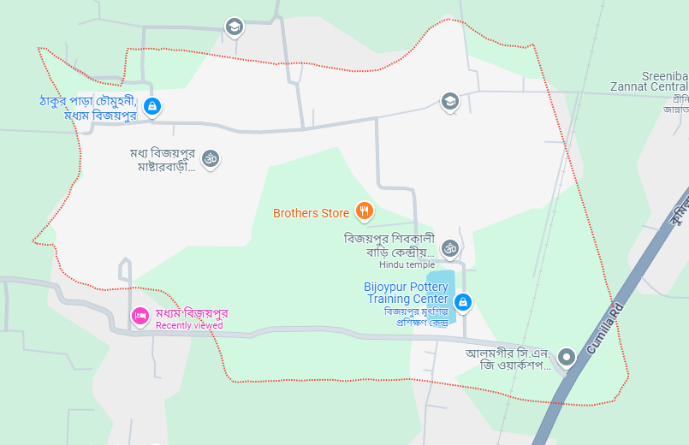

# **3. Research Methodology:**

To understand the socio-economic challenges in the rural education system, we applied the following research methods:

* Field Study & Observations: Observed school environments, teaching methods, and student participation.
* Surveys & Interviews: Conducted structured interviews with students, teachers, and parents to collect qualitative and quantitative data.
* Focus Group Discussions (FGD): Organized discussions with stakeholders to identify key concerns and potential improvements.
* Case Studies: Analyzed individual cases of students facing economic and social barriers to education.
* Document Analysis: Reviewed government policies, reports, and local initiatives related to rural education.

# **4. Session Overview**

*4.1 Session One: Introduction to BARD and Rural Development*

|  |  |  |
| --- | --- | --- |
| Date & Time | Title | Instructor Name |
| 11/02/2025  9:30 - 10:30 AM | Introduction to BARD and Rural Development | Mr. Abdullah Al Mamun  Joint Director, BARD |

This session provided an overview of BARD’s mission, objectives, and contributions to rural development. It emphasized the importance of community participation and sustainable development strategies. The instructor highlighted BARD's historical achievements and future goals in addressing rural poverty.

*4.2 Session Two: Thoughts and Contributions of Dr. Akhter Khan and BARD's Innovative Rural Development Models*

|  |  |  |
| --- | --- | --- |
| Date & Time | Title | Instructor Name |
| 11/02/2025  11:00 – 12:00 AM | Thoughts and Contributions of Dr. Akhter Khan and BARD's Innovative Rural Development Models | Dr. Abdul Karim  Additional Director General, BARD |

In this session, we explored the theories and contributions of Dr. Akhter Khan in rural development. The instructor elaborated on BARD's innovative models designed to uplift rural communities through education, economic opportunities, and sustainable practices. The session offered practical insights into integrating these models into real-world development initiatives.

*4.3 Session Three: Guidelines on Data Collection from Villages*

|  |  |  |
| --- | --- | --- |
| Date & Time | Title | Instructor Name |
| 11/02/2025  12:00 – 1:00 PM | Guidelines on Data Collection from Villages | Fouzia Nasrin Sultana Director, BARD |

This session focused on the ethical and methodological aspects of conducting field research in rural communities. It provided guidelines for conducting interviews, surveys, and observational studies while maintaining cultural sensitivity and respecting the privacy of the villagers.

*4.4 Sessions Four to Seven: Fieldwork and Data Collection*

|  |  |  |  |
| --- | --- | --- | --- |
| Date & Time | Title | | Instructor Name |
| 11/02/2025  2:30 – 4:00 PM | Fieldwork and Data Collection | Mr. Md. Zainal Abedin  Assistant Director  Mr. Faruk Hossain  Assistant Director (Sports) | |

During these sessions, we conducted practical fieldwork in Madhyam Bijoypur village. Activities included direct interaction with villagers, conducting surveys, and gathering first-hand information about the socio-economic challenges faced by the community. These sessions were instrumental in applying theoretical knowledge to real-world situations.

# **5. Key Findings and Observations**

*5.1 School Infrastructure and Environment*

* Many schools lack proper classrooms, sanitation facilities, and electricity.
* Insufficient desks, chairs, and blackboards hinder the learning process.
* Limited access to libraries, laboratories, and technology affects education quality.

*5.2 Number and Competency of Teachers*

* Schools face a shortage of trained and experienced teachers.
* Many teachers are not adequately trained in modern teaching methods.
* Lack of incentives discourages skilled teachers from working in rural areas.

*5.3 Learning Resources and Technology*

* Shortage of books, learning materials, and digital tools.
* Limited access to the internet and e-learning resources.
* Lack of proper training for teachers on integrating technology in classrooms.

*5.4 Student Attendance and Dropout Rates*

* High dropout rates due to financial constraints and household responsibilities.
* Many students miss school to work and support their families.
* Gender disparities in education, with girls facing more barriers to attending school.

*5.5 Parental Awareness and Community Involvement*

* Many parents are unaware of the long-term benefits of formal education.
* Limited community involvement in school development initiatives.
* Cultural and social factors discourage higher education, especially for girls.

*5.6 Government Policies and Support*

* Free textbooks and stipends are provided but are insufficient to cover educational expenses.
* Weak implementation of rural education policies and lack of proper monitoring.
* Insufficient government funding for rural schools.

# **6. Recommendations for Improvement:**

* Improve School Infrastructure: Build and upgrade classrooms, libraries, and sanitation facilities.
* Recruit & Train More Teachers: Offer incentives such as better salaries and housing to attract teachers to rural areas. Conduct regular teacher training programs to improve pedagogical skills.
* Encourage Digital Education: Provide smart classrooms and internet access. Train teachers and students in the use of digital learning tools.
* Increase Parental Awareness: Organize community meetings and workshops to educate parents on the importance of schooling. Encourage parents to actively participate in school management committees.
* Strengthen Government & NGO Support: Increase financial aid and resources for rural schools. Improve the monitoring and evaluation of rural education programs.
* Enhance Vocational Training: Introduce vocational education programs to equip students with practical skills. Provide alternative career pathways for students who cannot pursue higher education.
* Reduce Dropout Rates: Implement special programs such as midday meals to retain students. Develop flexible learning schedules to accommodate working students.

# **7. Conclusion:**

Education is a powerful tool for social and economic progress, and improving rural education is essential for reducing inequality and fostering national development. This internship has provided valuable insights into the state of rural education in Madhyam Bijoypur village, highlighting the pressing need for infrastructural improvements, better teacher training, increased community engagement, and stronger government intervention. While significant efforts have been made to enhance rural education, challenges such as inadequate school facilities, high dropout rates, and limited access to technology continue to hinder progress. Addressing these challenges requires a comprehensive approach that involves policymakers, educators, parents, and the local community working collaboratively. A well-functioning rural education system can equip students with the knowledge and skills needed for a brighter future. Through sustained investment in infrastructure, teacher development, digital education, and community participation, we can create an inclusive and equitable education system that empowers rural students and ensures long-term progress. With continued commitment and strategic planning, rural education can be transformed into a driving force for sustainable development in Bangladesh.