Bangabandhu Sheikh Mujibur Rahman Science and Technology University, Gopalganj-8100



**RESEARCH ON**

**Citizen Satisfaction with Web-Based Public Services:**

**In Bagerhat Sadar Upazila**

**Course No: PAD 420**

**Course Title: Research Paper**

**\**

**Submitted By**

Student ID: 19PAD046

Year: 4th

Semester: 1st

Session: 2019-2020

Department of Public Administration, BSMRSTU, Gopalganj

**Submitted To**

Department of Public Administration,

Faculty of Social Science,

BSMRSTU, Gopalganj

***Date of Submission:*** *29thJanuary, 2025*

**Acknowledgment**

First and foremost, I am deeply grateful to the Almighty Allah for granting me the strength, patience, and opportunity to complete this research.

I would like to express my heartfelt gratitude to my honorable supervisor for their valuable guidance, insightful suggestions, and unwavering support throughout the research process. Their constructive criticism and encouragement have been invaluable in shaping this study.

I am profoundly thankful to all the respondents who willingly shared their time and experiences, making this study possible.

Finally, I dedicate this research paper to my beloved parents, whose unconditional love and support have been my greatest source of inspiration. Thank you all for helping me achieve this milestone.

### **Abstract**

*This research explores citizen satisfaction with web-based public services in Baruipara Union, Bagerhat Sadar Upazila. With the government's emphasis on "Digital Bangladesh," the study evaluates how effectively these services meet the needs of rural communities. Key aspects such as accessibility, usability, internet connectivity, and technical challenges are examined to assess overall satisfaction.*

*Findings indicate that while these services reduce dependency on in-person visits and offer convenience, issues like limited digital literacy, poor internet infrastructure, and usability challenges hinder full adoption. The study identifies areas for improvement, such as raising awareness, enhancing service reliability, and addressing user challenges. By focusing on these aspects, this research aims to provide actionable recommendations to improve citizen satisfaction and contribute to the broader goal of making digital public services more inclusive and effective.*

*Keywords:**Citizen Satisfaction, Web-Based Public Services, Digital Bangladesh, E-Governance, Digital Literacy, Online Service Delivery, Government Services, Digital Transformation*

**Table of Contents**

|  |  |  |
| --- | --- | --- |
| **Serial No** | **Title** | **Page No** |
| **Chapter One** | **Introduction** |  |
| 1.1 | Background of the study | 1 |
| 1.2 | Statement of the problem | 1 |
| 1.3 | Research questions | 2 |
| 1.4 | Aim | 3 |
| 1.5 | Objectives | 3 |
| 1.6 | Significance of the study | 4 |
| 1.7 | Variables | 4 |
| 1.8 | Hypothesis | 5 |
| 1.9 | Area of the study | 5 |
| 1.10 | Methodology | 6 |
| 1.11 | Sample size | 7 |
| 1.12 | Sampling method | 7 |
| 1.13 | Source of data | 7 |
| 1.14 | Data processing | 8 |
| 1.15 | Limitations of the study | 8 |
| **Chapter Two** | **Literature Review** |  |
| 2.1 | Literature Review | 9-11 |
| **Chapter Three** | **Interconnectivity** |  |
| 3.1 | What is Web? | 12 |
| 3.2 | Understanding Web-Based Public Services | 12 |
| 3.3 | Evolution of Web-Based Public Services | 12 |
| 3.4 | The Current Situation in Bangladesh | 13 |
| 3.5 | The Current Situation in Some South Asian Country | 13 |
| 3.6 | Legal and Policy Framework in Bangladesh | 14 |
| 3.7 | Challenges and Opportunities | 15 |
| **Chapter Four** | **Data Processing** |  |
| 4.1 | Data Processing | 16-29 |
| **Chapter Five** | **Findings, Recommendation, Conclusion,** |  |
| 5.1 | Findings | 30 |
| 5.2 | Recommendation | 31 |
| 5.3 | Conclusion | 32 |
| 5.4 | Reference | 33-34 |
| 5.5 | Appendix | 35-37 |

# **CHAPTER ONE**

## **Background of the study**

Across the world, governments are increasingly using digital tools to provide public services to citizens more efficiently. The government of Bangladesh has joined this trend with its "Digital Bangladesh" vision, aiming to use online platforms to deliver essential services to people all over the country. By moving services online, the government hopes to make it easier for people to access the help they need from home or nearby rather than having to travel to a government office. These web-based services can help people with various tasks, such as applying for certificates, checking records, paying bills, and more. [1]

For rural areas like Baruipara Union in Bagerhat Sadar Upazila, the availability of these digital services is especially important. Many residents in these areas may find it difficult or time-consuming to visit government offices in person. By offering services online, the government can save citizens time and effort. However, while the shift to online services has great potential, it does not always work as smoothly as planned. Some citizens face challenges such as poor internet connections, limited knowledge about how to use online services, and a lack of guidance on where to get help if something goes wrong. These issues can prevent people from using the services effectively, making it harder for them to fully benefit from the government’s digital efforts.

This research aims to understand how people in Baruipara Union feel about these online services and how satisfied they are with using them. By identifying the areas where these services are working well and the places where they fall short, this study will provide a clearer picture of what needs improvement. Ultimately, the goal is to find ways to make online services more effective and user-friendly, so they truly meet the needs of the people in Baruipara Union.

## **Statement of the problem**

The introduction of online public services in Bangladesh aims to provide citizens with quicker and easier access to government services, especially for those in remote areas. However, in practice, many people in rural areas like Baruipara Union face various challenges that make it difficult to fully benefit from these digital services. Despite efforts to improve accessibility, several obstacles still affect how successfully residents can use online platforms for services such as certificate applications, record checking, or payments. [1]

One major issue is the accessibility of these services. For instance, internet connectivity in some parts of Baruipara Union is weak or unreliable, making it difficult for people to stay connected long enough to complete tasks. Even when internet access is available, not everyone has the devices or technical skills to navigate online platforms effectively. This digital divide means that while some people can easily use these services, others are left behind due to limited access or knowledge.

Another problem is the usability of these online services. Many residents may not be familiar with the structure or design of these platforms, leading to confusion or mistakes when trying to access information or complete applications. The lack of user-friendly instructions or guidance can discourage people from using these services, especially those who are less experienced with technology. Additionally, citizens may face frequent technical issues, such as website downtime or slow response times, which further impact their experience and willingness to use the services again in the future.

This study, therefore, seeks to explore these specific challenges and understand how they impact citizen satisfaction with web-based public services in Baruipara Union. By identifying and analyzing these barriers, the research will aim to suggest ways to improve the design, accessibility, and support for these digital services, so that more people can use them effectively and with greater ease. Ultimately, this research hopes to provide insights that will help make online public services more practical and beneficial for all residents, leading to higher satisfaction and better engagement with government services.

## **Research questions**

* What factors influence citizens' satisfaction with web-based public services in Baruipara Union?
* What challenges do residents face in accessing and using these online services?
* How reliable and user-friendly are these services for people with varying levels of technical skills?
* Do citizens feel they receive adequate support from local authorities when using these web-based services?

Understanding these factors is crucial for improving the effectiveness and user-friendliness of web-based public services, ultimately leading to higher citizen satisfaction.

## **Aim**

The aim of this research is to thoroughly examine the current state of web-based public services in Baruipara Union, Bagerhat Sadar Upazila, and to evaluate the level of citizen satisfaction with these services. This study intends to provide a comprehensive understanding of how well these digital platforms are meeting the needs of local residents and whether they are effective in enhancing accessibility to government services.

By analyzing various factors such as usability, reliability, and the availability of support from local authorities, the research seeks to identify the strengths and weaknesses of the current web-based service offerings. Additionally, it aims to explore the specific challenges and barriers that hinder residents from fully benefiting from these services. Ultimately, the goal is to provide insights and recommendations that can help improve the quality and effectiveness of web-based public services, leading to greater citizen satisfaction and more efficient government service delivery in Baruipara Union. This study aspires to contribute valuable information that can inform policymakers and local authorities in their efforts to enhance digital service accessibility and usability for all citizens.

## **Objectives**

The specific objectives of the research are:

* To investigate the accessibility of web-based public services in Baruipara Union.
* To determine how easily residents, particularly those with limited technical skills, can use these services.
* To evaluate the quality, reliability, and efficiency of these services.
* To assess if citizens receive adequate assistance from local.

## **Significance of the study**

This study holds significant importance for several reasons. First, it aims to contribute to a better understanding of how web-based public services are currently functioning in Baruipara Union. By examining citizens’ satisfaction levels, the research will provide valuable insights into the effectiveness of these digital services and whether they are meeting the needs of the local community.

Moreover, identifying the challenges and barriers that citizens face in accessing and using these services is crucial. This understanding can help local authorities and policymakers recognize the gaps in service delivery and the areas that require improvement. If the study successfully highlights these issues, it can serve as a guide for decision-makers to develop strategies that enhance the quality and accessibility of web-based public services.

Additionally, the findings of this research could lead to increased citizen engagement with government services. When residents feel satisfied with the services available to them, they are more likely to utilize them, leading to better overall community welfare. Improved public service delivery can foster greater trust in local authorities and encourage more active participation in governance.

Finally, this study can provide a framework for future research on digital public services in other regions. By documenting the experiences of citizens in Baruipara Union, it can serve as a reference point for similar studies elsewhere, ultimately contributing to the broader goal of improving public service delivery through digital means across Bangladesh and beyond.

## **Variables**

This study will focus on two main variables: dependent and independent.

|  |  |
| --- | --- |
| Independent | Dependent |
| Accessibility, Usability, Service quality, Support | Citizen satisfaction |

## **Hypothesis**

The hypothesis of this research is that citizen satisfaction with web-based public services in Baruipara Union is influenced by the level of awareness and education regarding these services. It is assumed that the lack of awareness and understanding about the availability and use of web-based services negatively impacts citizen satisfaction. Improving awareness and providing education on how to access and utilize these services is expected to lead to higher satisfaction among citizens.

## **Area of the study**

The study will be conducted in Baruipara Union, located in Bagerhat Sadar Upazila, within the Khulna Division of Bangladesh. This area was chosen due to its ongoing efforts to integrate digital technology into public service delivery. As a rural community, Baruipara Union presents unique challenges and opportunities in accessing web-based services.

The research will focus on gathering responses from at least 50 residents of Baruipara Union, ensuring a representative sample that reflects the diverse demographics of the area. By collecting feedback from individuals of various age groups and socio-economic backgrounds, the study aims to identify key factors influencing citizen satisfaction with web-based public services. This localized approach will provide valuable insights into how effectively these services are meeting the needs of the community and highlight areas for potential improvement.

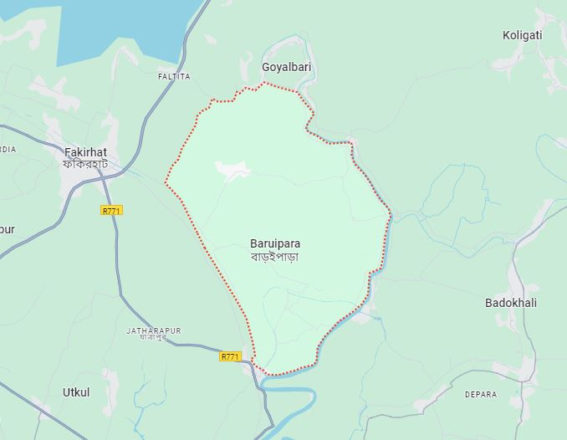

## **Methodology**

This research will employ both qualitative and quantitative methods.

|  |  |
| --- | --- |
| Methods | Explanation |
| Qualitative | Surveys and interviews will be conducted to gather data from residents. |
| Quantitative | Analyzed to measure the level of satisfaction and identify key factors affecting it. |

## **Sample size**

There will be total 50 respondents:

|  |  |
| --- | --- |
| Respondents | Numbers |
| Male | 25 |
| Female | 25 |
| Total: | **50** |

## **Sampling method**

A random sampling method will be used to select participants for the study.

|  |  |
| --- | --- |
| Sampling Method | Details |
| Method | Random sampling method will be used to select participants for the study. |
| Population | Include a total of 50 participants, consisting of 20 females and 30 males. |
| Purpose | This approach ensures that every individual in the population has an equal chance of being included in the sample, minimizing bias. |

## **Source of data**

The study will rely on both primary and secondary data sources.

|  |  |
| --- | --- |
| Sources of Data | Explanation |
| Primary | Collected through surveys and interviews with residents |
| Secondary | Existing literature, government reports, and other relevant sources |

## **Data processing**

Data processing is a crucial step in this research. After collecting data from the surveys and interviews using tools such as Google Forms, the information will be organized and prepared for analysis using MS Word and MS Excel. First, the responses will be reviewed for completeness and accuracy. Any incomplete or unclear responses will be noted and addressed.

Next, the qualitative data, such as open-ended answers from interviews, will be input into MS Word for analysis to identify common themes and insights. This will help in understanding the experiences and opinions of the participants regarding web-based public services.

On the other hand, quantitative data from the surveys will be input into MS Excel for statistical analysis. This data will be used to measure the level of satisfaction among citizens and to determine how different factors affect their experiences with the services.

Overall, this systematic approach to data processing, using MS Word, MS Excel, and Google Forms, will ensure that the findings are reliable and can provide valuable insights for improving web-based public services in Baruipara Union.

## **Limitations of the study**

**Time Constraints**: Due to limited time, it may not be possible to gather as much data or conduct as many interviews as needed, which could reduce the depth of the research.

**Communication Gaps:** Some participants may have difficulty understanding the questions due to differences in literacy levels or familiarity with technology, which may lead to unclear or incomplete responses.

**Limited Access to Data:** Certain information on public services may be restricted or unavailable, limiting the researcher’s ability to fully explore some aspects of the study.

**Sample Size Limitations:** With only 50 participants, the study may not fully capture the views of the entire population, which can affect how widely the findings apply.

# **CHAPTER TWO**

* 1. **Literature Review**

Dwivedi et al. (2017) explored the global adoption of e-government services, focusing on factors influencing their success and challenges in implementation. Their findings suggest that citizens' satisfaction with such services depends heavily on accessibility, ease of use, and perceived usefulness. The study highlights that while e-government initiatives aim to make public services more efficient, challenges such as lack of digital literacy, trust in online platforms, and infrastructure deficits persist. These findings are relevant to Baruipara Union, where limited awareness of web-based services might hinder adoption despite government efforts to improve service delivery. [2]

Heeks (2002) emphasized the concept of the "digital divide," particularly in rural and underdeveloped regions. His research underscores that access to digital resources is often unequal due to socio-economic disparities. Rural areas, like Baruipara Union, frequently face issues such as inadequate internet infrastructure, low levels of education, and financial constraints that prevent the widespread use of web-based public services. Addressing these barriers is critical to enhancing citizen satisfaction and ensuring equitable access to government services. [3]

Hossain et al. (2019) conducted a study on the effectiveness of web-based service delivery in developing countries, with a specific focus on South Asia. Their research identified that while web-based services have the potential to bridge gaps in traditional service delivery, a lack of awareness and trust in these platforms remains a significant hurdle. The study also emphasized that proper training programs and promotional campaigns are essential to educate citizens about the benefits of online services, a recommendation that could be applied to Baruipara Union. [4]

According to Carter and Bélanger (2005), citizen satisfaction in e-governance initiatives is largely driven by a citizen-centric approach that prioritizes user needs. Their research shows that services designed with the end-user in mind—incorporating user-friendly interfaces, multilingual support, and responsive customer service—are more likely to succeed. For Baruipara Union, applying such principles could significantly enhance satisfaction levels by addressing local needs and preferences. [5]

A study by Sharma and Gupta (2023) highlighted the critical role of awareness campaigns in promoting the adoption of web-based public services. They found that many citizens in rural areas are unaware of available digital platforms or how to access them. This lack of awareness contributes to low adoption rates. In the context of Baruipara Union, initiatives like workshops or community outreach programs could be vital in bridging the knowledge gap and fostering trust in online services. [6]

Safiul Hoque (2020) examined the role of Union Digital Centers (UDCs) in promoting e-governance in Bangladesh. Their study concluded that while UDCs have significantly improved access to government services, challenges such as limited internet speed, outdated equipment, and a lack of skilled personnel persist. These issues are particularly relevant to Baruipara Union, where UDCs might serve as a primary point of access for web-based services. Strengthening these centers could enhance citizen satisfaction. [7]

Gefen et al. (2003) explored the role of trust in the adoption of e-services, arguing that a lack of trust in online platforms can deter users from engaging with them. Their research found that trust is influenced by factors such as perceived security, reliability, and the transparency of service providers. For Baruipara Union, building trust through secure platforms and effective communication could significantly improve the uptake of web-based public services. [8]

Misra et al. (2021) investigated the infrastructural challenges that rural areas face when adopting e-governance services. Their findings revealed that poor internet connectivity, frequent power outages, and lack of technical support are major barriers to effective service delivery. These challenges resonate with the conditions in Baruipara Union, where infrastructural improvements are necessary to ensure the smooth functioning of web-based services. [9]

A study by Mohammad Jahangir Alam (2012) in Bangladesh identified the perceived benefits and challenges associated with e-government services. While citizens recognized the convenience and time-saving aspects of online platforms, they also reported frustrations due to technical glitches, slow responses, and lack of assistance. These insights suggest that addressing such issues could play a crucial role in enhancing the effectiveness of web-based services in Baruipara Union. [10]

Rahman and Rahim (2016) analyzed the socio-cultural factors affecting the adoption of e-governance in rural Bangladesh. Their study highlighted the influence of cultural attitudes and community dynamics in shaping citizens’ engagement with web-based services. They found that in rural areas, traditional ways of accessing public services often take precedence over digital platforms due to a general resistance to change and a preference for face-to-face interactions. Moreover, the lack of local language support in web-based systems creates additional barriers for non-urban populations. To address these challenges in Baruipara Union, the government could incorporate culturally sensitive approaches, such as involving local leaders in advocacy campaigns and ensuring the availability of services in Bengali. [11]

Frank et al. (2021) investigated the role of participatory governance in enhancing citizen satisfaction with e-services. The study concluded that involving citizens in the design and evaluation of web-based platforms significantly improves service effectiveness and user satisfaction. Their findings emphasized the importance of regular feedback mechanisms and community consultations to understand user needs and preferences better. In the context of Baruipara Union, implementing participatory approaches such as town hall meetings or user feedback surveys could help tailor services to local requirements and increase trust in government initiatives. [12]

# **CHAPTER THREE**

## **What Is Web?**

The term "web" refers to the World Wide Web (WWW), a system of interlinked documents and multimedia resources that are accessed via the internet. Invented in 1989 by Sir Tim Berners-Lee, the web has revolutionized the way people communicate, access information, and interact with various services. Initially designed to facilitate academic and research-based information sharing, the web has grown to include everything from social media to e-commerce and public service platforms. [13]

Web technologies operate through web browsers such as Google Chrome, Mozilla Firefox, and Microsoft Edge, enabling users to access resources hosted on servers worldwide. By leveraging the web, governments, organizations, and individuals have found innovative ways to deliver services efficiently and transparently. [13]

## **Understanding Web-Based Public Services**

Web-based public services refer to the provision of government or public sector services through digital platforms accessible over the internet. These services are designed to enhance accessibility, reduce bureaucratic hurdles, and improve the overall experience of citizens in interacting with public authorities. Examples of such services include online tax filing, land registration, e-health services, e-education, and e-voting systems. [14]

The advent of web-based public services marked a shift from traditional service delivery models, which often required physical presence and extensive paperwork, to streamlined, efficient, and user-friendly digital processes. These platforms are often integrated with databases and automated systems to provide real-time updates and reduce manual errors. [14]

## **Evolution of Web-Based Public Services**

The journey of web-based public services began in the late 1990s as part of the broader global e-government movement. The United States and European countries were among the pioneers in adopting e-governance, launching initiatives to digitize public administration and make services more accessible to their citizens. For instance, the U.S. introduced its "E-Government Act" in 2002 to promote electronic government services and processes. [15]

Asian nations such as South Korea and Singapore soon followed, implementing robust digital platforms that enabled citizens to access a wide range of public services online. These countries became global leaders in e-governance due to their early adoption of technology and focus on digital literacy. [16]

## **The Current Situation in Bangladesh**

In Bangladesh, web-based public services have been gradually gaining traction over the past decade. The government’s "Digital Bangladesh" initiative, launched in 2009, aims to transform the country into a knowledge-based economy by integrating digital technologies into various sectors. Union Digital Centers (UDCs) have been established across rural areas to provide citizens with access to online services such as birth registration, passport applications, and agricultural information. [17]

Despite these advancements, challenges persist. Limited internet penetration in rural areas, low levels of digital literacy, and technical issues often hinder the effective delivery of web-based services. Additionally, a lack of public awareness about the availability of such services prevents many citizens from utilizing them. However, the government is working on expanding infrastructure, providing training programs, and introducing user-friendly platforms to address these barriers. [17]

## **The Current Situation in Some South Asian Country**

**India:**

India has made significant strides in web-based public services through the Digital India initiative, launched in 2015. This program aims to transform India into a digitally empowered society and knowledge economy. Services such as DigiLocker, e-Hospital, and the Unified Payments Interface (UPI) have gained widespread adoption, simplifying processes like document storage, hospital appointments, and digital transactions. Additionally, India has implemented its e-Governance Plan, which includes the Aadhaar-based Direct Benefit Transfer (DBT) system to streamline welfare distribution and reduce leakages. However, challenges persist, including digital illiteracy, inadequate infrastructure in rural areas, and cybersecurity concerns. [18]

**Sri Lanka:**

Sri Lanka has pursued digitization through the e-Sri Lanka Initiative, which focuses on using ICT to reduce poverty, improve access to public services, and promote economic development. Online services like e-Revenue licenses, e-Pension, and digital land registration have become pivotal in enhancing transparency and reducing bureaucratic delays. Despite these advancements, challenges such as unequal access to technology, low digital literacy rates in rural areas, and slow internet speeds hinder progress. The government is actively working on improving ICT infrastructure and implementing targeted education programs to address these gaps. [19]

**Maldives:**

The Maldives is leveraging its small population and strong mobile penetration to enhance web-based public services. Over 60% of the population uses the internet, and digital platforms like the Asandha Portal for health insurance and online services for passport and visa applications have been launched. The government’s Digital Maldives Project aims to diversify its economy, decentralize services, and enhance resilience to climate change through digital technologies. While the Maldives has achieved remarkable progress, challenges such as limited technical expertise and vulnerability to cybersecurity threats remain concerns. [20]

## **Legal and Policy Framework in Bangladesh**

The legal and policy framework for web-based public services in Bangladesh is shaped by several acts and initiatives:

Information and Communication Technology (ICT) Act, 2006: This act provides the legal foundation for promoting ICT use in governance and service delivery. [21]

National ICT Policy, 2018: This policy outlines the government’s vision to use ICT as a tool for socio-economic development. It emphasizes the importance of e-governance and the delivery of web-based public services. [21]

Right to Information (RTI) Act, 2009: By promoting transparency and accountability, this act indirectly supports the development of web-based platforms to facilitate access to information. [21]

Digital Security Act, 2018: This act ensures the protection of digital platforms and the secure delivery of web-based services, though it has also faced criticism for its perceived restrictions on freedom of speech. [21]

These laws and policies provide a framework for the development and regulation of web-based public services in Bangladesh. However, their successful implementation requires coordinated efforts among government agencies, private sector stakeholders, and civil society organizations.

## **Challenges and Opportunities**

* Infrastructure Gaps: Many rural areas in Bangladesh still lack reliable internet connectivity and electricity, making it difficult to access web-based services.
* Digital Literacy: A significant portion of the population lacks the skills needed to navigate online platforms effectively.
* Technical Issues: Outdated technology and limited technical support can cause delays and inefficiencies.
* Trust Issues: Concerns about data security and misuse of personal information often deter citizens from using online services.
* Mobile Penetration: With increasing mobile phone usage, mobile-friendly platforms could make web-based services more accessible.
* Private Sector Collaboration: Partnerships with private companies can help develop innovative solutions and improve service delivery.
* International Support: Bangladesh can leverage international funding and expertise to enhance its e-governance initiatives.

Web-based public services represent a transformative approach to governance, offering significant benefits such as improved accessibility, transparency, and efficiency. While developed nations have set global benchmarks in e-governance, countries like Bangladesh are making steady progress despite facing numerous challenges. By addressing issues related to infrastructure, digital literacy, and trust, Bangladesh can further enhance the effectiveness of its web-based public services, contributing to the broader goals of "Digital Bangladesh" and sustainable development. With continued investment in technology, education, and public awareness, web-based public services can play a pivotal role in improving the quality of life for citizens across the nation.

## **CHAPTER FOUR**

**4.1 How often do you use web-based public services?**

|  |  |  |  |  |  |  |
| --- | --- | --- | --- | --- | --- | --- |
| Gender | How often do you use web-based public services? | | | | | Total |
| Daily | Weekly | Monthly | Rarely | Never |
| Male | 2 | 1 | 9 | 13 | - | 25 (50%) |
| Female | 1 | 2 | 7 | 15 | - | 25 (50%) |
| Total | 3(6%) | 3 (6%) | 16 (32%) | 28 (56%) | - | 100% |

*Table 4.1: Rate of using web based public services*

The survey indicates that among males, 8% use web-based public services daily, 4% weekly, 36% monthly, and 52% rarely, with none reporting "Never." Similarly, for females, 4% use these services daily, 8% weekly, 28% monthly, and 60% rarely, with no respondents indicating "Never."

Overall, 6% of individuals use web-based public services daily, 6% weekly, 32% monthly, and 56% rarely, with no respondents reporting "Never." The findings highlight that most individuals, regardless of gender, rarely access web-based public services.

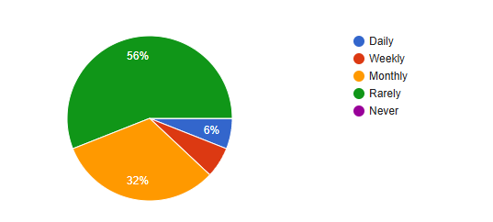

**6%**

*Chart 4.1: Rate of using web based public services*

|  |  |  |  |  |  |  |  |
| --- | --- | --- | --- | --- | --- | --- | --- |
| Gender | Which web-based public services have you used? | | | | | | Total |
| Birth and death registration | Passport and visa services | Tax filing | Utility bill payment | Land record services | Other |
| Male | 5 | 6 | - | 7 | 7 | - | 25 (50%) |
| Female | 8 | 4 | - | 9 | 4 | - | 25 (50%) |
| Total | 13 (26%) | 10 (24%) | - | 16 (32%) | 11 (22%) |  | 100% |

**4.2 Which web-based public services have you used?**

*Table 4.2: Most used web based public services*

The survey of 50 individuals reveals varying usage of web-based public services. Among males, 20% used birth and death registration, 24% passport and visa services, 28% utility bill payment, and 28% land record services, with no usage of tax filing services. For females, 32% used birth and death registration, 16% passport and visa services, 36% utility bill payment, and 16% land record services, with no tax filing usage.

Overall, utility bill payment (32%) and birth and death registration (26%) are the most utilized services, while tax filing services remain unused.

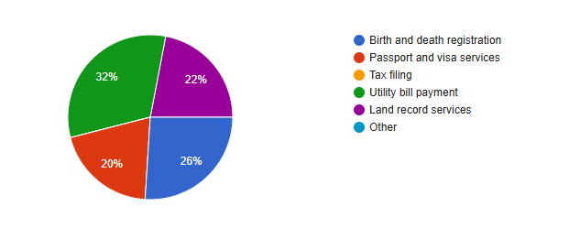

*Chart 4.2: Most used web based public services*

**4.3 How easy is it to access web-based public services?**

|  |  |  |  |  |  |  |
| --- | --- | --- | --- | --- | --- | --- |
| Gender | How easy is it to access web-based public services? | | | | | Total |
| Very Easy | Easy | Neutral | Difficult | Very Difficult |
| Male | 1 | 12 | 10 | 2 | - | 25 (50%) |
| Female | 1 | 7 | 9 | 8 | - | 25 (50%) |
| Total | 2 (6%) | 19 (38%) | 19 (38%) | 10 (20%) | - | 100% |

*Table 4.3: How easy is it to access web-based public services*

The survey reveals that among males, 4% find accessing web-based public services "Very Easy," 48% find it "Easy," 40% are "Neutral," 8% find it "Difficult," and none find it "Very Difficult." Among females, 4% find it "Very Easy," 28% find it "Easy," 36% are "Neutral," and 32% find it "Difficult," with no responses for "Very Difficult."

Overall, 6% of respondents find accessing web-based services "Very Easy," 38% find it "Easy," 38% are "Neutral," and 20% find it "Difficult." This indicates that while many find these services easy to access, a notable portion experiences challenges.

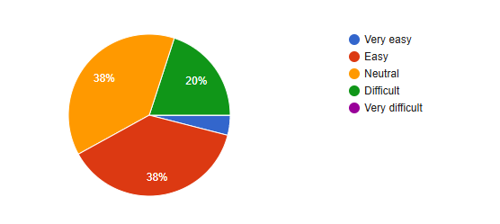

4%

*Chart 4.3: How easy is it to access web-based public services*

**4.4 Do you have access to a reliable internet connection?**

|  |  |  |  |
| --- | --- | --- | --- |
| Gender | Do you have access to a reliable internet connection? | | Total |
| Yes | No |
| Male | 18 | 7 | 25 (50%) |
| Female | 19 | 6 | 25 (50%) |
| Total | 37 (74%) | 13 (26%) | 100% |

*Table 4.4: Reliable internet connection*

The survey shows that among males, 72% have access to a reliable internet connection, while 28% do not. Similarly, among females, 76% have reliable internet access, whereas 24% do not.

Overall, 74% of respondents reported having access to a reliable internet connection, while 26% do not, indicating that most individuals have internet access, though a significant minority face connectivity issues.

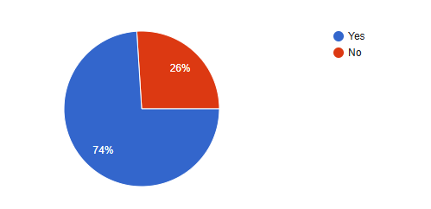

*Chart 4.4: Reliable internet connection*

**4.5 What device do you primarily use to access these services?**

|  |  |  |  |  |  |  |
| --- | --- | --- | --- | --- | --- | --- |
| Gender | What device do you primarily use to access these services? | | | | | Total |
| Smartphone | Tablet | Laptop | Desktop Computer | Other |
| Male | 13 | 1 | 9 | 2 | - | 25 (50%) |
| Female | 12 | 2 | 11 | - | - | 25 (50%) |
| Total | 25 (50%) | 3 (6%) | 20 (40%) | 2 (4%) | - | 100% |

*Table 4.5: Primary devices to access web based service*

The survey indicates that among males, 52% primarily use smartphones, 4% use tablets, 36% use laptops, and 8% use desktop computers, with no responses for "Other." Among females, 48% use smartphones, 8% use tablets, 44% use laptops, and none use desktop computers or other devices.

Overall, 50% of respondents primarily use smartphones, 6% use tablets, 40% use laptops, and 4% use desktop computers. This highlights that smartphones are the most commonly used device for accessing web-based services across both genders.

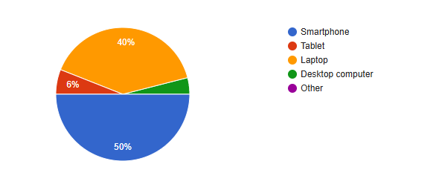

4%

*Chart 4.5: Primary devices to access web based service*

**4.6** **How would you rate the user-friendliness of the web-based public services?**

|  |  |  |  |  |  |  |
| --- | --- | --- | --- | --- | --- | --- |
| Gender | How would you rate the user-friendliness of the web-based public services? | | | | | Total |
| Very user-friendly | User- friendly | Neutral | Not user-friendly | Very difficult to use |
| Male | 3 | 7 | 6 | 9 | - | 25 (50%) |
| Female | 2 | 9 | 7 | 7 | - | 25 (50%) |
| Total | 5 (10%) | 16 (32%) | 13 (26%) | 16 (32%) | - | 100% |

*Table 4.6: Rate the user-friendliness of the web-based public service*

The survey shows that among males, 12% rated web-based public services as "Very user-friendly," 28% as "User-friendly," 24% as "Neutral," and 36% as "Not user-friendly." No respondents selected "Very difficult to use."

Among females, 8% rated the services as "Very user-friendly," 36% as "User-friendly," 28% as "Neutral," and 28% as "Not user-friendly," with no responses for "Very difficult to use."

Overall, 10% of respondents found the services "Very user-friendly," 32% "User-friendly," 26% "Neutral," and 32% "Not user-friendly." This suggests that while some respondents find the services user-friendly, a significant portion faces challenges in usability.

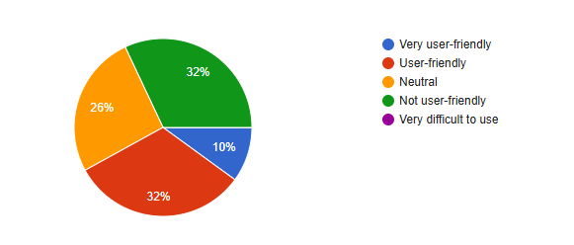

*Chart 4.6: Rate the user-friendliness of the web-based public service*

**4.7 Have you encountered any technical issues while using these services?**

|  |  |  |  |
| --- | --- | --- | --- |
| Gender | Have you encountered any technical issues while using these services? | | Total |
| Yes | No |
| Male | 12 | 13 | 25 (50%) |
| Female | 15 | 10 | 25 (50%) |
| Total | 27 (54%) | 23 (46%) | 100% |

*Table 4.7: Encountered any technical issues while using these services*

The survey shows that among males, 48% have encountered technical issues while using web-based public services, and 52% have not. Among females, 60% have faced technical issues, while 40% have not.

Overall, 54% of respondents have experienced technical issues, and 46% have not. This suggests that a majority of users face technical difficulties when using these services.

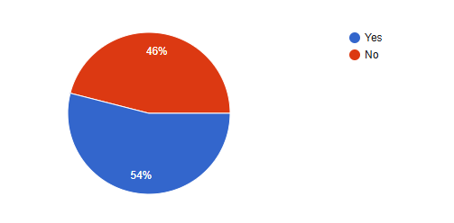

*Chart 4.7:* *Encountered any technical issues while using these services*

**4.8 Overall, how satisfied are you with the web-based public services?**

|  |  |  |  |  |  |  |
| --- | --- | --- | --- | --- | --- | --- |
| Gender | Overall, how satisfied are you with the web-based public services? | | | | | Total |
| Very Satisfied | Satisfied | Neutral | Dissatisfied | Very Dissatisfied |
| Male | 2 | 8 | 10 | 5 | - | 25 (50%) |
| Female | 1 | 10 | 10 | 3 | 1 | 25 (50%) |
| Total | 3 (6%) | 18 (36%) | 20 (40%) | 8 (16%) | 1 (2%) | 100% |

*Table 4.8: Overall satisfaction with the web-based public services*

The survey reveals that among males, 8% are "Very Satisfied," 32% are "Satisfied," 40% are "Neutral," 20% are "Dissatisfied," and no one is "Very Dissatisfied." Among females, 4% are "Very Satisfied," 40% are "Satisfied," 40% are "Neutral," 12% are "Dissatisfied," and 4% are "Very Dissatisfied."

Overall, 6% of respondents are "Very Satisfied," 36% are "Satisfied," 40% are "Neutral," 16% are "Dissatisfied," and 2% are "Very Dissatisfied." This indicates that most users are either satisfied or neutral with the services, while a smaller portion expresses dissatisfaction.

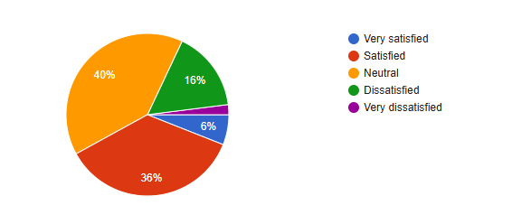

2%

*Chart 4.8: Overall satisfaction with the web-based public services*

**4.9 How satisfied are you with the response time of these services?**

|  |  |  |  |  |  |  |
| --- | --- | --- | --- | --- | --- | --- |
| Gender | How satisfied are you with the response time of these services? | | | | | Total |
| Very Satisfied | Satisfied | Neutral | Dissatisfied | Very Dissatisfied |
| Male | 2 | 10 | 5 | 7 | 1 | 25 (50%) |
| Female | 1 | 10 | 6 | 6 | 2 | 25 (50%) |
| Total | 3 (6%) | 20 (40%) | 11 (22%) | 13 (26%) | 3 (6%) | 100% |

*Table 4.9: Satisfaction with the response time of the web-based public services*

The survey shows that among males, 8% are "Very Satisfied," 40% are "Satisfied," 20% are "Neutral," 28% are "Dissatisfied," and 4% are "Very Dissatisfied." Among females, 4% are "Very Satisfied," 40% are "Satisfied," 24% are "Neutral," 24% are "Dissatisfied," and 8% are "Very Dissatisfied."

Overall, 6% of respondents are "Very Satisfied," 40% are "Satisfied," 22% are "Neutral," 26% are "Dissatisfied," and 6% are "Very Dissatisfied." This suggests that while a significant portion of users are satisfied, many express dissatisfaction with the response time of these services.

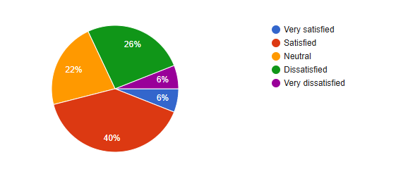

*Chart 4.9: Satisfaction with the response time of the web-based public services*

**4.10** **How satisfied are you with the accuracy of the information provided?**

|  |  |  |  |  |  |  |
| --- | --- | --- | --- | --- | --- | --- |
| Gender | How satisfied are you with the response time of these services? | | | | | Total |
| Very Satisfied | Satisfied | Neutral | Dissatisfied | Very Dissatisfied |
| Male | 3 | 9 | 8 | 5 | - | 25 (50%) |
| Female | 2 | 8 | 7 | 8 | - | 25 (50%) |
| Total | 5 (10%) | 17 (34%) | 15 (30%) | 13 (26%) | - | 100% |

*Table 4.10: Satisfaction with the accuracy of the information provided*

The survey reveals that among males, 12% are "Very Satisfied," 36% are "Satisfied," 32% are "Neutral," and 20% are "Dissatisfied," with no responses for "Very Dissatisfied." Among females, 8% are "Very Satisfied," 32% are "Satisfied," 28% are "Neutral," 32% are "Dissatisfied," and no one reported being "Very Dissatisfied."

Overall, 10% of respondents are "Very Satisfied," 34% are "Satisfied," 30% are "Neutral," and 26% are "Dissatisfied." This indicates that a majority of users are satisfied or neutral about the response time, but a notable portion is dissatisfied.

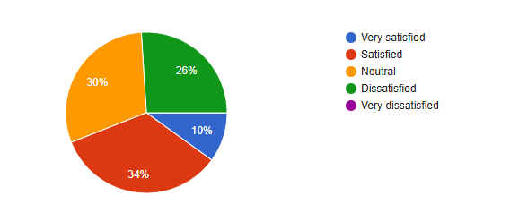

*Chart 4.10: Satisfaction with the accuracy of the information provided*

**4.11** **How satisfied are you with the customer support provided for these services?**

|  |  |  |  |  |  |  |
| --- | --- | --- | --- | --- | --- | --- |
| Gender | How satisfied are you with the customer support provided for these services? | | | | | Total |
| Very Satisfied | Satisfied | Neutral | Dissatisfied | Very Dissatisfied |
| Male | 2 | 7 | 8 | 8 | - | 25 (50%) |
| Female | 1 | 9 | 7 | 8 | - | 25 (50%) |
| Total | 3 (6%) | 16 (32%) | 15 (30%) | 16 (32%) | - | 100% |

*Table 4.11: Satisfaction with the customer support provided for these services*

The survey indicates that among males, 8% are "Very Satisfied," 28% are "Satisfied," 32% are "Neutral," and 32% are "Dissatisfied," with no responses for "Very Dissatisfied." Among females, 4% are "Very Satisfied," 36% are "Satisfied," 28% are "Neutral," and 32% are "Dissatisfied," with no responses for "Very Dissatisfied."

Overall, 6% of respondents are "Very Satisfied," 32% are "Satisfied," 30% are "Neutral," and 32% are "Dissatisfied." This suggests that while some users are satisfied with customer support, a significant portion remains dissatisfied.

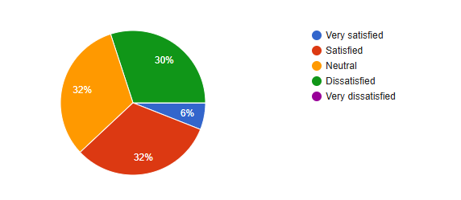

*Chart 4.11: Satisfaction with the customer support provided for these services*

**4.12** **Do you feel that web-based public services have made accessing public services easier?**

|  |  |  |  |  |  |  |
| --- | --- | --- | --- | --- | --- | --- |
| Gender | Do you feel that web-based public services have made accessing public services easier? | | | | | Total |
| Strongly Agree | Agree | Neutral | Disagree | Strongly Disagree |
| Male | 3 | 12 | 7 | 3 | - | 25 (50%) |
| Female | 1 | 11 | 9 | 3 | 1 | 25 (50%) |
| Total | 4 (8%) | 23 (46%) | 16 (32%) | 6 (12%) | 1 (2%) | 100% |

*Table 4.12: Accessing public services easier rate*

The survey reveals that among males, 12% "Strongly Agree," 48% "Agree," 28% are "Neutral," 12% "Disagree," and no one "Strongly Disagrees" with the statement that web-based public services have made accessing public services easier. Among females, 4% "Strongly Agree," 44% "Agree," 36% are "Neutral," 12% "Disagree," and 4% "Strongly Disagree."

Overall, 8% of respondents "Strongly Agree," 46% "Agree," 32% are "Neutral," 12% "Disagree," and 2% "Strongly Disagree." This indicates that a majority of respondents believe that web-based public services have made accessing public services easier, although some remain neutral or disagree.

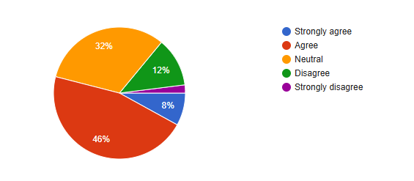

2%

*Chart 4.12: Accessing public services easier rate*

**4.13 Do you feel these services have reduced the need for in-person visits to government offices?**

|  |  |  |  |  |  |  |
| --- | --- | --- | --- | --- | --- | --- |
| Gender | Do you feel these services have reduced the need for in-person visits to government offices? | | | | | Total |
| Strongly Agree | Agree | Neutral | Disagree | Strongly Disagree |
| Male | 3 | 12 | 6 | 3 | 1 | 25 (50%) |
| Female | 2 | 13 | 7 | 3 | - | 25 (50%) |
| Total | 5 (10%) | 25 (50%) | 13 (26%) | 6 (12%) | 1 (2%) | 100% |

*Table 4.13: Reduced the need for in-person visits to government offices*

The survey indicates that among males, 12% "Strongly Agree," 48% "Agree," 24% are "Neutral," 12% "Disagree," and 4% "Strongly Disagree" that web-based public services have reduced the need for in-person visits to government offices. Among females, 8% "Strongly Agree," 52% "Agree," 28% are "Neutral," 12% "Disagree," and no one "Strongly Disagrees."

Overall, 10% of respondents "Strongly Agree," 50% "Agree," 26% are "Neutral," 12% "Disagree," and 2% "Strongly Disagree." This suggests that a majority of users feel that these services have effectively reduced the need for in-person visits to government offices, though some remain neutral or disagree.

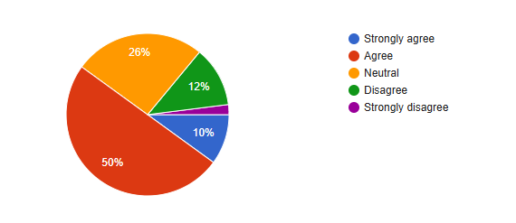

2%

*Chart 4.13: Reduced the need for in-person visits to government offices*

**4.14 Do you believe web-based public services have reduced the cost of accessing government services?**

|  |  |  |  |  |  |  |
| --- | --- | --- | --- | --- | --- | --- |
| Gender | Do you believe web-based public services have reduced the cost of accessing government services? | | | | | Total |
| Strongly Agree | Agree | Neutral | Disagree | Strongly Disagree |
| Male | - | 16 | 6 | 3 | 2 | 25 (50%) |
| Female | 1 | 13 | 6 | 4 | - | 25 (50%) |
| Total | 1 (2%) | 29 (58%) | 12 (22%) | 7 (14%) | 2 (4%) | 100% |

*Table 4.14: Reduced the cost of accessing government services*

The survey shows that among males, 64% "Agree," 24% are "Neutral," 12% "Disagree," and 8% "Strongly Disagree" with the statement that web-based public services have reduced the cost of accessing government services. Among females, 4% "Strongly Agree," 52% "Agree," 24% are "Neutral," 16% "Disagree," and no one "Strongly Disagrees."

Overall, 2% of respondents "Strongly Agree," 58% "Agree," 22% are "Neutral," 14% "Disagree," and 4% "Strongly Disagree." This indicates that most users believe that web-based public services have successfully reduced the cost of accessing government services, though some remain neutral or disagree.

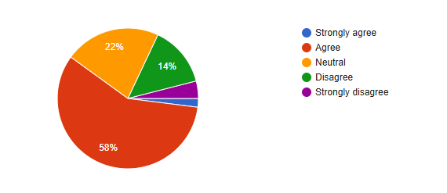

2%

4%

*Chart 4.14: Reduced the cost of accessing government services*

# **CHAPTER FIVE**

**5.1 Findings:**

**Usage of Services:** The majority (56%) of respondents rarely use web-based public services, with a smaller proportion accessing them monthly (32%). Daily or weekly usage is minimal at 6% each.

**Awareness and Types of Services Used:** Utility bill payment (32%) and birth and death registration services (26%) are the most used. Services like tax filing remain unused, reflecting limited awareness or accessibility of certain services.

**Ease of Access:** 38% find accessing web-based services easy, but 20% face difficulties. Neutral responses (38%) suggest varied levels of accessibility awareness.

**Internet Accessibility:** 74% of respondents have reliable internet access, but 26% still face connectivity issues.

**Device Usage:** Smartphones are the primary access device (50%), followed by laptops (40%). Tablets and desktop computers are less popular.

**User-Friendliness:** 42% find services user-friendly, but 32% find them not user-friendly, indicating significant usability challenges.

**Technical Issues:** Over half (54%) have encountered technical problems while using these services.

**Overall Satisfaction:** A mixed picture: 42% of respondents are satisfied, but 18% are dissatisfied, and 40% are neutral.

**Perceived Benefits:** 46% agree that these services ease access to public services, and 50% believe they reduce the need for in-person visits. However, satisfaction with response time and cost reduction is moderate.

**5.2 Recommendation:**

**Raise Awareness through Comprehensive Campaigns:** The government must launch awareness campaigns to educate citizens about the availability and benefits of web-based public services. These campaigns can include: Hosting workshops in rural communities like Baruipara Union. Utilizing TV, radio, and social media platforms to disseminate information widely. Collaborate with Union Digital Centers (UDCs) and local leaders to build trust and ensure people understand how to access and use these services.

**Expand and Improve Digital Infrastructure:** Invest in expanding broadband and mobile internet coverage, especially in underserved rural areas, to ensure uninterrupted service delivery. Establish public kiosks equipped with internet and necessary devices in libraries, schools, and community centers to make these services accessible to those without personal resources.

**Enhance Service Usability and Accessibility:** Simplify platforms with clear instructions, intuitive designs, and multilingual support (including Bengali). Introduce features like text-to-speech, voice commands, and responsive mobile designs to cater to diverse user needs, including the elderly and differently-abled individuals.

**Strengthen Digital Literacy Programs:** Conduct regular training programs at UDCs to teach citizens basic computer skills and how to use web-based services effectively. Include digital literacy in school curricula to create a future-ready generation familiar with online platforms.

**Improve Service Reliability and Support:** Set up dedicated technical support teams at UDCs to assist users with troubleshooting and service-related queries. Introduce an accessible feedback system to identify and address technical issues, delays, and service gaps in real time.

**Build Citizen Trust:** Develop secure platforms with clear policies on data privacy to increase user confidence. Share testimonials from citizens who have successfully benefited from these services to build trust and encourage adoption.

**Collaborate With the Private Sector:** Leverage partnerships with private IT firms to innovate and maintain the technological infrastructure of these services. Engage telecom providers to offer affordable internet packages tailored for accessing web-based public services.

**Monitoring and Evaluation:** Create a task force to evaluate the effectiveness of these initiatives periodically. Use data from citizen feedback to refine service offerings and address evolving needs.

**5.3 Conclusion:**

Web-based public services in Baruipara Union have immense potential to enhance accessibility, reduce costs, and improve citizen satisfaction. However, challenges such as low awareness, limited digital literacy, infrastructural deficiencies, and usability issues hinder their full adoption and effectiveness. The findings of this study confirm that citizens face significant barriers when accessing these services, including unreliable internet connectivity, technical difficulties, and insufficient support. While many recognize the convenience of these platforms, their potential remains untapped due to these persistent challenges.

To address these gaps, the government must prioritize,Education and Awareness- Educating citizens about the availability and benefits of web-based services. Infrastructure Development- Strengthening internet connectivity and providing affordable access points in rural areas. Service Improvement**-** Making platforms user-friendly and accessible to diverse populations. By adopting these measures, the government can transform the delivery of public services into an inclusive and efficient system. These improvements will not only boost citizen satisfaction but also align with the broader "Digital Bangladesh" vision, promoting transparency, accountability, and socio-economic growth.

Ultimately, investing in web-based public services is not merely a technological upgrade—it is a step toward empowering citizens, fostering trust in governance, and ensuring equitable access to essential resources for all.

# **5.4 References**

|  |  |
| --- | --- |
| [1] | Karim, M. R. (2015). E-government in service delivery and citizen’s satisfaction: a case study on public sectors in Bangladesh. International Journal of Managing Public Sector Information and Communication Technologies (IJMPICT), 6(2), 49-60. |
| [2] | Rana, N. P., Dwivedi, Y. K., Luthra, S., Lal, B., & Alryalat, M. A. A. (2017). Advances in electronic government (e-government) adoption research in SAARC countries. In Digital Nations–Smart Cities, Innovation, and Sustainability: 16th IFIP WG 6.11 Conference on e-Business, e-Services, and e-Society, I3E 2017, Delhi, India, November 21–23, 2017, Proceedings 16 (pp. 147-158). Springer International Publishing. |
| [3] | Heeks, R. (2002). Information systems and developing countries: Failure, success, and local improvisations. The information society, 18(2), 101-112. |
| [4] | Chowdury, M. S. U., Emran, T. B., Ghosh, S., Pathak, A., Alam, M. M., Absar, N., ... & Hossain, M. S. (2019). IoT based real-time river water quality monitoring system. Procedia computer science, 155, 161-168. |
| [5] | Carter, L., & Bélanger, F. (2005). The utilization of e‐government services: citizen trust, innovation and acceptance factors. Information systems journal, 15(1), 5-25. |
| [6] | Joshi, P., Gupta, O., Pant, M., Raina, K., & Sharma, B. (2023, April). Assessing the Effectiveness of Different Mass Communication Approaches Used for Government Medical Programs in Rural Areas of Uttarakhand. In International Conference on Paradigms of Communication, Computing and Data Analytics (pp. 699-711). Singapore: Springer Nature Singapore. |
| [7] | Hoque, S. M. S. (2020). Government information and service delivery through union digital centers in Bangladesh: Users' perceptions on good governance. International Journal of Electronic Government Research (IJEGR), 16(3), 45-64. |
| [8] | Model, A. I. (2003). Trust and tam in online shopping: An integrated model1. MIS Quarterly, 27(1), 51-90. |
| [9] | Malodia, S., Dhir, A., Mishra, M., & Bhatti, Z. A. (2021). Future of e-Government: An integrated conceptual framework. Technological Forecasting and Social Change, 173, 121102 |
| [10] | Alam, M. J. (2012). E-governance in Bangladesh: Present problems and possible suggestions for future development. International Journal of Applied Information Systems (IJAIS), 4(8), 21-25. |
| [11] | Rahman, A. (2016). E-governance in Bangladesh. The Daily Star, 1. |
| [12] | Chan, F. K., Thong, J. Y., Brown, S. A., & Venkatesh, V. (2021). Service design and citizen satisfaction with e‐government services: a multidimensional perspective. Public Administration Review, 81(5), 874-894. |
| [13] | Berners‐Lee, T., Cailliau, R., Groff, J. F., & Pollermann, B. (1992). World‐Wide Web: the information universe. Internet Research, 2(1), 52-58. |
| [14] | Ancarani, A. (2005). Towards quality e‐service in the public sector: The evolution of web sites in the local public service sector. Managing Service Quality: An International Journal, 15(1), 6-23. |
| [15] | Torres, L., Pina, V., & Acerete, B. (2005). E-government developments on delivering public services among EU cities. Government information quarterly, 22(2), 217-238. |
| [16] | Wescott, C. G. (2005). E-government in the Asia-Pacific region: Progress and Challenges. Systemics, Cybernetics, and Informaics, 3 (6), 37–42. |
| [17] | Mani, L. (2024). Gravitating towards the digital economy: opportunities and challenges for transforming smart Bangladesh. Pakistan Journal of Life and Social Sciences, 22(1), 3324-3334. |
| [18] | Dua, B. (2018). Digital India: Challenges and Suggestions for Implementation. Review Of Research, 8. |
| [19] | Erangi, D. H. N., & Stecenko, I. (2024). DIGITAL TRANSFORMATION IN SRI LANKA: EVALUATING PROGRESS AND ADDRESSING CHALLENGES. Green, Blue and Digital Economy Journal, 5(2), 1-11. |
| [20] | Shareef, M., Ojo, A., & Janowski, T. (2010, September). Electronic governance in the Maldives: status, issues and plans. In ICEG2006-Proceedings of the 6th International Conference on e-Government: ICEG2006 (p. 100). Academic Conferences Limited. |
| [21] | Baroi, H. S., & Alam, S. (2021). Operationalizing the Right to Information Act through e-governance in Bangladesh: challenges and opportunities. International Journal of Public Administration, 44(8), 685-698. |

**5.5 Appendix:**

**Citizen Satisfaction with Web-Based Public Services: In Bagerhat Sadar Upazila**

**Name:   
Age:   
Gender:**

**1. How often do you use web-based public services?**

a. Daily b. Weekly c. Monthly d. Rarely e. Never

**2. Which web-based public services have you used? (Select all that apply)**

a. Birth and death registration b. Passport and visa services c. Tax filing

d. Utility bill payment e. Land record services f. Other

**3. How easy is it to access web-based public services?**

a. Very easy b. Easy c. Neutral d. Difficult e. Very difficult

**4. Do you have access to a reliable internet connection?**

a. Yes b. No

**5. What device do you primarily use to access these services?**

a. Smartphone b. Tablet c. Laptop d. Desktop computer e. Other

**6. How would you rate the user-friendliness of the web-based public services?**

a. Very user-friendly b. User-friendly c. Neutral d. Not user-friendly

e. Very difficult to use

**7. Have you encountered any technical issues while using these services?**

a. Yes b. No

**8. Overall, how satisfied are you with the web-based public services?**

a. Very satisfied b. Satisfied c. Neutral d. Dissatisfied e. Very dissatisfied

**9. How satisfied are you with the response time of these services?**

a. Very satisfied b. Satisfied c. Neutral d. Dissatisfied e. Very dissatisfied

**10. How satisfied are you with the accuracy of the information provided?**

a. Very satisfied b. Satisfied c. Neutral d. Dissatisfied e. Very dissatisfied

**11. How satisfied are you with the customer support provided for these services?**

a. Very satisfied b. Satisfied c. Neutral d. Dissatisfied e. Very dissatisfied

**12. Do you feel that web-based public services have made accessing public services easier?**

a. Strongly agree b. Agree c. Neutral d. Disagree e. Strongly disagree

**13. Do you feel these services have reduced the need for in-person visits to government offices?**

a. Strongly agree b. Agree c. Neutral d. Disagree e. Strongly disagree

**14. Do you believe web-based public services have reduced the cost of accessing government services?**

a. Strongly agree b. Agree c. Neutral d. Disagree e. Strongly disagree

**15. What improvements would you suggest for the web-based public services?**

a. Very confident b. Confident c. Neutral d. Not confident e. Not at all confident

**16. How satisfied are you with the customer support provided for these services?**

a. Very satisfied b. Satisfied c. Neutral d. Dissatisfied e. Very dissatisfied

**17. How do you perceive the overall transparency of web-based public services?**

a. Very transparent b. Transparent c. Neutral d. Opaque e. Very opaque

**18. How confident are you in the security of online payment methods used in web-based public services?**

a. Very confident b. Confident c. Neutral d. Not confident e. Not at all confident

**19. Do you have any additional comments or suggestions regarding web-based public services in Bagerhat Sadar Upazila?**