
AMERICAN INTERNATIONAL UNIVERSITY – BANGLADESH (AIUB)
DEPARTMENT OF COMPUTER SCIENCE AND ENGINEERING
COURSE TITLE
Computer Graphics
PROJECT TITLE
Doraemon's Treat Hunt
COURSE INSTRUCTOR: DIPTA JUSTIN GOMES
SECTION – P ( GROUP L )
Sl. No. | Name / ID | Role | Major Contribution | Contribution
1 | SHAFAYAT JAMIL  ID: 23-55457-7 | Gameplay Logic & Integration Developer | Implemented and integrated the main gameplay flow, player movement, level selection, score updates, level completion return-to-menu logic and final testing/debugging. | 25%
2 | ABRAR KABIR  ID: 23-55095-3 | Graphics & Scene Designer | Designed and refined OpenGL-based visual scenes, backgrounds, character/environment drawing support, level atmosphere, scenery planning and screenshot preparation guidance. | 25%
3 | MD. TOWHIDUL ISLAM  ID: 23-55036-3 | Collision & Obstacle System Developer | Worked on randomized obstacle behaviour, hazard placement, obstacle movement, collision consistency, hitbox/cooldown improvement and gameplay balancing across levels. | 25%
4 | ADITYA ROY  ID: 23-55077-3 | Audio, File Handling & Documentation Support | Handled custom background music setup, music_config.txt use, high-score text-file saving, Code::Blocks setup instructions, documentation organization and report preparation support. | 25%
- Introduction
Doraemon's Treat Hunt is a 2D interactive graphics game, made in a computer graphics course with C++, OpenGL and GLUT. The game is a side-scrolling adventure where the player controls a Doraemon-inspired character who moves through various scenes, collects doracakes and avoids hazards. The basic gameplay is simple yet addictive: the player picks a level (one of five) from a home screen and tries to collect 10 doracakes before obstacles, incurring damage and trying to complete the level with as high a score as possible. In the game, the background varies with each level and the player has to encounter a number of obstacles, such as moving objects, manhole flames, rocks, falling rocks, and a ghost who pursues the player, as well as lightning. This project doesn't only include drawing graphics, but also visual design, character animation, handling user input, collision detection, adding sound effects, calculating score, saving high scores for each level, and a complete pause and end screen system.
The goal of this project was to show how much the basic concepts of Computer Graphics can be used to create a small but complete and playable interactive system. Most of the beginner's Computer Graphics projects are based on drawing something static, like a house, a car, a tree, a sky or a character. This project applies the same drawing ideas and associates them with an actual game building. Character is created with only OpenGL primitives such as Bezier curves, line strips and polygons. The backgrounds are made using basic shapes. Instead of moving the character around the screen, the world scrolls by moving a world offset coordinate. The positions, angles and states are updated at about 60 frames per second using a GLUT timer based loop to create animation. This project illustrates the use of coordinate systems, translation, scaling, rotation, keyboard-controlled graphics, and menu selection and continuous redrawing with the mouse. The game also provides constant feedback to the player through movement, collecting, scoring, life loss, sound effects and completion screens.
The novelty of the project is the following: a cartoon like world and arcade like game features in 5 progressively challenging levels. A different look and feel for each level. Level 1 is an animated bright daytime with cloudy environments. Level 2 adds in the evening or sunset sky. Dark night scene with lamp posts and dark overlay (Level 3). Level 4 is an environment in which it is raining and there are falling rock hazards. Stage 5 is a stormy night, with twinkling stars, lightning bolts and a ghost chasing enemy. The game maintains a separate score for each level in a plain text file, for remembering the score when the game is closed. Obstacle movement and placement is random, so there is less repetition and more replayability. The music system lets the user put any MP3 file into the sounds folder and specify a desired path within music_config.txt. A pause menu was added which allow the player to pause and resume the game at any time with a Resume, Restart and Main Menu options. Better end screen, which shows current score, level BEST score and obviously large navigation buttons. All of these features make the project more personal, reusable and game-like, but still a valid academic OpenGL project.
The background of the game scenario follows a familiar pattern of adventures. A cute cartoon character based on the popular Doraemon series goes around different environments to collect his favorite food. In his path he faces danger in the form of obstacles and enemies. The game consists of 3 major components: The targets (doracakes) to collect, the life support (hearts) to restore lives and the challenges (obstacles and hazards). The level design gradually shifts the mood and difficulty of the game. This progressive visual change gives the game the sense of being in progress and increasing in difficulty even though the same aim is to collect 10 doracakes throughout all five levels.
It is essential to understand the platform being used in this project. The main programming language used is C++ as it provides the direct control of variables, arrays, functions, conditions and loops and file operations. The 2D graphics are rendered using glBegin and glEnd with GL_POLYGON, GL_QUADS, GL_TRIANGLES and GL_LINE_LOOP using OpenGL. GLUT does the window creation, keyboard input via the specialKeyPress and keyPress callbacks, mouse input via mouseClick, display callback and the timer based update loop. Code::Blocks with MinGW and GCC is used as the development environment. The project utilizes the Windows multimedia system to play a sound using the mciSendString function and winmm library which supports MP3 and WAV formats. Music preference is read from music_config.txt and high scores are stored and loaded in highscore.txt. The glutIdleFunc is called in conjunction with the timer to ensure the display is refreshed smoothly even if the game is paused. In summary, this project is an integrated, educative and comprehensive game application that brings together graphics programming, event-driven programming, user interaction and basic file management.

- Related Works
This section looks at 10 2D graphics/games projects that have similar design ideas to Doraemon's Treat Hunt. Though no exact replication of these works was done in this project, they served as examples for concepts that are commonly found in the game, including level based progression, side scrolling scenes, OpenGL rendering, user control, collision detection, score feedback, sound integration, and game loop organization. The comparison is useful because the present project is also an academic game implemented in C++ and OpenGL, the main learning goal is to write graphics and to let them interact in real time.
No. | Related Work | URL
1 | The Pixie Engine | https://shelim.github.io/pixie_engine/
2 | Sea2D | https://jisyed.github.io/projects/sea2d/
3 | 2D Top-down Shooter | https://github.com/HbotondS/2D-Top-down-shooter
4 | Thalassa | https://xavimarin35.github.io/Thalassa/
5 | 2D Game Engine by Tim Arterbury | https://timart.me/projects/2d-game-engine
6 | Spaceship | https://github.com/natanaeljr/spaceship
7 | Shuttle Madness | https://etherealcross.itch.io/shuttle-madness
8 | Tiny Quest / 2D Game using OpenGL and GLUT | https://www.openglprojects.in/2016/12/2d-game-using-opengl-and-glut.html
9 | A Platformer Engine | https://jhoffislauda.itch.io/a-platformer-engine
10 | Snowy Mists | https://development-citm.github.io/2D-Platformer/

The Pixie Engine (Shelim, n.d.) is a 2D C++ game engine which utilizes OpenGL to render interactive scenes and custom game logic. It is of relevance because it shows how to use OpenGL directly to create a simple 2D scene with interactive objects – without using a bulky external framework. The same approach is taken in Doraemon's Treat Hunt – direct OpenGL rendering using immediate mode primitives instead of an entire external game engine. The Pixie Engine demonstrates that hand-coded graphics applications in C++ can be educational and viable for creating interactive graphical programs.
Sea2D (Syed, n.d.) is a C++ Sprite Engine for 2D graphics which introduces the concepts of Sprites, Animation and Scene Objects. The animated character, moving obstacle objects, collectible doracakes and level scenery in the present game are conceptually related in that they are not implemented by means of image sprites or textures. Sea2D is used to illustrate the independence of the organization and updating of objects in a scene. A simpler level of object-oriented scene organization is implemented in Doraemon's Treat Hunt, where each obstacle, collectible and hazard is handled by a separate array and draw function.
2D Top-down Shooter (HbotondS, n.d.) is a university level C++ and OpenGL game project which demonstrates player movement, enemy logic, rendering layers and project organization. It is useful for comparison, because Doraemon's Treat Hunt is also a game logic implementation built from scratch using C++ and OpenGL, as an academic exercise without the benefit of game libraries. The project illustrates how it is possible to structure an interactive system with student level games with update loops, input handling and rendering. Confirms the method used in this project of maintaining the game state, drawing functions and input callbacks in their own organized modules, included in a single source file.
Thalassa (Marín & Casaú, n.d.) is a 2D platformer game made in C and C++ from scratch that includes jumping mechanics, hazards, enemies and multiple levels. Doraemon's Treat Hunt is smaller and simpler, but the game has a similar platform running goal – the player has to run through a side scrolling world, avoiding obstacles and changing visual areas to gather treats. The progression in Thalassa is based on the level, with different themes and increased challenges, and this was the inspiration for the five level progression in the present project, with new hazards and sky atmosphere at each level.
2D Game Engine (Arterbury, n.d.) is a side-scrolling 2D engine that has rendering, audio, enemy AI, physics and level transitions. It is relevant because the current game also has visual rendering, sound effects and hazards and level based gameplay, albeit in a lighter educational mode that lacks physics and AI. The engine can be used to incorporate audio and level switching into a rendering loop that was utilised for the design of the sound system and level completion flow in Doraemon's Treat Hunt, where music is played continuously and level switching brings the player back to the main menu.
Spaceship (natanaeljr, n.d.) is a simple, handwritten space shooter in 2D using C++ and OpenGL, with collision detection, render layers, projectiles and audio. It's relevant because it demonstrates a neat organization of update loops, collision checking and sound effects in a small OpenGL game. This sort of project, using axis-aligned bounding box collision detection for obstacles and distance calculation based on radius for collectibles is what inspired the collision detection in Doraemon's Treat Hunt. This difference between the two types of collisions results in a game that is fair and responsive.
Shuttle Madness (etherealcross, n.d.) is a C++ OpenGL based game developed using glut.h with audio support, and is based on arcade style survival and scoring gameplay. This is very similar to the game Treat Hunt, which is also based on GLUT graphics, sound effects and a scoring mechanism, and is also developed by Doraemon. Shuttle Madness is an example of the implementation of a complete arcade type game with the GLUT framework, which includes lives, score keeping and game over screens. In this project, the end screen, score display and lives system are designed along similar lines as in the present project.
Tiny Quest / 2D Game using OpenGL and GLUT (Rajeev, 2016) is a 2D game created with C++, OpenGL and GLUT which contains levels, animation, enemies, GUI and audio-visual feedback. Strong related work is GLUT is also used for window management, level design for structure and interactive animation for character feedback in the present project. This project helped to prove that GUI elements, like buttons, menus and HUD displays, can be drawn using OpenGL primitives and positioned using orthographic coordinate system -- the same one used for the home menu, pause screen, end screen and HUD of Doraemon's Treat Hunt.
A Platformer Engine (jhoffislauda, n.d.) is a C++ platformer project that includes platform movement, jumping mechanics and map editing concepts using OpenGL and GLFW. It is related to Doraemon's Treat Hunt thanks to movements handled by the keyboard, jumping controls and obstacle avoidance. The jumping system in the present project follows the simple velocity-based method of movements, where the character ascends as long as it does not exceed the maximum height and then falls back to the ground as is typical in platformer engines as this one. The input handling pattern of platformer projects of this type also affected the stopping movement keyboard release.
Snowy Mists (Development CITM, n.d.) is a student 2D platformer project, implemented in C++ with maps, enemies, UI elements, saving and loading and collision systems. It's relevant because it demonstrates how the level design, interface feedback and collision systems can all be integrated into the overall playable project as the student creates a game. The High Score Saving System in Doraemon's Treat Hunt was inspired by the concept of persistent data storage in student projects, such as Snowy Mists. The current project uses a plain text file called highscore.txt to store the best score per level, and then reads it on start-up and updates it if a new best score is obtained in a level.
These related works provide a number of important design lessons for the current project. The first lesson is that the majority of 2D games are based on a loop that involves drawing, reading input, moving objects and detecting collisions. This structure is directly used in the GLUT display callback and update timer function in Doraemon's Treat Hunt where every frame draws the scene, checks input state and updates all game object positions. The second lesson is that the level environment and difficulty can be varied to make the game more interesting and replayable. This project puts that idea into practice with 5 (selectable) levels having very different visual moods, sky color, ground color and types of hazards. The third lesson is that if any graphics project is to be called a real game and not just a drawing demo, then it should have sound, score feedback and completion screens. This project will thus contain background music, collection sounds, hit sounds, score changes in the HUD and win and game over end screens.
The distinction between large game engines and OpenGL educational projects is also brought to light. More structured engine designs include Sea2D (Syed, n.d.) and the 2D Game Engine (Arterbury, n.d.) which include sprites, textures, physics engines and external asset pipelines. Doraemon's Treat Hunt is designed to be simpler, as it is intended to teach manual drawing, coordinate transformation, animation and interaction in the Computer Graphics course. There is no use of external asset pipelines and everything is drawn via arrays of vertices and mathematical functions. The advantages of this are that students can easily read, debug, and explain the implementation for each part of the visual output, which will be directly tied to a line of code. All ten works are related, and as such it is appropriate to consider the following as a small but complete OpenGL game, with multiple levels, user interaction, randomly-generated hazards, sound, and local score storage.

- Implementation
This Doraemon's Treat Hunt is implemented as a single source file in C++ using OpenGL and GLUT graphics libraries. The program is divided into four logical sections: Game State Management with Global Variables, Drawing Functions for all the Visual Elements, Input Handler Functions for the user control, and Timer Based Update Function for continuous animation. The main function sets up the random number seed, reads high scores stored from highscore.txt, reads the desired music path from music_config.txt, sets up the GLUT window and registers all the GLUT callback functions. The display function is used to determine what should be drawn each frame, based on the current game state, whether it is the home screen or a particular level.
3.1 Key Features of the Project
- Home menu with five selectable levels.
- Side-scrolling 2D gameplay with keyboard movement and jumping.
- Doraemon-inspired character drawn with OpenGL primitives.
- Doracake collection system with score increment.
- Heart and life system for player survival.
- Randomized obstacle placement, type selection and movement behaviour.
- Level-specific hazards such as fire, stones, falling rocks, ghost enemies and lightning effects.
- Per-level high-score saving in a text file named highscore.txt.
- Custom background music through music_config.txt and a local sounds folder.
- Sound effects for item collection, hit, level completion, game over and final win.
- Pause menu with Resume, Restart and Main Menu buttons accessible via P key or mouse click.
- Improved end screen with clearly visible Score, Level Best, Next Level, Main Menu and Restart buttons.
- Return-to-main-menu flow after completing a level.
- Invincibility cooldown after taking damage with hit-flash visual feedback.
- Animated clouds in Level 1 and twinkling stars in Level 5.
- Obstacle respawn system with randomized positions and movement after going offscreen.
- Dynamic window resizing support with glutReshapeFunc ensuring the game fills the full screen on any monitor size.
3.2 Key Technologies Used
Technology | Use in Project
C++ | Main programming language used for variables, arrays, functions, conditions, loops, input handling and file handling.
OpenGL | Used for drawing the 2D graphics, including the character, sky, houses, obstacles, collectibles, clouds, stars and HUD elements.
GLUT | Used for window creation, keyboard and mouse input callbacks, display callback, timer-based update loop and reshape callback for fullscreen support.
Code::Blocks with MinGW/GCC | Development and build environment used to compile and run the project.
Windows Multimedia / winmm | Used for MP3/WAV playback through mciSendString on Windows.
Text File I/O | Used to read the music path from music_config.txt and save per-level high scores in highscore.txt.
Random Number Generation | Used to randomize collectible placement, hearts, obstacle positions, obstacle types and obstacle movement.

3.3 List of Key Functions
Function / Module | Purpose
main() | Initializes the random seed, loads music preference and high scores, creates the GLUT window and registers callback functions.
init() | Sets the OpenGL projection, coordinate range and initial display settings.
display() | Controls whether the home screen or the selected level is drawn each frame.
homeScreen() | Draws the title screen and the level selection buttons.
mouseClick() | Detects mouse clicks on level buttons, pause menu buttons, end screen buttons and main menu controls.
specialKeyPress() / specialKeyRelease() | Controls left, right and jump movement using arrow key input.
keyPress() | Controls pause and resume using the P key.
update() | Main timer loop that updates movement, jumping, clouds, obstacles, special hazards and redraw timing.
idleFunc() | Keeps the display refreshing continuously using glutIdleFunc for smooth pause screen rendering.
Level1() to Level5() | Draws and controls each level scene with its own environment and hazard settings.
placeCollectibles() | Randomly places doracakes and hearts across the level while keeping minimum distance between objects.
checkCollectibles() | Detects doracake and heart collection, updates score, level score and lives, and triggers win condition.
placeObstacles() / placeObstaclesAdvanced() | Places obstacles with random positions and behaviour for normal and advanced levels.
respawnObstacle() | Respawns obstacles in new random positions with randomized movement settings when they drift offscreen.
updateObstacles() | Animates obstacle movement and updates rotation angle and movement bounds each frame.
checkObstacles() / damagePlayer() | Detects player-obstacle collision and reduces lives with a short invincibility cooldown after damage.
checkStones() | Detects player collision with stone hazards in Level 1 and applies damage.
checkManholeFire() | Detects player collision with active manhole fire hazards and applies damage.
checkFallingRocks() | Detects player collision with falling rock hazards in Level 4 and applies damage.
checkGhost() | Detects player proximity to the ghost enemy in Level 5 and applies damage.
updateGhost() | Moves the ghost enemy toward the player position each frame in Level 5.
drawPauseScreen() | Draws the pause overlay box with Resume, Restart and Main Menu buttons and current score display.
drawEndScreen() | Draws the end screen overlay with win or game over message, score, level best score and navigation buttons.
drawHUD() | Displays collected cakes count, lives hearts, current score and level best score during gameplay.
drawHitFlash() | Draws a red screen flash overlay when the player takes damage.
drawGroundStrip() | Draws the coloured ground strip at the bottom of each level scene.
loadHiScore() / saveHiScore() | Loads and writes all per-level high scores in highscore.txt.
updateHiScoreForCurrentLevel() | Compares the current level score with the saved score and updates the file if higher.
loadMusicPreference() | Reads the preferred music path from music_config.txt with null termination safety.
playBGM() / stopBGM() | Starts and stops looping background music using Windows MCI.
playSound() / playSoundForce() | Plays one-shot sound effects for game events such as collection, damage and level completion.
completeLevelAndReturnHome() | Saves the current level result and returns the player to the home menu after level completion.
advanceToNextLevel() | Resets all level state and advances to the next level when the Next Level button is clicked.
finishGameOverIfNeeded() | Checks if lives reached zero and triggers the game over end screen if conditions are met.
initFallingRocks() | Initializes falling rock positions and velocities at the start of Level 4.
initStars() | Initializes twinkling star positions and blink phases at the start of Level 5.
updateLightning() | Updates the lightning flash timer and triggers random bolt positions in Level 5.
resetGhost() | Resets the ghost enemy to its starting position far left offscreen at Level 5 start.
reshape() | Handles window resize events using glutReshapeFunc. Adjusts the OpenGL viewport to fill the full screen on any monitor size while keeping all game coordinates unchanged.

3.4 System Design and Game Flow
The primary interactive element of the game is the movement of players. The character that looks like Doraemon is controlled by the arrow keys. Left and right arrow keys control horizontal movement and the up arrow key is used to make the character jump. The global variables charX and charY are used to keep track of the character position. This jumping state is controlled by a boolean variable and a variable for the speed of the jump, which is calculated based on the height the character can jump to and then down again. Leg animation is achieved by swinging a legAngle variable back and forth while the character is moving which is applied using glRotatef inside glPushMatrix and glPopMatrix blocks around the leg drawing code. A worldX offset variable is used to tie player movements to world movements. When a character hits a certain point on screen the world offsets rather than the character continuing to move, to produce a nice side scrolling effect between multiple connected scenes.
Collectible system provides player with a clear objective for each level. At the beginning of every level, 10 doracakes and 3 heart pickups are randomly distributed to the game world by the placeCollectibles function. Random positions generated with minimum distance check for items not to overlap. A radius-based distance check will detect the collection of the doracake, add 100 points to the score and play a collection sound effect when the character gets close enough to it. If the player has less than 3 lives, Hearts give him 1 life. The win condition is when all 10 doracakes are collected, the end screen is shown with the end score and level best score, the player can either move to the next level, restart or return to the main menu.
The obstacle and hazard system were created to add a level of unpredictability and replayability to all 5 levels. Obstacles are kept in arrays, which store their position, type, movement speed, direction and boundary limits. Random level start and minimum spacing check between obstacles. Obstacles move horizontally, vertically or may be stationary based on the random values given at placement. The respawnObstacle function is used to put an obstacle at a new random location and set a new random movement if it gets too far offscreen. The hazard types are introduced at each level. Level 1 has stone obstacles on the ground. Level 2 introduces manhole fires which can be turned on and off, as well as rotating signboard obstacles. Level 3 adds ball obstacles, mouse obstacles, spiky fruit obstacles, a dark night overlay and lamp posts. The obstacles are signboards that move faster and rocks that fall from the sky and reset once they hit the ground, added at level 4. Level 5 features the highest speed obstacles (all types mixed), manhole fires, twinkling stars, lightning flashes and a ghost enemy that pursues the player around the screen.
There are two different collision detection methods, depending on the type of object. A simple radius based distance check is used for collectibles like doracakes and hearts since these items are friendly and should feel easy to collect and natural. A center based axis-aligned bounding box function centerAABB is used for harmful objects like obstacles, stones, manhole fires, falling rocks and ghost enemy. This function compares the half-widths and half-heights of the hitbox of the character and obstacle to check for overlap. The getObstacleHitbox function provides a size for each type of obstacle, to ensure that collisions are accurate and fair. The damagePlayer function is called when a collision is detected, which decreases lives by one, and initiates an invincibility timer so that the player can't be damaged again in the same instant, and generates a red screen hit flash effect.
The showHome, showEndScreen and gamePaused boolean flags are used to control which screen is displayed at any one time in the game state system. When showHome is true the homeScreen function draws the level selection menu. When a level button is pressed the showHome is set to false and the selected level function starts to draw. If gamePaused is true, the drawPauseScreen function is called to render a pause screen with Resume, Restart and Main Menu buttons over the top of the paused game screen. When the update timer is paused, the glutIdleFunc is still called and glutPostRedisplay is called continuously, so the pause screen is still visible. If showEndScreen is true, then drawEndScreen is used to draw the win or game over overlay with win/loss details and navigation buttons. The high score system stores the high score in highscore.txt, which is compared to the current level score after each collection and at the end of the level and changed only if a new high score is attained.
file handling: ties game session to permanent storage. On startup, all 5 level best scores are read from highscore.txt via formatted text parsing using the loadHiScore function. When a new best score is made, all five scores are written back to the file by the saveHiScore function. The loadMusicPreference function loads the desired music file path from music_config.txt, using a null termination safe method to avoid crashes if a music file is malformed. The Windows MCI system is used to play background music continuously via mciSendString and mpegvideo type for MP3 files. There are separate MCI aliases for short sounds, such as collection, damage, level completed and game over to avoid audio clipping when multiple sounds are playing simultaneously. Window resizing is handled by the reshape callback registered through glutReshapeFunc. When the window size changes or the game enters fullscreen mode, reshape() adjusts the OpenGL viewport using glViewport to fill the entire screen while the projection coordinates remain fixed at gluOrtho2D(-9.50, 9.50, -10.0, 10.0). This means all game object positions, collision hitboxes and HUD elements stay exactly in place regardless of the monitor size or resolution.

- Screenshot of the project
The following tables present five screenshots for each scenery or level. The screenshots show the starting view, movement or jumping, doracake collection, hazard interaction and level completion or return-to-main-menu state.
Level 1 - Bright Day / Home Environment
Screenshot No. | Screenshot | Description
1.1 | 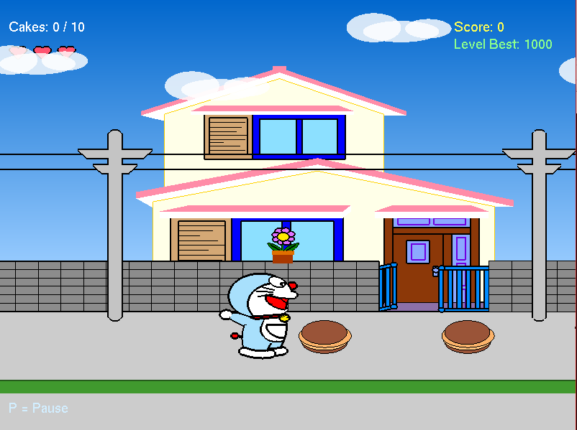 | Shows the starting view immediately after selecting Level 1 from the home menu.
1.2 | 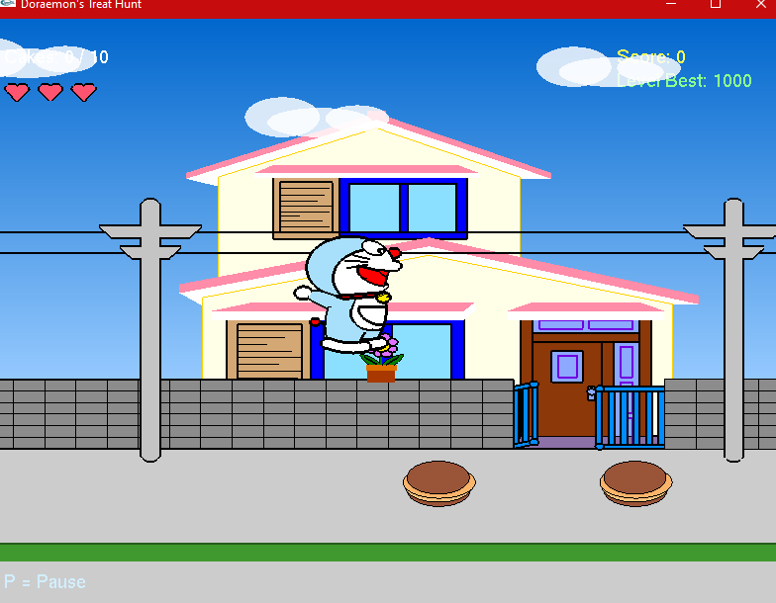 | Shows the character moving or jumping in the bright day environment.
1.3 |  | Shows doracakes placed in the level for collectible interaction.
1.4 | 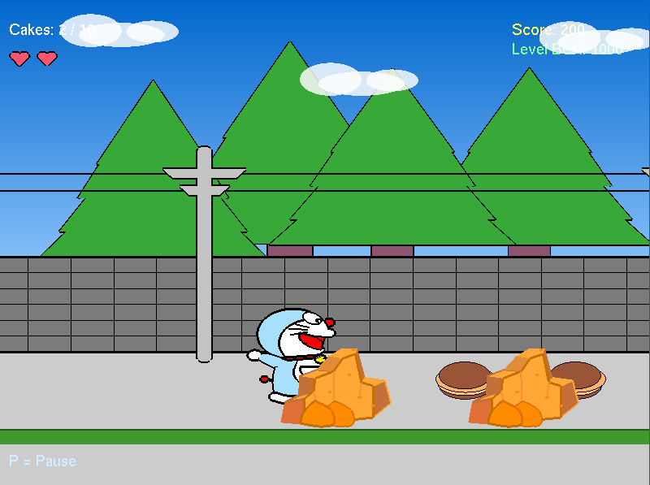 | Shows obstacle or hazard interaction in the Level 1 scenery.
1.5 | 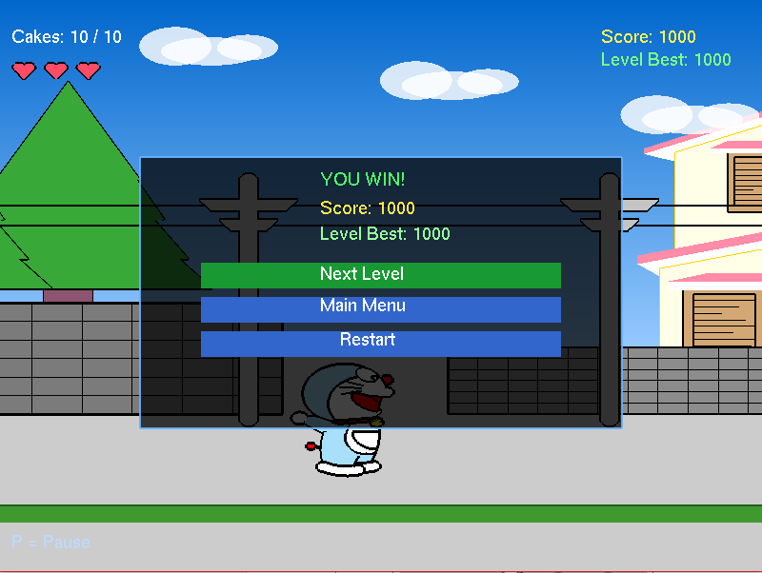 | Shows the level completion state or return-to-main-menu option after finishing the level.

Level 2 - Evening or Sunset Environment
Screenshot No. | Screenshot | Description
2.1 | 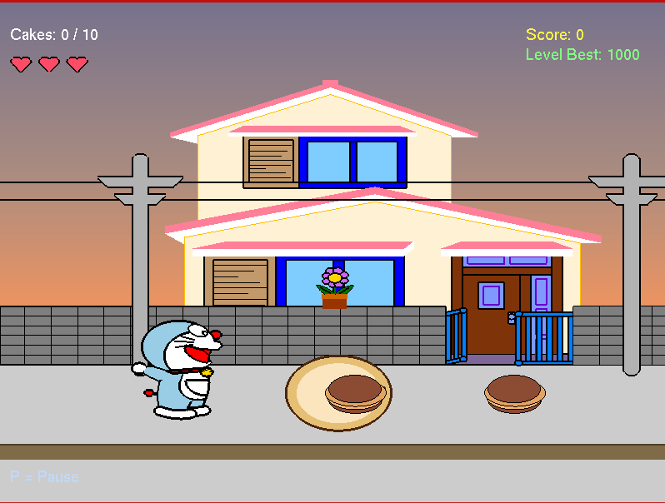 | Shows the starting view immediately after selecting Level 2 from the home menu.
2.2 | 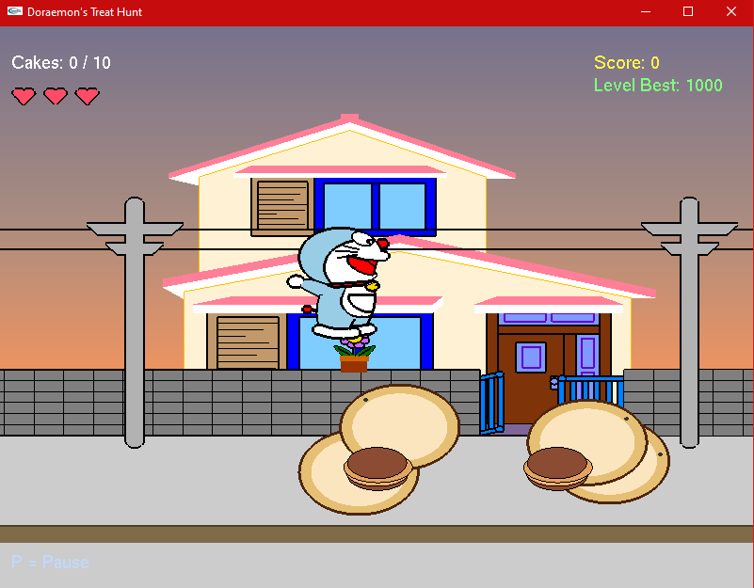 | Shows the character moving or jumping in the evening/sunset environment.
2.3 | 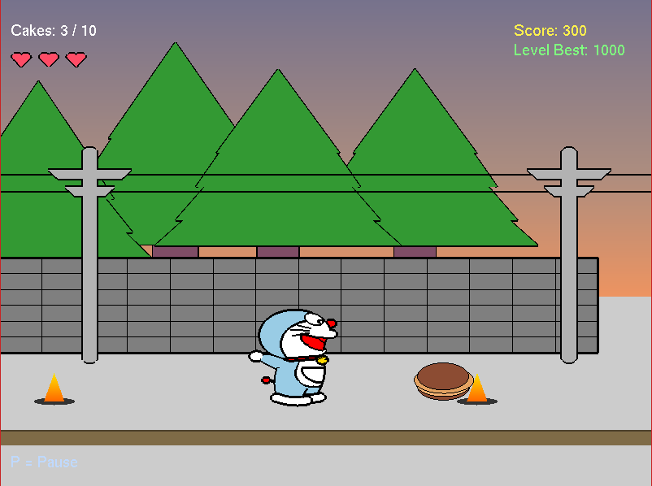 | Shows doracakes and collectible interaction in this level.
2.4 |  | Shows obstacle or hazard interaction in the Level 2 scenery.
2.5 | 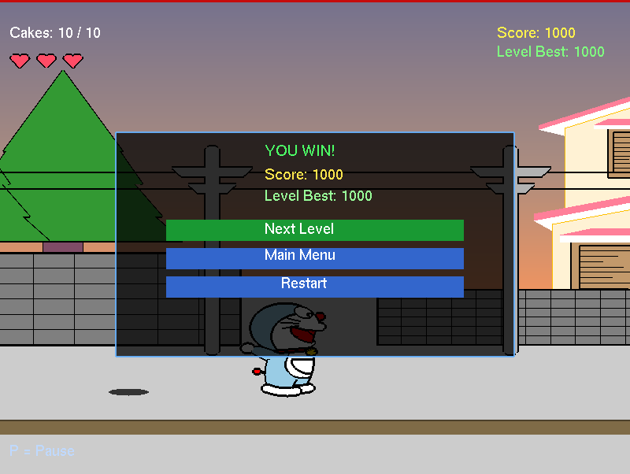 | Shows the level completion state or return-to-main-menu option after finishing the level.
Level 3 - Night Environment
Screenshot No. | Screenshot | Description
3.1 | 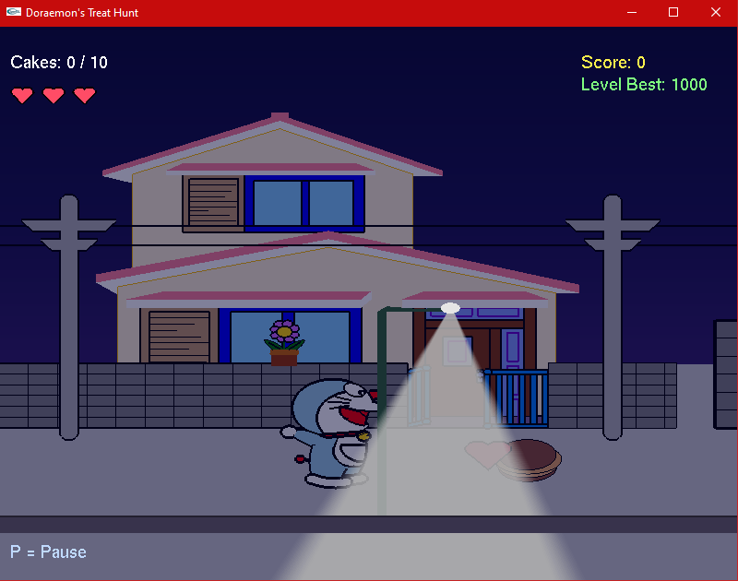 | Shows the starting view immediately after selecting Level 3 from the home menu.
3.2 |  | Shows the character moving or jumping in the night environment.
3.3 | 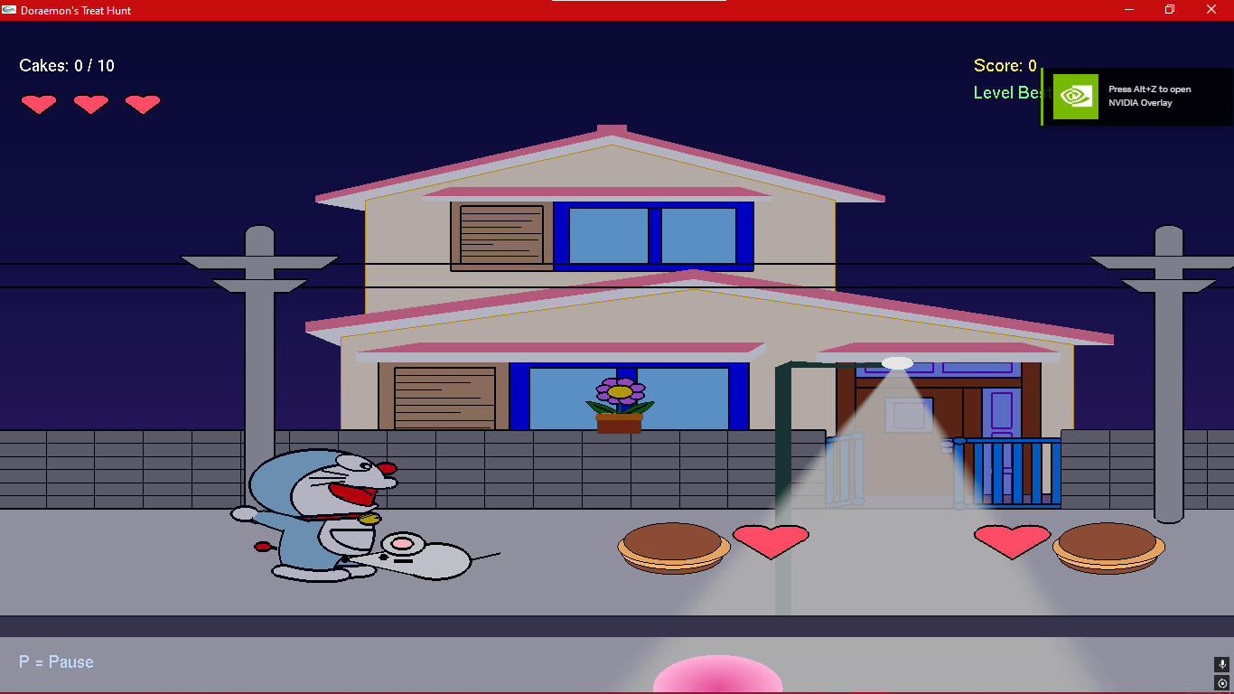 | Although the window resolution was modified, the scalability settings remained constant
3.4 | 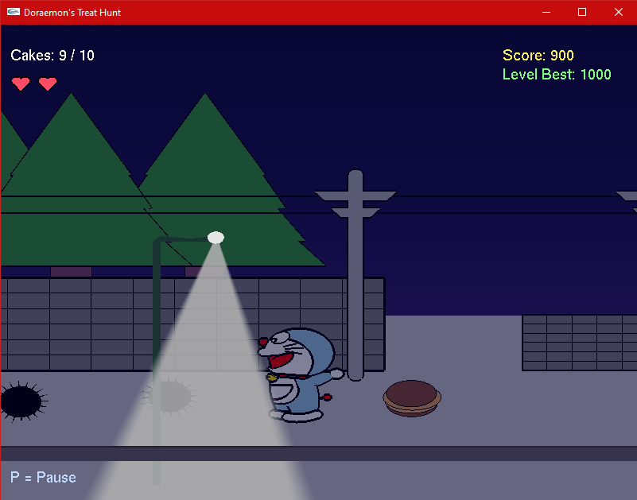 | Shows obstacle or hazard interaction in the Level 3 scenery.
3.5 | 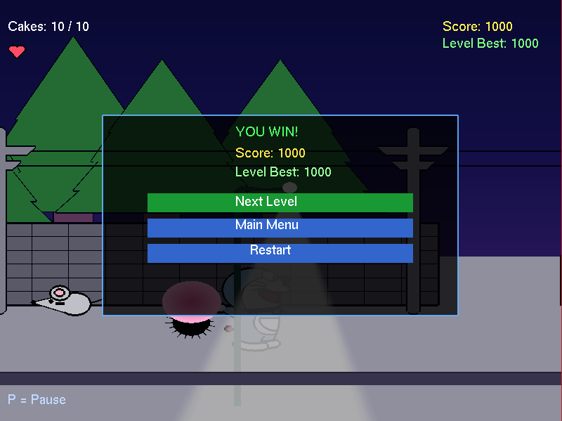 | Shows the level completion state or return-to-main-menu option after finishing the level.

Level 4 - Rainy Dawn / Falling Rock Environment
Screenshot No. | Screenshot | Description
4.1 | 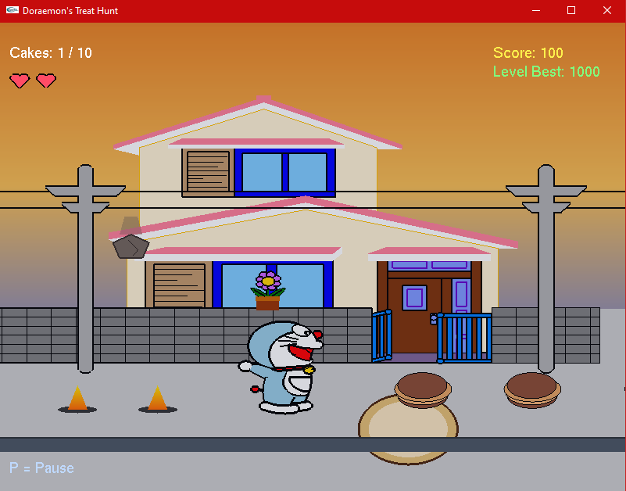 | Shows the starting view immediately after selecting Level 4 from the home menu.
4.2 | 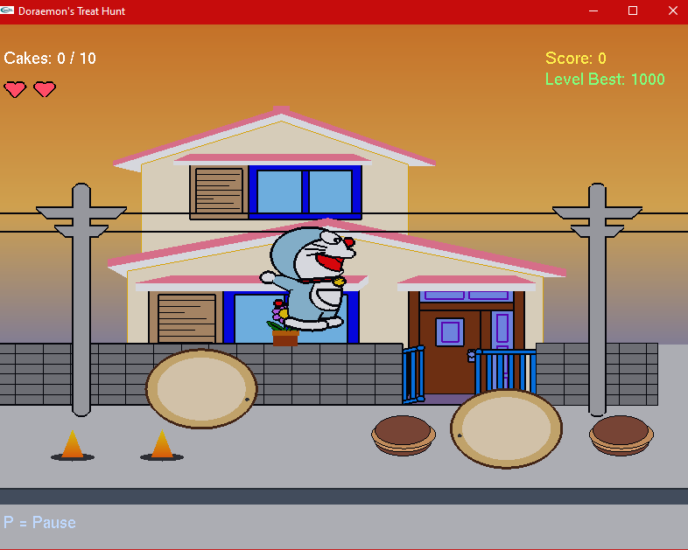 | Shows the character moving or jumping while falling-rock hazards are present.
4.3 |  | Shows doracakes and collectible interaction in the rainy dawn environment.
4.4 | 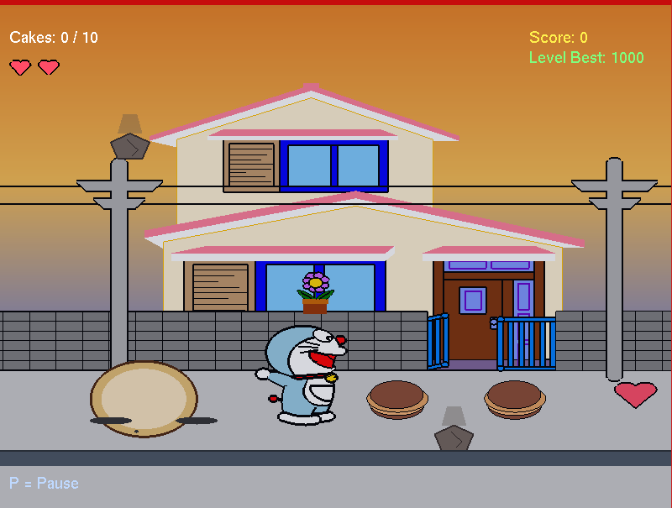 | Shows obstacle, stone, heart or falling-rock interaction in this level.
4.5 | 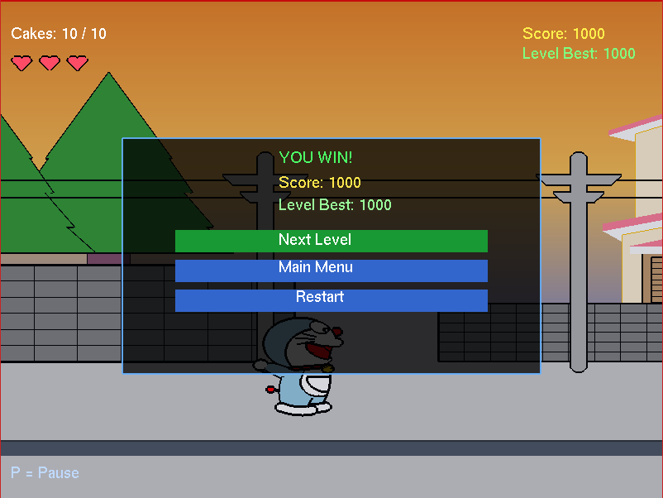 | Shows the level completion state or return-to-main-menu option after finishing the level.

Level 5 - Storm Night / Ghost and Lightning Environment
Screenshot No. | Screenshot | Description
5.1 | 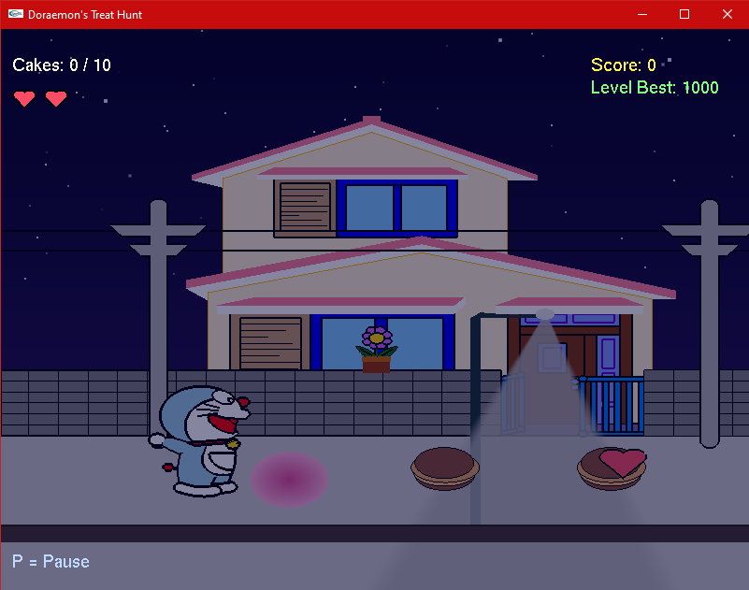 | Shows the starting view immediately after selecting Level 5 from the home menu.
5.2 | 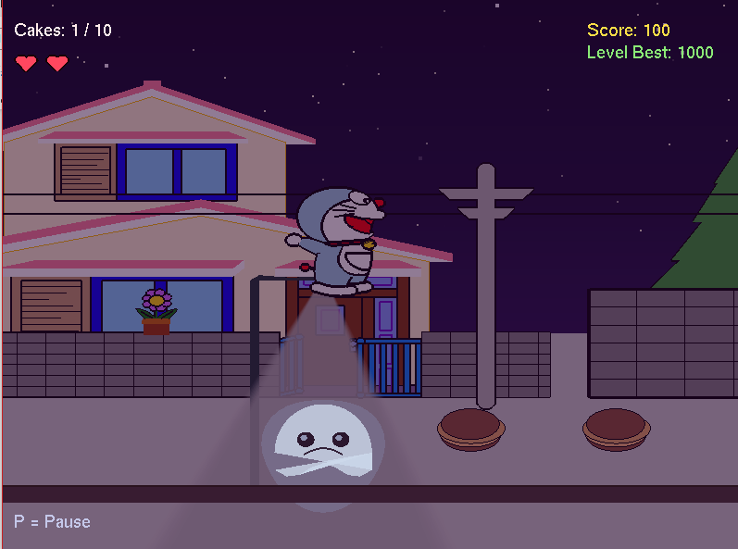 | Shows the character moving or jumping while the ghost enemy appears in the scene.
5.3 |  | Shows doracakes and collectible interaction in the storm-night environment.
5.4 | 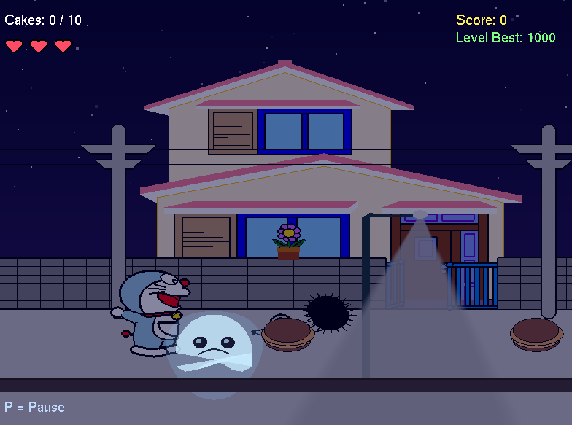 | Shows obstacle or ghost-related hazard interaction in this level.
5.5 | 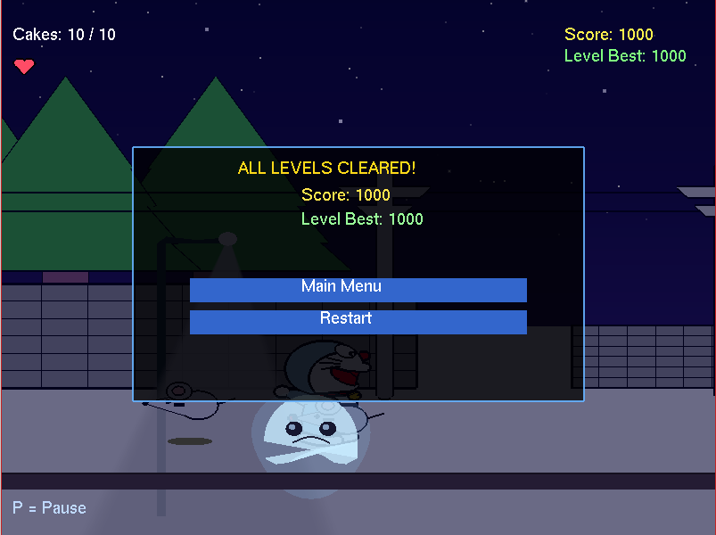 | Shows the level completion state or return-to-main-menu option after finishing the level.

- Code Availability
The project source code is available through the GitHub repository below. The repository should be opened in Code::Blocks and built with the required OpenGL/GLUT and Windows multimedia libraries. For full sound support, keep the required local sound files beside the executable as described in the table.
Item | Details
GitHub Repository Link | https://github.com/towhidislam772/Doraemons_Treat_Hunt
Repository Status | Public repository with C++ source and Code::Blocks project files.
Main Source File | main.cpp
Available Project Files | README.md, dora.cbp, dora.depend, dora.layout and main.cpp.
Required Local Files | music_config.txt, sounds/bgm.mp3, optional sound effects and highscore.txt generated automatically.
Build Libraries | -lopengl32 -lglu32 -lglut32 -lwinmm
Run Instruction | Open the Code::Blocks project, rebuild the project, run the executable and select a level from the home menu.

- Future Work
The following improvements would add to the strength of the current project but were not included in the current version due to time and scope limitations of the academic assignment:
- Use sprite images and texture mapping rather than using only OpenGL primitives to draw each character and object. This would significantly reduce the length of the source code and allow more detailed and visually appealing graphics.
- Provide an in-game settings menu with music volume control, sound effect volume control and difficulty level selection so the player can customize the experience without editing any files.
- Implement a player profile system that enables individual players to have their own saved high scores separately from other users on the same machine.
- Extend the number of levels beyond five, increase visual themes and introduce more varied difficulty progression with new obstacle types and enemy behaviours in each new level.
- Improve collision detection by using object-specific bounding boxes or pixel-level collision for complex shapes instead of the current simplified axis-aligned hitbox approach. This would make collisions feel more accurate especially for the irregularly shaped stone and spiky fruit obstacles.
- Add enemy AI that patrols a fixed area, chases the player when nearby and performs attack behaviour to make later levels more challenging and dynamic.
- Include a level editor or external level configuration file that allows obstacle positions, collectible placements and hazard settings to be changed without modifying the source code directly.
- Support cross-platform audio libraries such as OpenAL or SDL_mixer for reliable music and sound effect playback on Windows, Linux and macOS instead of the current Windows-only winmm system.
- Include animation smoothing and delta time independent motion so that the game runs at the same perceived speed regardless of the frame rate of the host machine.
- Display the top score of all five levels together on a dedicated scoreboard screen accessible from the home menu so players can track their overall performance across all levels.
- Make a full release package available on GitHub including a compiled executable, setup instructions, screenshots, required sound files and a README that explains how to build and run the project on a fresh machine.

- Conclusion
There are some things to be recognized about Doraemon's Treat Hunt. The project does not employ a modern rendering pipeline with vertex buffer objects or shaders, but renders directly using the OpenGL immediate mode system (glBegin/glEnd). This results in a long source code and makes it challenging to manage the code when more objects and levels are added. All the graphics, such as character, houses, trees, obstacles and collectibles are hand-drawn using hundreds of vertex coordinates, which makes future changes time consuming. The audio system is completely Windows based: it uses the winmm library, and the mciSendString function, which makes the project not compile or work properly on Linux or macOS without major work on the sound system. The obstacle positions, the range of collectibles and the layout of the scenes are written directly into the source code and thus modifying the level design always involves editing and recompiling the program. The collision detection system has been enhanced with reduced hitboxes and a center-based AABB collision method, but is still simplified and not polygon-based collision (which can sometimes be slightly inaccurate for certain shapes of objects that are hit, such as the stone or spiky fruit obstacles). The game also doesn't have a correct physics system, so jumping, falling and movement speeds are set with constant values, which are manually adjusted.
The project, despite its drawbacks, effectively meets the learning goals, and illustrates the use of Computer Graphics concepts in an interactive environment. Doraemon's Treat Hunt is a full and playable 2D game with a home menu, 5 selectable levels, side scrolling keyboard movements, jumping, collection system for Dora cakes with scoring, heart and life system, random placement of obstacles with multiple types of hazards, high scores saving per level in a plain text file, background music support with a configuration file, sound effects for all major game events, pause menu with resume, restart and main menu options, and an improved end screen with clearly visible navigation buttons. The project is designed to connect the dots between the basic computer graphics concepts (coordinate systems, drawing primitives, transformations, animation loops and event handling) and the actual game mechanics (collision detection, scoring, file persistence and user interface design). The gradual visual progression across five levels from a bright daytime environment through sunset, night, rainy dawn and storm night gives the game a sense of challenge and variety that keeps the player engaged. In summary, Doraemon's Treat Hunt is an innovative, practical and structured OpenGL graphics project which illustrates how the drawing and transformation methods taught in a Computer Graphics course can be extended to create an interactive game application.

References

Arterbury, T. (n.d.). 2D game engine. Retrieved April 22, 2026, from
https://timart.me/projects/2d-game-engine
Development CITM. (n.d.). Snowy Mists: About the game. Retrieved May 3,
2026, from https://development-citm.github.io/2D-Platformer/
etherealcross. (n.d.). Shuttle Madness [Game]. itch.io. Retrieved April
28, 2026, from https://etherealcross.itch.io/shuttle-madness
HbotondS. (n.d.). 2D-top-down-shooter [Source code]. GitHub. Retrieved
April 25, 2026, from https://github.com/HbotondS/2D-Top-down-shooter
jhoffislauda. (n.d.). A platformer engine [Game]. itch.io. Retrieved
May 7, 2026, from https://jhoffislauda.itch.io/a-platformer-engine
Marín, X., & Casaú, P. (n.d.). Thalassa. Retrieved April 30, 2026, from
https://xavimarin35.github.io/Thalassa/
natanaeljr. (n.d.). Spaceship [Source code]. GitHub. Retrieved May 2,
2026, from https://github.com/natanaeljr/spaceship
Rajeev. (2016, December 2). 2D game using OpenGL and GLUT. OpenGL
Projects. Retrieved May 5, 2026, from
https://www.openglprojects.in/2016/12/2d-game-using-opengl-and-glut.html
Shelim. (n.d.). The Pixie Engine. Retrieved April 27, 2026, from
https://shelim.github.io/pixie_engine/
Syed, J. (n.d.). Sea2D: 2D OpenGL-powered sprite engine for macOS.
Retrieved May 9, 2026, from https://jisyed.github.io/projects/sea2d/

