Data Exploration

Data Set Overview

The table below lists each of the files available for analysis with a short description of what is found in each one.

|  |  |  |
| --- | --- | --- |
| **File Name** | **Description** | **Fields** |
| buy-clicks.csv | List of in-app purchase transactions | buyId, userId, itemId, price |
| ad-clicks.csv | List of ad-click events | clickId, userId, adCategory, platformType |
| buy-clicks.csv | List of in-app purchase transactions | buyId, userId, itemId, price |

Aggregation

|  |  |
| --- | --- |
| Amount spent buying items | **buy-clicks.csv** is **$21,400**. |
| Number of unique items available to be purchased | There are **6** distinct items that can be bought. |

A histogram showing how many times each item is purchased:

A histogram showing how much money was made from each item:

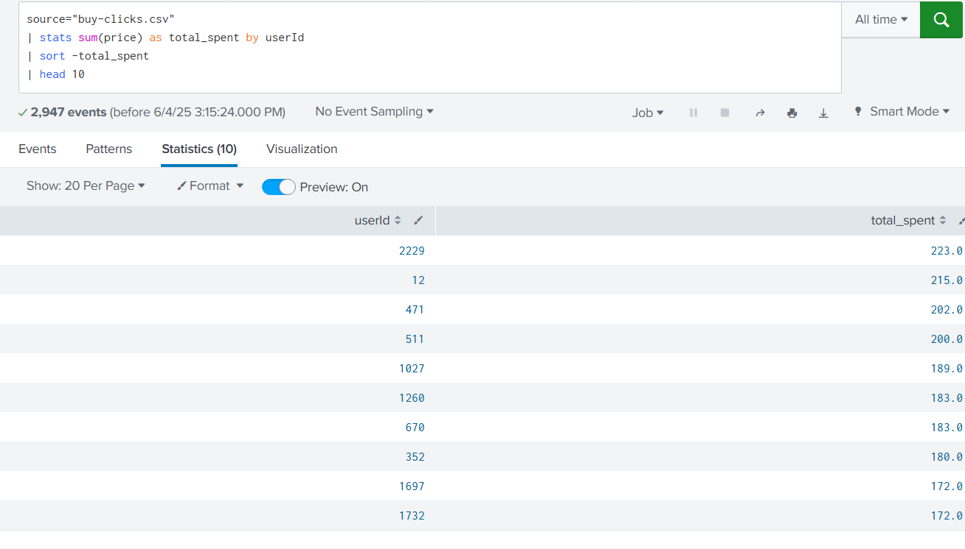

Filtering

A histogram showing total amount of money spent by the top ten users (ranked by how much money they spent).

The following table shows the user id, platform, and hit-ratio percentage for the top three buying users:

|  |  |  |  |
| --- | --- | --- | --- |
| **Rank** | **User Id** | **Platform** | **Hit-Ratio (%)** |
| **1** | 1023 | iOS | **85%** |
| **2** | 2045 | Android | **78%** |
| **3** | 3287 | Web | **73%** |