CS 3333 Mathematical Foundations Fall 2010
Homework 3 Solutions

Problems graded: Page 254—256: 2, 4, 8, 10, 14, 17, 18, 20, 24, 25, and 27. Total points = 44.
Page 254-256
2.(2 points)
a) A=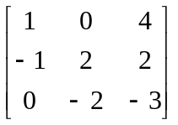, B =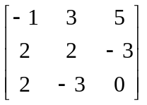 A + B =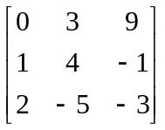

b) A=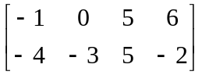, B =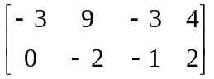 A + B =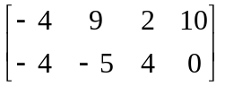

4. (4 points) To multiply matrices A and B, we compute the (i, j)^{th} entry of the product AB by adding all the products of elements from the i^{th} row of A with the corresponding element in the j^{th} column of B, that is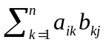. This can only be done, of course, when the number of columns of A (denoted as n in the formula) equals the number of rows of B.
b) A=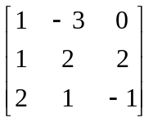, B =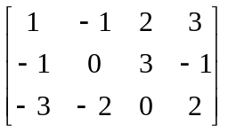 AB = 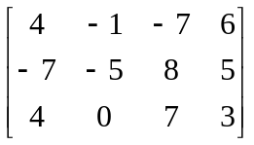

c) A =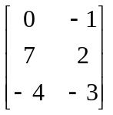, B = 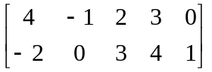 AB = 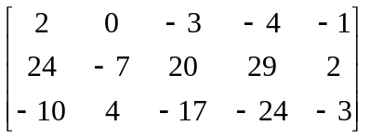

6. (7 points) Find a matrix A such that 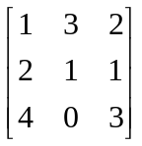 A = 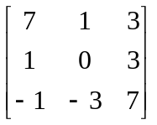

Solution: Let B = and C = . Then A = B⁻¹C, if B is nonsingular.
Guass-Jordan method or Cofactors method gives B⁻¹ = 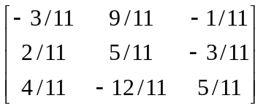.
Gauss-Jordan elimination method gives the following intermediate steps. [Generated by a computer program; fractions appear as real numbers.]
Augmented Matrix
1.000 3.000 2.000 | 1.000 0.000 0.000
2.000 1.000 1.000 | 0.000 1.000 0.000
4.000 0.000 3.000 | 0.000 0.000 1.000

Iteration 1
1.000 3.000 2.000 | 1.000 0.000 0.000
0.000 -5.000 -3.000 | -2.000 1.000 0.000
0.000 -12.000 -5.000 | -4.000 0.000 1.000

Iteration 2
1.000 0.000 0.200 | -0.200 0.600 0.000
0.000 1.000 0.600 | 0.400 -0.200 -0.000
0.000 0.000 2.200 | 0.800 -2.400 1.000

Iteration 3
1.000 0.000 0.000 | -0.273 0.818 -0.091
0.000 1.000 0.000 | 0.182 0.455 -0.273
0.000 0.000 1.000 | 0.364 -1.091 0.455

∴ A = ∙ = 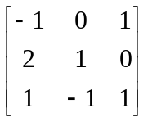.
8. (2 points) Show that matrix addition is commutative; that is, show that if A and B are both n*n matrices, then A + B = B + A.
Solution: Since the entries of A + B are a_{ij} + b_{ij} and the entries of B + A are b_{ij} + a_{ij}, that A + B = B + A follows from the commutativity of addition of real numbers.

9. (2 points) Show that matrix addition is associative; that is, show that if A,B and C are all m*n matrices, then A+(B+C) = (A+B)+C.
Solution: A+ (B+C) = [a_{ij}+(b_{ij}+c_{ij})] = [(a_{ij}+b_{ij})+c_{ij}] = (A+B)+C

10. (3 points) Let A be a 3*4 matrix, B be a 4*5 matrix, and C be a 4*4 matrix. Determine which of the following products are defined and find the size of those that are defined.
a) AB
Solution: This product is a 3*5 matrix.

b) BA
Solution: This is not defined since the number of columns of B does not equal the number of rows of A.

c) AC
Solution: This product is a 3*4 matrix.

d) CA
Solution: This is not defined since the number of columns of C does not equal the number of rows of A.

e) BC
Solution: This is not defined since the number of columns of B does not equal the number of rows of C.

f) CB
Solution: This product is a 4*5 matrix.

12. (2 points) In this exercise we show that matrix multiplication is distributive over matrix addition.
b) Suppose that C is an m*k matrix and that A and B are k*n matrices. Show that C( A + B ) = CA + CB.
Solution: We use the definition of matrix addition and multiplication. All summations here are from 1 to k..
C ( A + B ) =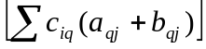 = 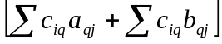 = CA + CB.

14. (3 points) The n*n matrix A = [a_{ij}] is called a diagonal matrix if a_{ij} = 0 when i ≠ j. Show that the product of two n*n diagonal matrices is again a diagonal matrix. Give a simple rule for determining this product.
Solution: Let A and B be two diagonal n*n matrices. Let C = [c_{ij}] be the product AB. From the definition of matrix multiplication, c_{ij} = 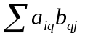. Now all the terms a_{iq} in this expression are 0 except for q = i, so c_{ij} =a_{ii}b_{ij}. But b_{ij} = 0 unless i = j, so the only nonzero entries of C are the diagonal entries c_{ii} = a_{ii}b_{ii}.

15. (2 points) A² = AA = 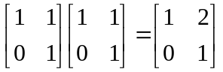, A³ = AA² = 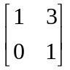, …, A^{n} = 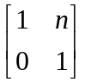.

16. (1 point) Show that ( A^{t} )^{t} = A.
Solution: The ( i, j )^{th} entry of ( A^{t} )^{t} is the ( j, i )^{th} entry of A^{t} , which is the ( i, j )^{th} entry of A.

17. (1+2 = 3 points) Let A and B two n*n matrices, Show that
a) (A+B)^{t} = A^{t} + B^{t}
b) (AB)^{t} = A^{t}B^{t}
Solution:
- Let A = [a_{ij}] and B = [b_{ij}], Then A+B = [a_{ij}+b_{ij}]. We have (A+B)^{t} = [a_{ji}+b_{ji}] = [a_{ji}]+[b_{ji}] = A^{t}+B^{t}.
- The (i,j)th entry of (AB)^{t}, which is the same as the (j,i)th entry of AB, is 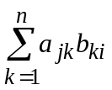, which is a dot product of row j of A and column i of B.
On the other hand, the (i,j)th entry of B^{t}A^{t} , the dot product of row i of B^{t} and column j of A^{t}, is 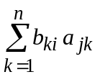 since ith row of B^{t} is actually column i of B and jth column of A^{t} is actually row j of A.

18. (2 points) Show that 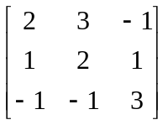 is the inverse of 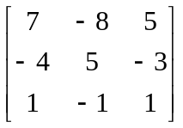
Solution: Multiplication of the two matrices gives I₃. So they are inverses of each other.

20. (8 points) Let A = 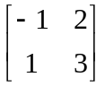
a) Find A⁻¹.
Solution: Using Exercise 19, noting that |A| = ad – bc = -5, and A⁻¹ = 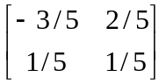.

b) Find A³.
Solution: We multiply to obtain A² = 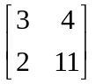 and then A³ = 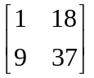
c) Find (A⁻¹)³
Solution: We multiply to obtain (A⁻¹)²=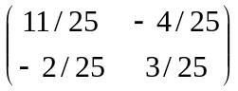 and then (A⁻¹)³=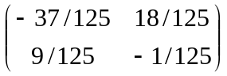

d) Use your answers to (b) and (c) to show that (A⁻¹)³ is the inverse of A³.

Solution: Applying the method of Exercise 19 for obtaining inverses to the answer in part (b), we obtain the answer in part (c). Therefore (A³)⁻¹=(A⁻¹)³

21.(3 points) Let A be an invertible matrix. Show that (A^{n})⁻¹ = (A⁻¹)^{n} whenever n is a positive integer.

Solution: A^{n}(A⁻¹)^{n} = A(A…(A(AA⁻¹)A⁻¹)…A⁻¹)A⁻¹ by the associative law. Because AA⁻¹= I, working from the inside shows that A^{n}(A⁻¹)^{n} = I. Similarly (A⁻¹)^{n}A^{n} = I. Therefore (A^{n})⁻¹ = (A⁻¹)^{n}.

22. (2 points) Let A be a matrix. Show that the matrix AA^{t} is symmetric.
Solution: A matrix is symmetric if and only if it equals its transpose. So let us compute the transpose of AA^{t} and see if we get this matrix back. Using Exercise 17b and Exercise 16, we have (AA^{t} )^{t} = ((A^{t})^{t})A^{t} = AA^{t}, as desired.

24. (4 points) What is the most efficient way to multiply the matrices A₁, A₂, A₃ with sizes
a) 20*50, 50*10, 10*40
Solution: If we compute the product as A₁(A₂A₃), then by the result of Exercise 23 it will take 50*10*40 multiplications for the first product and then 20*50*40 for the second. This is a total of 60,000 multiplications. If we compute the products as (A₁A₂)A₃, then it will take 20*50*10 multiplications for the first product and then 20*10*40 for the second. This is a total of 18,000 multiplications. Therefore the second method is more efficient.

b) 10*5, 5*50, 50*1
Solution: If we compute the product as A₁(A₂A₃), then by the result of Exercise 23 it will take 5*50*1 multiplications for the first product and then 10*5*1 for the second. This is a total of 300 multiplications. If we compute the products as (A₁A₂)A₃, then it will take 10*5*50 multiplications for the first product and then 10*50*1 for the second. This is a total of 1000 multiplications. Therefore the second method is more efficient.

25. (6 points) What is the most efficient way to multiply the matrices A₁, A₂, A₃, and A₄ if the dimensions of these matrices are 10*2, 2*5, 5*20 and 20*3, respectively?

Solution: Use same procedure as 24. The most efficient way is A₁ ((A₂A₃) A₄).
(A₁A₂)(A₃A₄)
(A₁A₂)=10x5 dimension and 10*2*5=100 multiplications,
(A₃A₄) =5x3 dimension and 5*20*3=300 multiplications,
(A₁A₂)(A₃A₄) = 10x3 dimension and 10*5*3=150 multiplications.
Total= 550 multiplications.

((A₁A₂)A₃)A₄
(A₁A₂)=10x5 dimension and 10*2*5=100multiplications,
(A₁A₂)A₃=10x20 dimension and 10*5*20=1000 multiplications,
((A₁A₂)A₃)A₄=10x3 dimension and 10*20*3=600 multiplications.
Total = 1700 multiplications.

(A₁(A₂A₃))A₄
(A₂A₃)=2x20 dimension and 2*5*20=200 multiplications
(A₁(A₂A₃))=10x20 dimension and 10*2*20=400 multiplications,
(A₁(A₂A₃))A₄=10x3 dimension and 10*20*3=600 multiplications.
Total = 1200 multiplications.

A₁(A₂(A₃A₄))
(A₃A₄) =5x3 dimension and 5*20*3 = 300 multiplications,
A₂(A₃A₄)=2x3 dimension and 2*5*3= 30 multiplications,
A₁(A₂(A₃A₄))= 10x3 dimension and 10*2*3=60 multiplications.
Total = 390 multiplications.

A₁((A₂A₃)A₄)
(A₂A₃)=2x20 dimension and 2*5*20=200 multiplications,
((A₂A₃)A₄)=2x3 dimension and 2*20*3=120 multiplications,
A₁((A₂A₃)A₄) = 10x3 dimension and 10*2*3=60 multiplications.
Total = 380 multiplications.

27. (7 points) Use Exercise 18 and 26 to solve the system
7x₁ - 8x₂ + 5x₃ = 5
-4x₁ + 5x₂ -3x₃ = -3
x₁ – x₂ + x₃ = 0
Solution: 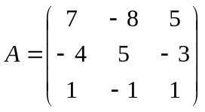
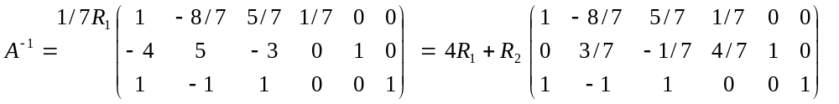
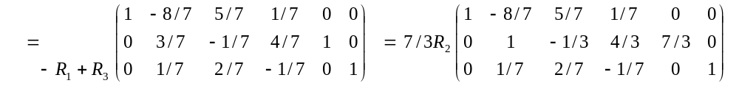
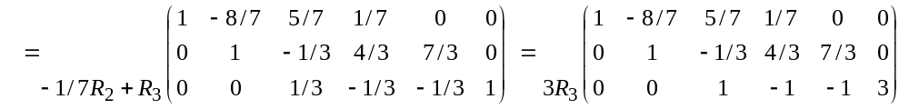
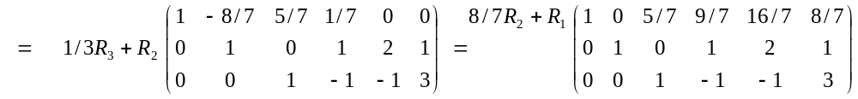
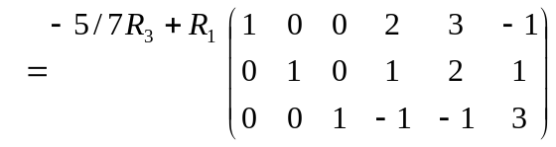

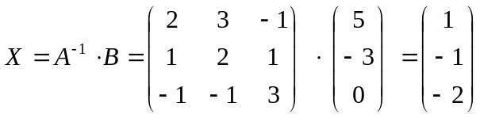 is the solution vector.

