Stage 2 Capstone Project
In Stage 2 of the capstone project, you’ll take on a real-world style challenge in ML: optimising unknown functions using limited information. Starting with this module and continuing through to Module 24, you'll follow a process that reflects how optimisation is approached in research and industry – balancing exploration, evidence and strategy. By the end of Module 24, your submission should be complete. Module 25 gives you time to fine-tune your work and, if you choose, share your results.
Let’s walk through how the challenge works and what's expected of you.
What is this challenge about?
This capstone project mimics a Bayesian optimisation-style competition, in which you will try to find the maximum of eight unknown functions, also known as black-box functions. You won't have the equations or visuals of these functions up front – just some initial data and the ability to make smart guesses.
Each function simulates a real-world task such as radiation detection, robot control or drug discovery, where evaluations are expensive or limited. This is your opportunity to apply what you’ve learned about intelligent search strategies to a realistic ML challenge. Perfect solutions are not expected. You’re encouraged to demonstrate a sound trial-and-error process throughout the capstone project.
What will you do?
You’ll be working with eight synthetic black-box functions. These are unknown mathematical functions that accept inputs and return a single output. Your goal is to find the inputs that give the highest possible output for each function.
Every function is a maximisation problem. You won't see the internal workings of the functions, but you’ll be able to observe how they respond to different inputs.
Remember, each function is:
- A maximisation task
- Initially represented by ten known (x,y) data points
- Of increasing dimensionality (from 2D to 8D)
Each week, you will:
- Review your existing data that grows week by week
- Choose a new input (x) point to query per function
- Submit your chosen input via the capstone project portal in the correct format
- Get the new output (y) once the submission is processed
- Update your data set and revise your strategy
- After each round, be encouraged to reflect on:
  - What method you used and why
  - Whether your query focused on exploration or exploitation
  - What the latest result taught you
  - What your strategy is for the next round
Note: You'll repeat this process each week, building your understanding iteratively, just as optimisation unfolds in real-world ML projects. Your weekly reflections will support your final write-up or presentation
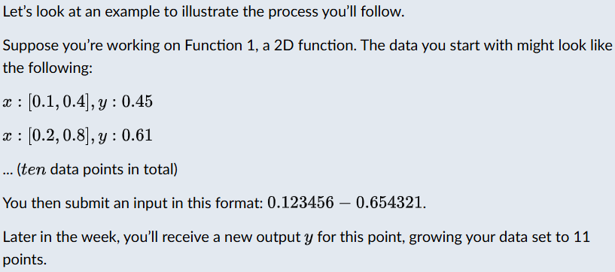
What if you don't find the best result?
That's okay! For example, one of the functions has two optima, but most will only find one. That’s still a strong result. In real-world ML, most progress is made not through perfect solutions but through thoughtful iteration and practical reasoning.
Note: make sure to submit your query and complete the required reflection each week. It’s your weekly reflection on strategy and next steps that counts towards the completion of this programme.
What techniques can you use?
You're free to use any ML method to decide what input to query next. Here are some examples:
- Random search using (np.random.uniform)
- Grid search to evaluate points on a grid, such as 10,000 points
- Bayesian optimisation using a GP and acquisition functions such as UCB
- Manual reasoning using scatter plots or your own insight to pick the next best point
- Custom surrogate models to train an ML model to predict y and guide your query
A note on what's NOT required
In Stage 2 of the capstone project, you do not need to:
- Write and submit an optimiser
- Build a full optimisation model from scratch
- Find the perfect global maximum for every function
Your task is to work with limited data, make smart decisions and reflect on your approach as you go.
Summary
Here's how the capstone project works:
- You're maximising eight unknown functions, one query per function per week.
- You choose the ML method, such as random, grid, Bayesian optimisation or manual.
- You submit your inputs in a precise format via the capstone project portal.
- You reflect, revise and iterate over several rounds.
- Your success isn't just the highest value – it’s showing thoughtful, data-driven decision-making in your reflection.

In this mini-lesson, you’ll take a closer look at the eight synthetic black-box functions you’ll be optimising. Each one is designed to mimic real-world complexity, with features such as non-linearity and multiple local maxima.
You’ll only be able to query each function occasionally, so every choice counts. Initial data Links to an external site.is provided as .npy files; use np.load() in Python to examine them.
The descriptions below highlight key properties of each function and give examples of where similar optimisation challenges arise in practice. All eight tasks are framed as maximisation problems. When a real-world objective is naturally a minimisation (e.g. side effects), we provide or apply a simple transform (such as negation), so higher is better.

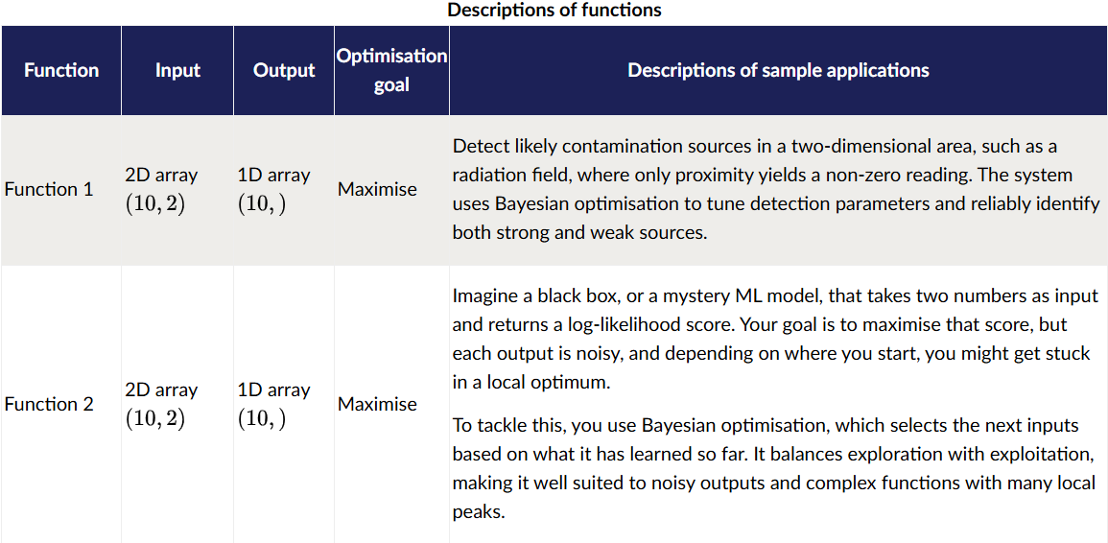
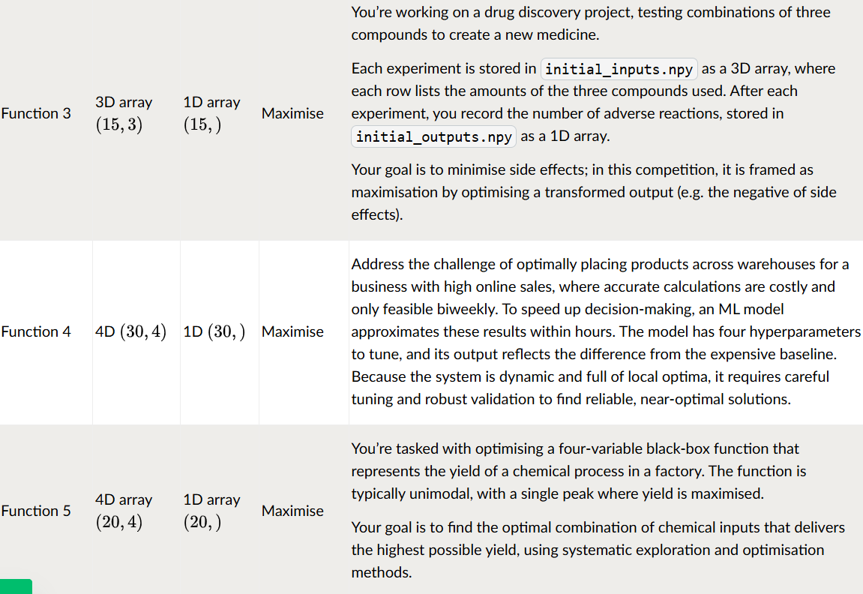
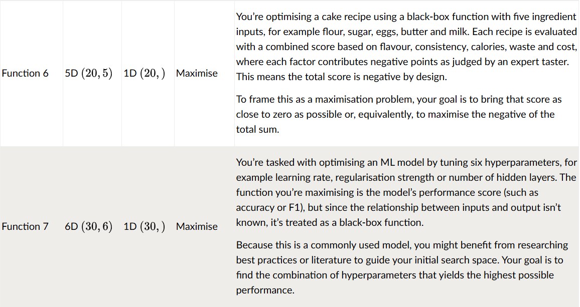
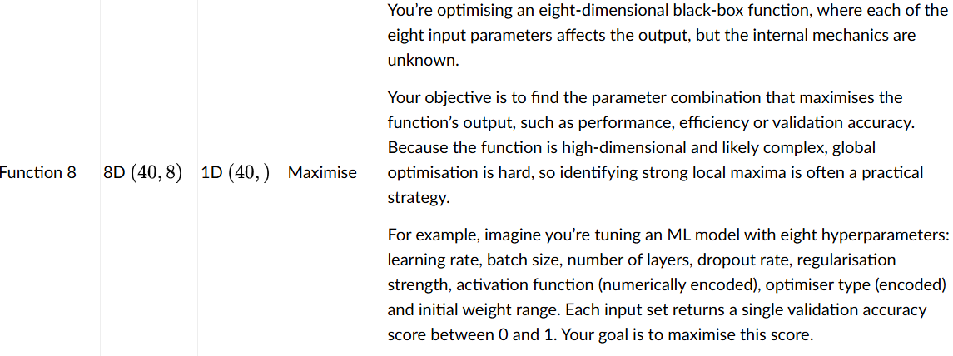

Introduction
This is your first formal submission in the capstone project’s BBO challenge. Your task is to propose a new query point for each of the eight unknown functions using the information you've gathered so far.
The activity has two parts. In part 1, you'll submit your queries using the provided capstone project portal. In part 2, you'll reflect on your strategy, specifically what guided your decision, what proved difficult and what you plan to adjust next.
This is an iterative, real-world-style optimisation task. Each week, you'll receive one new data point per function based on your submission. Your data set will grow over time, helping you improve your modelling and query strategy.
Through this activity, you will apply ML techniques to generate and evaluate query points for high-dimensional black-box functions.
Instructions
Part 1: submit your queries
- Submit your queries via the capstone project portal. Access will be provided via email with a link unique to you.
- The number of data points you work with will increase by one each module: starting with ten data points in Module 12, 11 data points in Module 13 and continuing up to 22 data points by the end of Module 24.
- For more instructions on how to access and navigate the portal, refer to this capstone project portal guide Download capstone project portal guide.
- Each query must follow this format: x₁-x₂-x₃-...-x_{n}, where each xᵢ must begin with 0 and is specified to six decimal places decimal places (for example, 0.123456-0.654321 for a 2D function).
Part 2: reflect on your approach
After you submit your query via the capstone project portal, reflect on your strategy and answer the following questions:
- What was the main principle or heuristic you used to decide on each query point (e.g. exploitation of high outputs, exploration of uncertain regions, diversity of samples)?
- Which function(s) were most challenging to query, and why? What additional information would have helped you?
- How do you plan to adjust your strategy in future rounds based on the current performance or uncertainty levels?
Completion requirements
- Submit your query via the linked capstone project portal (one response per function).
- Post your reflection on the discussion board in response to your own submission.
- Please keep your responses to under 700 words.
- Engage with peers by commenting thoughtfully on their posts.

WEEK 1 PORTAL SUBMISSION SUMMARY
================================================================================
Func | Dim | Current Best y | Submission String (x1-x2-...-xn)
--------------------------------------------------------------------------------
Func 1 | 2 D | 0.000000 | 0.829146-0.256281
Func 2 | 2 D | 0.611205 | 0.773869-0.944724
Func 3 | 3 D | -0.034835 | 0.375439-0.360518-0.460524
Func 4 | 4 D | -4.025542 | 0.384555-0.428957-0.409752-0.392875
Func 5 | 4 D | 1088.859618 | 0.314984-0.829694-0.978179-0.941555
Func 6 | 5 D | -0.714265 | 0.450383-0.325133-0.471110-0.818738-0.124614
Func 7 | 6 D | 1.364968 | 0.038644-0.565902-0.200304-0.089878-0.396909-0.792838
Func 8 | 8 D | 9.598482 | 0.050401-0.196416-0.014677-0.026846-0.870052-0.391372-0.184226-0.556620

Question 1
The primary heuristic was balancing exploration of high-epistemic-uncertainty regions with exploitation of known high-output regions using Expected Improvement (EI) derived from Gaussian Process (GP) surrogates.
For low-dimensional functions (Functions 1 & 2), grid search over GP mean and uncertainty maps revealed distinct local optima. For higher-dimensional functions (Functions 4, 7, and 8), GP surrogates demonstrated superior predictive capability ($R^2 > 0.90$), enabling EI to guide queries toward regions with high predicted mean and significant posterior variance.
Question 2
- Function 5 (4D) – Displayed an extreme output range ($0.11$ to $1088.86$), causing tree-based regressors to struggle with extrapolation beyond boundary training samples.
- Function 1 (2D) – Had extremely small magnitude outputs ($y \approx 10^{-16}$ to $-0.0036$). Standard static acquisition parameters ($\xi = 0.01$) led to flat EI landscapes. Scaling $\xi$ relative to the empirical range $\Delta y$ was essential to restore meaningful acquisition gradients.
- Function 8 (8D) – High dimensionality (8D with only 40 initial samples) creates severe volume sparsity. While the GP model fit well ($R^2 = 0.9089$), random candidate sampling requires tens of thousands of points to adequately cover the domain.
Question 3
- Dynamic Model Ensembling – As sample sizes grow from 10–40 up to 22–50+, I will weight surrogate models dynamically based on their weekly CV scores. If non-linear tree ensembles (Random Forest / Gradient Boosting) improve relative to GPs on complex functions like Function 5, we will incorporate optimistic upper bounds from tree variance.
- Hyperparameter Adaptation – We will update kernel lengthscale bounds dynamically as sample density increases to capture sharper local features.
- Exploitation Shift – In early rounds (Modules 12–15), we prioritise exploration ($\xi = 0.01$). In later rounds (Modules 20–24), I will gradually reduce $\xi$ to exploit ‘discovered’ global peaks.

