**CSE 115 Lab on Strings and 1D Array – Ara2**

1. **Passing an integer array as an argument of a function:**

#include <stdio.h>

double getAverage (int arr [] , int size);

void main()

{

int i, n;

printf("Enter size of array: ");

scanf("%d",&n);

int balance [n];

printf("Enter elements of array: ");

for(i=0;i<n;i++){

scanf("%d", &balance[i]);

}

double avg;

avg = getAverage( balance , n );

printf("Average is: %f ", avg);

}

double getAverage(int arr [], int size)

{

int i;

double avg;

double sum=0;

for (i=0; i< size; i++)

{

sum += arr[i];

}

avg = sum/size;

return avg;

}

**EXERCISE:**   
**1. Write a function that searches for a character in a string. The function should print “Found” if the character is present in that string, otherwise it should print “Not found”.  
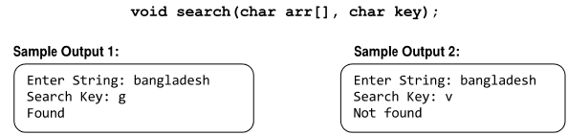**

1. **Write a function that returns the number of times an input value appears in an integer array.**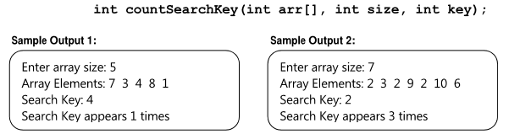
2. **Write a program that reads a string from user and then computes the number of whitespace characters (‘ ‘ or ‘\t’) in it. Use a function for this purpose.**
3. **Write a program using function that reads the size and elements of an float array from user and then computes the average of the numbers in it and prints it. Then it should compute number of elements which are greater than average and prints those elements. Sample input/output:**

Enter array size: **5**  
Enter elements: **12**

**13**

**16**

**15**

**14**

Average = 14.000000

The elements > average are: 16, 15

**Assignment:**

1. **Write C program using function to count the number of capital letters as well as the number of small letters in an input string and print those numbers.**
2. **Write C program using function to check if an input string is a palindrome or not. E.g. “madam”, “dad”, etc. are palindromes.**
3. **(bonus) Implement the following function which compares two strings.**

