We identified a few results in our screening tool this month that I couldn’t quite explain or figure out. I also wanted to confirm the SAMS search is looking at the first 5 characters of the last name now and that the tool is still searching entries that contain fewer characters than our default search criteria.

1. **Missouri EDL Search Results**

We ran a search today using the screening tool you’ve developed, and this is the first time it identified a potential match on the Missouri EDL List:

Missouri EDL List:

* Can we please have the dates in the results for all data sets in mm-dd-yyyy format?

update

* I’m attaching a copy of the employee data file we were searching. I don’t find a Gregory Ging on the employee list. There is a Gregory Lynn Ging in the Missouri EDL List but I cannot determine what employee was causing this potential match to be identified.

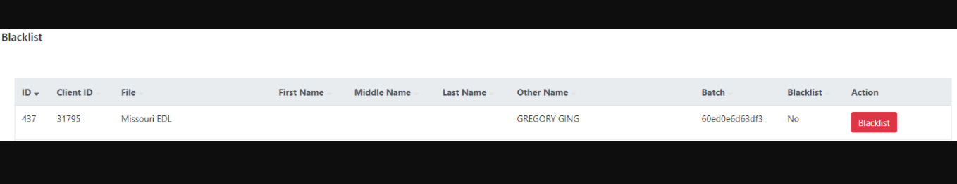

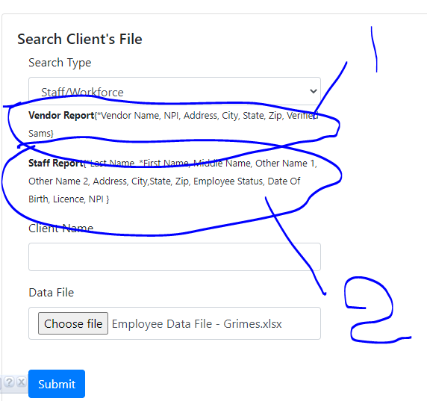

Can you check this when we do search we have 2 options one is vendor and one is staff report ..  
  
the file that you mention employee data file – Grimes contains one extra column that should not be there file columns should always match what we have in staff report (see 2 on screenshot )

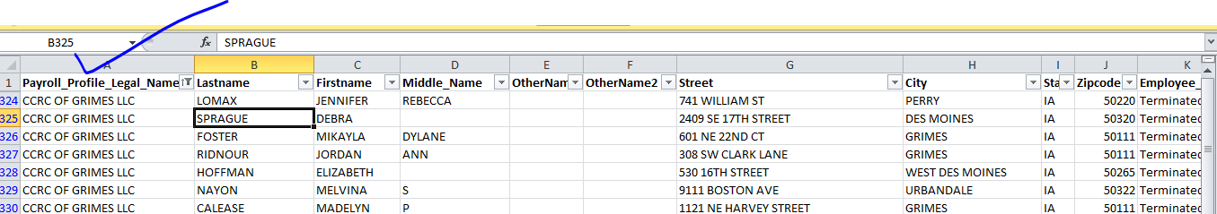

2nd issue is you tried to search vendor report but your file is for staff report not for vendor so that’s why you are seeing unwanted matches….



It doesn’t seem to be displaying in the Blacklist area correctly. There is no first or last name identified:

No we can’t use different format else our application will not work properly we need to use same format that is provided on search page and try then check below screenshot for format

we can’t use any else column other then that in search file.

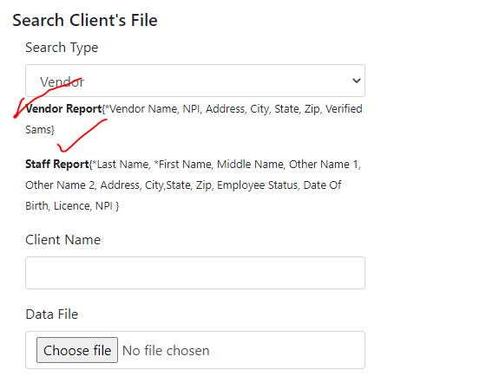

1. **SAMS Results**

I cannot locate the employee causing these matches to be identified (see Employee Data File – Grimes attached). I want to make sure the results are displaying the first and last name of the *employee* creating the potential match, and not the individual on the underlying SAMS Exclusion List.

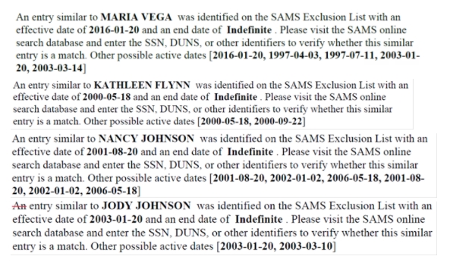

For Sam now we have updated query

First Name 5 characters   
Last Name 5 characters   
and Middle name 4 characters

These all 3 conditions should be true lets save if first name has only 3 characters then it will use 3 characters maximum characters is 4 and same for other conditions (last name and middle name )

1. **OIG Screening Results**

I cannot find the individual employed by CCRC of Overland Park who is creating this potential match:

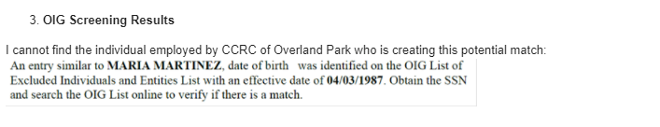

Can you please url where I can find that problem?

Am not able to find this page can you please tell me where I can find that page

I am trying to add a user to my coding query tool you designed, but the user is not able to log in. It’s my first attempt to add a new user and I’m hoping you can identify where I may be going wrong.

<https://codequery.richellemarting.com/admin/login>

New User Adarsh Kul

I added the user and his email address. I selected “verified” and entered a password for him. If I try to log in using the credentials I gave him, it doesn’t work.

Updated and fixed

Can you please reconfirm

[test_user@manaknight.com](mailto:test_user@manaknight.com)  
test_user2  
Add and Edit both are working I tried one test

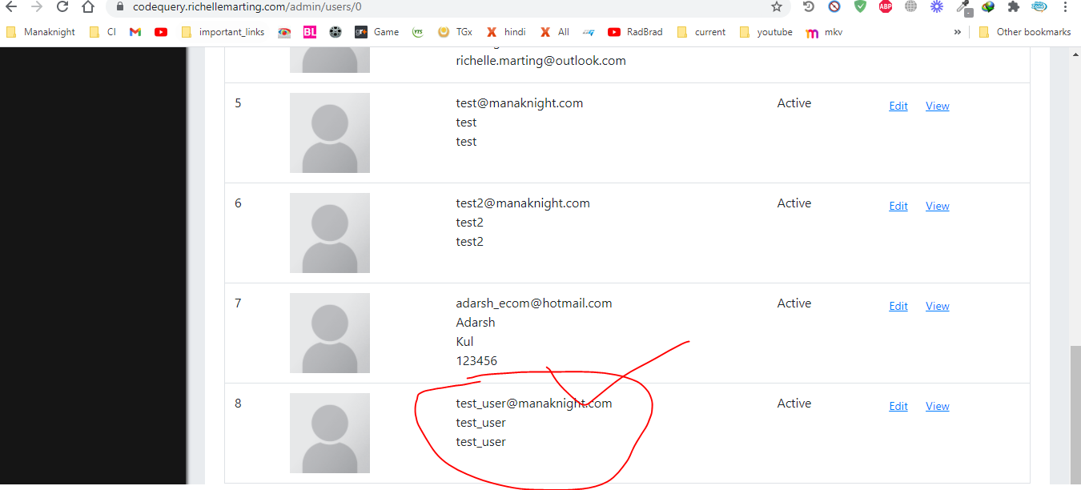

I was importing a data file today, and when I was reviewing the Import Data screen, it shows the last several months’ screening files are “Pending”.  Can you check to see if our monthly searches have been checked against the most current screening files, and why they’re showing as pending after several months still?

Can you please url where I can find that problem? And also can you find file as well so I can test it

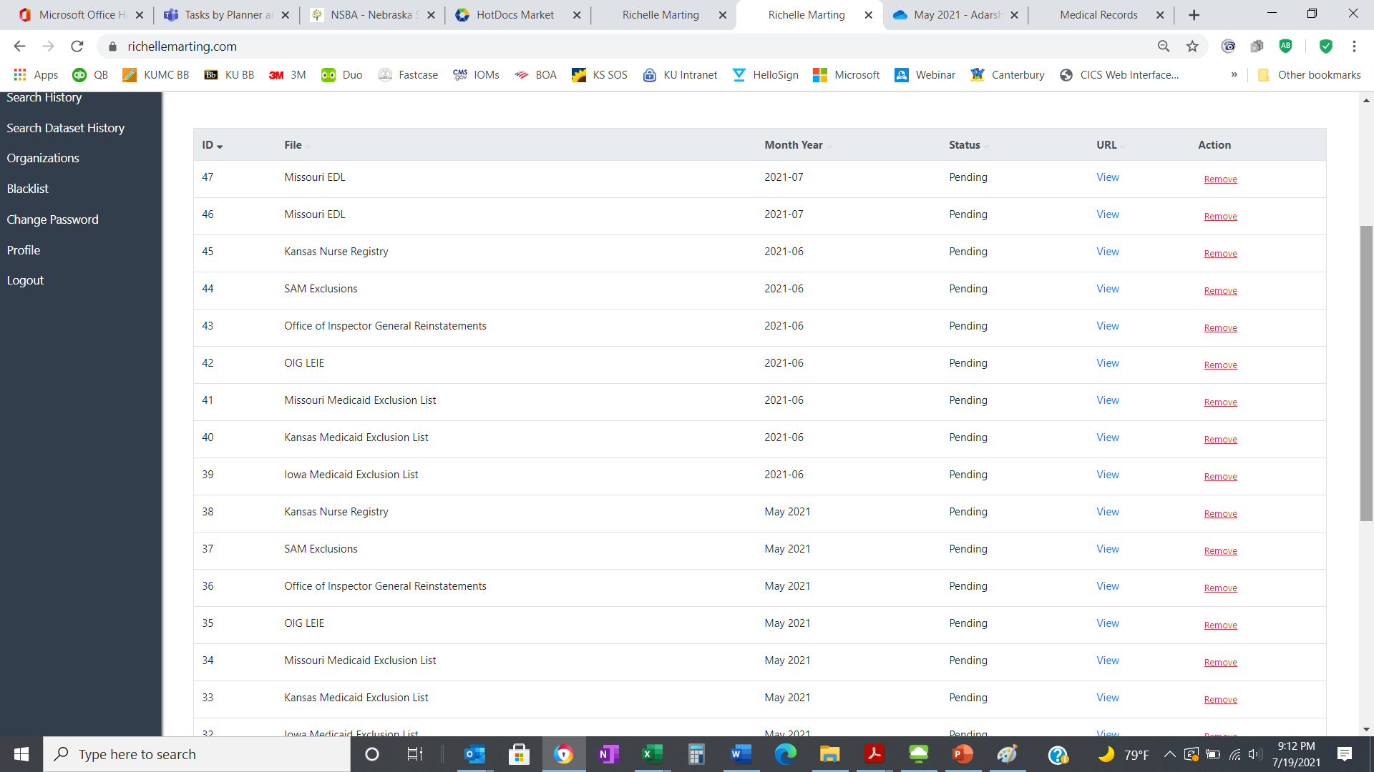

The issue was been fixed now all updates went successful. Office of inspector general was having some issue