TC_FUNC_01

Login to the system



Click Account Tab



Under the “My Profile Tab” Select either Male or Female

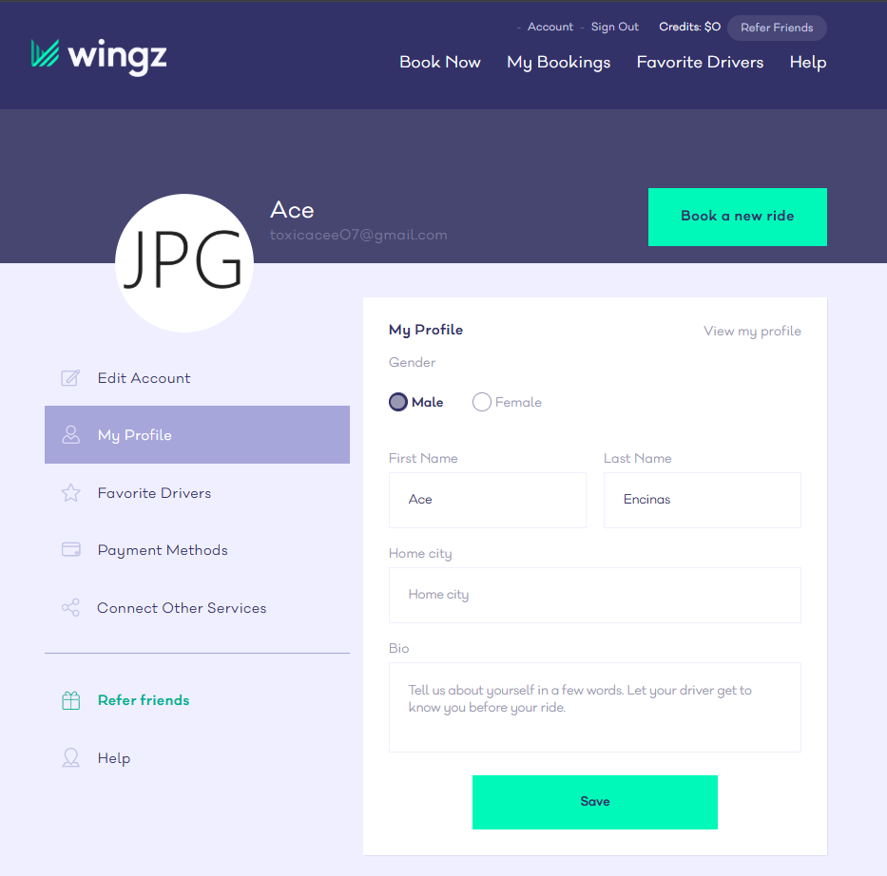

Verify if the system allow sthe user to select one option at a time

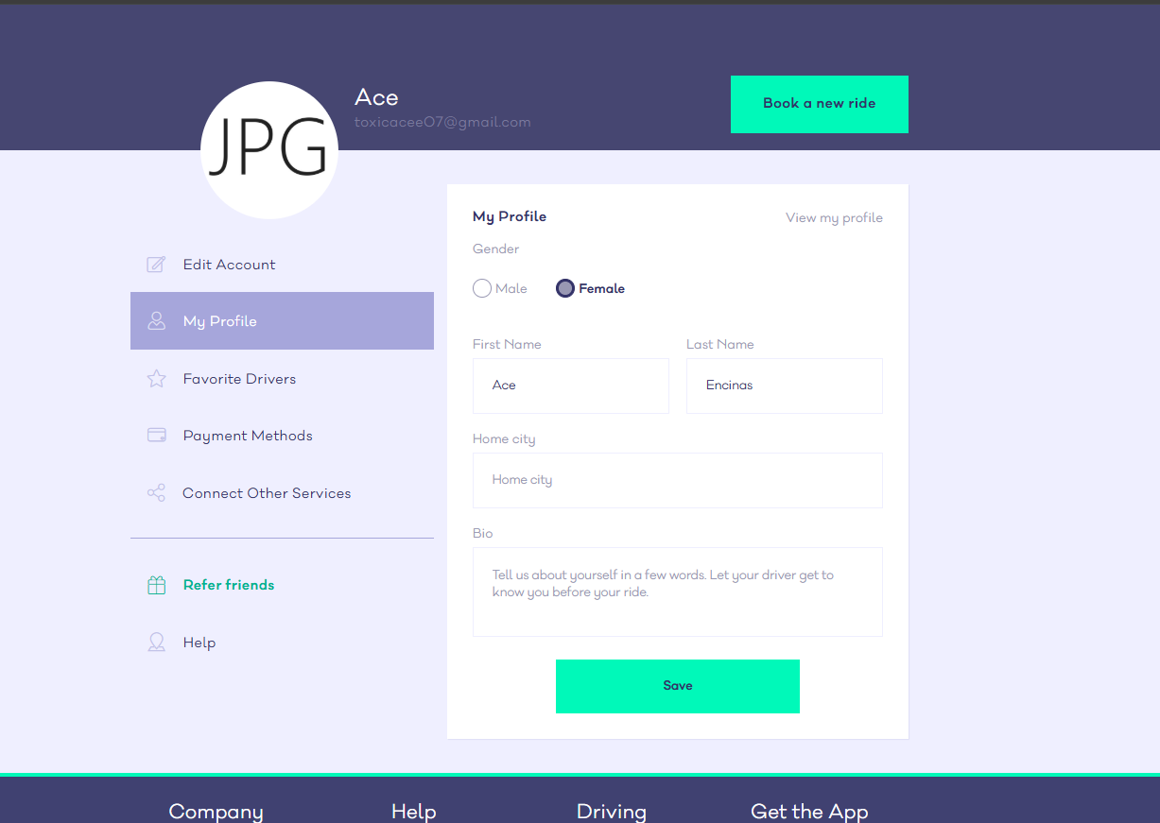

PASS