%Rate struck only affects the Acc.Penalty

Fig 1.1

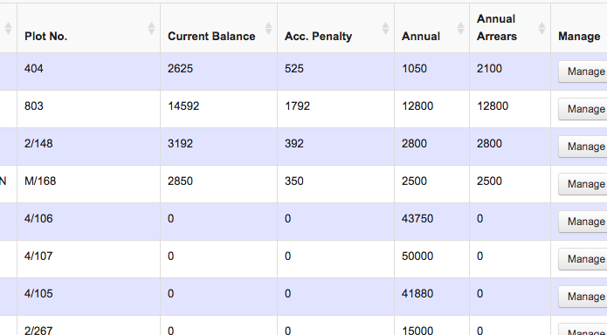

Rates Struck Concept-Fig 1.2

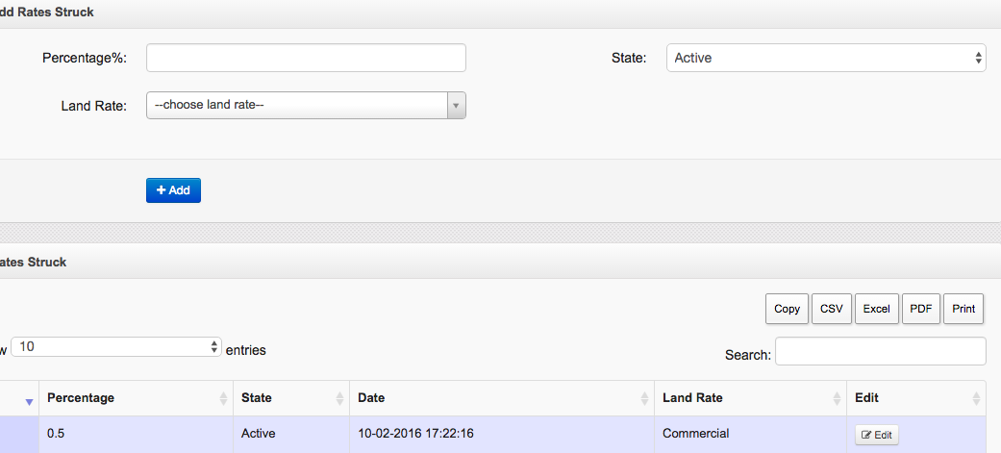

Date_Rage

s

s

Rates

Run

All

Year

All

**Changes**

1. The percentage is an input parameter that can be from zero to 100%
2. The percentage rate struck only affects the {Acc penalties} field for all land rates as indicated in Fig 1.1.
3. Fig 1.2 shows some changes to the original rates struck view. The idea is the waiver should affect no a single land rate file but all files regardless of their category.
4. When you execute the run command all land rates accumulated penalties should be computed based on the percentage.
5. The waiver is effected on a given date range say from October 15th to November 5th.if the range expires the Penalties revert to the original computations.
6. Maintain the two fields in Land Rates View {Acc. Penalty} and {Waiver Penalty} but within the waiver period the balance should be computed from the new {Waiver Penalty},when the period expires there should be a revert process to the previous penalties.