**Web design and development**

Technical discussion

At the beginning of the assignment I was required to design a presentation page with title of which it was suppose to disappear after three seconds. The challenge there was putting 3 in place of 3000 within the timing of javascript code . This is the code that made it execute successful.

<script>

setTimeout(function(){

window.location.href = 'http://127.0.0.1:5500/Main%20page.html';

}, 3000);

</script>

The second challenge was at the main page where I was required to add some link like a button this links where supposed o take user to three other pages I manage to add a button like link with the given below sample code.

<div>

<a href="http://127.0.0.1:5500/queryform.html"><button>Query form</button></a>

</div>

By clicking this links it will take you to the respective web pages. The second challenge on the main page was to upload a svg vile which I used css and its path to take control.

On the cv page the challenge was to code the anchors to take users to various sections ,This simple code was enough to take me through the challenge.

<a href="#skills and competencies"><button>Skills and Competencies</button></a>

<a href="#career objectives"><button>Career Objectives</button></a>

<a href="#personal review"><button>Personal Review</button></a>

<a href="#education background"><button>Education background</button></a>

<a href="#work experience"><button>Work experience</button></a>

<a href="#referees"><button>Referees</button></a>

The other part was the query form. The form included input field to key in full name and email ,the form also has three radio button of which only one out of the three was to be checked.

The form alsa has a text erea whre users can key in theire inputs.

This code is responsible for creating check buttons.

<label for="programming-experience">Programming Experience</label>

<input type="radio"id="subjectchoice" name="nameA" value 1>

when the user on query form page clicks the view on the view button the existing page should disappear and a new page with the inputs . to facilitate this I used javascript innerHTMl where I assigned the button a fuction which when clicked it will take the element IDs and pass them to the them, this is the javascript code that facilitated .

</heading>

<script>

function myFunction()

{

var fname = document.getElementById("fullname").value;

var femail = document.getElementById("e-mail").value;

The code should check an empty input field and send alert message to the user this was possible through the following javascript conditional code.

if (!fname ){

alert ("please input full name");

return;

}

if (!femail)

{

alert ("please input email");

to take get the edit and send button I created the button using the sample code below.

let btn = document.createElement("button");

btn.innerHTML = "send";

document.body.appendChild(btn);

MY WEB PAGES SCREENSHORTS

this is the presentation page.

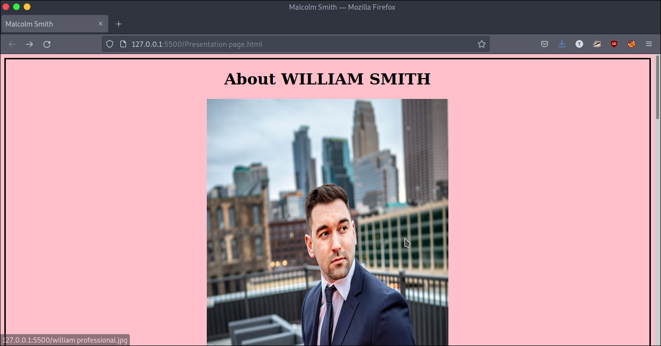

Below screenshort is the main page

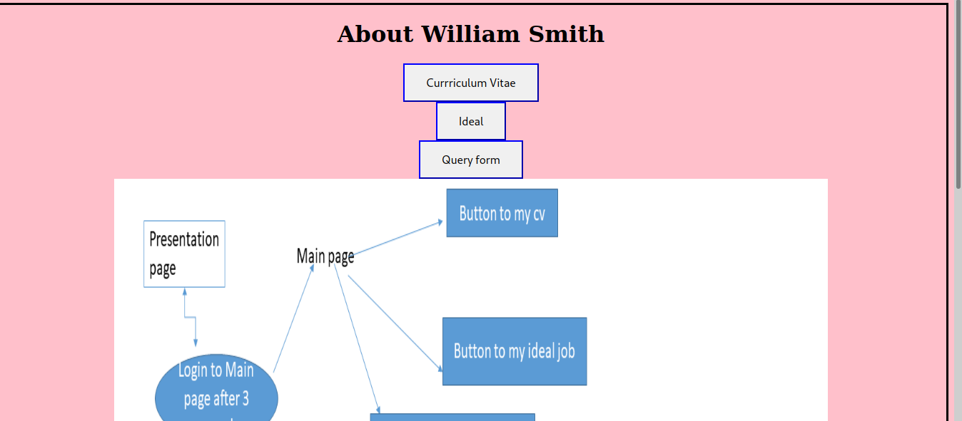

The screen short below shows a sample of Curriculum Vitae page

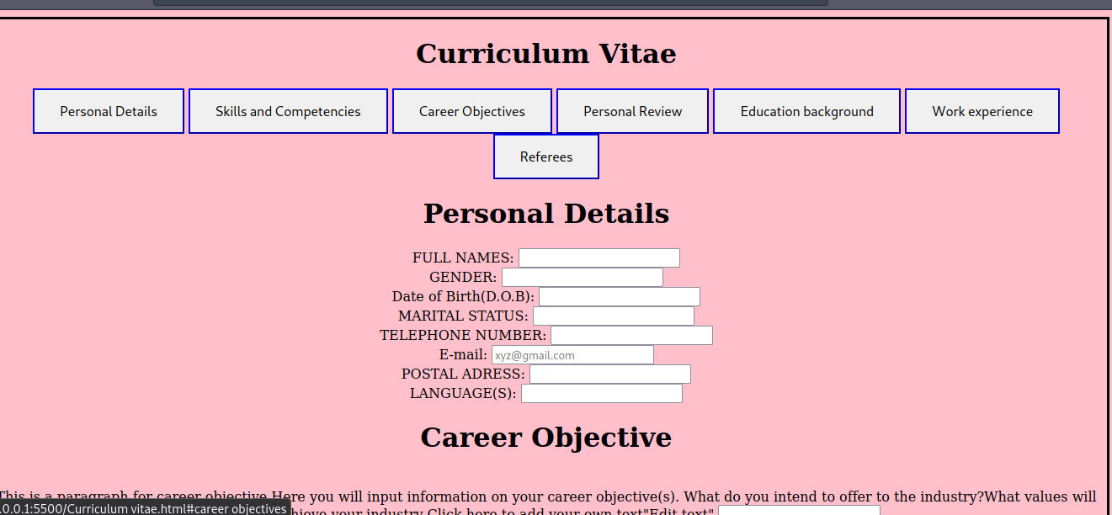

the screen short below is about my ideal job

