Adapting Parking-Occupancy Recognition to Snow-Covered Scenes with Hidden Road Markings: A Camera-Held-Out, Error-Constrained Evaluation
Togzhan Serik and Amina Kaliyeva Astana IT University, Astana, Kazakhstan

Abstract
Camera-based parking guidance usually depends on visible slot markings and on vehicle appearance learned in fair weather, and snow can remove both. We study how to adapt an occupancy classifier to snow-covered scenes when painted markings may no longer be visible. Fixed surveillance cameras make this tractable: each camera’s slot polygons are annotated once, so recognition no longer depends on detecting the markings in each frame and reduces to classifying fixed image regions. Using the 440 snow-tagged frames of the public SPKLv2 dataset, captured by four camera views, together with its 763 non-snow frames, we compare four adaptation strategies built on the same frozen ImageNet ResNet-18 encoder and a logistic head. The strategies are non-snow training alone, model and threshold selection using winter validation data, synthetic snow augmentation, and supervised training with real winter images. An approximately size-matched control and a learning curve examine the amount and composition of training data. For B2, S1, W1 and W2, regularisation and thresholds are selected on an independent winter camera; evaluation uses 12 test/validation camera pairs. We report free recall at an operating point constrained to a 5% false-free rate on validation, with frame-cluster bootstrap intervals. Real-winter adaptation reduces pooled AP(free) from 0.641 to 0.605; the paired difference is −0.0364 [95% CI: −0.0532, −0.0199]. Test false-free rates reach 0.112 for the winter-validation baseline and 0.159 for real-winter adaptation, exceeding the validation target. Polygon masking raises AP to 0.701 and 0.709, respectively. The findings motivate closer control of crop context, illumination and occlusion; a verified heavy-snowfall, hidden-marking subset is not yet available.
Key Words: parking occupancy detection; adverse weather; snow; domain adaptation; transfer learning; threshold selection; intelligent transportation systems.

Introduction
Vision-based parking guidance estimates which spaces in a lot are free from one or a few fixed cameras, and is a low-cost alternative to per-space sensors [1, 2]. Established datasets such as PKLot and CNRPark-EXT support this formulation through labelled parking-space regions [1, 2]. Their standard weather categories include sunny, overcast and rainy conditions. Strong performance under these conditions does not establish robustness to snow. In cities with long winters, such as Astana, the deployment conditions are different: snow lies on the ground and on vehicles, it falls in front of the lens, and it covers the painted lines that delimit the spaces. Prior work explores thermal sensing in difficult outdoor conditions [13] and automatic slot localisation [7]. Here, we examine occupancy recognition on snow-tagged images while keeping the slot layout known.
Snow raises two distinct problems. The first is geometric: if the markings are hidden, an algorithm that locates slots from paint cannot work. The second is photometric: a snow-covered car on a snow-covered ground has little contrast, and a classifier trained in fair weather faces a distribution shift. For the common case of a fixed camera, the geometric problem has a simple, well-established remedy. The slot polygons are annotated once, when the camera is installed [1, 2, 11], and occupancy is then decided per polygon without looking for lines. This study adopts that geometry prior and asks how best to solve the remaining photometric problem. Inferring an unknown layout without markings is a different task, which we do not address.
Several adaptation strategies are available. They include: (i) keep a non-snow classifier and select its regularisation and decision threshold on labelled winter images; (ii) simulate snow on fair-weather images [10]; and (iii) collect and label real winter images (supervised domain adaptation [19]). We compare these strategies under the same camera-held-out protocol and examine their false-free errors. Answering it is complicated by three practical issues that we found in our own pilot study. First, winter footage contains many night images, so a “winter” gain may really be a night gain. Second, gains in average accuracy can hide an increase in the most harmful error, where a driver is sent to an occupied space. Third, consecutive frames from one camera are strongly dependent, so per-crop statistics overstate the evidence.
Contributions. We do not propose a new architecture. Our contribution is empirical and methodological:
- A camera-held-out, error-constrained evaluation protocol for parking occupancy under snow. Model and threshold selection use an independent winter camera, and models are compared at an operating point constrained on validation, without assuming the bound transfers to test.
- A controlled comparison of winter-validation, synthetic-snow and real-winter adaptation on real snow footage. It includes an approximately size-matched control, illumination-stratified analysis examining snow and night, and a learning curve over the number of labelled winter frames.
- A two-reviewer annotation protocol for falling-snow intensity and marking visibility, intended to enable a verified heavy-snowfall, hidden-marking evaluation. Completed labels and agreement statistics are not yet available.
- A notebook implementation that downloads the public data and implements seeded experiments, result export and error analysis.

Related Work
Parking-occupancy datasets and classifiers. PKLot [1] established the standard formulation: fixed cameras, annotated space regions and a binary occupancy label, under sunny, overcast and rainy weather. CNRPark-EXT [2] added more cameras, seasons and viewpoints, and showed that a compact CNN (mAlexNet) classifies space patches accurately enough for embedded deployment. Marek [11] used annotated quadrilaterals as region proposals for R-CNN-style models and reported strong performance on held-out parking lots. Martynova et al. [12] compared patch-based and detector-based pipelines across five datasets, including their SPKL dataset, which contains 440 snow images among 1,203 frames from five parking areas. They observed that existing systems generalise poorly across visual conditions. These studies motivate evaluating visual-condition transfer; our experiments use SPKLv2 rather than training on PKLot or CNRPark-EXT.
Slot detection without markings. Grbic´ and Koch [7] detect slot positions automatically from vehicle detections accumulated over time, so manual polygon annotation is not needed. Thermal cameras have been proposed for dark and snowy conditions [13], but they need dedicated hardware and lose contrast when parked cars cool down. Our work is complementary: it assumes a one-time polygon annotation, as in [1, 2, 11], and studies the appearance shift that remains once the geometry is known.
Adverse weather and domain shift. Robustness to weather is studied in driving-scene understanding, for example with the ACDC dataset of fog, night, rain and snow [17], and with synthetic corruptions, including snow, in ImageNet-C [10]. Domain adaptation methods range from supervised fine-tuning with a few target labels to unsupervised feature alignment [19]. For parking specifically, Satyanath et al. [18] prepend a dehazing network to a patch classifier for hazy images. We compare simple training-data strategies while keeping the encoder fixed; the comparison does not cover every adaptation family. Features of a frozen ImageNet encoder [4, 9] are known to transfer well [20].
Calibration and operating points. Under a shift in class priors or appearance, a classifier’s scores can keep their ranking while its threshold becomes wrong [16, 8]. We therefore separate ranking quality, measured by average precision, from the operating point, and compare models at a threshold constrained on validation. Threshold selection is distinct from fitting a probability-calibration model, and its error bound need not transfer to a new camera.

Method

Problem formulation
A fixed camera view v observes S_{v} parking spaces with polygons P_{v,1}, . . . , P_{v,S}v , annotated once. For a frame I and space s, let x_{s} = crop(I, P_{v,s}) be the axis-aligned bounding box of the polygon, resized to 128 × 128 pixels, and y_{s} ∈ {0, 1} its label (1 = occupied). A frozen encoder ϕ (ResNet-18 pretrained on ImageNet [9, 4], 512-dimensional output) is followed by a logistic head on standardised features:
$p̂ₛ = σ(wᵀ std(φ(xₛ)) + b), ŷₛ = I[p̂ₛ ≥ τ]. (1)$
The head minimises class-balanced, L₂-regularised cross-entropy with inverse regularisation strength C. Freez-ing ϕ keeps every strategy on the same representation, so the comparison focuses on training data, regularisation selection and operating points rather than encoder fine-tuning.
Because the geometry is fixed, recognition never relies on the visibility of painted lines; hidden markings affect the method only through the appearance of the crop. Fig. 1 summarises the pipeline.

Adaptation strategies
All strategies share ϕ and the head architecture (Table 1).
B0 (majority). Always predicts “occupied”. It is a reference for imbalanced test sets.
B1 (source-only). Head trained on non-snow frames. C is selected by grouped 3-fold cross-validation over non-snow frames, and τ = 0.5. This is the source-only reference.
B2 (winter validation). Same training data as B1, but C and τ are selected on a labelled winter validation camera. This changes both regularisation selection and the threshold; it does not fit a probability-calibration model.
S1 (synthetic snow). Each clear crop is duplicated with a synthetic snow rendering (Section 3.3); selection as in B2; three augmentation seeds.
W1 (supervised winter adaptation). Head trained on non-snow and real snow frames of the training cameras; selection as in B2.
W2 (size-matched control). Approximately the B2 crop budget, split between non-snow and winter examples and sampled by whole frames; five seeds. Whole-frame sampling may exceed the requested budget and changes the condition mixture as well as quantity.

Synthetic snow
The synthetic baseline uses a seeded, label-free generator applied to a clear crop a ∈ [0, 1]^{H×W} ^{×3}. It has three components: (i) lying snow: a smooth random field n (bicubically upsampled 5×5 noise, Gaussian-blurred) defines a soft mask m = α clip(2.5(c − n) + 0.5, 0, 1), with coverage c ∼ U (0.25, 0.75) and opacity α ∼ U (0.45, 0.85); then a ← (1 − m) a + m w with w ∼ U (0.82, 0.97). This can obscure local appearance, including visible line fragments. (ii) haze: a ← (1 − h) a + h g with h ∼ U (0.05, 0.35) and g ∼ U (0.7, 0.85).
(iii) falling snow: 15–90 short white streaks with a common random inclination. The generator is deliberately simple and does not model night illumination. It represents a typical low-cost augmentation, not the best possible snow simulation.
Frozen ResNet-18
ϕ(x) ∈ R⁵¹²
Logistic head standardised features
Threshold τ
free / occupied
Per-space crop
128 × 128
Independent win-ter validation
B2, S1, W1, W2
Training data non-snow / syn-thetic / winter
Slot polygons annotated once
Snow frame (fixed camera)
Figure 1: Pipeline. Known polygons remove the need to detect painted lines in each frame. The adaptation strategies differ only in the data used to train the logistic head and in how C and τ are selected.
Table 1: Compared strategies. All share the frozen ResNet-18 encoder and the logistic head.
ID | Training data | Selection of C, τ | Seeds
B0 | – | – | –
B1 | non-snow frames | grouped CV on non-snow; τ =0.5 | 1
B2 | non-snow frames | winter validation camera | 1
S1 | non-snow + synthetic-snow copies | winter validation camera | 3
W1 | non-snow + real snow frames | winter validation camera | 1
W2 | as W1, approximately B2 size | winter validation camera | 5

Operating points
The false-free rate is the fraction of occupied spaces incorrectly reported as free:
$FFR = \frac{FNocc}{TPocc + FNocc}$
Two thresholds are selected on the validation camera by exhaustive search over its scores: τF1 maximises macro-F1, and
τ_safe = argmax over τ of FreeRecall_val(τ), subject to FFR_val(τ) ≤ 0.05. (2)
The test camera is never used for selection. “Safe” is according to the notebook notation where the 5% constraint is on validation and not the same error rate on a camera held out.
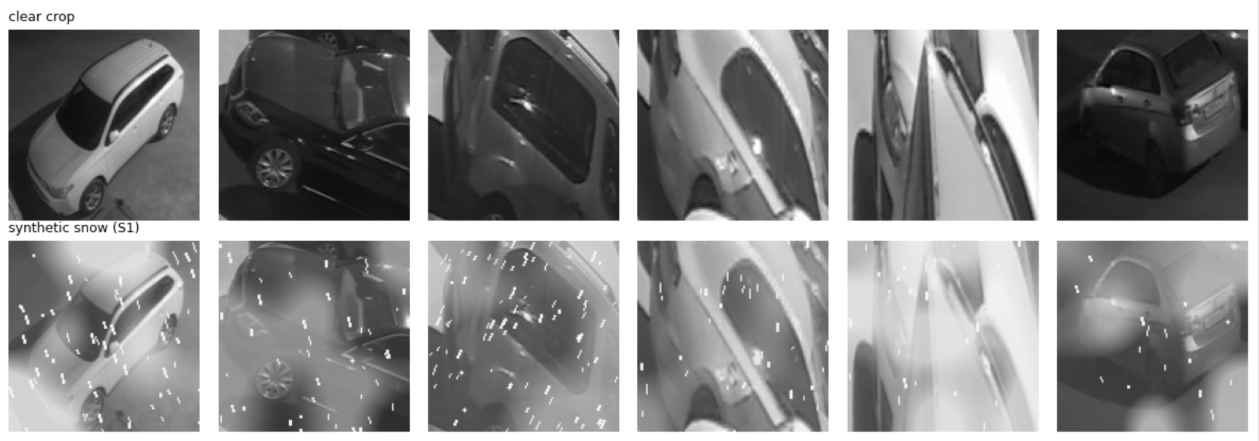
Figure 2: Non-snow crops (top) and synthetic-snow variants (bottom), extracted from the supplied notebook output. This is one inexpensive appearance-corruption baseline, not a physical snowfall model.

Experimental Setup

Data
SPKLv2 [12] supplies per-space quadrilaterals, binary occupancy labels and image-level condition tags. The supplied run contains 1,203 unique frames: 440 Snow frames from four winter camera views and 763 non-snow frames. The latter are matched to winter views when image dimensions and slot counts agree and the symmetric nearest-centroid distance is within 2% of image width. Unmatched frames form additional training views. This is an inferred geometry-based assignment and should be manually checked. No byte-identical duplicates were removed in the supplied run. Illumination is classified from tags as day, night RGB or infrared.
Table 2: Data composition after view assignment. Counts refer to unique frames and crops, before repeated test folds.
View | Condition | Day | Night | Infrared | Crops | Free crops
cam1 | snow | 51 | 80 | 2 | 1,729 | 220
cam2 | snow | 36 | 17 | 89 | 2,982 | 586
cam3 | snow | 39 | 69 | 0 | 2,376 | 671
cam4 | snow | 35 | 22 | 0 | 2,280 | 70
cam1 | non-snow | 166 | 23 | 65 | 3,302 | 287
cam2 | non-snow | 0 | 0 | 258 | 5,418 | 2,025
other 01 | non-snow | 167 | 3 | 81 | 1,255 | 175
Total | all | 494 | 214 | 495 | 19,342 | 4,034
The winter subset contains 9,367 unique crops, including 1,547 free crops (16.5%). Its 440 frames comprise 161 day, 188 night and 91 infrared images. cam4 has only 70 unique free crops, so its minority-class metrics require caution.
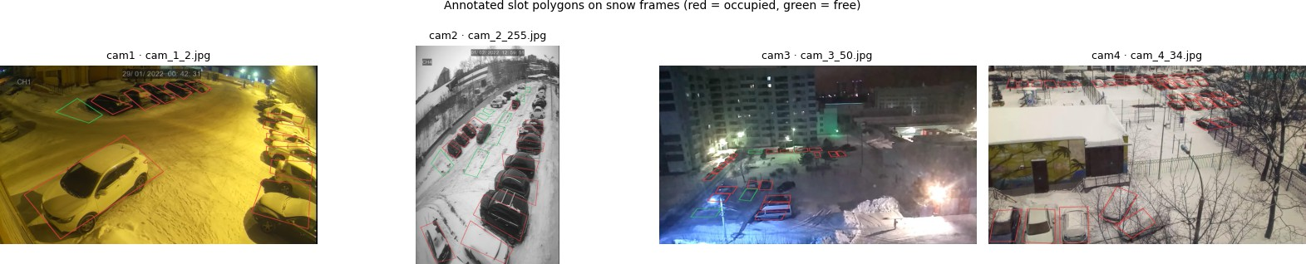
Figure 3: Snow-tagged examples from the four winter camera views. Red polygons indicate occupied slots and green polygons free slots. The illustration establishes known-region annotation, not a verified heavy-snowfall or hidden-marking subset.

Protocol
We use leave-one-snow-camera-out with an independent winter validation camera. For every ordered pair (t, v) of distinct snow cameras (12 folds), the test set is the snow frames of t and the validation set is the snow frames of v. The training pool contains every frame, snow or not, from all views except t and v. No frame of the test camera, including its clear-weather frames, is used for training or selection. C is chosen from {0.003, 0.03, 0.3} by the average precision of the free class on validation. The headline results pool all 12 folds. Each camera is tested against three validation-camera choices, producing 28,101 fold–crop rows from 9,367 unique winter crops. These repeated rows are not independent observations.

Metrics and statistical analysis
Free spaces are the minority class (and the one a driver needs), so we report average precision of the free class, AP(free), as the threshold-free ranking measure. At each operating point we report macro-F1, balanced
accuracy, FFR, free recall = TN/(TN + FP ) and free precision = TN/(TN + FN_{occ}). Spaces in one frame are dependent, and so are frames close in time. Confidence intervals (95%, percentile) therefore come from a cluster bootstrap [6, 5] that resamples whole frames with replacement within each test camera (B = 2000). All crops and repeated fold predictions of the same physical frame remain in one cluster. Differences between strategies use paired resamples. For seeded strategies (S1, W2), probabilities are averaged over seeds and decisions are taken by majority vote over seeds.

Pre-specified hypotheses
The original v2 notebook specifies the following hypotheses and decision rules: H1: W1 ranks free spaces better than B2 (95% CI of ∆AP(free) above zero). H2: at τ_{safe}, W1 keeps the test FFR ≤ 7% (the 5% target plus 2 percentage points) and has higher free recall than B2 (CI above zero). H3: the H1 gain holds separately in the day and the night strata. H4: W1 ranks free spaces better than S1 (CI above zero).

Condition annotation
The Snow tag does not separate falling from lying snow and does not establish whether painted markings exist beneath the snow. The notebook implements a review interface that displays a raw winter frame, hides predictions and shows a same-view non-snow reference where available. The intended protocol uses two independent reviewers. Snowfall categories are none visible, light, heavy and unknown; marking categories are visible, partial, hidden, unmarked and unknown. “Hidden” requires reference evidence that painted lines exist but are obscured; snow-covered ground alone does not establish heavy falling snow.
Agreement would be assessed with Cohen’s κ [3], followed by a consensus heavy-plus-hidden subset analy-sis if sufficient examples exist. Completed independent labels, agreement statistics and subset metrics were not supplied. The current evaluation therefore concerns snow-tagged scenes rather than a verified heavy-snowfall, hidden-marking condition.

Implementation
The experiments use PyTorch [14], torchvision and scikit-learn [15]. All randomness is seeded (global seed 2026). The notebook implements downloads, feature extraction, training, evaluation, figures and provenance export. Results in this revision were transcribed from the supplied experiment screenshots; raw predictions and bootstrap intervals were not independently recalculated here. Hardware and complete dependency-version records were not supplied, so timing claims remain limited to the logged run.

Results
The following results are taken from the supplied v2 experiment outputs. The pooled tables combine the 12 ordered test/validation camera pairs; repeated predictions of the same physical frame are retained within the same bootstrap cluster.

Main comparison
Table 3 pools the 12 folds. With bounding-box crops, W1 achieves AP(free) of 0.605 [0.559, 0.648], compared with 0.641 [0.600, 0.679] for B2 and 0.645 [0.604, 0.685] for S1. Adding real winter examples does not improve pooled ranking in this bounding-box configuration. The W1–B2 difference is −0.0364 [−0.0532, −0.0199], so H1 is not supported.
At τ_{safe}, W1’s free recall is 0.600, but its improvement over B2 is only 0.0088 [−0.0026, 0.0199]. In contrast, its false-free rate increases by 0.0477 [0.0427, 0.0528]. W1’s test FFR of 15.9% exceeds the proposed 7% tolerance, and the recall difference includes zero; H2 is not supported.
The 5% validation constraint does not transfer to the unseen test cameras. Test FFR is 0.112 [0.103, 0.121] for B2, 0.086 [0.079, 0.095] for S1 and 0.159 [0.151, 0.168] for W1. At W1’s free precision of 0.427, fewer than half of the spaces announced as free are truly free in the pooled observations.
Table 3: Pooled bounding-box test results over 12 camera pairs. “Safe” follows the notebook notation and means validation-constrained, not guaranteed safe on test. All entries are proportions.
Model | Policy | AP(free) | Macro-F1 | Bal. acc. | FFR | Free recall | Free prec.
B0 | Always occ. | .165 | .455 | .500 | .000 | .000 | –
B1 | Default | .648 | .756 | .805 | .140 | .751 | .514
B2 | F1 | .641 | .744 | .749 | .091 | .589 | .560
B2 | Safe | .641 | .725 | .740 | .112 | .591 | .512
S1 | Safe | .645 | .738 | .737 | .086 | .561 | .563
W1 | Safe | .605 | .687 | .720 | .159 | .600 | .427
W2 | Safe | .600 | .690 | .722 | .156 | .600 | .432
W1 | F1 | .605 | .718 | .736 | .121 | .593 | .492
Table 4: Paired differences at τ_{safe}, with supplied 95% frame-bootstrap intervals. Positive ∆FFR indicates more occupied spaces incorrectly reported free.
Comparison | ΔAP(free) | ΔFree recall | ΔFFR | ΔMacro-F1
W1 − B2 | −0.0364  [−0.0532, −0.0199] | 0.0088  [−0.0026, 0.0199] | 0.0477  [0.0427, 0.0528] | −0.0381  [−0.0439, −0.0332]
W1 − S1 | −0.0408  [−0.0574, −0.0234] | 0.0390  [0.0271, 0.0508] | 0.0731  [0.0684, 0.0776] | −0.0503  [−0.0562, −0.0444]
W1 − W2 | 0.0043  [0.0014, 0.0067] | 0.0000  [−0.0052, 0.0050] | 0.0032  [0.0011, 0.0052] | −0.0026  [−0.0052, −0.0001]
S1 − B2 | 0.0044  [−0.0073, 0.0161] | −0.0302  [−0.0404, −0.0192] | −0.0253  [−0.0284, −0.0222] | 0.0122  [0.0068, 0.0177]
S1 shows no clear AP advantage over B2 because the paired interval includes zero. It lowers FFR at the selected operating point while also lowering free recall. W1’s AP is below S1’s, so H4 is not supported. W2 remains close to W1, suggesting that the approximate training-size control does not remove the negative-transfer pattern.

Snow versus illumination
Table 5: Illumination-stratified test results at τ_{safe}.
Illumination | Model | AP(free) | FFR | Free recall
Day | B2 | .751 | .099 | .608
Day | S1 | .754 | .082 | .574
Day | W1 | .682 | .190 | .644
Infrared | B2 | .714 | .071 | .894
Infrared | S1 | .721 | .062 | .840
Infrared | W1 | .836 | .138 | .895
Night | B2 | .396 | .142 | .391
Night | S1 | .396 | .102 | .368
Night | W1 | .259 | .145 | .324
The W1–B2 AP difference is −0.0691 [−0.0824, −0.0560] by day, +0.1217 [0.0867, 0.1647] in infrared, and −0.1369 [−0.1630, −0.1161] at night. The infrared improvement does not extend to daytime or visible-light night images, so H3 is not supported. Camera identity, illumination and occupancy composition are not factorially balanced; the strata describe performance differences rather than isolating a causal effect of snow.

Per-camera results
W1 improves the displayed AP within each camera, yet reduces pooled AP. Pooled AP is not the average of per-camera AP and is affected by between-fold score scales and class composition. Both views of performance are therefore needed.
cam4 is particularly difficult: its free class contains only 70 unique crops, its AP values are low for both models, and W1’s FFR reaches 33.1%. The small free class and strong imbalance limit the stability of its minority-class metrics. The qualitative failures below also show severe visual obstruction in this view.
Table 6: Per-camera AP and false-free rate at τ_{safe}. Free-crop counts refer to unique crops rather than repeated fold rows.
Camera | Unique free crops | B2 AP(free) | W1 AP(free) | B2 FFR | W1 FFR
cam1 | 220 | .742 | .847 | .011 | .009
cam2 | 586 | .771 | .887 | .081 | .144
cam3 | 671 | .701 | .738 | .155 | .091
cam4 | 70 | .057 | .067 | .181 | .331

How many winter labels are needed?
Fig. 4(b) shows the learning curve as the fraction of available winter training frames increases. Intermediate fractions use five subsampling seeds and W1-selected C in each fold. The zero endpoint is B2, which selects its own C, while the full-data endpoint is W1.
Table 7: Winter-label learning curve: mean AP and standard deviation over subsampling seeds where available. The two endpoints have one run.
Winter fraction | 0 | 0.10 | 0.25 | 0.50 | 1.00
AP(free) | 0.641 | 0.647 | 0.633 | 0.626 | 0.605
Standard deviation | — | 0.010 | 0.011 | 0.002 | —
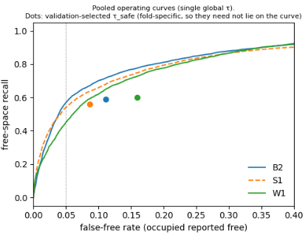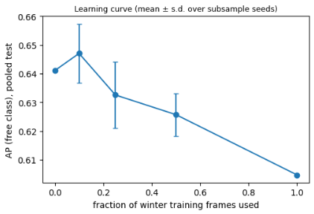
Figure 4: (a) Pooled free recall versus false-free rate for B2, S1 and W1, reproduced from the notebook output. Dots use fold-specific validation thresholds and need not lie on a pooled single-threshold curve. (b) AP(free) versus winter training-frame fraction, redrawn from the supplied summary; error bars are standard deviations over subsampling seeds, not confidence intervals.
The highest displayed mean is at 10% winter frames, after which AP declines. The result above does not mean that 10% is an optimal annotation budget: the percentage was evaluated by the test results and the endpoints do not have the same regularisation. More winter labels do not yield a monotonic gain in this experiment, but the curve cannot determine a universal number of frames needed for a new camera.

Crop masking
Masking raises B2 AP from 0.641 to 0.701 and W1 AP from 0.605 to 0.709. It reverses their ordering and lowers W1’s FFR from 15.9% to 8.9%. It looks like the result is a sign of a bad context in the bounding box crops; however, the masking experiment still needs more testing with uncertainties and verification.It does not prove that context alone caused the change, and masked W1 still exceeds the 5% validation target on test.
Table 8: Bounding-box and polygon-masked crops at τ_{safe}. Paired uncertainty estimates for the masking differences were not supplied.
Crop | Model | AP(free) | Macro-F1 | Bal. acc. | FFR | Free recall | Free prec.
Bounding box | B2 | .641 | .725 | .740 | .112 | .591 | .512
Bounding box | W1 | .605 | .687 | .720 | .159 | .600 | .427
Polygon mask | B2 | .701 | .761 | .780 | .103 | .663 | .561
Polygon mask | W1 | .709 | .775 | .788 | .089 | .665 | .596

Heavy snowfall with hidden markings
A verified heavy-snowfall, hidden-marking result is not available in the supplied outputs. The screenshot shows an annotation interface rather than completed independent reviews. Consequently, no Cohen’s κ, consensus-subset size or subset metrics are reported. The present quantitative results concern snow-tagged scenes, while the narrower heavy-snowfall and hidden-marking condition remains to be verified.

Error analysis and cost
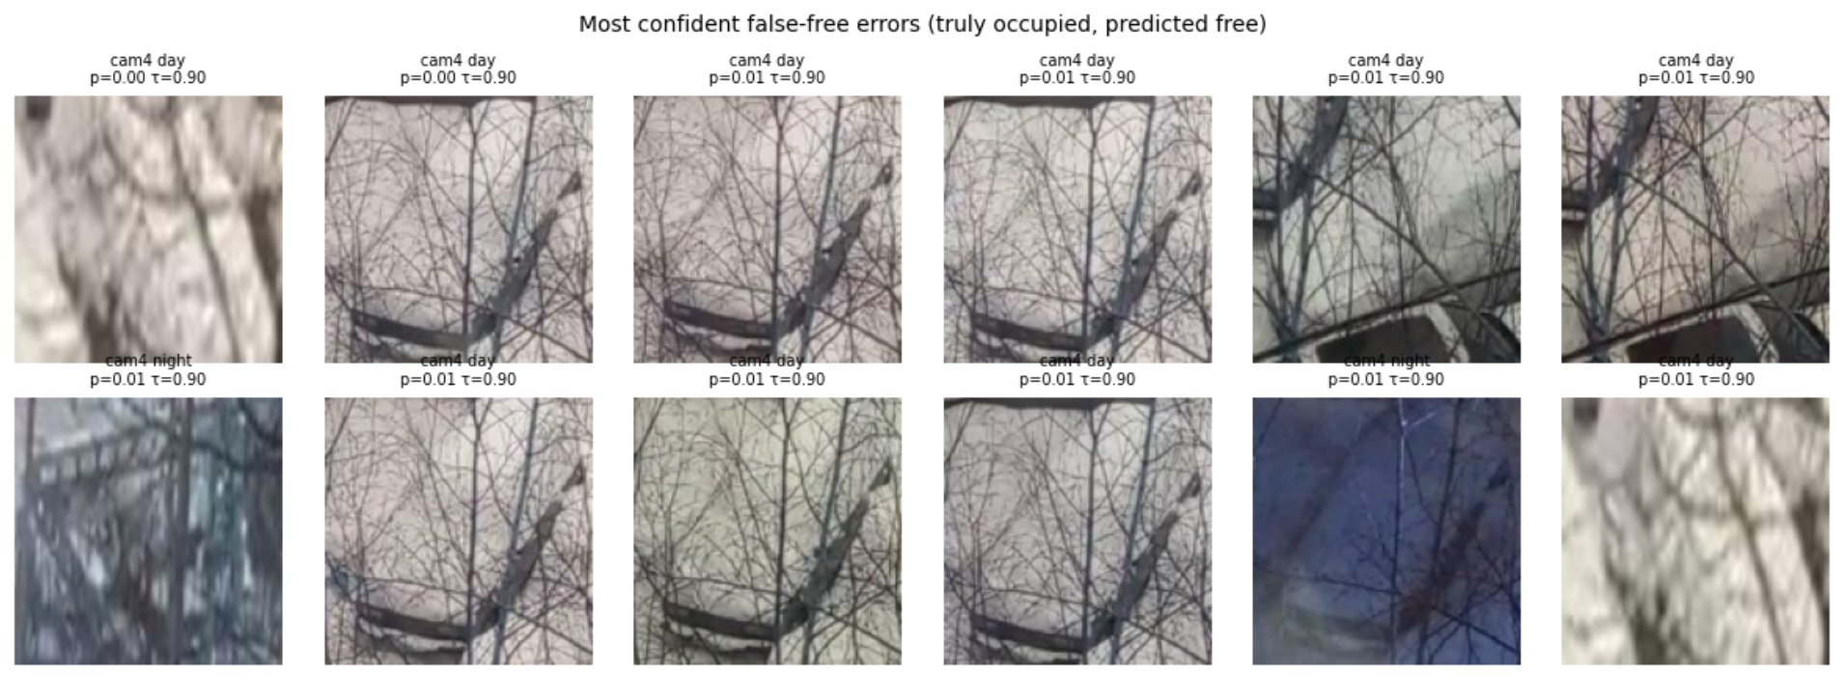
Figure 5: Highly confident false-free errors from the supplied experiment output. These occupied slots are reported free; many crops are dominated by branches and background structures in cam4. The displayed p is occupied probability. Selected failures are not a representative random sample.
Severe false-free errors are concentrated in cam4 slots, including nearly always occupied regions. Branches obscure several crops, motivating inspection of visibility and polygon alignment. These examples do not establish that annotations are wrong or that snow alone caused the errors. The reported Spearman correlation between crop area and slot false-free rate is −0.188, an exploratory association without a supplied significance analysis.
The screenshots report 17 seconds for 19,342 bounding-box embeddings and 15 seconds for the corresponding masked embeddings. Each synthetic set of 9,975 crops takes approximately 24–25 seconds. The main 12-fold experiment reports 303 seconds. These are run-specific logged times; the unavailable hardware specification and incomplete timing scope prevent a deployment-latency claim. The logistic head has 513 fitted coefficients including its intercept, and the frozen encoder has approximately 11.2 million parameters.

Discussion
Winter validation changes the operating point but does not establish reliable error control on a new camera. Relative to B1, B2 reduces false-free errors at its constrained point while retrieving fewer truly free spaces.
Because B2 selects both C and τ using winter data, this change cannot be attributed to threshold adjustment alone.
In the case of the bounding box crop experiment, there is a conditional negative transfer where the additional winter images do not increase recognition on unseen winter cameras. W1 ranks below B2 and S1, and the approximately size-matched W2 control does not remove this pattern. W2 changes both the quantity and composition of training data, so it does not perfectly isolate either factor.
Synthetic snow provides no clear AP gain over B2. Its lower FFR comes with lower free recall, making it a trade-off rather than an unconditional improvement. Real-winter training helps infrared ranking but worsens daytime and night ranking; camera and illumination differences prevent a causal claim about snow alone. None of H1–H4 is supported in the bounding-box configuration.
The masking result is the most promising direction in this run. Reducing outside-polygon content improves the observed ranking of both models and reverses their ordering, suggesting that visual context deserves closer investigation. This interpretation remains a hypothesis: the ablation needs paired uncertainty estimates and independent confirmation.
The learning curve does not establish a universal winter-label budget. Although 10% has the highest displayed mean, its apparent advantage was observed on test outcomes, and intermediate fractions do not share the zero endpoint’s regularisation selection. A deployment recommendation requires validation on new footage and on the actual camera, together with visibility checks for heavily occluded slots.
Threats to validity. All winter frames come from one dataset and four views, which may share site and sensor characteristics. Results may not transfer to other climates or lots, including Astana. Camera-held-out evaluation is not independent-site evaluation. Geometry-based view assignment requires manual checking. Nearby frames remain temporally correlated, so frame-bootstrap intervals may be optimistic and do not capture uncertainty over new sites or training-set refits. Pooled AP depends on cross-fold score comparability. The frozen encoder limits conclusions to this representation rather than end-to-end fine-tuning or other architectures.

Limitations
(i) The method requires a one-time annotation of slot polygons and a stable camera, so it does not recover an unknown layout without markings. (ii) The synthetic generator represents one inexpensive augmentation; stronger simulations could change the comparison. (iii) Infrared imagery is a separate modality whose camera distribution is uneven. (iv) Heavy snowfall and hidden markings lack completed independent verification. (v) Masking results lack supplied paired intervals and independent confirmation. (vi) The revision uses screenshot-transcribed outputs; raw predictions, provenance and an executed notebook are required for independent numerical verification.

Conclusion
Fixed parking polygons remove the need to detect painted boundaries in each frame, but winter appearance generalisation remains difficult. With bounding-box crops, real-winter adaptation reduces pooled AP(free) from 0.641 to 0.605, and a 5% validation error constraint does not transfer to unseen cameras. Polygon masking improves the observed results and reverses the adaptation ordering, identifying crop context as a promising direction for further study. Future work should verify snowfall and marking visibility, test independent winter footage from Astana or another site, and compare stronger models under the same camera-held-out protocol.

Declarations
Author contributions. Both authors contributed to the study design, interpretation of the experimental results, and preparation of the manuscript. Both authors reviewed and approved the final manuscript.
Data availability. The study uses the public SPKL resources [12], available at https://github.com/ Eighonet/parking-research. A completed manual condition-label release is not claimed.
Code availability. The accompanying research notebook implements the experimental pipeline. No public study-repository URL has been established.
Conflicts of interest. The authors declare no competing interests.
Funding. This research received no external funding.
Use of AI tools. Claude and ChatGPT were used to assist with manuscript preparation, language editing, and consistency checks between the text, code, and supplied experimental outputs. The authors are responsible for reviewing the final manuscript and verifying its claims.

References
[1] P. R. L. de Almeida, L. S. Oliveira, A. S. Britto Jr., E. J. Silva Jr., A. L. Koerich. PKLot -- A robust dataset for parking lot classification. Expert Systems with Applications, 42(11):4937--4949, 2015. doi:10.1016/j.eswa.2015.02.009.
[2] G. Amato, F. Carrara, F. Falchi, C. Gennaro, C. Meghini, C. Vairo. Deep learning for decentralized parking lot occupancy detection. Expert Systems with Applications, 72:327--334, 2017. doi:10.1016/j.eswa.2016.10.055.
[3] J. Cohen. A coefficient of agreement for nominal scales. Educational and Psychological Measurement, 20(1):37--46, 1960.
[4] J. Deng, W. Dong, R. Socher, L.-J. Li, K. Li, L. Fei-Fei. ImageNet: A large-scale hierarchical image database. In Proc. IEEE CVPR, pp. 248--255, 2009.
[5] B. Efron, R. J. Tibshirani. An Introduction to the Bootstrap. Chapman & Hall, 1993.
[6] C. A. Field, A. H. Welsh. Bootstrapping clustered data. Journal of the Royal Statistical Society: Series B, 69(3):369--390, 2007.
[7] R. Grbić, B. Koch. Automatic vision-based parking slot detection and occupancy classification. Expert Systems with Applications, 225:120147, 2023. doi:10.1016/j.eswa.2023.120147.
[8] C. Guo, G. Pleiss, Y. Sun, K. Q. Weinberger. On calibration of modern neural networks. In Proc. ICML, PMLR 70:1321--1330, 2017.
[9] K. He, X. Zhang, S. Ren, J. Sun. Deep residual learning for image recognition. In Proc. IEEE CVPR, pp. 770--778, 2016.
[10] D. Hendrycks, T. Dietterich. Benchmarking neural network robustness to common corruptions and perturbations. In Proc. ICLR, 2019.
[11] M. Marek. Image-based parking space occupancy classification: Dataset and baseline. arXiv:2107.12207, 2021.
[12] A. Martynova, M. Kuznetsov, V. Porvatov, V. Tishin, A. Kuznetsov, N. Semenova, K. Kuznetsova. Revising deep learning methods in parking lot occupancy detection. arXiv:2306.04288, 2023.
[13] V. Paidi, H. Fleyeh. Parking occupancy detection using thermal camera. In Proc. 5th Int. Conf. on Vehicle Technology and Intelligent Transport Systems (VEHITS), pp. 483--490, 2019. doi:10.5220/0007726804830490.
[14] A. Paszke et al. PyTorch: An imperative style, high-performance deep learning library. In Advances in Neural Information Processing Systems 32, pp. 8024--8035, 2019.
[15] F. Pedregosa et al. Scikit-learn: Machine learning in Python. Journal of Machine Learning Research, 12:2825--2830, 2011.
[16] M. Saerens, P. Latinne, C. Decaestecker. Adjusting the outputs of a classifier to new a priori probabilities: A simple procedure. Neural Computation, 14(1):21--41, 2002.
[17] C. Sakaridis, D. Dai, L. Van Gool. ACDC: The adverse conditions dataset with correspondences for semantic driving scene understanding. In Proc. IEEE/CVF ICCV, pp. 10765--10775, 2021.
[18] G. Satyanath, J. K. Sahoo, R. K. Roul. Smart parking space detection under hazy conditions using convolutional neural networks: A novel approach. arXiv:2201.05858, 2022.
[19] M. Wang, W. Deng. Deep visual domain adaptation: A survey. Neurocomputing, 312:135--153, 2018.
[20] J. Yosinski, J. Clune, Y. Bengio, H. Lipson. How transferable are features in deep neural networks? In Advances in Neural Information Processing Systems 27, pp. 3320--3328, 2014.

