Milestone1b[3538]

Use Case Report

Author: Author

Revision: 0.2

|  |  |
| --- | --- |
| No Magic |  |
| One Allen Center, 700 Central Expressway South, Suite 110 Allen, Texas 75013 USA | Date: November 30, 2018 |

**Revision History**

|  |  |  |  |
| --- | --- | --- | --- |
| **Revision** | **Date** | **Reason For Changes** | **Author** |
| 0.1 | <date 1> | <draft> | <Author name> |
| 0.2 | <date 2> | <release> | <Author name> |
|  |  |  |  |

**Table of Contents**

Microsoft Word users please click here and press F9 to create Table of Contents.

OpenOffice.org users please remove this text and select Insert Table of Content from menu.

**Table of Figures**

Microsoft Word users please click here and press F9 to create Table of Contents.

OpenOffice.org users please remove this text and select Insert Table of Content from menu.

# 

# Introduction

## Purpose

<This document provides an overview of use case view>

## Scope

<Provide a short description of the system being specified and its purpose, including relevant benefits, objectives, and goals>

## Overview

<Describe what the document contains and explain how document is organized>

# Foodora Application

## 1 Anwendungsfall

### Description

#### Complexity

Average Complexity

#### Component Complexity

Average Complexity

#### Priority

Normal

## 2 Anwendungsfall Send Letter to Customerfor Verification

* Send Letter to Customer
* for Verification includes Wait for Customer Conformation
* Send Letter to Customer
* for Verification is included by Check if Valid Customer

### Description

#### Complexity

Average Complexity

#### Component Complexity

Average Complexity

#### Priority

Normal

### Scenarios

#### Alternative Flow

There will be send a letter to the customer for verification, to be sure there won´t be registered a fake account

## 3 Anwendungsfall Uploading Menu

* Uploading Menu is included by Display OnlySubsciption
* Uploading Menu is included by Premium Subsciption
* Uploading Menu is included by Regular Subscription

### Description

#### Complexity

Average Complexity

#### Component Complexity

Average Complexity

#### Priority

Normal

### Scenarios

#### Alternative Flow

The restaurant have to upload a menu as a csv format or an excel sheet

## Anwendungsfall

## Anwendungsfall Block if non valid User

* Block if non
* valid User extends Check if Valid Customer

## Anwendungsfall Check if Valid Customer

* Check if Valid
* Customer is performed by CustomerSupport
* Check if Valid
* Customer includes Send Letter to Customerfor Verification
* Check if Valid
* Customer is included by Verify Sign Up

## Anwendungsfall Choose Membership

* Choose
* Membership is performed by Business Customer
* Choose
* Membership includes Display OnlySubsciption
* Choose
* Membership includes Premium Subsciption
* Choose
* Membership includes Regular Subscription
* Choose
* Membership includes Upload Menu
* Choose
* Membership is included by Sign Up

## Anwendungsfall Contact Customerfor invalid Sign Up

### Extension Points

* unbenannt1 : Contact Customerfor invalid Sign Up

## Anwendungsfall Create CustomerAccount

* Create Customer
* Account is included by Wait for Customer Conformation

## Anwendungsfall Display OnlySubsciption

* Display Only
* Subsciption includes Uploading Menu
* Display Only
* Subsciption is included by Choose Membership

## Anwendungsfall Premium Subsciption

* Premium Subsciption includes Uploading Menu
* Premium Subsciption is included by Choose Membership

## Anwendungsfall Regular Subscription

* Regular
* Subscription includes Uploading Menu
* Regular
* Subscription is included by Choose Membership

## Anwendungsfall Sign Up

* Sign Up is performed by Business Customer
* Sign Up includes Choose Membership
* Sign Up includes Verify Sign Up

## Anwendungsfall Upload Menu

* Upload Menu is performed by Business Customer
* Upload Menu includes
* Upload Menu is included by Choose Membership

## Anwendungsfall Verify Sign Up

* Verify Sign Up includes Check if Valid Customer
* Verify Sign Up is included by Sign Up
* Verify Sign Up extends Contact Customerfor invalid Sign Up

## Anwendungsfall Wait for Customer Conformation

* Wait for Customer Conformation includes Create CustomerAccount
* Wait for Customer Conformation is included by Send Letter to Customerfor Verification

# Model

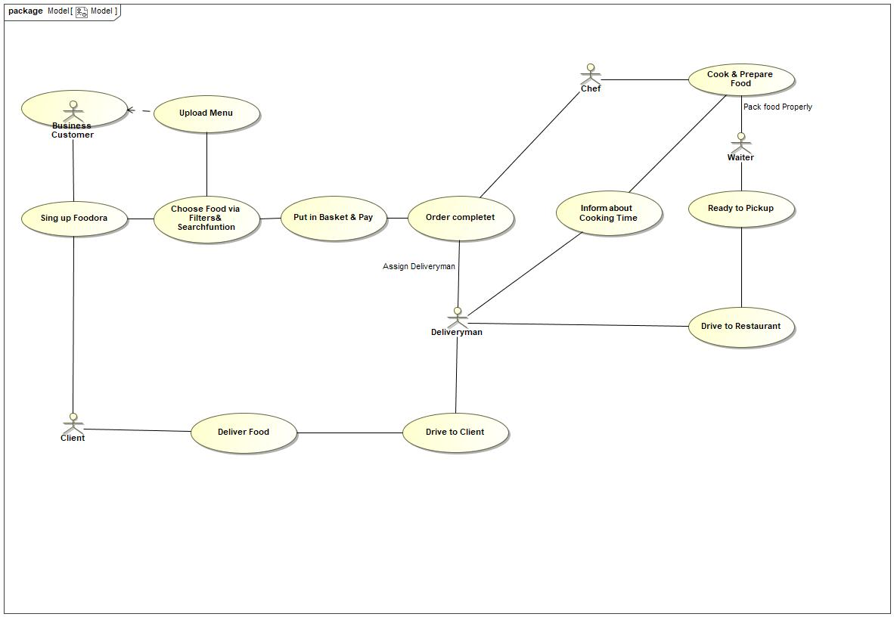

1. Model

## Akteur Business Customer

* Business
* Customer performs Choose Membership
* Business
* Customer performs Send Letter to Customerfor Verification
* Business
* Customer performs Sign Up
* Business
* Customer performs Sing up Foodora
* Business
* Customer performs Upload Menu

## Akteur Chef

* Chef performs Cook & Prepare Food
* Chef performs Order completet

## Akteur Client

* Client performs Deliver Food
* Client performs Sing up Foodora

## Akteur Deliveryman

* Deliveryman performs Drive to Client
* Deliveryman performs Drive to Restaurant
* Deliveryman performs Driver Deliversthe Food to Client
* Deliveryman performs Driver Picks up Food
* Deliveryman performs Inform about Cooking Time
* Deliveryman performs Order completet

## Akteur Waiter

* Waiter performs Cook & Prepare Food
* Waiter performs Ready to Pickup

## 1 Anwendungsfall

* is included by Upload Menu

### Description

#### Complexity

Average Complexity

#### Component Complexity

Average Complexity

#### Priority

Normal

## Anwendungsfall Choose Food via Filters& Searchfuntion

* Choose Food via Filters& Searchfuntion performs Put in Basket & Pay
* Choose Food via Filters& Searchfuntion performs Upload Menu
* Choose Food via Filters& Searchfuntion is performed by Sing up Foodora

## Anwendungsfall Cook & Prepare Food

* Cook & Prepare Food is performed by Chef
* Cook & Prepare Food is performed by Waiter
* Cook & Prepare Food performs Inform about Cooking Time

## Anwendungsfall Deliver Food

* Deliver Food is performed by Client
* Deliver Food is performed by Drive to Client

## Anwendungsfall Drive to Client

* Drive to Client is performed by Deliveryman
* Drive to Client performs Deliver Food

## Anwendungsfall Drive to Restaurant

* Drive to Restaurant is performed by Deliveryman
* Drive to Restaurant is performed by Ready to Pickup

## Anwendungsfall Inform about Cooking Time

* Inform about Cooking Time is performed by Deliveryman
* Inform about Cooking Time is performed by Cook & Prepare Food

## Anwendungsfall Order completet

* Order completet is performed by Chef
* Order completet is performed by Deliveryman
* Order completet is performed by Put in Basket & Pay
* Order completet includes

## Anwendungsfall Put in Basket & Pay

* Put in Basket & Pay performs Order completet
* Put in Basket & Pay is performed by Choose Food via Filters& Searchfuntion

## Anwendungsfall Ready to Pickup

* Ready to Pickup is performed by Waiter
* Ready to Pickup performs Drive to Restaurant

## Anwendungsfall Sing up Foodora

* Sing up Foodora is performed by Business Customer
* Sing up Foodora performs Choose Food via Filters& Searchfuntion

## Anwendungsfall Upload Menu

* Upload Menu is performed by Choose Food via Filters& Searchfuntion
* Upload Menu includes

# Model1

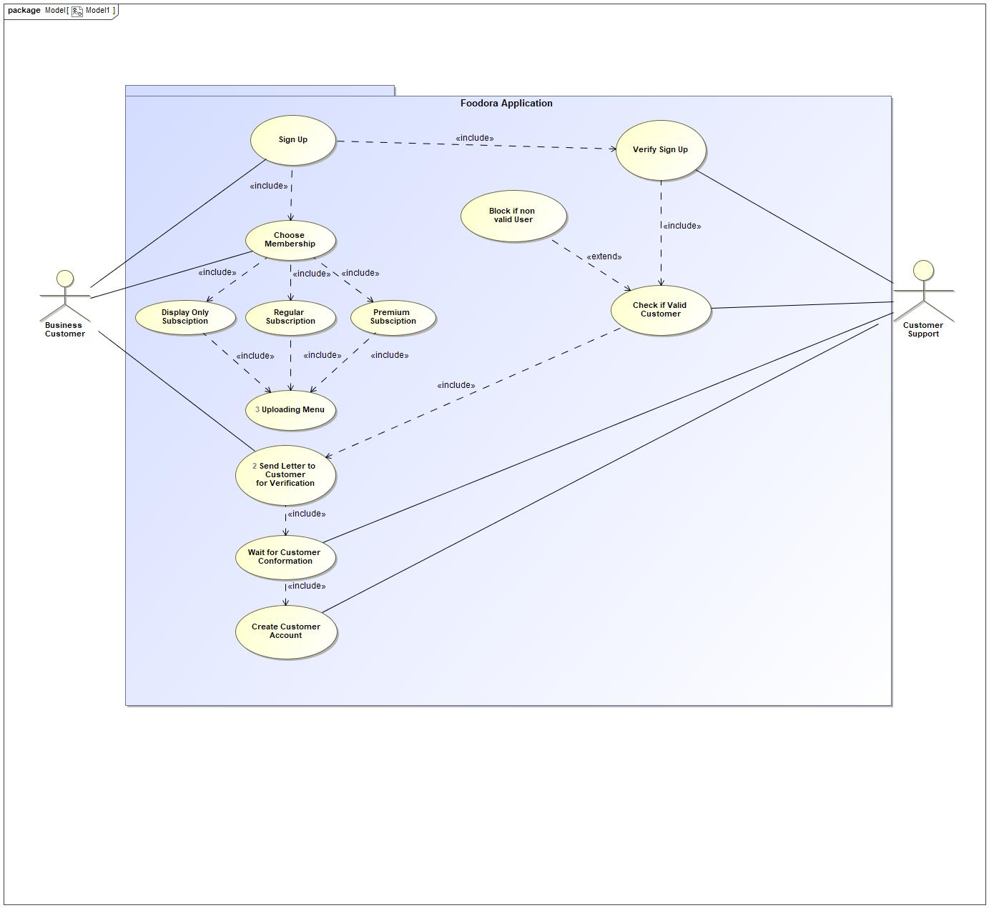

1. Model1

## Akteur CustomerSupport

* Customer
* Support performs Check if Valid Customer
* Customer
* Support performs Create CustomerAccount
* Customer
* Support performs Verify Sign Up
* Customer
* Support performs Wait for Customer Conformation

## Known other actors

Akteur Business Customer

## Known other usecases

Anwendungsfall Send Letter to Customerfor Verification, Anwendungsfall Uploading Menu, Anwendungsfall Block if non valid User, Anwendungsfall Check if Valid Customer, Anwendungsfall Choose Membership, Anwendungsfall Create CustomerAccount, Anwendungsfall Display OnlySubsciption, Anwendungsfall Premium Subsciption, Anwendungsfall Regular Subscription, Anwendungsfall Sign Up, Anwendungsfall Verify Sign Up, Anwendungsfall Wait for Customer Conformation

# Akteur

# 2 Anwendungsfall

* is included by Order completet

## Description

### Complexity

Average Complexity

### Component Complexity

Average Complexity

### Priority

Normal

# Anwendungsfall

# System-Level Use Cases

## System-Level Use Cases

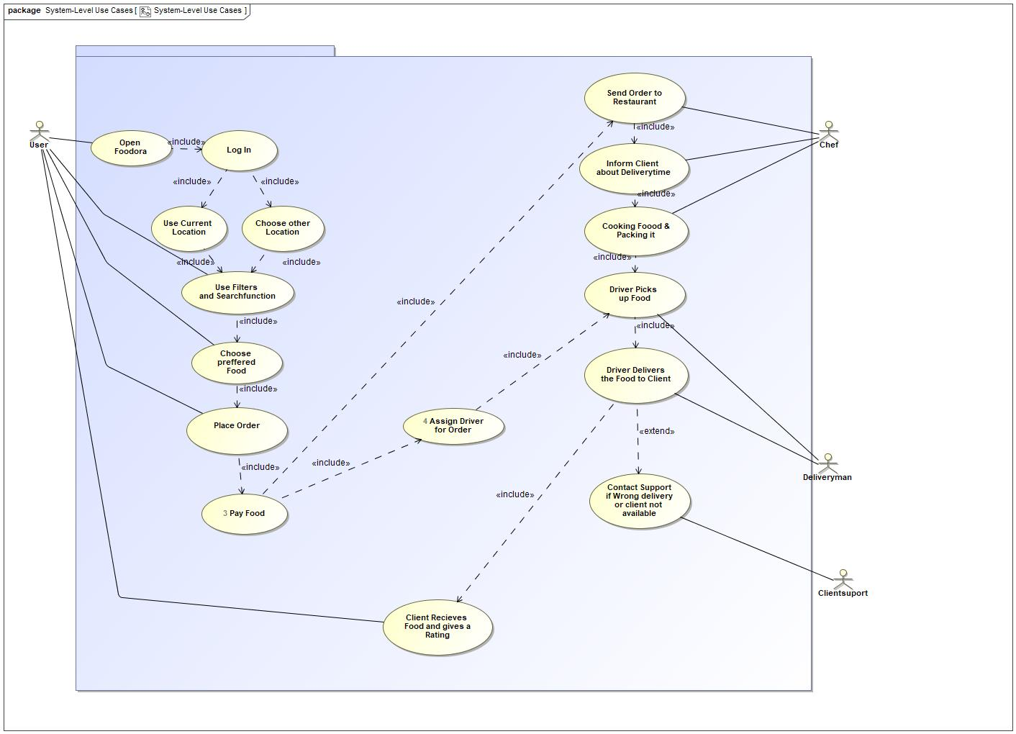

1. System-Level Use Cases

### Akteur Chef

* Chef performs Cooking Foood &Packing it
* Chef performs Inform Client about Deliverytime
* Chef performs Send Order toRestaurant

### Akteur Clientsuport

* Clientsuport performs Contact Supportif Wrong deliveryor client not available

### Akteur User

* User performs Choose prefferedFood
* User performs Client Recieves Food and gives aRating
* User performs Open Foodora
* User performs Place Order
* User performs Use Filters and Searchfunction

### Known other actors

Akteur Deliveryman

### 3 Anwendungsfall Pay Food

* Pay Food includes Assign Driverfor Order
* Pay Food includes Send Order toRestaurant
* Pay Food is included by Place Order

#### Description

##### Complexity

Average Complexity

##### Component Complexity

Average Complexity

##### Priority

Normal

#### Scenarios

##### Basic Flow

Payment must fit with the payment of the restaurant. then it must be recieved over banktransfer or paypal.

### 4 Anwendungsfall Assign Driverfor Order

* Assign Driver
* for Order includes
* Assign Driver
* for Order includes Driver Picks up Food
* Assign Driver
* for Order is included by Pay Food

#### Description

##### Complexity

Average Complexity

##### Component Complexity

Average Complexity

##### Priority

Normal

#### Scenarios

##### Alternative Flow

The deliverer will be assign, that he is the nearest deliverer, or a deliverer which fits for the delivery(delivery by bike, because with think green). then he have to come to the restaurant

### Anwendungsfall Choose otherLocation

* Choose other
* Location includes Use Filters and Searchfunction
* Choose other
* Location is included by Log In

### Anwendungsfall Choose prefferedFood

* Choose preffered
* Food is performed by User
* Choose preffered
* Food includes Place Order
* Choose preffered
* Food is included by Use Filters and Searchfunction

### Anwendungsfall Client Recieves Food and gives aRating

* Client Recieves
* Food and gives a
* Rating is included by Driver Deliversthe Food to Client

### Anwendungsfall Contact Supportif Wrong deliveryor client not available

* Contact Support
* if Wrong delivery
* or client not available is performed by Clientsuport

### Anwendungsfall Cooking Foood &Packing it

* Cooking Foood &
* Packing it includes Driver Picks up Food
* Cooking Foood &
* Packing it is included by Inform Client about Deliverytime

### Anwendungsfall Driver Deliversthe Food to Client

* Driver Delivers
* the Food to Client is performed by Deliveryman
* Driver Delivers
* the Food to Client includes Client Recieves Food and gives aRating
* Driver Delivers
* the Food to Client is included by Driver Picks up Food
* Driver Delivers
* the Food to Client extends Contact Supportif Wrong deliveryor client not available

### Anwendungsfall Driver Picks up Food

* Driver Picks
* up Food is performed by Deliveryman
* Driver Picks
* up Food includes Driver Deliversthe Food to Client
* Driver Picks
* up Food is included by Assign Driverfor Order
* Driver Picks
* up Food is included by Cooking Foood &Packing it

### Anwendungsfall Inform Client about Deliverytime

* Inform Client
* about Deliverytime is performed by Chef
* Inform Client
* about Deliverytime includes Cooking Foood &Packing it
* Inform Client
* about Deliverytime is included by Send Order toRestaurant

### Anwendungsfall Log In

* Log In includes
* Log In includes Choose otherLocation
* Log In includes Use Current Location
* Log In is included by Open Foodora

### Anwendungsfall Open Foodora

* Open
* Foodora is performed by User
* Open
* Foodora includes Log In

### Anwendungsfall Place Order

* Place Order
* includes Pay Food
* Place Order
* is included by Choose prefferedFood

### Anwendungsfall Send Order toRestaurant

* Send Order to
* Restaurant includes Inform Client about Deliverytime
* Send Order to
* Restaurant includes Start Cooking the Meal
* Send Order to
* Restaurant is included by Pay Food

### Anwendungsfall Use Current Location

* Use Current
* Location includes Use Filters and Searchfunction
* Use Current
* Location is included by Log In

### Anwendungsfall Use Filters and Searchfunction

* Use Filters
* and Searchfunction is performed by User
* Use Filters
* and Searchfunction includes Choose prefferedFood
* Use Filters
* and Searchfunction is included by Choose otherLocation
* Use Filters
* and Searchfunction is included by Use Current Location

# System-Level Use Cases::

## 1 Anwendungsfall

* is included by Log In

### Description

#### Complexity

Average Complexity

#### Component Complexity

Average Complexity

#### Priority

Normal

## 2 Anwendungsfall

* is included by Assign Driverfor Order

### Description

#### Complexity

Average Complexity

#### Component Complexity

Average Complexity

#### Priority

Normal

## Anwendungsfall AssignDriver for Order

### Extension Points

* ZZ : AssignDriver for Order

## Anwendungsfall Driver Picksup Food

## Anwendungsfall Start Cooking the Meal

* Start Cooking
* the Meal is included by Send Order toRestaurant

## Known other usecases

Anwendungsfall Pay Food, Anwendungsfall Assign Driverfor Order, Anwendungsfall Choose otherLocation, Anwendungsfall Choose prefferedFood, Anwendungsfall Client Recieves Food and gives aRating, Anwendungsfall Contact Supportif Wrong deliveryor client not available, Anwendungsfall Cooking Foood &Packing it, Anwendungsfall Driver Deliversthe Food to Client, Anwendungsfall Driver Picks up Food, Anwendungsfall Inform Client about Deliverytime, Anwendungsfall Log In, Anwendungsfall Open Foodora, Anwendungsfall Place Order, Anwendungsfall Send Order toRestaurant, Anwendungsfall Use Current Location, Anwendungsfall Use Filters and Searchfunction