**3D Basketball Game**

Snapshots:

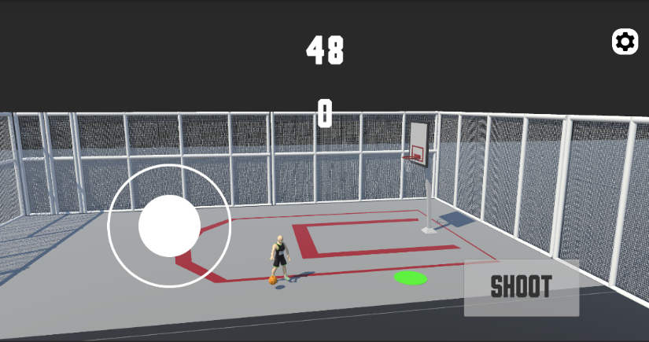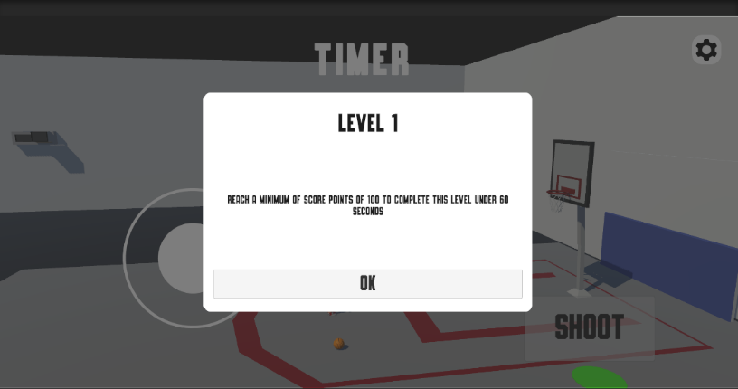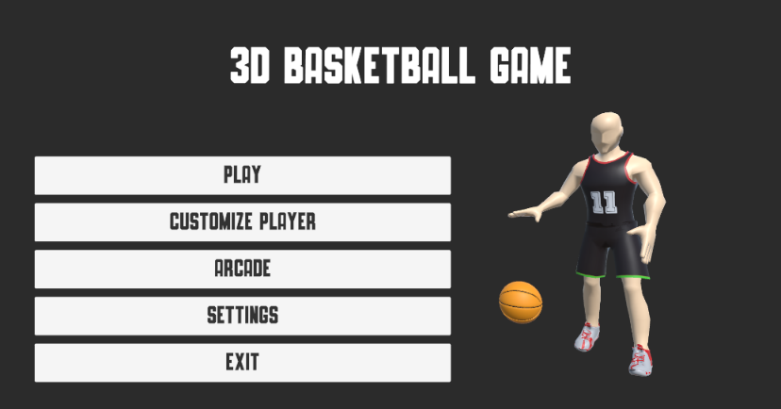

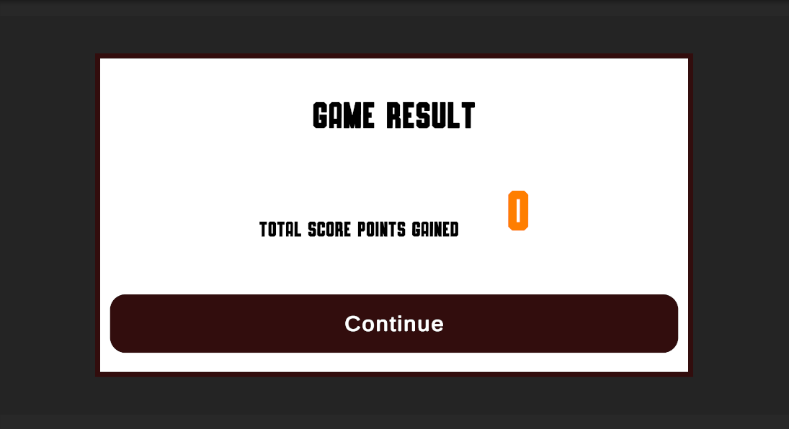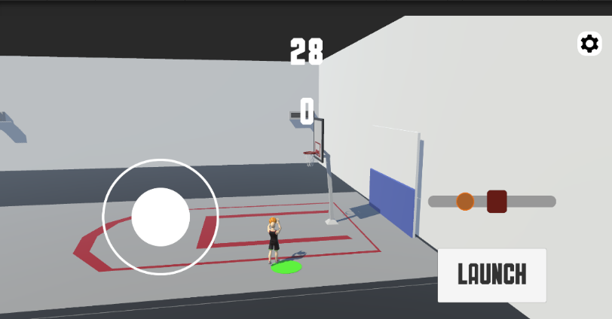

General Information

Game Name:

Platform: **Android 8.0 Up**

Scope of Development: **Full-Game**

Game Engine**: Unity3D 2022.3.39.f1 (LTS)**

**Player**

**Player Movement** –

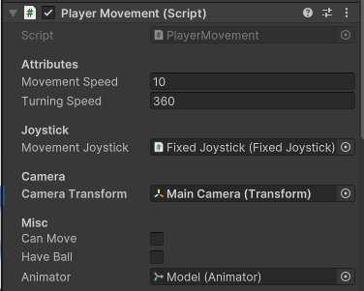This script handles the player's movement in a Unity game using a character controller. It captures input from a joystick and moves the player accordingly, allowing rotation based on input and camera direction. The script also controls player animations based on whether the player is moving and whether they are carrying a ball, allowing for smooth transitions between different states.

**Player Shooting –**

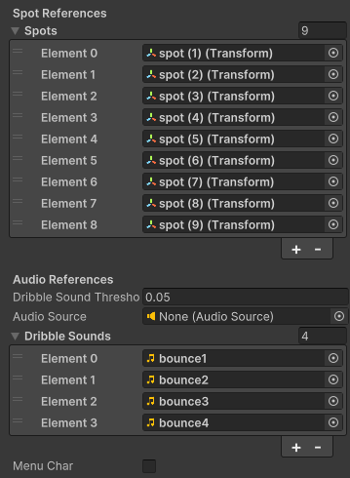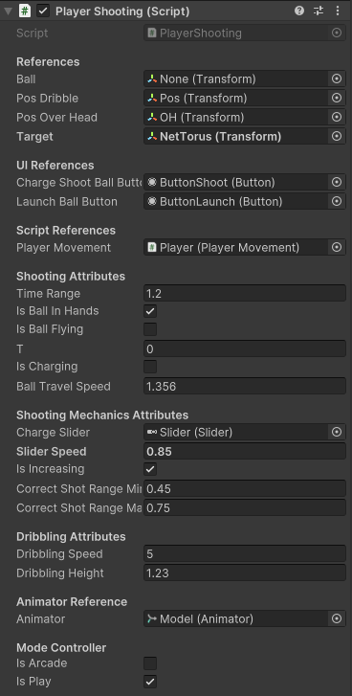This script handles the shooting and dribbling mechanics of the player. It handles the charge and launch a ball towards the net while also managing the position of the player. It has conditionals statement that manages the player shooting which only allow the player to shoot at a certain spot in the court. It also incorporates slider-based shot accuracy, dribbling animations, and sound effects. Additionally, it manages the ball's flight path with an arc mechanic and adjusts the player's ability to move or shoot based on various in-game states.

**Player Skin Manager**

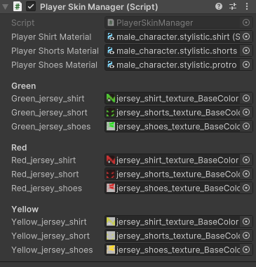This script manages the customization of the player's appearance, allowing them to change the colors of their shirt, shorts, and shoes. It uses Unity's PlayerPrefs system to save and load the chosen colors, ensuring that the selected outfit is retained between game sessions.

**Player Pointing System**

tracks the player's points and a streak counter, applying bonus points when the player reaches a specified streak threshold. The script also updates the UI in real-time, including animating the point text and a "wiggle" effect on the shot button when the player is "on fire." Additionally, it saves and loads points using Unity’s PlayerPrefs, ensuring that the player's progress is persistent across sessions.

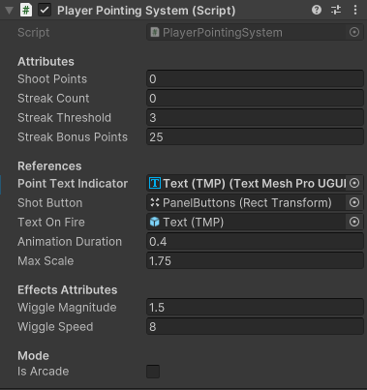

**Ball Controller**

This script manages the behavior of a ball in a Unity game, specifically its interaction with the player and its state while flying. It controls the ball's physics through a Rigidbody and uses a TrailRenderer to create a visual effect when the ball is flying. The ball’s collider is dynamically enabled or disabled depending on whether it's in the player's possession or flying. Additionally, a coroutine is used to disable the trail renderer after a brief delay when the ball stops flying, ensuring smooth transitions between states.

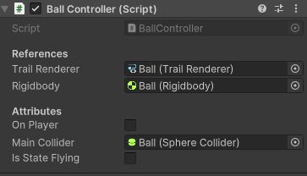

**Basket Controller**

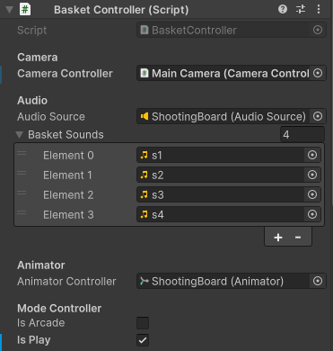This script manages interactions between the ball and the basketball hoop in a Unity game. When the ball enters the basket (detected via OnTriggerEnter), the script plays a random basket sound, triggers a camera animation using the CameraController, and plays an animation using the Animator. Depending on the game mode (Arcade or Play), it awards different points using the PlayerPointingSystem.

Game Play Flow

**Start**: The player begins the game, moving directly into the levels.

**Levels**: The player engages in various levels. As the player plays through these levels, they must meet certain requirements to succeed.

**Achieve Level Requirements Successfully**: If the player meets the level requirements, they can either continue playing the next level (keep playing) or proceed to the rewards stage if all levels are completed.

**Fail (No Reward)**: If the player does not meet the requirements, they fail the level and are given the option to try again by repeating the level. No rewards are granted for failing.

**Rewards**: If the player successfully completes all levels, they are rewarded.

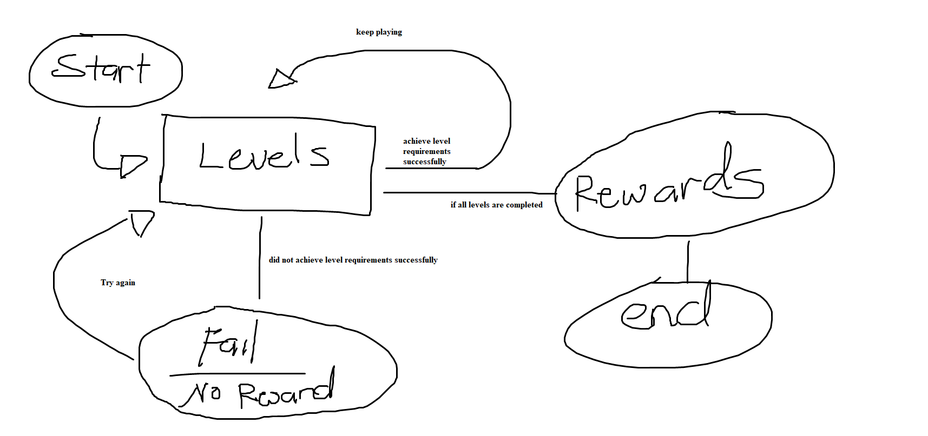**End**: After receiving rewards or failing a level, the game comes to an end.