## I. Download data

Go to [Kaggle](https://www.kaggle.com/selfishgene/historical-hourly-weather-data/) and download the “Historical Hourly Weather Data 2012-2017” data set. (Press the “Download” link near the “New Kernel” button.)

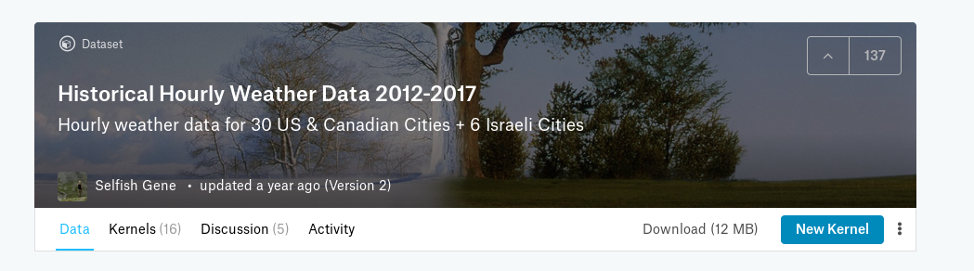

## II. DB

Choose a database for this exam. You may use any open source database that has a publicly available docker image. Choose a DB that is suitable for the tasks below. Explain why you chose that specific technology.

## III. load_wind_data.sh

Write a script called “load_wind_data.sh” that loads the “wind_direction.csv” and “wind_speed.csv” files into a database. The script may call a program written in another common language, if you prefer.

## IV. update_wind_data.sh

Write a script called “update_wind_data.sh” that updates the database with new or updated wind speed data (no need to do it for wind direction), whenever a new data file arrives in a given directory (it may sleep for intervals).

## V. query.sh

Write a script called “query.sh” that lists all time-stamps that the wind speed in Jerusalem went above the 5 day moving average in Jerusalem.

## VI. Send

Send us the following files, together with anything that we need to know in order to test your answers:

* load_wind_data.sh
* update_wind_data.sh
* query.sh
* any other script that the above are calling