Lê Minh Quân SE194262 LAB211: LAB_3
Funtion 1: List all Developers Display data in a formatted table with column headers (ID, Name, Language, Salary).
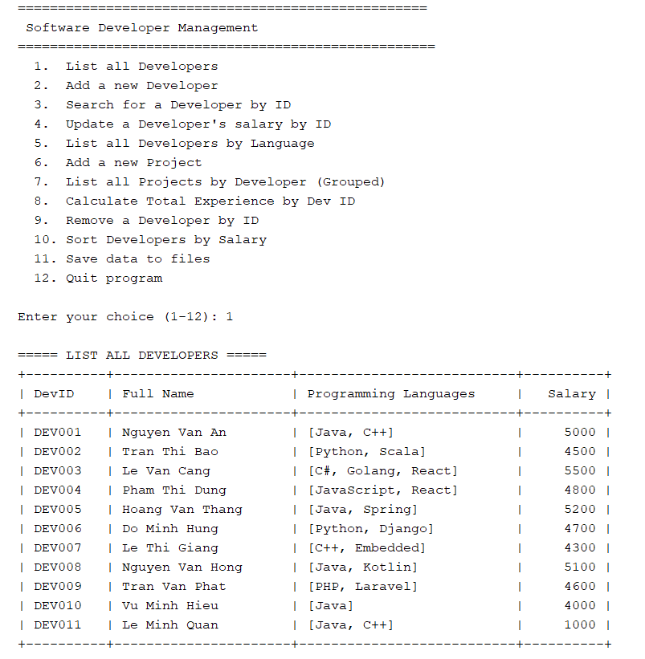
Funtion 2: Add a new Developer: Accept ID, Name, Language, and Salary. Add to the list only if all constraints are satisfied. Display success/failure message.
2.1 "If the DEV ID already exists, or the new ID does not match the required format."
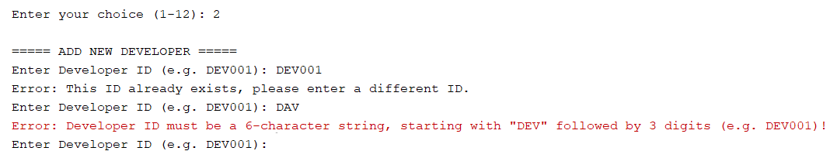
2.2 . "Return to the menu after 3 failed attempts."
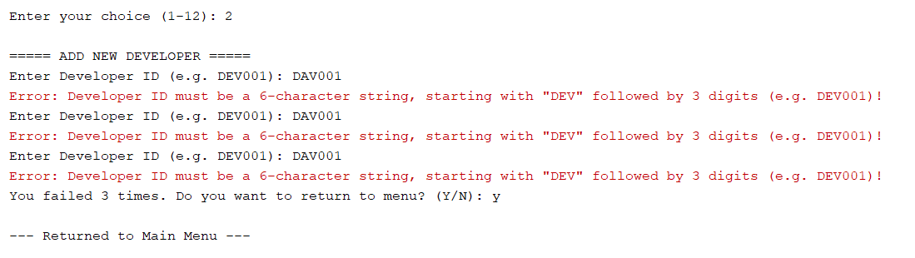
2.3 "DEV added successfully."
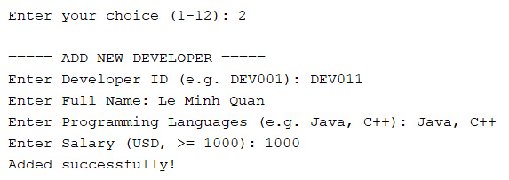
FUNCITON 3: Search for a Developer by ID
3.1 .If the Developer does not exist, show: "Developer ID does not exist!"
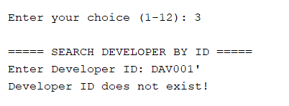
3.2. display Developer information.
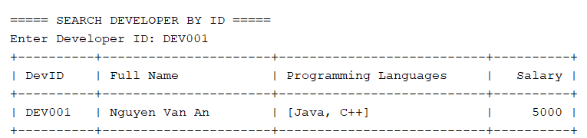

FUNCTION 4: Update a Developer's salary by ID
4.1 If the Developer does not exist, show: "Developer ID does not exist!"
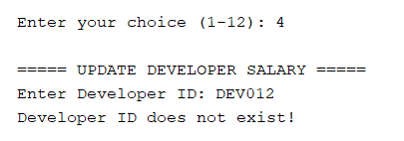
4.2 Otherwise, display Developer information.
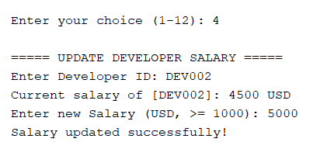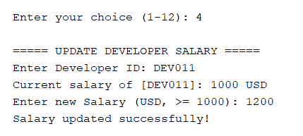
Function 5: List all Developers by Language
5.1 Accept a language input (e.g., "Java"); display all developers who list that language in their skills
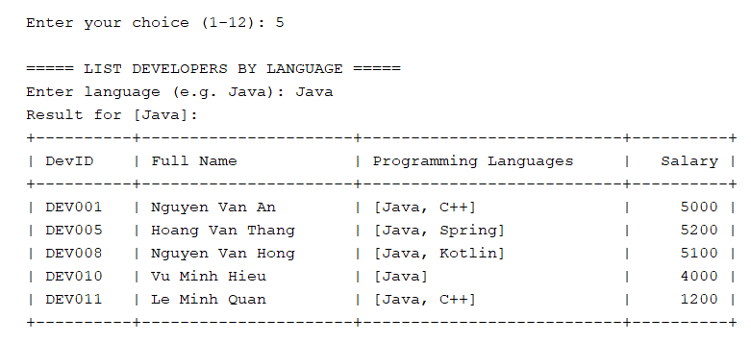
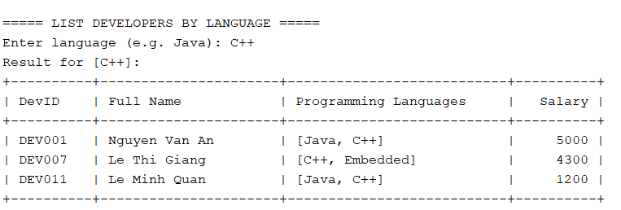
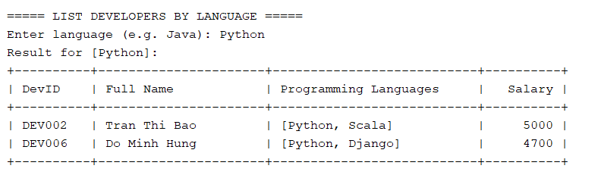

FUNCTION 6: Add a new Project
6.1 If the Project ID already exists, show: " Project ID already exists!"
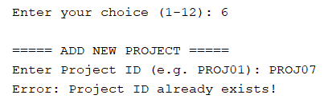
6.2 Accept Project ID, Dev ID, Project Name, Duration and Start Date. Dev ID must exist in the developers list. Validate all constraints.
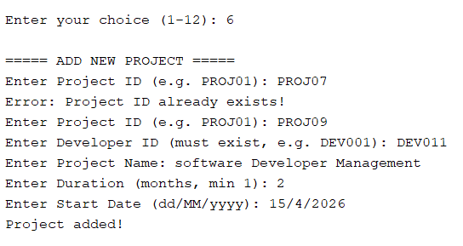

FUNCION 7 List all Projects by Developer (Grouped) Display the list of Developers. Under each developer, list all Projects they are currently or have been assigned to, showing Project ID, Duration, and Start Date.
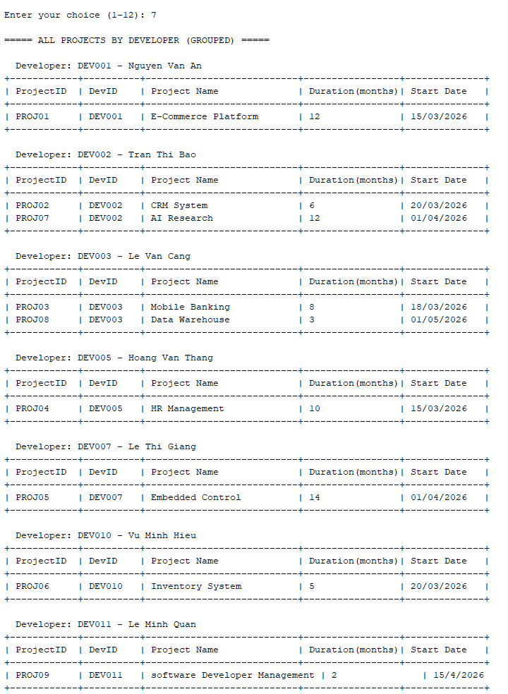
FUNCTION 8: Calculate Total Experience by Dev ID, Accept Dev ID; Display the total duration (in months) for the projects assigned to the developer.
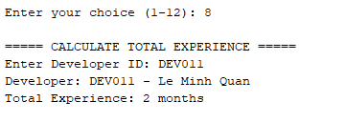
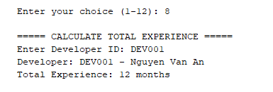
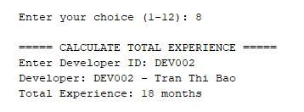
FUNCTION 9: Remove a Developer by ID
9.1 If the Dev ID does not exist, show: "Developer ID does not exist!"
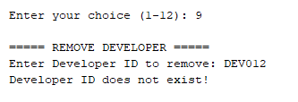
9.2 If the developer has participated in at least one project, show: "Cannot delete: Developer is assigned to project."
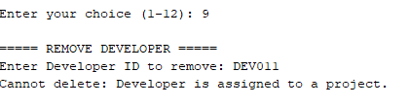
9.3. Otherwise, remove the record.
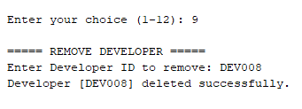
FUNCTION 10:
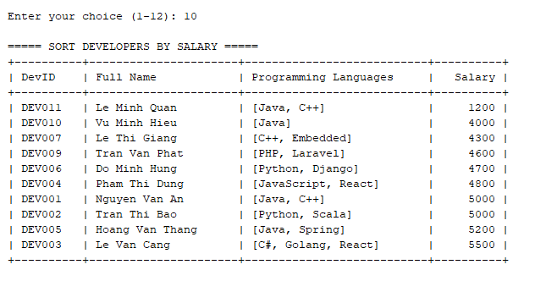
FUNCTION 11: Save data to files. Save both Developer and Project lists into developers.txt and projects.txt files, respectively. Show a confirmation message.
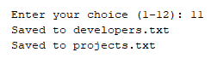
FUNCTION 12 .Quit program: Check for unsaved changes. If changes exist, prompt the user: "Do you want to save the changes before exiting? (Y/N)" .Exit the program after handling the save/discard choice and reload data on program start.
