

Module Code | : | CT071-3-3-DDAC
Module Name | : | Designing and Developing Applications on the Cloud
Project Title | : | Maersk Line Container Management System
Student ID | : | TP038460
Student Name | : | Raymond Loi Ming Yang
Intake Code | : | UC3F1706SE
Lecturer Name | : | Dr. Kalai Anand A/L Ratnam
Hand in Date | : | 13 April 2018

Acknowledgement
Firstly, I would like to thank to DDAC lecturer, Dr. Kalai for sharing his knowledge and guidance for me throughout this semester. I have learned the basics of cloud computing, as well as setting up and hosting my application in Azure hosting server. Besides, I would like to thank my fellow friends who provided guidance and support on my project. We helped each other by discussing our progress and checking each other’s work. Other than that, we perform testing together and ensure that the system is working fine before hosting it in Azure. Thanks to the help of Dr. Kalai and my fellow friends, I can complete this assignment and submitted on time.
Table of Contents
1 Introduction 1
1.1 Objective & Scope 2
1.2 Requirement Specification 2
2 PROJECT PLAN 3
3 Design 4
3.1 DESIGN CONSIDERATION 4
3.2 Modelling 4
3.2.1 Use Case Diagram 4
3.2.2 Use Case Description 5
3.2.3 Class Diagram 11
3.2.4 Sequence Diagram 13
3.2.5 Cloud Architectural Diagram 25
4 Implementation 28
4.1 Application Development 28
4.2 Azure Publishing 30
4.2.1 App Service Publish 30
4.2.2 Database Publish 34
4.3 APPLICATION SCALING 40
4.3.1 SQL Database Scaling 40
4.3.2 Web Application Scaling 42
4.4 Reliability and Performance 43
5 Test Plan & Testing Discussion 45
5.1 Unit Test 45
5.1.1 UNIT TEST (Admin) 45
5.1.2 UNIT TEST (Agent) 46
5.2 Performance Test 47
6 Managed Database (PaaS) 50
7 Conclusion 53
8 Reference 54

Introduction
Maersk Line is the global container division and the largest operating unit of the A.P. Moller – Maersk Group, a Danish business conglomerate. It is the world's largest container shipping company having customers through 374 offices in 116 countries. It employs approximately 7,000 sea farers and approximately 25,000 land-based people. Maersk Line operates over 600 vessels and has a capacity of 2.6 million TEU. The company was founded in 1928.
Operating in 100 countries and transporting goods around the globe, at first glance it would appear Danish shipping company Maersk Line is already handling all the cargo it can manage. But when Maersk determined that the volume of most of the goods it was shipping had grown to full capacity, the company decided that cloud powered solutions would be a crucial part of rectifying the situation.
“There was a ‘mind-opener’ where Maersk said, ‘How can we support the overall business strategy, and also from an IT perspective,” says Soeren Lorenzen, an account general manager with Hewlett-Packard company who is involved first-hand with Maersk’s ITO efforts. “There was a new CIO who wanted to outsource every part of IT, but without [negatively] impacting shipping.”
In an effort to support further business growth and increase organizational flexibility, Maersk decided to consolidate all of its data centers and server rooms operating worldwide onto a virtualized platform. Microsoft Azure was already hosting some of Maersk’s IT environment, and in March 2016 Maersk initially approached Microsoft about expanding the scope of the relationship. Moving forward, Lorenzen says Maersk is currently changing over its IT setup based on Microsoft Azure, starting with the desktop environment up to container management.
Thus, Maersk Line is looking at designing and developing a Container Management System (CMS) to cater to manage the containers, a solution that reduces overall supply chain costs and an efficient way to manage logistics.

Objective & Scope
- Demonstrate the understanding of application in cloud computing in its various forms and how Microsoft Azure fits within the cloud computing space.
- Explore the Microsoft Azure development environment.
- Design, implement, and deploy MAERSK Management Web Application on Azure.
- To architect and design an efficient MAERSK Management Web Application that utilizes Microsoft Azure as the public cloud platform.

Requirement Specification
The developer is required to design and develop a web solution that meets the following criteria:
Functional Requirement
- The system must allow admin to login and logout from the system.
- The system must allow admin to register, edit, and delete agent.
- The system must allow admin views the schedule.
- The system must allow admin to register new schedule.
- The system must allow admin to register, edit, and delete ship.
- The system must allow admin to approve and reject schedule booking.
- The system must allow agent to login and logout from the system.
- The system must allow agent register and delete customer.
- The system must allow agent to issue delivery invoice for customer.
- The system must allow agent to view and book schedule.
- The system must allow agent to add and delete item.
Non-Functional Requirement
- The system must be able to scale the solution and meet the needs of demand during the peak season.
- The system must be able to improve the profitability and reduce costs of the business.
- The system must be able to optimize resources to future-proof cargo handling business for high performance.
- Maximum down time of the system is 1 hour with 99% of availability.

PROJECT PLAN
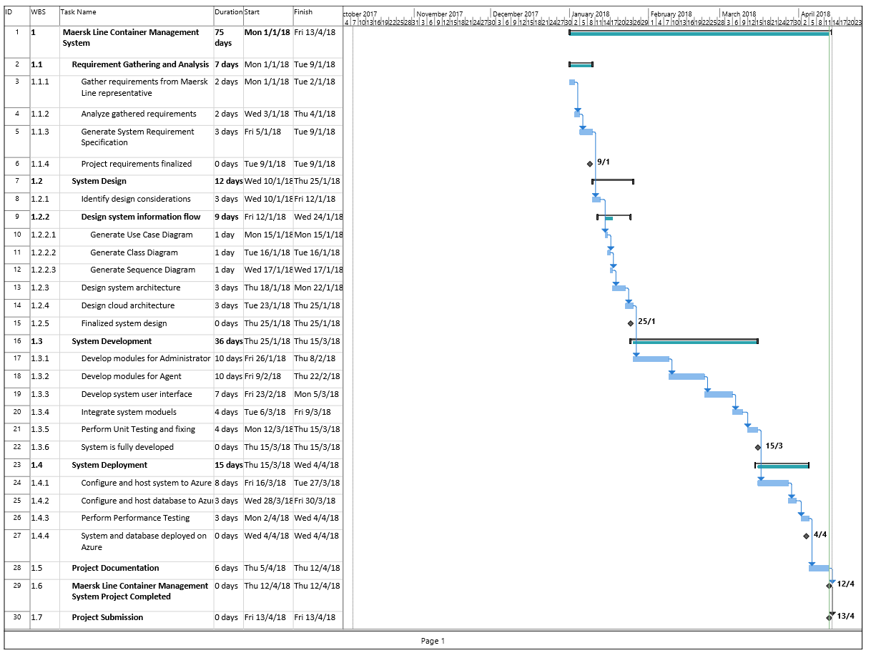
Figure 1: Gantt Chart

Design

DESIGN CONSIDERATION
The design of the Maersk Line Container Management System have some assumption or considerations have been made throughout the project such as listed below:
1) Agent will issue a delivery invoice which consist of a customer’s item to deliver in a schedule booking
2)TEU is used to measure the height and weight of the item been shipped

Modelling

Use Case Diagram

Use Case Diagram (Admin)
Figure 2: Use Case Diagram (Admin)

Use Case Diagram (Agent)
Figure 3: Use Case Diagram (Agent)

Use Case Description

Use Case Description (Admin)
Use Case 01: | Login
Summary | Allow admin to login to the system.
Dependency: | -
Actors: | Admin
Preconditions: | Admin must own an account
Description of main sequence: | - Admin enters correct username and password.  - The system validates the credentials.  - Admin successfully login to the system.
Description of alternative sequence | 1(A). If Admin enter the wrong username and password, the system will redirect user to login page and shows the error message.
Postconditions: | Admin successfully login to the system.

Use Case 02: | View Schedule
Summary | Allow admin to view the schedule.
Dependency: | <<extend>> Create Schedule, <<extend>> Delete Schedule
Actors: | Admin
Preconditions: | Admin logged in to the system
Description of main sequence: | - Admin go to schedule page.  - Admin view the shipping schedule.  - Admin plan to add or delete schedule.
Description of alternative sequence | 3(A). Admin add a new schedule by input necessary information  3(B). Admin delete a schedule.
Postconditions: | Admin successfully view or update the schedule.

Use Case 03: | View Schedule Booking
Summary | Allow admin to view the schedule booking request from agent.
Dependency: | <<extend>> Confirm Schedule Booking, <<extend>> Reject Schedule Booking
Actors: | Admin
Preconditions: | Admin logged in to the system
Description of main sequence: | - Admin go to schedule booking page.  - Admin view the shipping schedule booking.  - Admin plan to confirm or reject the schedule booking.
Description of alternative sequence | 3(A). Admin confirm a schedule booking.  3(B). Admin reject a schedule booking.
Postconditions: | Admin successfully view or update the schedule booking.

Use Case 04: | Manage Account
Summary | Allow admin to manage account of the system.
Dependency: | <<extend>> Create Account, <<extend>> Delete Account
Actors: | Admin
Preconditions: | Admin logged in to the system
Description of main sequence: | - Admin go to manage account page.  - Admin view the account page.  - Admin manage the account of system.
Description of alternative sequence | 3(A). Admin create a new account.  3(B). Admin delete an existing account.
Postconditions: | Admin successfully view or update the account.

Use Case 05: | View Invoice
Summary | Allow admin to view invoice create by agent.
Dependency: | <<extend>> View Item
Actors: | Admin
Preconditions: | Admin logged in to the system
Description of main sequence: | - Admin go to view invoice page.  - Admin view the invoice detail.
Description of alternative sequence | 2(A). Admin view the item list in invoice to get the detail of item in the invoice.
Postconditions: | Admin successfully view the invoice.

Use Case 06: | Logout
Summary | Allow admin to logout to the system.
Dependency: | -
Actors: | Admin
Preconditions: | Admin logged in to the system
Description of main sequence: | - Admin press logout button.  - The system logout from the system.
Description of alternative sequence | -
Postconditions: | Admin successfully logout to the system.

Use Case Description (Agent)

Use Case 07: | Login
Summary | Allow agent to login to the system.
Dependency: | -
Actors: | Agent
Preconditions: | Agent must own an account
Description of main sequence: | - Agent enters correct username and password.  - The system validates the credentials.  - Agent successfully login to the system.
Description of alternative sequence | 1(A). If Agent enter the wrong username and password, the system will redirect user to login page and shows the error message.
Postconditions: | Agent successfully login to the system.

Use Case 08: | View Schedule
Summary | Allow agent to view schedule plan by admin.
Dependency: | <<extend>> Book Schedule, <<include>> Receive Confirmation
Actors: | Agent
Preconditions: | Agent logged in to the system
Description of main sequence: | - Agent go to schedule page.  - Agent view the schedule detail.
Description of alternative sequence | 2(A). Agent input necessary information to book the schedule and wait for confirmation from admin.
Postconditions: | Agent successfully view or book schedule.

Use Case 09: | Manage Customer
Summary | Allow agent to manage customer information.
Dependency: | <<extend>> Create Customer, << extend >> Delete Customer
Actors: | Agent
Preconditions: | Agent logged in to the system
Description of main sequence: | - Agent go to customer page.  - Agent view the customer detail.
Description of alternative sequence | 2(A). Agent input necessary information to add a new customer.  2(B). Agent delete an existing customer.
Postconditions: | Agent successfully view or update customer.

Use Case 10: | Manage Invoice
Summary | Allow agent to manage invoice.
Dependency: | <<extend>> Create Invoice, << extend >> Delete Invoice
Actors: | Agent
Preconditions: | Agent logged in to the system
Description of main sequence: | - Agent go to Invoice page.  - Agent view the Invoice detail.
Description of alternative sequence | 2(A). Agent input necessary information to add a new invoice.  2(B). Agent delete an existing invoice.
Postconditions: | Agent successfully view or update invoice.

Use Case 11: | Manage Item
Summary | Allow agent to manage item.
Dependency: | <<extend>> Register Item, << extend >> Delete Item, << include >> Create Invoice
Actors: | Agent
Preconditions: | Agent logged in to the system
Description of main sequence: | - Agent go to Invoice page.  - Agent view the Invoice detail.  - Agent view the Item list.
Description of alternative sequence | 3(A). Agent input necessary information to add a new item.  3(B). Agent delete an existing item.
Postconditions: | Agent successfully view or update item.

Use Case 12: | Logout
Summary | Allow Agent to logout to the system.
Dependency: | -
Actors: | Agent
Preconditions: | Agent logged in to the system
Description of main sequence: | - Agent press logout button.  - The system logout from the system.
Description of alternative sequence | -
Postconditions: | Agent successfully logout to the system.

Class Diagram

Class Diagram (Admin)
Figure 4: Class Diagram (Admin)

Class Diagram (Agent)
Figure 5: Class Diagram (Agent)

Sequence Diagram

Sequence Diagram (Admin)

Login
Figure 6: Login

View Schedule
Figure 7: View Schedule

View Schedule Booking
Figure 8: View Schedule Booking

View Invoice
Figure 9: View Invoice

Manage Account
Figure 10: Manage Account

Logout
Figure 11: Logout

Sequence Diagram (Agent)

Login
Figure 12: Login

View Schedule
Figure 13: View Schedule

Manage Customer
Figure 14: Manage Customer

Manage Invoice
Figure 15: Manage Invoice

Manage Item
Figure 16: Manage Item

Logout
Figure 17: Logout

Cloud Architectural Diagram
Figure 18: Cloud Architectural Diagram
The MAERSK management system is implemented on cloud environment will be mainly focusing SEA region and East Asia region as a backup. According to section 1.3, the availability of the system must be achieved to ensure the minimal down time. Therefore, the backup of the system will be carry out daily and able to recover if error occur.
On top of that, the web application and database are stored in same group to ensure the data is consistency. The design of this system is main to have a cost-efficient design and able to scale up if the concurrent user increase. The plan chooses also to allow the app to create up to 10 instance if the user group increase to ensure the performance is good
In conclusion, the advantage of this design is to have the high cost cost-efficient design to within the large user group and the daily backup allow the system to be more durable and can back online quickly as there is backup to recover the system.

The total cost incurred by implementing the architecture above is shown in the table below:
Microsoft Azure Estimation
Service | Region | Description | Estimatied Cost
App Standard: 1 Small | Southeast Asia | 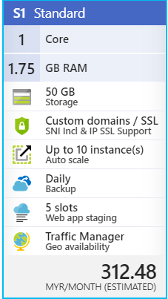 | RM312.48
Database Standard | Southeast Asia | 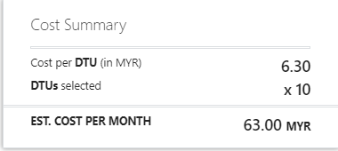  -250GB Storage | RM 63.00
Storage (general purpose v1) | East Asia | 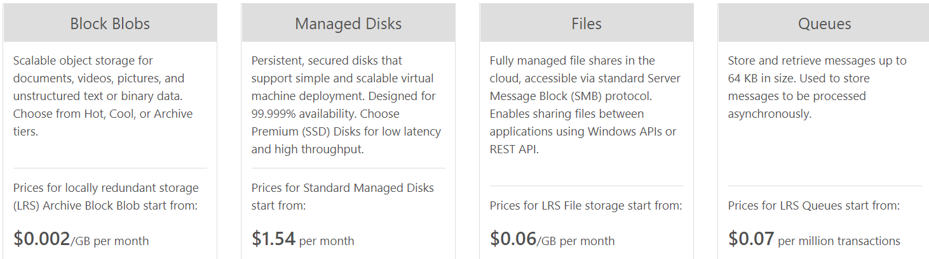 | Around  RM 20.00

Implementation

Application Development
The development of MAERSK Management system is done by using Visual Studio 2017. The programming language that used to develop this system is ASP.Net with C#. The MVC framework is applied to this development which organizes the structure of the system.
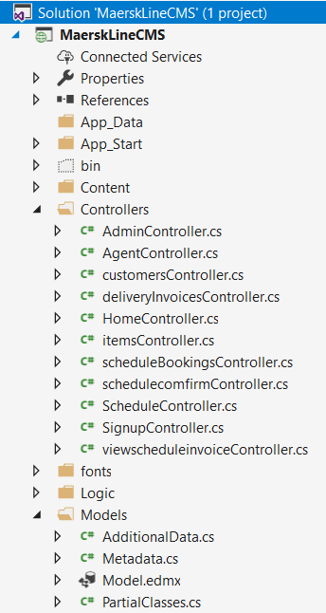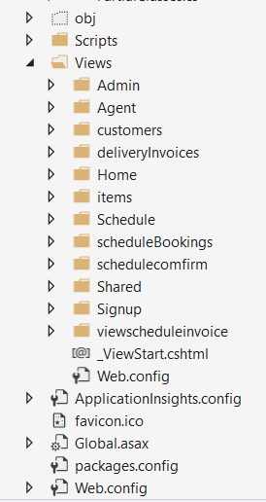
Figure 19: System files
The Model-View-Controller (MVC) is an architectural pattern that separates an application into three main logical components: the model, the view, and the controller. Each of these components are built to handle specific development aspects of an application. MVC is one of the most frequently used industry-standard web development framework to create scalable and extensible projects. (tutorialspoint, 2018)
The Model component corresponds to all the data-related logic that the user works with. This can represent either the data that is being transferred between the View and Controller components or any other business logic-related data. The View component is used for all the UI logic of the application. Controllers act as an interface between Model and View components to process all the business logic and incoming requests, manipulate data using the Model component and interact with the Views to render the final output. (tutorialspoint, 2018)
For the database, a Microsoft SQL Server database is used and integrated in this system to store and retrieve the application data. The database is managed by using Microsoft SQL Server Management Studio. The database tables are created by using SQL query. All the relationship between tables are identified and built too. The figure below shows the database table of this application.
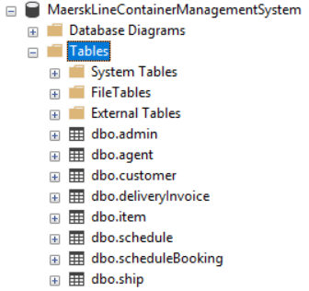
Figure 20: Database table

To access the data the entity framework is used to communicate with database. Entity Framework is an open-source ORM framework for .NET applications supported by Microsoft. It enables developers to work with data using objects of domain specific classes without focusing on the underlying database tables and columns where this data is stored. With the Entity Framework, developers can work at a higher level of abstraction when they deal with data, and can create and maintain data-oriented applications with less code compared with traditional applications. (Entityframeworktutorial, 2018)
For the frond-end of the application which is the user interface of the system is developed with combination HTML5, CSS, and Javascript. The figure below shows the schedule user interface of the system.
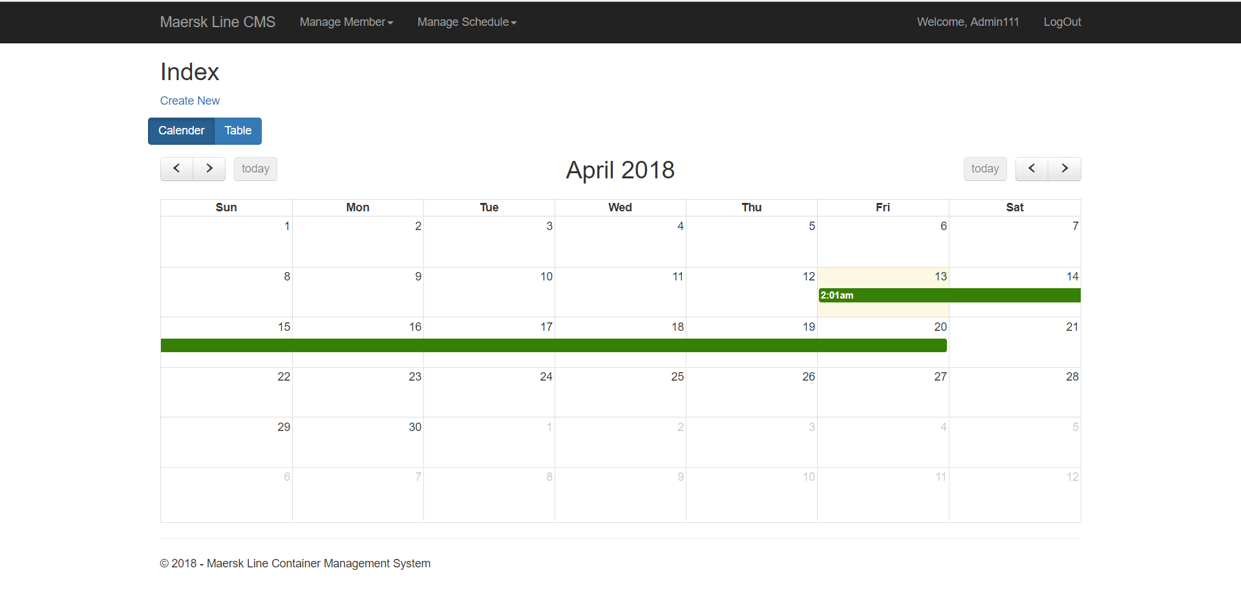
Figure 21: System user interface

Azure Publishing

App Service Publish
Step 1 – Create new web service on Azure
Firstly, create a new resource group that named “MaerskLineCMS_1” and located at Southeast Asia. The figure bellows shows the creation of resource group.
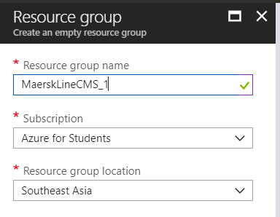
Figure 22: Create Resource Group
Then, create a new web app which requires the user to register app name, choose subscription, resource group, app service plan, location and operating system. Choose a most appropriate subscription that suit the web application with current situation. Also, choose a most suitable location to host the web application. The figure below shows the creation of app service.
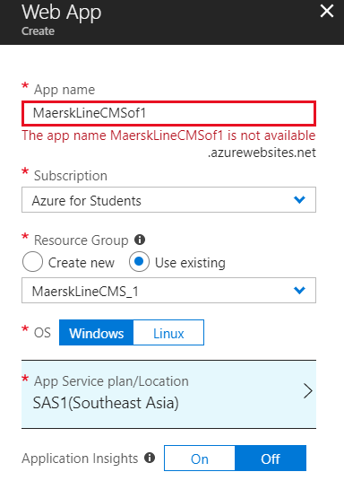
Figure 23: Create App Service
The app service plan also need to be create and the price tier is choosed.
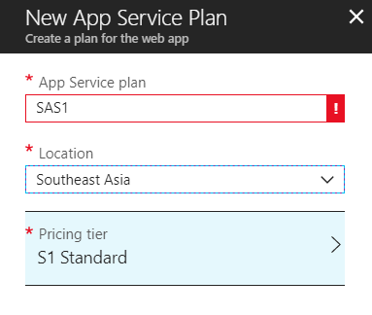
Figure 24: Create App Service Plan
Step 2 –Publish Web Application
Open Visual Studio and open the application’s project. Then find the publish action in the menu and select it.
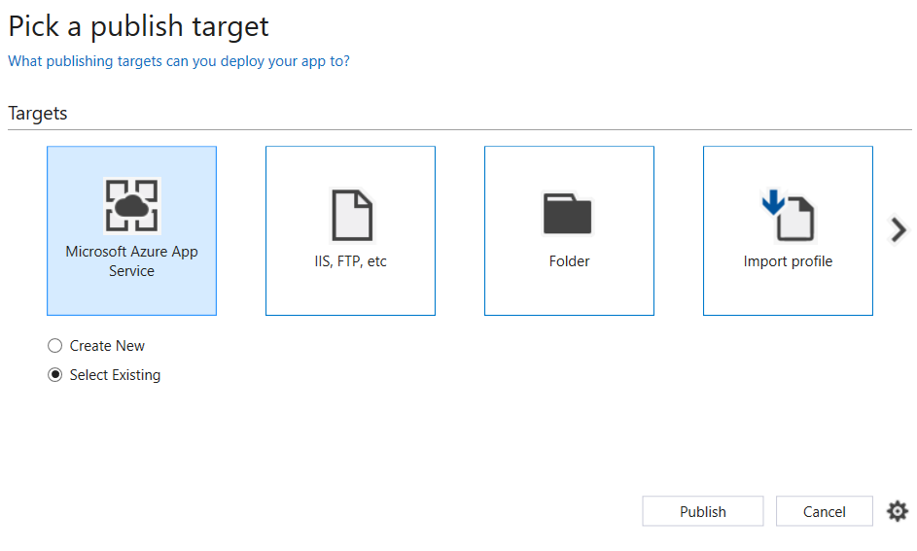
Figure 25:Publish Target
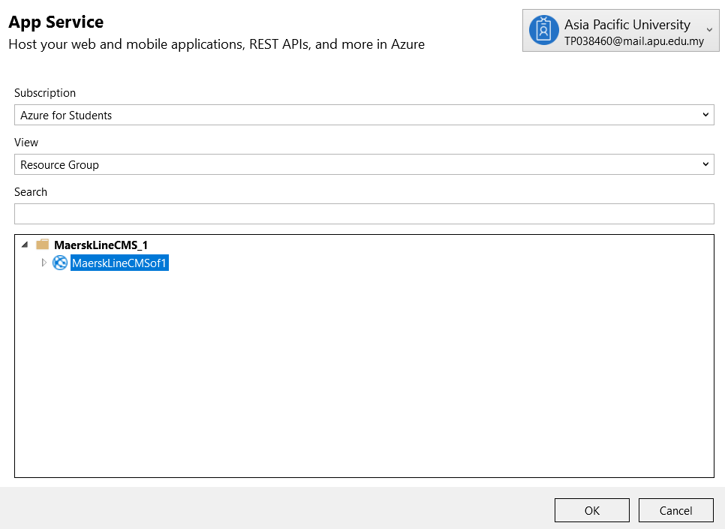
Figure 26: Select Resource Group
After select the publish target and the resource group to publish, visual studio will publish the project to azure.
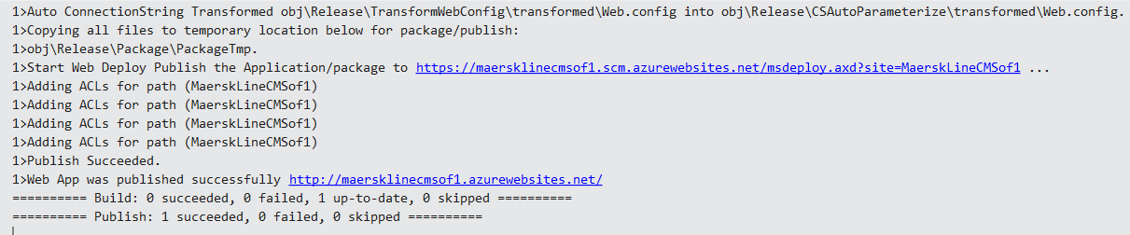
Figure 27:Publish Project

Database Publish
Step 1 – Create New Web Service on Azure
Firstly, in the same resource group for database which named “MAERKDBResourceGroup”. Then, create a new database service which is “SQL Database”. Fill up all the required information of the creation of new SQL Database service. The following figure shows the creation of new SQL Database service.
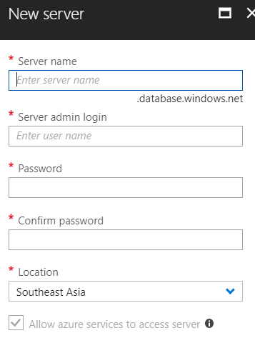
Figure 28: Create SQL Server
After created a server, select it and fill in the information to create a sql database.
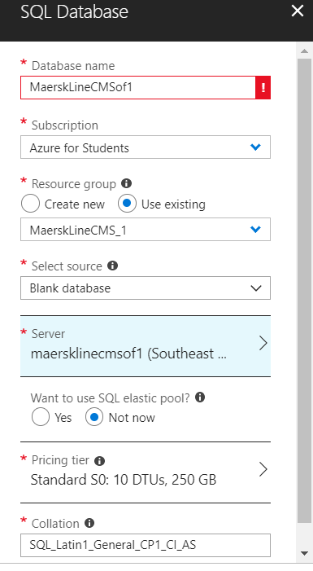
Figure 29: Create Database
After creating SQL database service, install an application called “Microsoft Data Migration Assistant (DMA)” to migrate the database from local server to Azure. Open DMA and press create to create a new migration project. Fill up all required information and press create button. The following figure shows the configuration of migration project.
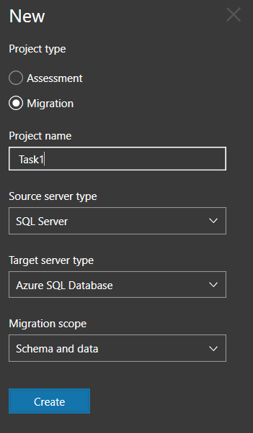
Figure 30:Data Migration Assistant
First fill in the database which want to migrate the data.
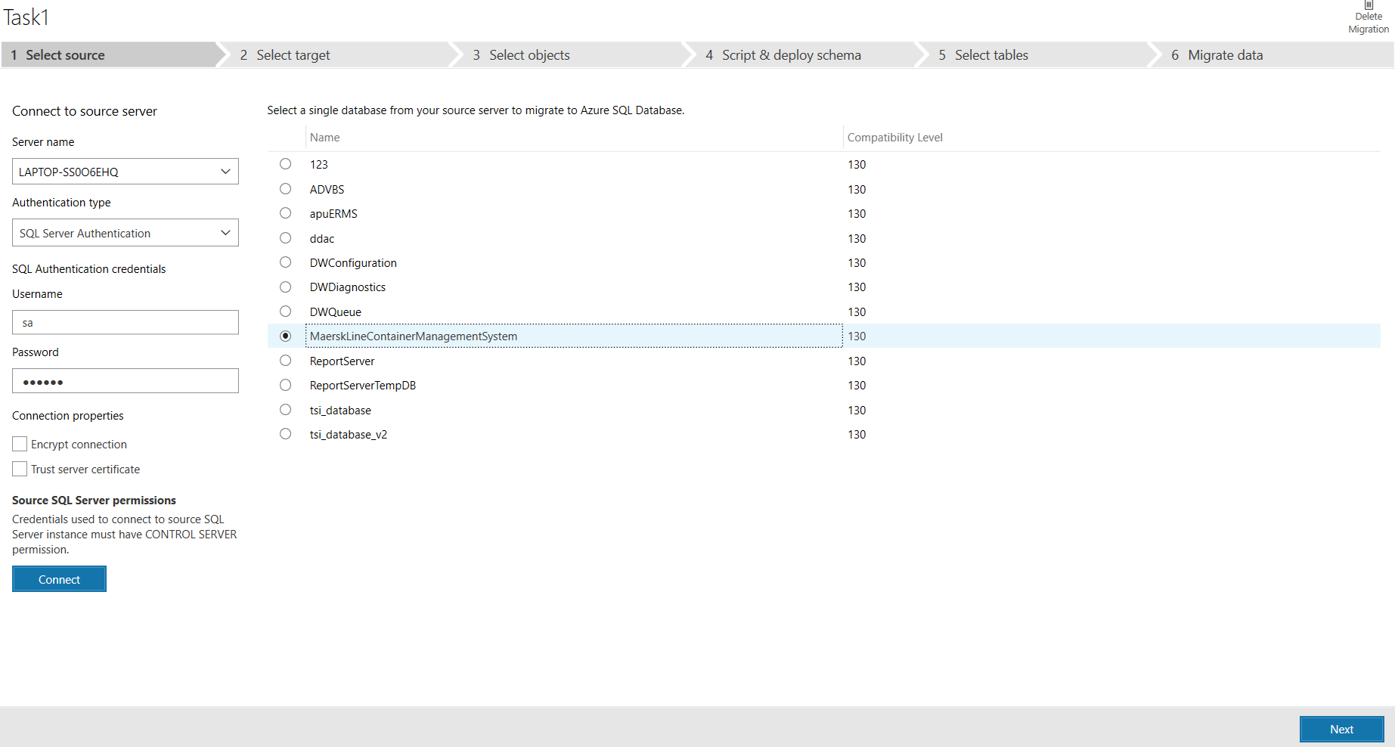
Figure 31:Migrate Database
Then fill in the database that receive the data.
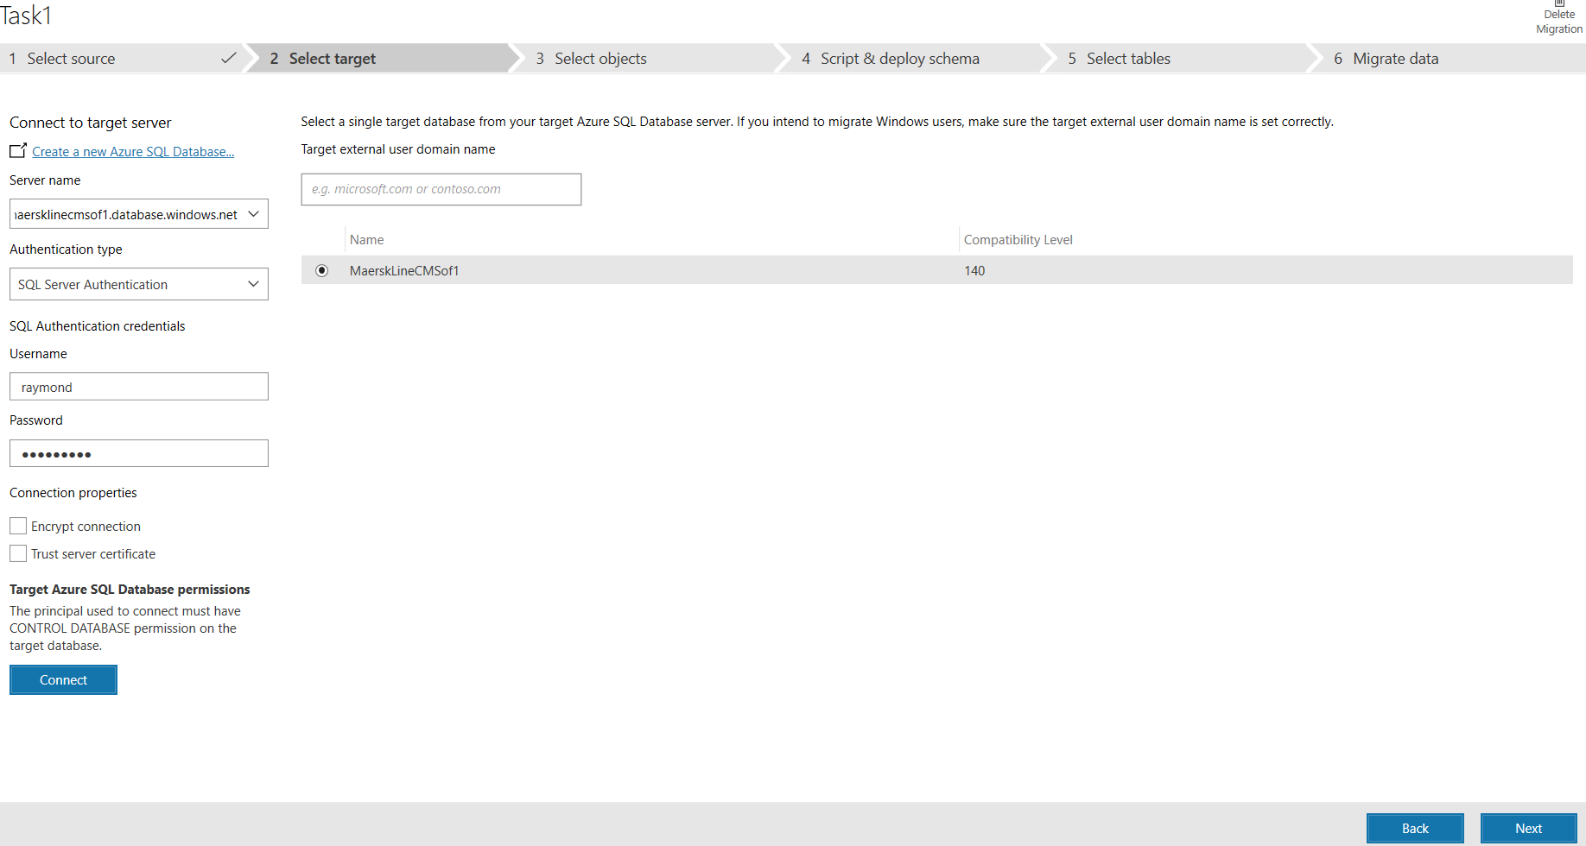
Figure 32:Receive Database
Select table and generate the script.
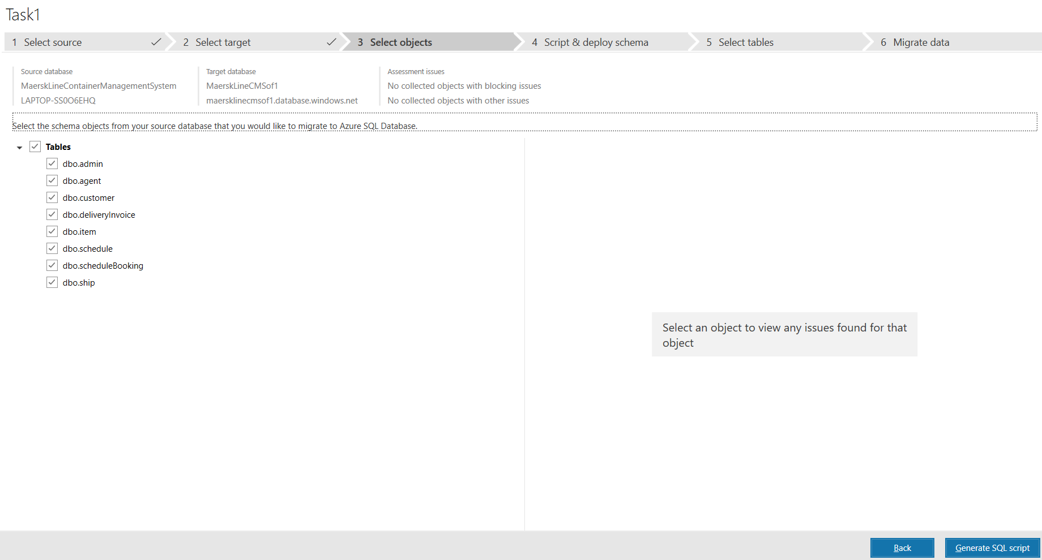
Figure 33: Generate Script
Deploy Script.
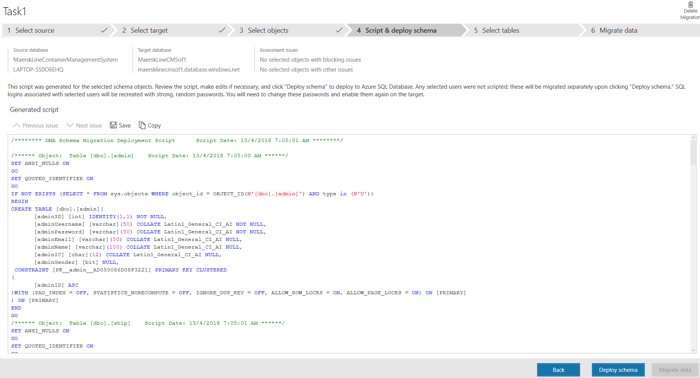
Figure 34: Deploy Script
Then select all the table data in the local database to copy the record to the database in azure.
The source code is available at: https://github.com/tp038460/raymond.github.io
The Presentation is available at: https://web.microsoftstream.com/video/09db3e61-c88d-4d22-ad4a-5395beecea05

APPLICATION SCALING
The MAERSK Management System is hosting on S1 Standard pricing tier and the SQL Database is hosting on Standard pricing tier with minimum data size and minimum amount of Database Transaction Unit (DTU).

SQL Database Scaling
The SQL Database will be using the standard plan for initial deployment phase which does not require much storage and computation. In the current situation, there will be 10 DTUs and 250 GB provided for storage size and this is sufficient enough for the initial deployment testing.
Figure 35:SQL Database Scaling
The above figure shows the current scale of the SQL database in Azure. The basic plan of this Azure SQL Database service is not suitable for this system. This is because the maximum amount of database size is only 2GB and only 5 DTUs are provided. It is not enough for this system to handle the large amount of data from different countries and the performance of the database might slow down. For the current state, standard plan is the most suitable plan to be used for initial deployment stage as it is slowly deploying to other country.
As the business grows, more data and DTU might be required to be assigned to the system depends on the situation. If current plan is not sufficient to support the larger load of the system, then a greater plan such as Premium tier will be considered in the future in order to handle the greater amount of transaction.

Web Application Scaling
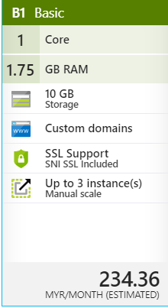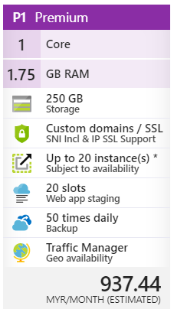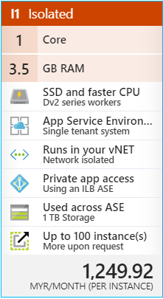
Figure 36:Web Application Scaling
For the MAERSK Line CMS, S1 Standard pricing tier will be used to host the web application. In standard pricing tier, the storage provided for user is 50 GB, compare to basic pricing tier which only provide 10GB storage for user. Standard plan is more reliable and scalable as the system might be improved in the future and the size of the web application will increase as well. Therefore, the basic plan is not scalable enough. Besides, the standard plan provides auto scaling for user while standard plan provides manual scaling. Auto scaling is important as the app service will automatically scale up or down the number of virtual machine’s instances based on the average performance of the CPU. Unlike basic plan, the user has to manually adjust the number of instances.
The premium and isolated plan provide much better spec such as 20 instances more slot for web app staging, SSD, and other more advance features but as a pre-implementation of the project the plan will be consider no cost efficient as the plan also can upgrade when needed in future.
On top of that, in standard plan, traffic manager is also provided for the user while basic plan does not provide traffic manager. Traffic manager is also an important feature that helps the user to route to the best performed internet location based on the available endpoint. This could reduce the latency of using this web application. Moreover, Standard plan allows the MAERSK Line to use their own domain name instead of the default Azure’s domain name. Also, Standard plan provides the feature of daily backup for the system and 5 slots of Web App staging. The benefit of deploying the web application in slot is to validate the system changes in a staging development before swapping it with the development slot. It allows the developer to test the system first in another slot.

Reliability and Performance
To increase the reliability and performance of the application, two methods has been select to increase the reliability and the performance.
The first method is by selecting the Standard Web Application Scaling. This is because by selecting Standard the auto scale instances function can be enable to within the increase of the user in the peak hour and scale back when user number drop. This enable the owner of the app can paid extra when user increase and pay less when user decrease that make the plan a cost-efficient plan.
To increase the reliability of the system, the developer selects a backup option for the both system and database backup.
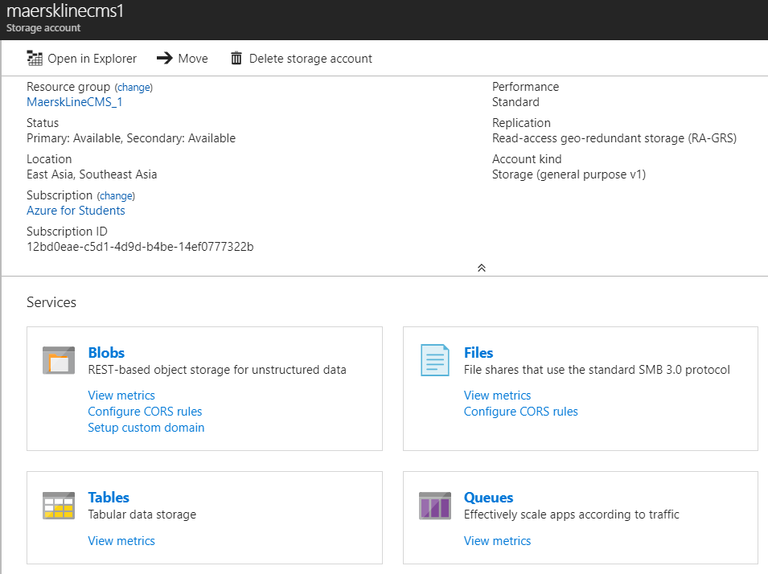
Figure 37: Backup
The backup can backup the Bolbs, Files, Tables and Queue of the system and can recover the system and database when critical situation occur. The backup is been schedule to backup 1 time per day and it will backup the whole system at the schedule time which in this case 2:00AM. By having all the data backup the system can be easily online even a critical situation occur.

Test Plan & Testing Discussion

Unit Test

UNIT TEST (Admin)
Figure 38: Unit Test (Admin)

UNIT TEST (Agent)
Figure 39:Unit Test (Agent)

Performance Test
The performance of MAERSKLineCMS can be tested by conducting the performance test of web application on particular server. This can be achieved stimulate numbers of concurrent user making request to the web application within a period of time. This feature is provided by the Microsoft Azure Portal. Each pricing tier allows for different number of user load to be applied and different time period to be tested. For example, for basic pricing tier, the maximum number of user load is 40 concurrent users which is not sufficient to test the performance of the system while standard pricing tier allows 20,000 concurrent users to be tested for the performance of the system. The performance test will be targeted the MAERSKLineCMS in South East Asia region. There will be three times of performance testing performed starting with user load of 500 concurrent users to 1500 concurrent users with each test having 500 user load increment. The figure below shows the configuration of the performance testing. It requires the developer to fill up all the required information such as generate the load from which region, number of user load, and duration of the request from these number of user load.
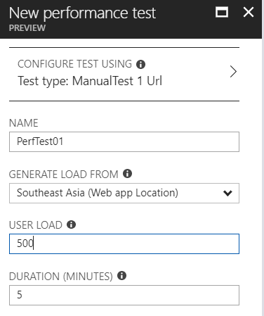
Figure 40:Performance Test
After press “Run Test” button, the performance testing is automated, and it requires 15 minutes in queue to complete the performance testing. The result of performance testing provides some important information in a pie chart, such as number of successful request and failed request, average response time from the server, throughput of the system, CPU Time and Memory working set within the period of performance testing as well as the application of scaling operation. In the first test, 500 concurrent users within 5 minutes is tested to make request to the web application. The result is 28191 successful requests and 0 failed request done to the server which is 100% successful rate of making request to server. The average response time of the web application is 5.13 seconds and the requests made per seconds is 97.4. This result is pretty good and is acceptable. The following figure shows the result of the first performance test.
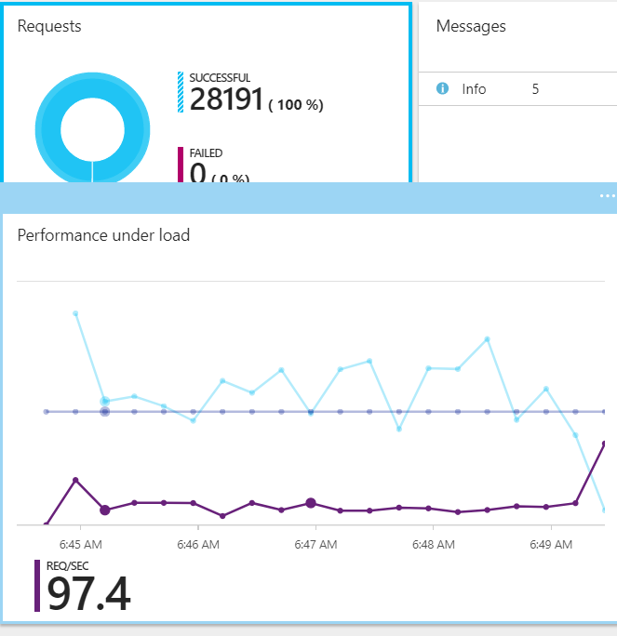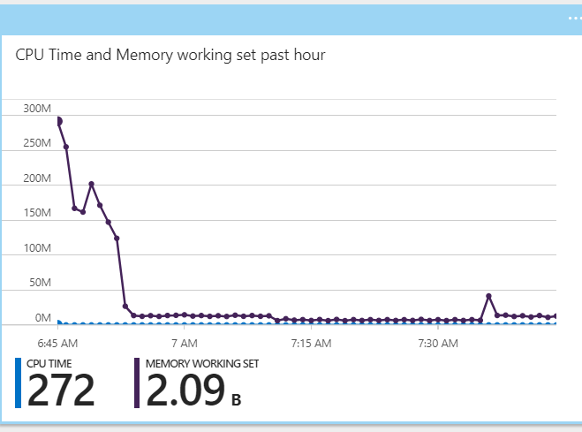
Figure 41: first performance test
As mentioned above, three different performance tests will be carried out and the result was documented in the following table.
 | 500 Concurrent User | 1000 Concurrent User | 1500 Concurrent User
Successful Request | 28191 | 44435 | 68378
Failed Request | 0 | 0 | 0
Average Response Time | 5.13 | 6.98 | 6.93
Request/second | 93.97 | 148.12 | 217.07

In conclusion, the performance of the MAERSKLineCMS is good. As shown in the table, there are 100% successful request made from 500 concurrent users up to 1500 concurrent users. Besides, the average response time of the web application is good as well. Both response time of the first and third performance test can be achieved within 7 second which is good to the users of the system. The respond time of the 1000 user with 1500 user is most likely because the increase instance of the system make the respond time did no decrease dramatically but can be maintain around 7 second. This show that the selected tier which is standard is sufficient to the current situation and able to handle the current situation and able to scale up when user increase.

Managed Database (PaaS)
In the world of cloud, there are few competitors in the market that provides web services, such as Amazon.com, Google, Microsoft, etc. Those company provide various database in the cloud and they gain different market share in the Q4 of 2017.
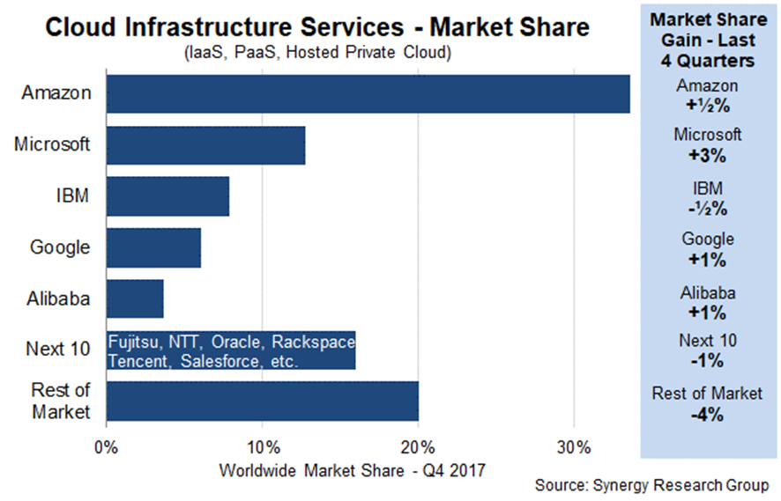
Figure 42: Cloud Infrastructure Service (WHEATLEY, 2018)
Platform as a service (PaaS) is a complete development and deployment environment in the cloud, with resources that enable you to deliver everything from simple cloud-based apps to sophisticated, cloud-enabled enterprise applications. User purchase the resources user need from a cloud service provider on a pay-as-you-go basis and access them over a secure Internet connection. (Microsoft, 2018)
Like IaaS, PaaS includes infrastructure—servers, storage, and networking—but also middleware, development tools, business intelligence (BI) services, database management systems, and more. PaaS is designed to support the complete web application lifecycle: building, testing, deploying, managing, and updating.
PaaS allows user to avoid the expense and complexity of buying and managing software licenses, the underlying application infrastructure and middleware or the development tools and other resources. User manage the applications and services you develop, and the cloud service provider typically manages everything else. (Microsoft, 2018)
Azure SQL Database is a SQL database native to the cloud, also known as a platform as a service (PaaS) database or a database as a service (DBaaS) that is optimized for software-as-a-service (SaaS) app development. It offers compatibility with most SQL Server features.
For Microsoft's data platform, the first things to understand in any discussion of Azure versus on-premises SQL Server databases is that user can use it all. Microsoft’s data platform leverages SQL Server technology and makes it available across physical on-premises machines, private cloud environments, third-party hosted private cloud environments, and public cloud. SQL Server on Azure virtual machines enables user to meet unique and diverse business needs through a combination of on-premises and cloud-hosted deployments, while using the same set of server products, development tools, and expertise across these environments.
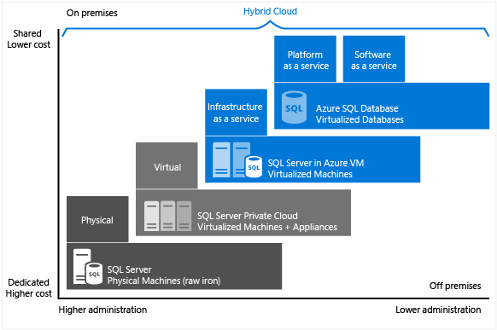
Figure 43: Cost VS Administration (Microsoft, 2018)

When designing an application, four basic options are available for hosting the SQL Server part of the application:
- SQL Server on non-virtualized physical machines
- SQL Server in on-premises virtualized machines (private cloud)
- SQL Server in Azure Virtual Machine (Microsoft public cloud)
- Azure SQL Database (Microsoft public cloud)
Azure SQL Database is a relational database-as-a-service (DBaaS) hosted in the Azure cloud that falls into the industry categories of Software-as-a-Service (SaaS) and Platform-as-a-Service (PaaS). SQL database is built on standardized hardware and software that is owned, hosted, and maintained by Microsoft. With SQL Database, you can develop directly on the service using built-in features and functionality. When using SQL Database, you pay-as-you-go with options to scale up or out for greater power with no interruption.
Azure SQL Database is optimized to reduce overall costs to the minimum for provisioning and managing many databases. It reduces ongoing administration costs because you do not have to manage any virtual machines, operating system or database software. You do not have to manage upgrades, high availability, or backups. In general, Azure SQL Database can dramatically increase the number of databases managed by a single IT or development resource.
Azure SQL Database is New cloud-designed applications that have time constraints in development and marketing. It is for teams that need built-in high availability, disaster recovery, and upgrade for the database. It is for teams that do not want to manage the underlying operating system and configuration settings. It databases of up to 4 TB, or larger databases that can be horizontally or vertically partitioned using a scale-out pattern. (Microsoft, 2018)
Thus, Azure SQL Database is for user that are building new cloud-based applications to take advantage of the cost savings and performance optimization that cloud services provide. This approach provides the benefits of a fully managed cloud service, helps lower initial time-to-market, and can provide long-term cost optimization. User want to have Microsoft perform common management operations on User’s databases and require stronger availability SLAs for databases.

Conclusion
As a conclusion, the develop of the MaerskLineCMS are complete successfully. All the objective and the requirement has been fulfil and the system work fine. The basic knowledge of the cloud computing is learn and apply when deploy the project to the azure cloud. The modelling of the system should be carefully plan and design and construct the system. The use case, class diagram, sequence diagram and other model tools help developer to develop the system. After everything is ready, the developer deploys the project onto the azure cloud. By using various application such as visual studio, Data Migration Tool, the system is then published online then various plan and scale is choose and adjust to fit the need of the deployed system. Then the performance test is carry out to determine the plan selected is suitable for the system to handle the expected amount of concurrent user. The result is record and document in the project.
As an overall, the developer learns many function and feathers of the azure cloud and able to publish a website to the azure with the correct selection of plan with the correct procedure. This help the developer easier to learn more new tactic in future.

Reference
Entityframeworktutorial (2018). What is Entity Framework?. [Online]. 2018. Entityframeworktutorial.net. Available from: http://www.entityframeworktutorial.net/what-is-entityframework.aspx. [Accessed: 2 March 2018].
Microsoft (2018). SQL (PaaS) Database vs. SQL Server in the cloud on VMs (IaaS). [Online]. 2018. Docs.microsoft.com. Available from: https://docs.microsoft.com/en-us/azure/sql-database/sql-database-paas-vs-sql-server-iaas. [Accessed: 8 March 2018].
Microsoft (2018). What is PaaS? Platform as a Service | Microsoft Azure. [Online]. 2018. Azure.microsoft.com. Available from: https://azure.microsoft.com/en-us/overview/what-is-paas/. [Accessed: 3 March 2018].
tutorialspoint (2018). MVC Framework Introduction. [Online]. 2018. www.tutorialspoint.com. Available from: https://www.tutorialspoint.com/mvc_framework/mvc_framework_introduction.htm. [Accessed: 1 March 2018].
WHEATLEY, M. (2018). Cloud infrastructure giants Amazon, Microsoft, Google and Alibaba all gain market share - SiliconANGLE. [Online]. 2018. SiliconANGLE. Available from: https://siliconangle.com/blog/2018/02/04/cloud-infrastructure-spending-grows-amazon-microsoft-google-increase-market-share/. [Accessed: 5 March 2018].

