Angular notes

# Data binding

1. String interpolation: {{ property }}. Always converted to string and data flow in one direction from TS to HTML.
2. Property binding: @Input() and @Output() between components.
3. Event binding
4. Two way binding

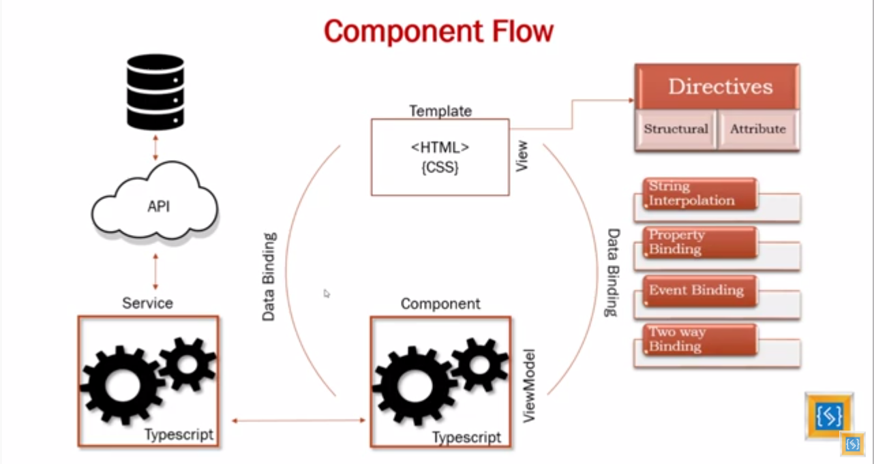

## Boostrap

Install it:

|  |
| --- |
| npm install bootstrap --save |

Add styles to angular.json:

|  |
| --- |
| "styles": [  "src/styles.css",  "node_modules/bootstrap/dist/css/bootstrap.min.css"  ], |

## Navbar

To fix navbar when user scrolls down, add “fixed-top” attribute:

|  |
| --- |
| <nav class="navbar navbar-expand-lg navbar-dark bg-primary fixed-top"> |

In this case Navbar acts as an overlay and can hide some content on top. To fix this we add components in “container” div with some top margin:

|  |
| --- |
| <div class="container" style="margin-top: 70px;">  <app-property-card></app-property-card>  <app-property-list></app-property-list>  </div> |

# Git

In the root folder run

|  |
| --- |
| git init |

Set up git credentials:

|  |
| --- |
| git config --global user.email "tone.petric@gmail.com"  git config --global user.name "tp1972"  git remote add origin https://github.com/tp1972/hspa.git |

# CSS zooming effect

Add css properties to card class:

|  |
| --- |
| .card:hover img{  transform: scale(1.2, 1.2);  transition-duration: 500ms;  transition-timing-function: ease-out;  height: 250px;  opacity: 0.7;  }  .card img{  transform: scale(1, 1);  transition-duration: 500ms;  transition-timing-function: ease-out;  height: 250px;  } |

To prevent image zooming out of card we put image in a div and add card-image-wrapper css class:

|  |
| --- |
| <div class="card-image-wrapper">  <img class="card-img-top"src="assets/images/house1.jpg" alt="">  </div>  Css:  .card-image-wrapper{  overflow: hidden;  } |

Buttons over image

Create <ul> list with some <li> items:

|  |
| --- |
| <ul class="list-inline text-center member-icons animate">  <li class="list-inline-item">  <button class="btn btn-primary"><i class="fas fa-edit"></i></button>  </li>  <li class="list-inline-item">  <button class="btn btn-primary"><i class="fas fa-phone-square"></i></button>  </li>  </ul> |

Add some styles

|  |
| --- |
| .member-icons{  position: absolute;  bottom: -10%;  left: 0;  right: 0;  margin-left: auto;  margin-right: auto;  opacity: 0;  }  .card-image-wrapper:hover .member-icons {  bottom: 0;  opacity: 1;  }    .animate{  transition: all 0.3s ease-in-out;  } |

Here we use opacity and bottom positioning to hide/show the buttons.