MARKETING REPORT

- SUMMARY

My Watt Smart Home App is designed to enhance smart home energy management by providing real-time energy monitoring, device automation and sustainability insights. With a growing emphasis on energy efficiency and cost-saving solutions, My Watt positions itself as an intuitive, user-friendly application that caters to a diverse range of homeowners.

This marketing strategy aims to:
- Increase brand awareness and user adoption through targeted marketing campaigns.
- Differentiate from competitors through innovative energy-saving solutions.
- Promote My Watt’s unique selling points such as Energy insights, user-friendly interface and sustainability features.
- Drive customer engagement via social media, influencer partnerships and educational content.

This section of the document outlines a comprehensive marketing strategy to position My Watt as a leader in Smart-home industry. By analyzing the current marketing landscape, identifying key opportunities, and implementing targeted marketing initiatives, we aim to maximize user engagement, increase brand recognition, and drive long-term revenue growth.

- OVERALL OBJECTIVES

- CUSTOMER SATISFACTION

- Provide an AI powered platform to optimize energy efficiency in modern home including real-time energy usage tracking, and automation of devices.
- Providing a user-friendly, reliable and secure app.
- Offer 24/7 customer support, FAQ, chatbot and easy trouble-shooting guides.
- Provide real-time, AI-powered energy insights for informed decision-making.
- Ensuring reliability, security, and accessibility will contribute to overall user satisfaction and long-term retention.

- MARKET PENETRATION

- Create brand awareness by implementing a multi-channel marketing approach which includes targeted digital marketing advertising, influencer partnerships and collaborations with smart home retailers.
- Engage with eco-conscious communities, home improvement forums, influencers will further strengthen our presence.

- REVENUE GENERATION

- Offer a freemium model, allowing users to access basic features for free while offering premium upgrades for dvanced analytics, automation and integrations with third party services.
- Partner with smart home device manufactures and sustainable cities to offer a bundled solutions. In-app purchases and affliate marketing will further contribute to revenue streams.

- PRODUCT AND MARKET BACKGROUND

- Product Overview

- The My Watt smart home App is an AI-powered platform designed to optimize energy efficiency in modern homes. Users can track real-time electricity usage and generation, receive energy saving tips and automate their devices for maximum efficiency.
- The app is fully responsive and compatible across all common web browsers and all mobile, tablet, desktop devices.
- The app’s AI-driven automation and Mood Profiles adjusts the energy based on user habits, optimizing consumption for cost-savings. With broad device compatibility, My Watt seamlessly integrates with Google Home, Alexa and SmartThings.
- Additionally, the app generates detailed energy reports, offering insights into consumption patterns and recommendations for reducing costs. To ensure user privacy, advanced security measures and encryption protect all stored data.

- Market
- The demand for smart home products with AI integration is increasing due to the rising popularity of smart features. The widespread use of smartphones and the internet is driving demand for connected smart home products, as users seek more seamless and intuitive automation. AI-powered digital assistants enhance user convenience, significantly influencing buyer preferences (Fortune Business Insights, 2024).

- The home automation market has grown rapidly, further accelerated by the COVID-19 pandemic, which led to increased time spent at home. As a result, more vendors have entered the market, expanding the availability of mid-range, entry-level, and low-cost home automation products. Higher online sales and increased competition have made smart home solutions more accessible to a broader audience (Fortune Business Insights, 2024).
- The global smart home market was valued at USD 121.59 billion in 2024 and is projected to grow from USD 147.52 billion in 2025 to USD 633.20 billion by 2032, exhibiting a CAGR of 23.1% during the forecast period (Fortune Business Insights, 2024). In the UAE, the smart home market is expected to generate USD 85.9 million in revenue by 2025, with a CAGR of 9.36% (2025-2029), reaching USD 122.9 million by 2029 (Statista, 2024). With these strong growth trends, My Watt is well-positioned to capitalize on the increasing demand for smart energy management solutions.

- Location
- My Watt is launching in the United Arab Emirates (UAE), where government-backed sustainability initiatives and a tech-savvy population drive strong smart home adoption. A Ciena study (2021) found that 94% of UAE and Saudi Arabian adults were considering more virtual activities to reduce their carbon footprint, with over 50% believing smart appliances would shape future energy efficiency (Fortune Business Insights, 2024). The UAE Vision 2030, which emphasizes sustainable development and technological innovation, aligns well with My Watt’s mission, positioning the country as an ideal base for launching AI-driven energy management solutions (UAE Vision 2030, n.d.).
- Expansion will focus on North America and Europe, where rising electricity costs, government incentives, and major tech players like Amazon, Apple, and Honeywell fuel market growth. North America leads the market, driven by advancements in Wi-Fi, Zigbee, and 5G connectivity. In Europe, investment in smart security and energy-monitoring systems is increasing, while Asia-Pacific is projected to see the highest growth due to rising automation adoption (Fortune Business Insights, 2024).
- With these opportunities, My Watt is well-positioned for global expansion, delivering AI-driven energy management solutions worldwide.
- Competitors
- The smart home industry is highly competitive, with major players dominating through strong brand recognition and extensive product ecosystems. Key competitors include:
  - Google Nest: A leader in smart thermostats and home automation, leveraging Google’s AI technology.
  - Amazon Alexa: Known for voice-controlled automation but lacks robust energy optimization features. It offers a wide range of integrations, including camera controls and full Matter support, with the Amazon Echo Studio as the best hub (HighSpeedInternet.com, n.d.).
  - Samsung SmartThings: A comprehensive platform for home automation, providing features like remote check-in and shared control options, but limited in energy management capabilities. It works best with the Aerotec Smart Home Hub (HighSpeedInternet.com, n.d.).
  - Apple HomeKit: A privacy-focused ecosystem with strong security but limited to Apple devices, making it less versatile compared to other platforms.
  - Regional Competitors: Various startups offering affordable, localized smart home solutions with unique or niche features.
- My Watt differentiates itself by focusing on advanced AI-driven energy monitoring, affordability, and seamless compatibility across multiple platforms, offering users a comprehensive and intelligent energy management experience.

- MARKETING ANALYSIS

  - SWOT Analysis
Strengths:
- AI-driven energy optimization and Device control:
My Watt uses machine learning algorithms to analyze individual user behavior using Mood Profiles and energy usage patterns, providing personalized energy-saving recommendations, optimizing appliance usage, and reducing unnecessary consumption. Adaptive learning capabilities mean the system continually improves its accuracy, enhancing long-term energy efficiency.
- Wide compatibility with smart home devices:
My Watt seamlessly integrates with a broad range of smart home devices, including smart thermostats, lights, HVAC systems, and appliances, ensuring it can cater to users with varying technology setups. The system is compatible with major smart home ecosystems such as Google Home, Amazon Alexa, and Apple HomeKit, which boosts adoption and ease of use.
- Affordable and flexible pricing plans:
The pricing structure includes tiered plans, making it accessible to users with different budgets. Plans cater to both individuals with small-scale needs and larger homes with extensive device setups. Subscription models allow for scalability, enabling users to upgrade as their smart home infrastructure expands.
- User-friendly interface designed for all demographics:
A minimalist design with easy navigation makes My Watt accessible to users of all ages, including those who may not be tech-savvy. Multilingual support and accessibility features, such as voice commands and high-contrast themes, easy mode ensure a wide demographic reach.
Weaknesses:
- New entrant in a competitive market:
My Watt faces challenges in gaining brand recognition and trust as a newcomer in an already crowded market of established smart home energy management companies. Lack of a strong user base compared to competitors may hinder initial growth, especially in regions where consumers are already loyal to other brands.
- Requires users to have or invest in smart home technology:
Users without existing smart home devices will have to invest in smart appliances or compatible technology, which may be a barrier to entry for a significant portion of the market. The initial setup and device compatibility checks can lead to higher upfront costs for users.
- Dependence on partnerships for broader market reach:
The business model heavily relies on partnerships with smart home manufacturers, energy providers, and IoT companies for market penetration and brand visibility. If these partnerships fall through or are not formed, it may impact My Watt’s ability to scale quickly or reach key markets.
Opportunities:
- Increasing smart home adoption worldwide:
The global market for smart home technology is growing rapidly, fueled by the increasing availability of affordable devices and a shift in consumer preferences towards automation and convenience. With smart home adoption expected to continue growing, My Watt has an opportunity to position itself as a go-to energy optimization platform for smart homes.
- Potential for integration with renewable energy solutions:
My Watt can take advantage of the increasing interest in solar panels, wind energy, and battery storage systems by offering seamless integration with these renewable technologies. The platform could optimize energy usage based on solar production, battery levels, and grid energy costs, further promoting sustainability and energy savings for users.
- Expanding government incentives for energy-saving technologies:
Governments are offering increasing incentives for consumers and businesses to adopt energy-efficient technologies, including tax credits, rebates, and grants. My Watt could collaborate with governmental bodies to promote its platform and potentially receive financial support, lowering costs for users and increasing adoption rates.
Threats:
- Strong competition from well-established brands:
Major players in the smart home industry, such as Google, Amazon, and Apple, already offer energy optimization solutions integrated into their ecosystems. Established brands benefit from brand recognition, customer loyalty, and financial resources, which may make it difficult for My Watt to differentiate itself.
- Rapid technological advancements may require continuous updates:
The smart home and energy management industries evolve quickly, requiring My Watt to frequently update its platform to keep pace with new technologies, standards, and consumer expectations. Failure to keep up with emerging technologies or adapt to new trends could make My Watt appear outdated and less appealing.
- Data privacy concerns among consumers regarding energy usage tracking:
As My Watt tracks and analyzes user’s energy usage patterns, concerns over privacy and data security could arise, especially if users perceive their personal data to be at risk.To address these concerns, My Watt must ensure transparency regarding data handling, provide clear user consent processes, and comply with privacy laws like GDPR.

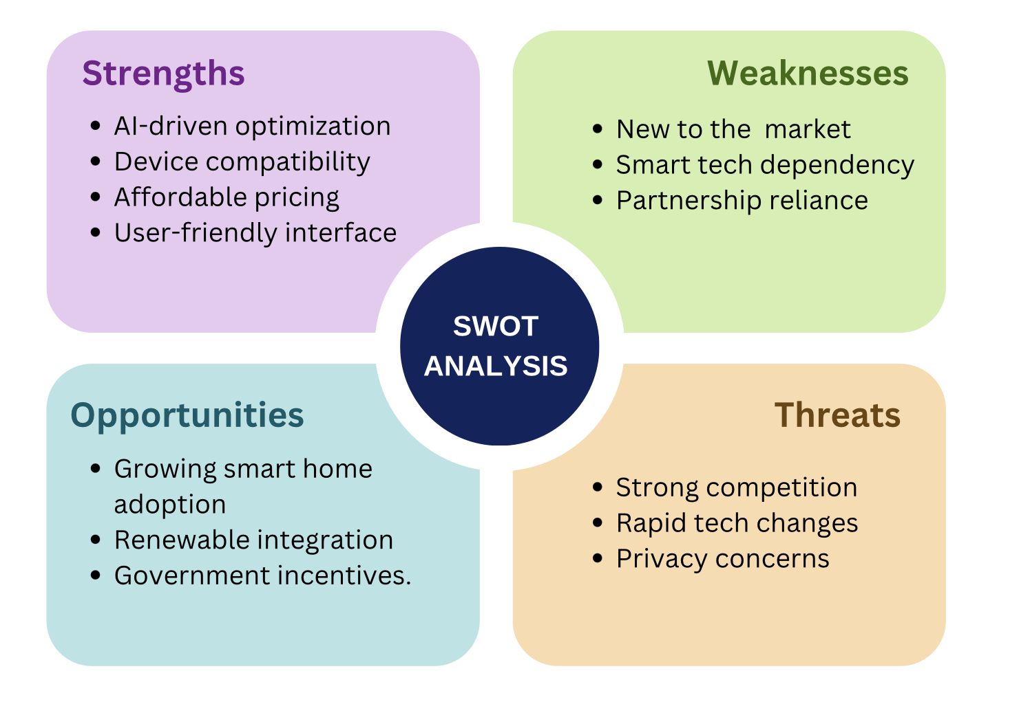

  - PESTLE Analysis
Political:
- Stricter regulations on energy efficiency drive adoption of smart solutions:
Governments worldwide are tightening regulations around energy efficiency and pushing for more sustainable energy practices. Policies such as energy efficiency standards for appliances and carbon reduction targets are encouraging homeowners and businesses to adopt energy-saving solutions. My Watt can align with these regulations by offering a tool that helps consumers comply with energy-saving mandates, such as energy-efficient home certifications.

Economic:
- High energy costs push consumers towards optimization tools:
The rising cost of energy, driven by fluctuating fuel prices and environmental policies, is motivating consumers to find ways to reduce their energy bills. My Watt can capitalize on this by positioning itself as a cost-saving tool that helps users track their energy consumption, identify inefficiencies, and make smarter decisions to lower their utility bills.
Social:
- Increasing awareness of climate change encourages energy conservation:
Growing public concern about climate change and environmental sustainability is driving consumer demand for products and services that help reduce carbon footprints. My Watt can attract environmentally conscious consumers by emphasizing its contribution to reducing energy waste and promoting greener living through optimized energy use.
Technological:
- Rapid IoT advancements improve smart home functionality:
The evolution of the Internet of Things (IoT) has greatly expanded the possibilities for smart home automation, allowing for deeper integration and control over home appliances. My Watt can leverage this rapid innovation in IoT to expand its range of compatible devices and improve its energy optimization algorithms, offering more efficient solutions for users.
Legal:
- Compliance with UAE PDPL (Personal Data Protection Law):
My Watt must comply with the UAE Personal Data Protection Law (PDPL) regarding user data, which includes behavior, energy consumption, and appliance usage. The company is required to implement strong data security measures, obtain clear consent from users for data collection, and maintain transparency throughout the process. Users have the right to access, correct, or delete their data, and My Watt must facilitate these rights. If data is transferred outside the UAE, it must comply with the legal safeguards set forth by the PDPL. Additionally, any data breaches must be reported to the relevant authorities and affected users promptly.

Environmental:
- Shift towards renewable energy sources aligns with My Watt’s mission:
The global transition towards renewable energy sources such as solar and wind power is creating a demand for tools that optimize energy consumption in relation to renewable energy availability. My Watt can align with this shift by incorporating features that help users manage energy produced by renewable sources, storing excess energy in batteries, or contributing to the grid during periods of high generation.
- MARKETING STRATEGIES
5.1. Target Market
As My Watt focuses on smart energy management, the primary target market consists of homeowners, property managers, and environmentally conscious consumers looking to reduce energy costs and optimize their electricity usage.

Initially, My Watt will launch in the United Arab Emirates (UAE), a region with high smart home adoption, strong government incentives, and increasing demand for energy efficiency. Studies indicate that 94% of adults in the UAE and Saudi Arabia are considering adopting more energy-efficient appliances (Fortune Business Insights, 2024).

Following a successful rollout in the UAE, My Watt will expand into Europe and North America, where rising electricity costs, smart city initiatives, and strong regulatory support for sustainability are driving demand for smart home technologies. The North American market is particularly promising due to the presence of major players like Amazon, Apple, and Honeywell, as well as the increasing adoption of Wi-Fi, Zigbee, and 5G-powered smart home solutions (Fortune Business Insights, 2024).

To encourage widespread adoption, My Watt will also collaborate with real estate developers, smart home device manufacturers, and government programs to promote energy-efficient living.

5.2. Product Positioning
Although My Watt operates in a highly competitive market with established players such as Google Nest, Amazon Alexa, and Samsung SmartThings, it is positioned as a cost-effective, AI-driven alternative that is accessible to a wider audience.
As a relatively new entrant, My Watt will follow a market challenger strategy, offering affordable subscription models, seamless multi-device compatibility, and AI-driven automation to differentiate itself from premium competitors. While it may not have the same brand recognition as industry leaders, My Watt’s unique energy optimization features will allow it to carve out a strong market presence.

5.3. Strategic Intent

My Watt is committed to continuous innovation, ensuring that its AI algorithms, user interface, and smart energy analytics remain competitive. The company will develop strategies to defend against competitors by offering regular software updates, expanding smart home integrations, and forming strategic partnerships.

Additionally, My Watt will focus on customer acquisition and retention through referral programs, loyalty incentives, and engaging customer support services. If positioned well, My Watt will not only sustain its market share but also expand into new territories when opportunities arise.

5.4. Stakeholders

Throughout the development and expansion of My Watt, several key stakeholders will be involved, providing support, funding, and strategic direction:

- End Users – Homeowners, businesses, and property managers looking for smart energy solutions.
- Government Agencies – Regulatory bodies supporting smart city initiatives and sustainability programs.
- Smart Device Manufacturers – Companies like Google, Amazon, and Samsung, ensuring compatibility with their ecosystems.
- Utility Providers – Potential partnerships to integrate My Watt’s energy optimization features with electricity providers.
- Investors & Venture Capitalists – Funding the growth and expansion of My Watt into new markets.

5.5. Revenue Model

My Watt will generate revenue through multiple streams, ensuring sustainable growth and profitability:

- Freemium Model – Basic features available for free, with premium upgrades offering advanced AI-driven automation and detailed analytics.
- Subscription-Based Revenue – Monthly and annual plans for homeowners, businesses, and property managers.
- Affiliate Partnerships – Collaborations with smart home device manufacturers and utility providers, earning revenue through bundled sales and commissions.
- Enterprise Licensing – Offering customized energy management solutions for corporate clients and real estate developers.
- In-App Advertising – Non-intrusive, targeted ads for free users, generating additional revenue.

5.6. Marketing Goals
i. Building a Reputation
My Watt is a new entrant in the smart home industry and must establish a strong reputation to build trust with consumers. Extensive market research and strategic partnerships will help position My Watt as a reliable and innovative smart energy solution. To achieve this, customer reviews, testimonials, and case studies will be used to showcase the app’s effectiveness.
ii. Increasing User Growth & Engagement
To increase user adoption, My Watt will implement referral programs, social media campaigns, and targeted ads. Regular updates and feature improvements will ensure a seamless experience, encouraging word-of-mouth marketing. The goal is to create a strong user base that consistently grows through organic recommendations.
iii. Raising Brand Awareness
A comprehensive brand awareness campaign will be launched, including a user-friendly website, social media presence, and strategic content marketing. My Watt’s unique AI-driven energy management features will be highlighted through video tutorials, influencer partnerships, and thought leadership articles to distinguish it from competitors.
6. MARKETING PROGRAMMES

8.1. Marketing Mix

8.1.1. Product

My Watt offers an AI-powered smart home energy management app that integrates with multiple smart home ecosystems, providing real-time monitoring, automation, and predictive energy analytics. Regular software updates and security enhancements will ensure it remains a leading smart energy solution.

8.1.2. Price

The pricing model will be affordable and scalable, ensuring accessibility for a broad customer base:
- Freemium Model – Basic features for free, with premium options for advanced automation.
- Subscription Plans – Monthly and annual pricing for advanced users.
- Enterprise Licensing – Custom pricing for large-scale property management and businesses.

8.1.3. Promotion

A strong digital marketing strategy will be implemented to increase visibility:

- Search Engine Optimization – Optimizing for relevant search queries.
- Social Media Campaigns – Engaging content on Instagram, LinkedIn, and Twitter.
- Influencer Marketing – Collaborations with tech bloggers and sustainability advocates.
- Email Campaigns – Personalized newsletters for updates and promotions.
- Paid Advertising – Google Ads, Facebook Ads, and retargeting campaigns.

8.1.4. Place

My Watt is a digital-first product, accessible via:

- Google Play & Apple App Store – Ensuring a global reach.
- Smart Home Retailers & Partners – Collaborations with device manufacturers.
- Official Website & Social Media Pages – Providing direct downloads and customer support.

8.1.5. People

- Dedicated customer support via live chat and email.
- Technical team for seamless AI updates and bug fixes.
- Marketing & brand specialists to ensure effective promotional campaigns.

8.1.6. Process

- Seamless onboarding experience, ensuring new users can easily set up and optimize their energy management.
- AI-driven recommendations, making energy optimization effortless for users.
- Regular app updates to enhance functionality and ensure compatibility with smart home devices.

8.1.7. Physical Evidence

- Success stories & case studies demonstrating real energy savings.
- User testimonials & reviews to build trust and credibility.
- Demo videos & online tutorials to guide new users through setup and usage.

9. UNIQUE SELLING PROPOSITION (USP)

- AI-powered real-time energy optimization, allowing users to track and reduce electricity consumption effortlessly.
- Gamification features that reward users for energy-saving habits, encouraging long-term engagement and sustainable practices.
- Mood Pages that allow users to customize energy settings based on different moods and scenarios, providing a personalized smart home experience.
- Easy Mode for users with disabilities, ensuring accessible navigation, voice control options, and simplified energy management features.
- Affordable pricing model, making smart energy management accessible to all households and businesses.
- User-friendly interface designed for both tech-savvy and non-technical users, ensuring ease of use.
- Commitment to sustainability, aligning with UAE Vision 2030 and global green energy initiatives to promote eco-friendly living.

REFERENCES
Fortune Business Insights. (2024). Smart Home Market Report. Retrieved from Fortune Business Insights.
Statista. (2024). "Smart Home Outlook UAE." Retrieved from statista.com.
UAE Vision 2030. (n.d.). Retrieved from https://u.ae/en/about-the-uae/uae-in-the-future/uae-future.
HighSpeedInternet.com. (n.d.). Best smart home apps. Retrieved from https://www.highspeedinternet.com/resources/best-smart-home-apps.

