MARKETING REPORT

- SUMMARY

My Watt Smart Home App is designed to enhance smart home energy management by providing real-time energy monitoring, device automation and sustainability insights. With a growing emphasis on energy efficiency and cost-saving solutions, My Watt positions itself as an intuitive, user-friendly application that caters to a diverse range of homeowners.

This marketing strategy aims to:
- Increase brand awareness and user adoption through targeted marketing campaigns.
- Differentiate from competitors through innovative energy-saving solutions.
- Promote My Watt’s unique selling points such as Energy insights, user-friendly interface and sustainability features.
- Drive customer engagement via social media, influencer partnerships and educational content.

This section of the document outlines a comprehensive marketing strategy to position My Watt as a leader in Smart-home industry. By analyzing the current marketing landscape, identifying key opportunities, and implementing targeted marketing initiatives, we aim to maximize user engagement, increase brand recognition, and drive long-term revenue growth.

- OVERALL OBJECTIVES

- CUSTOMER SATISFACTION

- Provide a platform to optimize energy efficiency in modern home including real-time energy usage tracking, and automation of devices.
- Providing a user-friendly, reliable and secure app.
- Offer 24/7 customer support, FAQ, chatbot and easy trouble-shooting guides.
- Provide real-time, AI-powered energy insights for informed decision-making.
- Ensuring reliability, security, and accessibility will contribute to overall user satisfaction and long-term retention.
- BRAND AWARENESS

- Create brand awareness by implementing a multi-channel marketing approach which includes targeted digital marketing advertising, influencer partnerships and collaborations with smart home retailers.
- Engage with eco-conscious communities, home improvement forums, influencers will further strengthen our presence.

- REVENUE GENERATION

- Offer a freemium model, allowing users to access basic features for free while offering premium upgrades for dvanced analytics, automation and integrations with third party services.
- Partner with smart home device manufactures and sustainable cities to offer a bundled solutions. In-app purchases and affliate marketing will further contribute to revenue streams.

- PRODUCT AND MARKET BACKGROUND

- Product Overview

- The My Watt smart home App is a platform designed to optimize energy efficiency in modern homes. Users can track real-time electricity usage and generation, receive energy saving tips and automate their devices for maximum efficiency.
- The app is fully responsive and compatible across all common web browsers and all mobile, tablet, desktop devices.
- The app’s Automation features and Mood Profiles adjusts the energy based on user habits, optimizing consumption for cost-savings.
- Additionally, the app generates detailed energy reports, offering insights into consumption patterns and recommendations for reducing costs. To ensure user privacy, advanced security measures and encryption protect all stored data.

- Market
- The demand for smart home products is increasing due to the rising popularity of smart features. The widespread use of smartphones and the internet is driving demand for connected smart home products, as users seek more seamless and intuitive automation. Digital assistants enhance user convenience, significantly influencing buyer preferences (Fortune Business Insights, 2024).
- The home automation market has grown rapidly, further accelerated by the COVID-19 pandemic, which led to increased time spent at home. As a result, more vendors have entered the market, expanding the availability of mid-range, entry-level, and low-cost home automation products. Higher online sales and increased competition have made smart home solutions more accessible to a broader audience (Fortune Business Insights, 2024).
- The global smart home market was valued at USD 121.59 billion in 2024 and is projected to grow from USD 147.52 billion in 2025 to USD 633.20 billion by 2032, exhibiting a CAGR of 23.1% during the forecast period (Fortune Business Insights, 2024). In the UAE, the smart home market is expected to generate USD 85.9 million in revenue by 2025, with a CAGR of 9.36% (2025-2029), reaching USD 122.9 million by 2029 (Statista, 2024). With these strong growth trends, My Watt is well-positioned to capitalize on the increasing demand for smart energy management solutions.
- Location
- My Watt is launching in the United Arab Emirates (UAE) because of its strong support for sustainability and growing smart home market. A Ciena study (2021) found that 94% of people in the UAE and Saudi Arabia were interested in using more smart technology to reduce their carbon footprint, and over 50% believed smart appliances would improve energy efficiency (Fortune Business Insights, 2024).
- The UAE Vision 2030, which emphasizes sustainable development and technological innovation, aligns well with My Watt’s mission, positioning the country as an ideal base for launching energy management solutions (UAE Vision 2030, n.d.).
- The UAE’s Net Zero 2050 Strategy aims for carbon neutrality by 2050, promoting clean energy, energy-saving technologies, and smart home solutions as part of its plan (UAE Net Zero 2050 Strategy, 2024).
- Competitors
- The smart home industry is highly competitive, with major players dominating through strong brand recognition and extensive product ecosystems. Key competitors include:
  - Google Nest: A leader in smart thermostats and home automation, leveraging Google’s AI technology.
  - Sense is a smart home energy monitoring app that tracks and analyzes your home’s energy consumption in real time. Using a smart energy monitor, it provides insights into individual appliances, helping users identify energy hogs and optimize usage.
  - Amazon Alexa: Known for voice-controlled automation but lacks robust energy optimization features. It offers a wide range of integrations, including camera controls and full Matter support, with the Amazon Echo Studio as the best hub (HighSpeedInternet.com, n.d.).
  - Samsung SmartThings: A comprehensive platform for home automation, providing features like remote check-in and shared control options, but limited in energy management capabilities. It works best with the Aerotec Smart Home Hub (HighSpeedInternet.com, n.d.).

Competitor Analysis

Features | My Watt | Google Nest | Amazon Alexa | Sense
Real-time energy optimization | Yes | Yes, but premium | No | Yes
Gamification features | Yes | No | No | No
Mood Pages | Yes | No | No | No
Easy-Mode | Yes | No | No | No
Automation and Smart Controls | Customizable | AI-driven | Voice-controlled | No
Affordable pricing | Yes | Expensive | Varies by device | Yes
User-friendly Interface | Yes | Yes | Yes | Yes
AI-driven Insights | Yes | Yes | No | Yes

- MARKETING ANALYSIS
Marketing analysis for My Watt involves evaluating factors that influence its success in the smart energy management market. This includes understanding the target audience, the competitive landscape, and market trends, as well as considering external factors such as economic, technological, and regulatory influences. By conducting a thorough analysis, My Watt can develop strategies to meet consumer needs, differentiate itself from competitors, and position its energy-saving solutions effectively in the UAE and beyond.
  - SWOT Analysis
SWOT analysis helps identify a company’s internal strengths and weaknesses, as well as external opportunities and threats. It enables businesses like My Watt to leverage strengths, address weaknesses, capitalize on opportunities, and navigate potential risks in the market.

Strengths:
- Real-time energy optimization and Device control:
My Watt provides personalized energy-saving recommendations to optimize appliance usage and reduce unnecessary consumption. With features like real-time energy optimization, gamification, and mood pages, the app helps users save energy in a fun and easy way. Its adaptive learning improves over time, making energy management simpler and more efficient.
- Wide compatibility with smart home devices:
My Watt seamlessly integrates with a broad range of smart home devices, including smart thermostats, lights, HVAC systems, and appliances, ensuring it can cater to users with varying technology setups.
- Affordable and flexible pricing plans:
The pricing structure includes tiered plans, making it accessible to users with different budgets. Plans cater to both individuals with small-scale needs and larger homes with extensive device setups. Subscription models allow for scalability, enabling users to upgrade as their smart home infrastructure expands.
- User-friendly interface designed for all demographics:
My Watt features a simple design with easy navigation, making it accessible for users of all ages, including those who are not familiar with technology. It also includes accessibility features like high-contrast themes and an easy mode for kids and users with disabilities.
Weaknesses:
- New player in a highly competitive market:
My Watt faces challenges in gaining brand recognition and trust as a newcomer in an already crowded market of established smart home energy management companies. Lack of a strong user base compared to competitors may hinder initial growth, especially in regions where consumers are already loyal to other brands.
- Requires users to have or invest in smart home technology:
Users without existing smart home devices will have to invest in smart appliances or compatible technology, which may be a barrier to entry for a significant portion of the market. The initial setup and device compatibility checks can lead to higher upfront costs for users.
- Dependence on partnerships for broader market reach:
The business model depends on partnerships with smart home manufacturers, energy providers for growth and visibility. If these partnerships don’t happen or fail, it could slow down My Watt’s ability to expand and reach important markets.
Opportunities:
- Increasing smart home adoption worldwide:
The global market for smart home technology is growing rapidly, fueled by the increasing availability of affordable devices and a shift in consumer preferences towards automation and convenience. With smart home adoption expected to continue growing, My Watt has an opportunity to position itself as a go-to energy optimization platform for smart homes.
- Integration with renewable energy solutions:
My Watt can benefit from the growing interest in renewable energy sources like solar panels and wind power by allowing users to connect their renewable energy systems to the app. The platform can help manage energy usage based on solar energy production, battery storage, and energy prices from the grid, making it easier for users to save energy and promote sustainability.
- Expanding government incentives for energy-saving technologies:
Governments are offering more incentives like tax credits and rebates to encourage energy-saving technologies. My Watt can work with government programs to promote its app, which could lower costs for users and help expand its user base.
Threats:
- Strong competition from well-established brands:
Major players in the smart home industry, such as Google, Amazon, and Apple, already offer energy optimization solutions integrated into their ecosystems. Established brands benefit from brand recognition, customer loyalty, and financial resources, which may make it difficult for My Watt to differentiate itself.
- Rapid technological advancements may require continuous updates:
The smart home and energy management industries evolve quickly, requiring My Watt to frequently update its platform to keep pace with new technologies, standards, and consumer expectations. Failure to keep up with emerging technologies or adapt to new trends could make My Watt appear outdated and less appealing.
- Data privacy concerns among consumers regarding energy usage tracking:
As My Watt tracks and analyzes user’s energy usage patterns, concerns over privacy and data security could arise, especially if users perceive their personal data to be at risk.To address these concerns, My Watt must ensure transparency regarding data handling, provide clear user consent processes, and comply with privacy laws like GDPR and PDPL.

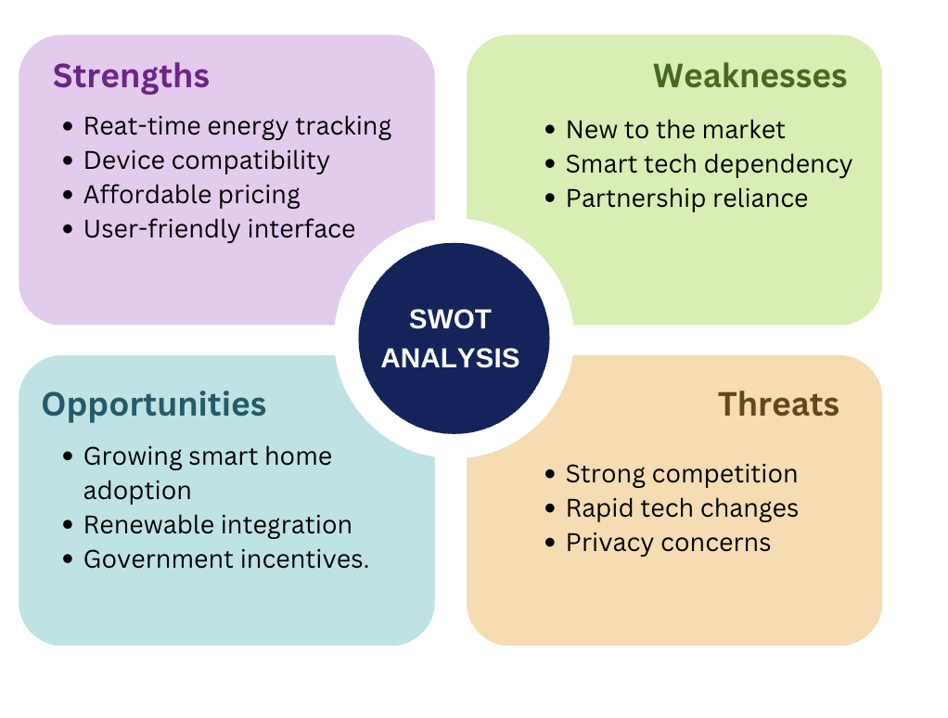

  - PESTLE Analysis
PESTLE analysis helps identify external factors that can impact a business. It looks at Political, Economic, Social, Technological, Legal, and Environmental aspects to understand the market landscape. For My Watt, this analysis helps adapt to changes and seize opportunities while staying compliant and competitive.
Political:
- Stricter regulations on energy efficiency drive adoption of smart solutions:
Governments worldwide, including the UAE, are tightening regulations around energy efficiency and promoting sustainable energy practices. In the UAE, policies like energy efficiency standards for appliances and initiatives such as the UAE Vision 2030 encourage homeowners and businesses to adopt energy-saving solutions. My Watt can align with these regulations by offering a tool that helps consumers comply with energy-saving mandates, such as energy-efficient home certifications.
Economic:
- High energy costs push consumers towards optimization tools:
The rising cost of energy, driven by fluctuating fuel prices and environmental policies, is motivating consumers to find ways to reduce their energy bills. My Watt can capitalize on this by positioning itself as a cost-saving tool that helps users track their energy consumption, identify inefficiencies, and make smarter decisions to lower their utility bills.
Social:
- Increasing awareness of climate change encourages energy conservation:
Growing public concern about climate change and environmental sustainability is driving consumer demand for products and services that help reduce carbon footprints. My Watt can attract environmentally conscious consumers by emphasizing its contribution to reducing energy waste and promoting greener living through optimized energy use.
Technological:
- Advances in smart home technology improve functionality:
New technologies are making smart home devices more powerful and easier to use. My Watt can take advantage of these advancements to support more appliances and improve its energy-saving features, offering better solutions for users.
Legal:
- Compliance with UAE PDPL (Personal Data Protection Law):
My Watt must comply with the UAE Personal Data Protection Law (PDPL) regarding user data, which includes behavior, energy consumption, and appliance usage. The company is required to implement strong data security measures, obtain clear consent from users for data collection, and maintain transparency throughout the process. Users have the right to access, correct, or delete their data, and My Watt must facilitate these rights. If data is transferred outside the UAE, it must comply with the legal safeguards set forth by the PDPL. Additionally, any data breaches must be reported to the relevant authorities and affected users promptly.
Environmental:
- Shift towards renewable energy sources aligns with My Watt’s mission:
As the world moves towards renewable energy like solar and wind, there’s a growing need for tools that help manage energy use based on availability. In the UAE, where solar energy is a key focus, My Watt can help users manage energy from renewable sources, store excess energy in batteries, or even send it back to the grid when there’s a lot of power generation.
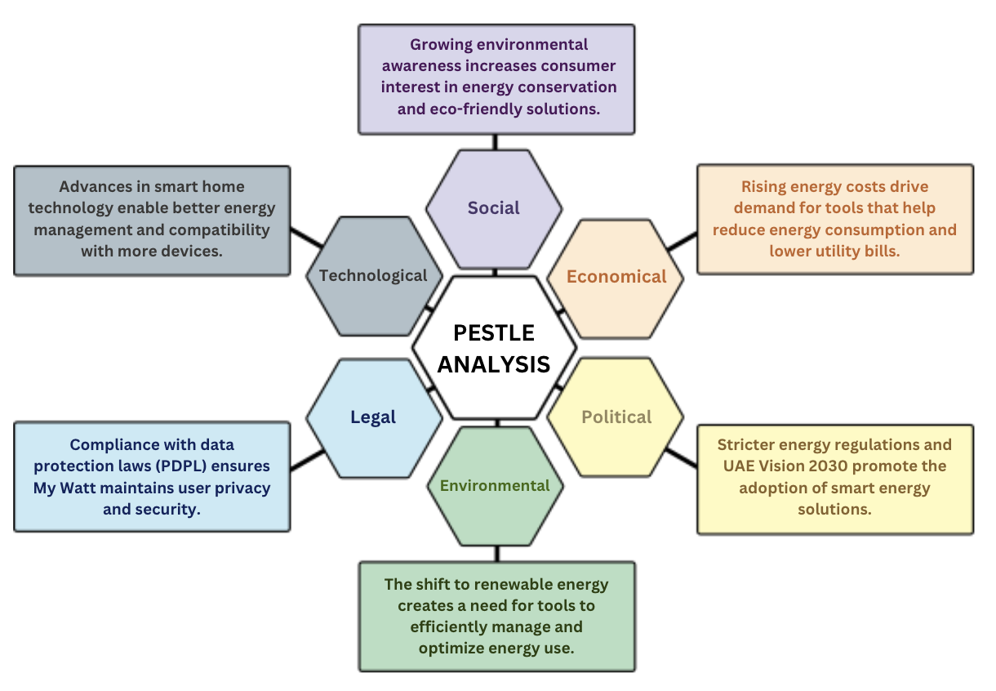

- MARKETING STRATEGIES

Marketing strategies are key to defining how a company reaches its target audience and stands out in a competitive market. For My Watt, these strategies will focus on building brand awareness, creating value for customers, and establishing long-term relationships. The aim is to position the product effectively, attract users, and foster loyalty through personalized marketing efforts. These strategies will be designed to ensure the app reaches the right customers, communicates its unique value, and drives growth in an increasingly competitive smart home energy market.

5.1. Target Market
My Watt focuses on smart energy management, primarily targeting homeowners, property managers, and environmentally conscious consumers seeking to optimize energy usage and reduce costs.

The initial market focus will be the United Arab Emirates (UAE), a region with high adoption of smart home technologies, substantial government incentives, and growing demand for energy-efficient solutions. Research shows that a significant percentage (94%) of adults in the UAE and Saudi Arabia are considering energy-efficient appliances (Fortune Business Insights, 2024).

To facilitate adoption, My Watt plans to collaborate with real estate developers to integrate energy optimization features into new housing projects. Additionally, partnerships with smart home device manufacturers will expand My Watt’s compatibility with various appliances, offering seamless integration for users. The company will also explore collaborations with government programs supporting energy efficiency, further promoting My Watt’s capabilities and expanding its user base.

5.2. Product Positioning
Although My Watt enters a competitive market with well-known brands like Google Nest, Amazon Alexa, and Samsung SmartThings, it stands out by being an affordable option that’s easy for more people to use.
As a new player, My Watt will focus on offering budget-friendly subscription plans, easy compatibility with various smart devices, and strong energy-saving features to set itself apart from the more expensive competitors. Even though it doesn’t have the same brand recognition as the bigger companies, My Watt’s focus on helping users save energy in a simple, effective way will help it build a strong presence in the market.

5.3. Strategic Intent

My Watt is focused on staying ahead of the competition by regularly improving its features, user interface, and energy management tools. The company will protect its position in the market by offering regular updates, making sure it works with more smart home devices, and forming key partnerships.

To attract and keep customers, My Watt will use strategies like referral programs, loyalty rewards, and strong customer support. With these efforts, My Watt aims to maintain its market share and grow into new areas as the opportunity comes.

5.4. Stakeholders

Throughout the development and expansion of My Watt, several key stakeholders will be involved, providing support, funding, and strategic direction:

- End Users – Homeowners, businesses, and property managers looking for smart energy solutions.
- Government Agencies – Regulatory bodies supporting smart city initiatives and sustainability programs.
- Utility Providers – Potential partnerships to integrate My Watt’s energy optimization features with electricity providers.
- Heriot-Watt University – Offering space, computing resources, and expert guidance to support the development and growth of My Watt, helping with research, testing, and project management.

5.5. Revenue Model

My Watt will generate revenue through multiple streams, ensuring sustainable growth and profitability:

- Freemium Model – Basic features available for free, with premium upgrades offering advanced AI-driven automation and detailed analytics.
- Subscription-Based Revenue – Monthly and annual plans for homeowners, businesses, and property managers.
- Affiliate Partnerships – Collaborations with smart home device manufacturers and utility providers, earning revenue through bundled sales and commissions.
- In-App Advertising – Non-intrusive, targeted ads for free users, generating additional revenue.
- UAE Startup Pitch Events & Competitions – Presenting My Watt at UAE-based events like Step Conference and ArabNet to secure funding, partnerships, and market exposure within the region.
6. Marketing Goals
Marketing goals focus on the long-term growth and success of a brand by setting clear objectives to reach and engage target customers. These goals are essential in guiding all marketing activities and ensuring that efforts are aligned with the overall business vision. For My Watt, marketing goals will be focused on building a strong brand reputation, driving user growth, increasing customer engagement, and raising awareness about its unique energy-saving features. By accomplishing these goals, My Watt aims to establish a solid presence in the smart home market, promote customer satisfaction, and ultimately increase sales and market share.

i. Building a Reputation
Since My Watt is new in the smart home market, it is important to build trust with customers. To achieve this, we will carry out market research, form partnerships with key players in the industry, and leverage social media to engage with customers directly. Customer reviews, testimonials, and social media posts will be used to highlight how effective the app is in helping users save energy and improve their smart home experience.
ii. Increasing User Growth & Engagement
To increase the number of users, My Watt will implement referral programs, run social media campaigns, and use targeted advertising. Regular updates and new features will improve the user experience, making users more likely to share the app with others and recommend it, which will help grow the user base organically.
iii. Raising Brand Awareness
We will create a brand awareness campaign with a user-friendly website, active social media presence, and content marketing. My Watt’s unique energy-saving features will be showcased through tutorials, influencer collaborations, and articles to stand out from competitors.

iv. Educational Content: Hosting webinars, creating informative blog posts, and offering guides about energy efficiency and smart home management can position My Watt as an expert in the field, adding to its reputation as a knowledgeable and trustworthy brand.

v. Customer Success Stories: Showcasing real-world examples of how My Watt has helped users save energy and reduce costs can strengthen the brand’s reputation. These could be in the form of video testimonials, blog posts, or case studies.
Sustainability Certifications:

7. MARKETING PROGRAMMES

8.1. Marketing Mix

The Marketing Mix for My Watt uses the 7Ps framework to create a complete strategy. It focuses on offering an easy-to-use smart energy management solution for both homes and businesses. By covering all aspects—product, pricing, place, promotion, people, process, and physical evidence—My Watt aims to provide real value, build trust, and meet the growing demand for smart home solutions while supporting sustainability goals.

8.1.1. Product

My Watt is an easy-to-use smart home energy management app that connects with various smart home systems. It allows users to track their energy usage in real-time, set up automatic routines for appliances, and receive personalized suggestions to reduce energy consumption. The app will be regularly updated with new features and security improvements to ensure it stays a reliable and effective tool for managing energy at home.

8.1.2. Price

The pricing for My Watt will be affordable and flexible, catering to a wide range of customers. The app will offer a freemium model, where basic features are available for free, with paid options providing advanced automation and additional functionality. For users who require more, there will be subscription plans available on a monthly or yearly basis, offering access to features like detailed analytics and enhanced customization. To encourage adoption and customer loyalty, special offers and discounts will be provided for new users, seasonal promotions, or long-term subscribers.

8.1.3. Promotion

A comprehensive digital marketing strategy will be implemented to boost My Watt’s visibility. Social media campaigns will engage users on platforms like Instagram, LinkedIn, and Twitter through regular posts and interactive content. Influencer marketing will involve partnerships with tech bloggers and sustainability advocates to help raise brand awareness. Email campaigns will send personalized newsletters with updates and promotions to keep users engaged. Lastly, paid advertising on platforms such as Google Ads and Facebook will target potential customers through retargeting campaigns to increase app downloads and usage.

8.1.4. Place

My Watt is a digital-first product that is easily accessible through multiple channels. In the UAE, it can be downloaded directly from the App Store and Google Play Store, ensuring easy access for both iOS and Android users. The app is also compatible with a wide range of smart home devices, making it easy to integrate into popular smart home ecosystems. My Watt can be accessed through all devices and web browsers, offering seamless functionality across smartphones, tablets, and desktops. Additionally, the app is available through smart home retailers and device manufacturers, with direct downloads and customer support available via the official website and social media pages.

9. UNIQUE SELLING PROPOSITION (USP)

- My Watt is designed to make managing energy use easy and efficient for everyone. It allows users to track and reduce their electricity consumption in real time, helping them save energy effortlessly. The app includes fun features like gamification, where users can earn rewards for saving energy. This encourages them to adopt long-term energy-saving habits.

- The app also offers Mood Pages, where users can personalize their energy settings for different moods or situations. For example, they can adjust settings for a cozy atmosphere or for work, creating a more personalized smart home experience.

- For users with disabilities or young adults, My Watt includes an Easy Mode that simplifies navigation and easier visualizations of the energy consumption. This makes it easier for everyone to use the app.

- My Watt’s pricing is affordable, making it accessible to all households and businesses. Its user-friendly design ensures that both tech-savvy users and those less familiar with technology can use it easily. Finally, My Watt supports sustainability by aligning with the UAE Vision 2030 and global green energy goals, helping users live in an eco-friendly way.

Brandinh
implementation
market testing

REFERENCES
Fortune Business Insights. (2024). Smart Home Market Report. Retrieved from Fortune Business Insights.
Statista. (2024). "Smart Home Outlook UAE." Retrieved from statista.com.
UAE Vision 2030. (n.d.). Retrieved from https://u.ae/en/about-the-uae/uae-in-the-future/uae-future.
UAE Net Zero 2050 Strategy. (2024). Retrieved from UAE Government.
HighSpeedInternet.com. (n.d.). Best smart home apps. Retrieved from https://www.highspeedinternet.com/resources/best-smart-home-apps.
https://stepconference.com
https://www.arabnet.me

