Dependable Systems and Networks
HW #2
Due Nov. 5, 2018
Each question is 10 points.
- Explain the differences between faults, errors, and failures and the relationships between them.
- Give three examples of applications in which a system failure can cost people’s lives or environmental disaster.
- Define the reliability of a system. What property of a system does the reliability characterize? In which situations is high reliability required?
- What is the difference between the reliability and the availability of a system? How does the point availability compare to the system’s reliability if the system cannot be repaired? What is the steady-state availability of a non-repairable system?
- Compute the downtime per year for A(∞) = 90, 75, and 50%.
- A telephone system has less than 3min per year downtime. What is its steady state availability?
- Explain the main differences between software and hardware faults.
- Why redundancy techniques used in hardware system cannot be used for software fault tolerance. If you are employed as a software quality engineer, what techniques you will prefer?
- A combinational circuit is said to be self dual if and only if f(X) = f’(X’), where f is the output of the circuit and X is the input vector for the circuit.
The dual of a function f_{d} is given by
f_{d} = f’(x₁’, x₂’, …, x_{n}’)
Show the function f_{sd} given by
f_{sd} = x_{n+1} f + x’_{n+1} f_{d}
is a self-dual function.
- The inputs of a two input OR gate may be stuck-at-0 or stuck-at-1 with probabilities P0 and P1, respectively. If the inputs are totally random, what is the reliability of the output?

- What is the difference between a permanent fault, an intermittent fault, and a transient fault (in terms of fault duration)? Is the following statement true or false? A single fault can cause multiple bit errors. Justify your answer
- Answer the following and where ever possible, use an example to make your point.
(a) Bridging fault between a pair of lines in a circuit cannot be modeled by stuck-at fault model.
(b) Circuit modification, i.e. adding more logic to the circuit, can be used to model a bridging fault between a pair of lines.
- Give an example of a combinational logic circuit in which a single stuck-at fault on a given line never causes an error on the output.
- A heart pacemaker has a failure rate of λ = 0.121 × 10−8 per hour. What is the probability that it fails during the first five years of operation? What is its MTTF?
- At the end of the year of service, the reliability of a component is 0.96.
1. What is the failure rate of the component?
2. If two components are connected in parallel, what will be the reliability of the resulting system during the first year of operation?
- Write an expression for the reliability of the system shown by the RBD in the figure below. Assume that Ri (t) is the reliability of the module Mi, for i ∈ {1, 2, 3, 4}.
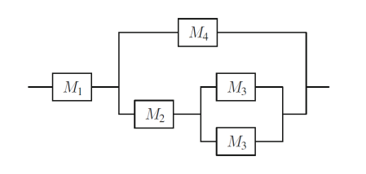
- Draw a Markov chain for reliability evaluation of the system shown below. The failure rate of the processors 1 and 2 is λp. The failure rates of the memory is λm. No repairs are allowed.
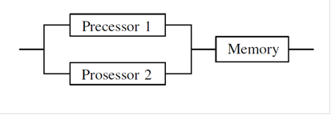
RBD of a three component system consisting of two duplicated processors and a memory
- Suppose that a system was modeled using the Markov chain model and the following transition matrix was obtained from the resulting chain:
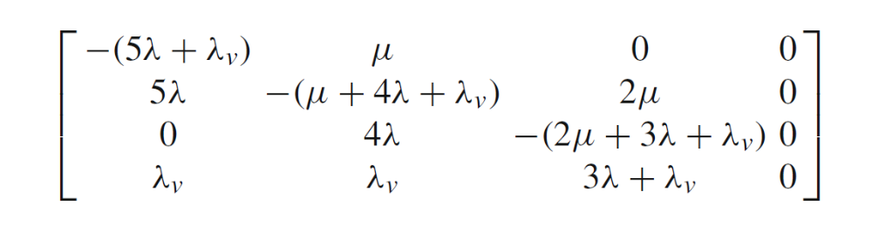
Draw the Markov chain corresponding to this transition matrix. Was the Markov chain intended for reliability or availability evaluation?
- Draw a Markov chain for reliability evaluation of the TMR with three voters shown below. Assume that the failure rate of each module is λm, and the failure rate of each voter is λv. No repairs are allowed.
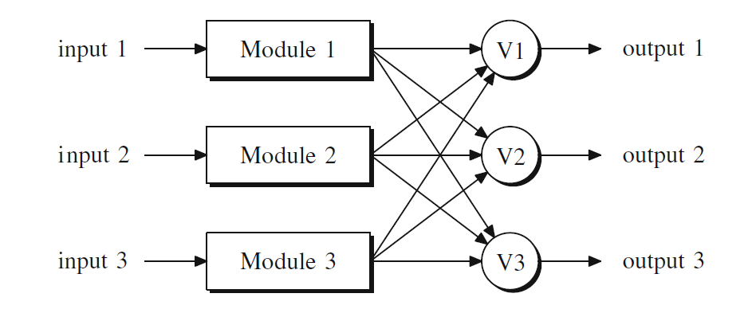
- Compare watchdog times and heartbeats. What are the advantages and disadvantages of each technique?

