Dependable Systems and Networks
HW #2
R07943098 劉治硯

Each question is 10 points.
- Explain the differences between faults, errors, and failures and the relationships between them.
Fault是指物理上或軟體設計的錯誤(根本錯誤)
Error是Fault表現在系統中的結果，例如計算10+10=30
Failure是Error表現給外在使用者的結果，例如使用者投20元買到30的飲料
- Give three examples of applications in which a system failure can cost people’s lives or environmental disaster.
(a) THE DHAHRAN MISSILE
In February 1991 (First Gulf War), an Iraqi missile hit the US base of Dhahran in Saudi Arabia, killing 28 American soldiers.
The base’s antiballistic system failed to launch because of a computer bug: the internal clock drifted by milliseconds and that had a huge impact on the system.Causing “600 meter” error.
(b) Therac-25
The Therac-25 was a computer-controlled radiation therapy machine. Because of concurrent programming errors, it sometimes gave its patients radiation doses that were hundreds of times greater than normal, resulting in death or serious injury.
(c) Deepwater Horizon oil spill
The Deepwater Horizon oil spill is an industrial disaster that began on 20 April 2010, in the Gulf of Mexico on the BP-operated Macondo Prospect According to the US Congressional investigation, the rig's blowout preventer, built by Cameron International Corporation, had a hydraulic leak and a failed battery, and therefore failed. Causing Huge Environmental impact
- Define the reliability of a system. What property of a system does the reliability characterize? In which situations is high reliability required?
- Reliability, R(t): Probability that the system is up during the whole interval [0,t], given it was up at time 0.
- 當系統沒有可行的修復手段(Ex:衛星、太空船)，或是系統無法容忍任何錯誤(飛機、心臟起搏器)時，就需要high reliability
[source:Module 1 p116].

- What is the difference between the reliability and the availability of a system? How does the point availability compare to the system’s reliability if the system cannot be repaired? What is the steady-state availability of a non-repairable system?
- Reliability是在一段時間內系統正常的機率，而Availability則是一瞬間。
- 若系統不能被修復，則reliability需要非常高，但因無法被修復，因此availability可能相對較低。
c. 對一不可修復的系統其steady-state為0，因downtime在系統毀損後為無限

- Compute the downtime per year for A(∞) = 90, 75, and 50%.
- 90%: 365*(1-90%) = 36.5 days/year
- 75%: 365*(1-75%) = 91.25 days/year
- 50%: 365*(1-50%) = 182.5 days/year
- A telephone system has less than 3min per year downtime. What is its steady state availability?
1 – 3/(365*24*60)= 99.999429223%
- Explain the main differences between software and hardware faults.
Software differs from hardware in several aspects:
it does not age or wear out
it cannot be deformed or broken
it cannot be affected by environmental factors
if deterministic, it always performs the same way in the same circuimstances
[source:Module 1 p108]
- Why redundancy techniques used in hardware system cannot be used for software fault tolerance. If you are employed as a software quality engineer, what techniques you will prefer?
- 假設軟體執行僅受軟體邏輯影響，那純粹的複製只會讓同樣的輸入，產出同樣錯誤的結果。
- 由於已假設錯誤是因邏輯錯誤產生，因此使用N-Version Programming應為較合適的作法，如同windows更新會保留上一個版本供使用者回復一樣。

- A combinational circuit is said to be self dual if and only if f(X) = f’(X’), where f is the output of the circuit and X is the input vector for the circuit.
The dual of a function f_{d} is given by
f_{d} = f’(x₁’, x₂’, …, x_{n}’)
Show the function f_{sd} given by
f_{sd} = x_{n+1} f + x’_{n+1} f_{d}
is a self-dual function.
dual(f_{sd}) = dual(x_{n+1} f + x’_{n+1} f_{d})
=(x_{n+1} f(x₁, x₂, …, x_{n}) + x’_{n+1} f’(x₁’, x₂’, …, x_{n}’))’
=(x_{n+1} +f(x₁, x₂, …, x_{n})) (x’_{n+1}+ f’(x₁’, x₂’, …, x_{n}’))
= x_{n+1} x’_{n+1}+ x_{n+1} f’(x₁’, x₂’, …, x_{n}’) + x’_{n+1} f(x₁, x₂, …, x_{n}) + ’(x₁, x₂, …, x_{n}) f’(x₁’, x₂’, …, x_{n}’)
= x_{n+1} f’(x₁’, x₂’, …, x_{n}’) + x’_{n+1} f(x₁, x₂, …, x_{n}) + (x_{n+1}+ x’_{n+1}) f(x₁, x₂, …, x_{n}) f’(x₁’, x₂’, …, x_{n}’)
= x_{n+1} f’(x₁’, x₂’, …, x_{n}’) (1+ ’(x₁, x₂, …, x_{n}))+ x’_{n+1} f(x₁, x₂, …, x_{n})(1+ f’(x₁’, x₂’, …, x_{n}’))
= x_{n+1} f’(x₁’, x₂’, …, x_{n}’)+ x’_{n+1} f(x₁, x₂, …, x_{n})
= x_{n+1} f + x’_{n+1} f_{d}
= f_{sd}
- The inputs of a two input OR gate may be stuck-at-0 or stuck-at-1 with probabilities P0 and P1, respectively. If the inputs are totally random, what is the reliability of the output?
若皆正常運作：(1-P0-P1)* (1-P0-P1)
若有一不正常：P0*(1-P0-P1)*(3/4)*2 + P1*(1-P0-P1)*(3/4)*2
兩者皆不正常：P0*P0*(1/4) + P1*P1*(3/4) + (3/4)*P0*P1*2
因此reliability為：
(1-P0-P1)² +
P0*(1-P0-P1)*(3/2) + P1*(1-P0-P1)*(3/2)+
P0² *(1/4) + P1² *(3/4) + (3/2)*P0*P1
- What is the difference between a permanent fault, an intermittent fault, and a transient fault (in terms of fault duration)? Is the following statement true or false? A single fault can cause multiple bit errors. Justify your answer
(a) permanent fault:除非壞掉的元件備修復，否則錯誤會一直發生
intermittent fault:錯誤發生在不規律的運作週期中
transient fault:只會出現一次，重複同樣的動作無法重現這個錯誤
(b) 可以，例如系統進行連續加法，假設1011₍₂₎要加4次，但0的那個位元卡在1，會使得結果從101100₍₂₎=44₍₁₀₎變成111011₍₂₎=60₍₁₀₎，結果看來產生4個位元的錯誤

- Answer the following and where ever possible, use an example to make your point.
- Bridging fault between a pair of lines in a circuit cannot be modeled by stuck-at fault model.
是，因bridging fault會受另一條線影響而改變數值，而stuck-at fault則否，兩者並不相同。
- Circuit modification, i.e. adding more logic to the circuit, can be used to model a bridging fault between a pair of lines.
是，Bridging fault分為wire-or, wire-and和A-dominant，這三種在模擬時即為增加對應邏輯。
- Give an example of a combinational logic circuit in which a single stuck-at fault on a given line never causes an error on the output.
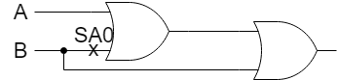
- A heart pacemaker has a failure rate of λ = 0.121 × 10−8 per hour. What is the probability that it fails during the first five years of operation? What is its MTTF?
- 1-R(t) = 1-e^{-0.121*10^(-8)*24*365} 0.00529966%
- MTTF=(1/λ)= 826446280.992(h)
- At the end of the year of service, the reliability of a component is 0.96.
- What is the failure rate of the component?
e^{-λ*24*365}=0.96
λ ≈4.66*10⁻⁶(per hour)
- If two components are connected in parallel, what will be the reliability of the resulting system during the first year of operation?
1-(1-0.96)* (1-0.96)=0.999984
- Write an expression for the reliability of the system shown by the RBD in the figure below. Assume that Ri (t) is the reliability of the module Mi, for i ∈ {1, 2, 3, 4}.
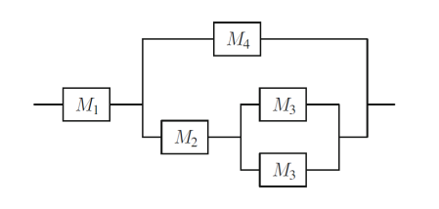
R(i)=R1{1-{1-R2[1-(1-R3)* (1-R3)]}(1-R4)}
= R1{1-[1-R2(2*R3 - R3²)](1-R4)}
= R1[1-(1-2*R2*R3 + R2*R3²)(1-R4)]
= R1[1-(1-2*R2*R3 + R2*R3² - R4 + 2*R2*R3*R4 - R2*R3²*R4)]
= R1(2*R2*R3 - R2*R3² + R4 - 2*R2*R3*R4 + R2*R3²*R4)
= R1(R4+R2*R3*(2-R3-2R4+R3*R4))
- Draw a Markov chain for reliability evaluation of the system shown below. The failure rate of the processors 1 and 2 is λp. The failure rates of the memory is λm. No repairs are allowed.
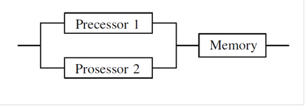
RBD of a three component system consisting of two duplicated processors and a memory
2processors
1memory
1processor
1memory
Failure
2λp
λp

λm

- Suppose that a system was modeled using the Markov chain model and the following transition matrix was obtained from the resulting chain:
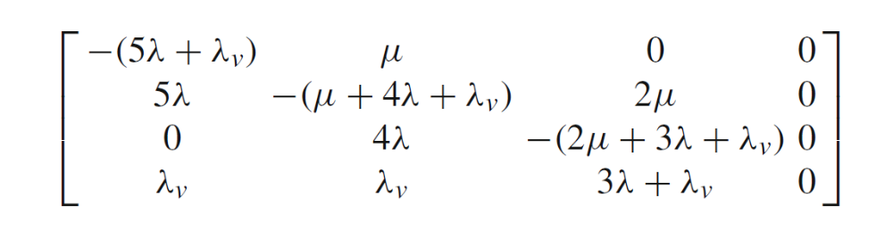
Draw the Markov chain corresponding to this transition matrix. Was the Markov chain intended for reliability or availability evaluation? 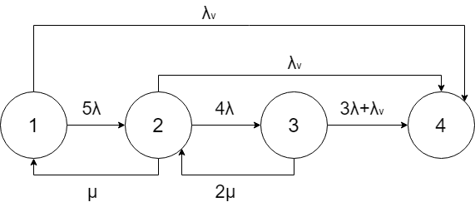
Reliability. Since Markov Models provide a structured approach for the derivation of the reliability of complex systems.
[source:Module 3 p85]

- Draw a Markov chain for reliability evaluation of the TMR with three voters shown below. Assume that the failure rate of each module is λm, and the failure rate of each voter is λv. No repairs are allowed.
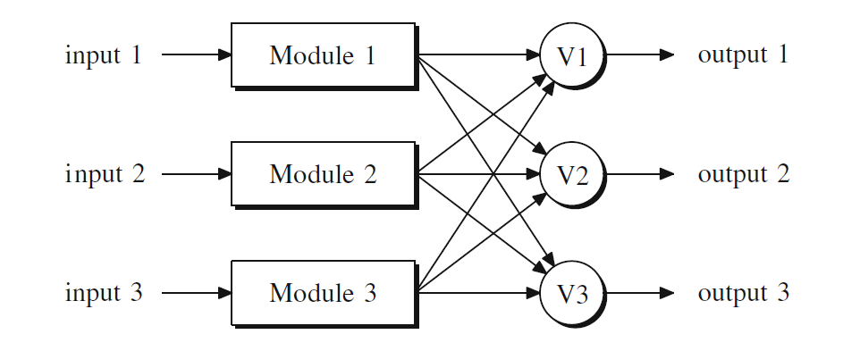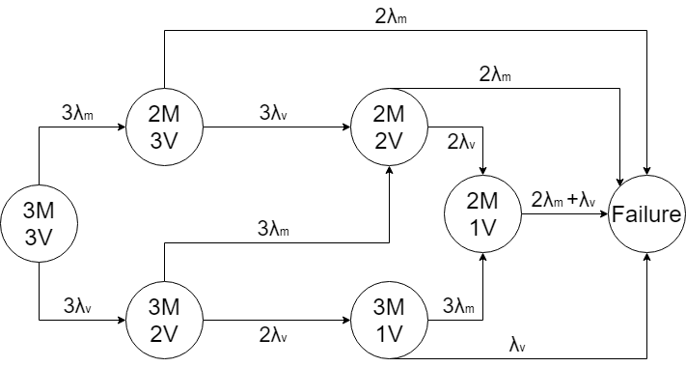
- Compare watchdog times and heartbeats. What are the advantages and disadvantages of each technique?
Watchdog timer:
- Coverage is limited, as neither the data nor the results are checked
- When used to reset the system, a watchdog timer can improve availability (the mean time to recovery is shortened) but not reliability
heartbeats:
- The timeout period is pre-negotiated by the two parties or sometimes even hard-coded by the programmer
- The monitored node is assumed to be healthy if it is able to respond to a heartbeat message, thus cannot detect deadlock
[source:Module 2 p5]

