National Taiwan University
Department of Electrical Engineering
Fault Tolerant Computing
Midterm Exam, Nov. 19, 2018

This is an open book exam. Feel free to consult any book, article, or notes. However, you cannot give or receive help from others during this examination period. All forms of calculating devices are permissible, so use them as you see fit. Please sign below, indicating that you agree with these terms. Return this signed page with your completed answers. Solve all problems. Show your work and clearly mark your final answer.

Student Name:___________________________

Signature:___________________________

- (5 points) Calculate the reliability of this system using the success diagram approach described in class. Derive the upper bound for the system reliability using the formula:

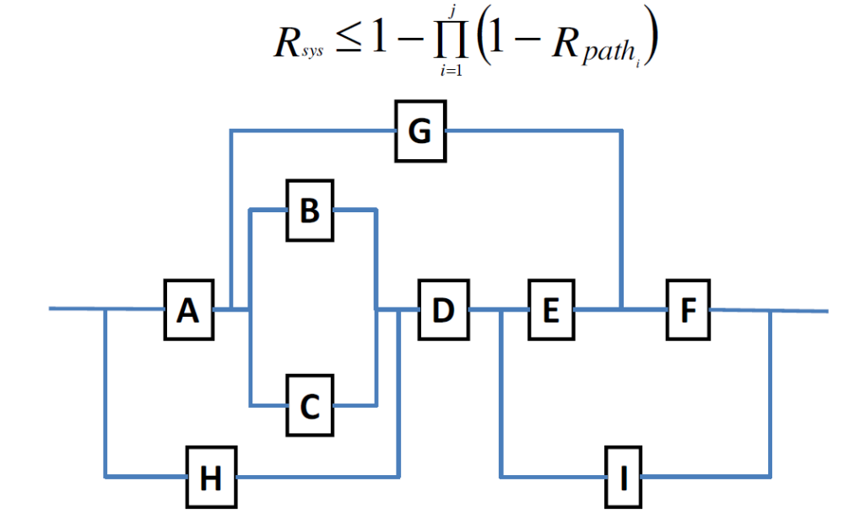

- (5 points) Draw a Markov chain for reliability evaluation for self-purging redundancy with 5 modules. Assume that the voter can adopt to vote on less inputs. When only 2 modules are left, it works as a comparator.
When we say ”voter fails”, we mean that it starts producing an incorrect value on its output, so the system fails.
The failure rates of modules and the voter areλm andλv, respectively, and the repair rate is µ for each. There are two repair teams. Switches are perfect.

Label the state ”XW” means ”X modules working and the voter works”.
- (5 points) How many faulty modules can you tolerate in:
  - 5-modular passive redundancy?
  - Standby sparing redundancy with 5 modules?
  - Pair-and-a-spare redundancy with 5 modules?
- (5 points) A copy machines manufacturer estimates that the reliability of the machines he produces is 73% during the first 3 years of operation.
  - How many copy machines will need a repair during the first year of operation?
  - What is the MTTF of the copy machines?
  - The manufactures guarantees MTTR = 2 days. What is the MTBF of the copy machines?
  - Suppose that two copy machines work in parallel and the failures are independent. What is the probability of failure during the first year of operation?
- (5 points) You company produces a system which consists of two components, A and B, placed in series. The reliabilities of the components are RA = 0.99 and RB = 0.85. Their cost is approximately the same. The warranty for this system is 1 year. Your boss decides that too many items are returned for repair during the warranty period. He gives you a task of improving the reliability of the system so that no more than 2% of items are returned for repair during the first year of operation. This should be done by adding no more than two redundant components to the system. Find a reliability block diagram for the system which meets your boss’s requirements.
- (15 points) Draw a Markov chain for 3-modular redundancy with one spare and the standard majority voter for the cases listed below.
- (5 points) Do reliability evaluation. Assume that:
  - Each of the main modules has the failure rateλm. The spare has the failure rateλs.
  - The spare cannot fail while in the spare mode.
  - The voter, switch and disagreement detector units are perfect.
No repairs are allowed.
- (5 points) Do availability evaluation. Assume that:
- The modules and the spare have the same failure rateλ. The voter has the failure ratλv.
- The spare cannot fail while in the spare mode.
- The switch and disagreement detector units are perfect.
- Repairs are allowed. There are 2 repair teams. The repair rat e of each module and the spare is µ.
When the system fails, it shuts itself down.
- (5 points) Do safety evaluation. Assume that:
- The modules and the spare have the same failure rateλ.
- The spare cannot fail while in the spare mode.
- The voter and switch are perfect.
- The disagreement detector unit detects the disagreement with the probability C.
No repairs are allowed.
- (5 points) Suppose that a system was modeled using a Markov chain with 3 states: S1, S2 and S3, and the following set of differential equations (in matrix form) were obtained from this chain:
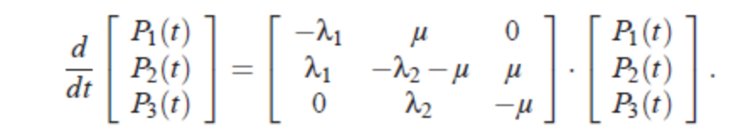

Draw the Markov chain corresponding to this set of equations.
- (5 points) Check whether the function f (a, b, c) = abc is self-dual.
- (10 points) A standby redundant system composed of three components connected in parallel, each with a constant failure rate of λ and it’s time to failure exponentially distributed. Only one component is required to be operative for the system to function properly. Initially the power is applied to only one component and the other two components are kept in a powered-off state (de-energized). When the energized component fails, it is de-energized and removed from operation, and the second component is energized and connected in the second’s place, while the third component is still kept in powered-off state. When the second component fails, it is replaced by the third component.
- Derive the reliability function of this standby redundant system.
- Name the distribution that best describes the time to failure of the system?
- Name the distribution that best describes the time to failure of the system if the failure rate of the three components were not identical?
(Hint: Reliability of a single component with a hazard/failure rate λ, R(t) = 𝑒−λ

- (a) (5 points) The system shown consists of a TMR core with a single spare a which can serve as a spare only for module 1. Assume that modules 1 and a are active. When either of the two module 1 or a fails, the failure is detected by the perfect comparator C and then the single operational module is used to provide an input to the voter. Assuming that the voter is perfect as well, which one of the following expressions for the system reliability is correct (where each module has a reliability R and the modules are independent). Explain your answer. A correct answer with either no explanation or an incorrect one is worth only 2 point.
  - R_{system}=R⁴+4R³(1-R)+3R²(1-R)²
  - R_{system}=R⁴+4R³(1-R)+4R²(1-R)²
  - R_{system}=R⁴+4R³(1-R)+5R²(1-R)²
  - R_{system}=R⁴+4R³(1-R)+6R²(1-R)²
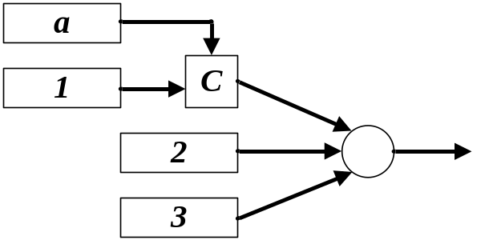
(b) (5 points) Write an expression for the readability of the system if instead of a perfect comparator for modules 1 and a there is a coverage factor c, i.e., c is the probability that a failure in one module is detected, the faulty module is correctly identified and the operational module is successfully connected to the voter (which is still perfect).
- (a) (5 points) A duplex system consists of two active units and a comparator. Assume that each unit has a failure rate of λ and a repair rate of μ. The outputs of the two active units are compared and when a mismatch is detected, a procedure to locate the faulty unit is performed. The probability that upon a failure, the faulty unit is correctly identified and the fault-free unit (and consequently, the system) continues to run properly is denoted by c and is called the coverage factor. Note that when a coverage failure occurs, the entire system fails and then both units have to be repaired (at a rate μ each). When one unit is repaired, the system become operational and the repair of the second unit continues allowing the system to return its original state.
Show the Markov model for the duplex system.
(b) (5 points) Derive an expression for the steady-state availability of the system assuming that μ=2λ.

- (20 points)
To answer this problem, you will need to read (and understand) the paper “Sender-Based Message
Logging” by D. B. Johnson and W. Zwaenepoel. The paper is provided at Ceiba.
In providing the answer, please use the following notation (from Section 4 of the paper). For process Pi, the following protocol variables are introduced:
- SSNi – the next sender sequence number to use;
- RSNi – the next receive sequence number to use;
- LOGi – a set containing logged message. Note that elements of this set are triples of the form (m, Pj, ssn);
- Ti’ – a table associating to each process the highest SSN value received in a message sent by that process;
- Ti” – a table associating to each received message m, the RSN value returned by Pi when m was received.
Consider the scenario in which application processes P1, P2, and P3 exchange messages as described in Figure 1. Assume that sending a message from one process to another takes one unit of time. (Time units are represented by vertical dotted lines in the figure.)

(A) (10 points) Suppose that processes use the protocol described in Section 5.1 of the paper (do not consider the optimistic protocol of Section 5.4) for implementing message-logging based checkpointing.
Complete Figure 1 by showing:
- The additional messages that the processes must exchange to support the message logging protocol.
- Any information piggybacked on any message.
- How protocol variables change as messages are exchanged. Assume that all processes start with SSN = 1, RSN = 1, Log = ∅, T’ = ∅, T” =∅ and no process takes a checkpoint. Show this in the form of a table with the columns representing the above 5 variables for each process and the rows representing the time intervals (from t0 to t11) as the three processes execute.

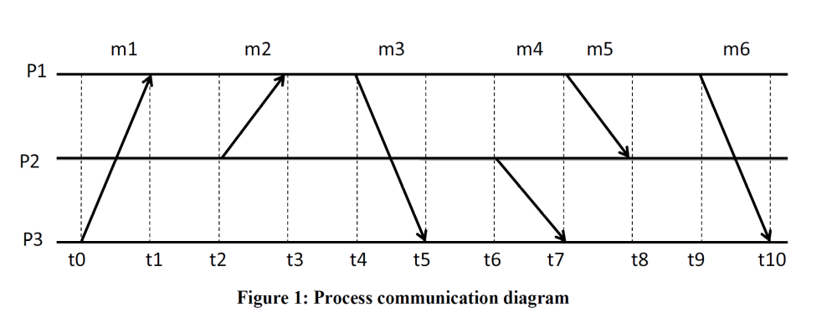
(B) (10 points) The paper proposes a recovery strategy without providing sufficient details for an actual implementation (see Section 5.2). Suggest and describe your own recovery protocol, based on that of Section 5.2, and show how it would work if, in Figure 1, process P3 crashes immediately after receiving message m6 (i.e., P3 does not send any message between receipt of m6 and the time it crashes). You can use the diagram in Figure 2 to show the messages exchanged by your recovery protocol and be precise in your answer.
Assume that P3 took its last checkpoint at time t0.
Be precise in your answer and do not write more than half a page.

