Ch2

1. Please write the image sensing pipeline, which shows a simple version of the processing stages that occur in modern digital cameras.
2. What is BRDF(Bidirectional Reflectance Distribution Function)?
3. Typical BRDFs can often be split into diffuse and specular components. Compare diffuse reflection with specular reflection.

ANS:

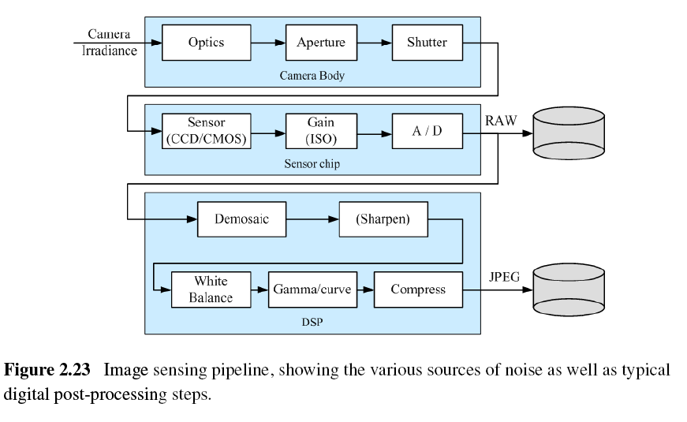

2.

(a) BRDF is a four-dimensional function that describes how much of each wavelength arriving at an incident direction is emitted in a reflected direction. It describes the angles of the incident and reflected directions relative to the surface frame.



i: incident direction

r: reflection direction

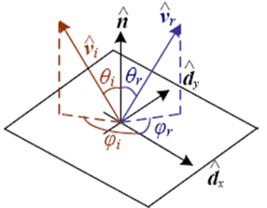

1. diffuse reflection: The diffuse component scatters light uniformly in all directions and is the phenomenon we most normally associate with shading.

Specular reflection: it is depends strongly on the direction of the outgoing light. Incident light rays are reflected in a direction that is rotated by 180° around the surface normal vector.