Ch3

1. A one-dimensional convolution can be represented in matrix-vector form. For example,

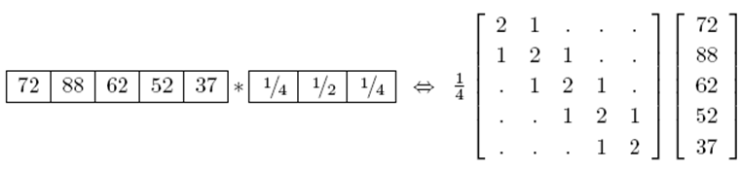

1. Why the results of filtering the image in this form will lead to a *darkening* of the corner pixels.
2. To compensate for this, a number of alternative padding or extension modes have been developed. Please write the padding methods.
3. Compare Gaussian pyramid with Laplacian pyramid.
4. How are two-dimensional wavelets constructed? After two-dimensional wavelet transform, it results three wavelet images. Write the property of three wavelet images.

ANS:

1. Because the original image is effectively being padded with 0 values wherever the convolution kernel extends beyond the original image boundaries.

* *zero*: set all pixels outside the source image to 0.
* *constant* (*border color*): set all pixels outside the source image to a specified border value.
* *clamp* (*replicate* or *clamp to edge*): repeat edge pixels indefinitely.
* (*cyclic*) *wrap* (*repeat* or *tile*): loop “around” the image in a toroidal configuration.
* *mirror*: reflect pixels across the image edge.
* *extend*: extend the signal by subtracting the mirrored version of the signal from the edge pixel value.

2.

(a)

Gaussian Pyramid: The technique involves creating a series of images which are weighted down using a Gaussian average and scaled down. It uses five-tap kernel, The weighting function closely approximates the Gaussian function, hence the origins of the pyramids name.

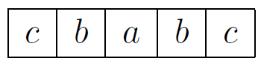



Laplacian Pyramid: First, interpolate a lower resolution image to obtain a reconstructed low-pass version of the original image. They then subtract this low-pass version from the original to yield the band-pass “Laplacian” image, which can be stored away for further processing.

(b)

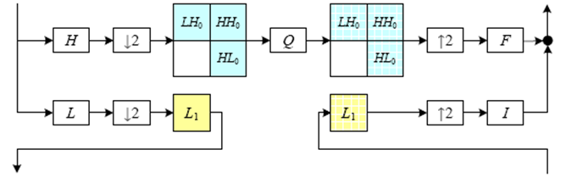

* The resulting three wavelet images are called the high–high (HH), high–low (HL), and low–high (LH) images.
* The HL and LH images accentuate the horizontal and vertical edges and gradients, while the HH image contains the less frequently occurring mixed derivatives.