1. (a) How can we project an image onto a cylindrical surface of unit radius?

(You can use parameters in the following figure.)

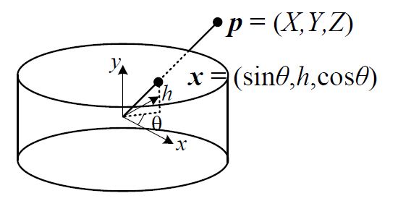

(b) In what situations should we project an image onto a spherical surface?

Ans:

(a)

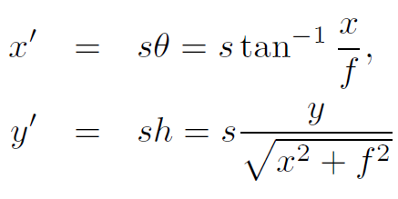

(We can set s = f to minimize the distortion near the center of the image.)

(b) The final panorama includes a full sphere or hemisphere of views?

2. How can we do “parallax removal” in the following four situations?

(a) Radial distortion

(b) 3D parallax

(c) Small-scale scene motions

(d) Large-scale scene motions

Ans:

(a) plumb-line method

(b) a full 3D bundle adjustment

(c) optical flow

(d) simply select pixels from only one image at a time