Cutaneous HPV is transcriptionally quiet in skin and carcinoma but productive in warts: a depth-controlled re-mining of public RNA-seq
Short version, formatted to Journal of Investigative Dermatology limits
[Authors to be added]
2026-08-24

Abstract
Cutaneous beta- and gamma-papillomaviruses are near-ubiquitous skin commensals, yet whether they are transcriptionally active in cutaneous squamous cell carcinoma (cSCC) is unsettled. Because standard pipelines discard the non-human reads carrying viral signal, we re-mined 11,556 public human RNA-seq libraries, typing positives and scoring productive infection from late (L1) capsid transcripts, with cell-line provenance, sequencing depth and library chemistry controlled. HPV signal concentrated in non-primary material: cell-line and engineered libraries were five-fold enriched for positivity (P < 10⁻⁸), dominated by integrated HPV16/HPV18, whereas primary skin carried HPV at 2–4%. Productive infection was abundant in warts and epidermodysplasia verruciformis (93.2% above a control-calibrated floor). cSCC and actinic keratosis, though sequenced four times more deeply, reached that floor in 1.5% of libraries, with median burden six orders of magnitude lower, and were indistinguishable from each other. The deficit was explained neither by depth nor by library chemistry. A minority of primary lesions carried genuine productive gamma- and alpha-HPV infection. Cutaneous HPV is productive in warts but transcriptionally quiet in healthy skin and carcinoma: a trace, non-productive footprint that any account of beta-HPV in skin cancer must accommodate.
Keywords: human papillomavirus; beta-papillomavirus; cutaneous squamous cell carcinoma; productive infection; RNA-seq; public data re-mining; contamination

Introduction
Cutaneous beta- and gamma-HPVs behave less like pathogens than like skin flora: acquired early, ubiquitous in healthy adults, and persisting as asymptomatic low-level infections (Antonsson et al. 2000; Doorbar 2023). At DNA level the reservoir is large and well mapped, with HPV in 61.3% of skin samples in shotgun metagenomics of healthy subjects (Ma et al. 2014) and beta-HPV in 92% of adults by skin swab (Rollison, Schell, et al. 2019), across a diversity extending to 396 types, 229 of them previously unknown (Bzhalava et al. 2014). What these figures cannot say is whether any of that material is transcribed.
The question matters because beta-HPV is a suspected cofactor in cSCC, particularly in organ-transplant recipients (Howley and Pfister 2015; Rollison, Viarisio, et al. 2019). Three accounts of its role are live and mutually compatible with the same data. Under “hit-and-run”, beta-HPV acts early with ultraviolet radiation and is dispensable once the tumour is established (Viarisio et al. 2018; Dorfer et al. 2021). Under the protective-immunity account, T-cell immunity to commensal papillomaviruses actively suppresses skin cancer, so viral loss reflects immune selection (Strickley et al. 2019); that claim drew a formal exchange in the same journal (Lambert et al. 2021; Strickley et al. 2021), and has since been extended to show papillomavirus colonisation blocking mutant p53 clone expansion, with beta-HPV lost as those clones expand (Son et al. 2025). A third account needs neither premise: the beta-HPV genome represses its own expression through E8^E2, and immortalisation of keratinocytes requires that repressor to be inactivated (Rehm et al. 2022), so quiescence may simply be the viral default. All three predict declining viral activity from healthy skin to carcinoma, which is why measuring that decline more precisely cannot separate them.
Whether HPV is transcribed in cutaneous carcinoma has been asked directly, and the answers converge on no: in the original cSCC transcriptome study (Arron et al. 2011), in 12 skin lesions at a median 66 million reads (Hultin et al. 2019), in 345 post-transplant tumours at 35 million reads with transcription in 15 (Arroyo Mühr, Hultin, and Dillner 2021), and in 23 risk-stratified biopsies with no expression against 64% DNA positivity (Vandiver et al. 2021); E6/E7 mRNA in situ hybridization agrees, at 0.9% of 225 non-anogenital cutaneous SCC (Fujimoto et al. 2019). The literature is not unanimous, since in situ hybridization demonstrated EV-HPV transcripts in 4 of 11 PCR-positive transplant cSCC (Purdie et al. 2005). What no study has had is a denominator: these series run from 11 to 345 specimens, four of five are lesion-only with no unselected-skin comparator, the largest is confined to formalin-fixed transplant material, and none scores productive replication.
Public archives can supply that denominator, since the non-human reads discarded by standard pipelines carry the signal (Edgar et al. 2022), an approach already applied to skin (Leiendecker et al. 2023; Bhargava et al. 2025). It is also booby-trapped: HeLa-derived HPV18 contaminates archived data extensively (Cantalupo, Katz, and Pipas 2015; Kazemian et al. 2015; Adey et al. 2013), and depth and library chemistry both bound what any survey can detect. Here we re-mine public human RNA-seq across the skin spectrum, asking at what rate cutaneous HPV is transcribed, which types, and whether the infection is productive.

Results

HPV signal in public RNA-seq is dominated by non-primary material
Across the unbiased sweep, HPV positivity concentrated in cultured and engineered material: engineered libraries were positive in 9.28% and cell lines in 10.34%, against 2.13% of clinical primary tissue (Table 1), roughly five-fold higher odds for both (engineered OR 4.7, P = 1.5×10⁻⁹; cell line OR 5.3, P = 9.9×10⁻²²). These positives were almost entirely mucosal alpha types: HPV18 accounted for 32/34 of its calls in cell lines and HPV16 for 24/28, the signature of integrated-HPV lines and their documented contamination of archived data. Genuine primary skin therefore carries HPV at only 2–4%, and the apparent abundance of HPV in public transcriptomes is largely a laboratory artefact that must be partitioned out before any prevalence claim.
Table 1: HPV positivity by sample provenance. HPV-positive calls (Kraken2 ≥ 10 papillomavirus reads) among 11,556 screened libraries. Percentages carry Wilson 95% confidence intervals; odds ratios are from logistic regression against clinical primary tissue (likelihood-ratio P = 8.5×10⁻²⁰). Cell-line and engineered libraries carry roughly five-fold higher odds than primary tissue, and their positives are predominantly the integrated mucosal types HPV16 and HPV18.
Sample class | Libraries (n) | HPV+ (n) | HPV+ % (95% CI) | Odds ratio (95% CI) | P
Clinical (primary tissue) | 10,946 | 233 | 2.13 (1.87–2.42) | 1 (reference) | n/a
Engineered | 194 | 18 | 9.28 (5.95–14.19) | 4.7 (2.8–7.8) | 1.5×10⁻⁹
Cell line | 416 | 43 | 10.34 (7.76–13.63) | 5.3 (3.8–7.5) | 9.9×10⁻²²

The transcripts carry an independent signature of that artefact. E1 and E2 lie on the same early message, so their counts should track unless integration disrupts E2; cell lines show a median E1:E2 ratio of 129 against 0.27 in productive controls and 0.49 in skin, separating cultured from productive primary infection almost completely (AUC 0.97; Figure 1). Virus-host junction calling confirms it where scored as clustering rather than raw count, and the ratio moves monotonically with grade across an independent HPV16-positive cervical series spanning normal epithelium, high-grade lesion and carcinoma, so it reads integration as biology rather than culture as provenance: on the log₂ scale of Figure 1 C the median rises from -1.48 in normal epithelium through -0.36 in high-grade lesion to 1.47 in carcinoma, roughly eightfold in the ratio itself, with late transcription falling away along the same axis.
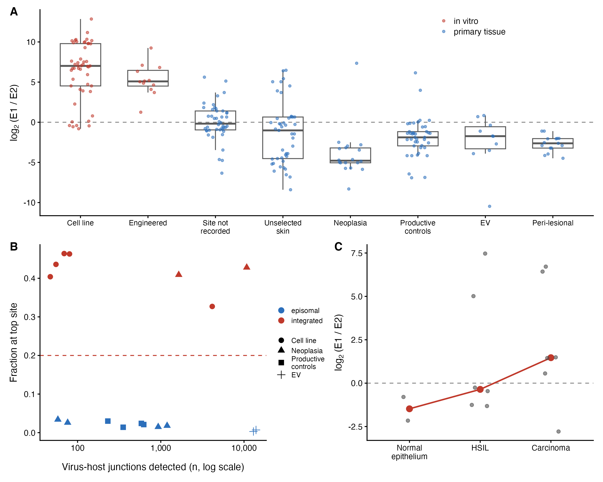
Figure 1: Integration read from viral transcription. (A) E1:E2 transcript ratio by tier, log₂((E1 + 0.5)/(E2 + 0.5)) for libraries with at least five combined reads; the dashed line is parity. In-vitro material sits far above parity and primary tissue at or below it, with the episomal HPV31-positive HaCaT derivative falling among primary tissue. (B) Virus-host chimeric junctions, plotted as the fraction falling at a library’s most-supported coordinate pair against the raw junction count. Clustering separates the groups completely; raw counts do not, and run the other way. (C) The ratio rises monotonically with grade across a graded HPV16-positive cervical series of normal epithelium, high-grade lesion and carcinoma; the red line joins arm medians.

Skin neoplasia carries trace HPV, not productive infection
Productive controls (warts, condyloma) reached the control-calibrated detection floor (13.2 RPM) in 93.2% of libraries, and EV biopsies in 80%, with median burdens of 5,408 and 229.6 RPM. Across 406 cSCC/AK libraries only 6 reached it (1.5%), median burden 0.012 RPM, six orders of magnitude lower (Figure 2; Fisher OR 10,183, P = 7.6×10⁻⁹⁹).
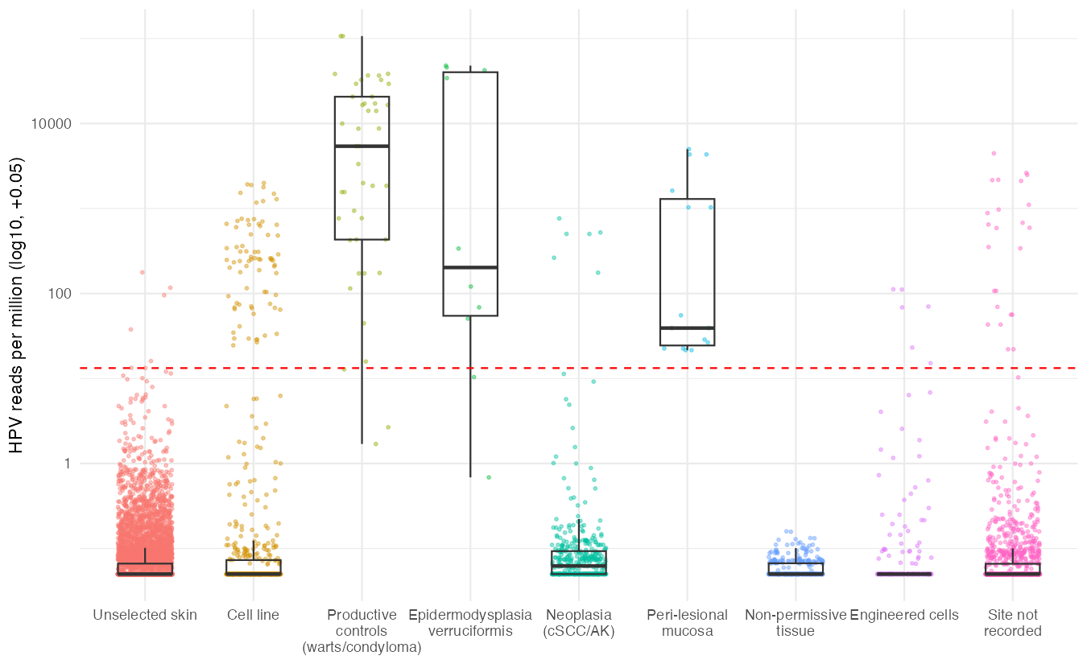
Figure 2: Depth-normalised HPV transcript burden by population tier. Each point is one screened library, scored as papillomavirus reads per million; boxes show median and interquartile range and the y-axis is log₁₀-scaled. The dashed red line is the control-calibrated detection floor (13.2 RPM, the 5th percentile of non-cell-line productive controls). Productive controls, EV biopsies and peri-lesional mucosa lie far above it, whereas cutaneous neoplasia and unselected skin sit near zero despite neoplasia being sequenced almost four times more deeply than the productive controls (median 45.2M vs 12.2M reads). Tier assignment is by metadata precedence with curated corrections.
This gap is not depth. Neoplasia libraries were sequenced almost four times more deeply than the productive controls (median 45.2M vs 12.2M reads), and depth raised the odds of any HPV read (OR per log₁₀ reads 5.2, P = 5.1×10⁻¹⁴⁴) without raising the odds of reaching the floor, either across tiers (OR 1.5, P = 0.49) or within neoplasia alone (OR 1.6, P = 0.7). The deepest cSCC/AK libraries, at 327.3M reads, did not cross it.
Nor is it library chemistry, the other bound on viral recovery. Chemistry was resolved for 6,751 libraries (62.2%) from SRA metadata and construction-protocol text, and its imbalance runs against the negative result: neoplasia is rRNA-depleted in 22.9% of libraries against 7.2% of unselected skin, while the productive controls contain none. Adjusting for depth and tier, rRNA-depleted libraries were no likelier than poly-A to carry an HPV read (OR 1.0, 95% CI 0.8–1.2), and among the 657 rRNA-depleted libraries alone, not one in either tier reached the productive floor.
Pooling actinic keratosis with carcinoma is supported rather than assumed: the 72 AK and 326 cSCC libraries both sit well above unselected skin (trace OR 2.6 and 1.9) and are indistinguishable from each other, depth-adjusted (trace OR 1.4, 0.8–2.3, P = 0.28; floor detection 1/72 against 5/326, Fisher P = 1).
Tissue that cannot host the virus fixes the meaning of that trace. Cutaneous adipose, blood and neural material offer no permissive compartment, yet the 334 such libraries carried a trace HPV read at 28.7%, indistinguishable from the 28% of unselected skin, and not one yielded an assignable type. The background trace rate is the assay’s floor, reproduced where infection is impossible. Unselected skin, once peri-lesional and EV material swept in by the targeted queries is reassigned, forms an almost clean null: 0.1% of 7,800 libraries reach the floor. All principal contrasts were refitted as Bayesian logistic regressions under weakly-informative priors, with concordant results (Table S3).
The transcript programme makes the distinction visible (Figure 3). Productive tiers run the complete viral programme, capsid genes included (L1 in 90% of productive controls, 95.5% of EV). Skin and neoplasia are not a truncated programme but a uniformly faint one, low across all six frames alike (unselected skin 10.3% for E6, 18.6% for L1). Cell lines are the third shape: E6 and E7 in 90.4% and 93.4% against E2 in 33.8% and L2 in 10.6%. In composition, productive controls place 34.9% of viral reads on late genes against 6.4% on the oncogenes; cell lines invert this exactly.
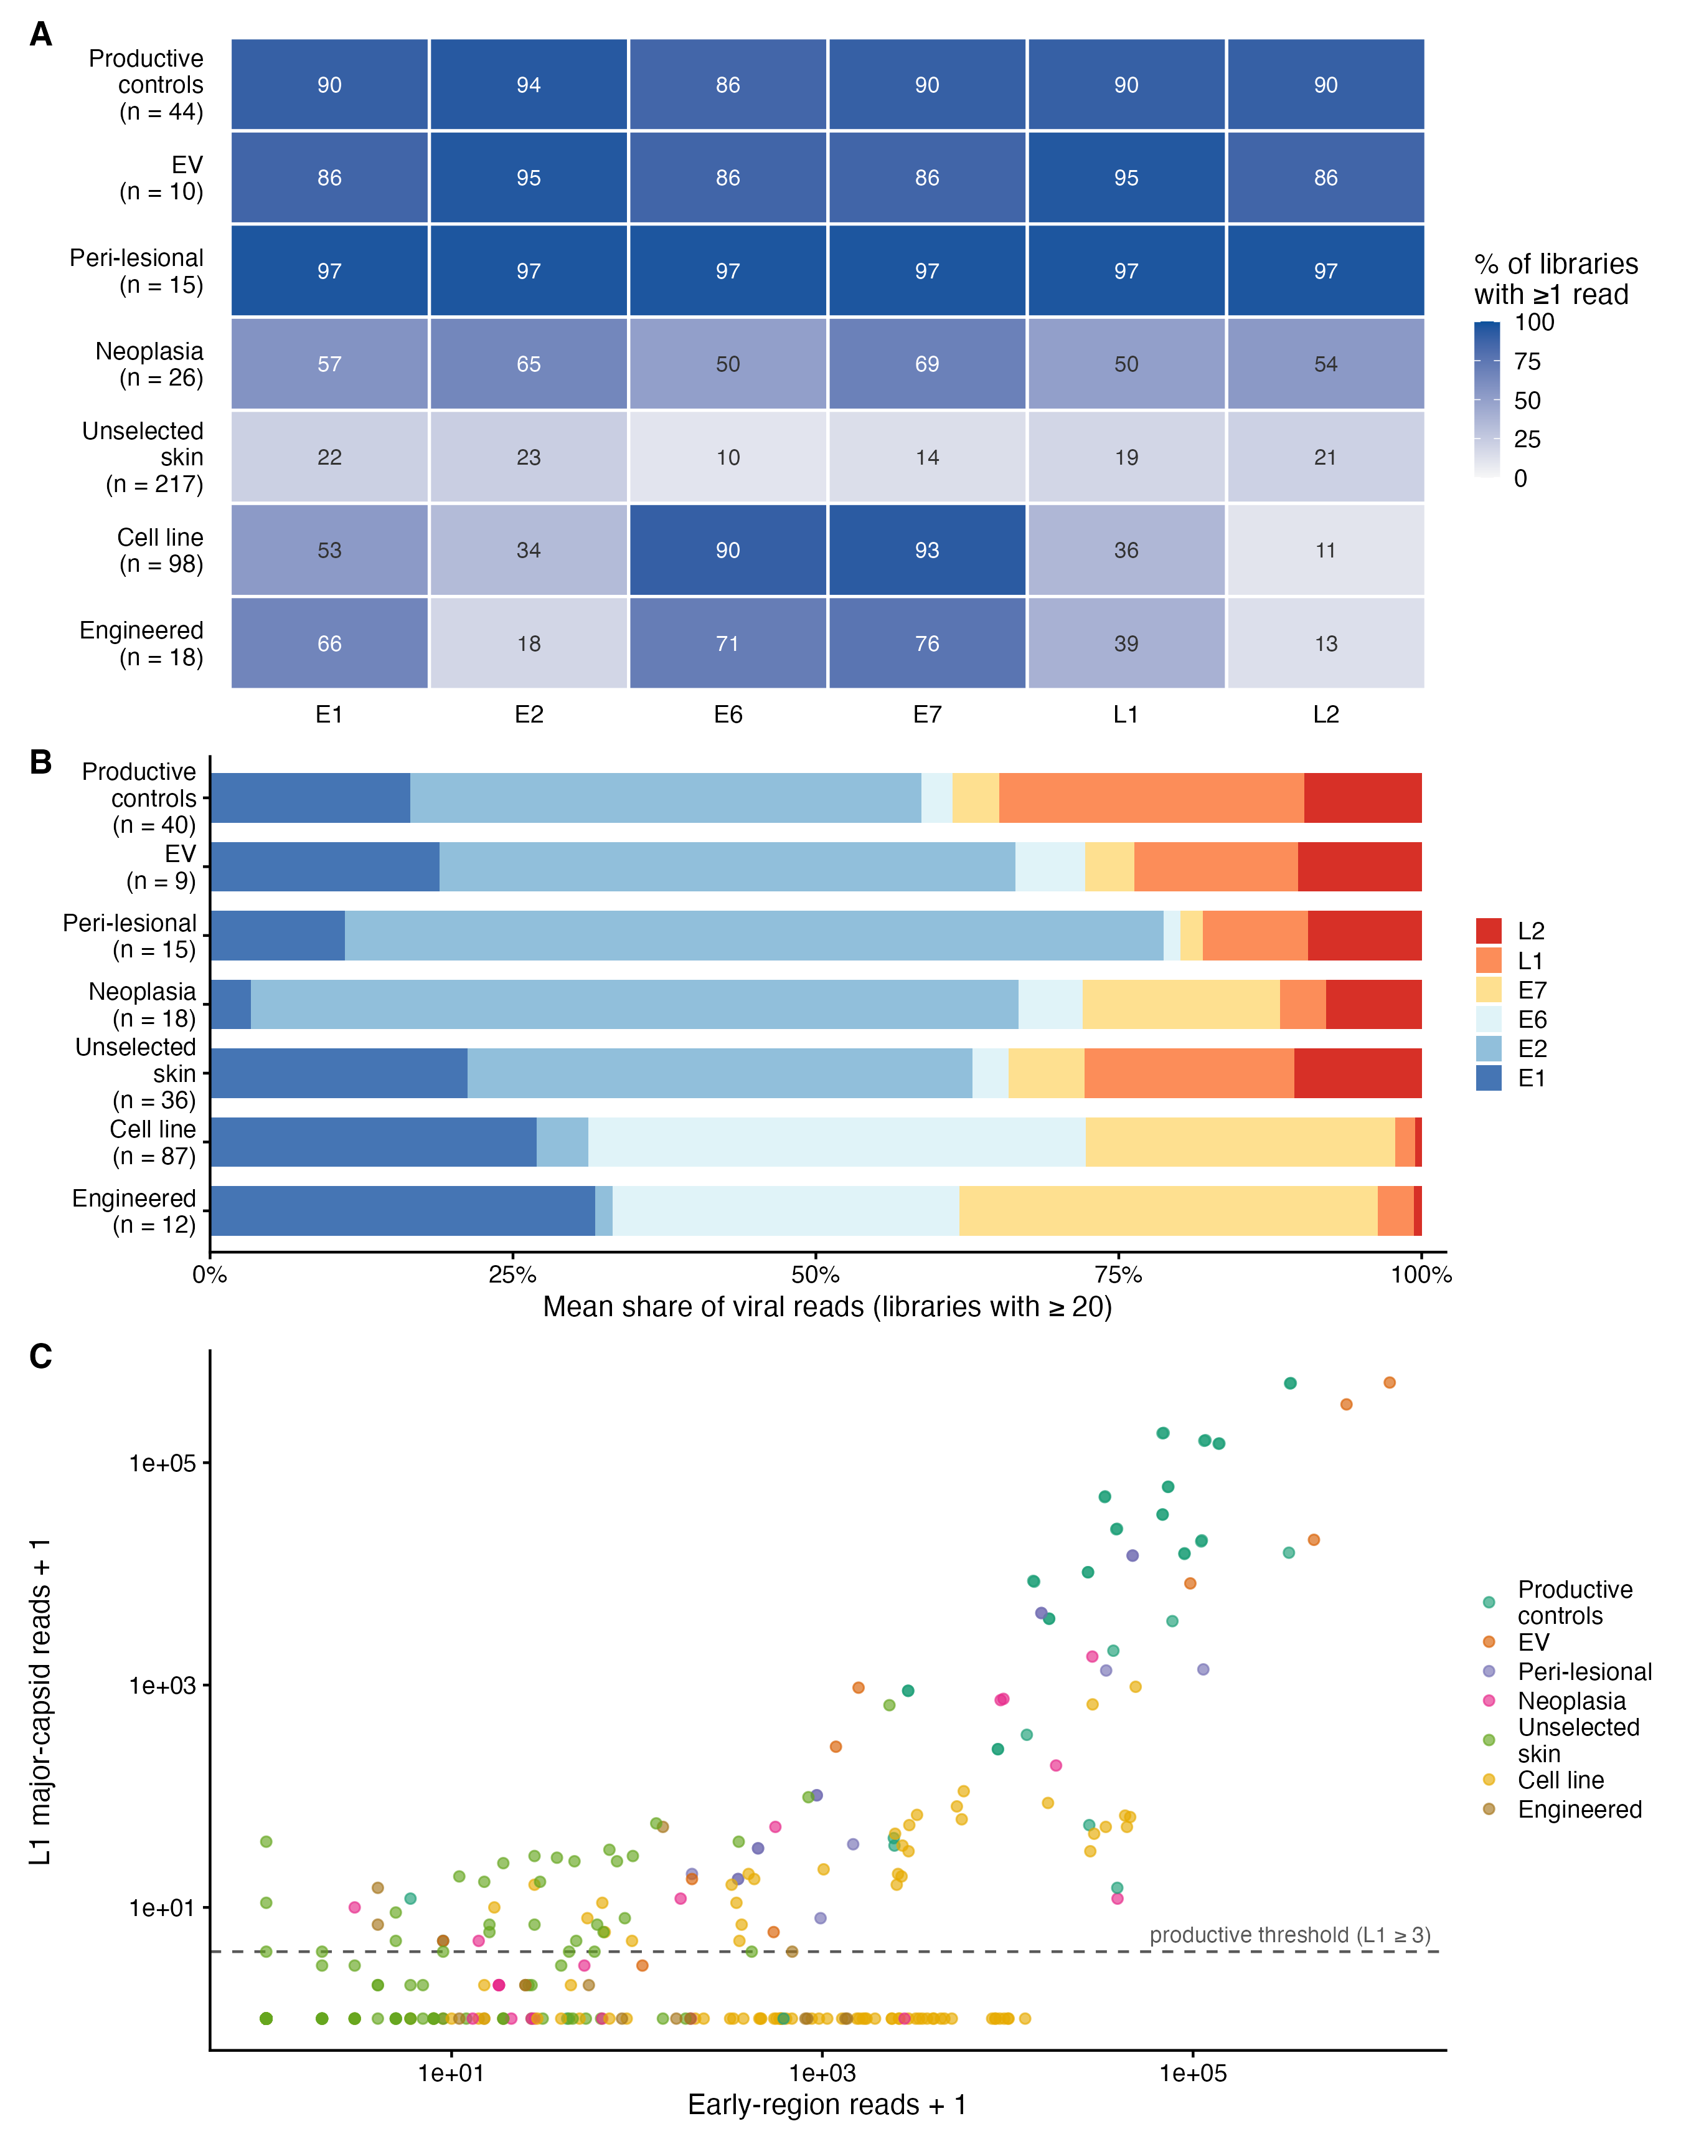
Figure 3: The viral transcriptional programme by population tier. All panels are conditional on HPV positivity and successful typing, so none is a prevalence statement; tier n is on each panel. (A) Percentage of a tier’s libraries carrying at least one read on each open reading frame, as a Beta-Binomial posterior mean. Productive tiers transcribe the whole genome including the capsid genes, skin and neoplasia are uniformly low across all frames, and cultured material retains the oncogenes while losing E2 and the late genes. (B) Mean share of viral reads per frame, among libraries with at least 20 viral reads. (C) Early-region against L1 reads per library, with the L1 ≥ 3 productive threshold drawn.

The assay detects genuine productive cutaneous infection where it occurs
Among HPV-positive typed samples, 64% of targeted wart/EV libraries met the L1 criterion against 31.8% of cSCC/AK (OR 3.8, P = 0.013), spanning the expected cutaneous repertoire. A minority of genuine primary-skin lesions carried unambiguous productive infection, most strikingly an HPV12-productive cSCC and two lesions co-infected with the gamma types HPV96 and HPV182 at near-complete genome coverage. The type landscape is partitioned by population (Figure 4): high-risk mucosal HPV16/18 confined almost entirely to cultured material, cutaneous wart and low-risk types in productive controls, the defining beta types in EV, and a beta/gamma reservoir in healthy skin visible mainly below the assignment threshold. Most of the small floor-level excess in neoplasia is attributable to 3 mucosal HPV16 cases the broadened query captured; excluding them halves it, to 0.7%.
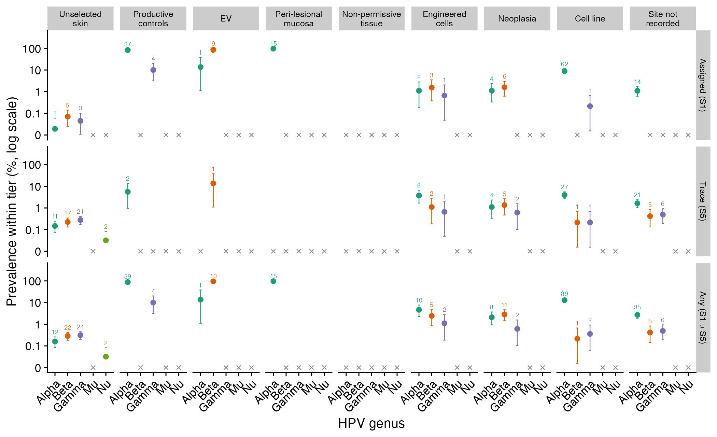
Figure 4: HPV genus prevalence by population tier. The assigned-type catalogue, the detection-tier trace catalogue, and their union, collapsed from HPV type to genus, with a library contributing to at most one row. High-risk mucosal alpha types concentrate in cultured and engineered material, the cutaneous beta and gamma genera dominate healthy skin and EV, and productive controls carry the wart-associated alpha and mu types. The trace tier is where the healthy-skin beta/gamma reservoir becomes visible, most of it falling below the criterion for a type assignment.

Discussion
Re-mining the reads that transcriptomic pipelines discard, we find cutaneous HPV productive in warts and EV, transcriptionally quiet in healthy skin, and present in cSCC and actinic keratosis only as a trace that no amount of sequencing depth or favourable library chemistry converts into productive burden.
This is not a new observation, and we do not present it as one. Transcriptional silence of HPV in cutaneous carcinoma has been reported from four independent RNA-sequencing series (Arron et al. 2011; Hultin et al. 2019; Arroyo Mühr, Hultin, and Dillner 2021; Vandiver et al. 2021) and corroborated by in situ hybridization at comparable cohort size (Fujimoto et al. 2019). Two of those series ran at 35 and 66 million median reads, so the possibility that the negative is an artefact of shallow sequencing was disposed of years ago; depth here is a modelled covariate, not a discovery. What our data add is the denominator, the controls and the criterion. The prior series run from 11 to 345 specimens; ours contrasts 406 cSCC/AK libraries against 7,800 unselected-skin libraries in one pipeline, converting an absence reported within lesions into a case/control contrast with an effect size. Where prior work scores presence or transcription, we score productive replication against a floor calibrated on lesions in which productive infection is certain, so “no productive infection in cSCC/AK” is measured on the instrument that reports 93.2% productivity in warts.
What the result does not settle is mechanism. All three live accounts predict a declining viral signal along the progression axis: hit-and-run because the virus becomes dispensable, protective immunity because virus-positive cells are selected against (Strickley et al. 2019; Son et al. 2025), and cis-restriction because quiescence is the viral default (Rehm et al. 2022). Our data measure exactly that axis and therefore cannot separate them. Son and colleagues also report beta-HPV activity elevated in sun-exposed skin, which is not in tension with our quiet reservoir: theirs is in situ activity localised to keratinocyte clones, ours a whole-biopsy average over libraries unstratified by ultraviolet exposure, and a focal clonal signal is what such an average dilutes. The same applies to the HPV8-driven expansion of Lrig1⁺ follicular stem cells proposed for actinic keratosis (Morgan et al. 2024): on presence we do not disagree, since trace HPV was recovered from 62.5% of AK libraries, and an E6-driven stem-cell mechanism requires oncogene function rather than capsid production, so a non-productive footprint is what it predicts. Interventional evidence exists and is worth stating precisely: nine-valent vaccination reduced actinic-keratosis burden in a randomised trial (Wenande et al. 2025), but that vaccine targets mucosal alpha types, so any effect runs through cross-reactive or non-specific immunity rather than neutralising the resident beta reservoir.
A 2–4% transcriptome prevalence is not a competing estimate against a 90% DNA reservoir. Three published quantities reconcile them. Beta-HPV DNA loads in normal skin sit below one viral copy per 60 cells (Weissenborn et al. 2012), which is beneath the detection floor of bulk RNA-seq by construction. The substrates differ: cutaneous HPV epidemiology samples skin swabs and plucked hair bulbs, where prevalence is 92% and 73% respectively (Rollison, Schell, et al. 2019), whereas archived RNA-seq is biopsy tissue and samples neither the surface nor the follicular compartment. And typing is panel-anchored, so the 229 skin types without reference genomes (Bzhalava et al. 2014) are invisible to it. Our figure is the transcriptionally detectable fraction of a genuinely near-ubiquitous reservoir. That the reservoir and the tumour virus are largely different is supported from the DNA side independently: fewer than 5% of beta-HPV types on a person’s skin appear in the cSCC they later develop (Rollison et al. 2021), and genotype concordance between paired eyebrow hair and cSCC was 9.1% in a second cohort (Oh et al. 2026).
Contamination is the dominant signal in naive analyses. The five-fold enrichment in cultured material mirrors documented HeLa-derived contamination of archives (Cantalupo, Katz, and Pipas 2015; Kazemian et al. 2015; Adey et al. 2013), traced in one centre to a cell-line pool run alongside tumours as a quality-control reference (Selitsky et al. 2020); more than 65% of viral sequences recovered from 712 libraries cluster with a reagent or protocol step rather than the specimen (Asplund et al. 2019), and re-analysis has invalidated an archive-scale microbial result outright (Gihawi et al. 2023). None of the individual safeguards we applied is novel and the requirements were set out before (Cantalupo and Pipas 2019); what we contribute is their operationalisation with the size of each artefact reported rather than asserted.
Limitations. Archival sampling is non-random, so the absolute healthy-skin rate is an estimate. Chemistry was resolvable for 62.2% of libraries; input amount, RNA integrity and fragment selection are not recoverable from archived metadata at all. Bulk sequencing averages over a whole biopsy, so focal transcription is diluted, which is not hypothetical for cutaneous HPV (Purdie et al. 2005) and makes our productivity estimates a lower bound. Tissue and diagnosis labels are programmatic and imperfect, typing is bounded by the reference panel, and our data are cross-sectional, so we describe the productive-status phenomenology rather than prove mechanism.
Conclusion. Cutaneous HPV is productive in warts and EV and a trace, non-productive footprint in cutaneous squamous neoplasia, independent of sequencing depth and library chemistry. That phenotype is the common ground every current account of beta-HPV in skin cancer must explain, and because all three predict it, separating them will not come from measuring viral activity more precisely. It will require designs that break the shared prediction: matched DNA and RNA profiling across the precursor-to-carcinoma transition, resolution of where residual virus sits relative to mutant clones and infiltrating T cells, and interventional studies of the kind now begun. Single-cell resolution is not the missing piece, having been demonstrated in cutaneous lesions already (Devitt et al. 2019); applying it at cohort scale across the actinic-keratosis-to-carcinoma transition is.

Materials and Methods
Full details are given in Supplementary Materials and Methods.
Pipeline and reference panel. A Nextflow workflow screened each library for papillomavirus reads with Kraken2 against a combined human/HPV database, typed positives against the complete PaVE reference set (455 sequences) by STAR alignment, and classified early versus late viral transcripts. Code and configuration are available as stated under Data availability.
Cohort. Public human RNA-seq runs were discovered through NCBI Entrez and assembled into a case/control design spanning productive controls (warts, condyloma), epidermodysplasia verruciformis, cutaneous neoplasia (cSCC, actinic keratosis), an unselected-skin null, and cell-line, engineered and non-permissive-tissue comparators. Tier assignment read curated SRA metadata, with a small override table correcting studies whose submitted metadata is absent or misleading. 11,556 libraries were screened.
Whole-library screening. Every library was screened in full: no step subsamples reads and fasterq-dump was run without a spot limit. This matters because reads deposited from a coordinate-sorted alignment emerge from the SRA in reference order, placing unmapped, and therefore viral, reads at the end of the run. Reads reaching the screen were a median 98.6% of the SRA-reported spot count, with per-tier medians spanning 95.8% to 100%, so no tier was read less completely than another.
Calling infection and productivity. A reference was assigned when coverage breadth was at least 0.10 and mean depth at least 2. Every library, including negatives, was scored as papillomavirus reads per million (RPM). Productive infection required at least three L1 major-capsid reads, and a control-calibrated detection floor was set at the 5th-percentile RPM of non-cell-line productive controls (13.2 RPM).
Confounder control and statistics. Sequencing depth entered every model as log₁₀ library size. Library-selection chemistry was recovered from SRA LibrarySelection and, where that field is generic, from library-construction protocol text, resolving 62.2% of libraries. Integration was read from the E1:E2 transcript ratio and validated against virus-host junctions and an independent graded cervical series. Logistic regressions and Fisher exact tests were fitted in R, with Wilson intervals for proportions and a Bayesian re-analysis under weakly-informative priors as a robustness check.

Funding
This research was supported by the Estonian Research Council grant (PRG2707).
This research was co-financed through the DURABLE project. The DURABLE project has been co-funded by the European Union, under the EU4Health Programme (EU4H), Project no. 101102733. Views and opinions expressed are however those of the authors only and do not necessarily reflect those of the European Union or the European Health and Digital Executive Agency. Neither the European Union nor the granting authority can be held responsible for them.

References
Adey, Andrew et al. 2013. “The Haplotype-Resolved Genome and Epigenome of the Aneuploid HeLa Cancer Cell Line.” Nature 500: 207–11. https://doi.org/10.1038/nature12064.
Antonsson, Annika, Ola Forslund, Henrik Ekberg, Gunnar Sterner, and Bo G. Hansson. 2000. “The Ubiquity and Impressive Genomic Diversity of Human Skin Papillomaviruses Suggest a Commensalic Nature of These Viruses.” Journal of Virology 74 (24): 11636–41. https://doi.org/10.1128/JVI.74.24.11636-11641.2000.
Arron, Sarah T. et al. 2011. “Transcriptome Sequencing Demonstrates That Human Papillomavirus Is Not Active in Cutaneous Squamous Cell Carcinoma.” Journal of Investigative Dermatology 131 (8): 1745–53. https://doi.org/10.1038/jid.2011.91.
Arroyo Mühr, Laila Sara, Emilie Hultin, and Joakim Dillner. 2021. “Transcription of Human Papillomaviruses in Nonmelanoma Skin Cancers of the Immunosuppressed.” International Journal of Cancer 149 (6): 1341–47. https://doi.org/10.1002/ijc.33683.
Asplund, Maria, Kristín R. Kjartansdóttir, Sarah Mollerup, Lasse Vinner, Helena Fridholm, Jose A. R. Herrera, Jens Friis-Nielsen, et al. 2019. “Contaminating Viral Sequences in High-Throughput Sequencing Viromics: A Linkage Study of 700 Sequencing Libraries.” Clinical Microbiology and Infection 25 (10): 1277–85. https://doi.org/10.1016/j.cmi.2019.04.028.
Bhargava, Devika, Alexandra Labadie, Rachel L. Hanson-Rios-Stutz, Austin Goodyke, Emily M. Moses, Amrita S. Das, Sarah Vanderweele, et al. 2025. “From Castaways to Discoveries: Unveiling Treasures in Skin RNAseq Using a Novel Multidimensional Data Processing Workflow Including Infection-Host Dynamics.” Physiological Genomics 57 (5): 343–56. https://doi.org/10.1152/physiolgenomics.00093.2024.
Bzhalava, Davit, Laila Sara Arroyo Mühr, Camilla Lagheden, Johanna Ekström, Ola Forslund, Joakim Dillner, and Emilie Hultin. 2014. “Deep Sequencing Extends the Diversity of Human Papillomaviruses in Human Skin.” Scientific Reports 4: 5807. https://doi.org/10.1038/srep05807.
Cantalupo, Paul G., Joshua P. Katz, and James M. Pipas. 2015. “HeLa Nucleic Acid Contamination in The Cancer Genome Atlas Leads to the Misidentification of Human Papillomavirus 18.” Journal of Virology 89 (8): 4051–57. https://doi.org/10.1128/JVI.03365-14.
Cantalupo, Paul G., and James M. Pipas. 2019. “Detecting Viral Sequences in NGS Data.” Current Opinion in Virology 39: 41–48. https://doi.org/10.1016/j.coviro.2019.07.010.
Chen, Shifu, Yanqing Zhou, Yaru Chen, and Jia Gu. 2018. “Fastp: An Ultra-Fast All-in-One FASTQ Preprocessor.” Bioinformatics 34 (17): i884–90. https://doi.org/10.1093/bioinformatics/bty560.
Danecek, Petr, James K. Bonfield, Jennifer Liddle, John Marshall, Valeriu Ohan, Martin O. Pollard, Andrew Whitwham, et al. 2021. “Twelve Years of SAMtools and BCFtools.” GigaScience 10 (2): giab008. https://doi.org/10.1093/gigascience/giab008.
Devitt, Katharina, Sarah J. Hanson, Zewen K. Tuong, Erin McMeniman, H. Peter Soyer, Ian H. Frazer, and Samuel W. Lukowski. 2019. “Single-Cell RNA Sequencing Reveals Cell Type-Specific HPV Expression in Hyperplastic Skin Lesions.” Virology 537: 14–19. https://doi.org/10.1016/j.virol.2019.08.007.
Di Tommaso, Paolo, Maria Chatzou, Evan W. Floden, Pablo Prieto Barja, Emilio Palumbo, and Cedric Notredame. 2017. “Nextflow Enables Reproducible Computational Workflows.” Nature Biotechnology 35 (4): 316–19. https://doi.org/10.1038/nbt.3820.
Dobin, Alexander, Carrie A. Davis, Felix Schlesinger, Jorg Drenkow, Chris Zaleski, Sonali Jha, Philippe Batut, Mark Chaisson, and Thomas R. Gingeras. 2013. “STAR: Ultrafast Universal RNA-seq Aligner.” Bioinformatics 29 (1): 15–21. https://doi.org/10.1093/bioinformatics/bts635.
Doorbar, John. 2023. “The Human Papillomavirus Twilight Zone: Latency, Immune Control and Subclinical Infection.” Tumour Virus Research 16: 200268.
Dorfer, Sonja et al. 2021. “MmuPV1 Is a Key Driver of Skin Cancer Development Upon Immunosuppression.” American Journal of Transplantation 21 (2): 525–39.
Edgar, Robert C. et al. 2022. “Petabase-Scale Sequence Alignment Catalyses Viral Discovery.” Nature 602: 142–47. https://doi.org/10.1038/s41586-021-04332-2.
Fujimoto, Masakazu, Ibu Matsuzaki, Yuki Takahashi, Yuichi Iwahashi, Kenji Warigaya, Fumiyoshi Kojima, Masatoshi Jinnin, and Shin-ichi Murata. 2019. “High-Risk Human Papillomavirus E6/E7 mRNA Is Rarely Detected in Nonanogenital Cutaneous Squamous Cell Carcinoma: An RNA in Situ Hybridization-Based Tissue Microarray Study.” The American Journal of Dermatopathology 41 (3): 205–10. https://doi.org/10.1097/DAD.0000000000001289.
Gihawi, Abraham, Yuchen Ge, Jennifer Lu, Daniela Puiu, Amanda Xu, Colin S. Cooper, Daniel S. Brewer, Mihaela Pertea, and Steven L. Salzberg. 2023. “Major Data Analysis Errors Invalidate Cancer Microbiome Findings.” mBio 14 (5): e0160723. https://doi.org/10.1128/mbio.01607-23.
Goodrich, Ben, Jonah Gabry, Imad Ali, and Sam Brilleman. 2024. rstanarm: Bayesian Applied Regression Modeling via Stan. https://mc-stan.org/rstanarm/.
Howley, Peter M., and Herbert J. Pfister. 2015. “Beta Genus Papillomaviruses and Skin Cancer.” Virology 479-480: 290–96.
Hultin, Emilie, Laila Sara Arroyo Mühr, Camilla Lagheden, and Joakim Dillner. 2019. “HPV Transcription in Skin Tumors.” PLOS ONE 14 (5): e0217942. https://doi.org/10.1371/journal.pone.0217942.
Kazemian, Majid et al. 2015. “Possible Human Papillomavirus 38 Contamination of Endometrial Cancer RNA-sequencing Samples in TCGA.” Journal of Virology 89 (17): 8967–73. https://doi.org/10.1128/JVI.00822-15.
Lambert, Paul F., Karl Münger, Frank Rösl, Daniel Hasche, and Massimo Tommasino. 2021. “Beta Human Papillomaviruses and Skin Cancer.” Nature 588 (7838): E20–21. https://doi.org/10.1038/s41586-020-3023-0.
Leiendecker, Lukas, Tobias Neumann, Pauline S. Jung, Shona M. Cronin, Thomas L. Steinacker, Alexander Schleiffer, Michael Schutzbier, et al. 2023. “Human Papillomavirus 42 Drives Digital Papillary Adenocarcinoma and Elicits a Germ Cell-Like Program Conserved in HPV-Positive Cancers.” Cancer Discovery 13 (1): 70–84. https://doi.org/10.1158/2159-8290.CD-22-0489.
Leinonen, Rasko, Hideaki Sugawara, and Martin Shumway. 2011. “The Sequence Read Archive.” Nucleic Acids Research 39 (Database issue): D19–21. https://doi.org/10.1093/nar/gkq1019.
Liao, Yang, Gordon K. Smyth, and Wei Shi. 2014. “featureCounts: An Efficient General Purpose Program for Assigning Sequence Reads to Genomic Features.” Bioinformatics 30 (7): 923–30. https://doi.org/10.1093/bioinformatics/btt656.
Ma, Yingfei, Ramana Madupu, Ulas Karaoz, Carlos W. Nossa, Liying Yang, Shibu Yooseph, Patrick S. Yachimski, Eoin L. Brodie, Karen E. Nelson, and Zhiheng Pei. 2014. “Human Papillomavirus Community in Healthy Persons, Defined by Metagenomics Analysis of Human Microbiome Project Shotgun Sequencing Data Sets.” Journal of Virology 88 (9): 4786–97. https://doi.org/10.1128/JVI.00093-14.
Morgan, Huw J., Carlotta Olivero, Boris Y. Shorning, Alex Gibbs, Alexandra L. Phillips, Lokapriya Ananthan, Annabelle Xiao Hui Lim, et al. 2024. “HPV8-Induced STAT3 Activation Led Keratinocyte Stem Cell Expansion in Human Actinic Keratoses.” JCI Insight 9 (15): e177898. https://doi.org/10.1172/jci.insight.177898.
Oh, Choon Chiat, Gek San Tan, Jeremy Wee Kiat Ng, Tony Kiat Hon Lim, Fan Foon Cheo, Po Yin Tang, N. Gopalakrishna Iyer, et al. 2026. “Human Papillomavirus Diversity in Asian Individuals with Cutaneous Squamous Cell Carcinoma.” JAMA Dermatology 162 (5): 509–14. https://doi.org/10.1001/jamadermatol.2026.0308.
Purdie, Karin J., Tharsi Surentheran, Jane C. Sterling, Lucy Bell, Jane M. McGregor, Charlotte M. Proby, Catherine A. Harwood, and Judith Breuer. 2005. “Human Papillomavirus Gene Expression in Cutaneous Squamous Cell Carcinomas from Immunosuppressed and Immunocompetent Individuals.” Journal of Investigative Dermatology 125 (1): 98–107. https://doi.org/10.1111/j.0022-202X.2005.23635.x.
Rehm, Tina M., Elke Straub, Thomas Iftner, and Frank Stubenrauch. 2022. “Restriction of Viral Gene Expression and Replication Prevents Immortalization of Human Keratinocytes by a Beta-Human Papillomavirus.” Proceedings of the National Academy of Sciences 119 (11): e2118930119. https://doi.org/10.1073/pnas.2118930119.
Rollison, Dana E., Rossybelle P. Amorrortu, Yayi Zhao, Jane L. Messina, Michael J. Schell, Neil A. Fenske, Basil S. Cherpelis, et al. 2021. “Cutaneous Human Papillomaviruses and the Risk of Keratinocyte Carcinomas.” Cancer Research 81 (17): 4628–38. https://doi.org/10.1158/0008-5472.CAN-21-0805.
Rollison, Dana E., Michael J. Schell, Neil A. Fenske, Basil Cherpelis, Jane L. Messina, Anna R. Giuliano, Pearlie K. Epling-Burnette, et al. 2019. “Cutaneous Viral Infections Across 2 Anatomic Sites Among a Cohort of Patients Undergoing Skin Cancer Screening.” The Journal of Infectious Diseases 219 (5): 711–22. https://doi.org/10.1093/infdis/jiy577.
Rollison, Dana E., Daniele Viarisio, Rossybelle P. Amorrortu, Tarik Gheit, and Massimo Tommasino. 2019. “An Emerging Issue in Oncogenic Virology: The Role of Beta Human Papillomavirus Types in the Development of Cutaneous Squamous Cell Carcinoma.” Journal of Virology 93 (7): e01003–18. https://doi.org/10.1128/JVI.01003-18.
Saeidian, Amir Hossein, Leila Youssefian, Maryam Naji, others, Jouni Uitto, and Hassan Vahidnezhad. 2023. “Whole Transcriptome–Based Skin Virome Profiling in Typical Epidermodysplasia Verruciformis Reveals $α$-, $β$-, and $γ$-HPV Infections.” JCI Insight 8 (5): e162558. https://doi.org/10.1172/jci.insight.162558.
Selitsky, Sara R., David Marron, Daniel Hollern, Lisle E. Mose, Katherine A. Hoadley, Corbin Jones, Joel S. Parker, Dirk P. Dittmer, and Charles M. Perou. 2020. “Virus Expression Detection Reveals RNA-Sequencing Contamination in TCGA.” BMC Genomics 21 (1): 79. https://doi.org/10.1186/s12864-020-6483-6.
Shen, Jessica Y. Q., Rayan Chikhi, Anton Korobeynikov, and Artem Babaian. 2026. “Petabase-Scale Papillomavirus Discovery.” bioRxiv. https://doi.org/10.64898/2026.04.21.719858.
Shen, Wei, Shuai Le, Yan Li, and Fuquan Hu. 2016. “SeqKit: A Cross-Platform and Ultrafast Toolkit for FASTA/Q File Manipulation.” PLoS ONE 11 (10): e0163962. https://doi.org/10.1371/journal.pone.0163962.
Son, Heehwa G., Dat Thinh Ha, Yun Xia, Tiancheng Li, Jasmine Blandin, Tomonori Oka, Marjan Azin, et al. 2025. “Commensal Papillomavirus Immunity Preserves the Homeostasis of Highly Mutated Normal Skin.” Cancer Cell 43 (1): 36–48.e10. https://doi.org/10.1016/j.ccell.2024.11.013.
Strickley, John D. et al. 2019. “Immunity to Commensal Papillomaviruses Protects Against Skin Cancer.” Nature 575 (7783): 519–22. https://doi.org/10.1038/s41586-019-1719-9.
Strickley, John D., Jonathan L. Messerschmidt, Alfred Bennett Jenson, Joongho Joh, and Shadmehr Demehri. 2021. “Reply to: Beta Human Papillomaviruses and Skin Cancer.” Nature 588 (7838): E22–23. https://doi.org/10.1038/s41586-020-3024-z.
Van Doorslaer, Koenraad et al. 2017. “The Papillomavirus Episteme: A Major Update to the Papillomavirus Sequence Database.” Nucleic Acids Research 45 (D1): D499–506. https://doi.org/10.1093/nar/gkw879.
Vandiver, Amy R., Bennett J. Thomas, Mehrdad Karimzada, Byron C. Knowles, Giovanni A. Botten, Roberto Spreafico, Jeremy N. Rotman, et al. 2021. “Detection of Viral Gene Expression in Risk-Stratified Biopsies Reveals No Active HPV in Cutaneous Squamous Cell Carcinoma.” Experimental Dermatology 30 (11): 1711–16. https://doi.org/10.1111/exd.14385.
Viarisio, Daniele et al. 2018. “Beta HPV38 Oncoproteins Act with a Hit-and-Run Mechanism in Ultraviolet Radiation-Induced Skin Carcinogenesis in Mice.” PLoS Pathogens 14 (1): e1006783. https://doi.org/10.1371/journal.ppat.1006783.
Weissenborn, Sönke, Rachel E. Neale, Tim Waterboer, Damiano Abeni, Jan Nico Bouwes Bavinck, Adele C. Green, Catherine A. Harwood, et al. 2012. “Beta-Papillomavirus DNA Loads in Hair Follicles of Immunocompetent People and Organ Transplant Recipients.” Medical Microbiology and Immunology 201 (2): 117–25. https://doi.org/10.1007/s00430-011-0212-3.
Wenande, Emily, Anna Hastrup, Stine Wiegell, Peter A. Philipsen, Niels Bech Thomsen, Shadmehr Demehri, Susanne K. Kjaer, and Merete Haedersdal. 2025. “Human Papillomavirus Vaccination and Actinic Keratosis Burden: The VAXAK Randomized Clinical Trial.” JAMA Dermatology 161 (6): 605–14. https://doi.org/10.1001/jamadermatol.2025.0531.
Wood, Derrick E., Jennifer Lu, and Ben Langmead. 2019. “Improved Metagenomic Analysis with Kraken 2.” Genome Biology 20: 257. https://doi.org/10.1186/s13059-019-1891-0.

Supplementary Material

Supplementary Materials and Methods

Methods

Overview and implementation
All analyses were performed with a custom, portable workflow implemented in Nextflow DSL2 (≥23.04; Di Tommaso et al. (2017)) and run on an HPC cluster under the SLURM scheduler. Each step runs in an isolated, version-pinned software environment specified per process as both a Conda environment.yml and an OCI container image; the exact container build was used for execution, and the versions quoted below are those pinned by the container tags. Default parameter values are given in parentheses and were used unless stated otherwise.
The workflow comprises a one-time reference-construction stage followed by a per-sample pipeline: SRA discovery → FASTQ download → quality control → Kraken2 papillomavirus screen → branch on HPV status (only HPV-positive libraries proceed) → STAR alignment to the HPV reference panel → coverage-based HPV typing → early/late transcript classification → aggregation and reporting.

HPV reference panel and Kraken2 database
A cutaneous-inclusive HPV reference panel was assembled from the Papillomavirus Episteme (PaVE 2.0; Van Doorslaer et al. (2017)). Because PaVE 2.0 exposes no bulk-FASTA endpoint, genomes were enumerated through its REST API (GET /api/genome?limit=9999&includeNonRef=true, which includes non-reference candidate genomes), filtered to human-host entries (host_common_name == "human"), and retrieved individually (GET /api/genome/{locus_id}), with each genome sequence taken from the returned itemSequence. Reference-quality complete HPV genomes from NCBI RefSeq were added on a best-effort basis via Entrez Direct (≥16.2; "Human papillomavirus"[Organism] AND refseq[filter] AND complete genome[Title]). Sequences were concatenated and deduplicated by identifier (seqkit ≥2.5; W. Shen et al. (2016)) to yield the final panel (hpv_all.fasta; n = 455 genomes spanning the alpha, beta, gamma, mu and nu genera plus unclassified candidate types; the panel is built at setup from live PaVE/RefSeq queries and its exact composition depends on build date). A per-type genus lookup was derived from the PaVE ICTV taxonomy array. Gene models for the eight protein-coding ORFs of interest (E1, E2, E4, E5, E6, E7, L1, L2) were extracted from each genome’s PaVE feature annotation, with multi-segment features collapsed to a single span, and written as a GFF3 annotation used downstream for transcript classification.
A STAR genome index was built over the panel (STAR ≥2.7.10; --genomeSAindexNbases 6 for the small viral genomes). A Kraken2 database (≥2.1.3; Wood, Lu, and Langmead (2019)) was constructed from the NCBI taxonomy and the human reference library (GRCh38), to which all panel HPV genomes were added under a Papillomaviridae taxon, so that human and HPV reads are jointly classified and HPV reads are resolved within the papillomavirus clade.

Dataset assembly and SRA discovery
Public human RNA-seq libraries were identified by programmatic query of the NCBI Sequence Read Archive through Entrez (Biopython Bio.Entrez; pysradb/Biopython container 2.2.1), with every query intersected with a common base filter ("Homo sapiens"[Organism] AND "RNA-Seq"[Strategy] AND "public"[Access]). We used three complementary discovery strategies, corresponding to the case/control framing of the study. An unbiased prevalence sweep of human skin and related tissues (the prevalence cohort) estimated baseline HPV-positivity rates in tissue not selected for infection. A targeted productive-lesion query (epidermodysplasia verruciformis, verruca/warts, condyloma) provided positive controls of known productive cutaneous HPV infection. A broadened skin-neoplasia query additionally captured cutaneous squamous cell carcinoma, actinic keratosis and Bowen disease alongside the wider wart/papilloma vocabulary, to interrogate HPV across the AK-to-cSCC setting.
For each retrieved run, metadata were parsed into a per-run samplesheet (one row per SRR). A tissue category was assigned by longest-keyword-first matching of sample title and source fields against a curated keyword table, yielding one of four classes: skin, anogenital, oral, or unclassified (the default, meaning no site keyword was present rather than a site outside the other three). Keywords are matched with letter boundaries on both sides, tolerating a plural suffix, so that a keyword is not matched inside an unrelated word; the boundary is letter-based rather than word-based because SRA free text routinely separates tokens with underscores and digits. Squamous- and basal-cell-carcinoma abbreviations are exempt from the boundary rule, since they legitimately take anatomical affixes (cSCC, RDEB-SCC, SCCIS). A free-text diagnosis was extracted against a fixed pathology vocabulary (carcinoma, SCC, BCC, keratosis, wart, verruca, condyloma, epidermodysplasia verruciformis, dysplasia/CIN, normal/healthy/control, and similar terms), defaulting to “unspecified”. Library layout (single- vs paired-end) was taken from the SRA record. To enable robust downstream parsing, comma-containing free-text fields were retained in a raw samplesheet and stripped from the slim samplesheet consumed by the workflow.

Read download and quality control
FASTQ files were retrieved from the SRA (Leinonen, Sugawara, and Shumway 2011) with the NCBI SRA Toolkit (3.1.1, pinned; later 3.4.x builds were unstable in our environment) by prefetch followed by fasterq-dump --split-3, and compressed with pigz. Reads were quality- and adapter-trimmed with fastp (0.23.4; Chen et al. (2018)) using a minimum qualified base quality of Phred 20 (--qualified_quality_phred 20) and a minimum retained read length of 36 nt (--length_required 36); paired-end libraries additionally used --detect_adapter_for_pe. Per-sample failures (withdrawn accessions, network errors) were tolerated by a fail-soft retry-then-ignore policy so that a single unavailable run did not abort a batch. Every library was screened in full: no step subsamples reads, and fasterq-dump was run without a spot limit. This matters more than it may appear, because reads deposited from a coordinate-sorted alignment emerge from the SRA in reference order, which places unmapped, and therefore viral, reads at the end of the run; screening only the leading portion of such a library would miss the signal entirely and would do so non-randomly. As a check on the whole path from download to classification, the reads reaching the Kraken2 screen correspond to a median 98.6% of the SRA-reported spot count across the 10,849 screened libraries (5th percentile 85.5%), the small shortfall being fastp quality and length filtering, and the per-tier medians span 95.8% to 100%, so no population tier was read less completely than another.

HPV screening and positivity calling
Trimmed reads were classified against the combined human+HPV Kraken2 database (≥2.1.3, paired or single mode as appropriate). HPV-classified reads were enumerated as the count of unique read identifiers assigned to the Papillomaviridae family or any papillomavirus genus/type taxon. A library was called HPV-positive when its HPV read count met or exceeded a threshold of 10 reads (hpv_min_reads = 10), and HPV-negative otherwise; HPV-negative libraries were recorded for rate estimation but proceeded no further. HPV-classified reads from positive libraries were extracted (seqtk 1.4), keeping paired mates in register, for targeted alignment. This split, in which every screened library contributes to positivity rates but only positives advance to typing, is the central branch point of the workflow.

HPV typing
HPV reads from positive libraries were aligned to the HPV reference panel with STAR (2.7.11b; Dobin et al. (2013)) in an end-to-end, splice-disabled configuration appropriate for compact viral genomes (--alignIntronMax 1, --alignEndsType EndToEnd, --outFilterMismatchNmax 3), permitting up to 50 multi-mapping locations (--outFilterMultimapNmax 50) to accommodate the high sequence similarity among HPV types. Sorted, indexed BAMs were summarised per reference with samtools coverage (samtools 1.21; Danecek et al. (2021)) at a minimum mapping quality of 10. For each reference we recorded read count, covered bases, coverage breadth (fraction of the reference covered ≥1×) and mean depth. A reference was assigned to a sample when it satisfied both coverage breadth ≥ 0.10 (hpv_min_coverage) and mean depth ≥ 2 (hpv_min_depth); the full per-reference coverage table was retained regardless of assignment. The dual breadth-and-depth criterion guards against spurious assignment from a few reads piling up on a short, conserved region.

Early/late transcript classification
To distinguish productive from non-productive infection, reads from each HPV-positive alignment were assigned to viral genes with featureCounts (subread ≥2.0; Liao, Smyth, and Shi (2014)) against the PaVE-derived gene annotation (-t gene -g gene_name, minimum overlap 20 nt, minimum mapping quality 10; pairing detected directly from the BAM and counted as read pairs when applicable). Per-gene counts were aggregated into an early total (E1, E2, E4, E5, E6, E7) and a late total (L1, L2). An infection was classified as productive when the L1 (major-capsid) read count reached the late-transcript threshold of 3 (late_transcript_min_reads = 3). Productivity was gated on L1 specifically, rather than on combined L1+L2 signal, because L1 capsid expression is the more stringent marker of virion-producing late-stage infection, whereas isolated L2 signal can arise from low-level transcription or cross-mapping; this single rule was applied uniformly across all samples and run batches.

Cell-line, engineered, and contaminant flagging
Because public RNA-seq is heavily populated by cancer cell lines, many carrying integrated HPV (e.g. HeLa/HPV18) that is a well-documented source of spurious HPV signal in archived data (Cantalupo, Katz, and Pipas 2015; Kazemian et al. 2015), every sample was annotated along three independent axes from its metadata using a shared pattern library: is_cell_line (named lines such as HeLa, SiHa, CaSki, HaCaT, A431, plus generic markers like “cell line”, “immortalized”, “passage n”, ATCC/DSMZ accessioning, PDX/xenograft), is_engineered (shRNA/siRNA/sgRNA, CRISPR/Cas9, transduction/transfection, lentiviral and plasmid-backbone constructs), and is_in_vitro (cultured but non-immortalised material such as primary keratinocytes/fibroblasts/melanocytes, NHEK, organotypic/raft cultures, organoids, and differentiation time-courses). Explicit “primary” annotations were treated as non-cell-line. These flags annotate rather than exclude samples, so that cell-line positives are retained as positive controls but can be separated from primary-tissue signal at analysis. For the prevalence-sweep cohort, study-level heuristic calls were additionally refined by manual curation through a structured workbook, with precedence sample > study > heuristic, and a provenance label recorded for each overridden call. As a further contaminant guard, low-coverage-breadth assignments (breadth < 0.15) and alpha-genus/HPV16/HPV18 calls were tabulated by study to surface project-level contamination.

Cohort framing and depth-normalised burden analysis
Because lesional libraries may simply be sequenced more deeply than unselected skin, raw HPV read counts confound infection burden with sequencing depth. To neutralise this, every Kraken2-screened library, including HPV-negative ones, was scored as papillomavirus reads per million (RPM), computed from the Kraken2 report as the Papillomaviridae clade read count divided by the sum of unclassified and root-level clade reads, times 10⁶. Samples were assigned to mutually exclusive population tiers in fixed precedence: cell_line (any cell-line flag), EV (epidermodysplasia verruciformis diagnosis), control_productive (wart/condyloma), neoplasia (squamous/carcinoma/SCC/keratosis/Bowen), contamination_study (pre-specified contaminated studies), unselected_skin (skin tissue), and other.
Because these rules read free-text SRA metadata, they mis-file the minority of studies whose submitted metadata is absent or actively misleading. Four such cases were identified by inspecting every library that reached the detection floor, and corrected through a curated override table (assets/tier_overrides.csv) in which each row records the accession, the corrected field, and the evidence. (i) A ten-library cohort of epidermodysplasia verruciformis patient skin biopsies (Saeidian et al. 2023) carries only tissue=Skin in its per-run metadata, so the diagnosis vocabulary never sees “verruciformis”; these were moved to the EV tier, which otherwise contained only immortalised EV culture models (retained under cell_line). (ii) Fifteen libraries annotated source_name=Skin or mucosa, tissue=adjacent mucosal tissues are the matched peri-lesional tissue of five condyloma acuminatum donors whose lesions are themselves in control_productive; the tissue matcher had filed them as skin on the substring “Skin”. They were placed in a separate peri_lesional tier, since neither an unselected-skin null nor a productive control describes them. (iii) Six libraries from a study of HPV31-positive HaCaT (HaCaT31) cells expose only a knockdown label and skin in their parsed fields, so no cell-line pattern can fire; the cell-line flag was set. (iv) One primary cutaneous wart carried a submitter sample label in the SRA cell_line attribute and was wrongly flagged as a line; the flag was cleared, returning it to control_productive. Together these corrections move 31 of 11,282 libraries. The same is_cell_line corrections are applied to the positivity model, so that sample-class definitions are identical across models. Running the pipeline with the override table disabled reproduces the uncorrected tier assignment exactly, and both outputs are retained. A control-calibrated detection floor was defined as the 5th-percentile RPM of non-cell-line productive controls (warts/condyloma); libraries below this floor were considered “not detected at control level”. To show that any tier difference was not an artefact of depth, the fraction of libraries at or above the detection floor was additionally computed within matched total-read bins (<5M, 5–10M, 10–20M, 20–40M, >40M). The same per-sample table also yielded an HPV-type × tier catalogue. This analysis pooled the lesion cohorts against the prevalence-sweep null and used the curated cell-line flags. Logistic-regression models (positivity by sample class; productive-level detection by tier with a log₁₀ sequencing-depth covariate) and Fisher exact tests were fitted in R; Wilson intervals are reported for proportions. As a robustness check, the positivity, depth-controlled detection and productivity models were additionally refitted as Bayesian logistic regressions with explicit weakly-informative priors, namely Normal(0, 2.5) on the log-odds coefficients and Normal(0, 5) on the intercept, applied directly to the log-odds scale rather than as flat or improper defaults, using rstanarm (Goodrich et al. 2024) (four Markov chains of 2,000 iterations; convergence confirmed by $\hat{R}≤1.004$ with no divergent transitions). Effects are summarised by the posterior median odds ratio, its 95% credible interval, and the posterior probability of a positive effect; the near-separated productive-controls-versus-skin contrast was additionally checked under a heavier-tailed Student-t(3) prior (Table S3).

Library-selection chemistry
Sequencing depth bounds what a viral-transcript survey can detect, and RNA-selection chemistry bounds it in a second, independent way: poly-A capture recovers polyadenylated early transcripts efficiently but is inefficient for the rest of the viral pool, so two libraries of equal depth need not have equal power to detect HPV. Chemistry was therefore looked up for every library in the burden analysis and entered alongside depth. SRA RunInfo LibrarySelection was fetched for the exact accession set already analysed, with no fresh search, so the cohort is unchanged (bin/fetch_library_selection.py). That field is authoritative where it carries a specific value (“PolyA”, “Oligo-dT”, “Inverse rRNA”, “RANDOM”) but is the generic “cDNA” for 74.7% of libraries, so the free-text LIBRARY_CONSTRUCTION_PROTOCOL and DESIGN_DESCRIPTION records were fetched in a second pass and matched against curated poly-A and rRNA-depletion phrase sets (bin/classify_library_chemistry.py). Libraries whose text supports both calls, or neither, are held at unspecified rather than assigned, and the amplification chemistries that are neither selection (3’-barcoded droplet libraries, SMART template-switching) are kept as their own levels rather than pooled with poly-A capture. This resolved chemistry for 6,751 of 10,849 libraries (62.2%).
The two-source procedure is necessary rather than merely convenient, and the graded cervical validation series is the demonstration: every one of its libraries is filed in SRA as LibrarySelection = cDNA, while its construction protocol reads “Ribosomal RNA was deleted”. Run as a blind test, the classifier recovers rRNA depletion for 15/15 of them from protocol text alone, which is also the independent confirmation that the series is rRNA-depleted rather than poly-A-selected.

Integration status: E1:E2 transcript ratio and virus–host junctions
Integration of a papillomavirus genome disrupts the E2 open reading frame, which represses E6 and E7. Because E1 and E2 are encoded on the same early transcript, their read counts track one another unless that disruption has occurred, so their ratio reports integration from the transcript classification already computed for every library. Libraries with at least five combined E1 and E2 reads were scored as log₂((E1 + 0.5)/(E2 + 0.5)); separation between tiers was quantified as the area under the ranked ratio and by Wilcoxon rank-sum test. A ratio is undefined where integration has proceeded to the point that the early region is lost apart from E6 and E7, since E1 and E2 are then both silent. Those libraries were called by a second criterion: at least five combined E6 and E7 reads, fewer than five combined E1 and E2 reads, and no more than 5% of viral reads assigned to L1 or L2, which is the integrated-carcinoma pattern of oncogene transcription without a late programme. A library was called integration-like if either criterion fired; the two are reported separately because the first is blind to the material the second detects.
The ratio was validated against direct evidence of integration in a subset of 17 libraries spanning its range. Reads were aligned with STAR (Dobin et al. 2013) to a combined index of GRCh38 and the HPV reference panel, with chimeric detection enabled (--chimSegmentMin 20, --chimJunctionOverhangMin 15), and chimeric junctions were retained when one side fell on an HPV contig and the other on a human chromosome. Integration was scored not by the number of such junctions, which scales with viral depth and is largest in episomal libraries, but by their clustering: the fraction of a library’s junctions falling at its single most-supported coordinate pair, since a genuine integration yields one recurrent junction whereas chimeric-read artefacts are scattered. Observed values were bimodal with an empty interval between 0.00–0.03 and 0.33–0.46, and a threshold of 0.2 was placed within it. The limit of a negative call was set empirically rather than by model: integration was called in a library carrying as few as 2,776 HPV reads, which bounds the viral depth at which absence is informative.
The ratio was validated externally on a graded cervical series (BioProject PRJNA612785, study SRP252916): HPV-negative normal cervical epithelium, HPV16-positive normal epithelium, HPV16-positive high-grade squamous intraepithelial lesion and HPV16-positive squamous carcinoma, six cases per arm, all paired-end and rRNA-depleted rather than poly(A)-selected. Libraries were typed with the same pipeline and scored with the same criteria and thresholds as the skin cohort, with the study’s own design arms supplied in place of the tier assignment (bin/e1e2_integration_marker.R --groups), so the marker was evaluated against labels it had no part in assigning. Single-cell and single-nucleus libraries are excluded from the marker by default throughout, since 3’-biased barcoded coverage cannot support a ratio across the early region; truncating such libraries does not remedy this, so they are dropped rather than downsampled.

Execution at scale
For cohorts of thousands of libraries, a chunked driver processed the samplesheet in fixed-size batches (default 100 libraries per chunk). After each successful chunk, per-sample outputs (Kraken2 reports, HPV typing and transcript tables, and HPV status) were aggregated and the chunk’s working directory was deleted to bound disk use; a failed chunk was left intact for inspection and resumed on rerun. A single combined report was generated over the aggregated outputs at completion. Summary tables and figures were produced in R (tidyverse), and the depth-normalised burden analysis was implemented as a standalone R script operating on the aggregated Kraken2 reports, typing tables, and curated sample flags.

Code and data availability
The complete analysis pipeline, comprising the Nextflow workflow, the per-process software environments and container definitions, the reference-construction and SRA-discovery scripts, and the downstream R analysis and statistical-inference code, is openly available at https://github.com/tpall/hpv-human-skin. All sequencing data analysed here are public and were obtained from the NCBI Sequence Read Archive; the per-cohort lists of accessions (SRR/SRX), with assigned tissue category, diagnosis, and cell-line/engineered annotations, are provided as Supplementary Data. Reference genomes were retrieved from the Papillomavirus Episteme (PaVE; https://pave.niaid.nih.gov) and NCBI RefSeq.

Supplementary Material
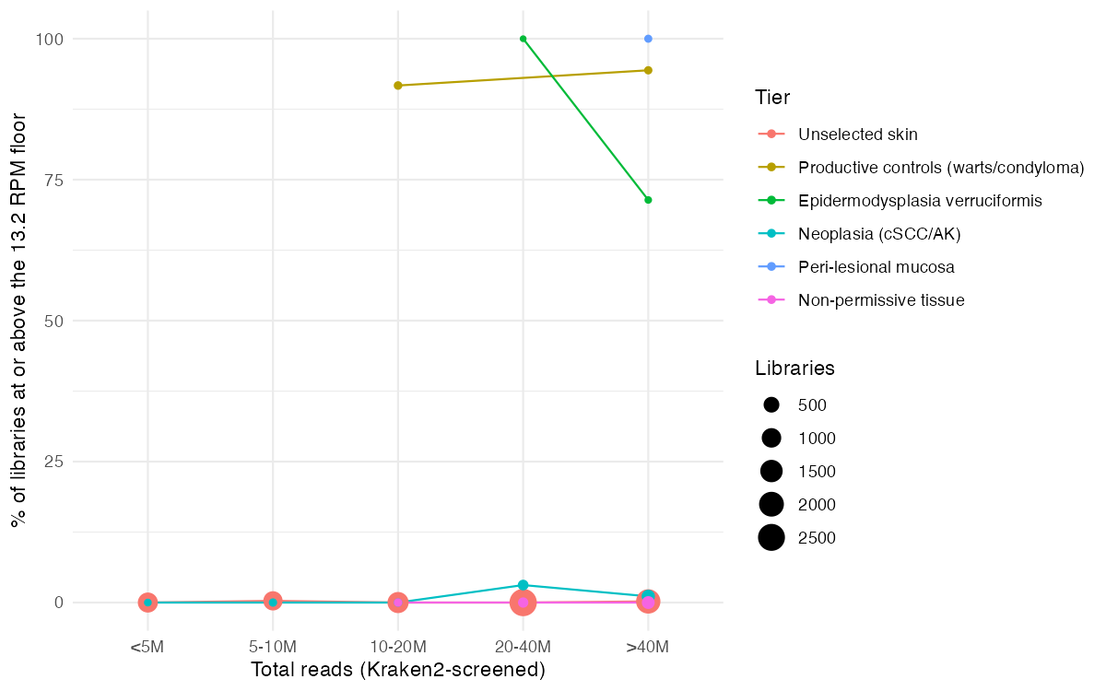
Figure S1: Control-level HPV detection within matched sequencing-depth bins. For each population tier, the percentage of libraries reaching the control-calibrated detection floor (13.2 RPM) is plotted within five total-read bins (<5M, 5–10M, 10–20M, 20–40M, >40M reads); a tier is drawn in a bin only where it has at least three libraries. Productive controls (warts/condyloma) detect at 90–100% in every bin in which they occur, as do the EV biopsies and the peri-lesional mucosa in the deep bins where they fall, whereas cutaneous neoplasia (cSCC/actinic keratosis) and unselected skin stay near zero across all bins, including the deepest. This depth-matched comparison confirms that the tier difference in Figure 2 is not produced by differences in sequencing depth: the tiers that reach the floor do so at every depth, and the tiers that do not never reach it, however deeply sequenced. Point size is proportional to the number of libraries in each tier × bin.

HPV type | Unselected skin (N=7,800) | Productive controls (N=44) | EV (N=10) | Peri-lesional mucosa (N=15) | Neoplasia (N=406) | Cell line (N=697) | Site not recorded (N=1,317) | Total
HPV11 | 0 | 14 (32%) | 0 | 14 (91%) | 0 | 0 | 8 (0.64%) | 36
HPV18 | 0 | 0 | 0 | 0 | 0 | 32 (4.7%) | 0 | 34
HPV16 | 1 (0.02%) | 0 | 0 | 0 | 3 (0.86%) | 24 (3.5%) | 0 | 28
HPV42 | 0 | 9 (21%) | 0 | 13 (84%) | 0 | 0 | 0 | 22
HPV6 | 0 | 3 (7.8%) | 0 | 3 (22%) | 0 | 0 | 6 (0.49%) | 12
HPV57 | 0 | 10 (23%) | 0 | 0 | 0 | 0 | 0 | 10
HPV2 | 0 | 7 (17%) | 1 (14%) | 0 | 0 | 0 | 0 | 8
HPV31 | 0 | 0 | 0 | 0 | 0 | 6 (0.93%) | 0 | 6
HPV90 | 0 | 3 (7.8%) | 0 | 3 (22%) | 0 | 0 | 0 | 6
HPV27 | 0 | 4 (10%) | 0 | 0 | 1 (0.37%) | 0 | 0 | 5
HPV74 | 0 | 0 | 0 | 5 (34%) | 0 | 0 | 0 | 5
HPV91 | 0 | 3 (7.8%) | 0 | 1 (9.4%) | 0 | 0 | 0 | 4
HPV182 | 1 (0.02%) | 0 | 0 | 0 | 2 (0.61%) | 0 | 0 | 3
HPV44 | 0 | 3 (7.8%) | 0 | 0 | 0 | 0 | 0 | 3
HPV52 | 0 | 3 (7.8%) | 0 | 0 | 0 | 0 | 0 | 3
HPV80 | 0 | 0 | 0 | 0 | 0 | 0 | 0 | 3
HPV-mKN1 | 0 | 2 (5.6%) | 0 | 0 | 0 | 0 | 0 | 2
HPV14 | 0 | 0 | 2 (23%) | 0 | 0 | 0 | 0 | 2
HPV20 | 0 | 0 | 1 (14%) | 0 | 1 (0.37%) | 0 | 0 | 2
HPV25 | 0 | 0 | 2 (23%) | 0 | 0 | 0 | 0 | 2
HPV47 | 0 | 0 | 2 (23%) | 0 | 0 | 0 | 0 | 2
HPV4 | 0 | 2 (5.6%) | 0 | 0 | 0 | 0 | 0 | 2
HPV78 | 0 | 2 (5.6%) | 0 | 0 | 0 | 0 | 0 | 2
HPV96 | 0 | 0 | 0 | 0 | 2 (0.61%) | 0 | 0 | 2
HPV9 | 0 | 0 | 2 (23%) | 0 | 0 | 0 | 0 | 2
Table S1: Number of libraries assigned to each HPV reference type across population tiers (types with ≥2 assigned libraries shown). Each cell also gives, in parentheses, the prevalence within that tier, the library count divided by the tier size in the column header, estimated as a Beta-Binomial posterior mean under a weakly-informative Beta(0.5, 0.5) prior. Because tier sizes span more than two orders of magnitude, raw counts are not comparable across tiers: the 14 HPV11 detections in productive controls and the 14 in peri-lesional mucosa correspond to very different prevalences (32% [20–46] versus 91% [73–99]; posterior mean with 95% credible interval), and the high-risk mucosal types HPV16 and HPV18 are confined almost entirely to cell-line material (3.5% [2.3–5.0] and 4.7% [3.2–6.3] of cell-line libraries, versus below 0.1% of skin libraries for both), the signature of integrated-HPV cell-line contamination. Productive controls are dominated by cutaneous wart and low-risk types (HPV57, HPV2, HPV27, HPV6/11, HPV42); the EV tier by the beta-types that define the syndrome (HPV9, HPV14, HPV20, HPV25, HPV47); peri-lesional mucosa by the mucosal alpha repertoire of the adjacent condylomata (HPV11, HPV42, HPV6, HPV74, HPV90). The neoplasia-associated infections are the gamma- and alpha-types HPV12, HPV16, HPV96 and HPV182. Unselected skin contributes no type above the two-library display threshold apart from two HPV18 contamination calls: its beta/gamma reservoir lies below the breadth-and-depth assignment criterion and appears instead in Table S6. Figure 4 summarises this table, and Table S6, at the level of HPV genus.

Sample | Tissue (diagnosis) | HPV type(s) | Coverage breadth | L1 reads | L2 reads
ERR2274877 | Skin (carcinoma) | HPV96 (+HPV182) | 0.99 | 750 | 999
ERR1971044 | Skin (actinic keratosis) | HPV96 (+HPV182) | 0.99 | 731 | 987
SRR19520005 | Skin (cSCC) | HPV12 | 1.00 | 1,803 | 3,546
SRR19520060 | Skin (cSCC) | HPV16 | 0.99 | 188 | 183
SRR19520029 | Skin (cSCC) | HPV16 | 0.75 | 11 | 96
SRR19520008 | Skin (normal) | HPV105 | 0.41 | 97 | 25
SRR24991592 | Skin (unspecified) | HPV227 | 0.67 | 38 | 56
Table S2: Genuine, non-cell-line productive HPV infections detected in primary skin and skin-associated tissue. Each library met the productive criterion (≥3 L1 major-capsid reads) and was flagged as primary tissue rather than cell line or engineered material. Coverage breadth is the maximum across assigned references for that sample. In the two site-unrecorded co-infections (ERR2274877, ERR1971044, both from cutaneous actinic-keratosis/cSCC cohorts) the co-infecting gamma-type HPV182 reached 98–99% genome coverage at 243–245× mean depth. These cases show that bona fide productive cutaneous beta- and gamma-HPV infection does occur in primary tissue, but against the population-scale null they are the exception (see main text and Figure 2).

Contrast (model) | Frequentist OR (P) | Posterior OR [95% CrI] | P(OR > 1)
Cell-line vs clinical positivity (M1) | 5.3 (9.9×10⁻²²) | 5.2 [3.6, 7.3] | >0.999
Engineered vs clinical positivity (M1) | 4.7 (1.5×10⁻⁹) | 4.6 [2.8, 7.4] | >0.999
Productive controls vs unselected skin, floor (M2) | 10,183 (7.6×10⁻⁹⁹) | 8,785 [2,887, 30,272] | >0.999
Neoplasia vs unselected skin, floor (M2) | 14 (6.7×10⁻⁶) | 12 [3.7, 39] | >0.999
Sequencing depth, per 10× reads, floor (M2) | 1.5 (0.49) | 1.6 [0.6, 5.5] | 0.809
Sequencing depth within neoplasia, floor (M2) | 1.6 (0.7) | 1.7 [0.2, 16] | 0.685
Neoplasia vs unselected skin, any-HPV / trace (M2) | 2.0 (5.5×10⁻¹⁰) | 1.9 [1.6, 2.4] | >0.999
Productive controls vs neoplasia, productive (M3) | 3.8 (0.013) | 3.7 [1.3, 11] | 0.991
Table S3: Bayesian re-analysis of the principal contrasts under weakly-informative priors. Each frequentist model (M1–M3; Methods, Table 1, Figure 2) was refitted as a Bayesian logistic regression with a Normal(0, 2.5) prior on the log-odds coefficients and a Normal(0, 5) prior on the intercept (rstanarm; four chains, all R-hat ≤ 1.004, no divergent transitions). Odds ratios are posterior medians with 95% credible intervals; P(OR > 1) is the posterior probability of a positive effect. Frequentist odds ratios (with P values) are shown for comparison; the productive-controls-versus-skin row is a Fisher exact estimate inflated by near-complete separation, whose Bayesian counterpart is regularised by the prior (a heavier-tailed Student-t(3) prior gives an even larger posterior OR, 14,515 [3,961, 77,562], confirming robustness). Sequencing depth is modelled per 10-fold (log₁₀) change in library size.

Accession | Study | Type | Tissue | Diagnosis | RPM
SRR19520029 | SRP378129 | HPV16 | Skin | scc | 765.1
SRR19520060 | SRP378129 | HPV16 | Skin | scc | 263.4
SRR35133829 | SRP612624 | HPV16 | Unclassified | scc | 175.8
Table S4: High-risk mucosal HPV16 cases captured by the broadened cutaneous-neoplasia query and conservatively retained in the neoplasia tier. All 3 are typed as the mucosal high-risk type HPV16 (dominant assigned reference) while carrying squamous-cell-carcinoma diagnoses at a cutaneous or unrecorded site, and all exceed the control-calibrated detection floor (13.2 RPM), so they make up 3 of the 6 above-floor detections in the whole tier. Excluding them halves cutaneous-neoplasia floor-level detection, from 1.5% to 0.7% (versus unselected skin: OR 7.5, P = 0.0055, down from OR 14), and strengthens the warts/EV-versus-neoplasia productivity contrast from OR 3.8 to OR 5.2 (P = 0.0038). Retaining them is therefore the conservative analytical choice: the small floor-level excess of neoplasia over skin reported in the main text is an upper bound. Virus–host junction calling supports the same reading from an independent direction: the members of this set that carry enough viral reads to test are integration-positive, whereas the cutaneous-neoplasia libraries outside it are not. Integration is the expected state of mucosal HPV16 in carcinoma and is not a property of the cutaneous reservoir, so the assignment of these libraries to a mucosal origin rests on genome state as well as on type.

Tier | Unspecified | Poly-A | rRNA-depleted | Random-primed | Template-switching | 3’-barcoded
Unselected skin (7,800) | 40.2 | 42.3 | 7.2 | 2.7 | 4.4 | 3.3
Neoplasia (cSCC/AK) (406) | 60.6 | 12.6 | 22.9 | 0 | 0 | 3.9
Productive controls (44) | 65.9 | 34.1 | 0 | 0 | 0 | 0
EV biopsies (10) | 0 | 0 | 0 | 100 | 0 | 0
Peri-lesional mucosa (15) | 0 | 100 | 0 | 0 | 0 | 0
Cell lines (697) | 42.3 | 49.6 | 2.9 | 5.2 | 0 | 0
Engineered (226) | 42 | 48.7 | 9.3 | 0 | 0 | 0
Non-permissive tissue (334) | 7.5 | 91.6 | 0 | 0.9 | 0 | 0
Other (1,317) | 21 | 40.3 | 25.4 | 3.4 | 8.5 | 1.4
Table S5: Library-selection chemistry by population tier, as a percentage of the libraries in each tier (tier size in parentheses). Chemistry was called from SRA LibrarySelection where that field carries a specific value, and otherwise from the free-text library-construction protocol (Methods); 62.2% of the 10,849 libraries resolved, the remainder being records in which neither source states how the library was selected. The table exists because poly-A capture is the chemistry least favourable to viral-transcript recovery, so an unbalanced distribution of chemistry across tiers could in principle manufacture the productivity contrast reported in the main text. It does not: the imbalance runs the other way. The neoplasia tier, in which no productive infection is found, is rRNA-depleted in 22.9% of libraries against 7.2% of unselected skin, while the productive controls, in which productive infection is abundant, contain no rRNA-depleted libraries at all. The two selection chemistries are in any case indistinguishable in their yield of trace HPV reads once depth and tier are accounted for (rRNA-depleted versus poly-A, OR 1.0, 95% CI 0.8–1.2, P = 0.93); the levels that do carry more trace signal are the amplification chemistries, template-switching (OR 4.4) and 3’-barcoded droplet libraries (OR 3.6), which is the profile of amplification and barcode-swapping artefact rather than of recovery. Restricting the skin-versus-neoplasia contrast to the 657 rRNA-depleted libraries alone leaves the trace excess intact (OR 5.6, 3.4–9.2, P = 7.2×10⁻¹²) and yields no above-floor library in either tier.

HPV type | Genus | Unselected skin (N=7,800) | Neoplasia (N=406) | Productive controls (N=44) | EV (N=10) | Site not recorded (N=1,317) | Cell line (N=697) | Total
HPV16 | Alpha | 3 (0.04%) | 4 (1.1%) | 0 | 0 | 2 (0.19%) | 18 (2.7%) | 27
HPV6 | Alpha | 0 | 0 | 0 | 0 | 16 (1.3%) | 0 | 16
HPV18 | Alpha | 3 (0.04%) | 0 | 0 | 0 | 1 (0.11%) | 9 (1.4%) | 13
HPV-mDysk6 | Gamma | 6 (0.08%) | 0 | 0 | 0 | 0 | 0 | 6
HPV12 | Beta | 3 (0.04%) | 2 (0.61%) | 0 | 0 | 0 | 0 | 5
HPV-mw34c11a | Gamma | 4 (0.06%) | 0 | 0 | 0 | 0 | 0 | 4
HPV134 | Gamma | 3 (0.04%) | 0 | 0 | 0 | 1 (0.11%) | 0 | 4
HPV-mw20c10a | Gamma | 1 (0.02%) | 0 | 0 | 0 | 3 (0.27%) | 0 | 4
HPV107 | Beta | 1 (0.02%) | 0 | 0 | 0 | 3 (0.27%) | 0 | 4
HPV20 | Beta | 3 (0.04%) | 0 | 0 | 0 | 0 | 0 | 3
HPV11 | Alpha | 0 | 0 | 1 (3.3%) | 0 | 2 (0.19%) | 0 | 3
HPV4 | Gamma | 2 (0.03%) | 0 | 0 | 0 | 0 | 0 | 2
HPV41 | Nu | 2 (0.03%) | 0 | 0 | 0 | 0 | 0 | 2
HPV65 | Gamma | 2 (0.03%) | 0 | 0 | 0 | 0 | 0 | 2
HPV66 | Alpha | 2 (0.03%) | 0 | 0 | 0 | 0 | 0 | 2
HPV-mDysk2 | Gamma | 1 (0.02%) | 0 | 0 | 0 | 0 | 1 (0.21%) | 2
HPV-mw18c25 | Gamma | 1 (0.02%) | 0 | 0 | 0 | 1 (0.11%) | 0 | 2
HPV38 | Beta | 1 (0.02%) | 0 | 0 | 0 | 0 | 1 (0.21%) | 2
HPV49 | Beta | 1 (0.02%) | 0 | 0 | 0 | 1 (0.11%) | 0 | 2
HPV182 | Beta | 0 | 2 (0.61%) | 0 | 0 | 0 | 0 | 2
Table S6: Detection-tier HPV type catalogue. This table is the complement of Table S1, not an extension of it: it contains only the 325 HPV-positive libraries that fell below the breadth ≥ 0.10 and depth ≥ 2 assignment threshold and therefore have no entry in Table S1. A library appears in exactly one of the two tables. That is why tiers dominated by high-coverage infection are nearly empty here: of the 44 productive-control libraries, 39 are assigned a type in Table S1 and only 5 remain eligible for this table, of which 2 resolve; the peri-lesional tier contributes none at all. The near-absence of productive controls from the detection tier is a positive control on the assignment criterion, not a missing signal. For each eligible library the best-hit reference was taken from unique STAR primary alignments (MAPQ 255); 137 resolved to a confident low-coverage type spanning 42 types (those with ≥ 2 resolved calls shown), with genus from the complete PaVE lookup. These are low-coverage, non-productive detections: the type is confidently identified but genome coverage is below the assignment breadth, so they extend the descriptive type catalogue without bearing on productivity. As in Table S1, each cell gives the count with its prevalence among all libraries of that tier in parentheses (Beta-Binomial posterior mean, Beta(0.5, 0.5) prior; tier sizes in the headers), keeping both tables on one denominator; the trace-eligible counts per tier are Unselected skin 209, Neoplasia 17, Productive controls 5, EV 1, Site not recorded 46, Cell line 35. Healthy skin is dominated by cutaneous beta/gamma/nu types (40 of 51 resolved skin calls), whereas the mucosal types HPV16 and HPV18 concentrate in cell-line and other material (HPV16 trace prevalence 2.7% [1.6–4.0] in cell lines versus 0.04% [0.01–0.10] in skin), reproducing the contamination pattern of Table S1 at the sensitivity floor. Figure 4 collapses this table, and Table S1, from HPV type to HPV genus.

Library | Tier | Study | Assigned types (coverage breadth, mean depth), ordered by depth
SRR10044860 | Productive controls | SRP219878 | HPV78 (1.00, 13,780×) + HPV57 (0.66, 5×)
SRR10044861 | Productive controls | SRP219878 | HPV78 (1.00, 13,697×) + HPV57 (0.70, 5×)
SRR14243786 | Productive controls | SRP314961 | HPV11 (1.00, 12,564×) + HPV42 (0.59, 3×)
SRR14243748 | Productive controls | SRP314958 | HPV11 (1.00, 6,988×) + HPV42 (0.29, 2×)
SRR14243785 | Productive controls | SRP314961 | HPV11 (1.00, 6,988×) + HPV42 (0.29, 2×)
SRR10044876 | Productive controls | SRP219878 | HPV27 (1.00, 4,998×) + HPV-mKN1 (0.49, 2×)
SRR10044877 | Productive controls | SRP219878 | HPV27 (1.00, 4,943×) + HPV-mKN1 (0.47, 3×)
SRR14243780 | Productive controls | SRP314961 | HPV11 (0.99, 2,996×) + HPV90 (0.92, 67×) + HPV42 (0.79, 62×) + HPV44 (0.98, 60×)
SRR14243745 | Productive controls | SRP314958 | HPV11 (1.00, 1,963×) + HPV90 (0.96, 90×) + HPV44 (0.99, 90×) + HPV42 (0.87, 27×)
SRR14243779 | Productive controls | SRP314961 | HPV11 (1.00, 1,963×) + HPV90 (0.96, 90×) + HPV44 (0.99, 90×) + HPV42 (0.87, 27×)
SRR14243784 | Productive controls | SRP314961 | HPV91 (0.99, 1,391×) + HPV52 (0.94, 83×) + HPV11 (0.66, 3×) + HPV42 (0.22, 2×)
SRR14243747 | Productive controls | SRP314958 | HPV91 (1.00, 1,114×) + HPV52 (0.95, 83×) + HPV11 (0.79, 6×)
SRR14243783 | Productive controls | SRP314961 | HPV91 (1.00, 1,114×) + HPV52 (0.95, 83×) + HPV11 (0.79, 6×)
SRR14243782 | Productive controls | SRP314961 | HPV6 (0.97, 1,102×) + HPV42 (0.44, 3×)
SRR14243746 | Productive controls | SRP314958 | HPV6 (0.99, 549×) + HPV11 (0.82, 12×)
SRR14243781 | Productive controls | SRP314961 | HPV6 (0.99, 549×) + HPV11 (0.82, 12×)
SRR14243788 | Productive controls | SRP314961 | HPV11 (0.95, 485×) + HPV42 (0.49, 2×)
SRR21205030 | EV | SRP394058 | HPV25 (1.00, 75,813×) + HPV14 (0.63, 4×)
SRR21205038 | EV | SRP394058 | HPV20 (0.91, 18,558×) + HPV9 (1.00, 736×)
SRR21205031 | EV | SRP394058 | HPV25 (0.98, 117×) + HPV37 (0.78, 5×)
SRR21205037 | EV | SRP394058 | HPV9 (0.98, 48×) + HPV2 (0.89, 19×)
SRR14243794 | Peri-lesional mucosa | SRP314961 | HPV42 (0.99, 3,816×) + HPV11 (0.79, 8×)
SRR14243752 | Peri-lesional mucosa | SRP314958 | HPV42 (1.00, 2,942×) + HPV11 (0.72, 9×) + HPV74 (0.16, 3×)
SRR14243793 | Peri-lesional mucosa | SRP314961 | HPV42 (1.00, 2,942×) + HPV11 (0.72, 9×) + HPV74 (0.16, 3×)
SRR14243790 | Peri-lesional mucosa | SRP314961 | HPV42 (0.99, 955×) + HPV90 (0.97, 273×) + HPV11 (0.93, 138×)
SRR14243750 | Peri-lesional mucosa | SRP314958 | HPV42 (1.00, 572×) + HPV90 (0.98, 272×) + HPV11 (0.98, 115×)
SRR14243789 | Peri-lesional mucosa | SRP314961 | HPV42 (1.00, 572×) + HPV90 (0.98, 272×) + HPV11 (0.98, 115×)
SRR14243792 | Peri-lesional mucosa | SRP314961 | HPV74 (0.76, 35×) + HPV6 (0.45, 13×) + HPV42 (0.20, 3×) + HPV91 (0.40, 2×) + HPV11 (0.32, 2×)
SRR14243796 | Peri-lesional mucosa | SRP314961 | HPV11 (0.61, 31×) + HPV42 (0.37, 3×)
SRR14243751 | Peri-lesional mucosa | SRP314958 | HPV74 (0.91, 24×) + HPV11 (0.78, 10×) + HPV6 (0.55, 6×) + HPV42 (0.51, 2×)
SRR14243791 | Peri-lesional mucosa | SRP314961 | HPV74 (0.91, 24×) + HPV11 (0.78, 10×) + HPV6 (0.55, 6×) + HPV42 (0.51, 2×)
SRR14243753 | Peri-lesional mucosa | SRP314958 | HPV11 (0.90, 20×) + HPV42 (0.53, 2×)
SRR14243795 | Peri-lesional mucosa | SRP314961 | HPV11 (0.90, 20×) + HPV42 (0.53, 2×)
SRR19520005 | Neoplasia | SRP378129 | HPV12 (1.00, 711×) + HPV27 (0.52, 5×)
ERR2274877 | Neoplasia | ERP106532 | HPV182 (0.99, 245×) + HPV96 (0.99, 63×)
ERR1971044 | Neoplasia | ERP022968 | HPV182 (0.98, 243×) + HPV96 (0.99, 61×)
SRR19519996 | Unselected skin | SRP378129 | HPV176 (0.26, 8×) + HPV-m7269 (0.26, 3×)
SRR29524701 | Unselected skin | SRP515675 | HPV-mw34c14a (0.50, 4×) + HPV49 (0.31, 3×)
Table S7: Libraries carrying more than one assigned HPV type. Every library in which two or more references independently cleared the assignment criterion (coverage breadth ≥ 0.10 and mean depth ≥ 2) is listed, with each type’s breadth and mean depth, ordered by depth; 38 of the 163 typed libraries qualify (24 with two types, 7 with three, 6 with four, 1 with five). Coverage is computed by samtools coverage -q 10, which retains only uniquely-mapped reads, since STAR assigns MAPQ ≤ 3 to any read placing equally well on two references, so cross-mapping between similar types cannot manufacture a co-infection call: each type in a row is supported by reads that map to it and to nothing else. Three cautions govern how far the table can be read. First, the rows are not independent observations: 25 of the 38 come from the paired studies SRP314958 (RNA-seq) and SRP314961 (MeRIP-seq), which are the same 9 donors, five condyloma lesions (CA_1 to CA_5) and four matched peri-lesional specimens (CON_1 to CON_4), each sequenced as an RNA-seq library plus a MeRIP input and IP fraction, so rows sharing a donor carry near-identical read profiles. Second, the secondary types often sit close to the threshold: across all non-dominant calls the median depth is 6.8× and 40% fall below 5×, so which type is called second can depend on the library fraction, and in donor CA_2 the RNA-seq and MeRIP input fractions call HPV6 + HPV11 while the IP fraction of the same specimen calls HPV6 + HPV42. Third, the deepest type in a co-infected library typically dominates its partner, by a median of 22-fold (interquartile range 3.9 to 330), so most rows describe one established infection alongside a minor second type rather than two comparable ones. Where both partners are unambiguous the pairings are biologically coherent: two carcinoma and actinic-keratosis libraries whose SRA records carry no tissue field (ERR2274877, ERR1971044) carry the gamma-types HPV96 and HPV182 together at 98–99% breadth and 61–245× depth, and an EV biopsy (SRR21205038) carries the beta-types HPV20 and HPV9 at 18,558× and 736×; both are two full genomes in one library, not a genome plus a fragment. The most frequent pairing in the study is HPV11 with HPV42: 20 libraries carry both, 16 carry HPV11 without HPV42, and only 2 carry HPV42 without HPV11; in the peri-lesional tier the association is forced by the marginals of Table S1, where 14 HPV11 and 13 HPV42 calls are distributed over 15 libraries. Requiring both partners to clear a stricter bar (breadth ≥ 0.70 and depth ≥ 5× for each) leaves 9 libraries from 3 donors: one condyloma lesion (CA_1) and two peri-lesional specimens (CON_1, CON_3). Their dominance relation is asymmetric but not cleanly so. HPV11 is the deeper type in all five condyloma lesions, exceeding HPV42 48- to 4,100-fold in the three with a strong HPV11 signal (CA_1, CA_4, CA_5) and 2- to 4-fold in the other two; in peri-lesional mucosa HPV42 is the deeper type in CON_1 and CON_3, the two specimens where it is unambiguous (955× versus 138×, and 3,816× versus 9×, i.e. 7-fold and 410-fold), whereas in CON_2, CON_4 and CON_5, where HPV42 barely clears the assignment threshold, HPV11 remains the deeper type. Whether that reflects a genuine tissue difference in which type predominates, or merely that HPV42 clears the threshold only where it happens to be abundant, cannot be settled from three donors of one study: it is a hypothesis the data motivate, not a result they support.

Above-floor HPV in tissue that cannot host it: two contaminated studies
The non-permissive tissue tier is defined by biology, not by its HPV content, so it also exposes the opposite case: libraries from non-permissive material that carry HPV above the trace level. Two studies do, and both were held out of the control tier for that reason.
SRP572742 (skeletal muscle and blood from myotonic dystrophy patients, n = 66) is HPV-positive at any level in 83% of libraries, with 3 crossing the control-calibrated detection floor and a maximum of 5.3 RPM. Neither muscle nor blood contains stratified squamous epithelium, so no part of that signal can be infection of the sampled tissue.
SRP565659 makes the point under internal control. It is a multi-omic cutaneous T-cell lymphoma study in which skin and peripheral blood were taken from the same patients and sequenced together (Table S1 of the source publication assigns every run a tissue). Its 26 skin libraries are strongly HPV-positive, 88% at any level and up to 12.0 RPM, as expected for lesional skin. Its 42 blood and lymph-node libraries (same patients, same runs, tissue that cannot host the virus) are HPV-positive at 52%, up to 3.6 RPM, with one library above the floor.
The pattern in both is a minority of reads appearing in libraries with no biological source for them, alongside co-sequenced libraries carrying a genuine high-titre signal. That is the signature of index hopping and inter-library carry-over rather than infection, and it is the same phenomenon that makes cell-line contamination the dominant driver of apparent HPV positivity in public transcriptomes. Two consequences follow for how the trace signal should be read. First, a non-zero HPV read count in a single library is not evidence of infection even when the tissue is plausible, which is why the analysis here is anchored on a control-calibrated floor rather than on detection. Second, studies whose design places high-titre and HPV-free material in the same sequencing run will inflate apparent prevalence in the HPV-free arm, so prevalence estimates drawn from public data without a non-permissive control are upper bounds.
Body site / lesion | Contigs (n) | E2 intact, all contigs | Contigs ≥7 kb (n) | E2 intact, ≥7 kb
Skin (metagenome) | 3,593 | 87.7% | 1,073 | 99.9%
Vaginal (metagenome) | 690 | 98.7% | 427 | 100.0%
Gut (metagenome) | 382 | 93.1% | 211 | 100.0%
Anogenital wart | 13 | 100.0% | 5 | 100.0%
Cervical CIN | 72 | 79.3% | 21 | 100.0%
Cervical carcinoma | 1,426 | 83.6% | 267 | 99.3%
Table S8: E2 integrity in assembled papillomavirus contigs, and why it cannot detect integration. Contigs recovered from the Logan-wide papillomavirus catalogue (J. Y. Q. Shen et al. 2026) were annotated by tblastn against RefSeq papillomavirus open reading frames, and scored for whether E2 is present given that E1 is present. The comparison that matters is between the two right-hand columns and the two left-hand ones. Across all contigs, E2 recovery tracks assembly quality rather than biology: it is lowest in cervical CIN (79.3%) and cervical carcinoma (83.6%), which are also the arms with the shortest contigs, and highest in the vaginal and gut metagenomes, which assemble best. Once the question is restricted to near-complete contigs (≥7 kb), where E2 presence can actually be assessed, every category converges on 100%, and cervical carcinoma, in which integration and E2 disruption are the rule, returns 99.3% against 99.9% for skin. That convergence is not a biological result. An integrated genome cannot assemble across the virus-host junction, so conditioning on completeness selects episomal genomes in every category, and the statistic is structurally incapable of detecting the event it was built to detect. This table is reported because the inference is an inviting one to draw from a public contig catalogue, and because it bounds what the DNA axis can contribute: presence of a papillomavirus in such a catalogue is presence of a detectable L1, and carries no information about the state of the genome (Discussion).

